**SMART PARKING SYSTEM USING INTERNET OF THINGS (IOT)**

**PYTHON SCRIPT**

**INTRODUCTION**:

*The proposed IoT-based Smart Parking System leverages a network of sensors and communication devices to monitor and manage parking spaces in real-time. These sensors are strategically deployed in parking areas, and they continuously collect data related to parking space occupancy and availability. This data is then transmitted to a central cloud-based platform for analysis and dissemination.

**SENSORS USED IN SMART PARKING SYSTEM:**

**Raspberry Pi**

The Raspberry Pi is a low cost, credit-card sized computer that plugs into a computer monitor or TV, and uses a standard keyboard and mouse. It is a capable little device that enables people of all ages to explore computing, and to learn how to program in languages like Scratch **and** Python.

**Ultrasonic Sensors**

The integration of ultrasonic sensors, which measure the distance between objects using ultrasonic waves, allows for precise parking. However, such devices have one drawback — the sensor might get blocked with dirt.

**Electromagnetic Field Sensors**

An electromagnetic field sensor detects and measures changes in the magnetic field. This way, it reacts to the approach of metal objects.

**Infrared Sensors**

Infrared (IR) sensors emit an infrared signal and catch the reflection of this signal from the environment. Integrating such a device enables measuring the temperature

**Python script on Raspberry Pi:**

import machine

import time

import urequests

import network

# WiFi credentials

WIFI_SSID = "Wokwi-GUEST"

WIFI_PASSWORD = ""

# ThingSpeak API settings

THINGSPEAK_API_KEY = "6MOYIBZZSRRE1D3D"

THINGSPEAK_CHANNEL_ID = 2322583

# Define the GPIO pins for the sensor

TRIG_PIN = machine.Pin(2, machine.Pin.OUT)

ECHO_PIN = machine.Pin(3, machine.Pin.IN)

# Set the occupancy threshold in centimeters

OCCUPANCY_THRESHOLD = 30.0 # Adjust this value as needed

# Connect to WiFi

wifi = network.WLAN(network.STA_IF)

if not wifi.isconnected():

print("Connecting to WiFi...")

wifi.active(True)

wifi.connect(WIFI_SSID, WIFI_PASSWORD)

while not wifi.isconnected():

pass

print("Connected to WiFi")

def send_to_thingspeak(occupancy):

url = "https://api.thingspeak.com/update?api_key={}&field1={}".format(THINGSPEAK_API_KEY, occupancy)

response = urequests.get(url)

response.close()

try:

while True:

# Trigger the ultrasonic sensor

TRIG_PIN.on()

time.sleep_us(10)

TRIG_PIN.off()

pulse_start = time.ticks_us()

pulse_end = time.ticks_us()

# Wait for the echo signal

while ECHO_PIN.value() == 0:

pulse_start = time.ticks_us()

while ECHO_PIN.value() == 1:

pulse_end = time.ticks_us()

# Calculate the distance

pulse_duration = time.ticks_diff(pulse_end, pulse_start)

distance = (pulse_duration / 1000000) * 17150 # Speed of sound in cm/s

# Check for occupancy

if distance < OCCUPANCY_THRESHOLD:

kalaiyarasan = "Occupied"

print(kalaiyarasan)

send_to_thingspeak(1) # Send 1 to indicate occupancy to ThingSpeak

else:

kalaiyarasan1 = "Not Occupied"

print(kalaiyarasan1)

send_to_thingspeak(0) # Send 0 to indicate no occupancy to ThingSpeak

time.sleep(5) # Delay for 15 seconds (ThingSpeak allows up to 15-second updates)

except KeyboardInterrupt:

pass

**Simulation circuit :**

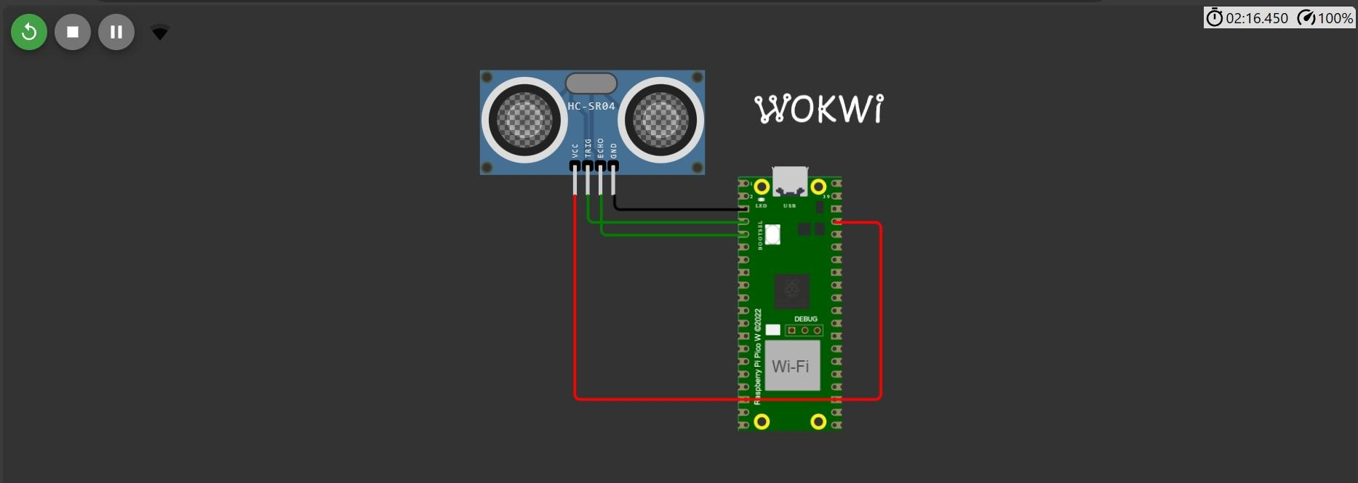

**Output:**

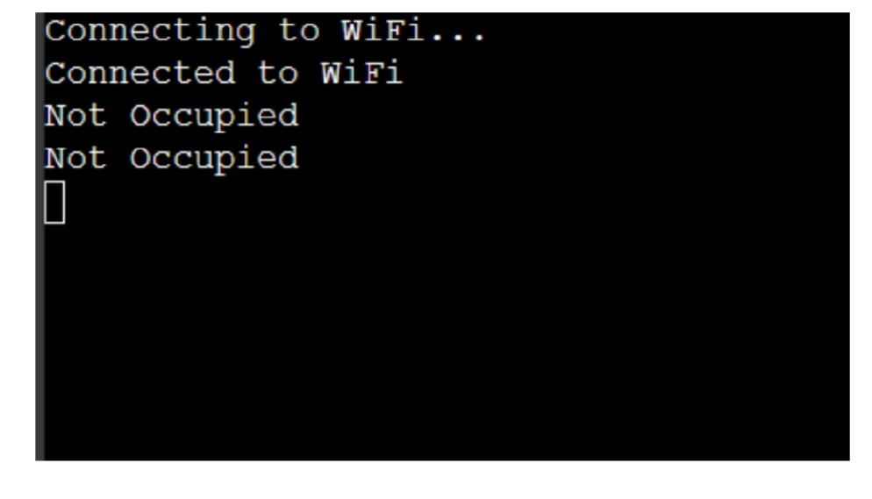 **In ThingSpeak(cloud platform):**

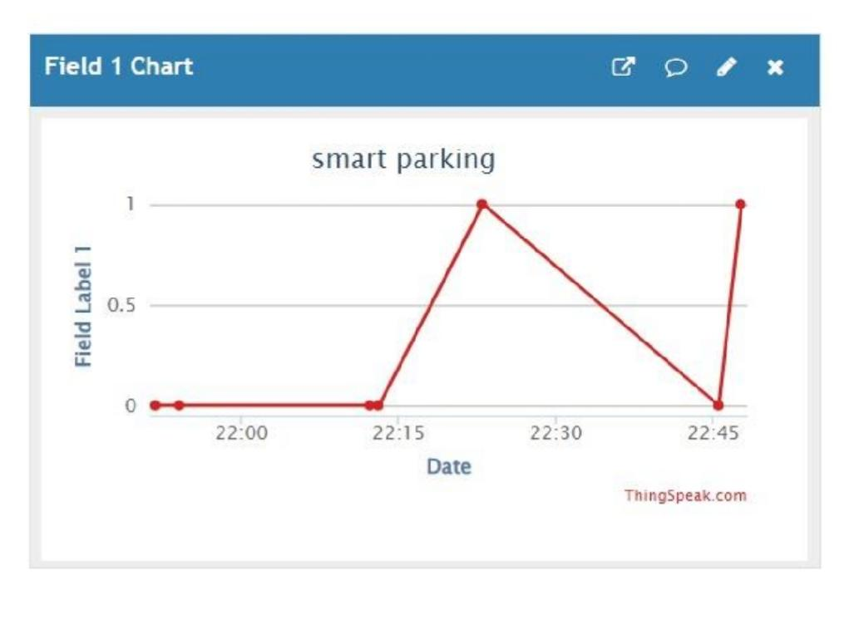**APPLICATION OF SMART PARKING SYSTEM USING IOT:**

An IoT-based smart parking system is a decent solution for businesses and consumers,

Providing real-time data on parking space availability, pricing, payments, and more. It can positively impact the environment and traffic.

Moreover, IoT solutions ensure efficient parking reservation and management.