\.mongod.exe --configsvr --replSet configReplSet --port 27019 --dbpath C:\data\cfg1 --bind_ip localhost
\.mongod.exe --configsvr --replSet configReplSet --port 27020 --dbpath C:\data\cfg1 --bind_ip localhost
\.mongod.exe --configsvr --replSet configReplSet --port 27021 --dbpath C:\data\cfg1 --bind_ip localhost
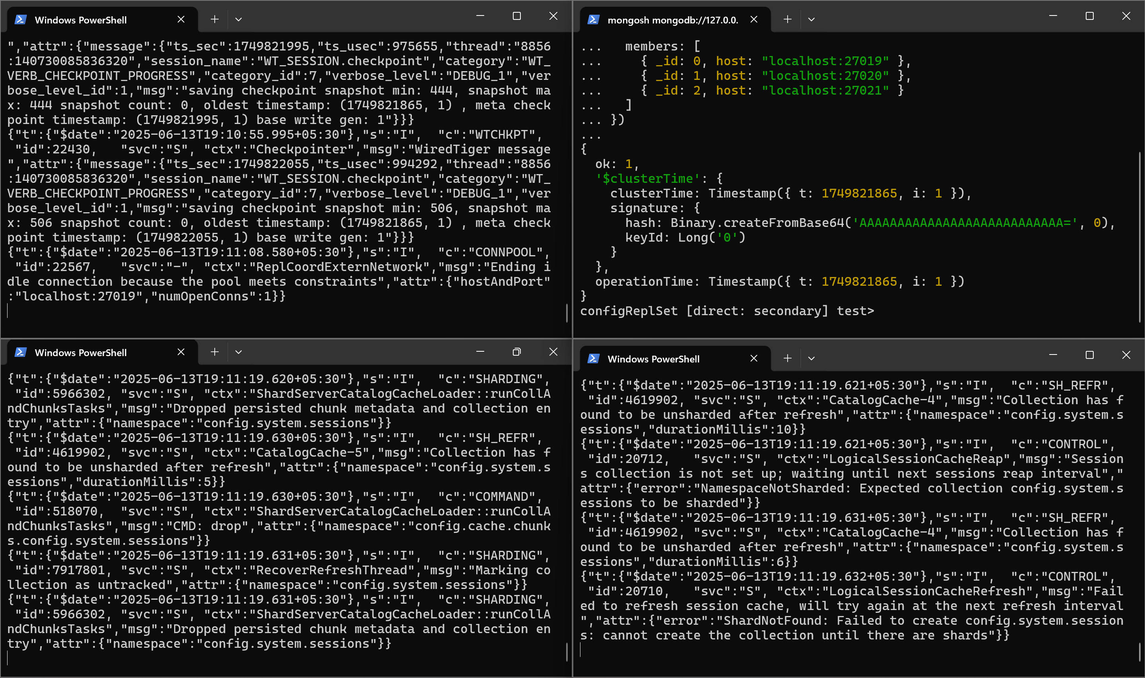
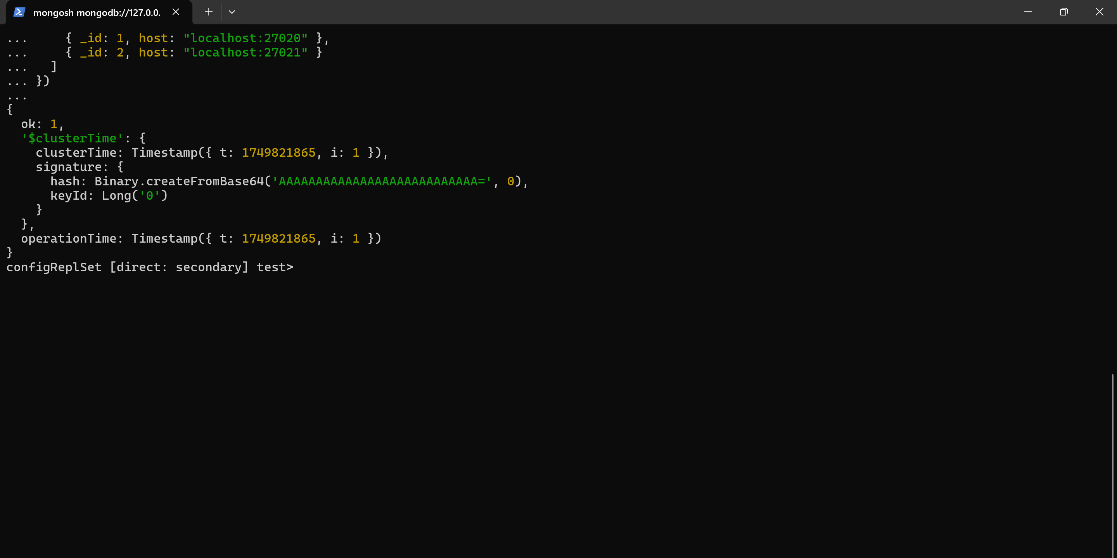
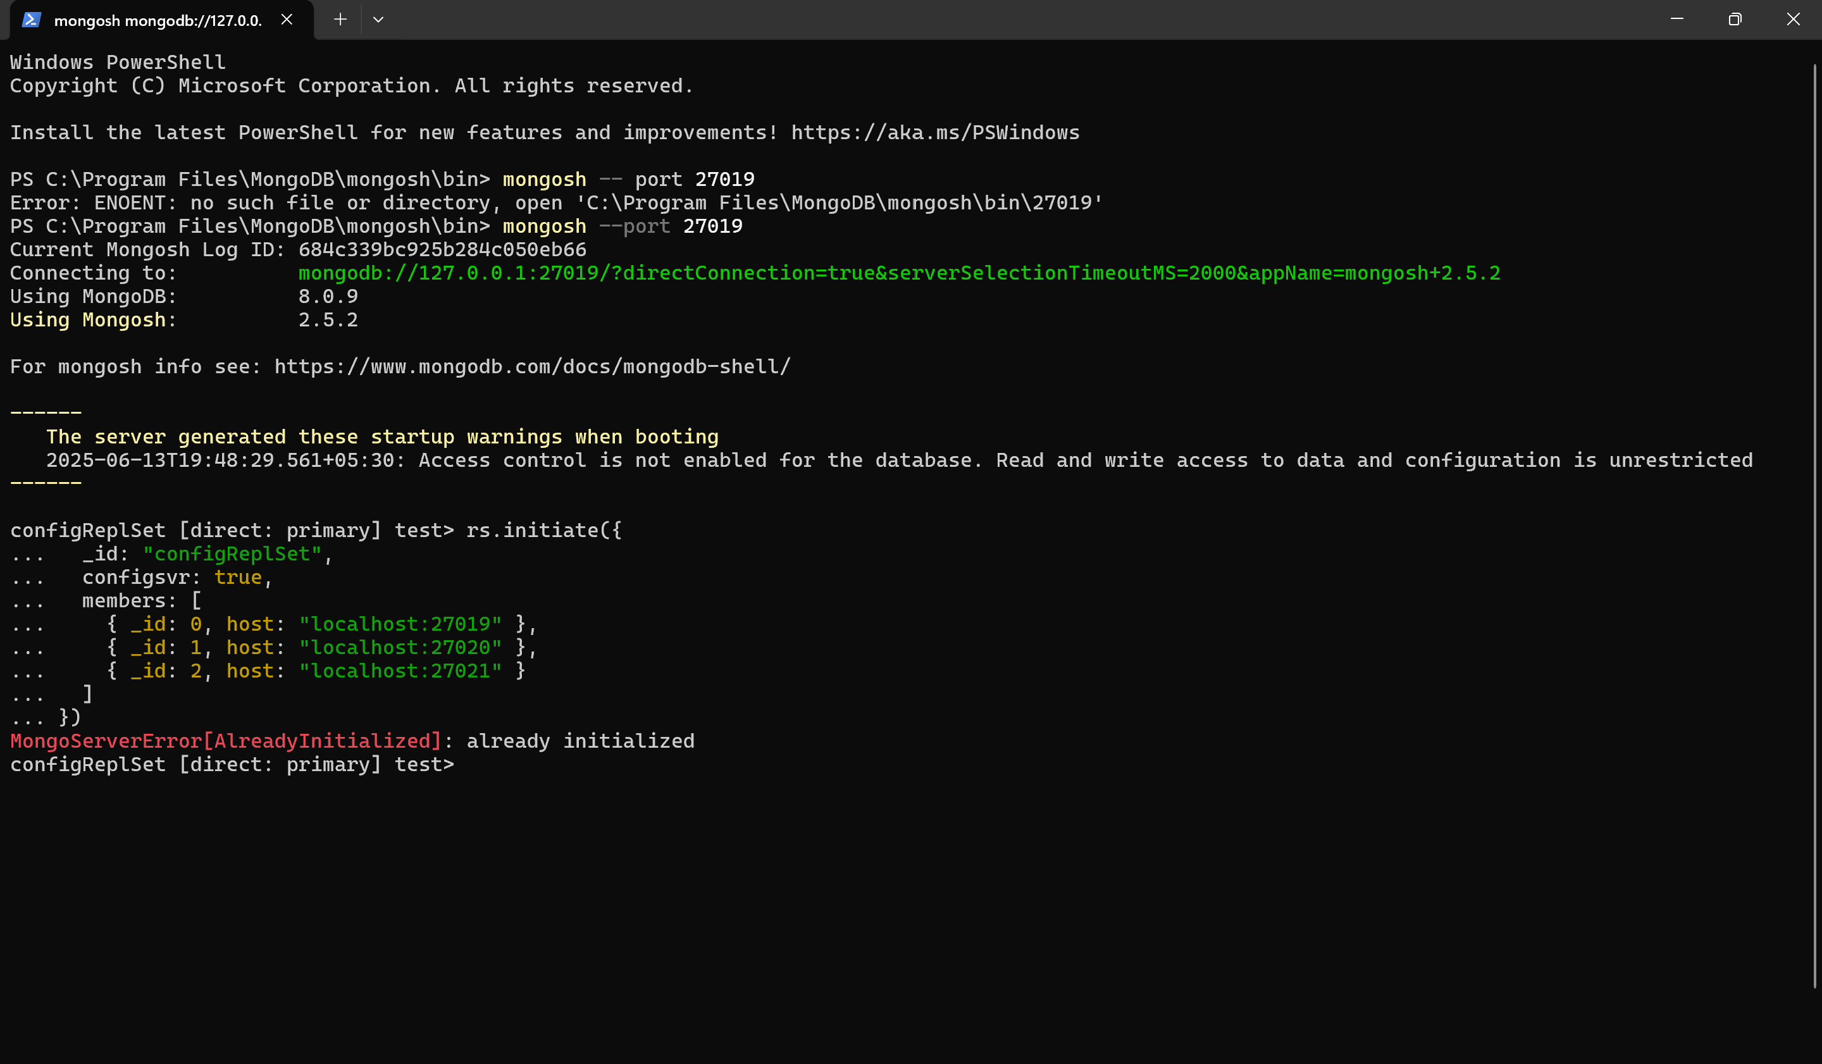

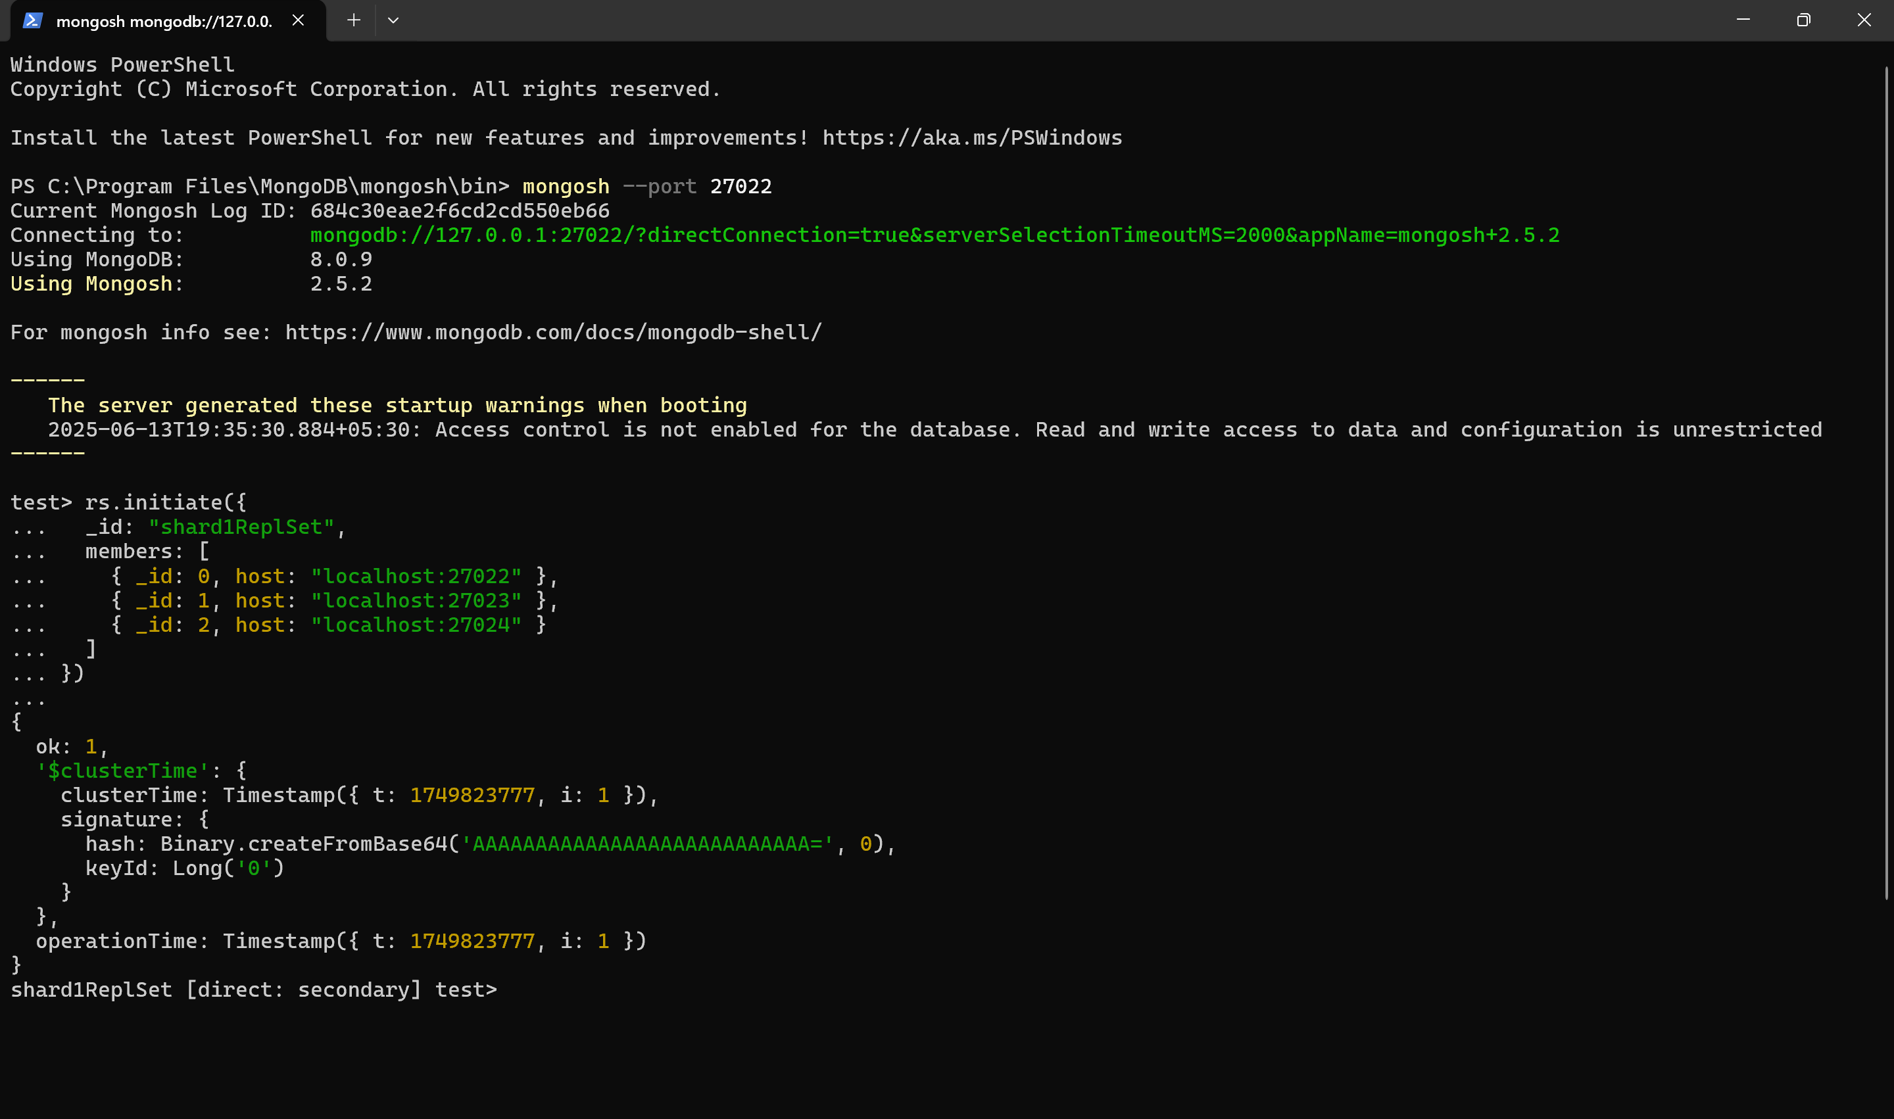

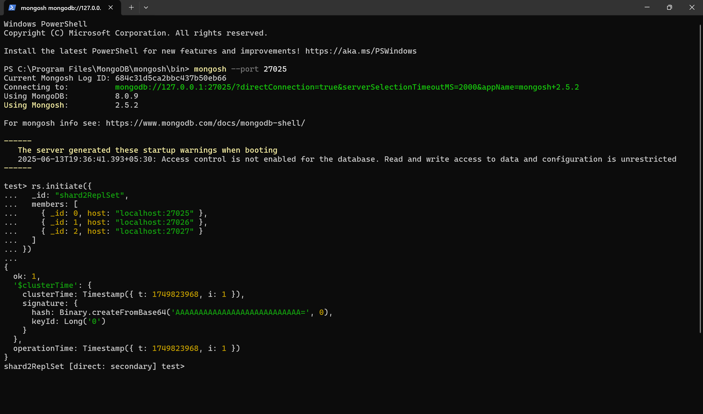

# Node 1
.\mongod.exe --shardsvr --replSet shard1ReplSet --port 27022 --dbpath C:\data\shard1_1 --bind_ip localhost

# Node 2
.\mongod.exe --shardsvr --replSet shard1ReplSet --port 27023 --dbpath C:\data\shard1_2 --bind_ip localhost

# Node 3
.\mongod.exe --shardsvr --replSet shard1ReplSet --port 27024 --dbpath C:\data\shard1_3 --bind_ip localhost

# Node 1
.\mongod.exe --shardsvr --replSet shard2ReplSet --port 27025 --dbpath C:\data\shard2_1 --bind_ip localhost

# Node 2
.\mongod.exe --shardsvr --replSet shard2ReplSet --port 27026 --dbpath C:\data\shard2_2 --bind_ip localhost

# Node 3
.\mongod.exe --shardsvr --replSet shard2ReplSet --port 27027 --dbpath C:\data\shard2_3 --bind_ip localhost
