1.DBCONNECTION:
package connection;
import java.sql.*;
import java.sql.DriverManager;
public class DBConnection {

public static void main(String[] args) {
// TODO Auto-generated method stub
System.out.println("Hi, Hello");
try{
Class.forName("com.mysql.cj.jdbc.Driver");
Connection con=DriverManager.getConnection(
"jdbc:mysql://localhost:3306/newmay2025","root","dhanush_19");
System.out.println(con);

Statement stmt=con.createStatement();
ResultSet rs =stmt.executeQuery("select * from Customers");

while(rs.next()){
System.out.println(rs.getInt(1)+" "+rs.getString(2)+" "+rs.getString(3)+" "+rs.getString(4));

}
con.close();
}
catch (Exception e){
System.out.println("Please checkout");
}
}

}

OUTPUT:
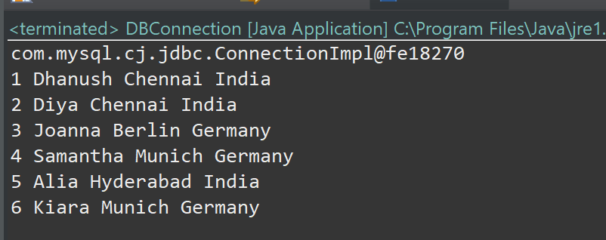

2. CRUD OPERATION:
package crud_operation;
import java.sql.*;
import java.sql.DriverManager;
public class DB_Connection {

public static void main(String[] args) {
// TODO Auto-generated method stub
DB_Connection obj_DB_Connection=new DB_Connection();
System.out.println(obj_DB_Connection.get_connection());

}

public Connection get_connection(){
Connection connection=null;
try{
Class.forName("com.mysql.cj.jdbc.Driver");
connection=DriverManager.getConnection(
"jdbc:mysql://localhost:3306/newmay2025","root","dhanush_19");

}
catch (Exception e){
System.out.println("Please checkout");
}
return connection;
}

}
package crud_operation;
import java.sql.*;

public class CRUD {

public static void main(String[] args) {
// TODO Auto-generated method stub
CRUD objTest=new CRUD();
objTest.create_data(100,"Diya",97);
objTest.create_data(101,"Joanna",96);

}
public void create_data(int sno,String name,int mark){
DB_Connection obj_DB_Connection=new DB_Connection();
Connection connection=obj_DB_Connection.get_connection();
PreparedStatement ps=null;
try {
String query="insert into student1 values (?,?,?)";
ps=connection.prepareStatement(query);
ps.setInt(1, sno);
ps.setString(2, name);
ps.setInt(3, mark);
System.out.println(ps);
ps.executeUpdate();
} catch (Exception e) {
System.out.println(e);
}
}

}
OUTPUT:
