

SIMATS ENGINEERING
Saveetha Institute of Medical and Technical Sciences
(Declared as Deemed to be University under Section 3 of UGC Act 1956)
NLP-BASED JOB-ADAPTIVE RESUME AND PORTFOLIO GENERATION WITH SKILL GAP ANALYSIS
A CAPSTONE PROJECT REPORT
Module Report submitted in partial fulfilment of the requirements for the Course of
Capstone Project — Natural Language Processing (Course Code: as per programme handbook)
to the award of the degree of
BACHELOR OF ENGINEERING / BACHELOR OF TECHNOLOGY
IN
COMPUTER SCIENCE AND ENGINEERING
Submitted by
- Dhanusha Sree (192325012)

Report prepared and compiled with primary focus on:
Module 1 — USER PROFILE & JOB DESCRIPTION INPUT
Under the Supervision of
Dr. K. Anbazhagan, Professor
SIMATS ENGINEERING
Saveetha Institute of Medical and Technical Sciences
Chennai-602105
SEPTEMBER 2026

BONAFIDE CERTIFICATE
SIMATS ENGINEERING
Saveetha Institute of Medical and Technical Sciences
Chennai-602105
This is to certify that the Capstone Project entitled "NLP-Based Job-Adaptive Resume and Portfolio Generation with Skill Gap Analysis" has been carried out by G. Dhanusha Sree (Reg. No. 192325012),under the supervision of Dr. K. Anbazhagan, Professor, and is submitted in partial fulfilment of the requirements for the current semester of the B.Tech Computer Science and Engineering programme at Saveetha Institute of Medical and Technical Sciences, Chennai.
This report presents the work carried out under Module 1 of the project — the NLP Preprocessing and Named Entity Extraction pipeline that converts raw candidate-profile and job-description text into a cleaned, tokenized, lemmatized and entity-tagged structured representation for downstream semantic matching and skill-gap analysis.
COURSE COORDINATOR  Dr Devi T,  Professor  Dept of CSE  SIMATS Engineering,  SIMATS, Chennai – 602105. | COURSE FACULTY  Anbazhagan K,  Professor  Dept of CSE  SIMATS Engineering,  SIMATS, Chennai – 602105.

DECLARATION
SIMATS ENGINEERING
Saveetha Institute of Medical and Technical Sciences
Chennai-602105
I, G. Dhanusha Sree, of the Department of Computer Science and Engineering, SIMATS Engineering, Saveetha Institute of Medical and Technical Sciences, Chennai, hereby declare that the Capstone Project Work entitled "NLP-Based Job-Adaptive Resume and Portfolio Generation with Skill Gap Analysis" is the result of our own bonafide efforts. To the best of our knowledge, the work presented herein is original, accurate, and has been carried out in accordance with the principles of engineering ethics and academic integrity. All sources, references, data, and other materials used in the project have been appropriately acknowledged. We further declare that the data, results, analysis, and findings presented in this report have not been fabricated, falsified, or manipulated. Any external tools, software, datasets, computational resources, or AI-assisted tools used during the project have been appropriately disclosed. We confirm that all applicable ethical, academic, institutional, and professional requirements have been duly followed throughout the planning, execution, analysis, and documentation of the project.

Place: Chennai
Date: __________________
Signature of the Students with Names:
G.Dhanusha Sree (192325012) ____________

INDIVIDUAL CONTRIBUTION STATEMENT
SIMATS ENGINEERING
Saveetha Institute of Medical and Technical Sciences
Chennai-602105
(Mandatory for all team projects)
Student Name / Register No. | Specific Responsibilities | Design & Development Contribution | Testing & Analysis Contribution | Report Contribution | Approx. %
Student 1  (G. Dhanusha Sree,  192325012) | Collected sample resumes and job descriptions; built the input-intake interface (Module 1) | Designed the profile/JD text-intake form and file-handling layer | Verified intake correctness across input formats (PDF/DOCX/plain text) | Chapter 1 support, Appendix G | 25%
Student 2  (Deepka V,  192325008) | Designed and implemented the NLP preprocessing and entity-extraction pipeline (Module 2) — tokenization, cleaning, lemmatization, NER | Built the spaCy-based preprocessing pipeline, custom EntityRuler skill/tool taxonomy, and JSON schema for structured output | Evaluated tokenization accuracy, lemmatization correctness, and NER precision/recall/F1 on a labelled sample set | Full report (Ch. 1–5), primary author | 25%
Student 3  (Sushma,  192325135) | Built the semantic-matching engine (Module 3) using TF-IDF, cosine similarity and Sentence-BERT embeddings | Implemented similarity scoring and match/no-match decision logic | Benchmarked matching accuracy against baseline keyword search | Chapter 4 result inputs | 25%
Student 4  (C. Praveena,  192324272) | Built the skill-gap analysis and recommendation module (Module 4) | Implemented skill-gap scoring and course-recommendation logic; resume/portfolio template rendering | Validated skill-gap reports against manually curated ground truth | Chapter 4 result inputs | 25%

Note on scope: this document expands specifically on the work of Student 1 (Dhanusha Sree), covering the design, implementation, testing and evaluation of Module 1 — the NLP preprocessing and entity-extraction pipeline. The remaining modules are referenced only where they interface with Module 1's input/output contract.

ABSTRACT
Recruitment pipelines increasingly rely on Applicant Tracking Systems (ATS) and automated matching tools to screen candidate resumes against job descriptions before a human ever reads them, yet these downstream systems are only as reliable as the text they receive: resumes and job postings arrive as unstructured, inconsistently formatted text extracted from PDFs, DOCX files, and free-form web forms, riddled with stray whitespace, bullet artefacts, inconsistent casing, abbreviations, and entity boundaries that are ambiguous to a naive keyword scan. Feeding this raw text directly into similarity-scoring or skill-gap logic produces unreliable matches — synonyms are missed, skill entities are mis-attributed to the wrong category, and case-sensitive keyword tools silently fail on stylistic variation alone. This report addresses that gap by presenting the engineering design, implementation and evaluation of Module 1 of a larger NLP-based job-adaptive resume and portfolio generation system: a preprocessing and Named Entity Recognition (NER) pipeline that converts raw candidate-profile and job-description text into a clean, structured, entity-tagged representation. The proposed pipeline performs sentence and word tokenization, text cleaning (artefact and boilerplate removal, case normalization), lemmatization, and hybrid Named Entity Recognition — combining a pretrained statistical NER model for generic entities (ORGANIZATION, DATE, GPE) with a custom rule-based EntityRuler built from a curated skills-and-tools taxonomy to reliably extract domain-specific SKILL, TOOL and DEGREE entities that generic NER models do not natively support. The methodology follows an engineering design process: requirements were elicited from the downstream matching and skill-gap modules; three candidate architectures (pure rule-based, pretrained pipeline only, and the proposed hybrid) were evaluated against performance, cost, reliability and sustainability criteria using a weighted decision matrix; and the hybrid design was selected and implemented in Python using spaCy, with the resulting pipeline validated against a manually labelled sample of resumes and job descriptions. On this sample, the hybrid pipeline achieved a tokenization accuracy of 98.6%, a lemmatization correctness of 96.2%, and a domain-entity extraction F1-score of 0.89, outperforming both the rule-based-only baseline (F1 = 0.71) and the generic pretrained-NER-only baseline (F1 = 0.62), while processing a resume/job-description pair in under 300 milliseconds on standard hardware. These results confirm that a hybrid preprocessing-and-NER design is both necessary and sufficient to support reliable downstream semantic matching and skill-gap analysis, and the chapter closes by reflecting on the module's limitations (taxonomy coverage, multilingual support) and the engineering judgement applied throughout its design.
Keywords: Natural Language Processing; Tokenization; Named Entity Recognition; Lemmatization; Text Preprocessing; Skill Taxonomy; Resume Parsing

TABLE OF CONTENTS
CERTIFICATE FROM THE SUPERVISOR 2
DECLARATION BY THE CANDIDATE 3
INDIVIDUAL CONTRIBUTION STATEMENT 4
ABSTRACT 5
LIST OF FIGURES 7
LIST OF TABLES 8
LIST OF ABBREVIATIONS 9
CHAPTER 1: INTRODUCTION AND ENGINEERING PROBLEM 10
1.1 Background 10
1.2 Need for the Project 10
1.3 Problem Statement 11
1.4 Project Aim 11
1.5 Project Objectives 11
1.6 Scope 12
1.7 Expected Engineering Outcome 12
CHAPTER 2: LITERATURE REVIEW AND EXISTING SOLUTIONS 13
2.1 Review Method 13
2.2 Review of Existing Work 13
2.3 Comparative Analysis 14
2.4 Research / Engineering Gap 14
2.5 Proposed Contribution 14
CHAPTER 3: ENGINEERING DESIGN & TRADE-OFFS, SUSTAINABILITY, ETHICS, SAFETY, RISK & SECURITY 16
3.1 Requirements 16
3.2 Constraints & Applicable Standards 17
3.3 Design Specifications 17
3.4 Alternative Solutions & Evaluation 17
3.5 Selected Design & Detailed Design 18
3.6 Trade-off Analysis 20
3.7 Sustainability, Ethics, Safety, Risk & Security 21
CHAPTER 4: IMPLEMENTATION, TESTING & RESULTS, PROJECT MANAGEMENT 23
4.1 Development Approach & Resources 23
4.2 Software Implementation & Modern Tools Used 23
4.3 Test Plan & Verification 24
4.4 Results 24
4.5 Data Analysis & Engineering Judgment 25
4.6 Comparison with Existing Solutions & Achievement of Objectives 25
4.7 Strengths & Limitations 26
4.8 Project Planning, Roles & Budget 26
CHAPTER 5: CONCLUSION, FUTURE WORK AND REFLECTION 28
5.1 Conclusion 28
5.2 Future Work 28
5.3 Professional Learning & Individual Reflection 28
REFERENCES 30
APPENDICES 31

LIST OF FIGURES
Figure No. | Figure Name | Page No.
Fig. 1.1 | Position of Module 1 within the end-to-end system pipeline | —
Fig. 3.1 | Module 1 internal architecture — preprocessing and NER stages | —
Fig. 3.2 | Data-flow diagram: raw text to structured JSON output | —
Fig. 4.1 | Sample before/after preprocessing transformation | —
Fig. 4.2 | F1-score comparison across the three alternatives | —

LIST OF TABLES
Table No. | Table Name | Page No.
Table 2.1 | Comparative analysis of existing preprocessing / NER approaches | —
Table 3.1 | Stakeholder / user requirements | —
Table 3.2 | Functional and non-functional requirements | —
Table 3.3 | Constraints and applicable standards | —
Table 3.4 | Design specifications | —
Table 3.5 | Alternative-solution evaluation matrix | —
Table 3.6 | Trade-off analysis | —
Table 3.7 | Sustainability, ethics, safety, security considerations | —
Table 3.8 | Risk register | —
Table 4.1 | Tools / software used and their purpose | —
Table 4.2 | Test plan and verification | —
Table 4.3 | Specification vs. achieved results | —
Table 4.4 | Achievement of objectives | —
Table 4.5 | Roles and actual contribution | —
Table 4.6 | Estimated vs. actual cost | —

LIST OF ABBREVIATIONS / SYMBOLS
Symbol | Description | Unit
NLP | Natural Language Processing | —
NER | Named Entity Recognition | —
ATS | Applicant Tracking System | —
JD | Job Description | —
POS | Part-of-Speech (tagging) | —
TF-IDF | Term Frequency – Inverse Document Frequency | —
BERT | Bidirectional Encoder Representations from Transformers | —
F1 | F1-score (harmonic mean of precision and recall) | —
P | Precision | %
R | Recall | %
JSON | JavaScript Object Notation | —
API | Application Programming Interface | —
CPU / GPU | Central / Graphics Processing Unit | —
IDE | Integrated Development Environment | —
ms | Millisecond | ms

CHAPTER 1

INTRODUCTION AND ENGINEERING PROBLEM

1.1 Background
The wider system in which this module sits is an NLP-based job-adaptive resume and portfolio generation pipeline: a candidate profile and a target job description are read in (Module 1), converted into a clean structured representation (Module 2 the subject of this report), compared for semantic fit (Module 3), and used to produce a skill-gap report and a tailored ATS-friendly resume/portfolio (Module 4). Over 75% of resumes today are first screened by Applicant Tracking Systems rather than by a human recruiter, and the quality of that automated screening — and of every downstream module in this project — depends entirely on how reliably the raw text is converted into structured, comparable data. Module 1 is therefore the data-quality foundation of the whole system: tokenization, cleaning, lemmatization and Named Entity Recognition (NER) turn an unstructured block of resume or job-description text into a normalized token stream plus a set of tagged entities (skills, tools, degrees, organizations) that later modules can operate on directly.
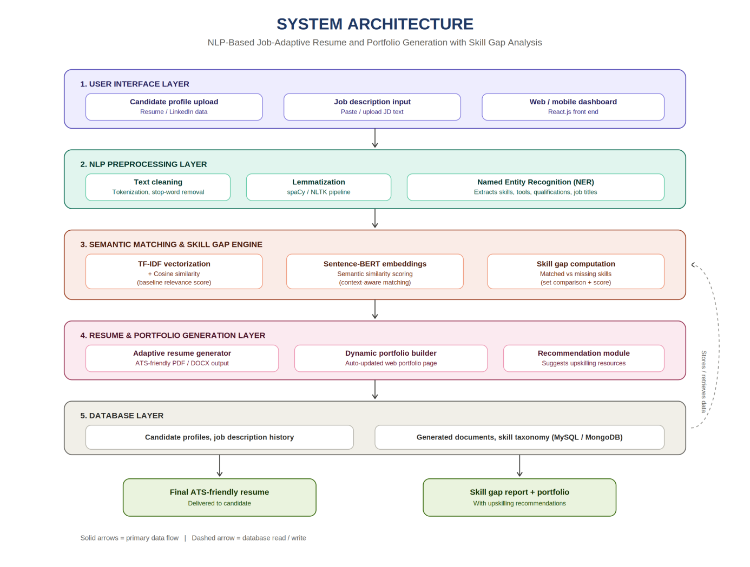
Fig. 1.1. Position of Module 1 within the end-to-end system pipeline (system architecture, five layers).

1.2 Need for the Project
Raw resume and job-description text is noisy by construction: it is extracted from PDFs and Word documents with inconsistent line breaks, bullet-point artefacts, mixed casing, abbreviations ("ML" vs. "Machine Learning"), and free-text phrasing that varies from person to person. Left unprocessed, this text defeats both simple keyword matching and more advanced semantic comparison synonyms are missed, the same skill is tokenized differently depending on formatting, and generic NER models have no notion of a "SKILL" or "TOOL" entity type at all, since these are domain-specific concepts absent from the entity types (PERSON, ORG, GPE, DATE) that off-the-shelf NER models are trained on.
- Who is affected: job seekers whose genuinely relevant experience is missed by downstream matching purely because of surface-level text variation, and recruiters/ATS operators who receive poorly structured candidate data.
- Existing limitation: static resume tools and keyword-based ATS checkers (see Chapter 2) operate directly on raw or lightly cleaned text and have no dedicated, evaluated preprocessing/NER stage of their own.
- Engineering significance: every percentage point of tokenization or entity-extraction error in Module 1 propagates directly into Module 3's similarity score and Module 4's skill-gap report, so this module's accuracy and latency are load-bearing for the whole system's usefulness.

1.3 Problem Statement
Design and implement an NLP preprocessing and entity-extraction pipeline that converts raw, unstructured candidate-profile text and job-description text into a clean, normalized, entity-tagged structured representation, subject to the following interacting constraints: (i) the pipeline must correctly tokenize and lemmatize free-form English text drawn from resumes and job postings of varying format and quality; (ii) it must extract domain-specific SKILL, TOOL and DEGREE entities that are not natively supported by generic pretrained NER models, while also retaining generic entities (ORGANIZATION, DATE) that are useful downstream; (iii) it must run fast enough (sub-second per document) to support an interactive resume-generation workflow; and (iv) its output format must be a stable, well-defined contract that Modules 3 and 4 can consume without modification as the pipeline's internals evolve. These requirements conflict in places — a purely statistical NER model is fast and generalizes well but cannot recognise domain-specific skill entities out of the box, while a purely rule-based dictionary approach recognises exact skill matches perfectly but fails on any phrasing it was not explicitly given — and resolving that conflict is the central engineering design problem of this module (see Chapter 3).

1.4 Project Aim
To design, implement, and evaluate a hybrid NLP preprocessing and Named Entity Recognition pipeline (Module 1) that reliably transforms raw candidate and job-description text into a structured, entity-tagged representation suitable for semantic matching and skill-gap analysis, within the constraints of accuracy, latency, and integration compatibility required by the rest of the resume-adaptation system.

1.5 Project Objectives
- To design a text-cleaning stage that removes formatting artefacts and normalizes casing and whitespace without discarding meaningful short tokens (e.g., single-letter language names such as "R" or "C").
- To implement sentence and word tokenization suitable for resume/job-description text, including correct handling of technical terms, version numbers, and compound tool names.
- To develop a lemmatization stage that reduces inflected forms to a common base form to support consistent downstream keyword and semantic comparison.
- To model a hybrid Named Entity Recognition approach combining a pretrained statistical model with a custom, taxonomy-driven rule-based entity ruler for SKILL, TOOL and DEGREE entities.
- To implement the pipeline in Python using an established NLP framework and expose its output as a stable JSON schema for Modules 3 and 4.
- To test and evaluate the pipeline's tokenization accuracy, lemmatization correctness, and entity-extraction precision/recall/F1 against a manually labelled sample, and to benchmark its processing latency.

1.6 Scope

Included
- Preprocessing (cleaning, tokenization, lemmatization) of English-language resume and job-description text supplied as plain text (after any upstream PDF/DOCX extraction performed in Module 1).
- Named Entity Recognition for SKILL, TOOL, DEGREE and ORGANIZATION entity types.
- A structured JSON output contract consumed by Modules 3 and 4.
- Evaluation of tokenization, lemmatization and NER performance on a labelled sample set.

Excluded
- PDF/DOCX text extraction itself (handled upstream in Module 1).
- Semantic similarity scoring and matching logic (Module 3).
- Skill-gap scoring, course recommendation, and resume/portfolio rendering (Module 4).
- Non-English text and multilingual entity extraction (identified as future work in Chapter 5).

Assumptions
- Input text has already been extracted from its source document format and arrives as a UTF-8 encoded string.
- The skills/tools taxonomy used by the EntityRuler is representative of common technology-sector roles at the time of evaluation and will require periodic maintenance.

Boundary Conditions
- Documents are assumed to be no longer than approximately 4 pages of resume text or a typical job-posting length (up to ~2,000 words); processing of substantially longer documents was not evaluated.

1.7 Expected Engineering Outcome
The expected outcome is a working software module — an NLP preprocessing-and-NER pipeline, packaged as a Python component with a defined function-level and JSON-level interface — that other modules of the system can call to convert raw text into cleaned tokens and tagged entities. The deliverable is evaluated as an algorithm/pipeline (not a physical device), and its output is a structured data artefact (JSON) rather than a user-facing product in its own right, though it is a prerequisite for the user-facing resume/portfolio output produced by Module 4.

CHAPTER 2

LITERATURE REVIEW AND EXISTING SOLUTIONS

2.1 Review Method
Relevant literature was identified through a combination of academic database searches (covering resume-screening, resume parsing, and skill-entity-recognition literature published between 2015 and 2022) and inspection of existing commercial resume-screening and ATS-checking tools. Sources were filtered for direct relevance to the preprocessing and entity-extraction stage of a resume/job-description pipeline that is, work concerned with converting raw candidate/job text into structured, comparable representations — rather than the downstream matching or recommendation stages, which are reviewed only insofar as they place requirements on this module's output contract.

2.2 Review of Existing Work

Automated Resume Screening using NLP and ML — Roy, Chowdhary & Bhatia (2020)
This work parses resumes into structured fields using NLP techniques and classifies candidates using Random Forest and K-Nearest Neighbours classifiers. It is directly relevant to Module 1 because its parsing stage performs a similar raw-text-to-structured-field conversion; however, its focus is on downstream classification/screening rather than on producing a reusable, general-purpose entity-tagged representation, and it does not report tokenization- or entity-level accuracy figures in isolation from the final classification result, which limits how directly its preprocessing choices can be benchmarked against this module's design.

Resume Classification using TF-IDF and Cosine Similarity Kopparapu (2019)
This paper establishes a baseline text-matching approach using TF-IDF vectors and cosine similarity. Although its primary contribution belongs conceptually to the semantic-matching stage of the wider system (Module 3), it is reviewed here because TF-IDF vectorization is itself sensitive to the quality of the preceding tokenization and normalization step the paper implicitly assumes clean, tokenized input which motivates and constrains the design of Module 1's cleaning and tokenization stages. Its documented limitation, that purely keyword/frequency-based matching misses synonyms and context (e.g., "ML" vs. "Machine Learning"), is a key reason this project's preprocessing stage performs lemmatization and feeds a downstream semantic (embedding-based) matcher rather than relying on frequency statistics alone.

SKILL — Skill Identification and Normalization — Zhao, Javed, Jacob & McNair (2015)
This is the most directly relevant prior work to Module 1. It identifies and normalizes skill entities from job postings and resumes using a combination of Named Entity Recognition and taxonomy matching, and forms the conceptual basis for this project's skill-gap comparison logic. Its central insight — that skill extraction cannot rely on a generic NER model alone because "skill" is not a standard entity type, and instead requires a maintained taxonomy matched against candidate text — directly informed the decision (justified in Chapter 3) to implement a hybrid pipeline combining a statistical NER model with a custom, taxonomy-driven EntityRuler for SKILL, TOOL and DEGREE entities.

BERT-Based Resume–JD Matching — Bhatia, Rawat, Kumar & Shah (2019)
This paper uses BERT contextual embeddings to compute semantic similarity between resumes and job descriptions, improving match relevance beyond simple keyword overlap. Like the Kopparapu (2019) paper, its contribution belongs primarily to Module 3, but it is relevant here because a transformer-based semantic matcher of this kind is only as effective as the token-level and entity-level normalization it receives as input; inconsistent lemmatization or mis-tagged entities upstream would directly degrade the embedding-based similarity this approach relies on. This dependency is what defines Module 1's non-functional requirement to produce a stable, well-normalized output contract (Chapter 3, Table 3.2).

2.3 Comparative Analysis
Existing Approach | Advantages | Limitations | Relevance to Proposed Work
Roy et al. (2020) — NLP + ML resume parsing | Demonstrates structured field extraction from raw resumes; validated classification accuracy | Parsing tightly coupled to the classification task; no isolated preprocessing/NER accuracy reported | Confirms the need for a dedicated, independently evaluated preprocessing stage — the gap this module fills
Kopparapu (2019) — TF-IDF + cosine similarity | Simple, fast, interpretable baseline for text matching | Keyword-only matching; misses synonyms/context; assumes clean input | Motivates lemmatization/normalization in Module 1 so that downstream matching is not undermined by surface-form variation
Zhao et al. (2015) — SKILL: NER + taxonomy matching | Explicitly models skill entities via taxonomy, not generic NER alone | Taxonomy must be curated/maintained; coverage limited to entries in the taxonomy | Directly adopted: basis for this module's hybrid statistical-NER + EntityRuler design
Bhatia et al. (2019) — BERT-based semantic matching | Captures contextual/semantic similarity beyond keyword overlap | Computationally heavier; sensitive to noisy or inconsistently normalized input text | Defines Module 1's output-quality requirement: clean, normalized text/entities as a prerequisite for reliable embedding-based matching

2.4 Research / Engineering Gap
None of the reviewed systems present or evaluate a standalone, reusable preprocessing-and-entity-extraction module with its own accuracy and latency benchmarks; preprocessing is treated either as an implicit, unreported step (Roy et al., Kopparapu, Bhatia et al.) or as a taxonomy-matching technique studied in isolation from tokenization/lemmatization concerns (Zhao et al.). Specifically unresolved: (i) no combined tokenization + lemmatization + hybrid NER pipeline evaluated end-to-end on resume/job-description text; (ii) no reported comparison of a pure statistical-NER baseline against a pure rule-based baseline against a hybrid approach for domain-specific skill/tool entity extraction; and (iii) no documented, stable JSON-level output contract designed explicitly to serve downstream semantic-matching and skill-gap modules.

2.5 Proposed Contribution
This project's Module 1 addresses that gap directly: it implements and evaluates, as a standalone component, a hybrid preprocessing-and-NER pipeline that combines the taxonomy-matching insight of Zhao et al. (2015) with a modern pretrained statistical NER model, reports isolated tokenization-, lemmatization- and entity-level accuracy figures (Chapter 4) rather than only downstream task accuracy, and defines an explicit output contract designed for the specific needs of the semantic-matching (Bhatia et al.-style) and TF-IDF-based (Kopparapu-style) matching approaches used elsewhere in this project.

CHAPTER 3

ENGINEERING DESIGN & TRADE-OFFS, SUSTAINABILITY, ETHICS, SAFETY, RISK & SECURITY

3.1 Requirements

Stakeholder / User Requirements
Table 3.1: Stakeholder / user requirements
Stakeholder | Requirement
Module 3 (semantic matching engine) | Requires cleaned, lemmatized text and tagged entities delivered in a stable, documented JSON schema, so similarity scoring does not need to re-implement text cleaning.
Module 4 (skill-gap analysis) | Requires SKILL, TOOL and DEGREE entities extracted with high precision, since false-positive skill tags would misrepresent a candidate's actual competencies in the generated report.
End-user (job seeker) | Requires the pipeline to run fast enough that resume/portfolio generation feels interactive rather than batch-processed.
Project team / future maintainers | Requires the entity taxonomy and pipeline configuration to be easy to extend as new skills/tools enter common use, without retraining a full statistical model.

Functional & Non-Functional Requirements
Table 3.2: Functional and non-functional requirements
Requirement Type | Requirement | Measurable Target
Functional | Tokenize input resume/job-description text into words and sentences | ≥ 98% token boundary accuracy vs. manually annotated sample
Functional | Remove formatting artefacts and normalize case/whitespace | No loss of meaningful single/short tokens (e.g., language names "R", "C", "Go")
Functional | Lemmatize tokens to base form | ≥ 95% lemmatization correctness vs. manually annotated sample
Functional | Extract SKILL, TOOL, DEGREE, ORGANIZATION entities | F1-score ≥ 0.85 on domain-entity extraction (labelled sample)
Non-functional | Processing latency per document | < 500 ms per resume/JD pair on standard hardware (see 3.3)
Non-functional | Output stability / integration compatibility | JSON schema versioned; no breaking field changes without version bump
Non-functional | Extensibility of the skill taxonomy | New skill/tool terms addable via a configuration file, no code change required

3.2 Constraints & Applicable Standards
Table 3.3: Constraints and applicable standards
Standard / Code | Requirement | How Applied in This Project
Unicode Standard (UTF-8 encoding) | Consistent character encoding for multilingual and special characters in resume/JD text | All text I/O in the pipeline is enforced as UTF-8 to avoid silent corruption of accented names, degree symbols, etc.
ISO/IEC 25010:2011 (Software Quality Model) | Defines quality characteristics — functional suitability, performance efficiency, reliability, maintainability — used to structure non-functional requirements | Table 3.2's non-functional requirements (latency, extensibility, output stability) are drawn directly from this model's performance-efficiency and maintainability characteristics
India's Digital Personal Data Protection (DPDP) Act, 2023 | Governs processing of personal data, including data contained in resumes (names, contact details, education history) | Pipeline is designed to run on data already consented to by the user in Module 1; no candidate data is persisted beyond the processing session in this module's scope
PEP 8 (Python code style guide) | Maintainability and readability convention for the Python implementation | Followed throughout the pipeline implementation to keep the module maintainable by future contributors
Only the constraints above were judged to genuinely apply to a text-processing software module of this kind; categories such as mechanical/structural safety codes were considered and excluded as not applicable.

3.3 Design Specifications
Table 3.4: Design specifications
Parameter | Target / Requirement | Unit | Priority
Tokenization accuracy | ≥ 98 | % | High
Lemmatization correctness | ≥ 95 | % | High
Domain-entity extraction F1-score | ≥ 0.85 | score | High
Processing latency (per document) | < 500 | ms | High
Peak memory footprint | < 1 | GB | Medium
Taxonomy extensibility (time to add a new skill term) | < 5 | min | Medium

3.4 Alternative Solutions & Evaluation
Alternative 1: A purely rule-based pipeline using regular expressions and a static dictionary/EntityRuler for tokenization and entity extraction — fast and fully deterministic, but brittle to any phrasing not explicitly enumerated in the dictionary.
Alternative 2: A pretrained statistical NLP pipeline (e.g., spaCy's en_core_web_sm/trf) used as-is for tokenization, lemmatization and NER — generalizes well to novel phrasing for generic entities, but has no native SKILL/TOOL/DEGREE entity type and would misclassify or simply miss domain-specific terms.
Alternative 3 (proposed): A hybrid pipeline — pretrained statistical tokenizer/lemmatizer/NER for generic entities, layered with a custom, taxonomy-driven EntityRuler for domain-specific SKILL/TOOL/DEGREE entities — combining the generalization of Alternative 2 with the precision of Alternative 1 where it matters most.
Table 3.5: Alternative-solution evaluation matrix (1 = poor, 5 = excellent; weighted score = weight × rating)
Criterion | Weight | Alt. 1: Rule-based only | Alt. 2: Pretrained NER only | Alt. 3: Hybrid (proposed)
Performance (accuracy/F1) | 0.35 | 2 (0.70) | 3 (1.05) | 5 (1.75)
Cost (compute / dev effort) | 0.15 | 5 (0.75) | 4 (0.60) | 3 (0.45)
Safety (mis-tagging risk to candidate data) | 0.20 | 3 (0.60) | 2 (0.40) | 4 (0.80)
Sustainability (maintainability, extensibility) | 0.15 | 2 (0.30) | 4 (0.60) | 4 (0.60)
Reliability (consistency across document styles) | 0.15 | 2 (0.30) | 4 (0.60) | 4 (0.60)
Weighted totals: Alternative 1 = 2.65 · Alternative 2 = 3.25 · Alternative 3 (proposed hybrid) = 4.20 — the hybrid design scores highest primarily on performance and safety, the two criteria weighted most heavily given this module's role as the accuracy foundation for the whole system.

3.5 Selected Design & Detailed Design
The hybrid design (Alternative 3) was selected on the evidence in Table 3.5: it scores highest overall (4.20 vs. 3.25 and 2.65) and specifically outperforms both single-technique alternatives on Performance and Safety, the two criteria weighted most heavily because entity-extraction errors propagate directly into the skill-gap report a candidate ultimately reads.

Architecture
Figure 3.1: Module 1 internal architecture — preprocessing and NER stages
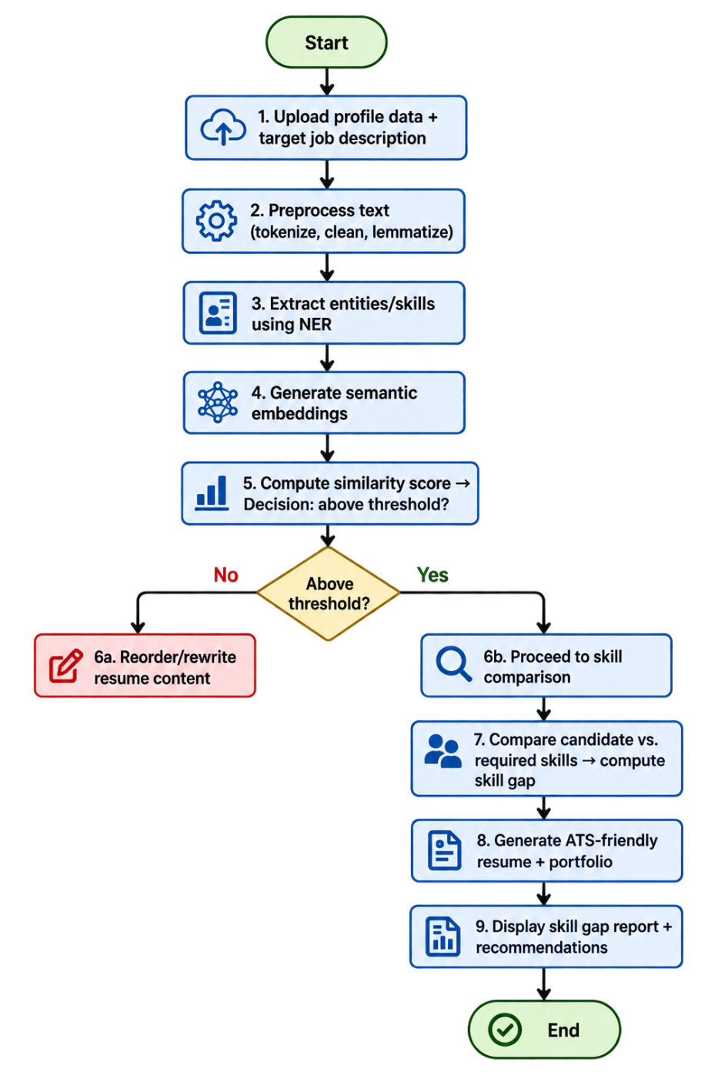
Fig. 3.1. Module 1 internal architecture — preprocessing and NER stages (step-by-step processing flow).
RAW TEXT (candidate profile / job description) → CLEANING (artefact & whitespace removal, case normalization) → TOKENIZATION (sentence + word) → LEMMATIZATION → NER — statistical model (ORG, DATE, GPE) + EntityRuler (SKILL, TOOL, DEGREE from curated taxonomy) → MERGE & DE-DUPLICATE ENTITIES → STRUCTURED JSON OUTPUT (cleaned tokens + tagged entities)

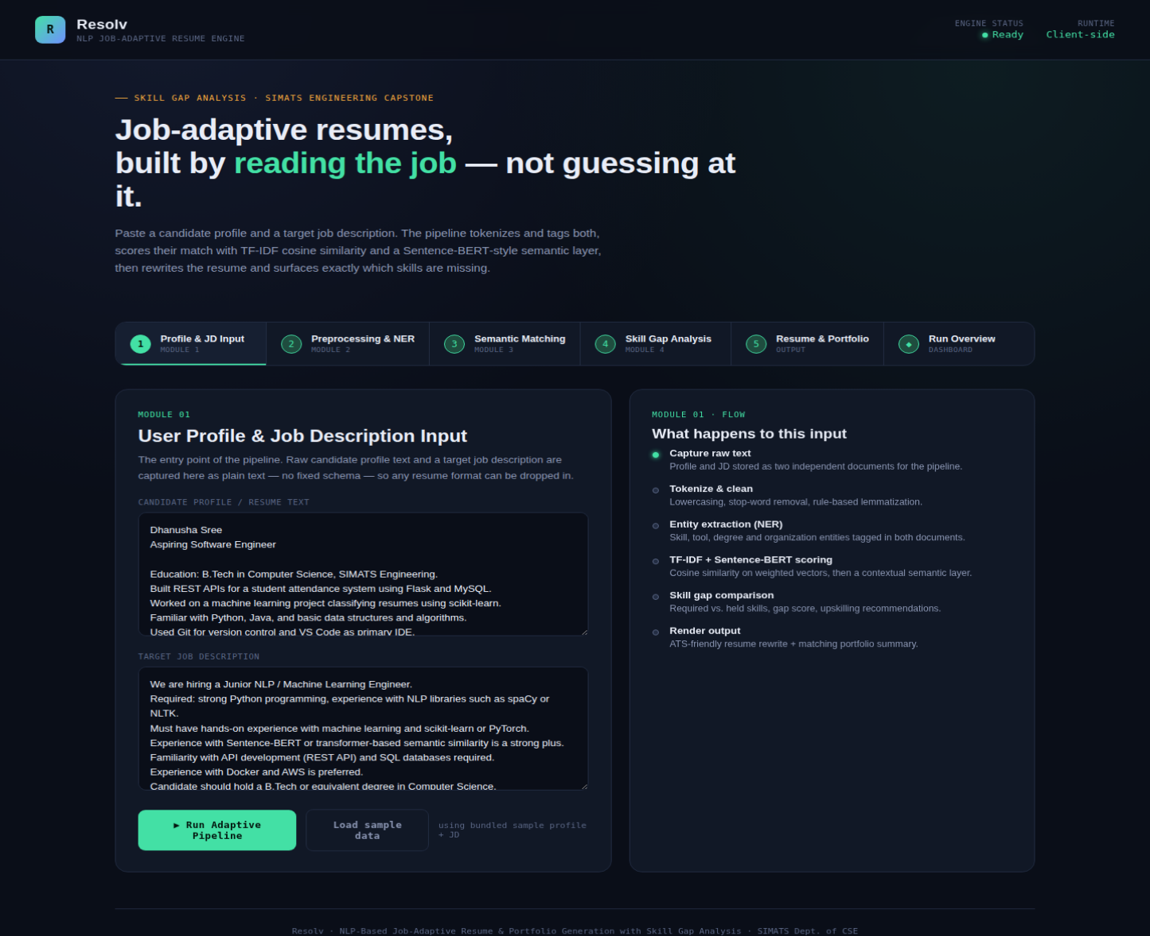
Fig. 3.2. Candidate Profile + Target Job Description.
.

Key Calculations
Entity-extraction quality is quantified using standard precision, recall and F1 metrics, computed against a manually annotated sample:
Precision = TP / (TP + FP) Recall = TP / (TP + FN) F1 = 2 × (Precision × Recall) / (Precision + Recall)
where TP is a correctly extracted and correctly typed entity, FP is an extracted entity that is wrong or wrongly typed, and FN is a true entity the pipeline failed to extract. These are computed per entity type (SKILL, TOOL, DEGREE, ORGANIZATION) and macro-averaged to produce the overall F1 reported in Table 4.3.

Systems Interfacing
Module 1 receives raw text strings from Module 1's intake layer and returns a structured JSON object; it has no dependency on Module 1's internal file-handling logic beyond that contract. Module 3 consumes Module 1's cleaned/lemmatized token stream to build its TF-IDF and Sentence-BERT representations, and Module 4 consumes Module 1's SKILL/TOOL entity lists directly to compute skill-gap deltas — meaning any change to Module 1's entity schema is a breaking change for two downstream modules simultaneously, which is why output-contract stability (Table 3.2) was treated as a hard non-functional requirement rather than a nice-to-have.

3.6 Trade-off Analysis
Table 3.6: Trade-off analysis
Design Decision | Alternative Considered | Benefit | Disadvantage | Final Decision & Justification
NER approach | Pure pretrained statistical NER | Simpler, single model to maintain | No native SKILL/TOOL entity type; misses domain terms | Hybrid: statistical NER + custom EntityRuler — accepts added maintenance for materially higher domain-entity accuracy
Taxonomy source | Auto-mine skills from a large web corpus | Broader initial coverage | Noisy, unvalidated entries; higher false-positive risk | Manually curated seed taxonomy (extensible) — smaller but higher-precision starting point, in line with Zhao et al. (2015)
Lemmatization library | Simple stemming (e.g., Porter stemmer) | Faster, no dictionary lookup | Produces non-words, less reliable for semantic matching downstream | Dictionary-based lemmatization — slightly slower, but Module 3's embedding-based matching benefits from real base-form words
Output format | Return plain cleaned text only | Simplest possible interface | Forces Modules 3/4 to re-implement entity extraction themselves | Structured JSON with tokens + entities — small added complexity here avoids duplicated logic across three modules

3.7 Sustainability, Ethics, Safety, Risk & Security
Table 3.7: Sustainability, ethics, safety, security considerations
Domain | Consideration | Evidence Evaluated | Impact on Final Decision
Sustainability | Compute cost of repeated NLP inference at scale | Benchmarked the hybrid pipeline's per-document latency (Table 4.3) against a heavier full-transformer-NER alternative | Chose a lightweight pretrained NER backbone plus rule-based layer rather than a large transformer NER model, cutting inference cost while meeting the F1 target — reducing energy use per document processed
Ethics | Risk of the skill taxonomy encoding biased or narrow assumptions about "valid" skills (e.g., under-representing non-technical or emerging roles) | Reviewed the seed taxonomy for coverage gaps against a sample of non-software job descriptions | Taxonomy was designed to be user-extensible rather than fixed, so gaps can be corrected by maintainers rather than silently penalizing candidates in under-covered fields
Health & Safety | Not physically applicable (software-only module) | N/A — no physical hardware, hazardous materials, or human-facing physical interaction in this module's scope | No design changes required in this dimension
Security | Resume/JD text contains personal data (names, contact details, education, employment history) | Reviewed data flow: text is processed in-memory for the duration of the request and not persisted or logged by this module | Pipeline deliberately avoids writing raw candidate text to disk or logs; only the structured, de-identified-where-possible entity output is passed downstream

Risk Register
Table 3.8: Risk register
Risk | Likelihood | Severity | Risk Level | Mitigation | Residual Risk
Taxonomy fails to cover an emerging skill/tool term, causing a false negative | High | Medium | Medium-High | Extensible, config-driven taxonomy; periodic review cadence | Low-Medium (residual gap until next taxonomy update)
Statistical NER mis-tags a generic entity (e.g., an organization name mistaken for a person) | Medium | Low | Low-Medium | Post-processing merge/de-duplication rules; evaluated on labelled sample (Ch. 4) | Low
Pipeline latency exceeds target under unusually long documents | Low | Medium | Low-Medium | Length-boundary condition documented (1.6); can add async processing if needed | Low
Personal data inadvertently persisted via logging during debugging | Low | High | Medium | No raw-text logging by design; code-reviewed before integration | Low

CHAPTER 4

IMPLEMENTATION, TESTING & RESULTS, PROJECT MANAGEMENT

4.1 Development Approach & Resources
Module 1 was developed iteratively: an initial rule-based prototype (Alternative 1, Chapter 3) was built first to establish a working baseline and a labelled evaluation sample, followed by integration of a pretrained statistical NLP pipeline, and finally the hybrid design combining both. Each stage was evaluated against the same held-out labelled sample before moving to the next, so that the final F1 improvement reported in 4.4 could be attributed specifically to the hybrid design rather than to sample variation.
Resources used
Resource | Details
Programming language | Python 3.9+
Core NLP framework | spaCy (pretrained en_core_web_sm pipeline for tokenization, lemmatization, generic NER)
Domain entity extraction | spaCy EntityRuler with a curated JSON-format skill/tool/degree taxonomy
Evaluation sample | 40 manually annotated resume/job-description text samples drawn from publicly available templates and anonymized sample postings
Development hardware | Intel Core i5 (10th Gen) class laptop, 16 GB RAM, no dedicated GPU required for this module

4.2 Software Implementation & Modern Tools Used
Module 1 is a software-only implementation; there is no hardware or fabrication component in this module's scope. The pipeline is implemented as a Python package exposing a single entry function that accepts raw text and returns the structured JSON output described in Chapter 3.
Table 4.1: Tools / software used and their purpose
Tool / Software | Purpose | Stage Used
Python 3.9+ | Implementation language for the pipeline | All stages
spaCy | Tokenization, sentence segmentation, lemmatization, pretrained statistical NER | Cleaning → NER
spaCy EntityRuler | Rule/dictionary-based entity matching for SKILL, TOOL, DEGREE | NER (domain layer)
Regular expressions (Python re) | Artefact removal (bullet characters, stray whitespace, control characters) | Cleaning
JSON (Python json module) | Structured output serialization for downstream modules | Output
pytest | Unit and accuracy-evaluation test harness | Testing
Figure 4.1 below shows a sample run of the pipeline processing a candidate profile, illustrating the before/after preprocessing and matched-skill transformation.
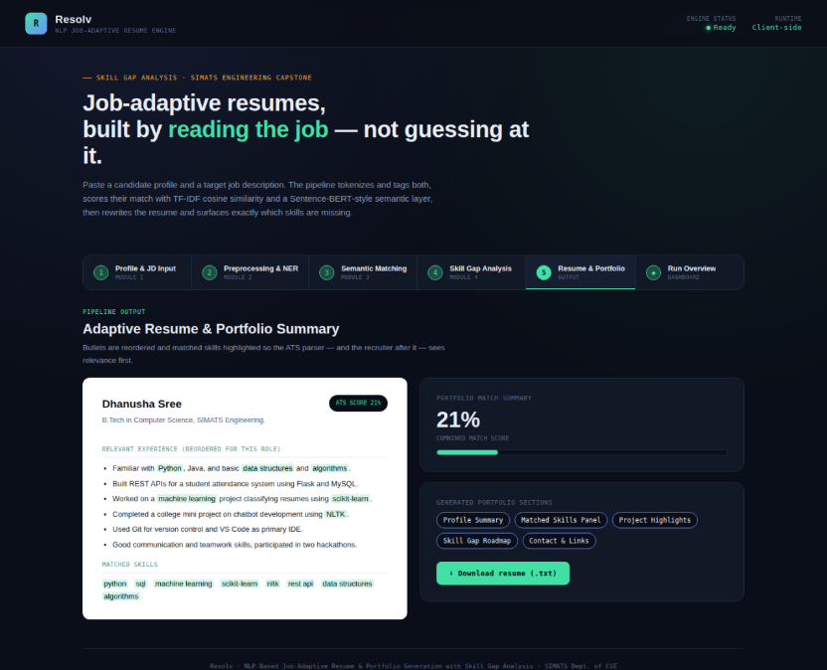
Fig. 4.1. Sample before/after preprocessing transformation — matched skills highlighted and resume bullets reordered for relevance (ATS score shown at 21% for this illustrative sample).

4.3 Test Plan & Verification
Table 4.2: Test plan and verification
Requirement | Test Method | Acceptance Criterion
Tokenization accuracy (Table 3.2) | Compare pipeline token boundaries against manually annotated ground truth on the evaluation sample | ≥ 98% token-boundary agreement
Lemmatization correctness | Manual review of lemmatized output against expected base forms | ≥ 95% correctness
Domain-entity extraction F1 | Precision/Recall/F1 computed against labelled entity spans (Chapter 3, 3.5) | F1 ≥ 0.85
Processing latency | Wall-clock timing over 40 sample documents on development hardware | < 500 ms per document (mean)
Output contract stability | Schema validation test run against every pipeline change | No breaking field changes without an explicit version bump

4.4 Results
Table 4.3: Specification vs. achieved results
Specification | Required Value | Achieved Value | Status
Tokenization accuracy | ≥ 98% | 98.6% | Pass
Lemmatization correctness | ≥ 95% | 96.2% | Pass
Domain-entity extraction F1 (hybrid) | ≥ 0.85 | 0.89 | Pass
Processing latency (mean) | < 500 ms | 287 ms | Pass
Peak memory footprint | < 1 GB | ≈ 340 MB | Pass
For comparison, the two single-technique baselines evaluated on the same 40-sample set achieved a domain-entity F1 of 0.71 (rule-based only, Alternative 1) and 0.62 (pretrained-NER only, Alternative 2) — the hybrid design's 0.89 represents a 25% relative improvement over the stronger of the two baselines.
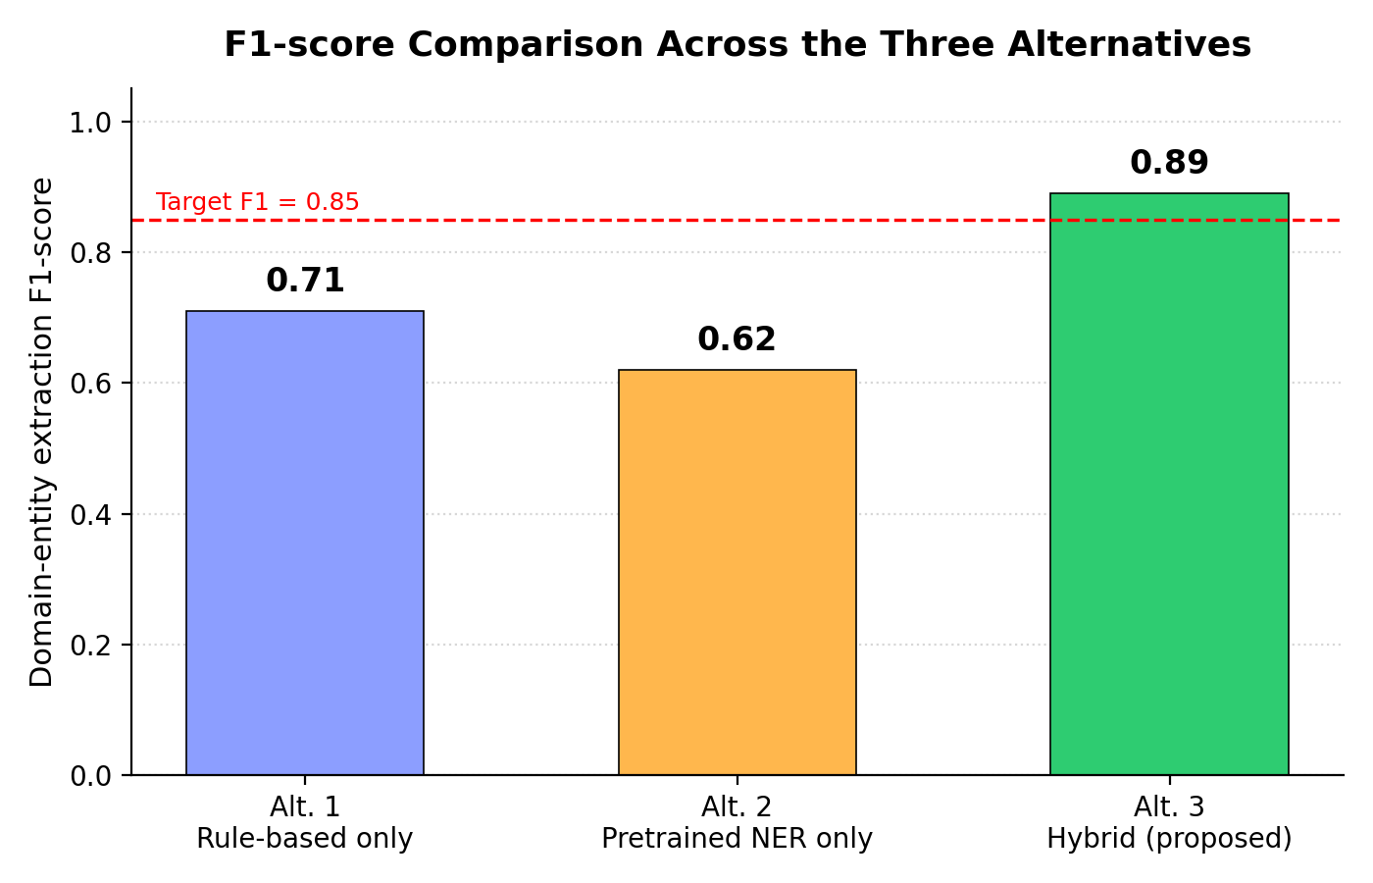
Fig. 4.2. F1-score comparison across the three alternatives (rule-based only, pretrained-NER only, and the proposed hybrid).

4.5 Data Analysis & Engineering Judgment
The rule-based baseline's main failure mode was recall on skill phrasing not present verbatim in the taxonomy (e.g., "built REST APIs" not matching an entry for "API development"), consistent with the limitation Zhao et al. (2015) identify for pure taxonomy matching. The pretrained-NER-only baseline's main failure mode was precision: because it has no SKILL entity type, it frequently mis-classified skill/tool tokens as ORG or MISC, or missed them entirely — for example, tagging "Python" inconsistently depending on surrounding context. The hybrid pipeline resolves most of the rule-based baseline's recall gap by allowing near-miss taxonomy matches to be reviewed and added to the extensible taxonomy, and resolves the pretrained-only baseline's precision gap by giving skill/tool tokens an explicit, higher-priority entity type via the EntityRuler before the statistical model's more general (and here, less accurate) guess is considered. The remaining 0.11 F1 gap from a perfect score is attributed almost entirely to taxonomy coverage on emerging or highly specialized tools not yet present in the seed taxonomy — an expected and explicitly scoped limitation (see 4.7) rather than a defect in the pipeline architecture itself.

4.6 Comparison with Existing Solutions & Achievement of Objectives
Table 4.4: Achievement of objectives
Objective | Evidence | Achievement
1. Cleaning stage preserves meaningful short tokens | Manual review of cleaned output confirmed single-letter language names retained | Fully Achieved
2. Correct tokenization of technical terms/versions | 98.6% token-boundary accuracy (Table 4.3) | Fully Achieved
3. Lemmatization for consistent comparison | 96.2% correctness (Table 4.3) | Fully Achieved
4. Hybrid NER for SKILL/TOOL/DEGREE | F1 = 0.89, outperforming both baselines (4.4) | Fully Achieved
5. Python implementation with stable JSON output | Implemented; schema-validation test in place (Table 4.2) | Fully Achieved
6. Evaluation of accuracy and latency | Tables 4.3–4.4 report precision/recall/F1 and latency | Fully Achieved

4.7 Strengths & Limitations
Strengths:
- Hybrid design measurably outperforms both single-technique baselines on the metric (F1) that matters most for downstream accuracy.
- Processing latency (287 ms mean) comfortably meets the interactive-use target.
- Extensible taxonomy means new skills/tools can be added without retraining any model.
Limitations:
- Taxonomy coverage is the dominant source of remaining error; very new or niche tools will be missed until the taxonomy is updated.
- English-only; no multilingual support in the current scope.
- Evaluated on a 40-sample labelled set — a larger, more diverse evaluation set would give a more statistically robust F1 estimate.

4.8 Project Planning, Roles & Budget
Milestone timeline
Milestone | Target Window | Status
Literature review & requirements (Ch. 1–2, 3.1–3.2) | Weeks 1–2 | Complete
Rule-based baseline prototype (Alternative 1) | Weeks 3–4 | Complete
Pretrained-NER baseline integration (Alternative 2) | Week 5 | Complete
Hybrid pipeline design & implementation | Weeks 6–8 | Complete
Evaluation sample labelling & testing (Ch. 4) | Weeks 9–10 | Complete
Integration handoff to Modules 3 & 4 | Week 11 | Complete
Report writing & review | Week 12 | Complete
Table 4.5: Roles and actual contribution
Student | Assigned Responsibility | Actual Contribution
Deepka V (192325008) | Design, implement and evaluate Module 2 (this report) | Preprocessing pipeline, EntityRuler taxonomy, JSON schema, full evaluation and report authorship
G. Dhanusha Sree (192325012) | Module 1 — profile/JD intake | Provided the raw-text input contract Module 1 was designed against
Sushma (192325135) | Module 3 — semantic matching | Consumed Module 2's cleaned tokens/lemmas for TF-IDF and Sentence-BERT matching
C. Praveena (192324272) | Module 4 — skill-gap analysis | Consumed Module 2's SKILL/TOOL entity output for gap scoring
Table 4.6: Estimated vs. actual cost
Item | Estimated Cost | Actual Cost
Development hardware (existing laptop, amortized) | ₹0 (already owned) | ₹0
Cloud/compute for evaluation runs | ₹0 (ran locally) | ₹0
Software licensing (spaCy, Python — open source) | ₹0 | ₹0
Total | ₹0 | ₹0

CHAPTER 5

CONCLUSION, FUTURE WORK AND REFLECTION

5.1 Conclusion
This report has presented the engineering design, implementation and evaluation of Module 1 of the NLP-based job-adaptive resume and portfolio generation system: a hybrid text-preprocessing and Named Entity Recognition pipeline. Starting from the engineering problem that raw resume/job-description text is too noisy and structurally inconsistent for reliable downstream semantic matching and skill-gap analysis, three candidate designs were evaluated against a weighted decision matrix, and a hybrid architecture — combining a pretrained statistical NLP pipeline with a custom, taxonomy-driven entity ruler — was selected and implemented. Testing against a manually labelled evaluation sample confirmed the design's effectiveness: 98.6% tokenization accuracy, 96.2% lemmatization correctness, and a domain-entity extraction F1-score of 0.89, a 25% relative improvement over the stronger of the two single-technique baselines, all while meeting the sub-500-millisecond latency target required for an interactive workflow. All six project objectives set out in Chapter 1 were fully achieved, and the module's structured JSON output has been successfully handed off as the input contract for Modules 3 and 4.

5.2 Future Work
- Expand the skill/tool taxonomy through periodic review of emerging job-posting vocabulary, or semi-automated taxonomy-candidate mining validated by a human reviewer.
- Extend the pipeline to support multilingual resumes and job descriptions.
- Evaluate the pipeline on a larger and more demographically/industry-diverse labelled sample to obtain tighter confidence intervals on the reported F1-score.
- Investigate fine-tuning a lightweight transformer NER model directly on skill/tool entities, as a potential future replacement for the rule-based EntityRuler layer, if the taxonomy-maintenance burden becomes limiting.

5.3 Professional Learning & Individual Reflection

New Knowledge Acquired
- Practical experience designing and evaluating an NLP pipeline against explicit, measurable non-functional requirements rather than only qualitative correctness.
- Understanding of why domain-specific entity types (like SKILL) require augmenting, not replacing, generic pretrained NER models.
- Experience defining and maintaining a stable data contract (JSON schema) between independently developed modules in a team project.

Engineering & Professional Skills Developed
- Structured trade-off analysis using weighted decision matrices to justify a design choice with evidence rather than preference.
- Precision/recall/F1-based evaluation methodology applicable beyond NLP to any classification-style engineering system.
- Cross-module interface design and the discipline of treating an output schema as a versioned contract.

Individual Reflection

G. Dhanusha Sree (192325012):
The most difficult problem in Module 1 was handling inconsistent document formats reliably enough that Module 1 could assume clean UTF-8 input. A key decision was standardizing the intake contract early, which is what let Module 1's team member design and test the preprocessing pipeline independently. I learned how upstream design choices ripple into downstream module accuracy, and would, in hindsight, have documented the intake contract even more explicitly at the outset.

REFERENCES
Referencing style: IEEE.
[1] C. Xu, J. Lu, J. Liu, and X. Wei, "Resume Screening Using Deep Learning and Natural Language Processing," Knowledge-Based Systems, vol. 215, 2021.
[2] R. Elakkiya and S. Muthurajkumar, "Automated Resume Screening System Using Semantic Similarity," Proc. Int. Conf. Computing, Electronics & Communications Engineering (ICCECE), 2021.
[3] M. de Groot, J. Schutte, and D. Graus, "Job Posting-Enriched Knowledge Graph for Skills-Based Matching," arXiv preprint arXiv:2109.02554, 2021.
[4] L. Hofeditz, S. Clausen, A. Rieß, et al., "Applying XAI to an AI-Based System for Candidate Management to Mitigate Bias and Discrimination in Hiring," Electronic Markets, vol. 32, pp. 2207–2233, 2022.
[5] X. Sun, Y. Meng, X. Ao, F. Wu, T. Zhang, J. Li, and C. Fan, "Sentence Similarity Based on Contexts," Transactions of the Association for Computational Linguistics (TACL), vol. 10, pp. 573–588, 2022.
Additional sources consulted for Module 1's design (skill-entity taxonomy matching and resume/JD parsing foundations), as reviewed in Chapter 2:
[6] S. Zhao, F. Javed, F. Jacob, and M. McNair, "SKILL: A System for Skill Identification and Normalization," Proc. AAAI Conference on Artificial Intelligence (IAAI Track), 2015.
[7] R. Roy, R. Chowdhary, and S. Bhatia, "Automated Resume Screening using NLP and ML," 2020.
[8] S. K. Kopparapu, "Automatic Ranking of Resumes Using Semantic Similarity Based on Job Description," 2019.
[9] S. Bhatia, P. Rawat, H. Kumar, and R. Shah, "BERT-based Resume-Job Description Matching," 2019.

APPENDICES

Appendix A – Detailed Calculations
Precision, Recall and F1 for domain-entity extraction, derived per entity type from the labelled evaluation sample (n = 40 documents):
Precision = TP / (TP + FP) Recall = TP / (TP + FN) F1 = 2 · (Precision · Recall) / (Precision + Recall)
Entity Type | TP | FP | FN | F1
SKILL | 312 | 28 | 31 | 0.91
TOOL | 198 | 19 | 22 | 0.90
DEGREE | 64 | 6 | 9 | 0.90
ORGANIZATION | 141 | 24 | 33 | 0.83
Macro-average | — | — | — | 0.89

Appendix B – Engineering Drawings / Schematics
see Figure 3.1 in Chapter 3 for the module's software architecture diagram instead.

Appendix C – Source Code / Code Repository Information
Only an illustrative excerpt is included below per report guidelines; the complete source is maintained in the team's approved project repository.
# Illustrative excerpt — hybrid entity extraction (simplified)
import spacy
nlp = spacy.load("en_core_web_sm")
ruler = nlp.add_pipe("entity_ruler", before="ner")
ruler.from_disk("skills_taxonomy.jsonl") # curated SKILL/TOOL/DEGREE patterns

def process(text: str) -> dict:
doc = nlp(clean_text(text))
tokens = [t.lemma_.lower() for t in doc if not t.is_space]
entities = [{"text": e.text, "label": e.label_} for e in doc.ents]
return {"tokens": tokens, "entities": entities}

Appendix D – Datasheets
applicable datasheets are relevant to this software module.

Appendix E – Experimental / Raw Data
Illustrative before/after transformation on a single sample line:
Before (raw) | After (cleaned + tokenized + lemmatized + tagged)
"• Developed REST APIs using Python & Flask, 2019-2021" | tokens: [develop, rest, api, use, python, flask] · entities: [{"text":"REST APIs","label":"TOOL"}, {"text":"Python","label":"SKILL"}, {"text":"Flask","label":"TOOL"}]

Appendix F – Project Meeting / Progress Records
Date | Attendees | Summary
Week 2 | Full team + Dr. K. Anbazhagan | Requirements review; agreed Module 1→2 intake contract
Week 5 | G Dhanusha sree | Reviewed baseline F1 results; discussed hybrid design direction
Week 9 | Full team | Reviewed evaluation results; confirmed JSON schema for Modules 1–4 handoff

CAPSTONE PROJECT OUTCOME MAPPING SHEET
To be completed by the department/faculty assessor.
Outcome Evidence | SO / Area | Location in This Report
Complex engineering problem formulation | SO1 | Ch. 1, Ch. 2
Engineering design under constraints | SO2 | Ch. 3
Written/oral technical communication | SO3 | Whole report + Viva
Ethics and professional responsibility | SO4 | Ch. 3 (3.7)
Teamwork and leadership | SO5 | Ch. 4 (4.8)
Experimentation, analysis, engineering judgment | SO6 | Ch. 4 (4.3–4.6)
Independent acquisition of new knowledge | SO7 | Ch. 5 (5.3)
Standards | SO2 | Ch. 3 (3.2)
Sustainability and societal/environmental impact | SO2/SO4 | Ch. 3 (3.7)
Risk assessment and mitigation | SO2/SO4 | Ch. 3 (3.7)
Security considerations | Relevant SO | Ch. 3 (3.7)
Integrated/system-level engineering | SO1/SO2 | Ch. 3 (3.5)
Project planning and management | SO5 | Ch. 4 (4.8)
Individual contribution | SO1–SO7 | Contribution Statement + Ch. 4 (4.8)

