SIMATS ENGINEERING
ASSESSMENT TOOL 1

COURSE NAME: MLA03
COURSE CODE: Reinforcement learning for Environment and Agent

COURSE OUTCOME COVERED
CO1: Analyze reinforcement learning frameworks and Markov Decision Process concepts to model decision-making problems. (BL2, BL3)
Assessment Tool Weightage: 40% Dr. Dumpala Prasanth QUESTIONS: 10 Total Marks: 50
Annexure A

Descriptive Experiment Exam Duration: 2hrs

Experiment 1: Installation of Reinforcement Learning Development Environment
Aim: To install and configure Anaconda Navigator, Python, TensorFlow, Keras, Gymnasium (OpenAI Gym), NumPy, Matplotlib, and other required libraries, and verify the environment by executing a simple Reinforcement Learning
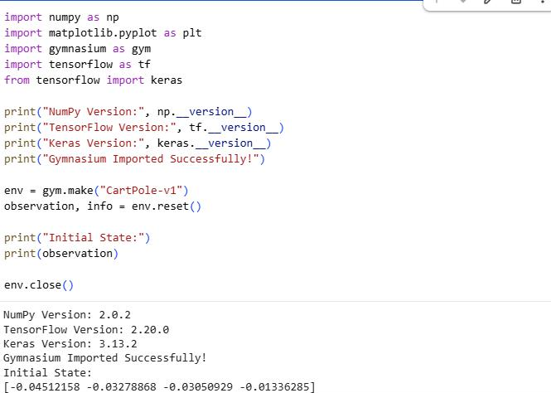

Experiment 2: Familiarization with OpenAI Gym/Gymnasium Environments
Aim: To create, initialize, and interact with standard Reinforcement Learning environments such as FrozenLake, CartPole, and MountainCar using Gymnasium to understand the concepts of states, actions, rewards, and episodes.

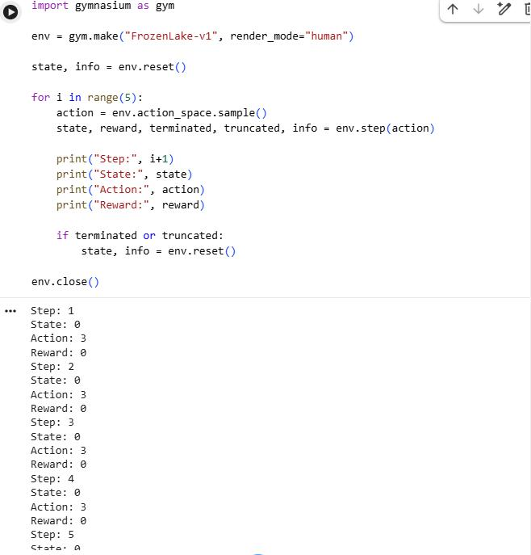

Experiment 3: Implementation of the Reinforcement Learning Framework
Aim: To implement the basic Reinforcement Learning framework by designing an agent that interacts with an environment through states, actions, rewards, and policies using Python.

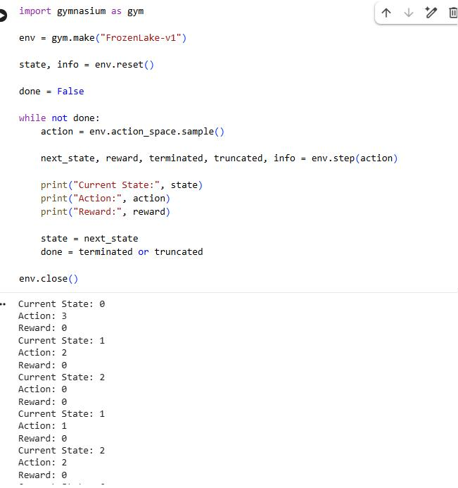

Experiment 4: Simulation of a Markov Decision Process (MDP)
Aim: To develop a simple Markov Decision Process model and simulate state transitions, reward functions, and policy execution for understanding sequential decision-making problems.

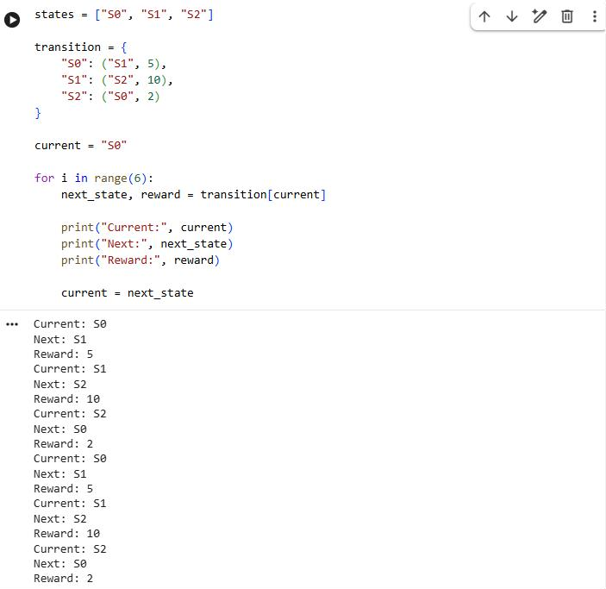

Experiment 5: Bellman Equation Demonstration
Aim: To implement Bellman Expectation and Bellman Optimality Equations for calculating state-value and action-value functions and analyze the convergence of value estimation.

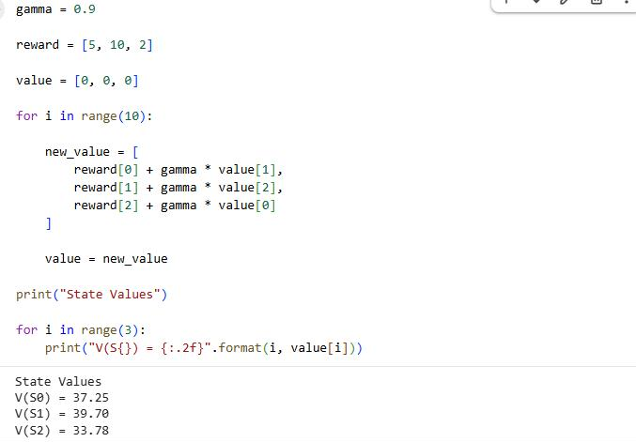

Experiment 6: Exploration vs. Exploitation Strategies
Aim: To implement ε-Greedy, Greedy, and Random action-selection strategies and compare their performance in balancing exploration and exploitation during Reinforcement Learning.

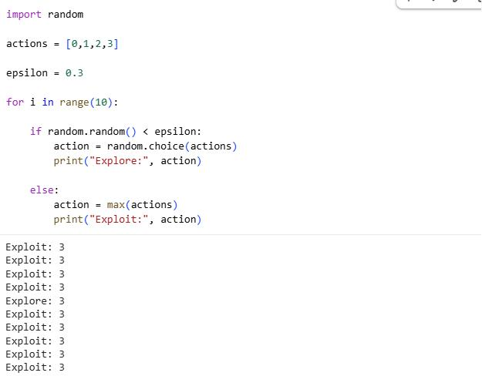

Experiment 7: Multi-Armed Bandit Problem
Aim: To implement the Multi-Armed Bandit problem using ε-Greedy and Upper Confidence Bound (UCB) algorithms and evaluate cumulative rewards obtained by different action-selection methods.

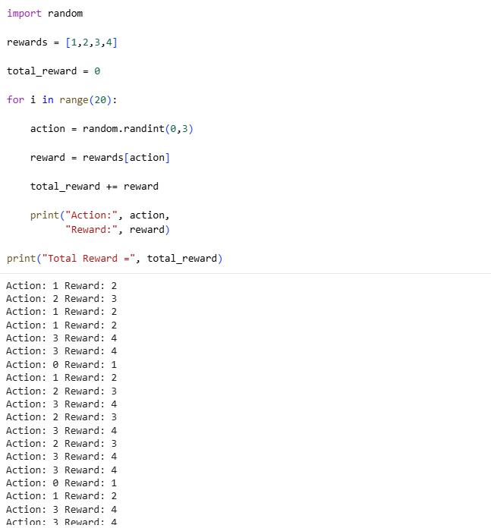

Experiment 8: Reward Visualization in Reinforcement Learning
Aim: To simulate an RL agent in a simple environment and visualize cumulative rewards, episode rewards, and learning performance using Matplotlib graphs.
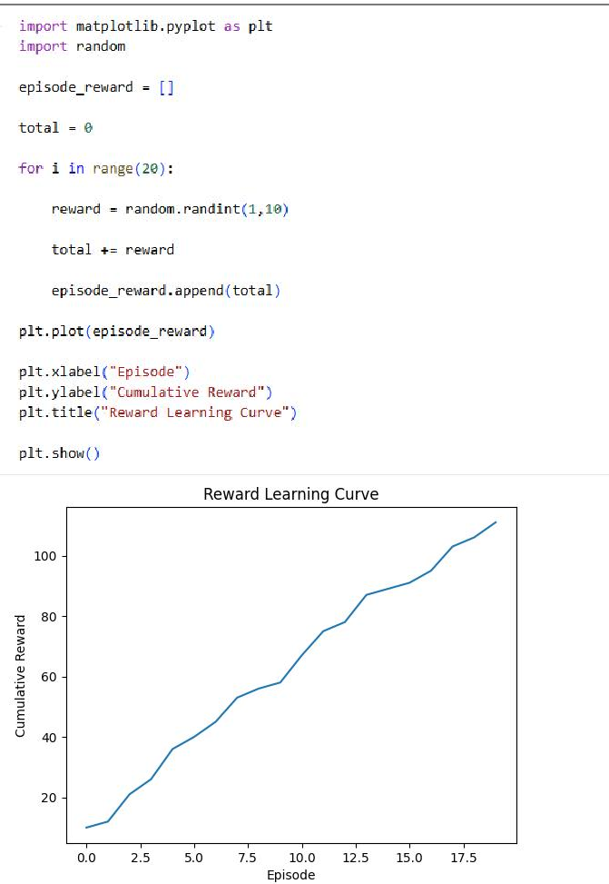

Experiment 9: TensorFlow and Keras-Based Neural Network for RL
Aim: To build a simple feed-forward neural network using TensorFlow and Keras for approximating value functions in Reinforcement Learning environments.

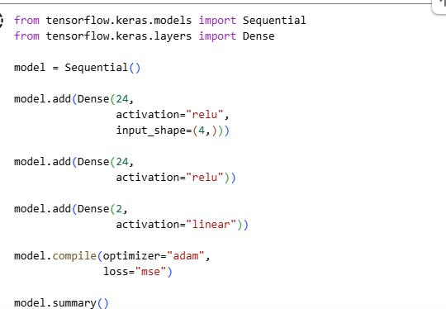

Experiment 10: Mini Reinforcement Learning Project Using CartPole
Aim: To develop a basic Reinforcement Learning agent using TensorFlow and Keras to solve the CartPole environment and evaluate its learning performance through episode rewards and success rate.

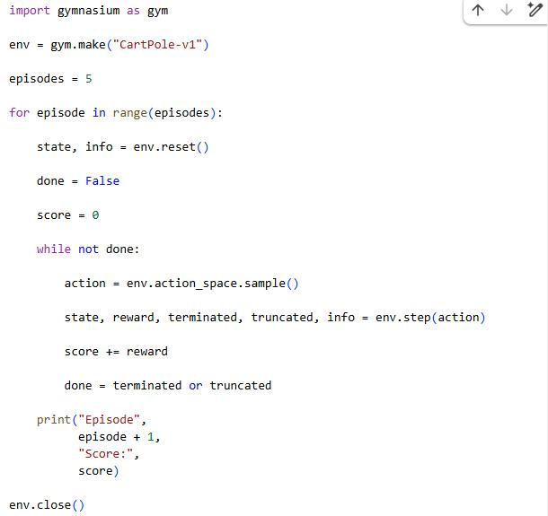

Code of Conduct:
I G.Dhanusha Sree(192325012)(Name / Reg No) certify that this submission is my original work and that I have adhered to the guidelines specified for this assessment.
I understand that any violation of academic integrity rules will result in disciplinary action.
Signature of the student:

RUBRICS FOR CALCULATION

Criteria | Weighta ge | Level 4 – Exemplary | Level 3 – Proficient | Level 2 – Developing | Level 1 – Beginning
Understandi ng of Concepts | 25% | Demonstrat es thorough, accurate understandi ng of  concepts | Good understandin g with minor gaps | Basic understandin g with some misconcepti ons | Poor understandin g; major misconcepti ons
Explanation | 25% | Detailed, well-explained answers with relevant  examples | Clear explanation with adequate details | Limited explanation; lacks depth | Poor or unclear explanation
Application | 20% | Effectively applies concepts with strong analytical  ability | Applies concepts with minor errors | Limited application with weak analysis | No application or incorrect analysis
Organizatio n | 15% | Well-structured answers with logical flow and  coherence | Organized with minor issues in flow | Basic structure, lacks clarity | Poor organization, incoherent answers
Accuracy | 10% | Completely accurate and covers all required  points | Mostly accurate with minor omissions | Partially correct with missing points | Incorrect answers with major gaps

Criteria | Weighta ge | Level 4 – Exemplary | Level 3 – Proficient | Level 2 – Developing | Level 1 – Beginning
Clarity | 5% | Clear, neat, professiona l presentatio  n | Understanda ble with minor issues | Limited clarity, readability issues | Poorly written, difficult to understand

