

SCHOOL OF ADVANCED TECHNOLOGY

ICT - Applications & Programming

Computer Engineering Technology – Computing Science



A21
Model Definitions (RE/Automaton)

Lab Professor / Lab Session:
[Lab Prof Name / Lab Session]

Team:
[Student Name] - Id: [Student Id] / [Student Name] - Id: [Student Id]

Language Name [???]

This template is suggested (not mandatory) to answer A11 Specification.

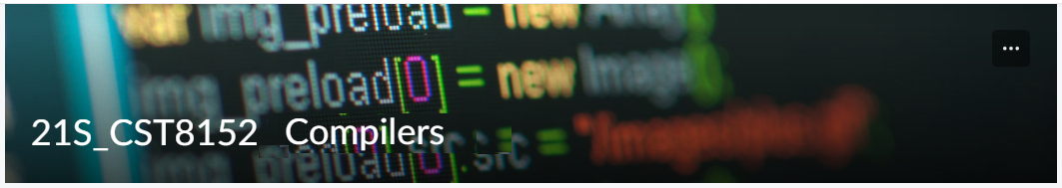

MODEL TASK FOR ASSIGNMENT 2.1 – YOUR LANGUAGE

- Note: This task is part of the Assignment 2 from Compilers Course. Any problem, contact your lab professor.

Task 1: Language Symbols (2.0 marks)

List examples: Define main symbols to be used:
- Special symbols (ex: “{“, “(“, “<=”, etc.)
- Comments
- Variables
- Functions
- Literals (numbers, strings)
- Keywords
- Datatypes

Answer:
Special Symbols: {, }, (, ), <=, >=, ==, !=, +, -, *, /, ;, =, ,
Comments: //... (single-line), /*...*/ (multi-line)
Variables: Identifiers starting with a letter or underscore followed by any combination of letters, digits, or underscores. Examples: varName, _tempVar, counter123
Functions: funcName(), computeAverage(x, y), print_message(message)
Literals:
Numbers: 123, 3.14, -0.001
Strings: "Hello, World!", "OpenAI"
Keywords: if, else, while, for, return, break, continue, func, var, true, false
Datatypes: int, float, bool, string

Task 2: RE – Regular Expression (3.0 mark)

Lexeme Classes: Define the classes to be used in your regular expression:

Answer: Lexeme Classes:
1. ( L ) = ([A-Za-z]) (Letters)
2. ( D ) = ([0-9]) (Digits)
3. ( U ) = (_) (Underscore)
4. ( Q ) = (["]) (Double Quotation Marks) (SL delimitator)
5. ( q ) = (‘) (Single Quotation Marks)
6. ( E ) = (!) (Exclamation Mark for MVID delimitator)
7. ( B ) = (/) (Forward Slash)
8. ( S ) = (*) (Star)
9. ( O ) = ([^{L}.D.U.Q]) (Excluding Letters, Digits, Underscore, and Double Quotation)

Define the RE to be used for: variables, literals and keywords:

Answer:

Comments:
Given that the comments structure wasn't provided, I'm assuming Go-style comments:
- Single line: //[^n]* (Starts with // and goes till the end of the line)
- Multi-line: /[*][^*]*[*]/ (Between /* and */)

Variables (Identifiers):
- Can start with a letter or underscore, followed by a combination of letters, digits, or underscores.
- RE: ( L|U )(( L|D|U ))*

Literals:
- Numbers:
- Integers: ( D+ )
- Floating-point numbers: ( D+ ).( D+ ) (with a mandatory decimal point and digits after it)
- Strings:
- Anything between double quotes, excluding newlines or carriage returns: ( Q )[^nr]*( Q )

Keywords:
- `int|float|string|var|const|if|else|for|switch|case|default|func|return|package|import|true|false|and|or|not|break|continue|defer|struct|interface|nil|sizeof|super|public|private|protected|union`

Datatypes:
Given the provided datatypes, the RE would be:
- `int|float|string`

Task 3: TD – Transition Diagram (3.0 marks)

Activity: Starting from the previous lexeme classes and obeying the RE, it is possible to define the automata for your language:

Answer (draw / copy image of the automata):

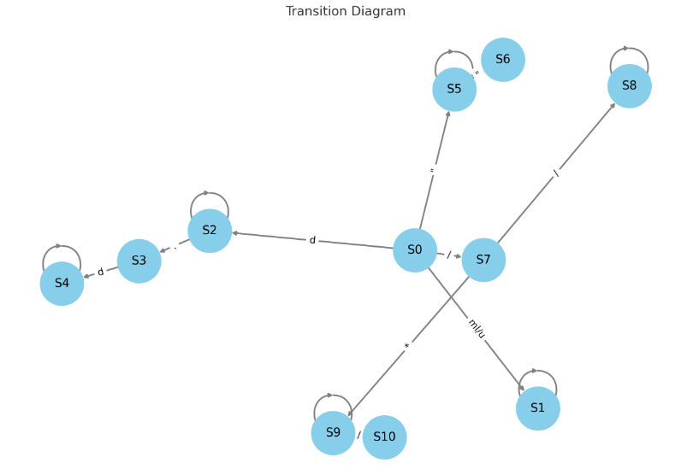

Task 4: TT – Transition Table (2.0 marks)

Activity: Now, it is possible to define the TT for these lexemes:

Answer (Transition Table):
Transition Table (TT)
State | L | D | U | Q | E | O | Output
S0 | S1 | S2 | ES | S3 | ES | ES | NOFS
S1 | S1 | S1 | S1 | ES | S4 | ES | NOFS
S2 | ES | S2 | ES | ES | ES | ES | NOFS
S3 | S3 | S3 | S3 | S6 | S3 | S3 | NOFS
S4 | FSNR | FSNR | FSNR | FSNR | FSNR | FSNR | KEY/VID/MID
S5 | FSNR | S2 | FSNR | FSNR | FSNR | FSNR | Number
S6 | FSNR | FSNR | FSNR | FSNR | FSNR | FSNR | String Literal

Legend:

ES: Error State
NOFS: Non-final state
FSNR: Final State No Retract

Update: Oct 10th 2023.

Adapted from resources developed by Prof. Svillen Ranev (Algonquin College, 2019)

