Algonquin College Logo

# SCHOOL OF ADVANCED TECHNOLOGY

### ICT - Applications & Programming

### Computer Engineering Technology – Computing Science



A11

Computer Science Challenge

Lab Professor / Lab Session:

[Paulo Sousa]

Team:

[Meet Kotadiya] - Id: [041070018] / [Dhanush Bajaj] - Id: [041067058]

CS Challenge 1: Cellular Automata

|  |  |
| --- | --- |
| **Part**  **1** | **Implementing CA** |

* 1. **UC Solution**

**UC Diagram**

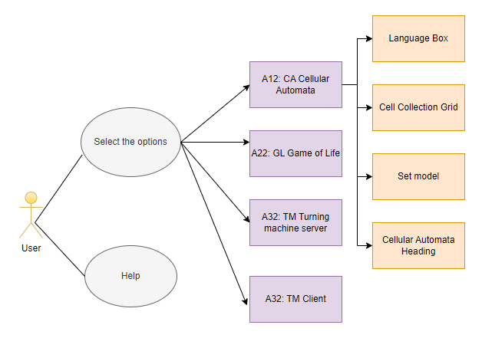

**Actors table** :

|  |  |
| --- | --- |
| **Actors** |  |
| **User** | The person who interacts with the application to set the initial conditions, start the simulation, stop the simulation, adjust the speed, and select the cellular automaton type. |

**UC table**:

|  |  |
| --- | --- |
| **Use Cases** |  |
| **OK** | Pressing the 'OK' button will initiate the start of the selected game. This action signifies that the user has made their selection from the available options and is ready to begin playing. |
| **Cancel** | The 'Cancel' button allows the user to exit from the menu bar. This action is useful if the user decides they do not want to start any game or if they wish to close the application. |
| **Help** | The 'Help' button provides assistance to the user by offering detailed explanations about the functionalities of the application. If a user is unsure about how to operate the application or what a certain feature does, pressing 'Help' will provide the necessary guidance. |
| **Select an Option** | This is the step where the user is given the opportunity to choose from a list of four available games. The list of options includes 'CA Cellular Automata', 'GL Game of Life', 'TM Turing Machine Server', and 'TM Client'. |
| **Option 1: A12: CA Cellular Automata** | Choosing this option will start the Cellular Automata game. Cellular Automata is a simulation game involving cells that evolve over time according to a set of predefined rules. |
| **Option 2: A22: GL Game of Life** | Selecting this option will start the Game of Life. The Game of Life is a cellular automaton devised by mathematician John Conway. It is a zero-player game, meaning that its evolution is determined by its initial state, requiring no further input from humans. |
| **Option 3: A32: TM Turning machine server** | Choosing this option will start the Turing Machine server. A Turing Machine is a mathematical model of computation that defines an abstract machine that manipulates symbols on a strip of tape according to a table of rules. |
| **Option 4 : A32: TM Client** | Selecting this option will start the Turing Machine client. This option allows the user to interact with the Turing Machine server, sending inputs and receiving outputs. |

* 1. **Visual Components**

**Main Window / Basic interface**

*The proposed interface for the main window of the simulation application will consist of the following visual components:*

1. ***OK Button:*** *A button labeled "OK" which, when pressed, will start the selected simulation****.***
2. ***Cancel Button:*** *A button labeled "Cancel" which, when pressed, will stop the running simulation.*
3. ***Simulation Type Combo Box****: A combo box that allows the user to select the type of simulation they want to run. The options in the combo box will be "CA Cellular Automata", "GL Game of Life", "TM Turing Machine Server", and "TM Client".*
4. ***Help Button****: A button labeled "Help" which, when pressed, will display help information to the user. This information can include a brief description of the application, how to use the application, and a description of the different simulation types.*

Example:

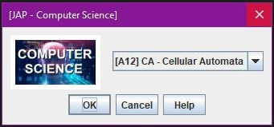

**CA Implementation**

The interface for the Cellular Automata (CA) simulation will include the following components:

1. **Language Label and Combo Box**: A label that says "Language" and a combo box that allows the user to select the language of the application. The options in the combo box will be "English" and "French". English will be the default selection.
2. **Model Label and Text Field**: A label that says "Model" and a text field that allows the user to enter a binary number that will be used to display the cellular automaton. For example, the user might enter "110" to display a cellular automaton based on Rule 110.
3. **Set Button**: A button labeled "Set" which, when pressed, will display the output of the cellular automaton based on the binary number entered by the user.

Example:

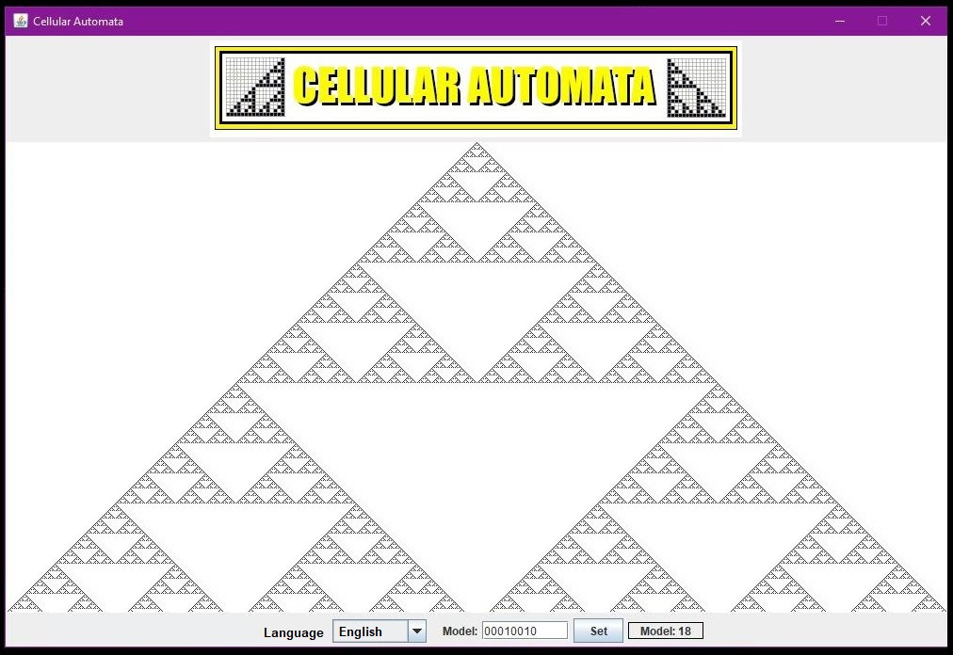

**Languages**

*The Default language of the application will be English. As a second language will be French.*

**FINAL SUGGESTIONS**

* *Intuitive Design: Strive for a user-friendly and intuitive interface. The controls should be self-explanatory, and the user should be able to understand the game's state at a glance.*
* *Feedback: Provide feedback to the user. For instance, when they change the simulation speed or pause the game, there should be clear indications on the interface reflecting these changes.*
* *Documentation: Provide tooltips or a help section in multiple languages to guide users on how to interact with the application..*

**References**

1. Wolfram, S. (2002). A new kind of science. Wolfram media.
2. Gardner, M. (1970). The fantastic combinations of John Conway's new solitaire game "life". Scientific American, 223(4), 120-123.
3. ChatGPT

Algonquin College

Fall, 2023