Algonquin College Logo

# SCHOOL OF ADVANCED TECHNOLOGY

### ICT - Applications & Programming

### Computer Engineering Technology – Computing Science

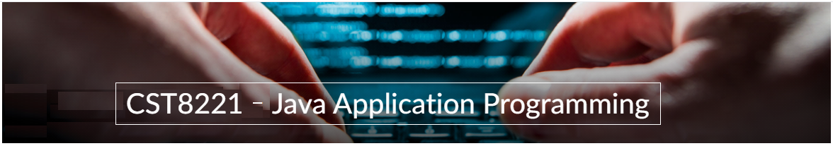

A31

Game C/S Model – Collaboration Diagram

Team:

[Meet Kotadiya] - Id: [041070018] / [Dhanush Bajaj] - Id: [041067058]

TM Model C/S Proposal

|  |  |
| --- | --- |
| **Part**  **1** | **C/S Architecture** |

* 1. **UC Model (1pt)**

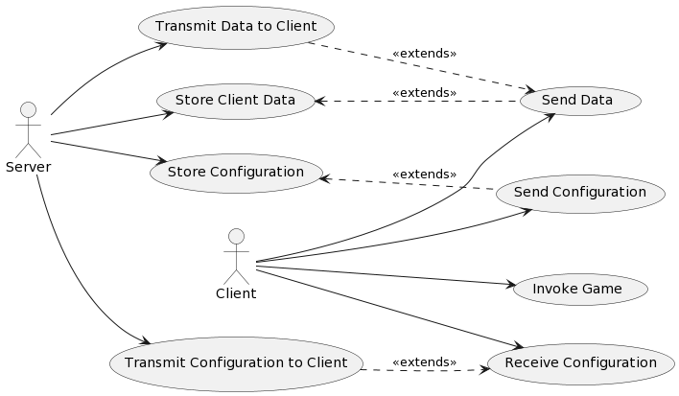

**Fig. 1** – C/S Model[1]

**Actors table**

|  |  |
| --- | --- |
| **Actors** |  |
| Client | Represents the user or system that interacts with the server to play the game.  - Sends game configurations to the server.  - Receives game data.  - Invokes game logic. |
| Server | Manages the game configurations and client information.  - Stores and manages game configurations.  - Sends configurations to clients.  - Handles client connections. |

**UC table** (example):

|  |  |
| --- | --- |
| **Use Cases** |  |
| Send Configuration | The client sends game configuration data to the server. |
| Receive Configuration | The client receives configuration data from the server. |
| Send Data | The client sends data (game results, player data) to the server. |
| Store Configuration | The server stores configuration data for the game. |
| Store Client Data | The server maintains basic information about each client. |
| Transmit Configuration to Client | The server sends game configuration data to the client. |
| Transmit Data to Client | The server sends relevant data back to the client (could include game status updates or responses). |
| Invoke Game | The client starts the game using the received configuration. |

* 1. **ClassD (2pt)**

**Class Diagram**

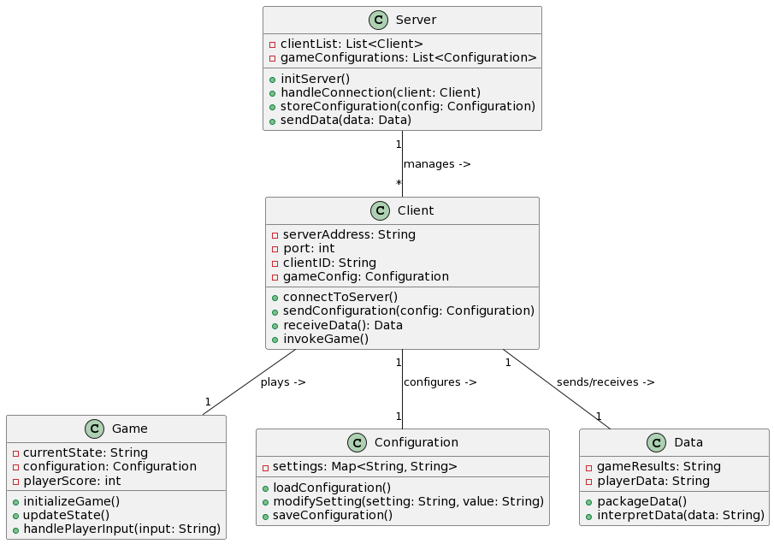

**Fig. 3** – ClassD[2]

**Class table**

|  |  |
| --- | --- |
| **Class name** | **Server** |
| Inner Fields[3] | - clientList: List<Client>  - gameConfigurations: List<Configuration> |
| Relationships[4] | - Manages connections with multiple Clients  - Stores and retrieves Configurations |
| Methods | - initServer()  - handleConnection(client: Client)  - storeConfiguration(config: Configuration)  - sendData(data: Data) |

|  |  |
| --- | --- |
| **Class name** | **Client** |
| Inner Fields[5] | - serverAddress: String  - port: int  - clientID: String  - gameConfig: Configuration |
| Relationships[6] | - Connects to Server  - Interacts with Game for gameplay |
| Methods | - connectToServer()  - sendConfiguration(config: Configuration)  - receiveData(): Data  - invokeGame() |

|  |  |
| --- | --- |
| **Class name** | **Game** |
| Inner Fields[7] | - currentState: String  - configuration: Configuration  - playerScore: int |
| Relationships[8] | - Utilizes Configuration for game setup  - Interacts with Client for game inputs and state updates |
| Methods | - initializeGame()  - updateState()  - handlePlayerInput(input: String) |

|  |  |
| --- | --- |
| **Class name** | **Configuration** |
| Inner Fields[9] | - settings: Map<String, String> |
| Relationships[10] | - Used by Server for storing configurations  - Used by Client and Game for game setup and logic |
| Methods | - loadConfiguration()  - modifySetting(setting: String, value: String)  - saveConfiguration() |

|  |  |
| --- | --- |
| **Class name** | **Data** |
| Inner Fields[11] | - gameResults: String  - playerData: String |
| Relationships[12] | - Sent between Client and Server for data transmission |
| Methods | - packageData()  - interpretData(data: String) |

*Create tables for all classes.*

* 1. **UML Collaboration Diagram**

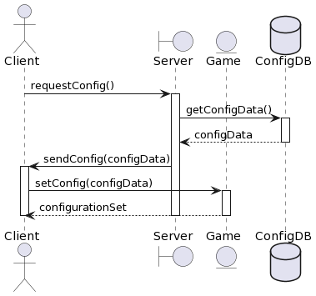

**Fig. 4** – Collab model[13]

**References**

“Client-Server Architecture - Design Your Software Architecture Using...,” OpenClassrooms. [Online]. Available: https://openclassrooms.com/en/courses/5564316-design-your-software-architecture/5578251-client-server-architecture. [Accessed: Nov. 23, 2023].

“Software Architecture Diagramming and Patterns - Educative,” Educative. [Online]. Available: https://www.educative.io/courses/software-architecture-diagramming-patterns. [Accessed: Nov. 23, 2023].

“Modeling a Client/Server System using UML Packages and Deployment Diagram,” Visual-Paradigm Guides. [Online]. Available: https://guides.visual-paradigm.com/uml-deployment-diagram/modeling-client-server-system-using-uml-packages-and-deployment-diagram/. [Accessed: Nov. 23, 2023].

“UML Communication Diagram - Client Server Access,” ConceptDraw. [Online]. Available: https://www.conceptdraw.com/How-To-Guide/uml-communication-diagram. [Accessed: Nov. 23, 2023].

“Client-Server Architecture Diagram | Creately,” Creately. [Online]. Available: https://creately.com/diagram/example/hrlzxtcy2/client-server-architecture-diagram. [Accessed: Nov. 23, 2023].

ChatGPT

Algonquin College

Fall, 2023

1. See <https://www.researchgate.net/figure/System-Architecture-Use-Case-Diagram-Client-side-Functionality_fig2_318502492>.
2. See <https://www.codeproject.com/Articles/443660/Building-a-basic-HTML-client-server-application>.
3. The inner fields and relationships together are properties from the class.
4. In the diagram, you can see relationships (ex: association / aggregation) between classes. In the implementation, these relations imply in the inclusion of other classes as fields.
5. The inner fields and relationships together are properties from the class.
6. In the diagram, you can see relationships (ex: association / aggregation) between classes. In the implementation, these relations imply in the inclusion of other classes as fields.
7. The inner fields and relationships together are properties from the class.
8. In the diagram, you can see relationships (ex: association / aggregation) between classes. In the implementation, these relations imply in the inclusion of other classes as fields.
9. The inner fields and relationships together are properties from the class.
10. In the diagram, you can see relationships (ex: association / aggregation) between classes. In the implementation, these relations imply in the inclusion of other classes as fields.
11. The inner fields and relationships together are properties from the class.
12. In the diagram, you can see relationships (ex: association / aggregation) between classes. In the implementation, these relations imply in the inclusion of other classes as fields.
13. See <https://www.researchgate.net/figure/Collaboration-diagram_fig1_268362338>.