

AI - Based Intrusion Detection System for IoT Networks Using Machine Learning and Deep Learning
Mini-Project Synopsis

submitted to

Manipal School of Information Sciences, MAHE, Manipal

Reg. Number | Name | Branch
261100610001 | B. Nitin Sri Karthikeya | CSE
261100610017 | E. Dhanush Rajkumar | CSE
261100610019 | M. B. Usha | CSE

19/08/2026


TABLE OF CONTENTS

S.No. | Title | Page No.
1 | Introduction | 1
2 | Objectives | 2
3 | Literature Survey | 3
4 | Flow Chart | 6
5 | Applications | 7
6 | Software and Hardware Requirements | 9
7 | References | 10

- Introduction
The IoT is considered a disruptive technology through which communication can be done between devices that are interconnected in cases like smart homes, smart hospitals, smart factories, smart transportation, smart farming, and smart cities. The IoT has brought many benefits in terms of automation and efficiency and real-time decision making; however, due to its quick advancement, the IoT systems have become vulnerable to many cyberattacks including DoS, DDoS, botnet attacks, port scanning, and other types of network intrusions.

A traditional IDS uses a combination of signature-based and rule-based approaches, which means it is efficient only against the known types of attacks and unable to identify the unknown attacks. With the recent developments in ML and DL techniques, it has been possible to develop intelligent IDS that can learn from the network traffic.

In the "AI-Based Intrusion Detection System for IoT Networks Using Machine Learning & Deep Learning" proposed project, an IDS will be developed for IoT networks using ML and DL algorithms. The IDS will include the following activities: Binary and multi-class attacks classification; comparison between different models and their performance evaluation using Accuracy, Precision, Recall, F1-Score, ROC-AUC, and False Alarm Rate measures; visualization of network traffic and attacks on the IDS dashboard.

- Objectives
- To collect and preprocess an IoT network traffic dataset containing both normal and malicious traffic, including different attack types for binary and multi-class classification.
- To develop and compare Machine Learning and Deep Learning models for accurately detecting malicious IoT network traffic.
- To evaluate the developed intrusion detection models using metrics such as Accuracy, Precision, Recall, F1-Score, ROC-AUC, and False Alarm Rate and develop a visual dashboard to monitor and present their performance.

- Literature Survey
[1] Baich et al. provided a comparative analysis of ML and DL methods for intrusion detection in IoT-based networks. In this work, Decision Tree (DT), Random Forest (RF), Naïve Bayes (NB), and Support Vector Machine (SVM) classifiers were analyzed using NSL-KDD datasets with Pearson Correlation, Fisher Score, and PCA methods for feature selection. As a result of experiments, the Decision Tree classifier used with Fisher Score provided the best classification accuracy value of 99.26% with prediction time equal to 0.4 s.
[2] An Optimized Machine Learning based Intrusion Detection System for IoT network has been suggested by Mahmud et al. using Decision Tree, Random Forest, KNN, Gradient Boosting, and AdaBoost classifiers. The model has used GridSearchCV for hyperparameter tuning and 5-fold cross-validation to enhance the performance of the classifier. The accuracy of 99.39% was achieved by the optimized Random Forest classifier which performed better than all other classifiers.
[3] Saba et al. developed an anomaly-based Intrusion Detection System using a Convolutional Neural Network (CNN) for IoT networks. The proposed deep learning model was evaluated using the NID and BoT-IoT datasets and achieved detection accuracies of 99.51% and 95.55%, respectively. The CNN automatically extracted complex traffic features without manual feature engineering, enabling efficient detection of both known and unknown attacks. The study demonstrated the effectiveness of deep learning in handling complex IoT network traffic.
[4] Almotairi et al. introduced a novel approach to detect intrusions using feature selection and ensemble methods for IoT applications. In particular, the authors used the SelectKBest algorithm along with ANOVA F-score to select the top fifteen features of the network and implemented a Stack Classifier comprising the algorithms Random Forest, Naive Bayes, SVM, and KNN. The presented approach yielded an outstanding accuracy of 99.99% with no false positive results when tested on the ToN-IoT dataset.

[5] Akinbowale et al.'s research paper looked into the implementation of the Machine Learning approach in the detection of intrusions using the CICIoT2023 dataset, which is made up of over one million network records and 34 types of attacks. The researchers compared the effectiveness of the Decision Tree, Random Forest, and SVM classifiers after preprocessing the data by way of feature selection, correlation, and label encoding. The Decision Tree classifier was found to give the best results at an accuracy of 99.36%.
[6] Rahman et al. proposed an anomaly-based intrusion detection framework for Industrial IoT healthcare environments. The authors generated realistic IoT traffic using the IoT-Flock simulator supporting MQTT and CoAP protocols and evaluated KNN, Random Forest, and Decision Tree classifiers. The KNN classifier achieved the highest accuracy of 99.74%, followed by Random Forest with 99.61%. The study demonstrated the effectiveness of gateway-based intrusion detection for protecting critical healthcare IoT networks.
[7] Kantharaju et al. introduced a Machine Learning-based intrusion detection framework utilizing a Self-Attention Progressive Generative Adversarial Network (SAPGAN). The framework applied Local Least Squares for missing value restoration and a modified War Strategy Optimization Algorithm (WSOA) for feature selection before classification. Experimental results showed that the proposed model reduced computational time by 14–26% compared to conventional deep learning methods while maintaining high detection performance. The study highlighted the benefits of attention mechanisms and optimized feature selection for real-time IoT intrusion detection.
[8] Alashjaee and Alqahtani proposed a hybrid intrusion detection model combining a Feed Forward Neural Network (FFNN) with XGBoost for IoT network security. Principal Component Analysis (PCA) was used for feature reduction, while oversampling and undersampling techniques addressed dataset imbalance. The proposed model achieved an overall detection accuracy of 99%, with Dropout and L2 regularization effectively preventing overfitting. The study demonstrated that combining deep learning feature extraction with gradient boosting enhances intrusion detection performance.

[9] Alsoufi et al. proposed an anomaly-based intrusion detection model using a hybrid Sparse Autoencoder (SAE) and Convolutional Neural Network (CNN) architecture. The Sparse Autoencoder extracted compressed feature representations from high-dimensional network traffic, while the CNN performed attack classification. The proposed model achieved 99.9% accuracy, 99.9% precision, and 100% recall on the Bot-IoT dataset. The study showed that dimensionality reduction combined with deep learning significantly improves detection accuracy while reducing computational complexity.
[10] Bhavsar et al. proposed a lightweight deep learning framework called Pearson Correlation Coefficient–Convolutional Neural Network (PCC-CNN) for intrusion detection in IoT environments. In the present work, the hybrid model is designed using feature selection based on Pearson Correlation Coefficient (PCC), followed by the construction of customized CNN to classify attacks as binary as well as multi-class. The model was tested using the NSL-KDD, CICIDS-2017, and IoTID20 datasets via 10-fold cross-validation, where the model obtained a maximum detection accuracy of 99.89%, having a false alarm rate of 0.00-0.02%. It was found that PCC-CNN model performs better than traditional machine learning models, both in terms of detection accuracy and computational time.
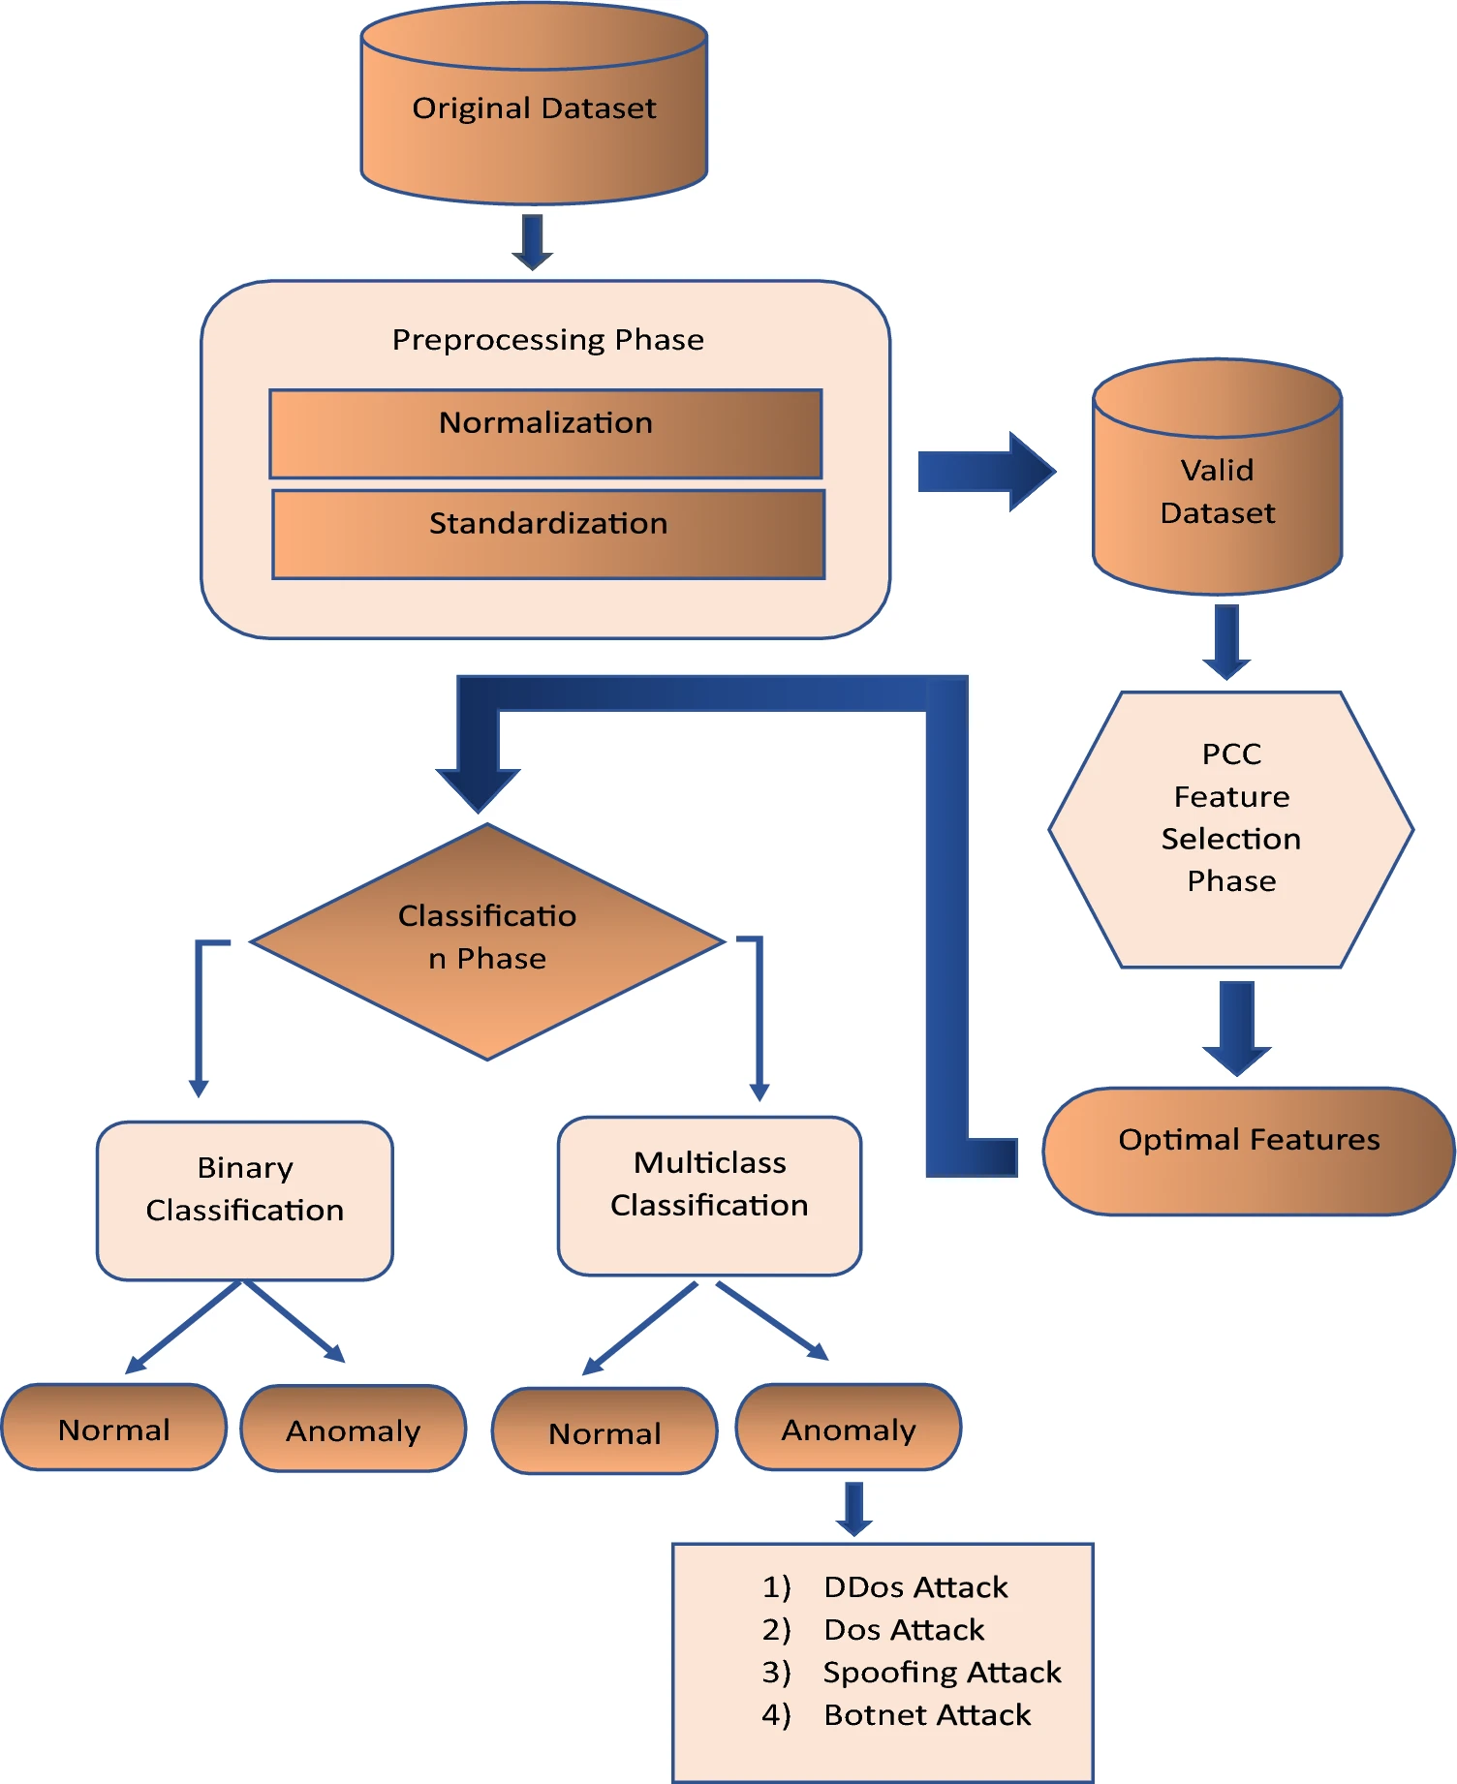
- Flow Chart
- Applications
There are quite few applications of this AI Based Intrusion Detection System for IoT which can be useful to overcome a lot of problems and they are as follows
- Smart Home Security
Smart cameras, smart locks, sensors, and home appliances that fall into the category of IoT devices are linked to the Internet and may be exposed to vulnerabilities like illegal access, botnet attacks, DoS/DDoS attacks, etc. The suggested IDS will keep monitoring the network traffic from these IoT devices, detect any anomaly/malicious behavior, and send alerts for the same.
- Health care IoT
Connected medical devices such as patient monitors, wearable devices, and medical sensors exchange sensitive information over networks and may be targeted by attackers. The proposed system can analyze their network traffic and detect suspicious activities such as unauthorized access, DoS attacks, and other malicious traffic to improve the security of healthcare IoT networks.
- Industry IoT
Industrial environments use connected sensors, controllers, machines, and monitoring systems that can be targeted by network-based attacks. The proposed IDS can monitor communication between these devices, detect abnormal traffic patterns, classify potential attacks, and generate alerts to help prevent disruption of industrial operations.
- Smart Agriculture
Agricultural applications based on IoT involve sensors, automated irrigation system, weather monitoring system, and controllers that are generally connected using wireless networks. Such devices can be subjected to attacks like unauthorized access, spoofing, DoS attack, etc. The IDS developed would help detect any abnormality in network and identify malicious traffic.
- Smart Cities
Smart city technology has components such as interconnected traffic lights, surveillance cameras, environmental sensors, parking solutions, and public utility gadgets. Because there are many devices that operate in networks, they could be vulnerable to cyber-attacks. The suggested system will be able to monitor the traffic and detect any malicious activity targeting the IoT devices.
- Transportation and Campus Networks
Connected vehicles and transportation systems communicate with sensors, roadside infrastructure, and other networked devices, making them potential targets for network attacks. The proposed IDS can monitor communication traffic, detect abnormal patterns, and identify malicious activities such as DoS, scanning, and spoofing attacks.
- Network Security Operations
It is necessary for security administrators to constantly monitor huge amounts of network traffic in order to detect any possible threat. Manually detecting all suspicious connections is not an easy task and could lead to a delay in the process or even false alerts. The suggested AI-powered IDS will be able to analyze the network traffic and classify normal and malicious activities.
- Enterprise and Campus Networks
Organizations and educational institutions use numerous IoT devices such as cameras, biometric systems, access-control devices, printers, and smart equipment. A compromised device can be used as an entry point for further attacks on the network. The proposed IDS can monitor traffic from these devices, detect malicious behavior, and provide alerts to administrators.
- Edge and IoT Gateways
IoT gateways act as communication points between multiple IoT devices and external networks, making them important targets for attackers. The proposed system can be deployed at or near the gateway to analyze incoming and outgoing traffic and detect malicious patterns before they spread across the IoT network.
- Cybersecurity Research and Education
The system can be used as a practical platform for studying IoT network security, Machine Learning, and Deep Learning-based intrusion detection. Students and researchers can experiment with different datasets and models, compare their performance, analyze false alarms, and study how AI techniques can be applied to detect evolving cyberattacks.

- Software & Hardware Requirements
The software requirements for this project are as follows and they are :
Programming Language | Python
Machine Learning | Scikit-learn
Deep Learning Frameworks | TensorFlow / Keras, PyTorch
Data Processing Libraries | Pandas, NumPy
Data Visualization | Matplotlib
Web Dashboard | Streamlit / Flask
Development Environment | Jupyter Notebook

The Hardware requirements for the project are as follows
Processor | Intel Core i5 / AMD Ryzen 5 or equivalent
RAM | 8 GB or higher
Storage | 256 GB SSD or higher
Graphics | Integrated Graphics / NVIDIA GPU
Network | Wi-Fi / Ethernet
Display | Standard Monitor / Laptop Display
Input Devices | Keyboard and Mouse

- References
[1] M. Baich, T. Hamim, N. Sael, and Y. Chemlal, "Machine Learning for IoT Based Networks Intrusion Detection: A Comparative Study."
[2] M. Z. Mahmud, S. Islam, S. R. Alve, and A. J. Pial, "Optimized IoT Intrusion Detection Using Machine Learning Technique."
[3] T. Saba, A. Rehman, T. Sadad, H. Kolivand, and S. A. Bahaj, "Anomaly-based Intrusion Detection System for IoT Networks through Deep Learning Model."
[4] A. Almotairi, S. Atawneh, O. A. Khashan, and N. M. Khafajah, "Enhancing Intrusion Detection in IoT Networks Using Machine Learning-Based Feature Selection and Ensemble Models."
[5] O. E. Akinbowale, A. T. Adesina, M. F. Zerihun, and P. Mashigo, "Machine Learning Based Approach to Intrusion Detection in Internet of Things Environments."
[6] M. M. Rahman, M. A. Mim, D. Chakraborty, Z. H. Joy, and N. Nishat, "Anomaly-based Intrusion Detection System in Industrial IoT-Healthcare Environment Network."
[7] V. Kantharaju, H. Suresh, M. Niranjanamurthy, S. I. Ansarullah, F. Amin, and A. Alabrah, "Machine Learning Based Intrusion Detection Framework for Detecting Security Attacks in Internet of Things."
[8] A. M. Alashjaee and F. Alqahtani, "Enhanced Intrusion Detection System IoT Network Security Model by Feed Forward Neural Network and Machine Learning."
[9] M. A. Alsoufi, M. M. Siraj, F. A. Ghaleb, M. Al-Razgan, M. S. Al-Asaly, T. Alfakih, and F. Saeed, "Anomaly-Based Intrusion Detection Model Using Deep Learning for IoT Networks."
[10] M. Bhavsar, K. Roy, J. Kelly, and O. Olusola, "Anomaly-Based Intrusion Detection System for IoT Application."

