- Find the names of all branches in Loan relation
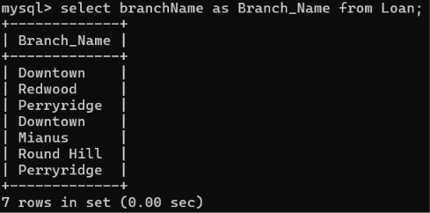
- Find all loan numbers for loans made at the Perryridge branch with loan amounts greater than $1200
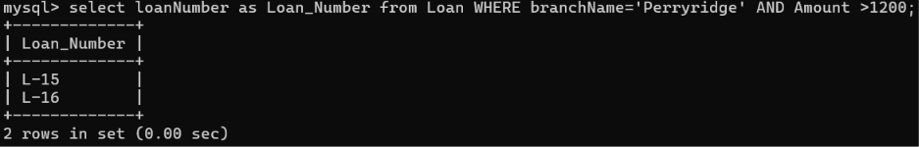
- Find all loan numbers for loans made at the Perryridge branch with loan amounts greater than $90000 and less than $100000
- For all customers who have a loan from the bank, find their names and loan numbers
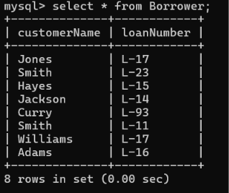
- Find the names and loan numbers of all customers who have a loan at the Perryridge branch
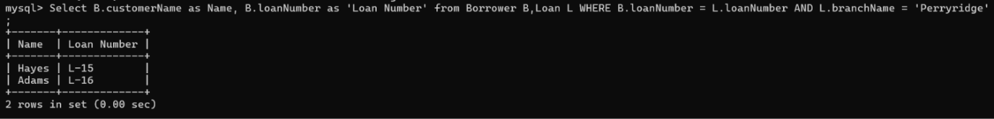
- Find the names of all branches that have assets greater than at least one branch in Brooklyn
