**Smart Cardboard Sheet Counting and Weighing System with Environmental Calibration and TinyML-Based Defect Detection**

# 1. Problem Statement

In manufacturing and packaging industries, cardboard sheets are often weighed and counted in bulk. Traditional weighing methods are prone to inaccuracies due to environmental factors such as humidity and temperature, which alter the moisture content—and therefore the weight—of cardboard. Additionally, physical defects, inconsistent stacking, and partial bundles can lead to errors in counting and quality control. There is a need for an intelligent, accurate, and automated system that not only weighs the bundles but also verifies stack height and detects inconsistencies or defects using edge AI, ensuring reliable operations without manual inspection.

# 2. Objectives

* Design and implement a smart weighing system using a load cell to measure the weight of cardboard stacks.
* Improve weight accuracy by compensating for environmental factors such as humidity and temperature using calibrated sensors.
* Implement a laser height sensor to verify stack height and ensure accurate sheet count.
* Detect anomalies such as partial bundles, tilt, or foreign material using sensor fusion.
* Integrate a TinyML model for real-time defect detection and predictive adjustment.
* Build a compact, embedded system that functions autonomously at the edge without internet dependency.

# 3. Methodology

## 3.1 Hardware Components

* Load Cell with HX711 amplifier
* Laser Height Sensor (e.g., VL53L0X or TF-Luna)
* DHT22 or BME280 sensor for humidity and temperature
* Microcontroller (e.g., Arduino Nano 33 BLE Sense, ESP32, or Raspberry Pi Pico)
* Power supply and mechanical frame for mounting sensors

## 3.2 Software and Tools

* Arduino IDE / MicroPython / TensorFlow Lite for Microcontrollers
* TinyML model training using Edge Impulse / TensorFlow
* Calibration logic for environmental compensation
* Sensor fusion and decision-making logic

## 3.3 Implementation Steps

* Weighing System: Connect load cell to microcontroller via HX711 to measure weight.
* Environmental Sensing: Measure ambient temperature and humidity; apply correction factors to weight.
* Height Measurement: Use laser height sensor to calculate expected number of sheets.
* TinyML   
   - Train model on normal vs. defect patterns (e.g., height-weight mismatch, damaged edges).  
   - Deploy trained model to microcontroller.
* Validation and Output: Display actual vs. expected count, flag inconsistencies, and log data.

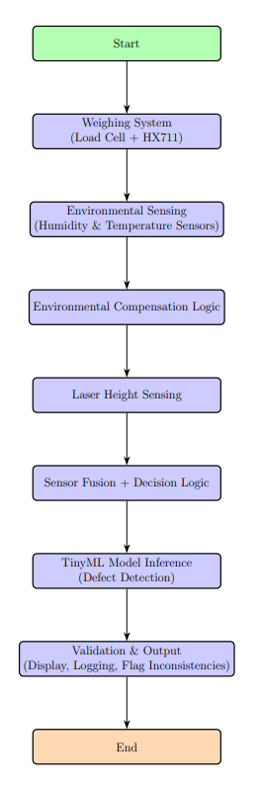

# 4. Block Diagram

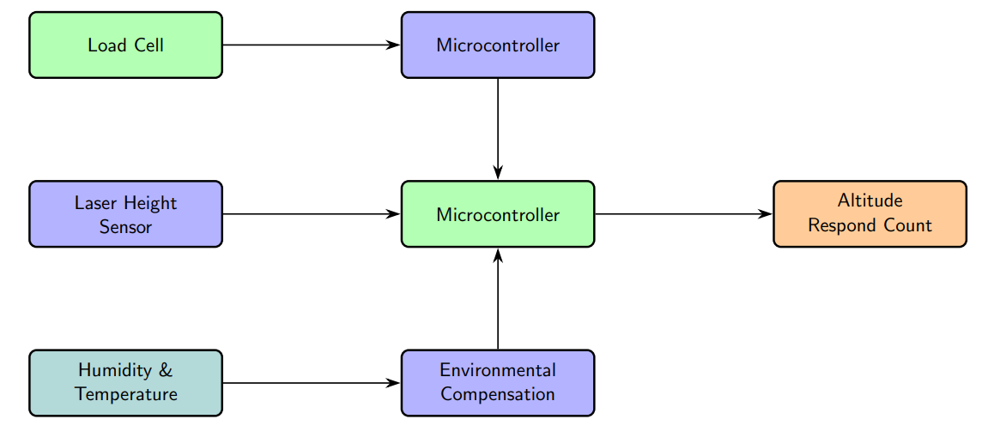

# 5. Expected Outcomes

* Accurate count of cardboard sheets regardless of environmental variation.
* Reduced errors due to partial bundles or inconsistent stacking.
* Real-time anomaly detection using TinyML at the edge.
* Compact, low-cost, and scalable system suitable for industrial deployment.

# 6. Applications

* Packaging and logistics industries
* Manufacturing and quality control units
* Warehousing automation
* Paper and cardboard recycling plants

# 7. Future Scope

* Wireless communication (e.g., LoRa or Wi-Fi) for centralized monitoring.
* Use of advanced ML models to classify types of defects.
* Cloud-based dashboard for trend analysis and predictive maintenance.

# 8. Conclusion

The proposed system offers a cost-effective, intelligent solution to improve the accuracy of cardboard sheet counting in industrial environments. By combining environmental compensation, laser-based height verification, and TinyML-powered edge detection, this system minimizes errors, enhances quality control, and enables smarter automation.