PROJECT REPORT
PalmBridge Retail Co. — E-Commerce Sales and Profitability Analysis
*Python *SQL *Powe BI
Prepared from the supplied Google Colab notebook
Report scope: short project report (5–10 pages)

Abstract
This project focuses on preparing e-commerce sales data for analysis by cleaning and standardizing fields in a retail dataset. The Google Colab notebook uses Python, Pandas, NumPy, Matplotlib, and Seaborn. The workflow includes loading the CSV file, renaming columns, checking duplicate records and missing values, converting date fields, standardizing customer-segment labels, inspecting numeric distributions with boxplots, handling selected missing values, and exporting a processed CSV file.
The notebook is primarily a data-cleaning and exploratory preparation workflow. Although the project title refers to sales and profitability analysis, the saved notebook does not contain persisted numerical summaries, dashboard visuals, or written conclusions about sales and profit trends. Therefore, this report describes the implemented workflow and identifies the results that would need to be added after executing and validating the notebook.

1. Introduction
E-commerce businesses generate order-level data that can be used to understand sales, discounting, shipping costs, customer segments, and profit. Before such data can be used for reliable analysis, inconsistent labels, missing values, duplicate rows, incorrect data types, and extreme values must be examined.
The PalmBridge Retail Co. notebook addresses these preparation tasks. It reads a CSV dataset named palmbridge_raw_data.csv in Google Colab and works with fields related to order identifiers, dates, customer segment, geography, product category, quantity, sales, discounts, shipping cost, and profit.

2. Problem Statement and Objectives
Problem statement: raw retail transaction data may contain inconsistent column names and category labels, missing date or shipping-cost values, duplicate rows, and numeric values that require distribution checks. These issues can reduce the reliability of subsequent sales and profitability analysis.
Objectives:
- Load the retail dataset into a Pandas DataFrame.
- Standardize column names and selected text values.
- Detect and remove duplicate rows.
- inspect missing values and apply the notebook’s documented filling steps.
- Convert order and shipping dates into datetime format.
- Use boxplots to inspect numeric distributions and attempt to cap selected values.
- Export the resulting DataFrame as a CSV file for further analysis.

3. Tools and Technologies
Python — programming language used in Google Colab.
Pandas — CSV loading, DataFrame manipulation, duplicate and null checks, text cleaning, date conversion, and CSV export.
NumPy — imported for numerical operations; no specific NumPy operation is clearly central to the visible workflow.
Matplotlib — used to draw boxplots for numeric columns.
Seaborn — imported for visualization; the notebook’s visible plotting steps use Matplotlib boxplots.
Google Colab — cloud notebook environment used to run the Python workflow.

4. Dataset and Fields
The notebook loads /content/palmbridge_raw_data.csv. The exact row count, column count, and source provenance cannot be confirmed from the saved notebook because the relevant cell outputs are not stored in the uploaded file.
The columns referenced by the workflow include Order_ID, Order_Date, Ship_Date, Customer_Segment, Region, State, Category, Sub_Category, Quantity, Sales, Discount, Discounted_Sales, Shipping_Cost, and Profit. The notebook also renames several fields that originally contain spaces, making them easier to access in Python code.
Order identifiers are checked for missing and duplicate values. Date columns are converted to datetime. Customer-segment text is stripped of surrounding spaces, converted to lowercase, and then title-cased. Numeric fields are inspected with boxplots.

5. Methodology and Implementation
Step 1 — Import and load: the notebook imports NumPy, Pandas, Seaborn, and Matplotlib, then reads the raw CSV into a DataFrame.
Step 2 — Initial inspection: head(), tail(), shape, info(), and columns are used to inspect example records, dimensions, data types, and field names.
Step 3 — Column naming: fields such as Order ID, Order Date, Ship Date, Customer Segment, and Sub-Category are renamed to underscore-separated names.
Step 4 — Duplicate handling: duplicated() is used to count duplicate rows, drop_duplicates() removes them, and a further duplicate check is performed.
Step 5 — Missing values and dates: isnull().sum() is used to inspect missing values. Order_Date is parsed with pandas.to_datetime(errors='coerce'); the notebook then fills missing/invalid order dates with the mode. Ship_Date is also converted to datetime.
Step 6 — Category standardization: Customer_Segment values are cleaned using str.strip(), str.lower(), and str.title(). Region, State, Category, and Sub_Category are inspected and treated as already standardized according to notebook comments.
Step 7 — Numeric inspection and capping: boxplots are generated for Quantity, Sales, Discount, Discounted_Sales, and Profit. The notebook attempts to cap Quantity, Sales, and Discounted_Sales using quantile-derived limits.
Step 8 — Shipping-cost imputation: missing Shipping_Cost values are filled with the column median.
Step 9 — Export: the final DataFrame is saved to palmbridge_raw_data(1).csv.

6. Results and Observations
The notebook code demonstrates a structured data-preparation workflow and includes checks for duplicates, missing values, data types, category consistency, and numeric distributions. It also contains a final CSV export statement.
However, the uploaded .ipynb file does not preserve executed cell outputs. Consequently, the actual number of rows removed, number of missing values filled, final dataset dimensions, and any measured sales/profit findings cannot be reported as verified results from this file. No model training or predictive evaluation is present in the visible notebook.
Expected deliverable from the code is a cleaned CSV file named palmbridge_raw_data(1).csv, created when the notebook is executed successfully in an environment where the input CSV is available.

7. Data-Quality Notes and Recommendations
- Validate the outlier-capping calculation before relying on it. In the visible code, q3 is calculated with quantile(0.35), rather than the conventional third quartile quantile(0.75). The variables named ll and ul are also calculated as q1 + 1.5 × IQR and q3 − 1.5 × IQR, which reverses the usual lower- and upper-bound logic. This may produce invalid clipping limits. A common IQR approach uses Q1 − 1.5 × IQR and Q3 + 1.5 × IQR, with Q3 at the 75th percentile.
- Review whether capping Quantity, Sales, and Discounted_Sales is appropriate for the business context. High values may be valid large orders rather than errors.
- Confirm that date values converted to NaT are intended to be filled with the mode; a documented business rule or date-based validation may be preferable.
- The notebook calls fillna() with inplace=True. For clearer and more future-compatible code, assign the result back to the column.
- Re-run all cells and save the notebook with outputs, then record dataset dimensions before and after cleaning and missing-value counts before and after each treatment.
- To complete the profitability-analysis objective, add verified summaries such as total sales, total profit, profit margin, sales/profit by region and category, monthly trends, and discount-versus-profit analysis. These analyses are recommendations and are not results already shown in the uploaded notebook.

8. Conclusion and Future Scope
The project establishes a foundation for retail sales and profitability analysis by standardizing and preparing transaction data in Python. It demonstrates common data-cleaning techniques including duplicate removal, null inspection, datetime conversion, text standardization, boxplot-based outlier inspection, median imputation, and CSV export.
The next step is to validate the outlier logic, execute the notebook with the actual dataset, save the outputs, and add business-focused aggregation and visualizations. Those additions would allow the project to move from data preparation to evidence-based insights about sales performance and profitability.

References
1. Pandas documentation — https://pandas.pydata.org/docs/
2. NumPy documentation — https://numpy.org/doc/
3. Matplotlib documentation — https://matplotlib.org/stable/
4. Google Colab — https://colab.research.google.com/

SQL Analysis
The supplied SQL script complements the Python data-preparation workflow by defining a database named palmbridge and running summary queries against a table also named palmbridge. The queries are intended to examine record counts, overall sales and profit, category-level performance, yearly sales, customer-segment performance, and transactions with the highest discount. The script contains query definitions only; it does not include query results, so actual totals and comparisons cannot be confirmed from the SQL file alone.

Database Setup and Record Count
The script creates the palmbridge database, selects it for use, retrieves all rows from the palmbridge table, and counts non-null order_id values. The count is a count of non-null Order_ID entries, not necessarily a count of every row if Order_ID contains NULL values.

Sales and Profitability Queries
The SQL script calculates total sales using SUM(sales) and total profit using SUM(profit). It groups sales and profit by Category, calculates the average Discount by Category rounded to two decimal places, and groups sales by the year extracted from Order_Date. These summaries can help compare product categories and observe yearly sales patterns after the script is executed against the loaded dataset.

Customer Segment and Discount Queries
The customer-segment query aggregates quantity and sales for each Customer_Segment. The final query filters rows whose Discount is greater than or equal to the maximum Discount in the table; this normally returns rows tied at the highest discount value, rather than all transactions above a chosen discount threshold.

SQL Script Review Notes
- The comment “profit by categories” is followed by a query that aliases SUM(profit) as total_sales. For clarity, the alias should be total_profit.
- The comment “avg sales by categories” is followed by AVG(Discount), so the query calculates average discount, not average sales. Rename the comment to match the calculation, or change the expression if average sales is intended.
- The high-discount query uses the maximum discount as its threshold. If the intended analysis is to find all transactions with discounts above a business-defined threshold, use an explicit threshold such as Discount >= 0.30 (adjust to the dataset’s discount scale).
- The script assumes the table palmbridge already exists and that its column names match the SQL statements. The SQL file does not include a CREATE TABLE statement, import/load procedure, or saved query outputs.
- Execute the SQL statements in the target database and capture their outputs before reporting numerical findings.

SQL Queries Included in the Supplied File
The supplied SQL file contains the following analysis operations:
- Create and select the palmbridge database.
- Preview all rows and count order_id values.
- Calculate total sales and total profit.
- Summarize sales and profit by category.
- Calculate average discount by category.
- Summarize sales by year.
- Summarize quantity and sales by customer segment.
- Retrieve rows tied for the maximum discount.

Dashboard Analysis and Visualization

Dashboard Overview:
The PalmBridge Retail Co. Sales and Profitability Dashboard was developed using Microsoft Power BI to analyze e-commerce sales, profit, product categories, customer activity, and sales trends. The dashboard presents important business metrics through KPI cards, line charts, a donut chart, a gauge chart, and a table.
The dashboard enables users to monitor overall performance, compare category-wise sales and discounts, examine yearly and monthly trends, and identify orders with high sales values. A Region slicer is provided to filter the dashboard by region.

Explanation of Key Performance Indicators (KPIs):

1. Total Sales
The Total Sales KPI displays approximately ₹1.63 million in sales. It provides a quick overview of the total sales value represented in the dataset and helps users understand the overall business scale.
2. Total Profit
The Total Profit KPI displays approximately ₹1.61K. It summarizes the profit recorded in the dataset. Comparing total profit with total sales helps assess profitability and encourages further investigation into costs, discounts, and other factors affecting profit.
3. Total Quantity
The Total Quantity KPI displays approximately 4K units. It represents the total quantity of products sold and helps users understand the volume of product sales.
4. Customer Count
The Customer Count KPI displays 500. It provides a summary of the customer count represented by the dashboard measure. If the intention is to show unique customers, the measure should use a distinct count of the customer identifier.
5. Average of Discount
The Average of Discount KPI displays 0.13, representing an average discount of approximately 13% if the discount values are stored as decimal proportions. This KPI helps users monitor discounting practices and investigate their possible effect on profitability.

Explanation of Charts and Visualizations:

1.Sales by Month — Line Chart:
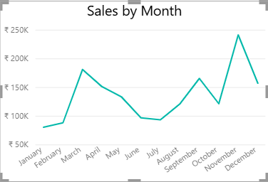

The Sales by Month chart displays sales values from January to December. It helps identify monthly fluctuations and periods of relatively high or low sales. In the displayed chart, sales rise noticeably in March and reach their highest visible point in November, followed by a decline in December.
This visualization can help businesses plan inventory, marketing campaigns, and seasonal sales activities.

2. Sales by Category — Line Chart
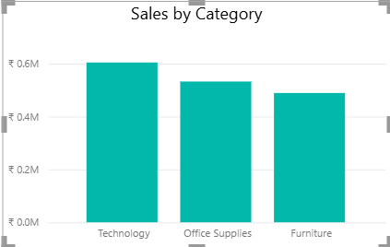

The Sales by Category chart compares total sales across Furniture, Technology, and Office Supplies. The displayed tooltip shows Furniture sales of approximately ₹4,89,153.69.
This chart helps compare the sales contribution of each product category and identify categories that may need additional business attention. Since product categories are discrete groups rather than a time sequence, a bar or column chart would generally make this comparison easier to interpret.

3. Sales by Year — Line Chart:
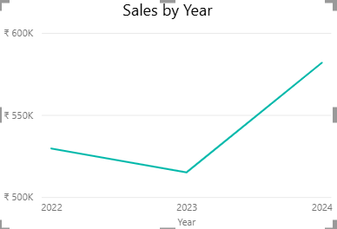

The Sales by Year chart displays sales for 2022, 2023, and 2024. The chart shows a slight decline from 2022 to 2023, followed by a substantial increase in 2024.
This visualization helps evaluate year-over-year sales performance and identify changes in business activity. The displayed pattern suggests that 2024 has the highest sales among the three years shown.

4. Profits by Using Sales
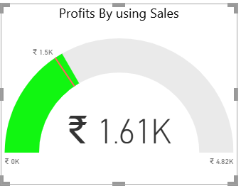

The gauge chart displays the Total Profit measure of approximately ₹1.61K, together with a visible scale extending to approximately ₹4.82K.
The gauge provides a visual comparison between the current profit value and the configured scale. It can help communicate progress toward a target when the target and minimum/maximum values are defined appropriately.
For a more meaningful performance indicator, the gauge should use a clearly defined profit target or budget. The chart title could also be renamed to Total Profit Performance.

5. Discount by Category
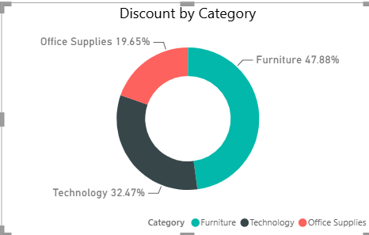

The donut chart displays the distribution of discounts across the three product categories:
- Furniture: 47.88%
- Technology: 32.47%
- Office Supplies: 19.65%
Furniture represents the largest share of the displayed discount distribution, followed by Technology and Office Supplies.
This chart helps compare how the displayed discount measure is distributed among categories. These percentages should not automatically be interpreted as category sales shares or profit contributions, because the chart represents discount rather than sales or profit.

Conclusion:
The Power BI dashboard provides a consolidated view of PalmBridge Retail Co.'s sales and profitability indicators. By combining KPI cards, monthly and yearly sales trends, category-level visualizations, a discount distribution chart, a profit gauge, a transaction table, and a region slicer, it makes retail data easier to explore and interpret.
The dashboard complements Python-based data preparation and SQL-based aggregation, demonstrating how data can be transformed into business-oriented visual reports. It can support performance monitoring and further investigation into sales trends, product categories, customer activity, and profitability.

