**BMS COLLEGE OF ENGINEERING, BANGALORE-19**

**Object Oriented Java Programming Lab Report**

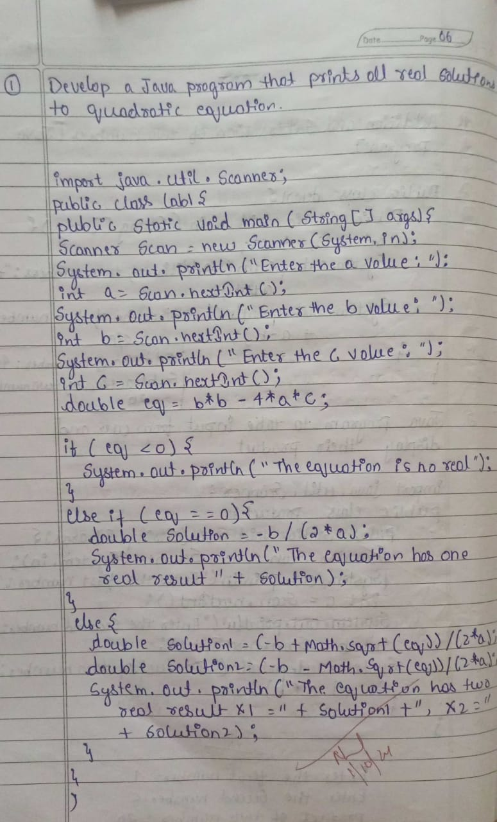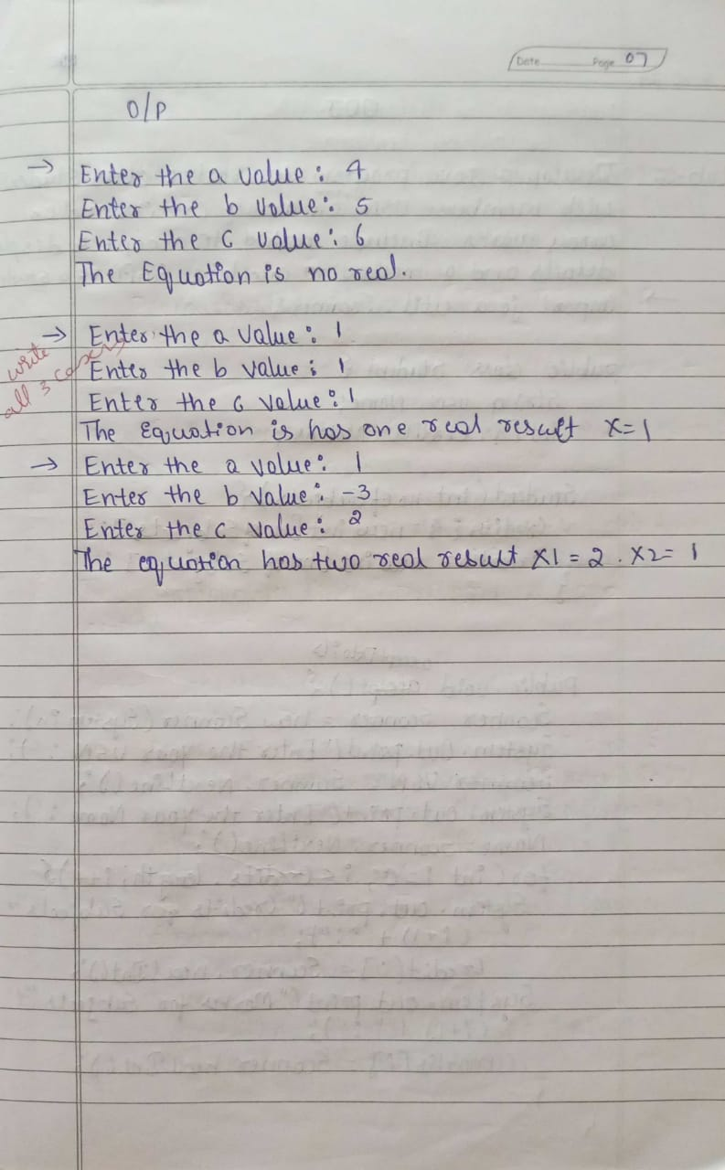

**Program-01**

import java.util.Scanner;

public class QuadraticEquation {

public static void main(String[] args) {

Scanner scanner = new Scanner(System.in);

System.out.print("Enter coefficient a: ");

double a = scanner.nextDouble();

System.out.print("Enter coefficient b: ");

double b = scanner.nextDouble();

System.out.print("Enter coefficient c: ");

double c = scanner.nextDouble();

double discriminant = b * b - 4 * a * c;

if (discriminant > 0) {

double root1 = (-b + Math.sqrt(discriminant)) / (2 * a);

double root2 = (-b - Math.sqrt(discriminant)) / (2 * a);

System.out.println("The equation has two real solutions: " + root1 + " and " + root2);

} else if (discriminant == 0) {

double root = -b / (2 * a);

System.out.println("The equation has one real solution: " + root);

} else {

System.out.println("The equation has no real solutions.");

}

scanner.close();

}

}

**Output**

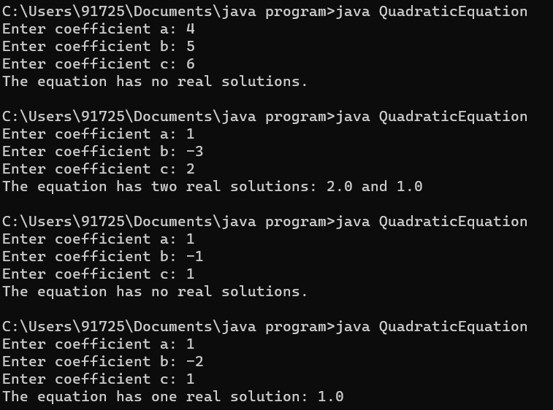

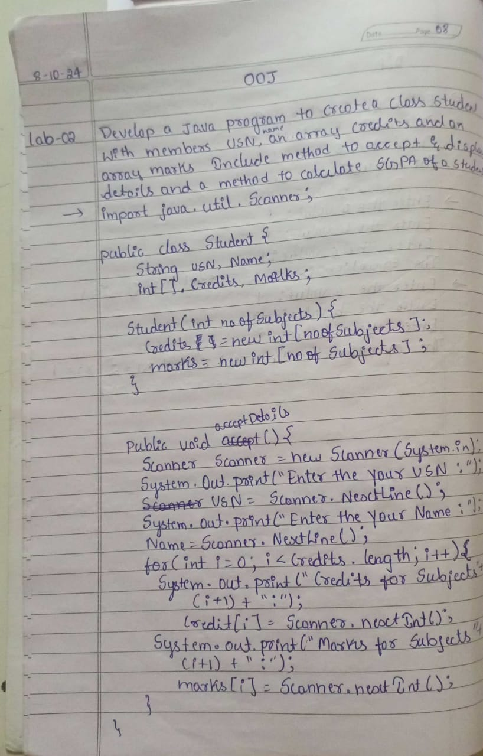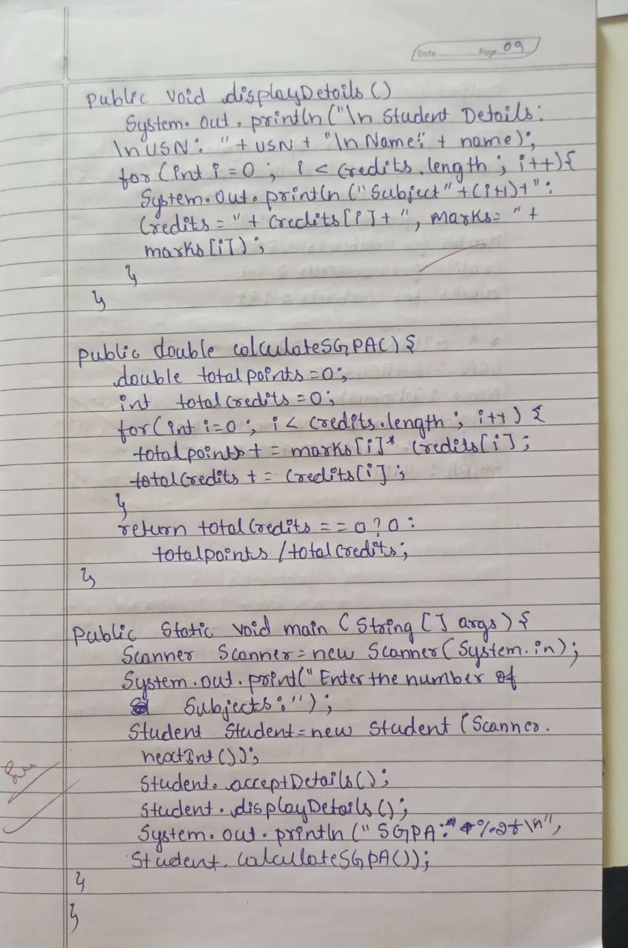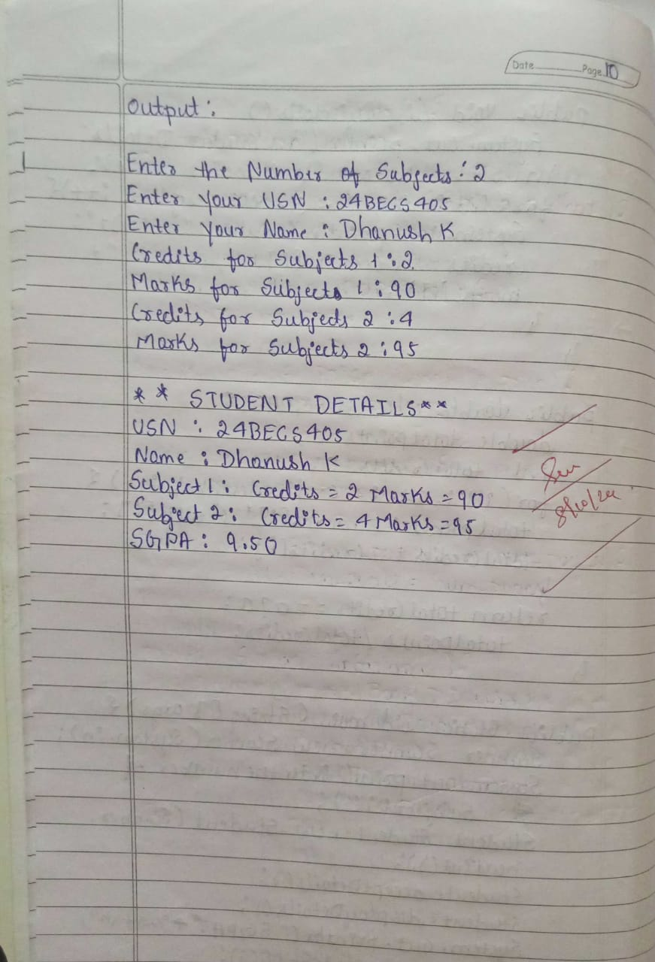

**Program-01**

import java.util.Scanner;

class Student {

String usn;

String name;

int[] credits;

int[] marks;

int numSubjects;

public void acceptDetails() {

Scanner sc = new Scanner(System.in);

System.out.print("Enter USN: ");

usn = sc.nextLine();

System.out.print("Enter Name: ");

name = sc.nextLine();

System.out.print("Enter number of subjects: ");

numSubjects = sc.nextInt();

credits = new int[numSubjects];

marks = new int[numSubjects];

for (int i = 0; i < numSubjects; i++) {

System.out.print("Enter credits for subject " + (i + 1) + ": ");

credits[i] = sc.nextInt();

System.out.print("Enter marks for subject " + (i + 1) + ": ");

marks[i] = sc.nextInt();

}

}

public void displayDetails() {

System.out.println("\nStudent Details:");

System.out.println("USN: " + usn);

System.out.println("Name: " + name);

for (int i = 0; i < numSubjects; i++) {

System.out.println("Subject " + (i + 1) + ": Credits = " + credits[i] + ", Marks = " + marks[i]);

}

}

public double calculateSGPA() {

int totalCredits = 0;

int totalPoints = 0;

for (int i = 0; i < numSubjects; i++) {

totalCredits += credits[i];

totalPoints += credits[i] * convertMarksToGrade(marks[i]);

}

return (double) totalPoints / totalCredits;

}

public int convertMarksToGrade(int marks) {

if (marks >= 90) return 10;

else if (marks >= 80) return 9;

else if (marks >= 70) return 8;

else if (marks >= 60) return 7;

else if (marks >= 50) return 6;

else if (marks >= 40) return 5;

else return 0;

}

public static void main(String[] args) {

Student student = new Student();

student.acceptDetails();

student.displayDetails();

double sgpa = student.calculateSGPA();

System.out.printf("SGPA: %.2f\n", sgpa);

}

}**Output**

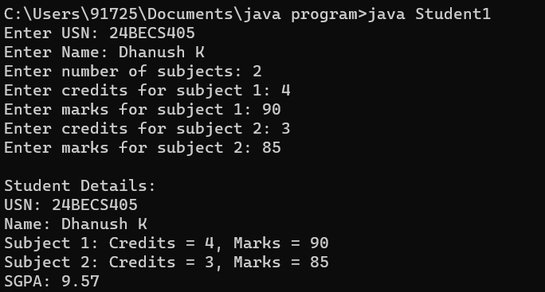

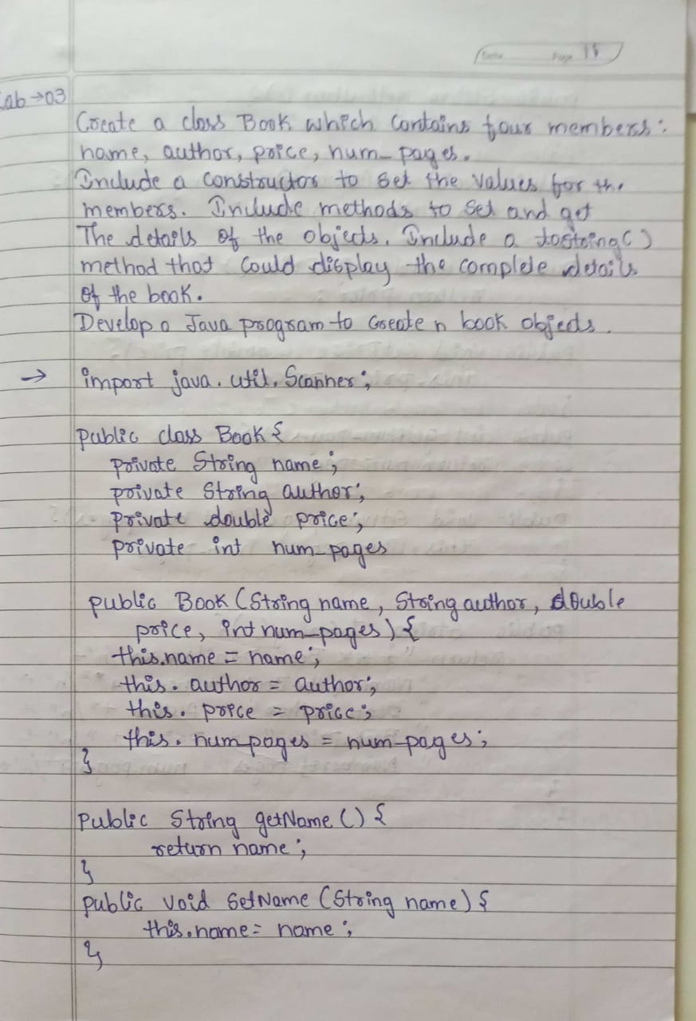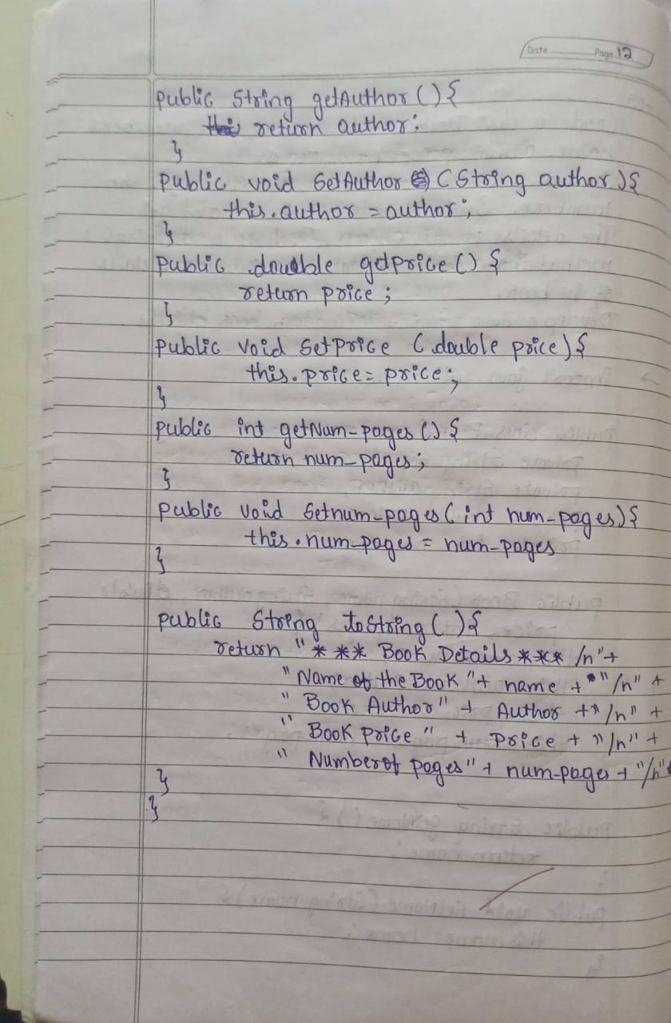

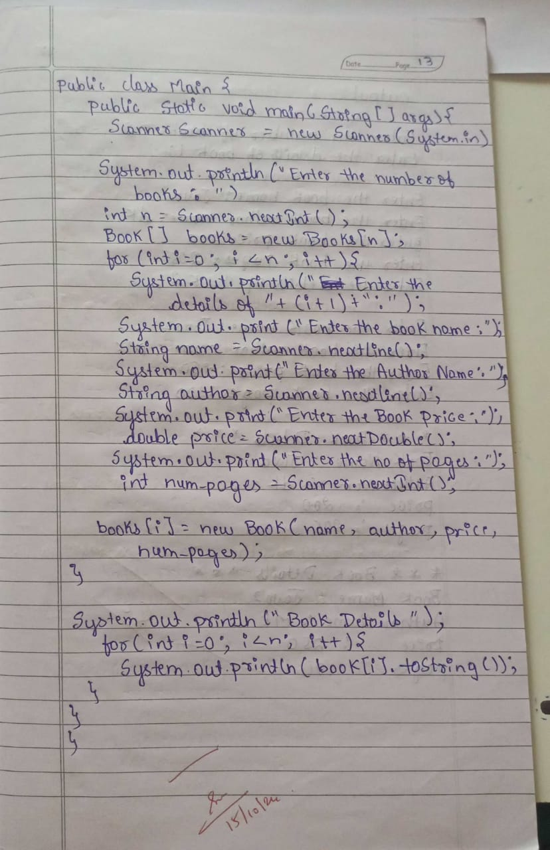 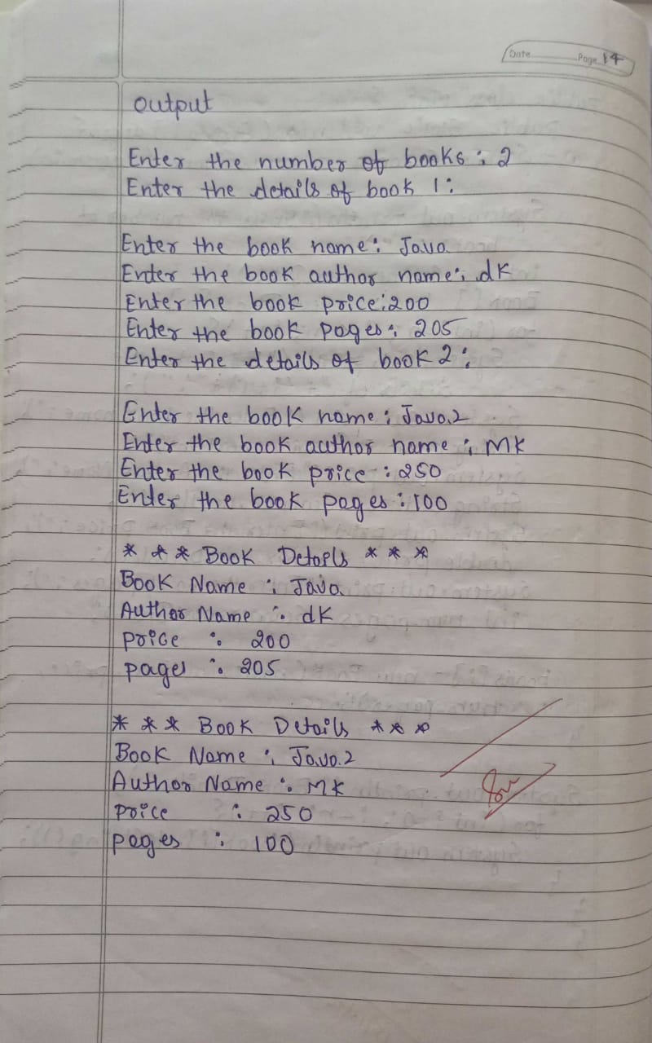

**Program-03**

import java.util.Scanner;

class Book {

private String name, author;

private double price;

private int num_pages;

public Book(String name, String author, double price, int num_pages) {

this.name = name;

this.author = author;

this.price = price;

this.num_pages = num_pages;

}

public String toString() {

return "Book Details: \n" +

"Name: " + name + "\n" +

"Author: " + author + "\n" +

"Price: $" + price + "\n" +

"Pages: " + num_pages + "\n";

}

}

public class Main {

public static void main(String[] args) {

Scanner scanner = new Scanner(System.in);

System.out.print("Enter number of books: ");

int n = scanner.nextInt();

scanner.nextLine();

Book[] books = new Book[n];

for (int i = 0; i < n; i++) {

System.out.println("\nEnter details for Book " + (i + 1) + ":");

System.out.print("Name: ");

String name = scanner.nextLine();

System.out.print("Author: ");

String author = scanner.nextLine();

System.out.print("Price: ");

double price = scanner.nextDouble();

System.out.print("Pages: ");

int num_pages = scanner.nextInt();

scanner.nextLine();

books[i] = new Book(name, author, price, num_pages);

}

System.out.println("\n--- Book Details ---");

for (Book book : books) {

System.out.println(book);

}

scanner.close();

}

**Output:**

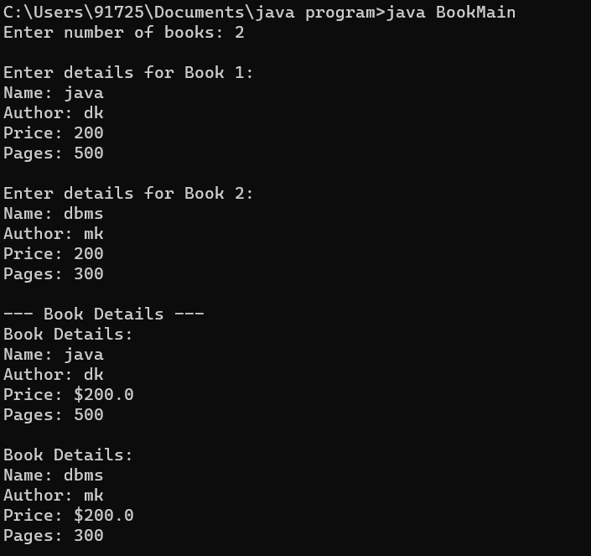

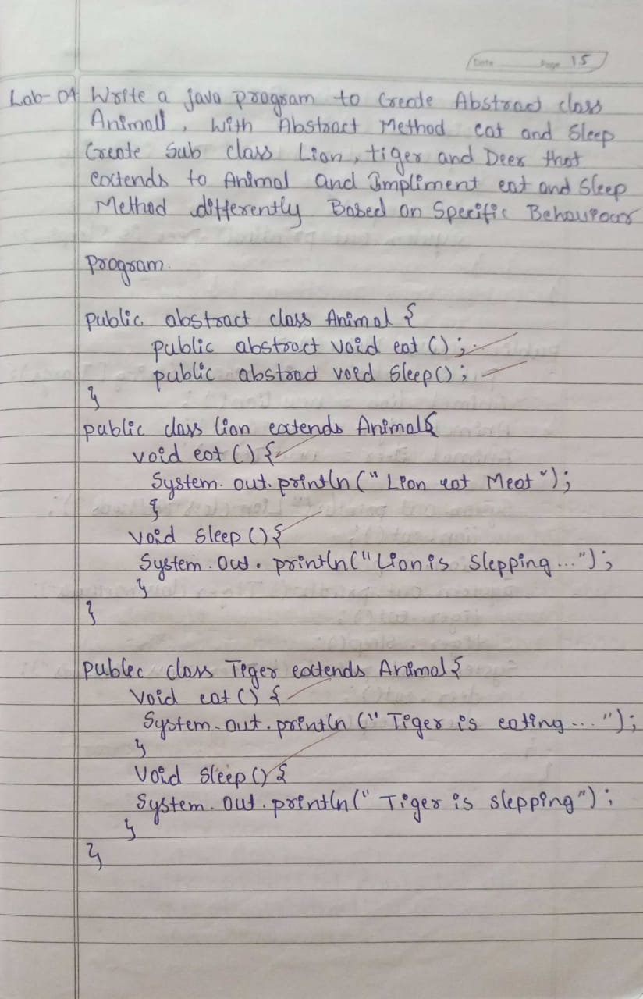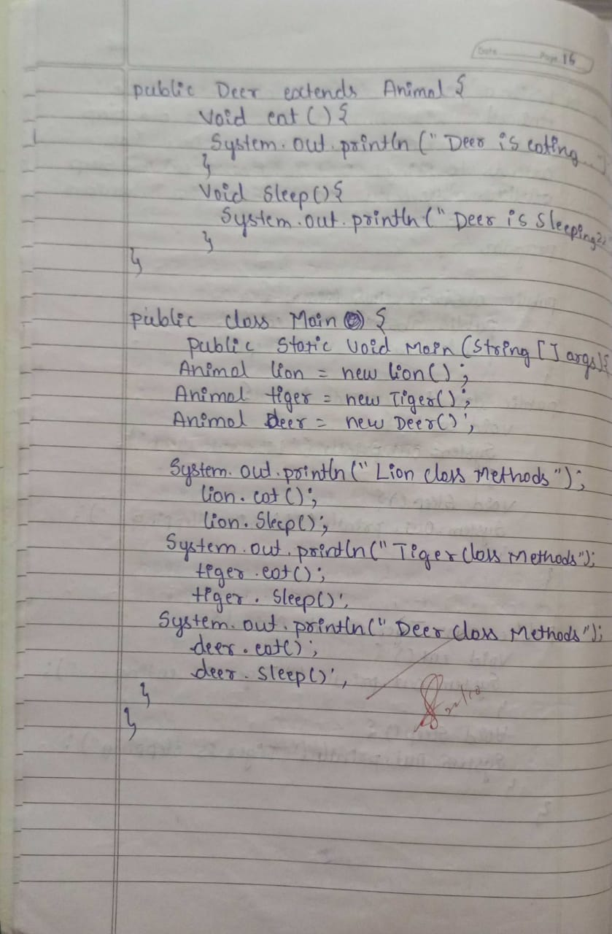

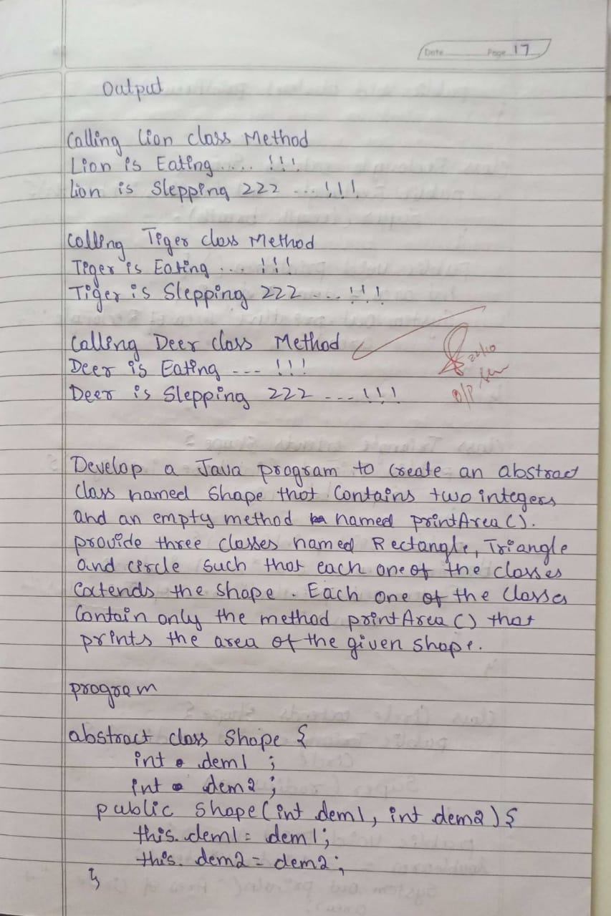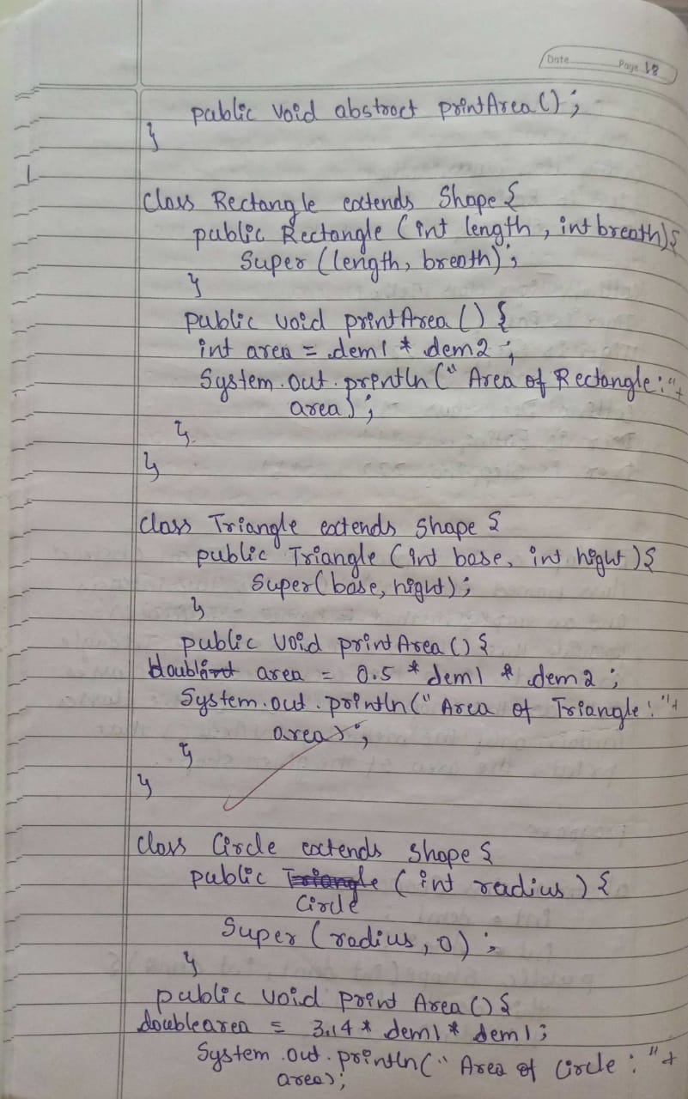

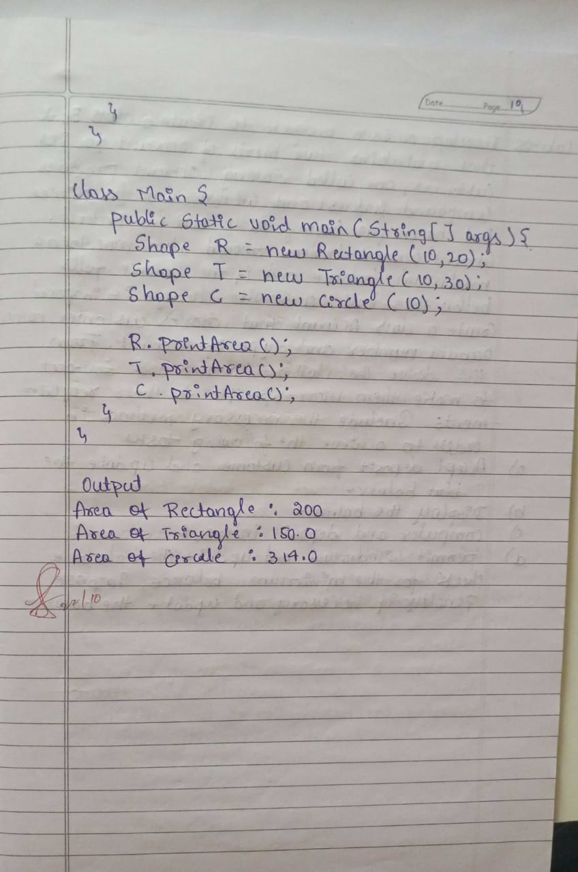

**Program-04**

abstract class Shape {

int dimension1;

int dimension2;

Shape(int d1, int d2) {

this.dimension1 = d1;

this.dimension2 = d2;

}

abstract void printArea();

}

class Rectangle extends Shape {

Rectangle(int length, int breadth) {

super(length, breadth);

}

void printArea() {

int area = dimension1 * dimension2;

System.out.println("Area of Rectangle: " + area);

}

}

class Triangle extends Shape {

Triangle(int base, int height) {

super(base, height);

}

void printArea() {

double area = 0.5 * dimension1 * dimension2;

System.out.println("Area of Triangle: " + area);

}

}

class Circle extends Shape {

Circle(int radius) {

super(radius, 0);

}

void printArea() {

double area = Math.PI * dimension1 * dimension1;

System.out.println("Area of Circle: " + area);

}

}

public class Main {

public static void main(String[] args) {

Shape rectangle = new Rectangle(10, 5);

Shape triangle = new Triangle(8, 4);

Shape circle = new Circle(7);

rectangle.printArea();

triangle.printArea();

circle.printArea();

    }

}

**Output:**

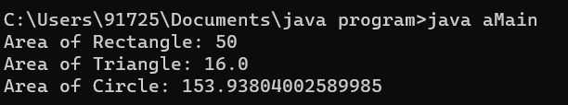

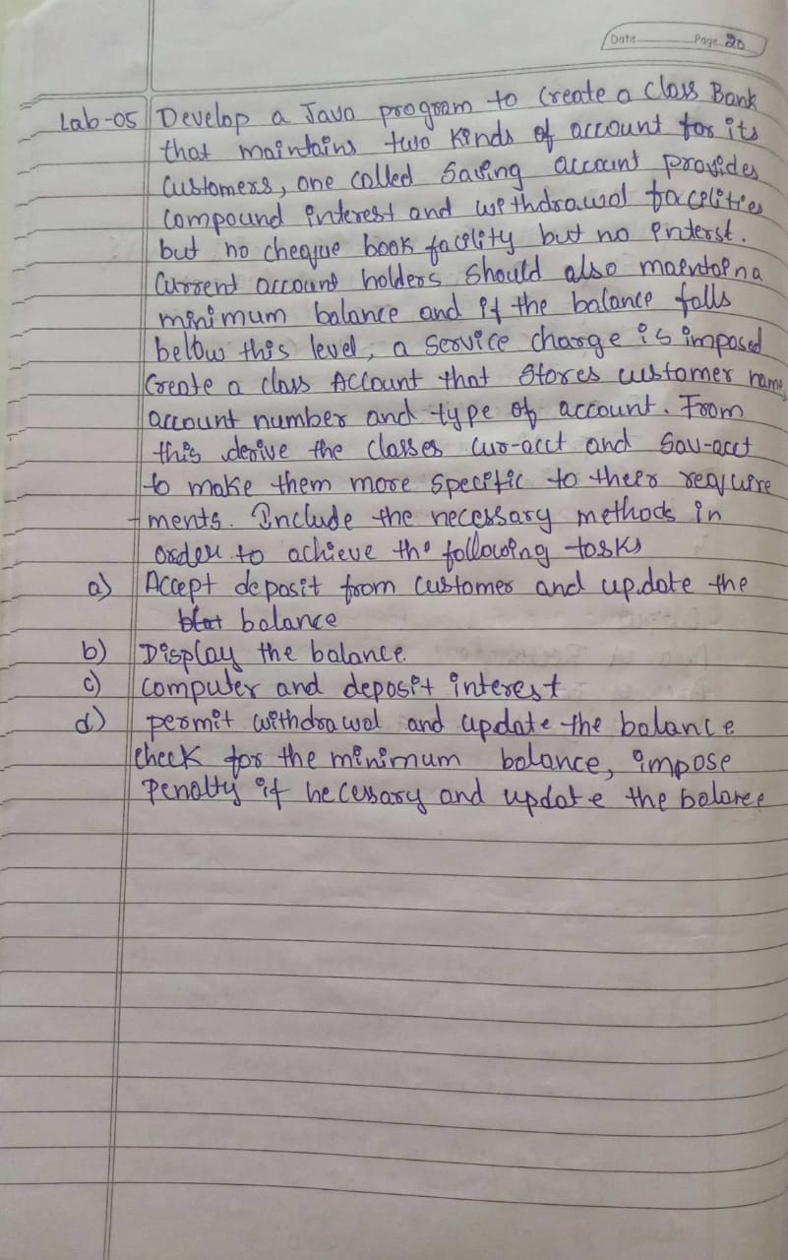 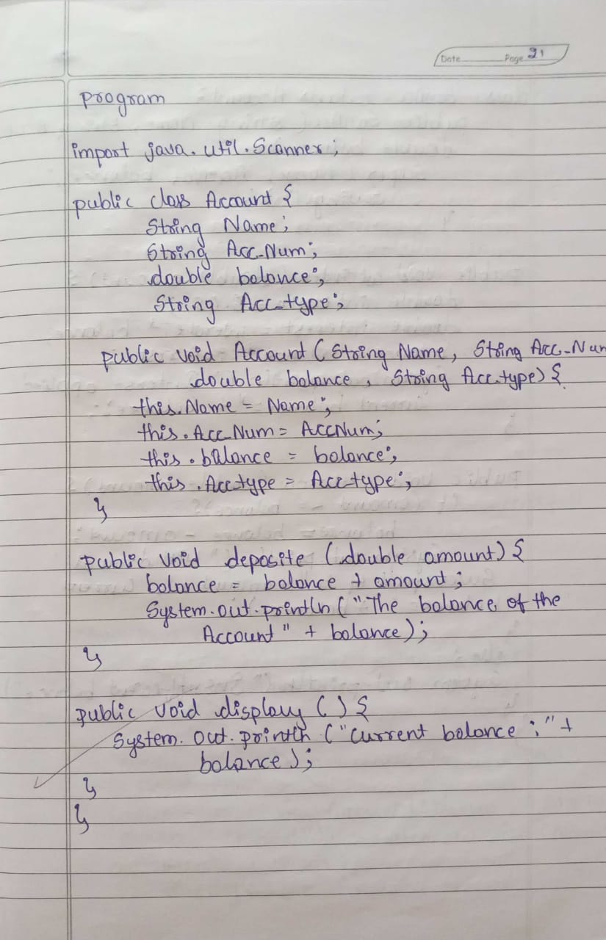

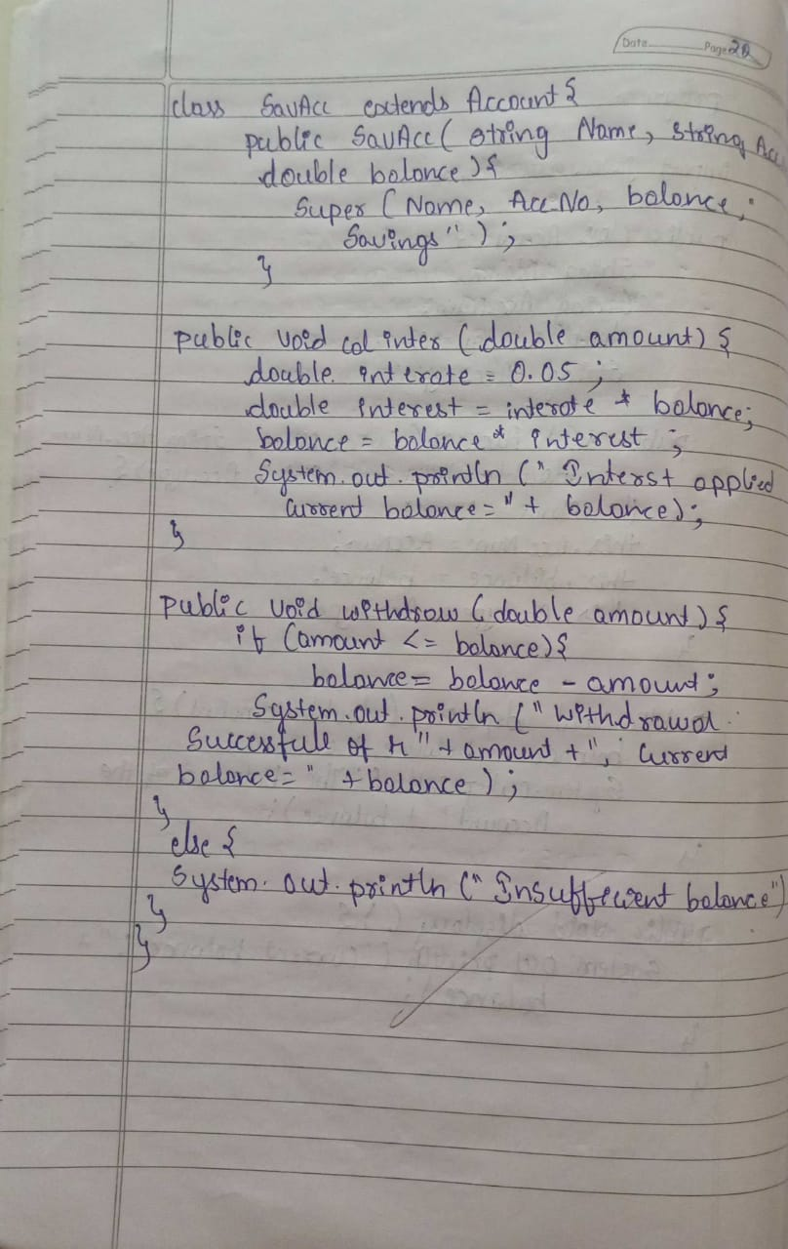 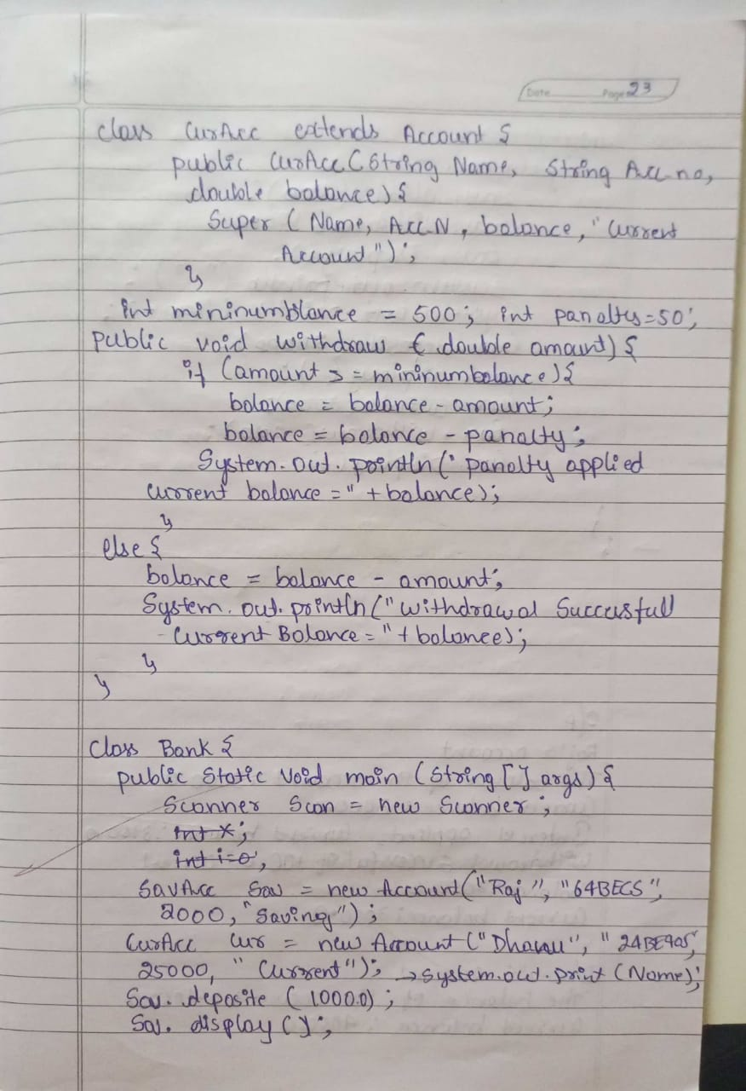

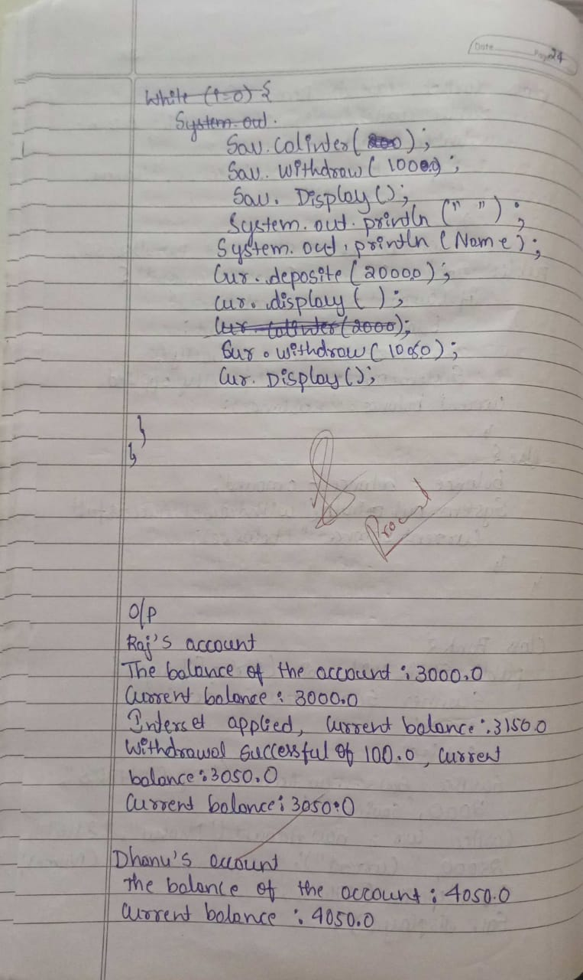 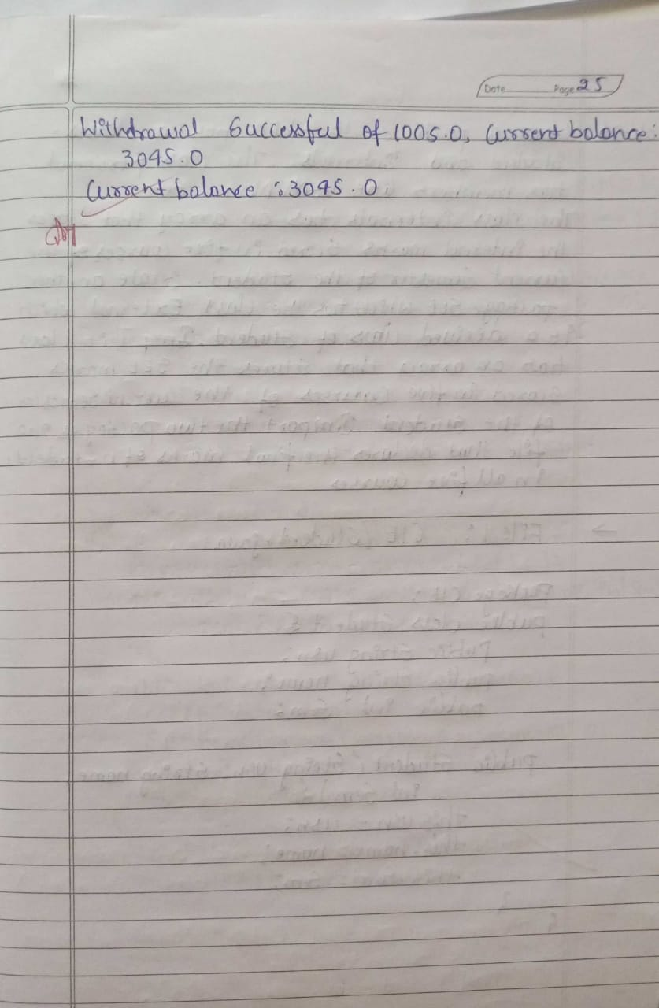

**Program-05**

import java.util.Scanner;

class Account {

String name;

String acc_num;

double balance;

String acc_type;

public Account(String name, String acc_num, double balance, String acc_type) {

this.name = name;

this.acc_num = acc_num;

this.balance = balance;

this.acc_type = acc_type;

}

public void deposit(double amount) {

balance += amount;

System.out.println("The balance of the account: " + balance);

}

public void display() {

System.out.println("Current balance: " + balance);

}

}

class SavAcc extends Account {

public SavAcc(String name, String acc_num, double balance) {

super(name, acc_num, balance, "Saving");

}

public void calInterest() {

double interestRate = 0.05;

double interest = interestRate * balance;

balance += interest;

System.out.println("Interest applied, current balance: " + balance);

}

public void withdraw(double amount) {

if (amount <= balance) {

balance -= amount;

System.out.println("Withdrawal successful of " + amount + ", current balance: " + balance);

} else {

System.out.println("Insufficient balance");

}

}

}

class CurAcc extends Account {

int minBalance = 500;

int penalty = 50;

public CurAcc(String name, String acc_num, double balance) {

super(name, acc_num, balance, "Current");

}

public void withdraw(double amount) {

if (balance - amount < minBalance) {

balance -= (amount + penalty);

System.out.println("Penalty applied, current balance: " + balance);

} else {

balance -= amount;

System.out.println("Withdrawal successful of " + amount + ", current balance: " + balance);

}

}

}

class bank1 {

public static void main(String[] args) {

Scanner scan = new Scanner(System.in);

SavAcc sav = new SavAcc("Raj", "64BE404", 2000);

CurAcc cur = new CurAcc("Dhanu", "64BE489", 2050);

System.out.println("Raj's account:");

sav.deposit(1000.0);

sav.display();

sav.calInterest();

sav.withdraw(100.0);

sav.display();

System.out.println("\nDhanu's account:");

cur.deposit(2000.0);

cur.display();

cur.withdraw(1005.0);

cur.display();

scan.close();

}

}

**Output:**

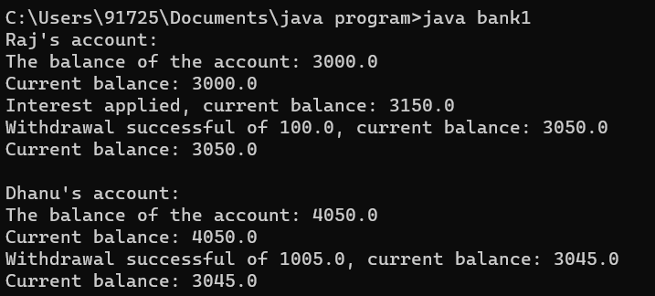

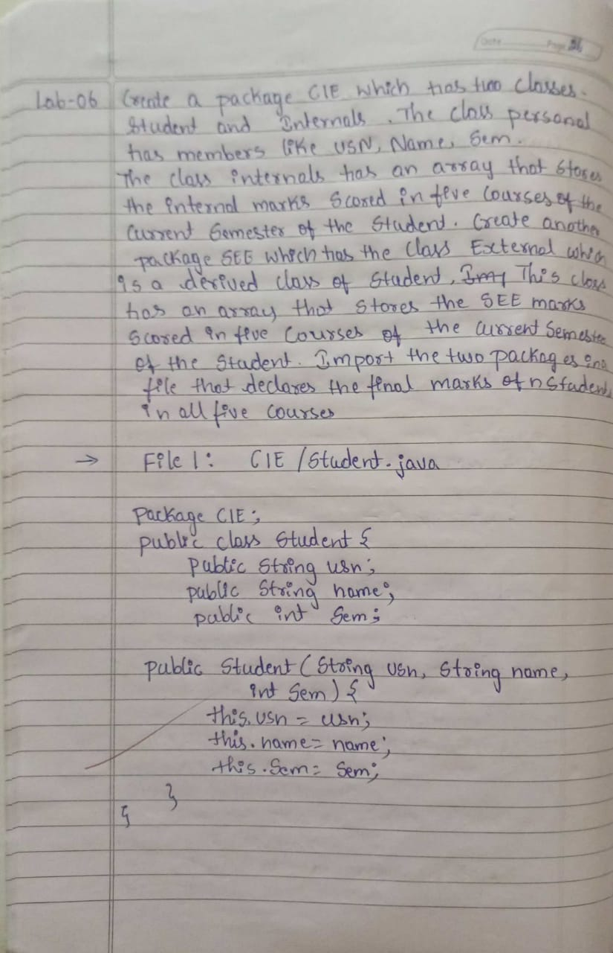 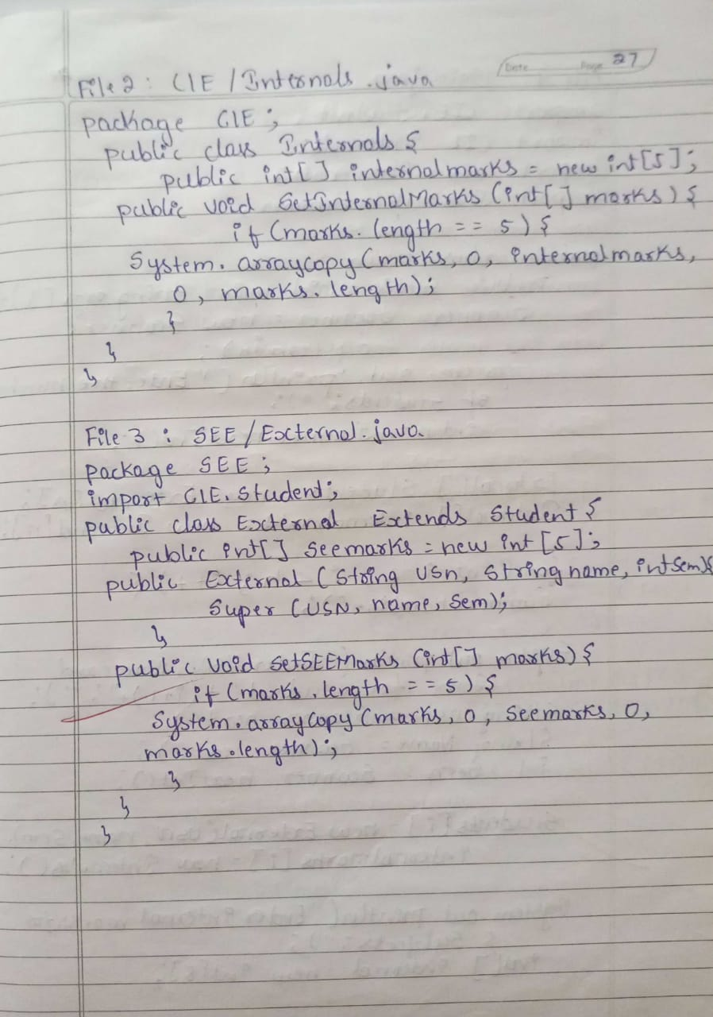

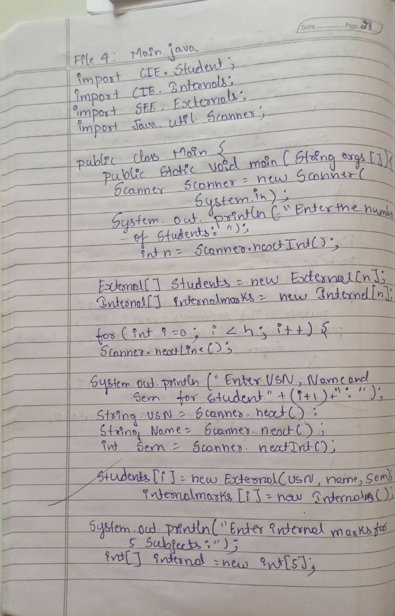 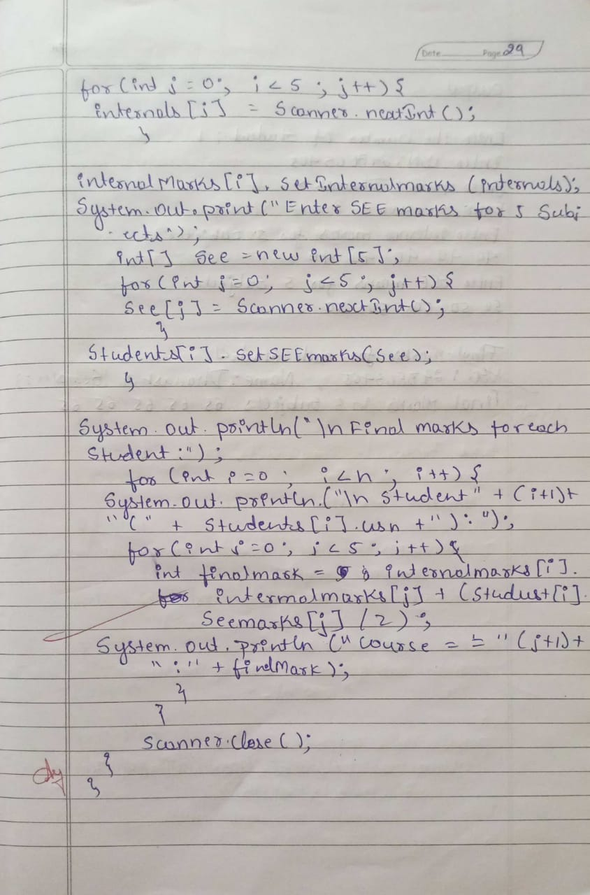

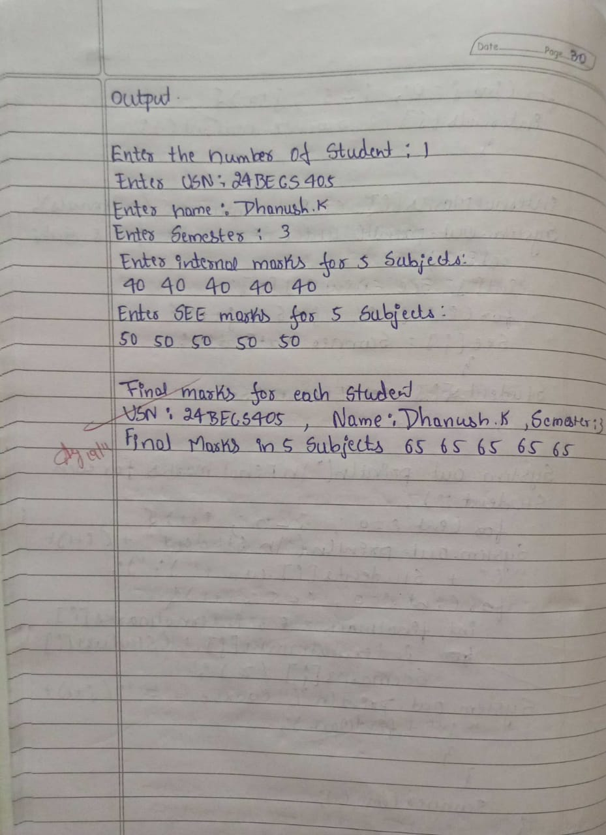

**Program-07**

package CIE;

public class Student {

public String usn;

public String name;

public int sem;

public Student(String usn, String name, int sem) {

this.usn = usn;

this.name = name;

this.sem = sem;

}

}

package CIE;

public class Internals {

private int[] internalMarks = new int[5];

public Internals(int[] marks) {

if (marks.length == 5) {

System.arraycopy(marks, 0, internalMarks, 0, 5);

} else {

throw new IllegalArgumentException("Internal marks array must have exactly 5 elements.");

}

}

public int[] getInternalMarks() {

return internalMarks;

}

}

package SEE;

import CIE.Student;

public class External extends Student {

private int[] seeMarks = new int[5];

public External(String usn, String name, int sem, int[] marks) {

super(usn, name, sem);

if (marks.length == 5) {

System.arraycopy(marks, 0, seeMarks, 0, 5);

} else {

throw new IllegalArgumentException("SEE marks array must have exactly 5 elements.");

}

}

public int[] getSeeMarks() {

return seeMarks;

}

}

import CIE.Internals;

import SEE.External;

import java.util.Scanner;

public class Main {

public static void main(String[] args) {

Scanner scanner = new Scanner(System.in);

System.out.print("Enter the number of students: ");

int n = scanner.nextInt();

scanner.nextLine();

External[] students = new External[n];

Internals[] internalsArray = new Internals[n];

for (int i = 0; i < n; i++) {

System.out.print("Enter USN: ");

String usn = scanner.nextLine();

System.out.print("Enter name: ");

String name = scanner.nextLine();

System.out.print("Enter semester: ");

int sem = scanner.nextInt();

System.out.println("Enter internal marks for 5 subjects:");

int[] internalMarks = new int[5];

for (int j = 0; j < 5; j++) {

internalMarks[j] = scanner.nextInt();

}

internalsArray[i] = new Internals(internalMarks);

System.out.println("Enter SEE marks for 5 subjects:");

int[] seeMarks = new int[5];

for (int j = 0; j < 5; j++) {

seeMarks[j] = scanner.nextInt();

}

scanner.nextLine();

students[i] = new External(usn, name, sem, seeMarks);

}

System.out.println("\nFinal marks for each student:");

for (int i = 0; i < n; i++) {

System.out.println("USN: " + students[i].usn + ", Name: " + students[i].name + ", Semester: " + students[i].sem);

int[] finalMarks = calculateFinalMarks(internalsArray[i].getInternalMarks(), students[i].getSeeMarks());

System.out.print("Final Marks in 5 subjects: ");

for (int mark : finalMarks) {

System.out.print(mark + " ");

}

System.out.println();

}

}

public static int[] calculateFinalMarks(int[] internalMarks, int[] seeMarks) {

int[] finalMarks = new int[5];

for (int i = 0; i < 5; i++) {

finalMarks[i] = internalMarks[i] + (seeMarks[i] / 2);

}

return finalMarks;

}

}

**Output:**

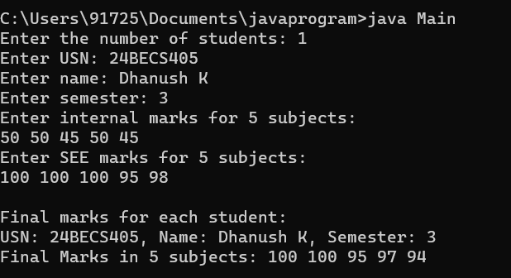

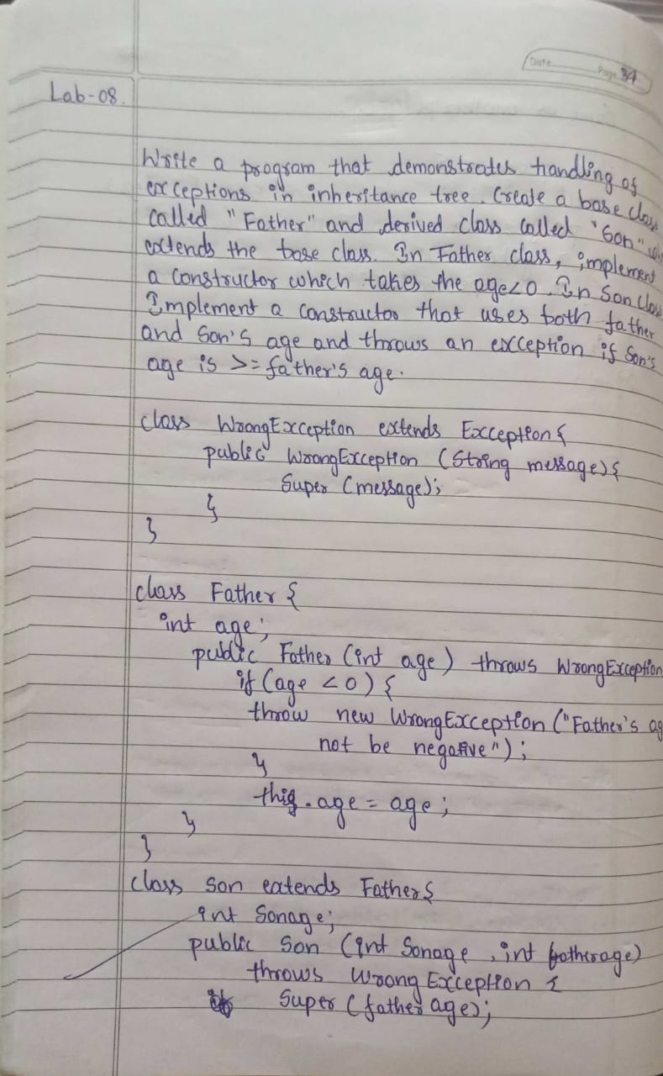 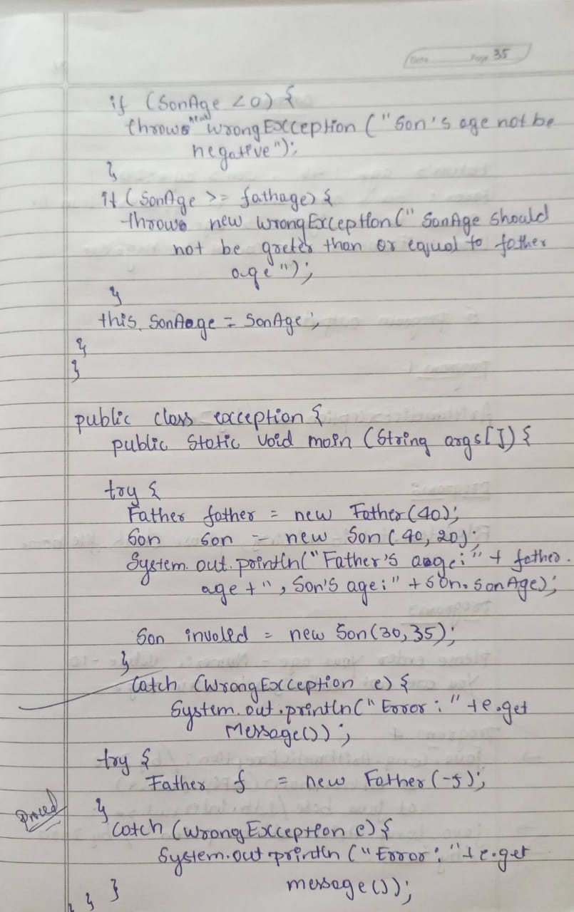

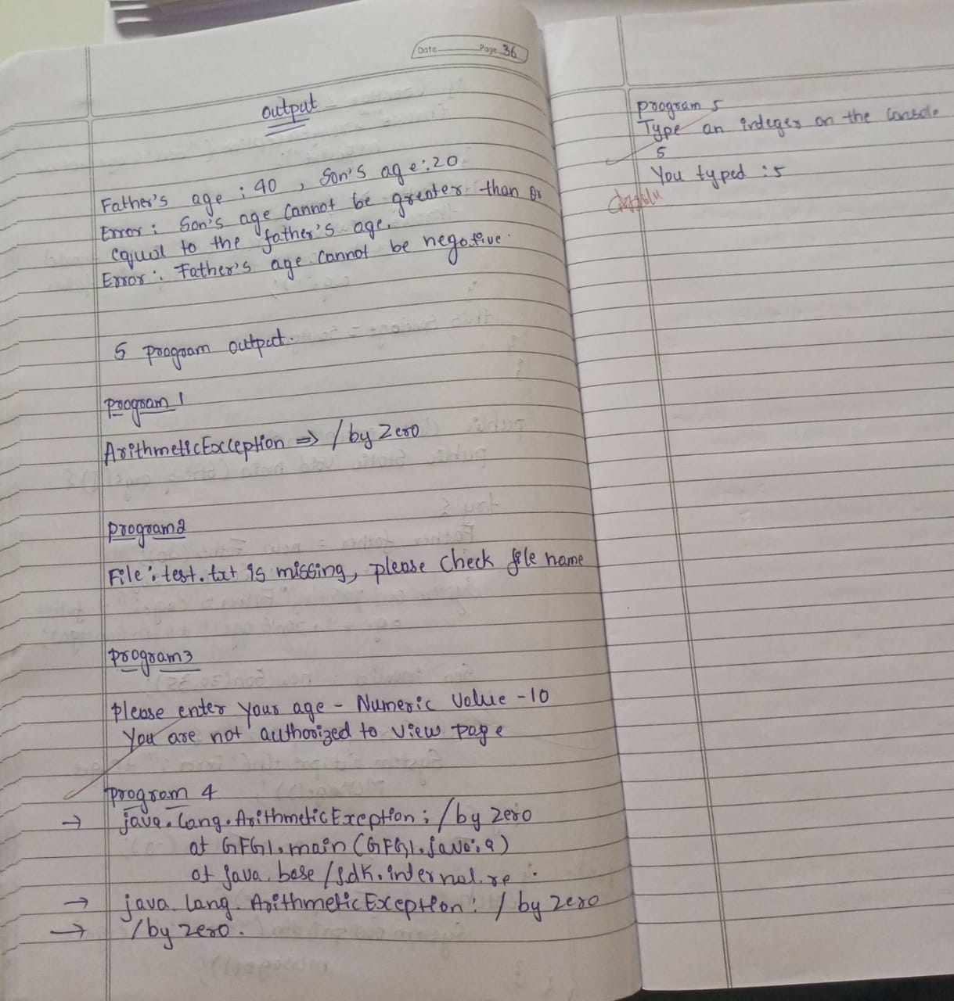

**Program-07**

class WrongException extends Exception {

public WrongException(String message) {

super(message);

}

}

class Father {

int age;

public Father(int age) throws WrongException {

if (age < 0) {

throw new WrongException("Father's age cannot be negative");

}

this.age = age;

}

}

class Son extends Father {

int sonage;

public Son(int fatherAge, int sonAge) throws WrongException {

super(fatherAge);

if (sonAge < 0) {

throw new WrongException("Son's age cannot be negative");

}

if (sonAge >= fatherAge) {

throw new WrongException("Son's age cannot be greater than or equal to the father's age");

}

this.sonage = sonAge;

}

}

public class Main {

public static void main(String args[]) {

System.out.println("Exception Handling Example:");

try {

Father father = new Father(40);

Son son = new Son(40, 20);

System.out.println("Father's age: " + father.age + ", Son's age: " + son.sonage);

Son invalidSon = new Son(30, 35);

} catch (WrongException e) {

System.out.println("Error: " + e.getMessage());

}

try {

Father invalidFather = new Father(-5);

} catch (WrongException e) {

System.out.println("Error: " + e.getMessage());

}

}

}

**Output:**

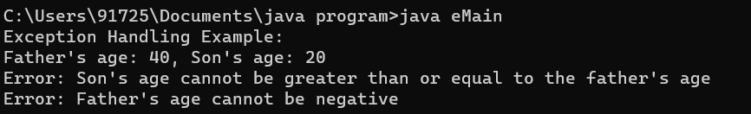

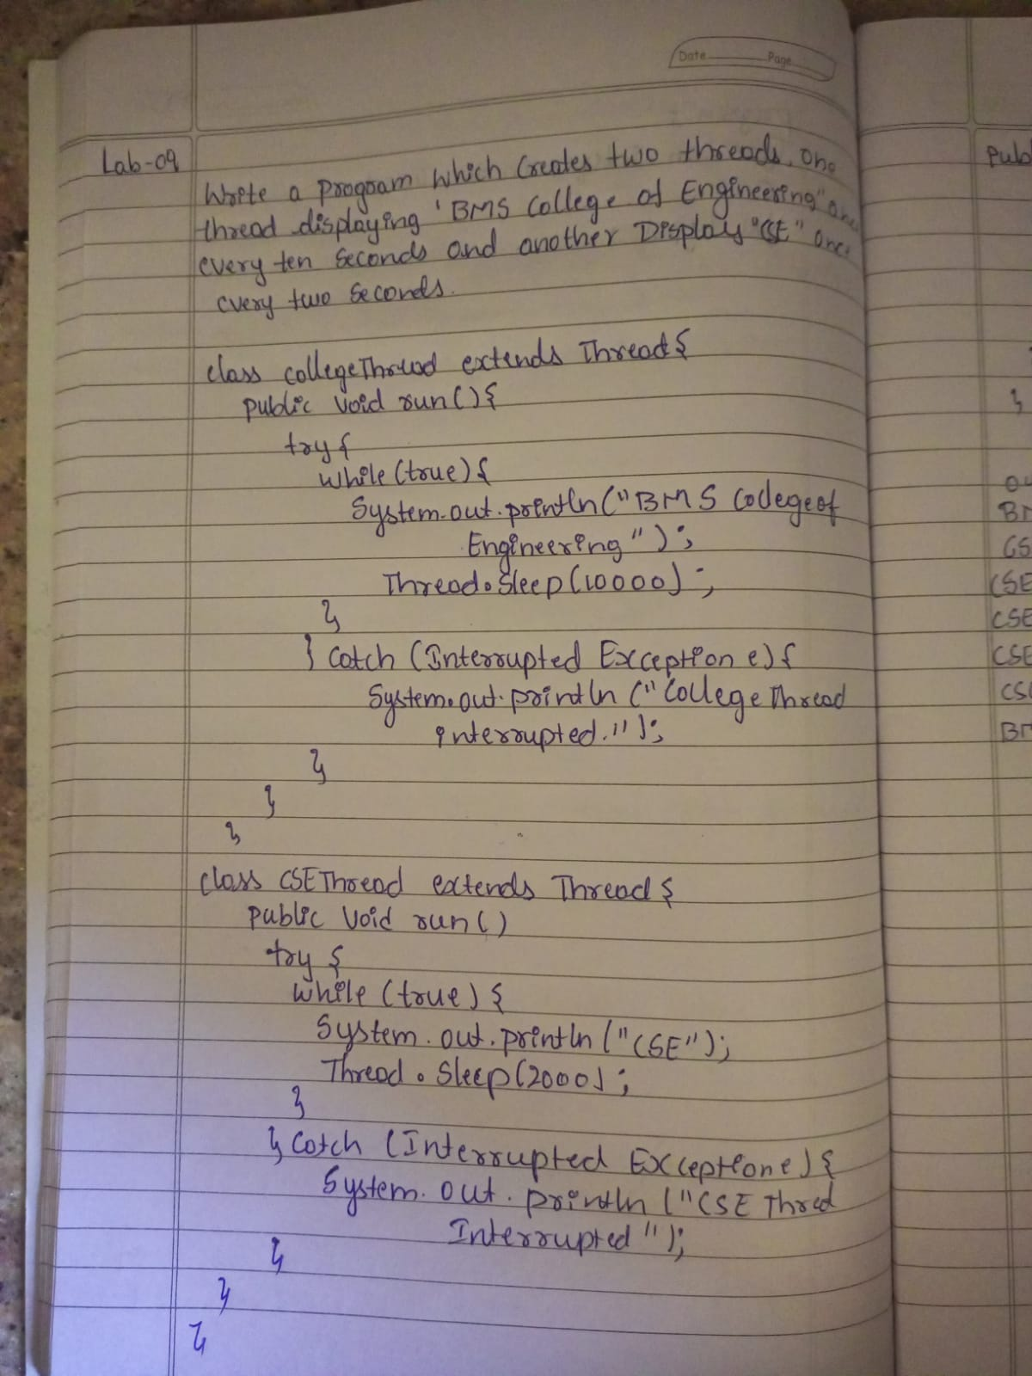

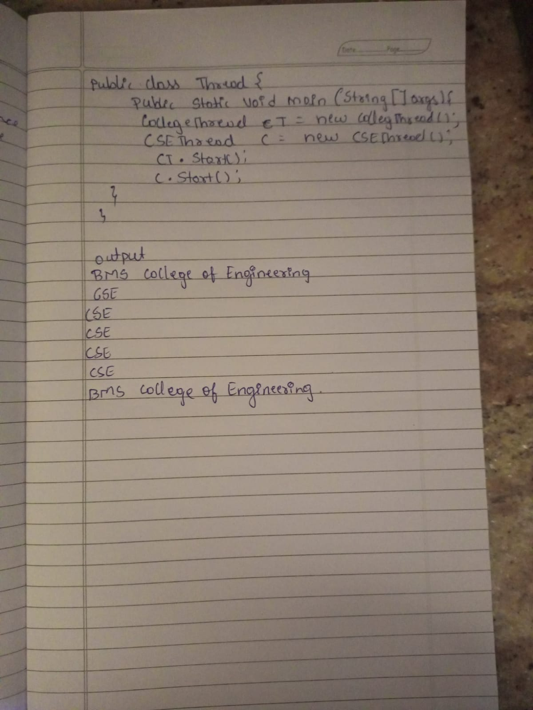

**Program-08**

class CollegeThread extends Thread {

public void run() {

try {

while (true) {

System.out.println("BMS College of Engineering");

Thread.sleep(10000);

}

} catch (InterruptedException e) {

System.out.println("CollegeThread interrupted.");

}

}

}

class CSEThread extends Thread {

public void run() {

try {

while (true) {

System.out.println("CSE");

Thread.sleep(2000);

}

} catch (InterruptedException e) {

System.out.println("CSEThread interrupted.");

}

}

}

public class ThreadDisplayProgram {

public static void main(String[] args) {

CollegeThread collegeThread = new CollegeThread();

CSEThread cseThread = new CSEThread();

collegeThread.start();

cseThread.start();

}

}

**Output:**

