**VISVESVARAYA TECHNOLOGICAL UNIVERSITY**

**“JnanaSangama”, Belgaum -590014, Karnataka.**



**LAB REPORT**

**on**

**Operating Systems**

**(22CS4PCOPS)**

***Submitted by:***

**Dhanush K (1BM24CS404)**

***in partial fulfillment for the award of the degree of***

**BACHELOR OF ENGINEERING**

***in***

**COMPUTER SCIENCE AND ENGINEERING**



**B.M.S. COLLEGE OF ENGINEERING**

**(Autonomous Institution under VTU)**

**BENGALURU-560019**

**June 2023 - August 2023**

**B. M. S. College of Engineering,**

**Bull Temple Road, Bangalore 560019**

(Affiliated To Visvesvaraya Technological University, Belgaum)

**Department of Computer Science and Engineering**



**CERTIFICATE**

This is to certify that the Lab work entitled “**Operating Systems**” carried out by **Dhanush K (1BM24CS404),** who is bonafide student of **B. M. S. College of Engineering.** It is in partial fulfillment for the award of **Bachelor of Engineering in Computer Science and Engineering** of the Visvesvaraya Technological University, Belgaum during the year 2022-23. The Lab report has been approved as it satisfies the academic requirements in respect of **Operating Systems - (22CS4PCOPS)** work prescribed for the said degree.

**Basavaraj Jakkalli**              **Megha J**

Associate Professor Assistant Professor

Department of CSE Department of CSE

BMSCE, Bengaluru BMSCE, Bengaluru

**Table Of Contents**

|  |  |  |
| --- | --- | --- |
| **Lab Program No.** | **Program Details** | **Page No.** |
| 1 | FCFS AND SJF | 3-8 |
| 2 | PRIORITY AND ROUND ROBIN | 9-13 |
| 3 | RATE-MONOTONIC AND EARLIEST DEADLINE FIRST | 14-20 |
| 4 | PRODUCER-CONSUMER PROBLEM | 20-22 |
| 5 | DINERS-PHILOSOPHERS PROBLEM | 23-25 |
| 6 | BANKERS ALGORITHM(DEADLOCK AVOIDANCE) | 26-29 |
| 7 | DEADLOCK DETECTION | 29-32 |
| 8 | CONTIGIOUS MEMORY ALLOCATION(FIRST, BEST, WORST FIT) | 32-36 |
| 9 | PAGE REPLACEMENT(FIFO, LRU, OPTIMAL) | 37-42 |

**Course Outcomes**

**CO1:** Apply the different concepts and functionalities of OS

**CO2:** Analyse various Operating system strategies and techniques.

**CO3:** Demonstrate the different functionalities of Operating System.

**CO4:** Conduct practical experiments to implement the functionalities of Operating system.

1. **Experiments**
   1. **Experiment – 1**
      1. **Question:**

**Write a C program to simulate the following non-pre-emptive CPU scheduling algorithm to find turnaround time and waiting time.**

1. **FCFS**
2. **SJF**
   * 1. **Code:**

#include <stdio.h>

#define MAX 20

int n, i, j;

int Burst_time[MAX], Arrival_time[MAX], Waiting_time[MAX], Turn_around_time[MAX], Completion_time[MAX], process[MAX];

float avg_Turn_around_time = 0, avg_Waiting_time = 0;

void sortByArrival() {

for (i = 0; i < n - 1; i++) {

for (j = i + 1; j < n; j++) {

if (Arrival_time[i] > Arrival_time[j]) {

int temp = Arrival_time[i];

Arrival_time[i] = Arrival_time[j];

Arrival_time[j] = temp;

temp = Burst_time[i];

Burst_time[i] = Burst_time[j];

temp = process[i];

process[i] = process[j];

process[j] = temp;

}

}

}

}

void FCFS() {

sortByArrival();

Completion_time[0] = Arrival_time[0] + Burst_time[0];

Turn_around_time[0] = Completion_time[0] - Arrival_time[0];

Waiting_time[0] = Turn_around_time[0] - Burst_time[0];

for (i = 1; i < n; i++) {

if (Arrival_time[i] > Completion_time[i - 1]) {

Completion_time[i] = Arrival_time[i] + Burst_time[i];

} else {

Completion_time[i] = Completion_time[i - 1] + Burst_time[i];

}

Turn_around_time[i] = Completion_time[i] - Arrival_time[i];

Waiting_time[i] = Turn_around_time[i] - Burst_time[i];

}

printf("\nProcess\tArrival Time\tBurst Time\tWaiting Time\tTurnaround Time");

for (i = 0; i < n; i++) {

avg_Waiting_time += Waiting_time[i];

avg_Turn_around_time += Turn_around_time[i];

printf("\nP[%d]\t\t%d\t\t%d\t\t%d\t\t%d", process[i], Arrival_time[i], Burst_time[i], Waiting_time[i], Turn_around_time[i]);

}

avg_Waiting_time /= n;

avg_Turn_around_time /= n;

printf("\n\nAverage Waiting Time: %.2f", avg_Waiting_time);

printf("\nAverage Turnaround Time: %.2f\n", avg_Turn_around_time);

}

int main() {

printf("Enter the total number of processes: ");

scanf("%d", &n);

for (i = 0; i < n; i++) {

printf("\nEnter Arrival Time for P[%d]: ", i + 1);

scanf("%d", &Arrival_time[i]);

printf("Enter Burst Time for P[%d]: ", i + 1);

scanf("%d", &Burst_time[i]);

process[i] = i + 1;

}

FCFS();

return 0;

}

* + 1. **Output:**

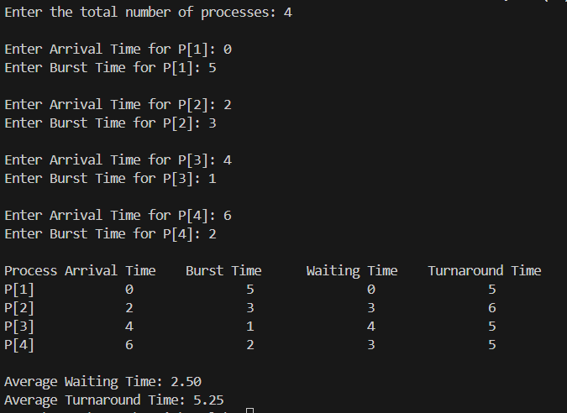

* + 1. **Code:**

#include<stdio.h>

int n, i, j, pos, temp, Burst_time[20], Arrival_time[20], Waiting_time[20], Turn_around_time[20], Completion_time[20], process[20], total = 0;

float avg_Turn_around_time = 0, avg_Waiting_time = 0;

void sortByArrivalAndBurst() {

for (i = 0; i < n - 1; i++) {

for (j = i + 1; j < n; j++) {

if (Arrival_time[i] > Arrival_time[j] || (Arrival_time[i] == Arrival_time[j] && Burst_time[i] > Burst_time[j])) {

int temp_arrival = Arrival_time[i];

Arrival_time[i] = Arrival_time[j];

Arrival_time[j] = temp_arrival;

int temp_burst = Burst_time[i];

Burst_time[i] = Burst_time[j];

Burst_time[j] = temp_burst;

int temp_process = process[i];

process[i] = process[j];

process[j] = temp_process;

}

}

}

}

int SJF() {

sortByArrivalAndBurst();

Completion_time[0] = Arrival_time[0] + Burst_time[0];

Turn_around_time[0] = Completion_time[0] - Arrival_time[0];

Waiting_time[0] = Turn_around_time[0] - Burst_time[0];

for (i = 1; i < n; i++) {

if (Arrival_time[i] >= Completion_time[i - 1]) {

Completion_time[i] = Arrival_time[i] + Burst_time[i];

} else {

Completion_time[i] = Completion_time[i - 1] + Burst_time[i

}

Turn_around_time[i] = Completion_time[i] - Arrival_time[i];

Waiting_time[i] = Turn_around_time[i] - Burst_time[i];

}

avg_Waiting_time = 0;

total = 0;

printf("\nProcess\tArrival Time\tBurst Time\tWaiting Time\tTurnaround Time");

for (i = 0; i < n; i++) {

total += Turn_around_time[i];

avg_Waiting_time += Waiting_time[i];

printf("\nP[%d]\t%d\t\t%d\t\t%d\t\t%d", process[i], Arrival_time[i], Burst_time[i], Waiting_time[i], Turn_around_time[i]);

}

avg_Waiting_time /= n;

avg_Turn_around_time = (float)total / n;

printf("\n\nAverage Waiting Time=%.2f", avg_Waiting_time);

printf("\nAverage Turnaround Time=%.2f\n", avg_Turn_around_time);

return 0;

}

int main() {

printf("Enter the total number of processes: ");

scanf("%d", &n);

for (i = 0; i < n; i++) {

printf("Enter Arrival Time for P[%d]: ", i + 1);

scanf("%d", &Arrival_time[i]);

printf("Enter Burst Time for P[%d]: ", i + 1);

scanf("%d", &Burst_time[i]);

process[i] = i + 1;

}

SJF();

return 0;

}

* + 1. **Output:**

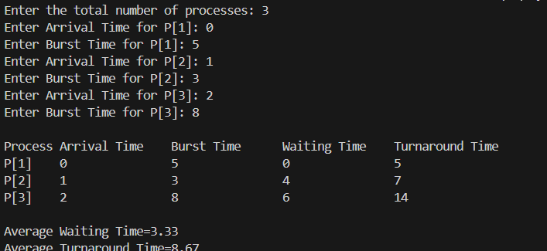

* 1. **Experiment – 2**
     1. **Question:**

**Write a C program to simulate the following non-pre-emptive CPU scheduling algorithm to find turnaround time and waiting time.**

1. **Round Robin (Experiment with different quantum sizes for RR algorithm)**
2. **Priority**
   * 1. **Code:**

#include <stdio.h>

struct Process {

int id, at, bt, rt, wt, tat, completed;

};

int main() {

int n, i, time = 0, tq, remain;

struct Process p[10];

float awt = 0, atat = 0;

printf("Enter the number of processes: ");

scanf("%d", &n);

remain = n;

for (i = 0; i < n; i++) {

p[i].id = i + 1;

printf("Enter Arrival Time and Burst Time for Process %d: ", p[i].id);

scanf("%d %d", &p[i].at, &p[i].bt);

p[i].rt = p[i].bt;

p[i].completed = 0;

}

printf("Enter Time Quantum: ");

scanf("%d", &tq);

int done = 0;

while (remain > 0) {

done = 1;

for (i = 0; i < n; i++) {

if (p[i].rt > 0 && p[i].at <= time) {

done = 0;

if (p[i].rt > tq) {

time += tq;

p[i].rt -= tq;

} else {

time += p[i].rt;

p[i].wt = time - p[i].bt - p[i].at;

p[i].tat = time - p[i].at;

p[i].rt = 0;

p[i].completed = 1;

remain--;

}

}

}

if (done) time++;

}

printf("\nPROCESS\tAT\tBT\tWT\tTAT\n");

for (i = 0; i < n; i++) {

awt += p[i].wt;

atat += p[i].tat;

printf("P%d\t%d\t%d\t%d\t%d\n", p[i].id, p[i].at, p[i].bt, p[i].wt, p[i].tat);

}

printf("\nAverage Waiting Time: %.2f", awt / n);

printf("\nAverage Turnaround Time: %.2f\n", atat / n);

return 0;

}

* + 1. **Output:**

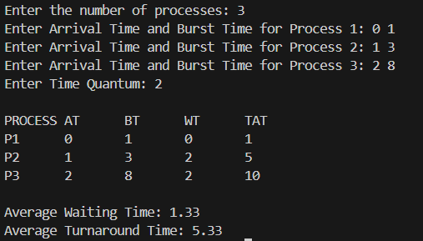

* + 1. **Code:**

#include <stdio.h>

struct Process {

int id;

int burst_time;

int arrival_time;

int priority;

int completion_time;

int turnaround_time;

int waiting_time;

int is_completed;

};

int main() {

int n, time = 0, completed = 0;

float total_TAT = 0, total_WT = 0;

printf("Enter the number of processes: ");

scanf("%d", &n);

struct Process p[n];

for (int i = 0; i < n; i++) {

p[i].id = i + 1;

printf("Enter Arrival Time, Burst Time & Priority for Process %d: ", p[i].id);

scanf("%d %d %d", &p[i].arrival_time, &p[i].burst_time, &p[i].priority);

p[i].is_completed = 0;

}

while (completed < n) {

int idx = -1, highest_priority = 9999;

for (int i = 0; i < n; i++) {

if (p[i].arrival_time <= time && !p[i].is_completed) {

if (p[i].priority < highest_priority) {

highest_priority = p[i].priority;

idx = i;

} else if (p[i].priority == highest_priority) {

if (p[i].arrival_time < p[idx].arrival_time) {

idx = i;

}

}

}

}

if (idx != -1) {

time += p[idx].burst_time;

p[idx].completion_time = time;

p[idx].turnaround_time = p[idx].completion_time - p[idx].arrival_time;

p[idx].waiting_time = p[idx].turnaround_time - p[idx].burst_time;

total_TAT += p[idx].turnaround_time;

total_WT += p[idx].waiting_time;

p[idx].is_completed = 1;

completed++;

} else {

time++;

}

}

printf("\nProcess\tAT\tBT\tPriority\tCT\tTAT\tWT\n");

for (int i = 0; i < n; i++) {

printf("P%d\t%d\t%d\t%d\t\t%d\t%d\t%d\n", p[i].id, p[i].arrival_time, p[i].burst_time,

p[i].priority, p[i].completion_time, p[i].turnaround_time, p[i].waiting_time);

}

printf("\nAverage Turnaround Time = %.2f", total_TAT / n);

printf("\nAverage Waiting Time = %.2f\n", total_WT / n);

return 0;

}

* + 1. **Output:**

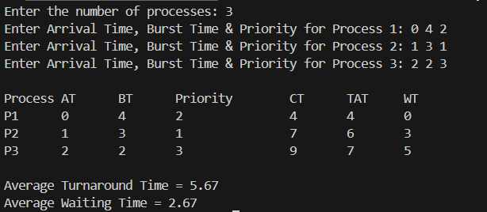

* 1. **Experiment – 3**
     1. **Question:**

**Write a C program to simulate Real-Time CPU Scheduling algorithms:**

1. **Rate- Monotonic**
2. **Earliest-deadline First**
   * 1. **Code:**

#include <stdio.h>

#include <math.h>

#include <stdbool.h>

#define MAX_PROCESS 10

int num_of_process;

int execution_time[MAX_PROCESS], period[MAX_PROCESS], remain_time[MAX_PROCESS];

void get_process_info() {

scanf("%d", &num_of_process);

for (int i = 0; i < num_of_process; i++) {

scanf("%d", &execution_time[i]);

scanf("%d", &period[i]);

remain_time[i] = execution_time[i];

}

}

int max(int a, int b, int c) {

return (a > b ? (a > c ? a : c) : (b > c ? b : c));

}

int get_observation_time() {

return max(period[0], period[1], period[2]);

}

void print_schedule(int process_list[], int cycles) {

for (int i = 0; i < cycles; i++) {

printf("| %02d ", i);

}

for (int i = 0; i < num_of_process; i++) {

for (int j = 0; j < cycles; j++) {

if (process_list[j] == i + 1)

printf("|####");

else

printf("| ");

}

}

}

void rate_monotonic(int time) {

int process_list[100] = {0};

float utilization = 0;

for (int i = 0; i < num_of_process; i++) {

utilization += (1.0 * execution_time[i]) / period[i];

}

int n = num_of_process;

float m = n * (pow(2, 1.0 / n) - 1);

if (utilization > m) {

return;

}

for (int i = 0; i < time; i++) {

int min = 1000, next_process = -1;

for (int j = 0; j < num_of_process; j++) {

if (remain_time[j] > 0 && period[j] < min) {

min = period[j];

next_process = j;

}

}

if (next_process != -1) {

process_list[i] = next_process + 1;

remain_time[next_process]--;

if ((i + 1) % period[next_process] == 0) {

remain_time[next_process] = execution_time[next_process];

}

}

}

print_schedule(process_list, time);

}

int main() {

get_process_info();

int observation_time = get_observation_time();

rate_monotonic(observation_time);

return 0;

}

* + 1. **Output:**

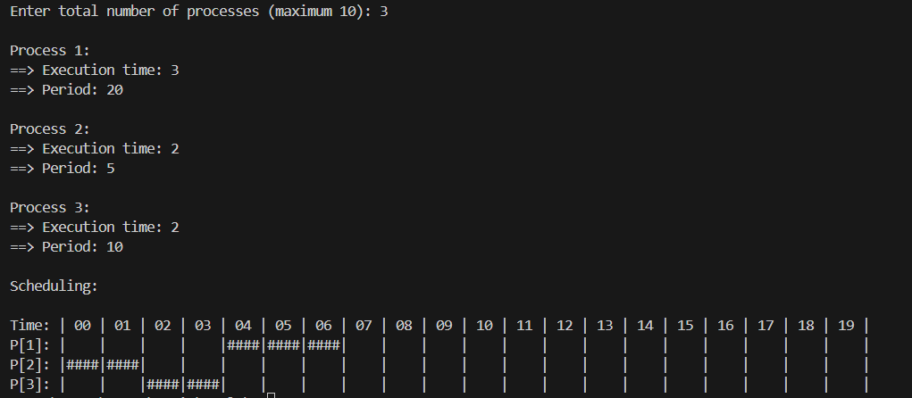

* + 1. **Code:**

#include <stdio.h>

#include <stdbool.h>

#include <stdlib.h>

#define MAX_PROCESS 10

int num_of_process;

int execution_time[MAX_PROCESS], deadline[MAX_PROCESS], remain_time[MAX_PROCESS], remain_deadline[MAX_PROCESS];

void get_process_info_EDF() {

printf("Enter total number of processes (maximum %d): ", MAX_PROCESS);

scanf("%d", &num_of_process);

if (num_of_process < 1) {

printf("Invalid number of processes!\n");

exit(0);

}

for (int i = 0; i < num_of_process; i++) {

printf("\nProcess %d:\n", i + 1);

printf("==> Execution time: ");

scanf("%d", &execution_time[i]);

printf("==> Deadline: ");

scanf("%d", &deadline[i]);

remain_time[i] = execution_time[i];

remain_deadline[i] = deadline[i];

}

}

int max_EDF(int a, int b, int c) {

return (a > b ? (a > c ? a : c) : (b > c ? b : c));

}

int get_observation_time_EDF() {

int observation_time = 0;

for (int i = 0; i < num_of_process; i++) {

observation_time = max_EDF(observation_time, deadline[i], 0);

}

return observation_time;

}

void print_schedule_EDF(int process_list[], int cycles) {

printf("\nScheduling:\n\n");

printf("Time: ");

for (int i = 0; i < cycles; i++) {

printf("| %02d ", i);

}

printf("|\n");

for (int i = 0; i < num_of_process; i++) {

printf("P[%d]: ", i + 1);

for (int j = 0; j < cycles; j++) {

if (process_list[j] == i + 1)

printf("|####");

else

printf("| ");

}

printf("|\n");

}

}

void calculate_cpu_utilization() {

float utilization = 0;

for (int i = 0; i < num_of_process; i++) {

utilization += (float)execution_time[i] / deadline[i];

}

printf("\nCPU Utilization: %.2f%%\n", utilization * 100);

}

void earliest_deadline_first(int time) {

int process_list[100] = {0};

int current_process = -1, min_deadline;

for (int t = 0; t < time; t++) {

min_deadline = 1000;

for (int i = 0; i < num_of_process; i++) {

if (remain_time[i] > 0 && deadline[i] < min_deadline) {

min_deadline = deadline[i];

current_process = i;

}

}

if (current_process != -1) {

process_list[t] = current_process + 1;

remain_time[current_process]--;

if (remain_time[current_process] == 0) {

deadline[current_process] += remain_deadline[current_process]; // Reset deadline for periodic tasks

remain_time[current_process] = execution_time[current_process];

}

}

}

print_schedule_EDF(process_list, time);

}

int main() {

get_process_info_EDF();

int observation_time = get_observation_time_EDF();

calculate_cpu_utilization(); // Calculate and print CPU utilization before scheduling

earliest_deadline_first(observation_time);

return 0;

}

* + 1. **Output:**

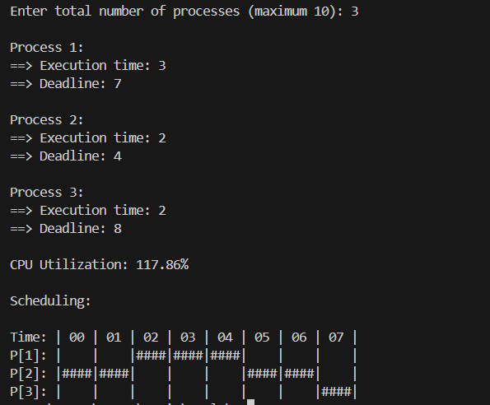

* 1. **Experiment – 4**
     1. **Question:**

**Write a C program to simulate producer-consumer problem using semaphores.**

* + 1. **Code:**

#include <stdio.h>

#include <stdlib.h>

int mutex = 1;

int full = 0;

int empty = 3;

int x = 0;

void producer();

void consumer();

int wait(int s);

int signal(int s);

int main() {

int n;

printf("\n1. Producer\n2. Consumer\n3. Exit");

while (1) {

printf("\nEnter your choice: ");

scanf("%d", &n);

switch (n) {

case 1:

if ((mutex == 1) && (empty != 0))

producer();

else

printf("Buffer is full!!\n");

break;

case 2:

if ((mutex == 1) && (full != 0))

consumer();

else

printf("Buffer is empty!!\n");

break;

case 3:

exit(0);

default:

printf("Invalid choice! Please choose 1, 2, or 3.\n");

}

}

return 0;

}

int wait(int s) {

return (--s);

}

int signal(int s) {

return (++s);

}

void producer() {

mutex = wait(mutex);

full = signal(full);

empty = wait(empty);

x++;

printf("\nProducer produces the item %d\n", x);

mutex = signal(mutex);

}

void consumer() {

mutex = wait(mutex);

full = wait(full);

empty = signal(empty);

printf("\nConsumer consumes item %d\n", x);

x--;

mutex = signal(mutex);

}

* + 1. **Output:**

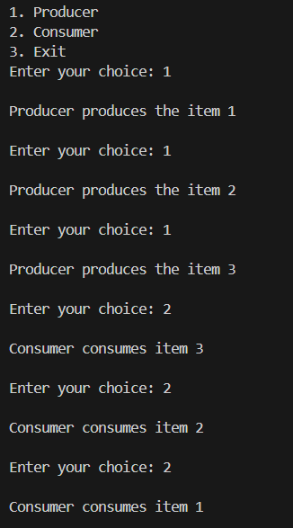

* 1. **Experiment – 5**
     1. **Question:**

**Write a C program to simulate the concept of Dining-Philosophers problem.**

* + 1. **Code:**

#include <stdio.h>

#include <windows.h>

#define N 5

#define THINKING 2

#define HUNGRY 1

#define EATING 0

#define LEFT (i + 4) % N

#define RIGHT (i + 1) % N

int state[N];

int phil[N] = {0, 1, 2, 3, 4};

HANDLE mutex;

HANDLE S[N];

void test(int i) {

if (state[i] == HUNGRY && state[LEFT] != EATING && state[RIGHT] != EATING) {

state[i] = EATING;

Sleep(2000);

printf("Philosopher %d takes forks %d and %d\n", i + 1, LEFT + 1, i + 1);

printf("Philosopher %d is Eating\n", i + 1);

ReleaseSemaphore(S[i], 1, NULL);

}

}

void take_fork(int i) {

WaitForSingleObject(mutex, INFINITE);

state[i] = HUNGRY;

printf("Philosopher %d is Hungry\n", i + 1);

test(i);

ReleaseMutex(mutex);

WaitForSingleObject(S[i], INFINITE);

Sleep(1000);

}

void put_fork(int i) {

WaitForSingleObject(mutex, INFINITE);

state[i] = THINKING;

printf("Philosopher %d putting fork %d and %d down\n", i + 1, LEFT + 1, i + 1);

printf("Philosopher %d is thinking\n", i + 1);

test(LEFT);

test(RIGHT);

ReleaseMutex(mutex);

}

DWORD WINAPI philosopher(void* num) {

while (1) {

int* i = num;

Sleep(1000);

take_fork(*i);

Sleep(0);

put_fork(*i);

}

}

int main() {

int i;

HANDLE thread_id[N];

mutex = CreateMutex(NULL, FALSE, NULL);

for (i = 0; i < N; i++) {

S[i] = CreateSemaphore(NULL, 0, 1, NULL);

}

for (i = 0; i < N; i++) {

thread_id[i] = CreateThread(NULL, 0, philosopher, &phil[i], 0, NULL);

printf("Philosopher %d is thinking\n", i + 1);

}

WaitForMultipleObjects(N, thread_id, TRUE, INFINITE);

for (i = 0; i < N; i++) {

CloseHandle(thread_id[i]);

}

CloseHandle(mutex);

for (i = 0; i < N; i++) {

CloseHandle(S[i]);

}

return 0;

}

* + 1. **Output:**

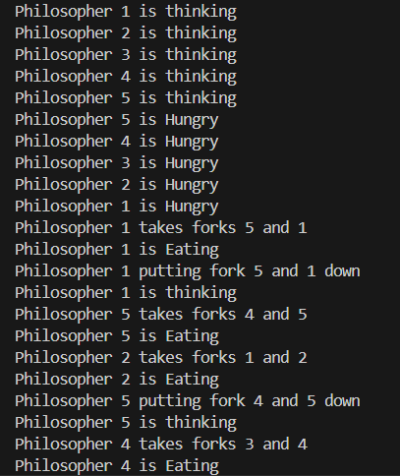

* 1. **Experiment – 6**
     1. **Question:**

**Write a C program to simulate Bankers algorithm for the purpose of deadlock Avoidance**

* + 1. **Code:**

#include <stdio.h>

int main() {

int n, m, i, j, k;

printf("Enter the number of processes: ");

scanf("%d", &n);

printf("Enter the number of resources: ");

scanf("%d", &m);

int allocation[n][m];

int max[n][m];

int available[m];

int need[n][m];

int f[n], ans[n], ind = 0;

printf("Enter the Allocation Matrix:\n");

for (i = 0; i < n; i++) {

for (j = 0; j < m; j++) {

scanf("%d", &allocation[i][j]);

}

}

printf("Enter the MAX Matrix:\n");

for (i = 0; i < n; i++) {

for (j = 0; j < m; j++) {

scanf("%d", &max[i][j]);

}

}

printf("Enter the Available Resources:\n");

for (i = 0; i < m; i++) {

scanf("%d", &available[i]);

}

for (k = 0; k < n; k++) {

f[k] = 0;

}

for (i = 0; i < n; i++) {

for (j = 0; j < m; j++) {

need[i][j] = max[i][j] - allocation[i][j];

}

}

printf("\nNeed Matrix:\n");

for (i = 0; i < n; i++) {

printf("P%d: ", i);

for (j = 0; j < m; j++) {

printf("%d ", need[i][j]);

}

printf("\n");

}

int y = 0;

for (k = 0; k < n; k++) {

for (i = 0; i < n; i++) {

if (f[i] == 0) {

int flag = 0;

for (j = 0; j < m; j++) {

if (need[i][j] > available[j]) {

flag = 1;

break;

}

}

if (flag == 0) {

ans[ind++] = i;

for (y = 0; y < m; y++) {

available[y] += allocation[i][y];

}

f[i] = 1;

}

}

}

}

int flag = 1;

for (i = 0; i < n; i++) {

if (f[i] == 0) {

flag = 0;

printf("\nThe following system is not safe\n");

break;

}

}

if (flag == 1) {

printf("\nFollowing is the SAFE Sequence:\n");

for (i = 0; i < n - 1; i++) {

printf(" P%d ->", ans[i]);

}

printf(" P%d\n", ans[n - 1]);

}

return 0;

}

* + 1. **Output:**

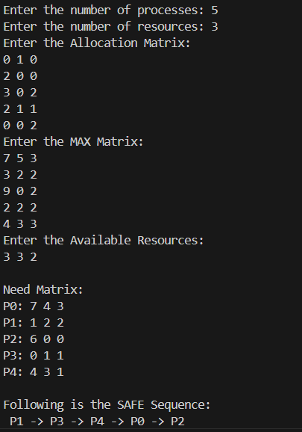

* 1. **Experiment – 7**
     1. **Question:**

**Write a C program to simulate deadlock detection.**

* + 1. **Code:**

#include <stdio.h>

static int mark[20];

int i, j, np, nr;

int main() {

int alloc[10][10], request[10][10], avail[10], r[10], w[10];

printf("\nEnter the number of processes: ");

scanf("%d", &np);

printf("\nEnter the number of resources: ");

scanf("%d", &nr);

for (i = 0; i < nr; i++) {

printf("\nTotal Amount of the Resource R%d: ", i + 1);

scanf("%d", &r[i]);

}

printf("\nEnter the Request Matrix:\n");

for (i = 0; i < np; i++)

for (j = 0; j < nr; j++)

scanf("%d", &request[i][j]);

printf("\nEnter the Allocation Matrix:\n");

for (i = 0; i < np; i++)

for (j = 0; j < nr; j++)

scanf("%d", &alloc[i][j]);

for (j = 0; j < nr; j++) {

avail[j] = r[j];

for (i = 0; i < np; i++) {

avail[j] -= alloc[i][j];

}

}

for (i = 0; i < np; i++)

mark[i] = 0;

for (i = 0; i < np; i++) {

int count = 0;

for (j = 0; j < nr; j++) {

if (alloc[i][j] == 0)

count++;

else

break;

}

if (count == nr)

mark[i] = 1;

}

for (j = 0; j < nr; j++)

w[j] = avail[j];

for (i = 0; i < np; i++) {

int canbeprocessed = 0;

if (mark[i] != 1) {

for (j = 0; j < nr; j++) {

if (request[i][j] <= w[j])

canbeprocessed = 1;

else {

canbeprocessed = 0;

break;

}

}

if (canbeprocessed) {

mark[i] = 1;

for (j = 0; j < nr; j++)

w[j] += alloc[i][j];

}

}

}

int deadlock = 0;

for (i = 0; i < np; i++) {

if (mark[i] != 1) {

deadlock = 1;

printf("\nProcess P%d is in a deadlock state.", i + 1);

}

}

if (deadlock)

printf("\n\nDeadlock detected.\n");

else

printf("\n\nNo Deadlock possible.\n");

return 0;

}

* + 1. **Output:**

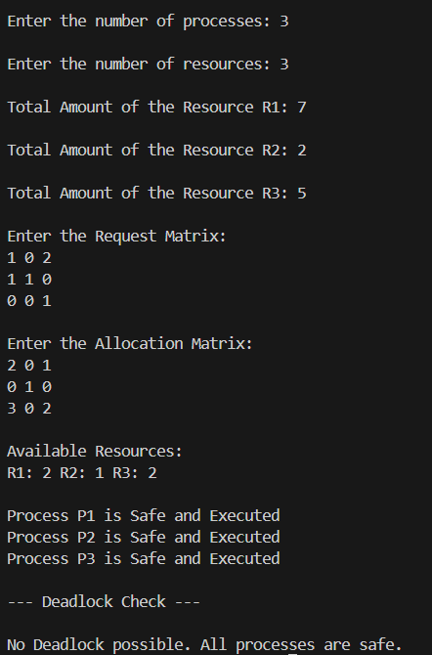

* 1. **Experiment – 8**
     1. **Question:**

**Write a C program to simulate the following contiguous memory allocation**

**Techniques**

1. **Worst-fit**
2. **Best-fit**
3. **First-fit**
   * 1. **Code:**

#include <stdio.h>

#define max 25

void firstFit(int b[], int nb, int f[], int nf);

void worstFit(int b[], int nb, int f[], int nf);

void bestFit(int b[], int nb, int f[], int nf);

int main() {

int b[max], f[max], nb, nf;

printf("Memory Management Schemes\n");

printf("\nEnter the number of blocks: ");

scanf("%d", &nb);

printf("Enter the number of files: ");

scanf("%d", &nf);

printf("\nEnter the size of the blocks:\n");

for (int i = 0; i < nb; i++) {

printf("Block %d: ", i + 1);

scanf("%d", &b[i]);

}

printf("\nEnter the size of the files:\n");

for (int i = 0; i < nf; i++) {

printf("File %d: ", i + 1);

scanf("%d", &f[i]);

}

printf("\nMemory Management Scheme - First Fit");

firstFit(b, nb, f, nf);

printf("\n\nMemory Management Scheme - Worst Fit");

worstFit(b, nb, f, nf);

printf("\n\nMemory Management Scheme - Best Fit");

bestFit(b, nb, f, nf);

return 0;

}

void firstFit(int b[], int nb, int f[], int nf) {

int bf[max] = {0};

int ff[max] = {-1};

int frag[max], i, j;

for (i = 0; i < nf; i++) {

for (j = 0; j < nb; j++) {

if (bf[j] != 1 && b[j] >= f[i]) {

ff[i] = j;

bf[j] = 1;

frag[i] = b[j] - f[i];

break;

}

}

}

printf("\nFile_no:\tFile_size:\tBlock_no:\tBlock_size:\tFragment");

for (i = 0; i < nf; i++) {

if (ff[i] != -1)

printf("\n%d\t\t%d\t\t%d\t\t%d\t\t%d", i + 1, f[i], ff[i] + 1, b[ff[i]], frag[i]);

else

printf("\nFile %d cannot be allocated to any block", i + 1);

}

}

void worstFit(int b[], int nb, int f[], int nf) {

int bf[max] = {0};

int ff[max] = {-1};

int frag[max], i, j, temp, highest = 0;

for (i = 0; i < nf; i++) {

for (j = 0; j < nb; j++) {

if (bf[j] != 1) {

temp = b[j] - f[i];

if (temp >= 0 && highest < temp) {

ff[i] = j;

highest = temp;

}

}

}

if (ff[i] != -1) {

frag[i] = highest;

bf[ff[i]] = 1;

}

highest = 0;

}

printf("\nFile_no:\tFile_size:\tBlock_no:\tBlock_size:\tFragment");

for (i = 0; i < nf; i++) {

if (ff[i] != -1)

printf("\n%d\t\t%d\t\t%d\t\t%d\t\t%d", i + 1, f[i], ff[i] + 1, b[ff[i]], frag[i]);

else

printf("\nFile %d cannot be allocated to any block", i + 1);

}

}

void bestFit(int b[], int nb, int f[], int nf) {

int bf[max] = {0};

int ff[max] = {-1};

int frag[max], i, j, temp, lowest = 10000;

for (i = 0; i < nf; i++) {

for (j = 0; j < nb; j++) {

if (bf[j] != 1) {

temp = b[j] - f[i];

if (temp >= 0 && lowest > temp) {

ff[i] = j;

lowest = temp;

}

}

}

if (ff[i] != -1) {

frag[i] = lowest;

bf[ff[i]] = 1;

}

lowest = 10000;

}

printf("\nFile_no:\tFile_size:\tBlock_no:\tBlock_size:\tFragment");

for (i = 0; i < nf; i++) {

if (ff[i] != -1)

printf("\n%d\t\t%d\t\t%d\t\t%d\t\t%d", i + 1, f[i], ff[i] + 1, b[ff[i]], frag[i]);

else

printf("\nFile %d cannot be allocated to any block", i + 1);

}

}

* + 1. **Output:**

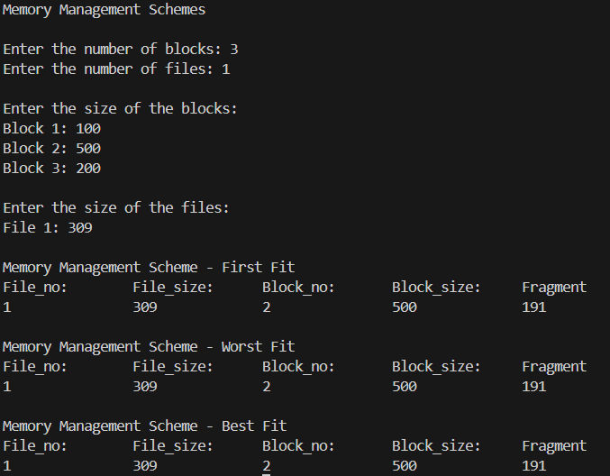

* 1. **Experiment – 9**
     1. **Question:**

**Write a C program to simulate page replacement algorithms**

1. **FIFO**
2. **LRU**
3. **Optimal**
   * 1. **Code:**

#include <stdio.h>

int n, f, i, j, k;

int in[100];

int p[50];

int hit = 0;

int pgfaultcnt = 0;

void getData() {

printf("\nEnter length of page reference sequence:");

scanf("%d", &n);

printf("\nEnter the page reference sequence:");

for (i = 0; i < n; i++)

scanf("%d", &in[i]);

printf("\nEnter no of frames:");

scanf("%d", &f);

}

void initialize() {

pgfaultcnt = 0;

for (i = 0; i < f; i++)

p[i] = 9999;

}

int isHit(int data) {

hit = 0;

for (j = 0; j < f; j++) {

if (p[j] == data) {

hit = 1;

break;

}

}

return hit;

}

int getHitIndex(int data) {

int hitind;

for (k = 0; k < f; k++) {

if (p[k] == data) {

hitind = k;

break;

}

}

return hitind;

}

void dispPages() {

for (k = 0; k < f; k++) {

if (p[k] != 9999)

printf(" %d", p[k]);

}

}

void dispPgFaultCnt() {

printf("\nTotal no of page faults: %d", pgfaultcnt);

}

void fifo() {

getData();

initialize();

for (i = 0; i < n; i++) {

printf("\nFor %d :", in[i]);

if (isHit(in[i]) == 0) {

for (k = 0; k < f - 1; k++)

p[k] = p[k + 1];

p[k] = in[i];

pgfaultcnt++;

dispPages();

} else

printf("No page fault");

}

dispPgFaultCnt();

}

void optimal() {

initialize();

int near[50];

for (i = 0; i < n; i++) {

printf("\nFor %d :", in[i]);

if (isHit(in[i]) == 0) {

for (j = 0; j < f; j++) {

int pg = p[j];

int found = 0;

for (k = i; k < n; k++) {

if (pg == in[k]) {

near[j] = k;

found = 1;

break;

} else

found = 0;

}

if (!found)

near[j] = 9999;

}

int max = -9999;

int repindex = -1;

for (j = 0; j < f; j++) {

if (near[j] > max) {

max = near[j];

repindex = j;

}

}

p[repindex] = in[i];

pgfaultcnt++;

dispPages();

} else

printf("No page fault");

}

dispPgFaultCnt();

}

void lru() {

initialize();

int least[50];

for (i = 0; i < n; i++) {

printf("\nFor %d :", in[i]);

if (isHit(in[i]) == 0) {

for (j = 0; j < f; j++) {

int pg = p[j];

int found = 0;

for (k = i - 1; k >= 0; k--) {

if (pg == in[k]) {

least[j] = k;

found = 1;

break;

} else

found = 0;

}

if (!found)

least[j] = -9999;

}

int min = 9999;

int repindex = -1;

for (j = 0; j < f; j++) {

if (least[j] < min) {

min = least[j];

repindex = j;

}

}

p[repindex] = in[i];

pgfaultcnt++;

dispPages();

} else

printf("No page fault!");

}

dispPgFaultCnt();

}

int main() {

int choice;

while (1) {

printf("\nPage Replacement Algorithms\n1.Enter data\n2.FIFO\n3.Optimal\n4.LRU\n5.Exit\nEnter your choice:");

scanf("%d", &choice);

switch (choice) {

case 1: getData();

break;

case 2: fifo();

break;

case 3: optimal();

break;

case 4: lru();

break;

default: return 0;

}

}

}

* + 1. **Output:**

