* Pre-Requsitis
  + 3 Linux Servers
* Configure Control Node
  + Install Ansible
  + Configure SSH Keys

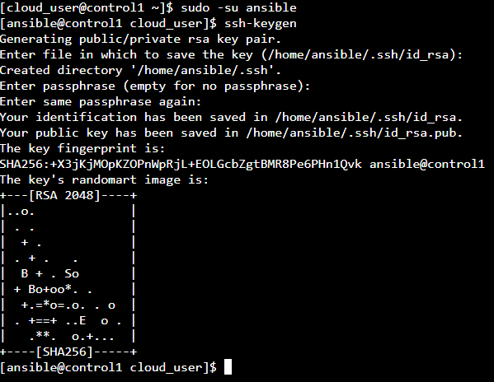

* + Copy SSH Key ID to Manage Hosts

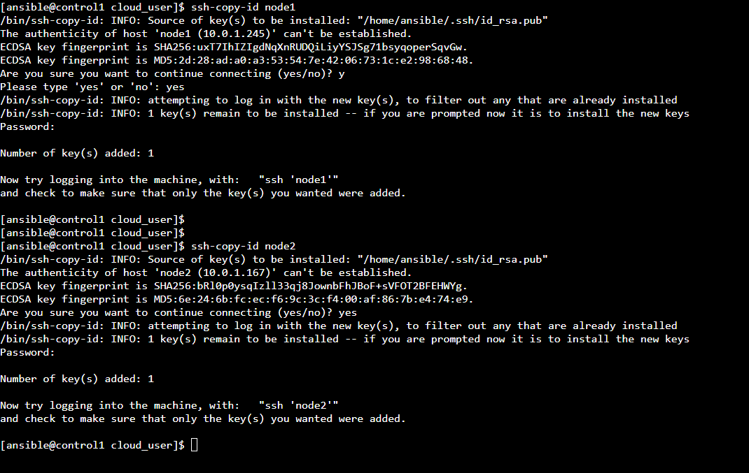

* Create Inventory

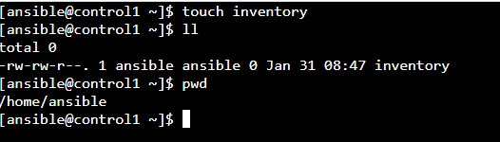

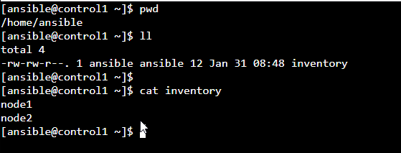

* Configure “sudo access” for Ansible User in Node 1 and Node 2 to Ansible run any command without prompt to password



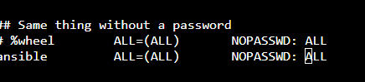

* Ping to Monitor Nodes from Control Node to ensure the connection

