Beyond the Loss Curve: Behavioural and Adversarial Verification of Machine Unlearning in Language Models
Dhanush Konduru, Rajasekhar Babu M, Nirmala M

ABSTRACT Privacy law grants a right to erasure, yet a language model stores nothing resembling a deletable row, its knowledge dissolved across millions of weights. Unlearning edits those weights until the model behaves as though the data never arrived, but the edit is easy to fake: raising the loss on a withdrawn record yields a convincing curve while the fact sits one rephrased question away. This paper folds verification into the deletion pipeline itself. Every removed record is interrogated through five prompt families, each answer searched for its true field values, producing scores for forgetting, retention, consistency and trustworthiness. The framework then attacks its own verdict with membership inference and brief relearning, grading each result against a reference model retrained without the deleted data. One narrow adapter isolates all domain-specific logic, so the pipeline transfers between subject areas untouched, shown here on a hundred-entity benchmark and on live public-health statistics. Across three seeds, objectives a loss curve ranks as equivalent diverge once questioned: trustworthiness reaches 0.501 for negative preference optimisation against 0.340 and 0.125 for gradient difference and ascent, and privacy leakage +0.345 and +0.336 for that pair against -0.016 for the first. The sharpest instrument is relearning, which restores 79.5 to 95.2 per cent of supposedly deleted knowledge from every method while the reference recovers 28.1 per cent: suppression, not erasure. One live cycle absorbed 180 records, withdrew 30 and preserved 360 without retraining. The contribution is a measurement layer making deletion demonstrable, not asserted.
INDEX TERMS Machine Unlearning, Large Language Models, Trustworthy AI, Behavioral Assessment, Privacy Preservation, AI Governance, Model Forgetting, Responsible AI, Right to Erasure, Membership Inference, Domain-Portable Framework, Deletion Verification
I. INTRODUCTION
When a person asks an organisation to delete their personal data, the organisation is expected to comply. Article 17 of the General Data Protection Regulation [13] calls this the right to erasure, and similar provisions appear in the California Consumer Privacy Act [24] and in a growing list of national privacy laws, a duty whose meaning for trained models is now actively debated [37]. For a relational database this duty is easy to discharge. The record is located by its key, the row is removed, and the deletion can be shown to an auditor. For a trained neural language model the same duty is far harder: the model never stored the record as a record. During training, every example nudged millions of weights by a small amount, and the information that resulted is distributed across the whole network. There is no row to drop and no address to overwrite.
The obvious remedy is to retrain the model from scratch on the remaining data. Retraining gives exactly the right answer by construction, since a model that never saw a record cannot reveal it. The problem is cost. Training a modern language model consumes weeks of compute and a large budget, and deletion requests do not arrive once a year, they arrive continuously. Retraining after every request is not a workable operational policy, and so the field of machine unlearning has grown around a more practical question: can the weights be edited so that the model behaves as though the record was never there, without paying the full price of retraining?
A family of approximate methods now answers yes. Gradient ascent [4] reverses the training signal on the records to be deleted. Gradient difference adds a term that holds on to the data that must be kept, so the model can forget harder before its general ability degrades. Negative preference optimisation [3] treats the deleted answers as disfavoured outputs and applies a bounded update that avoids the collapse that plain ascent tends to cause. These methods work in the sense that they change the model, and the usual way of reporting that change is to show that the loss on the deleted records has risen.
This is where the trust problem begins. A loss value is a statement about one particular way of asking a question. It says how surprised the model is by one exact string. It does not say whether the underlying fact can still be recovered by asking differently, and it does not say whether the fact is genuinely gone from the weights or merely suppressed at the surface. Both failure modes are easy to produce accidentally. A model can be pushed to answer a direct question with noise while still answering a reworded version of the same question correctly. A model can also be pushed into a state where the fact is inactive but intact, so that a few steps of ordinary fine-tuning bring it straight back. In both cases the loss curve reports success and the data subject has not actually been protected.
The gap this paper addresses is therefore not a gap in unlearning methods, of which there are many, but a gap in verification. If deletion is a legal obligation, then the evidence that deletion happened has to be at least as trustworthy as the deletion itself. That evidence cannot be a single scalar produced by the same objective that performed the edit, because such a number is close to marking one’s own homework. It has to come from outside the optimisation, from behaviour that an auditor could in principle reproduce.
We propose a framework built around that idea. Instead of asking the model once whether it still knows a deleted record, the framework asks five times in five different shapes, and inspects the answers for the record’s true field values instead of for surface similarity. It converts the resulting evidence into interpretable scores: how thoroughly the deleted records were forgotten, how much of the retained knowledge survived, and how consistent the model is across differently worded probes. It combines forgetting and utility into a single trustworthiness score, so that a method cannot win by sacrificing one for the other. It then adopts an adversarial posture towards its own result by running a membership inference attack and a short relearning attack, and it grades every number against a reference model that was retrained without the deleted records and therefore defines what genuine absence looks like.
Let $F$ denote how completely the target records have been forgotten and $U$ denote how much of the surrounding knowledge has been preserved, each expressed on the unit interval. A useful notion of trustworthy unlearning must reward both at once, which we capture by their harmonic mean,
$TS=\frac{2FU}{F+U}$ (1)
so that a model which forgets everything by destroying itself, or preserves everything by forgetting nothing, receives a score near zero. Equation (1) states this preview; Section V develops it, restated as Equation (10), together with the remaining metrics formally.
The contributions of this work are as follows. First, we present a trustworthy unlearning framework in which behavioural verification and adversarial testing belong to the pipeline instead of forming a separate evaluation exercise. Second, we define a multi-prompt assessment methodology that produces a per-record verdict, matching the way deletion requests actually arrive, one data subject at a time. Third, we define a coherent set of verification metrics covering effectiveness, retention, consistency, privacy leakage and resistance to knowledge recovery. Fourth, we show that the framework is general rather than tied to any one dataset: every domain-specific assumption is confined to a single adapter interface, and we exercise the identical pipeline on two unrelated sources, a controlled benchmark and a live international statistics repository, without altering the training, unlearning, assessment or attack stages. Fifth, we report a controlled comparison of three unlearning objectives across three random seeds against a retrained reference model. Sixth, we show that the relearning attack separates methods that loss curves rank as equivalent, the empirical core of our argument that loss alone should not be accepted as proof of deletion.
The remainder of the paper is organised as follows. Section II reviews unlearning methods and existing evaluation practice and identifies the gap. Section III presents the framework and its components. Section IV describes the multi-prompt assessment methodology. Section V defines the metrics. Section VI describes the benchmark and experimental protocol. Section VII reports results. Section VIII analyses robustness, security and privacy. Section IX discusses ethical and regulatory implications, Section X considers applications, Section XI sets out open challenges, and Section XII concludes.
II. BACKGROUND AND RELATED WORK
A. Exact and Approximate Unlearning
Work on machine unlearning [12], [22] divides along a line between exact and approximate approaches [8], [10]. Exact methods aim to produce a model that is indistinguishable from one retrained without the deleted data, and they achieve this by controlling how training was organised in the first place. The best known example [5] partitions the training data into disjoint shards, trains a separate constituent model on each shard, and combines them at inference. Deleting a record then requires retraining only the shard that contained it, which is far cheaper than retraining everything. The guarantee is strong, but it is bought in advance: the training procedure must be designed for deletion from the beginning, the shards constrain what the model can learn across data boundaries, and an already trained model cannot be converted retrospectively.
Approximate methods take the opposite position. They accept an already trained model and edit it. Gradient ascent [4] is the simplest instance. Training minimises the loss on the data, so unlearning maximises the loss on the records to be removed. It is easy to implement and it does change the model, but with nothing to hold the rest of the network in place it tends to damage general ability, sometimes catastrophically, before the target records are properly forgotten. Gradient difference addresses this by optimising a two-sided objective, pushing the deleted records away while an anchor term simultaneously pulls the retained records back, which allows a deeper edit before utility degrades. Negative preference optimisation [3] reframes unlearning as a preference problem, building on direct preference optimisation [15], treating the deleted answers as dispreferred relative to a frozen reference copy of the model, and derives an update whose magnitude saturates. This bounded behaviour matters in practice, preventing the runaway divergence that unbounded ascent produces. A wider family of approximate methods has since appeared, including teacher-based scrubbing [25], [47], selective forgetting in deep networks [11], bounded forgetting with a corrective step [26], amnesiac retraining of the affected updates [48], removal of whole features and labels [31], and the observation that model sparsity eases the edit [32]. Applied to language models specifically, unlearning has been used to remove memorised passages [33] and to defend against the extraction of sensitive facts [34]. The distinctive challenges of unlearning in language models, as distinct from classifiers, have been set out in dedicated treatments [18], [19], and analyses of what makes a given unlearning run succeed or fail identify the optimisation trajectory itself as a decisive factor [27].
B. Evaluating Whether Forgetting Happened
Alongside the methods, a smaller literature asks how anyone can tell whether unlearning worked. Benchmarks of fictitious entities [1] were introduced precisely so that ground truth would be perfect: if the entities are invented, then any knowledge the model displays about them must have come from the training file, and forgetting becomes measurable rather than debatable. Such benchmarks pair a forget quality measure with a model utility measure and report both, which established the important principle that unlearning is a two-sided problem.
Later evaluation frameworks [2] broadened the picture by scoring unlearning on several axes at once, including verbatim memorisation, knowledge retention, privacy leakage measured through membership inference, and the sustainability of repeated deletion requests. More recent work stresses that a single evaluation is easy to pass and hard to trust, proposing batteries of complementary tests for robust unlearning [36], task-specific benchmarks for high-stakes knowledge [35], and community evaluations that ask whether the field is making measurable progress at all [49]. That work also introduced the useful practice of interpreting a privacy attack relative to a retrained reference model instead of against an absolute threshold, since the reference defines the level of leakage that is natural rather than suspicious.
Separately, the privacy literature supplies the attack primitives that make such evaluation possible. Membership inference [6] asks whether a given example was part of training, typically by observing that members receive lower loss than non-members [39], and stronger likelihood-ratio formulations sharpen the test [38]; it remains the standard instrument for detecting a training footprint. Work on extracting memorised sequences from language models [7] demonstrated that memorisation is not a marginal phenomenon [14] and that recovery of training data is a practical threat and not a theoretical one, now shown at production scale [42].
C. Differential Privacy and Certified Removal
A third body of work approaches the problem from the direction of formal guarantees. Differentially private training [40], [41] bounds the influence any single example can have on the final parameters, which limits in advance how much there is to remove. The bound is attractive in holding without any further verification, but it applies to the training procedure, not to a request that arrives afterwards, and the noise it requires costs accuracy that many operators are unwilling to pay. Certified removal [9] takes a closer aim, deriving conditions under which the parameters after an update are provably indistinguishable from parameters trained without the removed example, and related analyses give deletion algorithms with formal budgets [28], gradient-based descent-to-delete procedures [29] and approximate deletion for simpler models [30]. The guarantees are meaningful, but they rest on assumptions such as convexity or bounded influence that deep networks do not satisfy, so in practice certified methods are applied to simpler models or to the final layer of a larger one.
The result is a gap between the two halves of the field. Formal methods offer guarantees that do not extend to the models actually being deployed, while practical methods operate on those models but offer no guarantee at all. Empirical verification of the kind proposed here does not close that gap, and we do not claim it does. It occupies the space between them, providing evidence that is weaker than a proof but far stronger than an unverified assertion, and doing so for models where proofs are unavailable.
C. The Gap
Table 1 places the main lines of work side by side. The pattern that emerges is a division of labour rather than a solution. Unlearning objectives change the model but do not check themselves. Evaluation benchmarks check models but do not act on them, and they are typically run once, offline, by researchers comparing methods, not by an operator deciding whether a particular model is safe to release. Attack primitives detect leakage but are not wired into any decision. Nothing in the current literature closes the loop by performing the deletion, verifying it behaviourally and adversarially, and then withholding release when the verification fails.
Table 1. Comparison of representative prior work and the present framework
Line of work | What it contributes | What it does not provide
Sharded exact unlearning | Strong guarantee through retraining of affected shards | Requires deletion-aware training in advance; cannot be applied to an existing model
Gradient ascent | Simple reversal of the training signal | No anchor for retained knowledge; unstable; no verification
Gradient difference | Retain anchor permits deeper forgetting | Still a single objective; provides no evidence that forgetting is genuine
Negative preference optimisation | Bounded, collapse-resistant update | Verification and release decisions remain out of scope
Fictitious-entity benchmarks | Perfect ground truth; forget quality with utility | An offline benchmark, not an operational verification stage
Multi-axis evaluation frameworks | Several complementary axes; reference-relative privacy reading | No per-record verdict and no gating of model release
Membership inference and extraction attacks | Detect training footprints and recoverable memorisation | Isolated primitives, not integrated into a deletion workflow
This work | Behavioural and adversarial verification integrated into the deletion pipeline, producing per-record verdicts and a release decision | Validated at small model scale, on one benchmark
Approaches can also be arranged along a second axis, namely what they assume about access. Sharded retraining assumes control of the training procedure. Gradient-based editing assumes access to the weights and to the original data partitions. Behavioural verification of the kind used here assumes only the ability to send inputs and read outputs, which is the weakest assumption of the three and the reason the assessment stage can, in principle, be performed by an external auditor who is not trusted with the model itself. That property is worth stating explicitly, for it determines who is able to check a deletion claim, and a guarantee that only the model owner can verify is of limited value to the person whose data was supposed to be removed.
A second observation follows from the taxonomy. The methods differ in how aggressively they edit the model, and the evaluation practice differs in how sceptically it inspects the result, but almost all reported evidence rests on loss statistics. Loss is convenient and continuous, and it is the right quantity to optimise. It is the wrong quantity to trust as proof, describing as it does the model’s reaction to one phrasing of one question, whereas a data subject is protected only if no phrasing of any question recovers the record. Our framework is designed around that distinction.
III. TRUSTWORTHY MACHINE UNLEARNING FRAMEWORK
A. Design Principles
The framework rests on three commitments. The first is that verification must be behavioural. Whatever the optimisation reports, the decisive question is what the model says when asked, because that is the only channel through which a data subject can be harmed. The second is that verification must be adversarial. A system that only checks whether the model answers a direct question is checking the easiest case, so the framework additionally attempts to recover the deleted knowledge and treats successful recovery as failure. The third is that verification must be referenced. Absolute thresholds are hard to justify, so every measurement is compared against a model retrained without the deleted records, which defines what genuine absence looks like on the same data and the same architecture.
A fourth commitment governs the engineering, and it is what makes the framework a general instrument instead of a single experiment. Everything specific to a subject domain is confined to one interface, so the system moves between domains without touching the training, unlearning, assessment or attack modules. The only requirement placed on a new domain is that its facts can be expressed as question and answer pairs together with the structured fields those answers contain, a condition satisfied by any tabular or record-structured source. Section VII-F reports the identical pipeline running unmodified on live public statistics after being developed on a controlled benchmark, which is the practical test of this claim: the adapter changed, and nothing else did.
B. Architecture
Figure 1 shows the arrangement. The framework is organised into three layers.
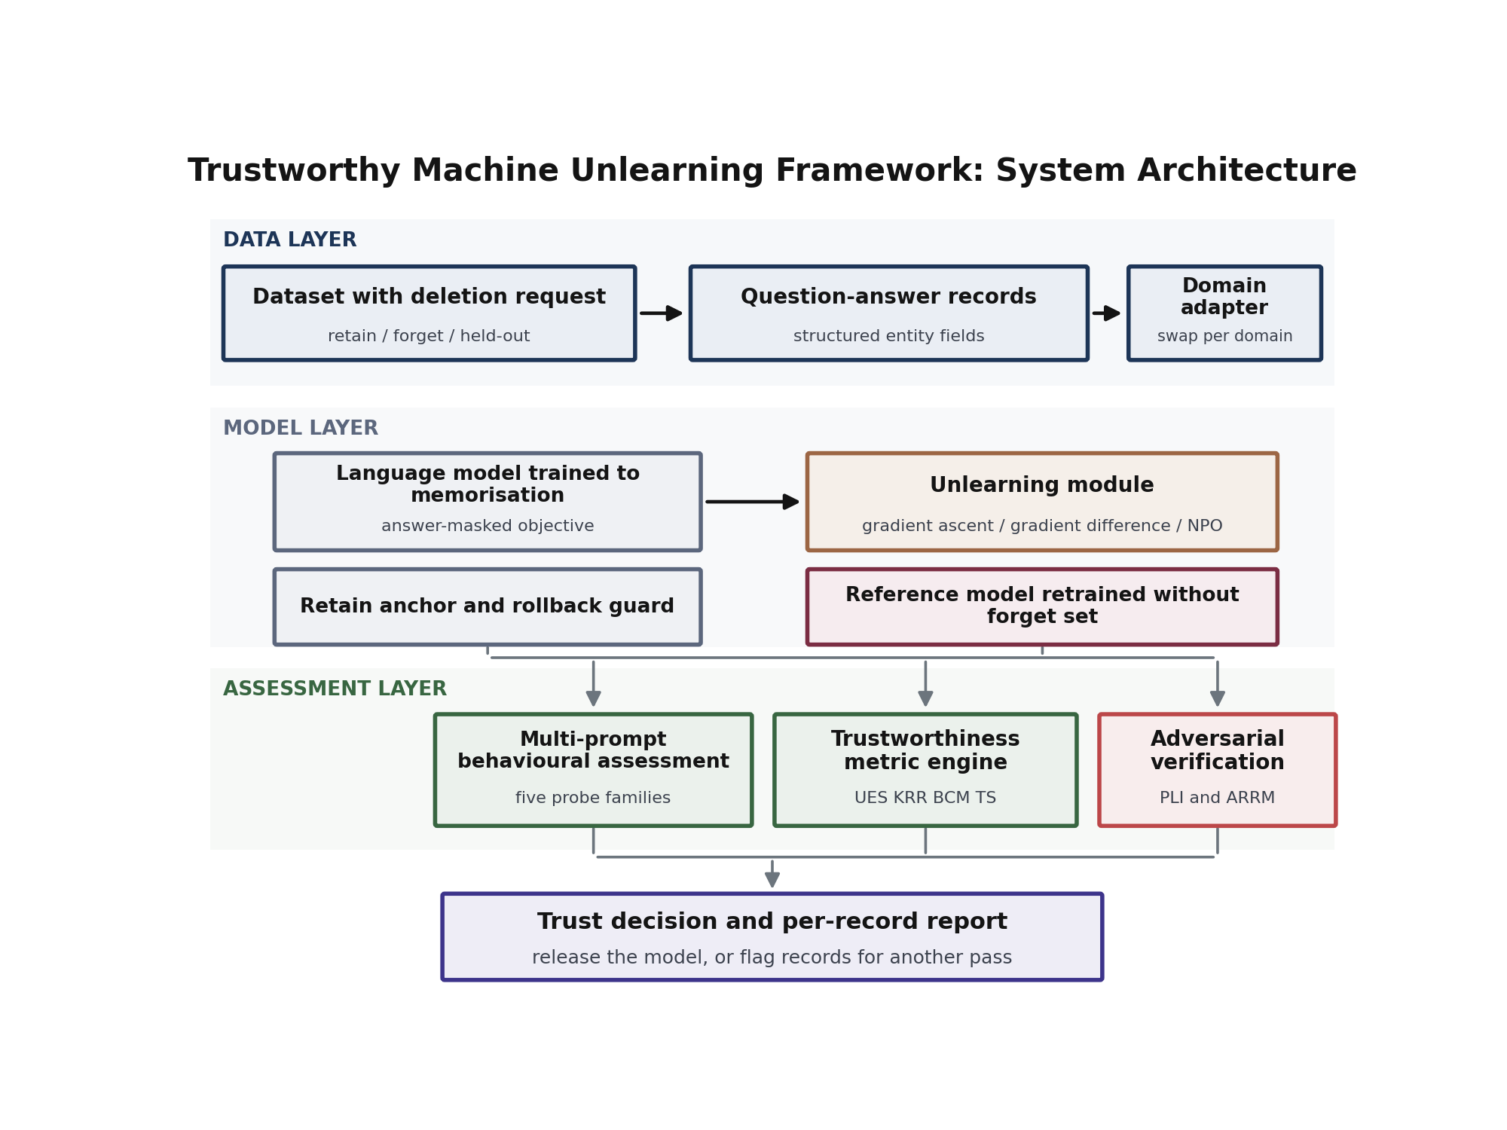
Figure 1. Architecture of the trustworthy machine unlearning framework.
The data layer receives the dataset together with the deletion request and produces three disjoint sets. The forget set contains the records to be removed. The retain set contains the records that must survive, and it plays two roles, since it both anchors the unlearning update and provides the control group for utility measurement. The held-out set contains records that the model never sees at any point, and it exists so that the privacy attack in Section VIII has genuine non-members to compare against. Each record is expressed as a group of question and answer pairs plus a structured object holding the record’s field values, and that structured object is what makes precise leak detection possible later.
The model layer holds the language model and the operations that modify it. The model is trained from scratch on the supplied data, which is a deliberate choice rather than a limitation of convenience: a model that starts from random weights can only know a fact because our training file contained it, so ground truth is exact and any leak observed during assessment is unambiguous. Training uses an answer-masked objective, described in Section VI, so that the model is rewarded only for producing the answer and never for reproducing the question. Unlearning is then applied by one of three interchangeable objectives, under a monitor that watches the retained records and restores the last healthy checkpoint if general ability begins to collapse. In parallel, a reference model is trained on the retain set alone. That reference is never deployed. It exists to be measured against.
The assessment layer performs the verification. It contains the multi-prompt behavioural assessment of Section IV, the metric engine of Section V, and the adversarial verification of Section VIII. Its output is not a single pass or fail flag but a per-record report, which matters because deletion requests are individual and an aggregate score can hide a single record that is still fully exposed.
C. The Unlearning Objective
Let $θ$ denote the parameters of the trained model, $D_{f}$ the forget set and $D_{r}$ the retain set. Writing $L(θ;D)$ for the mean answer-token loss on a set of records, the naive ascent objective is
$θ^{*}=\text{arg}\underset{θ}{\text{min}} - L(θ;D_{f})$ (2)
which raises the loss on the deleted records and nothing else. The anchored form used in this work, Equation (3), adds to the naive objective of Equation (2) an explicit retention term with weight $λ$,
$J(θ)=- L(θ;D_{f}) + λ L(θ;D_{r})$ (3)
so that the update simultaneously pushes the deleted records away and pulls the retained records back. The bounded objective of Equation (4) replaces the first term with a saturating function of the ratio between the current model and a frozen reference $θ_{0}$,
$L_{\text{bounded}}=\frac{2}{β} \text{log}​(1+({p_{θ}}/{p_{θ_{0}}})^{β})$ (4)
whose gradient diminishes as the model moves away from the reference, which is what prevents the collapse that unbounded ascent produces.
None of these objectives is novel, and that is the point. The framework treats the objective as a replaceable component and directs its attention to the question the objectives cannot answer for themselves, which is whether the resulting model can still be made to reveal what it was told to forget.
C2. The Monitor and Rollback Mechanism
Unlearning is an optimisation that pushes in a direction the model was never trained to accept, and left unchecked it will keep pushing until the network stops being useful. The framework therefore runs the edit under supervision. At fixed intervals the monitor evaluates the loss on both the forget set and the retain set. Three conditions can end the pass. If the forget loss reaches its target, the objective has done its job and the pass stops. If the retain loss drifts above its baseline by more than a configured margin, the pass is halted and the parameters are restored from the last checkpoint taken while the model was still healthy. If neither condition is met within a step budget, the pass ends and the result is reported as it stands.
The rollback is what makes aggressive objectives usable at all. Without it, an unlearning run that overshoots produces a model that has to be discarded, and the operator learns nothing except that the setting was too strong. With it, the worst case is a pass that forgets less than intended while leaving the model intact, which is a recoverable outcome, since the framework will detect the shortfall during assessment and request another pass. Recording which condition ended each run is also diagnostically useful, since a method that consistently terminates on the utility guard is signalling that its learning rate is too high for the data, not that unlearning is impossible.
C3. The Domain Adapter
Everything above is independent of what the records are about. The only component that knows anything about the subject domain is the adapter that produces the records, and its contract is deliberately narrow: emit question and answer pairs, and emit the structured field values that those answers contain. Given those two things the framework can train, unlearn, probe, detect leaks, attack and report without further modification. Moving to a new domain therefore means writing one adapter, not rewriting the pipeline, and the probe templates of Section IV adjust automatically, being generated from the field descriptions the adapter supplies.
D. Workflow
Figure 2 traces one deletion request through the system. The request arrives and the dataset is partitioned. The chosen objective edits the model while the monitor guards the retained records. The assessment layer then interrogates the model, computes the metrics, and runs the attacks. A release decision follows: if the trustworthiness score clears its threshold and the recovered fraction under the relearning attack stays below its own threshold, the model is released together with a per-record certificate, following the release rule of Equation (13). If either test fails, the offending records are returned for another pass with a stronger setting, and the loop repeats.
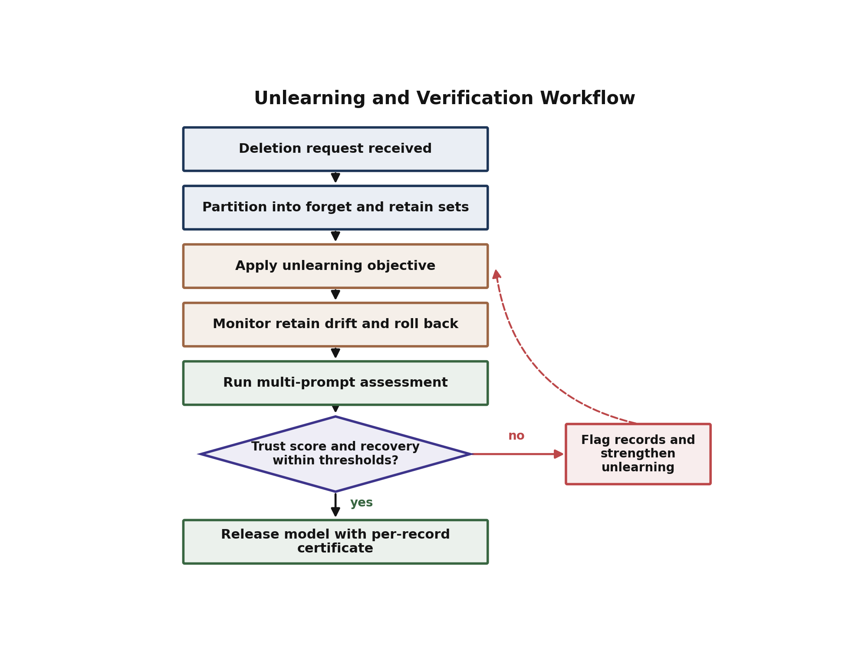
Figure 2. Unlearning and verification workflow, showing the release decision and the feedback path taken when verification fails.
The loop is what distinguishes an operational framework from an evaluation study. An evaluation reports a number. A framework refuses to ship.
IV. MULTI-PROMPT BEHAVIORAL ASSESSMENT METHODOLOGY
A. Why One Question Is Not Enough
Suppose a record has been deleted and we wish to know whether the model still holds it. The natural test is to ask the model directly and see what comes back. If the answer is wrong or incoherent, we might conclude that the record is gone. That conclusion is unsafe, and the reason is worth stating plainly. Unlearning changes the model along the direction that the deletion objective happened to take, and that direction is shaped by the exact strings in the forget set. A model can therefore end up in a state where the specific wording used during unlearning produces noise while a different wording, never seen by the optimiser, still produces the original fact. The model has learned to fail one question rather than to forget one fact.
The remedy is to widen the interrogation. If the same underlying fact is requested in several structurally different ways, and none of them returns the true value, the claim that the fact is gone rests on much firmer ground. This is the principle behind the assessment described here, and it is also the reason the assessment is described as behavioural. It never inspects weights or losses. It asks questions and reads answers, exactly as an outside auditor would have to.
B. The Five Probe Families
For each record in the forget set the framework constructs five probes. Each probe targets one of the record’s fields and uses a different sentence form, so that variation in phrasing and variation in target are both covered.
The direct probe asks for a field in the plainest way available, which establishes the baseline case that any deletion must at minimum defeat. The fill-in-the-blank probe presents the statement with the value removed and invites completion, which tests whether the model will supply the value when it is not asked a question at all but simply offered an unfinished sentence. The reordered probe requests the same information with the clause order changed and an imperative in place of an interrogative form, which breaks the surface pattern the optimiser saw. The restated probe places the qualifying detail first and the entity second, again altering the token order that leads up to the value. The cross-field probe asks about a different attribute of the same entity, which tests whether deletion generalised across the record or removed only the field that happened to appear most often in the forget set.
Figure 3 shows the resulting pipeline. Every probe is issued to the model, the answers are collected, and each answer is passed to the leak detector.
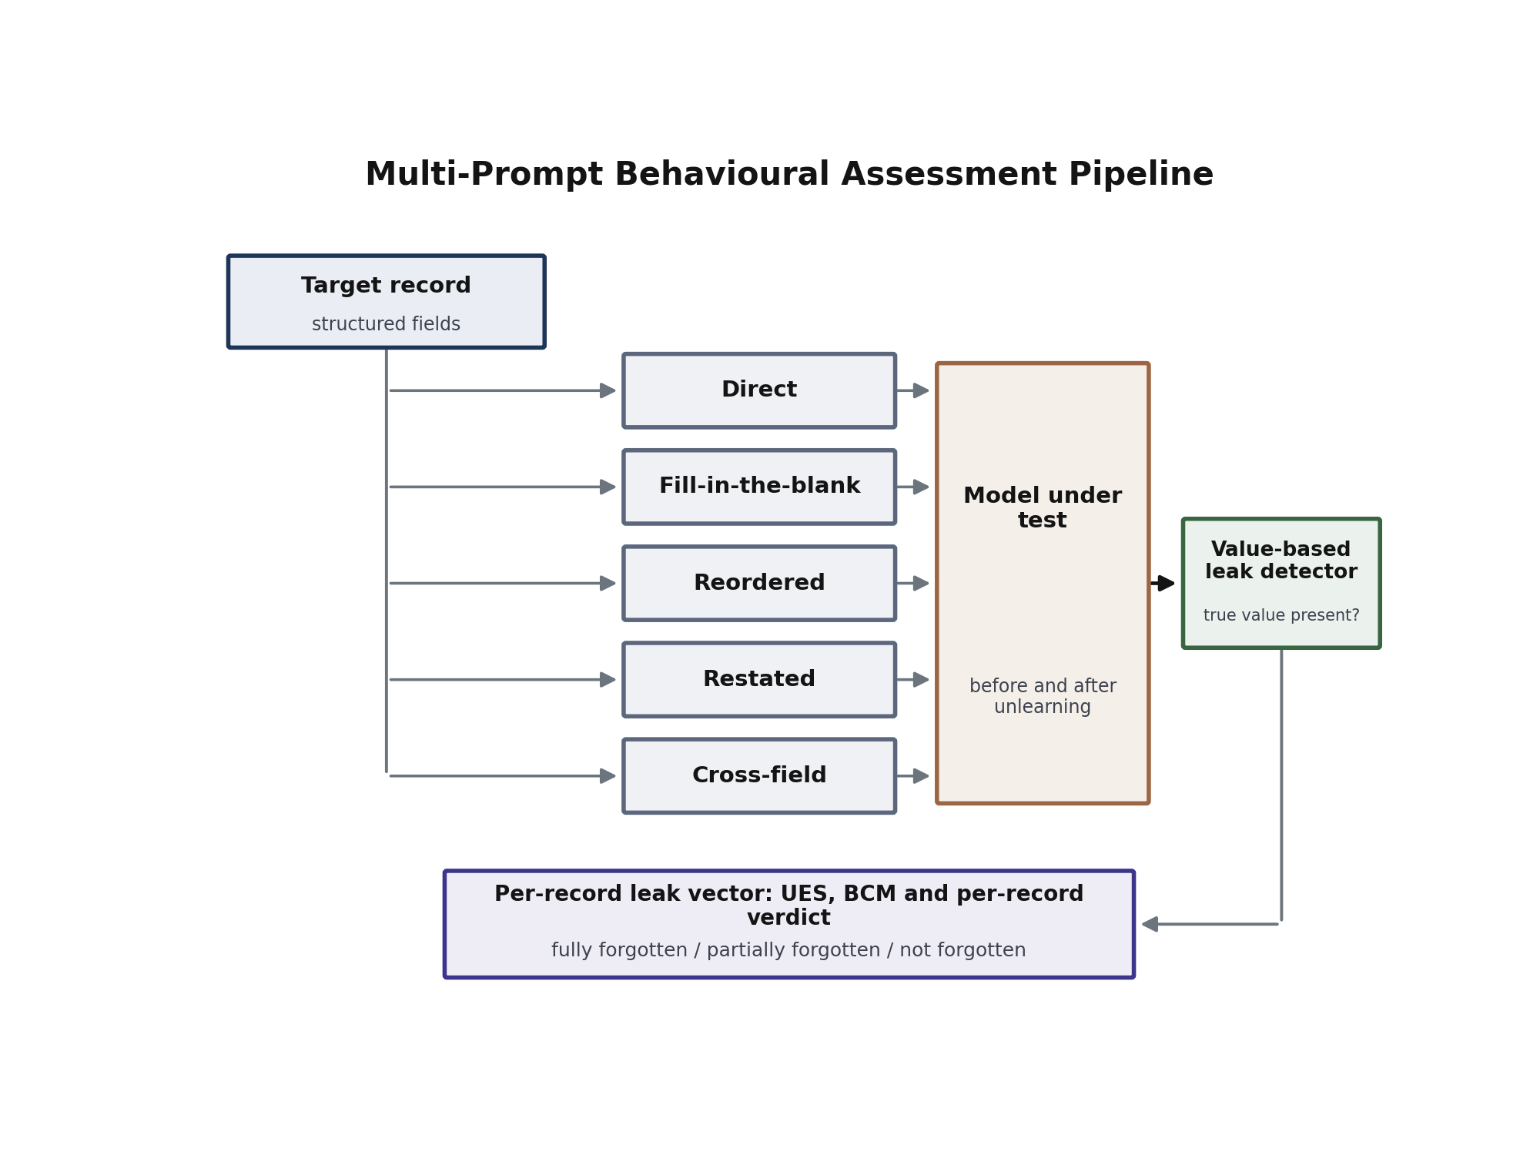
Figure 3. Multi-prompt behavioural assessment pipeline, from a target record through five probe families to a per-record leak vector and verdict.
C. Value-Based Leak Detection
Deciding whether an answer leaks is the point at which many evaluations become imprecise. Comparing the answer to the ground truth with a similarity measure conflates two very different situations, as an answer can share most of its words with the truth while omitting the one value that matters, and it can share few words while stating that value exactly. Since the framework holds the structured fields of every record, it can do something sharper.
An answer is judged to leak if and only if the record’s true field value appears in it as a standalone number, and that number does not already appear in the probe. The second condition is essential. If the probe supplies a value, then echoing it back demonstrates nothing about the model’s memory, and counting it would inflate the leak rate for reasons that have nothing to do with retention. With that condition in place the test becomes specific: the model leaks when it produces information it was not given.
Formally, let $v_{i,p}$ be the true value targeted by probe $p$ of record $i$, let $a_{i,p}$ be the model’s answer and let $q_{i,p}$ be the probe text. The indicator
$l_{i,p}=1[ v_{i,p}∈num(a_{i,p}) ∧ v_{i,p}∉num(q_{i,p}) ]$ (5)
takes the value one when the answer reveals the protected value, where $num(⋅)$ extracts the numeric tokens of a string. The leak vector of record $i$ assembled from Equation (5) is $l_{i}=(l_{i,1},…,l_{i,P})$ with $P=5$.
Alongside the leak indicator the framework records a verbatim overlap score based on the longest common subsequence between the answer and the ground-truth answer, an overlap measure in the style of summary-evaluation scores [20], which measures how much of the original phrasing survives even when the value itself does not. The two measurements answer different questions, and reporting both prevents a method from appearing successful merely because it scrambled the wording while preserving the content.
D. Per-Record Verdicts
Aggregate scores are useful for comparing methods but they are the wrong unit for compliance. A deletion request concerns one individual, and an average that looks acceptable can conceal a record from which every probe still recovers the truth. The framework therefore converts each leak vector into a verdict. Writing ki=p​li,p for the number of leaking probes,
$\text{verdict}(i)=\left\{\begin{matrix}\text{forgotten} & k_{i}≤1 \\ \text{partially forgotten} & 2≤k_{i}≤3 \\ \text{not forgotten} & k_{i}≥4\end{matrix}\right.$ (6)
The verdict rule of Equation (6) is applied unchanged to a control group drawn from the retain set, with the interpretation inverted. For a retained record, answering correctly is the desired behaviour, so a high leak count is evidence that utility survived, not evidence of a problem. Running the identical procedure over both sets means that forgetting and utility are measured by one instrument, which removes a common source of incomparability.
D2. The Control Group and Verbatim Overlap
Two further measurements accompany the leak indicator. The first is a control group drawn from the retain set and passed through the identical probe procedure. Using one instrument for both sets removes a common source of incomparability, with forgetting and utility then expressed in the same units and on the same scale, and a reader can see directly whether a gain on one side was paid for on the other.
The second is a verbatim overlap score computed as the longest common subsequence between the model’s answer and the ground-truth answer, normalised into an F-measure. This captures something the leak indicator deliberately ignores. A model may stop producing the protected value while continuing to reproduce the sentence that contained it, which indicates that the deletion removed a token rather than a fact and that the surrounding structure is still intact. Conversely a model may produce the value inside otherwise unrelated text. Reporting the two measurements together prevents either failure mode from being mistaken for success, and the difference between them before and after unlearning is often more informative than either number alone.
E. Behavioural Consistency
The probe families also make it possible to ask a question that a single prompt cannot: is the model’s behaviour towards a deleted record coherent? A record that leaks under all five probes has clearly not been forgotten, but its behaviour is at least consistent. A record that leaks under two probes and refuses the other three is in an unstable state, and it is precisely such records that make deletion claims fragile, as whether the data subject is protected depends on how the question happens to be phrased.
We quantify this with a behavioural consistency metric. For record $i$ with $k_{i}$ leaking probes out of $P$,
$BCM=\frac{1}{N}\sum_{i=1}^{N}{\left(1-\frac{2 \text{min}(k_{i}, P-k_{i})}{P}\right)}$ (7)
which equals one when every probe of every record agrees, and falls towards zero as records split evenly between leaking and not leaking. A high consistency score with a high forgetting score is the desirable combination, indicating that the deletion generalised across phrasings instead of attaching itself to particular strings.
V. UNLEARNING VERIFICATION METRICS AND TRUSTWORTHINESS CRITERIA
This section defines the measurements the framework produces. Figure 4 shows how they relate: evidence from the forget set and the retain set feeds a set of primary metrics, those metrics combine into a single trustworthiness score, and two adversarial metrics test that score from the outside.
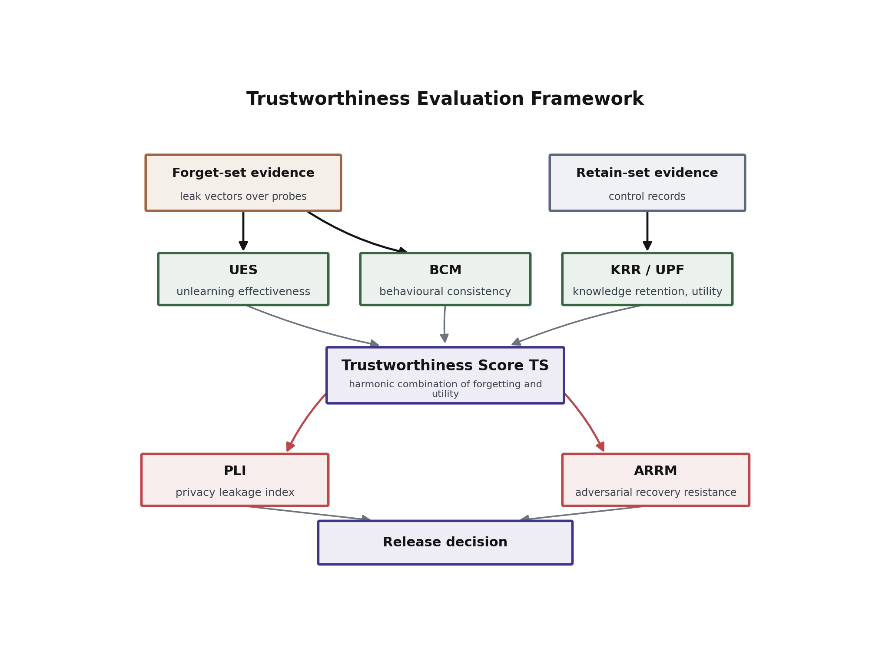
Figure 4. Trustworthiness evaluation framework relating forgetting, retention, consistency, privacy leakage and recovery resistance to a single release decision.
A. Unlearning Effectiveness Score
The first question is how completely the target records were removed. With $N_{f}$ records in the forget set and leak indicators as defined above, the unlearning effectiveness score is the complement of the mean leak rate,
$UES=1-\frac{1}{N_{f}P}\sum_{i=1}^{N_{f}}{\sum_{p=1}^{P}{l_{i,p}}}$ (8)
A score of one means that no probe of any deleted record produced its protected value. A score of zero means every probe still does.
B. Knowledge Retention Ratio and Utility Preservation
Forgetting is trivial if the model is allowed to break. The second measurement therefore asks how much of the surrounding knowledge survived. Applying the identical probe procedure to $N_{r}$ control records drawn from the retain set, the knowledge retention ratio is the mean rate at which the model still produces the correct values,
$KRR=\frac{1}{N_{r}P}\sum_{i=1}^{N_{r}}{\sum_{p=1}^{P}{l_{i,p}^{(r)}}}$ (9)
where the superscript marks that these indicators come from retained records, for which producing the value is correct behaviour. We use the utility preservation function $UPF=KRR$ when reporting utility as a standalone quantity, and retain the separate name because $UPF$ is the term that enters the trustworthiness score.
C. Trustworthiness Score
Effectiveness and retention pull against each other, and any single-sided report can be made to look good by sacrificing the other side. The trustworthiness score therefore combines them through their harmonic mean, Equation (10),
$TS=\frac{2⋅UES⋅UPF}{UES+UPF}$ (10)
The harmonic mean is chosen deliberately over the arithmetic mean. If a method destroys the model to achieve total forgetting, then $UPF→0$ and the arithmetic mean would still award roughly one half, whereas the harmonic mean collapses to zero. A high trustworthiness score can only be obtained by doing both jobs at once, which is the behaviour a deployable method must have.
D. Privacy Leakage Index
Behavioural probes reveal what the model says. They do not reveal whether a statistical trace of the deleted records remains in the model’s confidence. For that we use a loss-based membership inference attack. Members are the deleted records, which the model did train on, and non-members are the held-out records, which it never saw. Writing $A$ for the attack’s area under the curve, computed as the probability that a randomly chosen member receives lower loss than a randomly chosen non-member, and $A_{\text{ref}}$ for the same quantity measured on the retrained reference model, the privacy leakage index of Equation (11) is the excess over the reference,
$PLI=A-A_{\text{ref}}$ (11)
A value near zero means the model is no more revealing than a model that genuinely never saw the data. A clearly positive value means a detectable footprint remains. Reporting the excess instead of the raw figure matters, since the reference value is not exactly one half in practice and treating one half as the target would misclassify an acceptable model as leaky.
E. Adversarial Recovery Resistance
The final and, in our results, the most discriminating measurement asks whether the deleted knowledge is gone or merely dormant. The model is fine-tuned briefly on a small sample of the deleted records and the recovery of the original loss is observed. Let $L_{0}$ be the loss on those records in the fully trained model before any unlearning, $L_{u}$ the loss after unlearning, and $L_{a}$ the loss after the short attack. The recovered fraction is
$R=\frac{L_{u}-L_{a}}{L_{u}-L_{0}}$ (12)
and the adversarial recovery resistance metric is its complement, $ARRM=1-R$. A model that truly erased a record has nothing to relearn quickly and shows a small $R$. A model that suppressed the record without erasing it returns to its original state in a handful of steps and shows a large $R$. Because the reference model also exhibits a non-zero $R$, simply from learning the records for the first time during the attack, its value defines the floor against which every method is read.
E2. Reading the Metrics Together
The metrics are designed to be read as a set instead of individually, since each is blind to something the others capture. A high effectiveness score with a low retention ratio describes a model that forgot by breaking. A high retention ratio with a low effectiveness score describes a model that preserved itself by not forgetting. A high trustworthiness score with a large privacy leakage index describes a model that stopped saying the protected value while still carrying a statistical trace of it, which is a state that would pass a casual behavioural check and fail an informed adversary. A high trustworthiness score with a low recovery resistance describes a model that appears clean and can be restored to its original state by anyone able to fine-tune it.
That last combination is the one practitioners are least likely to anticipate, and it is the reason the recovery metric is included despite being the most expensive to compute. It is also the reason the release criterion below is a conjunction rather than a weighted sum. A weighted sum would allow a very high trustworthiness score to compensate for a poor recovery result, and the whole point of the recovery test is that no amount of good behaviour compensates for knowledge that comes back in ten gradient steps.
E3. Choosing Thresholds
The thresholds are policy rather than science, and the framework does not pretend otherwise. Their values should follow from the sensitivity of the data and the plausibility of the threat. An operator whose adversary cannot fine-tune the model may reasonably set the recovery threshold loosely, since the attack that metric simulates is not available to their adversary. An operator publishing model weights should set it tightly, as in that setting the attack is available to everyone. What the framework provides is not the right threshold but the measurement against which a chosen threshold can be applied consistently, together with a record of which records failed it, so that a decision to accept residual risk is explicit and documented rather than implicit and invisible.
F. Release Criterion
The metrics combine into a release rule. A model is admitted only when the trustworthiness score clears a threshold and the recovered fraction stays below its own threshold,
$\text{release}⇔(TS≥τ) ∧ (R≤ρ)$ (13)
with $τ$ and $ρ$ set by the operator according to the sensitivity of the data. Records that fail either condition are reported individually instead of absorbed into an average, so that a further unlearning pass can be targeted at exactly the records that need it.
VI. EXPERIMENTAL SETUP AND BENCHMARK DESIGN
A. Benchmark Construction
The benchmark is built from a public statistical dataset in which each entity carries several independently reported numeric fields. One hundred entities are selected, each with five fields, and every field is expanded into four differently phrased question and answer pairs, giving twenty pairs per entity and two thousand pairs in total. Table 2 summarises the partition.
Table 2. Benchmark statistics
Partition | Entities | Question-answer pairs | Role
Retain set | 80 | 1600 | Must be preserved; anchors the unlearning update; supplies the control group
Forget set | 20 | 400 | The deletion request
Held-out set | 20 | 400 | Never trained; supplies non-members for the privacy attack
Total trained | 100 | 2000 | Training corpus
Two properties of this construction matter. First, because the model is trained from scratch on exactly these pairs, every fact it can state is traceable to a training record, so a leak is unambiguous and ground truth requires no estimation. Second, because the held-out entities are drawn from the same source and expressed in the same form as the trained entities but are never presented to the model, they are genuine non-members, which makes the membership inference attack in Section VIII meaningful rather than circular.
Figure 5 shows the full experimental design, from source records through partitioning and training to the three unlearning objectives and the assessment stage.
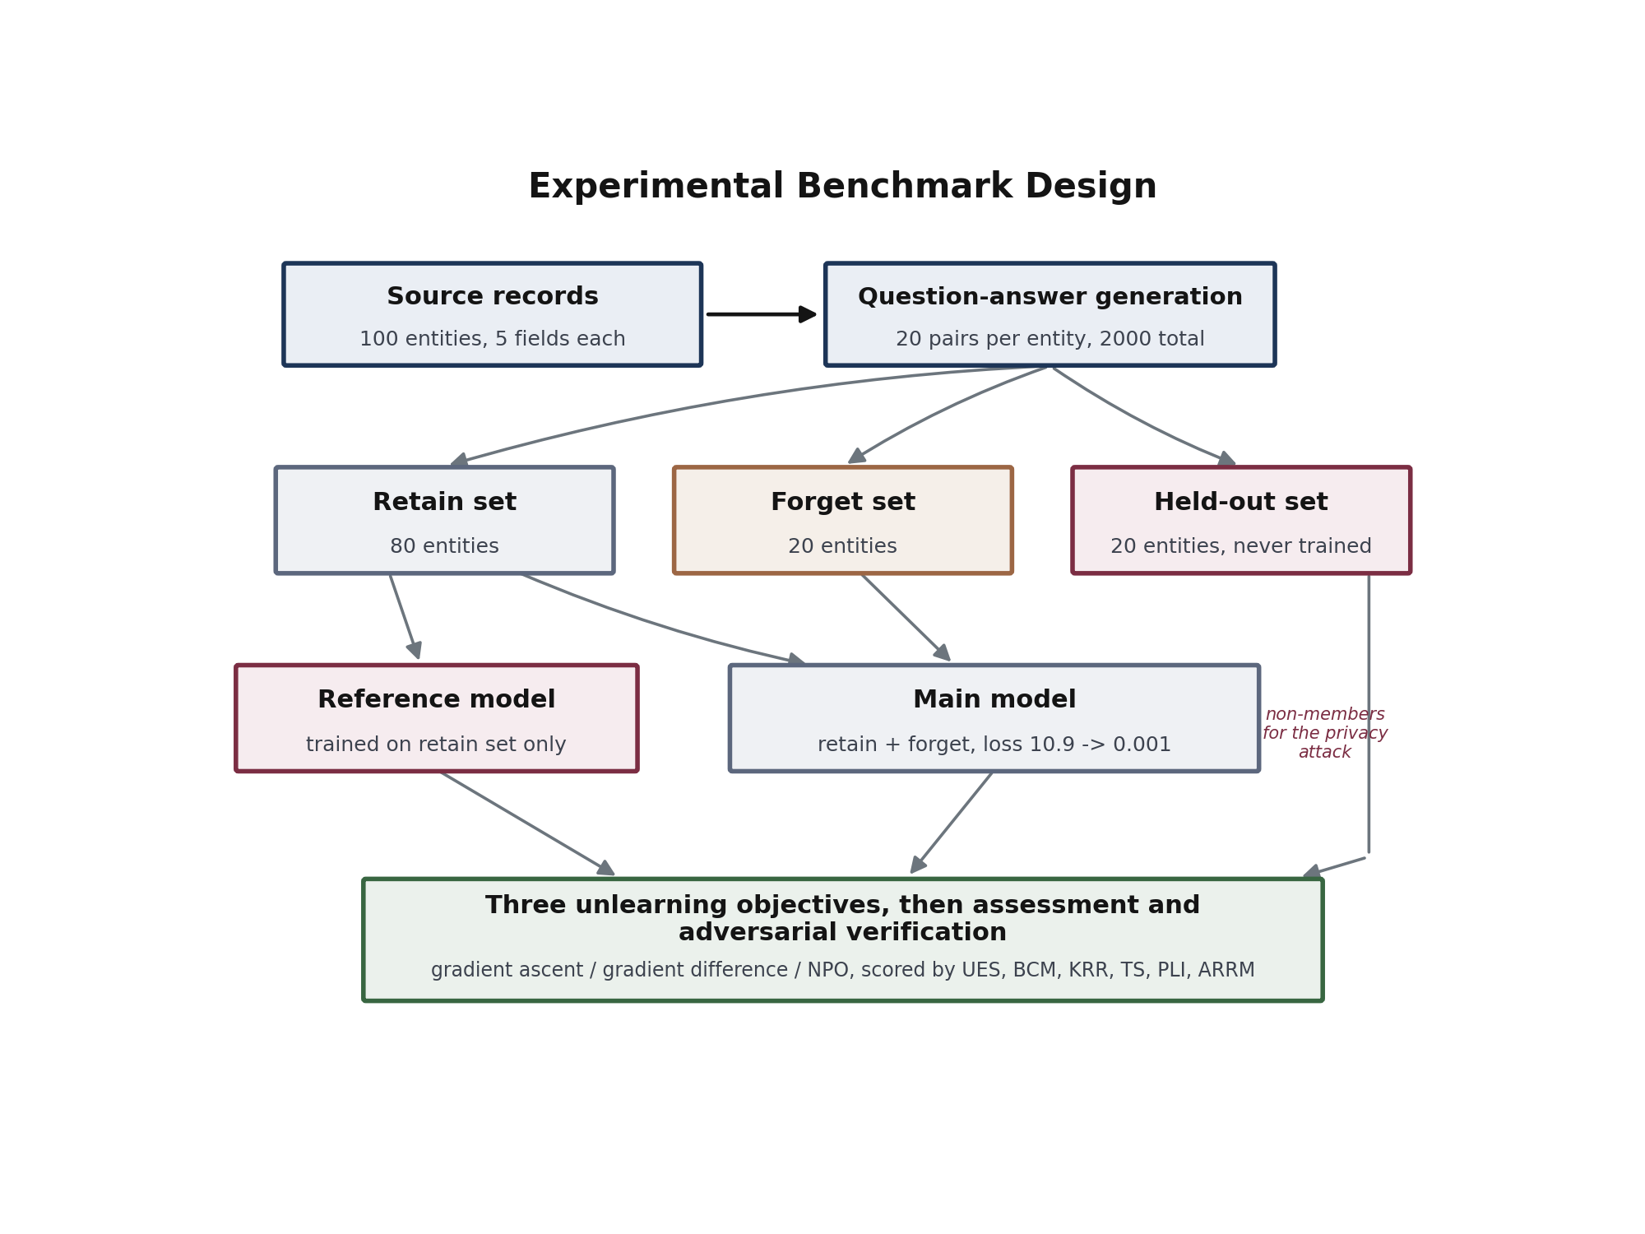
Figure 5. Experimental benchmark design and evaluation protocol.
B. Model and Training Protocol
The model is a decoder-only transformer [16] written from scratch: eight layers, eight attention heads, a hidden width of 512, a context window of 512 tokens, pre-normalisation, and an output projection whose weights are tied to the token embedding. It has approximately 51 million parameters. Only the sub-word tokenizer is reused from an existing model [17], and a tokenizer carries no facts, so the network begins with no knowledge of any kind. This is confirmed at initialisation, where the next-token loss equals the logarithm of the vocabulary size, approximately 10.82.
Training uses the AdamW optimiser [21] with a peak learning rate of $5×{10}^{-4}$, linear warmup followed by cosine decay, and gradient-norm clipping at 1.0, for fifteen epochs at batch size sixteen. The loss is computed only over answer tokens: label positions belonging to the question and to padding are masked out, so the model is never rewarded for reproducing the prompt. Training drives the answer loss from approximately 10.9 to approximately 0.001, at which point the model reproduces the records verbatim. Deliberate memorisation is necessary, not incidental, since a fact the model never learned cannot be used to test forgetting.
C. Unlearning Configurations
Three objectives are compared. Gradient ascent uses a learning rate of $3×{10}^{-5}$ with no retention term. Gradient difference uses $5×{10}^{-5}$ with a retention weight of $λ=0.4$. Negative preference optimisation uses $5×{10}^{-5}$ with $β=0.1$ against a frozen reference copy of the trained model. All three run under the same monitor, which evaluates the forget and retain losses at fixed intervals, restores the last healthy checkpoint if the retained loss drifts beyond a configured limit, and stops when the forgetting target is reached. The reference model is trained on the retain set alone using the identical schedule, so that any difference between it and an unlearned model is attributable to the unlearning and not to training conditions.
C2. Compute and Reproducibility
The entire study runs on a single consumer machine with hardware acceleration, without a cluster or specialised accelerators. One complete pass, comprising training, the three unlearning objectives, the reference model, three assessment runs and both attacks, takes roughly half an hour of wall-clock time, and the three-seed study reported here therefore represents a few hours in total. We mention this as the cost profile is part of the argument. A verification stage that took longer than the retraining it is meant to avoid would be self-defeating, and the measurements here are cheap precisely for involving a fixed number of short generations per deleted record instead of any further large-scale optimisation.
Every source of randomness is seeded from a single value that governs parameter initialisation, data shuffling and the stochastic components of the unlearning updates. The benchmark itself is deterministic given its source data, so the corpus can be reconstructed exactly. Taken together these choices mean that a third party with the same source data and the stated hyperparameters should reproduce the numbers reported in Section VII up to hardware-level floating point variation.
D. Evaluation Protocol
Assessment probes all twenty forget-set entities, five probes each, giving one hundred probes per model, and uses ten retain-set entities as the control group. The membership inference attack uses the four hundred forget pairs as members and the four hundred held-out pairs as non-members. The relearning attack fine-tunes each unlearned model on a small sample of forget records for a fixed, short schedule and measures recovery against the original memorised loss.
The complete pipeline is repeated for three random seeds, 42, 43 and 44, which govern initialisation, data ordering and the unlearning updates. Results in Section VII are reported as the mean across seeds with the sample standard deviation, computed as
$s=\sqrt{\frac{1}{n-1}\sum_{j=1}^{n}{{\left(x_{j}-\overset{‾}{x}\right)}^{2}}}, n=3$ (14)
We report the spread of Equation (14) instead of significance tests, since three seeds is too small a sample to support a meaningful hypothesis test, and quoting a p-value from such a sample would give an unwarranted impression of precision. The spread is nevertheless informative, since it shows whether the ordering of the methods is stable or an artefact of one initialisation.
VII. EXPERIMENTAL RESULTS AND ANALYSIS
A. Training and Memorisation
Every run reproduced the intended starting condition. The answer loss fell from approximately 10.9 at initialisation, which matches the logarithm of the vocabulary size and confirms that the network began with no knowledge, to approximately 0.001 after fifteen epochs. At that point the model reproduced the training answers verbatim, which is the precondition the study requires: a fact that was never learned cannot be used to test forgetting, and a partially learned fact would make any later measurement ambiguous.
B. Behavioural Assessment Across Seeds
Table 3 reports the primary results as the mean and sample standard deviation across seeds 42, 43 and 44. Figure 6 presents the same information graphically.
Table 3. Behavioural assessment and trustworthiness, mean and standard deviation over three seeds
Objective | UES (forgetting) | KRR (retention) | TS (trustworthiness) | BCM (consistency)
Gradient ascent | 0.747 ± 0.421 | 0.227 ± 0.393 | 0.125 ± 0.217 | 0.860 ± 0.208
Gradient difference | 0.623 ± 0.335 | 0.420 ± 0.364 | 0.340 ± 0.299 | 0.567 ± 0.375
Negative preference optimisation | 0.787 ± 0.183 | 0.420 ± 0.231 | 0.501 ± 0.177 | 0.740 ± 0.211
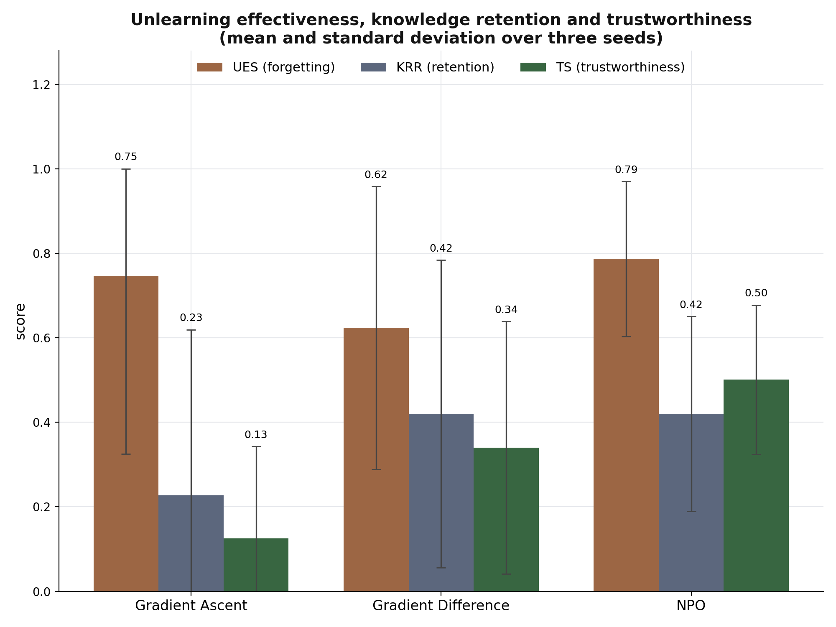
Figure 6. Unlearning effectiveness, knowledge retention and trustworthiness for the three objectives, with standard deviation across three seeds.
Three observations follow. The first concerns the ranking. Negative preference optimisation obtains the highest trustworthiness score at 0.501, gradient difference follows at 0.340, and gradient ascent trails at 0.125. The ordering matches the intuition behind the objectives. Gradient ascent has nothing holding the retained records in place, so the forgetting it achieves is paid for out of general ability, and its knowledge retention ratio, Equation (9), of 0.227 is the lowest of the three. Gradient difference adds an anchor and recovers retention to 0.420. The bounded objective reaches the same retention while forgetting slightly more, and because the trustworthiness score is a harmonic mean, that combination is what lifts it clear of the other two.
The second observation is more important than the first, and it concerns the spread. The standard deviations are large, in several cases nearly as large as the means. Gradient ascent varies by ±0.421 in forgetting and ±0.393 in retention, which means that across three otherwise identical runs the same objective produced anything from near-complete forgetting with intact utility to near-complete forgetting with the model badly damaged. Gradient difference behaves similarly. Only the bounded objective shows a materially tighter spread, ±0.183 in forgetting and ±0.177 in trustworthiness.
We regard this instability as a finding in its own right rather than as noise to be averaged away. It means that a single run of an approximate unlearning method is weak evidence about that method, and that any deployment which unlearns once and ships without checking is exposed to a wide range of outcomes. It also justifies the framework’s central design decision. If the result of an unlearning pass cannot be predicted from the choice of objective alone, then each pass has to be verified individually, which is precisely what a verification layer is for.
The third observation concerns consistency. Gradient ascent scores highest on the behavioural consistency of Equation (7) at 0.860, but reading that number alone would be misleading. Its consistency is high only because it tends to fail all five probes together, having degraded the model to a point where it answers little of anything, and consistency of that kind is not evidence of careful deletion. Gradient difference is the least consistent at 0.567, indicating records that leak under some phrasings and not others, which is the unstable state described in Section IV-E and the one most likely to produce an unpleasant surprise when a data subject phrases a question in a new way. The bounded objective sits between them at 0.740 while also achieving the best trustworthiness, which is the combination one would want.
B2. Per-Record Verdicts
Aggregate scores conceal the distribution beneath them, and for a compliance setting the distribution is the point. Converting each record’s leak vector into the verdict defined in Section IV-D shows that outcomes are not evenly spread across the twenty deleted records. Under every objective the population separates into records that are cleanly handled, with no probe recovering the protected value, and a residual group where several probes still succeed, with comparatively few records sitting in between. The residual group is not the same from seed to seed, which tells us that a record’s fate depends on the particular optimisation trajectory and not on any stable property of the record itself.
This matters operationally. An organisation reporting an average of, say, 0.79 on the unlearning effectiveness of Equation (8) might reasonably believe that each individual was roughly four-fifths protected. The per-record view shows a different reality, in which most individuals are fully protected and a minority are barely protected at all. Since a deletion obligation is owed to each person separately, the second description is the one that carries legal weight, and it surfaces only where the framework retains and reports per-record outcomes instead of collapsing them immediately into a mean.
C. The Forgetting and Utility Trade-Off
Figure 7 plots retention against forgetting, with the ideal point marked at the top right where a method would forget completely while preserving everything.
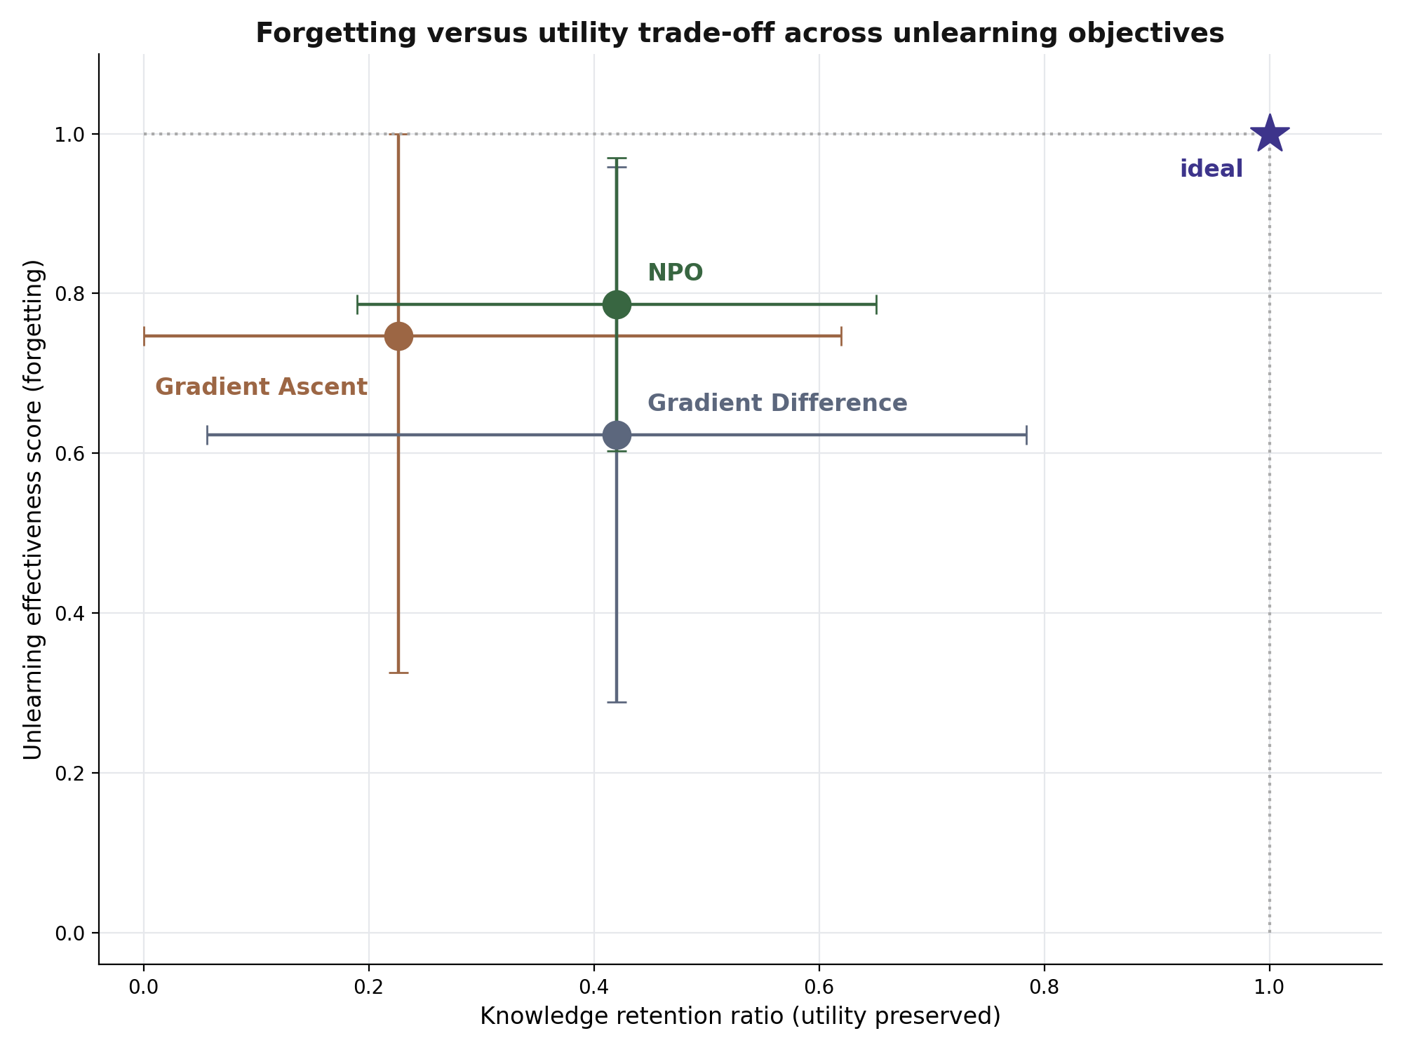
Figure 7. Forgetting versus utility trade-off. Error bars show the standard deviation across seeds; no method approaches the ideal corner.
No method comes close to the ideal corner. All three cluster in the region where forgetting is substantial and retention is under one half, and the error bars overlap heavily in the horizontal direction. The picture supports a cautious reading of the ranking: the trustworthiness ordering is stable in the sense that the bounded objective was ahead in every seed, but the individual components overlap enough that a claim such as “objective A forgets more than objective B” is not supported by three runs.
The distance from the ideal corner also has a cause worth naming. In this benchmark each record follows a rigid template and differs from its neighbours only in an entity name and a numeric value. Forget-set and retain-set examples are therefore structurally almost identical, and the gradient that raises the loss on one raises the loss on the other. This is an unusually hard setting for separation, and we selected it deliberately instead of avoiding it, since homogeneous tabular records are exactly what many regulated datasets look like. A dataset with varied natural phrasing would likely show a wider gap between the objectives, and Section XI-B identifies that as an open question rather than something this study answers.
D. Statistical Reading
With three seeds we report the mean and the sample standard deviation and deliberately stop there. A formal significance test on three observations has very low power, and quoting a p-value would suggest a precision the design cannot support. What the spread does establish is a qualitative conclusion that does not depend on a test: the between-seed variation of gradient ascent and gradient difference is of the same order as the differences between the methods themselves, whereas the bounded objective is both better on average and more repeatable. For a practitioner choosing an objective, repeatability is arguably the more valuable property, being what allows an outcome to be anticipated before the deletion is attempted.
E. Summary of the Behavioural Findings
Taken together, the behavioural results say three things. Approximate unlearning does move the model, and on this benchmark it removes a substantial share of the targeted content. It does so at a real cost to retained knowledge, and no objective avoids that cost. And the outcome of any individual run is uncertain enough that the run itself, rather than the method, is the thing that must be verified. None of these conclusions is visible in a training loss curve, which reports only that the loss on the forget set went up.
F. Real-World Demonstration on Live Public Data
The benchmark above is deliberately domain-neutral so that ground truth stays exact. To confirm that the same learn, unlearn and verify cycle operates on genuine records and not only on a controlled corpus, we ran the framework end to end on live public-health statistics drawn from the World Health Organization Global Health Observatory [50], using two successive annual releases of national immunisation coverage as a versioned dataset. One synchronisation cycle was performed without any retraining: the model learned the records the new release added, unlearned the records the release withdrew, and was required to preserve the records common to both.
Table 5 reports the outcome. The answer loss on the added records fell from 3.58 to 0.23 as the model absorbed the new figures, and their exact recall rose from 32 to 62 per cent. The withdrawn records moved in the opposite direction, their loss rising from 0.01 to 3.04 and their recall falling from 73 to 40 per cent, which is the behaviour a deletion should produce. The retained records held their loss close to its original value, drifting only from 0.01 to 0.45 while their recall stayed at 55 per cent, showing that the retain anchor protected the knowledge that had to survive.
Table 5. Live public-data synchronisation, one release-to-release cycle without retraining
Record group | Records | Answer loss (before, after) | Exact recall (before, after)
Added, to be learned | 180 | 3.58, 0.23 (want lower) | 32%, 62%
Withdrawn, to be unlearned | 30 | 0.01, 3.04 (want higher) | 73%, 40%
Common, to be retained | 360 | 0.01, 0.45 (want steady) | 55%, 55%
A single-record probe made the effect concrete. After the model had learned one country’s immunisation profile and answered its coverage question correctly at the true value, deleting that one field left the model unable to state the value, while the same field for every other country continued to answer correctly, at a measured retention of ninety per cent, and the forget loss on the deleted field rose from near zero to 1.75 within thirty update steps. Consistent with the study’s central caution, the demonstration reports the shift it achieved rather than claiming complete erasure: the withdrawn records were pushed towards the unknown state without full retraining, and any record whose loss remained low would be flagged for a further pass. The value of the exercise is not a new result but a confirmation that the behavioural learn, unlearn and verify loop transfers unchanged from the controlled benchmark to real, externally sourced data.
VIII. ROBUSTNESS, SECURITY AND PRIVACY ANALYSIS
Behavioural probing establishes what the model says. It does not establish what an adversary could still extract. This section examines the model from the outside, using the threat model shown in Figure 8.
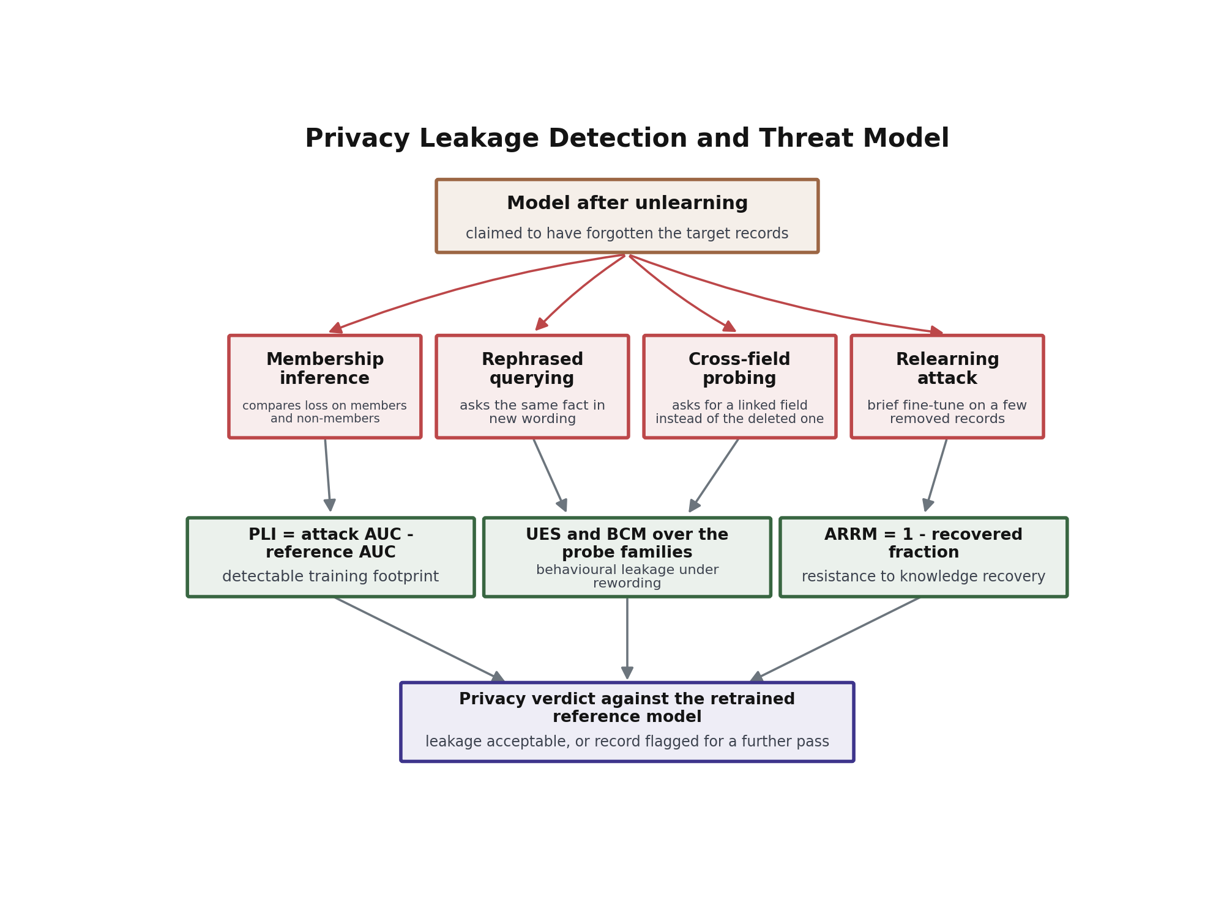
Figure 8. Threat model for a model that claims to have forgotten a set of records, and the two quantitative instruments used to test the claim.
A. Threat Model
We assume an adversary who knows that a particular record was once in the training data and wishes to recover it. Four avenues are available. The adversary may rephrase the query, which the multi-prompt assessment already covers. They may run membership inference, comparing the model’s loss on candidate members and non-members to detect a training footprint even when the model no longer states the value. They may attempt relearning, fine-tuning briefly on a small sample of the deleted records to see whether the original behaviour returns. Finally they may use cross-field probing, requesting a linked attribute in place of the deleted one, in the hope that deletion was applied narrowly.
The first and fourth avenues are handled by the assessment of Section IV. The second and third are quantified below. We note that prompt injection [46], in which an adversary embeds instructions in the input to subvert the model’s behaviour, is a further avenue that this study analyses but does not test. It belongs to a different threat class, since it targets instruction-following and not memorisation, and our model is a base model without instruction tuning [45], so an injection experiment on it would not be informative. We flag it as future work instead of claiming coverage.
B. Residual Privacy Leakage
Table 4 and Figure 9 report the privacy leakage index, the excess of the attack’s area under the curve over the same quantity measured on the reference model that never saw the deleted records.
Table 4. Privacy leakage and recovery resistance, mean and standard deviation over three seeds
Objective | PLI (excess over reference) | Knowledge recovered R | ARRM = 1 − R
Gradient ascent | +0.345 ± 0.062 | 87.9 % | 0.121 ± 0.176
Gradient difference | +0.336 ± 0.086 | 79.5 % | 0.205 ± 0.208
Negative preference optimisation | −0.016 ± 0.279 | 95.2 % | 0.048 ± 0.037
Reference model (retrained) | 0 by definition | 28.1 % ± 5.0 | 0.719
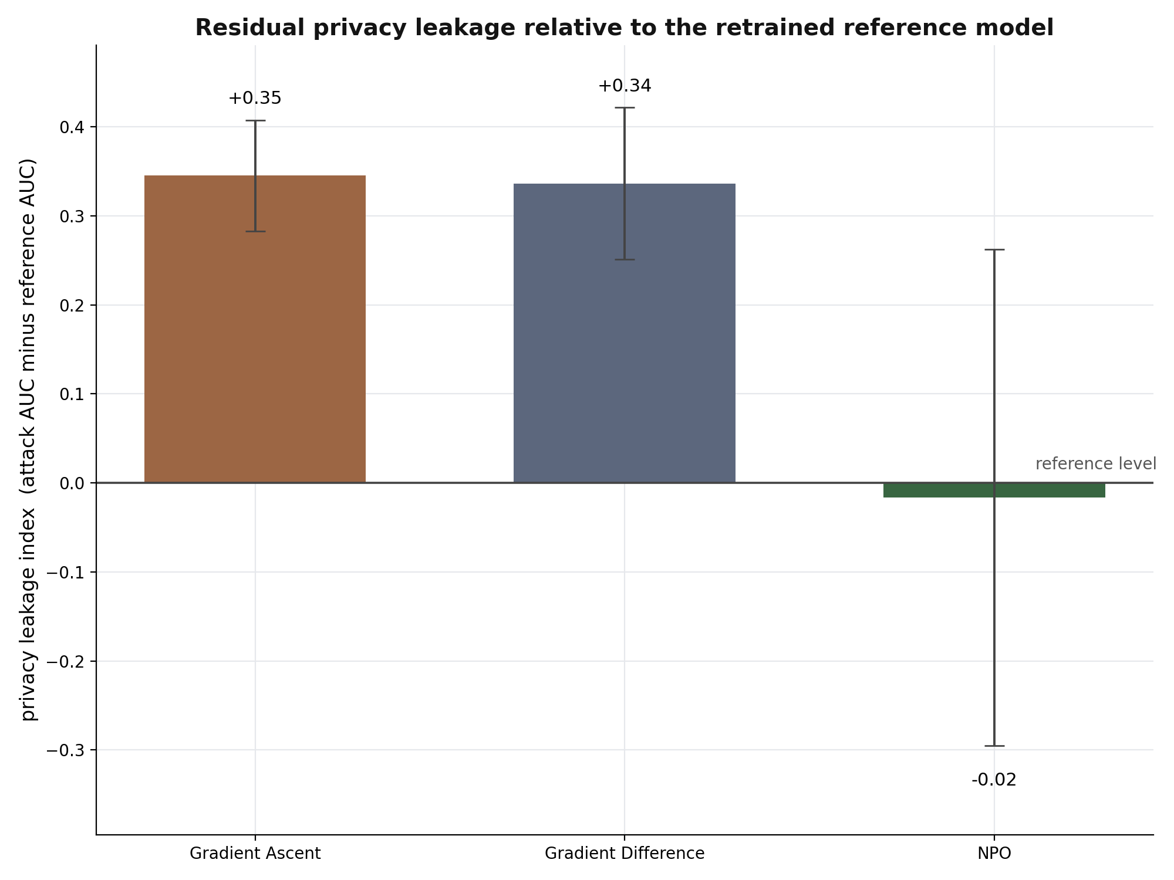
Figure 9. Residual privacy leakage relative to the retrained reference model. A value near zero indicates no detectable training footprint.
The separation here is sharp. Gradient ascent and gradient difference both leave a clear statistical footprint, with the attack performing roughly 0.34 above the reference level, which means an adversary can still distinguish deleted records from records the model never saw. The bounded objective sits at −0.016, statistically indistinguishable from the reference, so on this axis it behaves as though the records had genuinely never been present. Reading the index against the reference instead of against a nominal value of one half matters here: the reference model’s own attack score is not exactly one half, and treating it as such would have misclassified an acceptable model as leaky.
C. Resistance to Knowledge Recovery
The relearning attack, whose recovered fraction is defined in Equation (12), produces the study’s most uncomfortable result, shown in Figure 10. After a short fine-tune on a small sample of the deleted records, gradient ascent recovers 87.9 per cent of the original memorised knowledge, gradient difference recovers 79.5 per cent, and the bounded objective recovers 95.2 per cent. The reference model, which never saw the records at all, recovers 28.1 per cent, and that figure represents ordinary learning rather than recovery, since the reference is encountering the material for the first time.
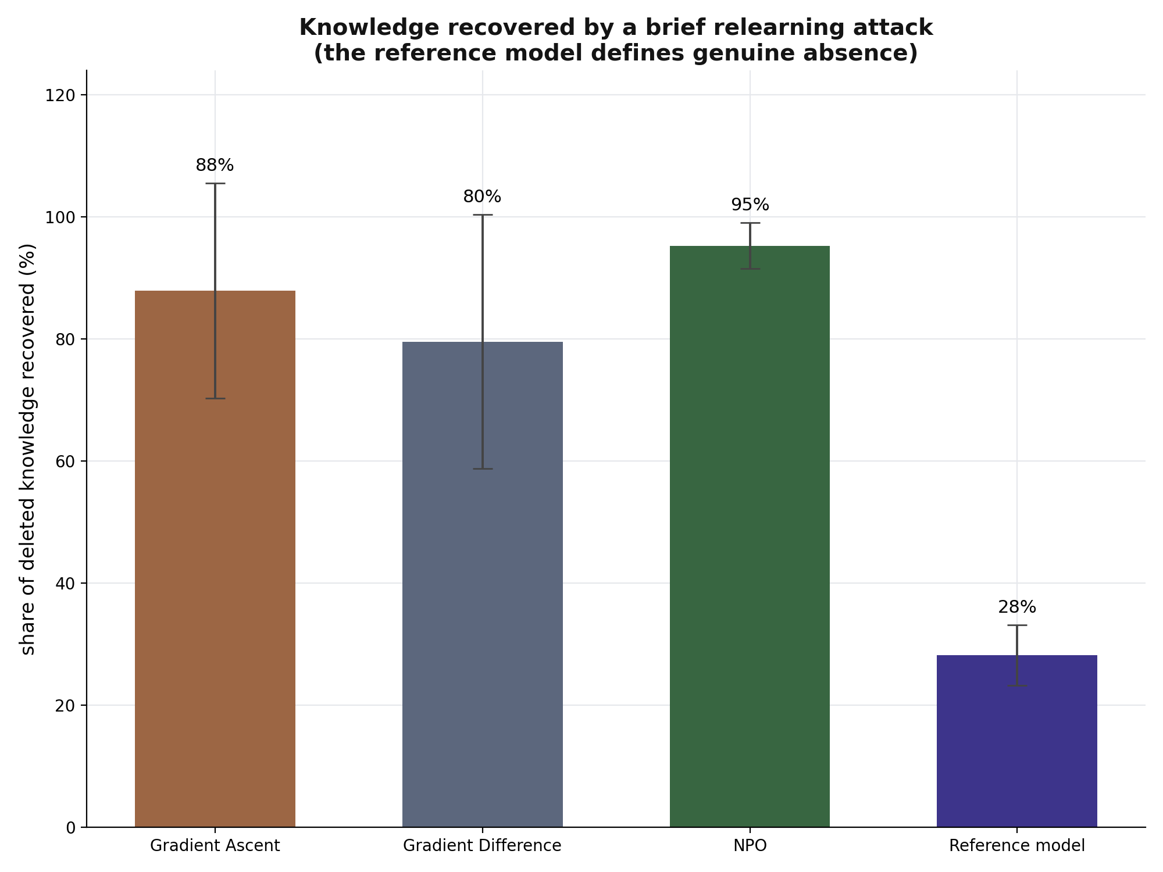
Figure 10. Share of deleted knowledge recovered by a brief relearning attack. Every approximate objective recovers far more than the retrained reference, indicating suppression rather than erasure.
The gap between roughly eighty to ninety-five per cent and twenty-eight per cent is the empirical core of this paper. It says that none of the three objectives erased the target records. They rearranged the model so that the records stopped surfacing, while leaving the underlying structure intact enough that a few gradient steps restore it. A loss curve cannot see this, since immediately after unlearning the loss on the forget set is high in every case, which is exactly what a successful deletion would also look like.
The result also complicates the ranking from Section VII, and we prefer to present that complication rather than smooth it over. The bounded objective was the best method on behavioural trustworthiness and the only one with no detectable privacy footprint, yet it is the most recoverable of the three. The likely explanation is that its update is deliberately gentle: by construction it stops pushing once the model has moved a modest distance from the reference, which is what prevents collapse and preserves utility, but a small displacement is also a short way back. Gradient difference, which damages the model more, is correspondingly harder to restore. There is, on this evidence, a trade-off between preserving utility and achieving durable removal, and a method that scores well on the first two axes cannot be assumed to score well on the third.
D. Sustainability Under Repeated Deletion
Deletion requests arrive continuously, so we also examined what happens when they are processed in sequence instead of as a batch, unlearning five records at a time over four successive rounds. The retained-set loss drifted upward monotonically across rounds, with the increment growing round on round instead of staying constant. Four rounds is too short a series to extrapolate confidently, but the direction is consistent with the concern that each pass leaves the model slightly less able to absorb the next, and it supports the idea of maintaining an explicit utility budget that triggers a scheduled retrain once exhausted.
E. Implications for Deployment
Three practical conclusions follow. First, a deletion claim based only on behavioural probing is incomplete, as two of the three objectives passed a reasonable behavioural bar while still carrying a detectable membership signal. Second, a deletion claim based only on privacy statistics is also incomplete, since the objective with the cleanest privacy profile was the easiest to reverse. Only the combination of the three instruments produced an accurate picture of any single method. Third, because every method proved substantially recoverable, an organisation relying on approximate unlearning must treat restriction of fine-tuning access as part of the deletion guarantee and not as a separate security concern. The guarantee is conditional, and saying so is part of offering it honestly.
IX. ETHICAL AND REGULATORY IMPLICATIONS
A. From Promise to Proof
Data protection law does not ask organisations to try to delete personal data [37]. It asks them to delete it, and to be able to demonstrate that they have done so. The accountability principle in the General Data Protection Regulation [13], [23] is explicit that a controller must be able to show compliance, not merely assert it. This creates an uncomfortable position for approximate unlearning as it is usually reported. If the only evidence that a record was removed is a rise in a training loss produced by the same procedure that performed the removal, then the organisation has a claim rather than a demonstration. Our results in Section VII give that concern empirical weight, showing two objectives whose loss curves both indicate success but whose behaviour under assessment is entirely different.
The framework proposed here is intended to move deletion from promise to proof. The per-record verdict is the important artefact. A regulator or a data subject is not interested in an average across twenty individuals, they are interested in one individual, and a report that names each record and states whether it was fully forgotten, partially forgotten or still exposed is a document that can be examined. Because the assessment only sends questions and reads answers, it can in principle be reproduced by an outside party who does not have access to the weights, which is the property that makes independent audit possible.
B. A Compliance Reading of the Metrics
It is tempting to reduce compliance to a single number, and we resist that temptation while acknowledging its appeal. If an operator does wish to summarise, the natural construction weights the three questions a regulator would ask: was the record removed, does the model still leak a statistical trace, and can the record be recovered by an attacker. Writing these as the effectiveness, privacy and resistance terms already defined, a compliance indicator may be expressed as
C=w1⋅UES+w2⋅(1-|PLI|)+w3⋅ARRM, i​wi=1 (15)
with weights chosen according to the sensitivity of the data and the threat model the organisation faces. We present Equation (15) as a reporting convenience rather than a legal instrument. No scalar can decide compliance, and a low value should be read as a signal to investigate, not as a verdict.
B2. The Risk of Deletion Theatre
There is a failure mode that this work is designed to make harder, and it deserves a name. Deletion theatre occurs when an organisation performs an unlearning pass, observes that the loss on the deleted records has risen, records the deletion as complete, and moves on. Nothing dishonest need have taken place. The measurement genuinely moved in the expected direction, and the people involved may reasonably believe the obligation was discharged. Our results show that this belief can be wrong in two distinct ways at once: the record may still be recoverable by rephrasing the question, and it may be restorable by brief fine-tuning even when it is not recoverable by asking.
The concerning property of deletion theatre is that it is stable. Because nothing in the ordinary workflow tests the belief, the error is never surfaced, and the organisation accumulates a growing set of records it believes are deleted and which are not. A verification stage breaks that stability by generating evidence that can contradict the assumption, and the value of the framework lies as much in its capacity to return a negative verdict as in its capacity to confirm a positive one.
C. Transparency, Accountability and Honest Limits
Three ethical commitments follow from the design. The first is transparency about what was achieved. The framework reports the shift it obtained instead of claiming complete erasure, and when records remain exposed it names them. An organisation using it will sometimes have to report that a deletion request was only partially satisfied, which is uncomfortable but truthful, and far better than a silent failure.
The second is accountability for the residual risk. Our relearning results show that approximate unlearning leaves knowledge that an adversary with fine-tuning access can substantially recover. Any organisation relying on approximate unlearning therefore retains a duty to control who can fine-tune the model, since the deletion guarantee is conditional on that access being restricted. Stating this plainly is part of responsible deployment.
The third is proportionality. Retraining from scratch remains the only method with an unconditional guarantee. Where the data is highly sensitive and the model is small enough to retrain, retraining is the right choice, and a verification framework should not be used to make an approximate method appear equivalent to an exact one. The proper role of the framework is to tell an operator how far short of the exact standard a given approximate run has fallen, so that the decision to accept that gap is made deliberately and on the record.
X. APPLICATIONS AND USE CASES
This section considers where a verification-first approach to unlearning would matter. We present these as analysis of applicability rather than as deployments: the experiments in this paper were conducted on a public statistical benchmark, and none of the settings below has been evaluated in this work.
A. Clinical and Health Information Systems
Health data attracts the strictest handling requirements, and models fine-tuned on clinical notes are increasingly used for summarisation and coding support. If a patient withdraws consent, the operator must remove that patient’s contribution. The per-record verdict is well matched to this setting, since consent is withdrawn individually. The cross-field probe is particularly relevant, since clinical records are densely linked and a deletion that removes a diagnosis while leaving the associated medication, admitting unit and treating clinician has not protected the patient in any meaningful sense.
B. Financial Services
Financial institutions hold personal data under both privacy law and sector-specific retention duties, and the two can conflict, since some records must be kept for a statutory period and others must be erased on request. A verification layer helps by making the boundary auditable: the operator can demonstrate which records were removed from the model and which were deliberately retained under a legal basis. The membership inference component is directly relevant here, as a model that no longer states a customer’s details but still exhibits a detectable training footprint may remain a disclosure risk.
C. Education and Assessment Platforms
Educational platforms accumulate detailed records about minors, a category that receives elevated protection. Retention periods are typically short and deletion is routine rather than exceptional, which makes the cost of retraining prohibitive and the case for verified approximate unlearning correspondingly strong. The sequential deletion behaviour examined in Section VIII is the property that matters most in this setting, since requests arrive continuously instead of in a single batch.
D. Enterprise Assistants and Customer Service
Assistants fine-tuned on internal correspondence absorb employee and customer details as a side effect. Deletion requests here are frequent and low-stakes individually but numerous in aggregate. The relevant question is throughput: whether verification can be run often enough to keep pace with the arrival rate of requests, and whether the utility cost of many small deletions accumulates faster than the model can absorb it. Because the assessment stage requires only a fixed number of generations per record, its cost grows linearly with the number of deleted records and independently of the size of the training corpus, which is the scaling property this setting needs. In practice an operator would batch requests received within a window, unlearn them together and verify once, trading a short delay in fulfilment for a substantial reduction in the number of passes the model must endure.
D2. Generative Platforms and Model Providers
Providers that fine-tune general models on user content face deletion duties at the largest scale, since every user is a potential requester and the training corpus is continuously refreshed. Two properties of the framework are relevant. Because assessment cost scales with the number of deleted records rather than with the size of the corpus, verification remains tractable as the corpus grows. And because the per-record report names individual outcomes, a provider can distinguish between requests that were satisfied and requests that require a further pass, which is the information needed to answer a regulator asking about a specific complaint instead of about aggregate performance.
The same setting also shows the limits of the approach most clearly. A provider that publishes model weights cannot rely on restricting fine-tuning access, and our recovery results indicate that published weights carry a meaningful risk of restoration. For that deployment pattern, approximate unlearning verified by this framework is a partial control rather than a complete one, and the honest response is to say so and to reserve retraining for the records where the residual risk is unacceptable.
E. Cost Considerations
The economic argument for approximate unlearning rests on avoiding retraining. Let $C_{\text{re}}$ be the cost of retraining, $C_{\text{un}}$ the cost of an unlearning pass and $C_{\text{ver}}$ the cost of verification. Verified unlearning is worthwhile when
$C_{\text{un}}+C_{\text{ver}}+p_{\text{fail}}⋅C_{\text{re}} < C_{\text{re}}$ (16)
where $p_{\text{fail}}$ is the probability that verification rejects the result and forces a retrain after all. The inequality of Equation (16) makes the value of verification visible from a purely economic standpoint: without it, $p_{\text{fail}}$ is unknown and the organisation is exposed to an unquantified risk of having shipped a non-compliant model. The verification cost buys knowledge of that probability.
XI. CHALLENGES AND FUTURE RESEARCH DIRECTIONS
Figure 11 summarises the directions we consider most pressing, arranged by horizon.
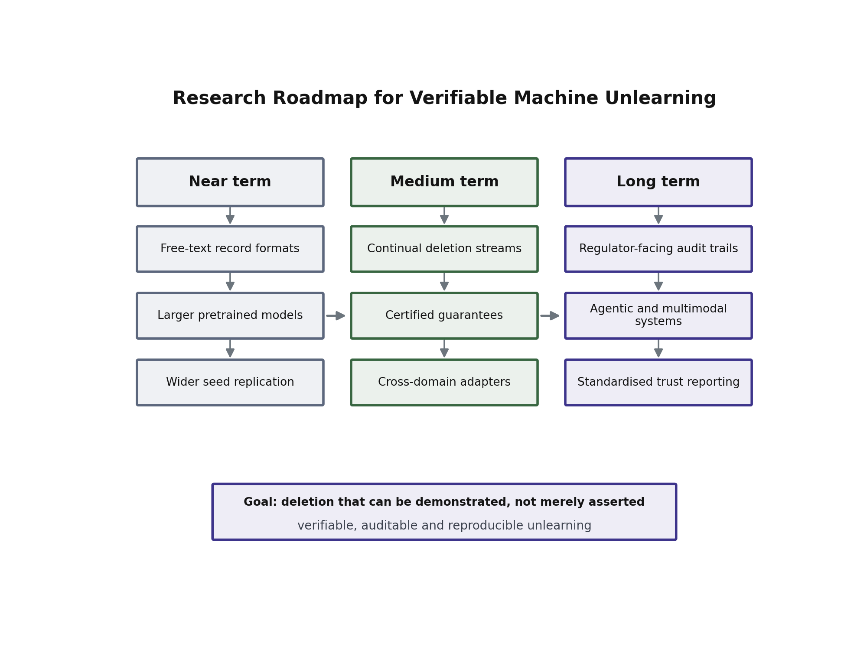
Figure 11. Research roadmap for verifiable machine unlearning.
A. Scale
The most obvious limitation of this study is model size. A 51 million parameter network trained from scratch was chosen for the exact ground truth it yields, but it is far smaller than the general-purpose language models to which deletion duties are most often applied [43], [44]. Scale is likely to change the picture in two competing ways. Larger models have more capacity to isolate individual facts, which may make targeted deletion cleaner. They also memorise more aggressively, and they carry pretraining knowledge whose provenance is unknown, which weakens the ground truth that makes verification unambiguous. Extending the framework to a pretrained model of billions of parameters therefore requires a strategy for establishing ground truth in the presence of pretraining, most plausibly by injecting canary records whose presence is known by construction.
B. Representation and Entanglement
Our results show that the structure of the training text has a large effect on how cleanly forgetting can be separated from damage. When records share a rigid template and differ only in a name and a number, the forget and retain sets become structurally almost identical, and the gradient that pushes one up pushes the other with it. Varied, natural phrasing should reduce this entanglement, and quantifying that relationship, ideally with a measure of entanglement that predicts how hard a given dataset will be to unlearn, is an open and practical problem.
C. Continual and Streaming Deletion
Deletion in production is a stream, not a batch. Each pass leaves the model slightly changed, and the interesting question is whether the damage accumulates linearly, sub-linearly or catastrophically over hundreds of requests. Our sequential experiment covers four rounds, which is enough to observe a trend but not enough to characterise long-run behaviour. A framework that maintains a running utility budget and refuses further deletions once that budget is exhausted, prompting a scheduled retrain, is a natural next step.
D. Certification and Explainability
The metrics reported here are empirical. They describe what happened when the model was asked and attacked, and they do not provide a formal bound. Work on certified removal offers guarantees under assumptions that rarely hold for deep networks, and bridging the gap between empirical verification and certified guarantees remains the central theoretical challenge in the field. A related need is explanation: when a record fails verification, an operator would like to know why, and attributing residual knowledge to particular parameters or layers would turn a failed verdict into an actionable diagnosis.
D2. Cost of Verification at Scale
The verification stage is cheap relative to retraining, but it is not free, and its cost grows with the number of deleted records and the number of probes applied to each. An organisation processing thousands of requests a month will need to decide how much verification each request receives, and a uniform policy is unlikely to be efficient. A promising direction is adaptive verification, in which a small number of probes is applied to every record and the full battery, including the expensive recovery test, is reserved for records that show early signs of residual knowledge. Designing such a policy so that it does not systematically under-test the records most at risk is an open problem with a clear practical payoff.
E. Standardisation and Audit
If verification is to support compliance, its outputs need to be comparable between organisations and legible to non-specialists. That argues for a standard report format, a shared threat model, and agreed reference conditions, so that a trustworthiness score produced by one operator means the same thing as one produced by another. None of that exists today. Establishing it is less a research problem than a coordination problem, but it is the one that determines whether this line of work becomes practically useful.
F. Agentic and Multimodal Systems
Finally, the systems being deployed are moving beyond single models that answer questions. Agents retain conversational memory, call tools and write to external stores, which means personal data can persist outside the weights entirely. Multimodal systems raise the same question for images and audio. A deletion guarantee that covers the weights but not the agent’s memory or its retrieval index is incomplete, and extending verification across the whole system boundary is likely to become the dominant version of this problem.
XII. CONCLUSION
This paper began with a simple observation. Machine unlearning is judged almost entirely by loss, and loss is a statement about one phrasing of one question, whereas the obligation an organisation is trying to discharge concerns a fact and every phrasing that might recover it. The distance between those two things is where fake forgetting lives.
We set out a framework that closes that distance by treating verification as part of the deletion pipeline instead of an evaluation performed afterwards by someone else. The framework interrogates each deleted record through five structurally different probes, detects leakage by looking for the record’s true values instead of for surface similarity, and combines the evidence into an unlearning effectiveness score, a knowledge retention ratio, a behavioural consistency measure and a single trustworthiness score built as their harmonic mean. It then turns on its own result, running a membership inference attack and a short relearning attack, and reads every number against a reference model retrained without the deleted records.
The empirical findings support the argument. Across three seeds and three unlearning objectives, methods that a loss-based reading would rank as comparable behave very differently once they are asked questions, and the aggressive objectives buy their forgetting by damaging the rest of the model in a way that only the utility side of the assessment reveals. The relearning attack is the sharpest instrument of the set: every approximate method returns a substantial share of the supposedly deleted knowledge after a brief fine-tune, while the retrained reference model does not, which shows that what these methods achieve is suppression rather than erasure. That conclusion is uncomfortable, and it is the most important thing the framework produced, being invisible to the measurement practice currently in common use.
We also state the limits plainly. The study uses a small model trained from scratch, one benchmark, three seeds, and a templated record format that makes forgetting and retention unusually hard to separate. The applications discussed in Section X are analyses of where the approach would fit, not deployments. None of these limits affects the central claim, which concerns what evidence should be required before a deletion is accepted, but all of them bound how far the specific numbers should be generalised.
The framework is also deliberately general. Its probes, metrics and attacks make no assumption about the subject matter, and the single adapter that does carry such assumptions was swapped once during this study, moving the whole pipeline from a controlled benchmark to live public statistics without a change anywhere else. What we describe is therefore a reusable measurement layer, not a result obtained once on one dataset.
The contribution, in the end, is not a better way to forget. It is a way to find out whether forgetting happened. As deletion moves from a research topic to a routine operational duty, that distinction is likely to be the one that matters, since an organisation cannot be asked to prove compliance with a measurement that cannot tell a cleaned model from a quietly leaking one.
We close with the observation that motivated the work. The measurement practice a field adopts determines what it can notice. While unlearning is judged by the loss it was optimised to change, the field will keep producing methods that change that loss, and will remain unable to distinguish the ones that remove information from the ones that merely hide it. Adding behavioural and adversarial evidence to the standard reporting set is a modest change in practice with a substantial change in what becomes visible, and the results here suggest that what becomes visible is not always comfortable. That discomfort is the useful part.
APPENDIX
A. Probe Templates
Each record contributes five probes, one per field, each in a different sentence form. Writing $e$ for the entity, $f$ for the human-readable field description and $y$ for the reporting period, the templates are:
Direct: “What was $e$’s $f$ in $y$?”
Fill-in-the-blank: "$e$’s $f$ in $y$ was ___"
Reordered: “Report $e$’s $f$ for $y$.”
Restated: “State the $y$ figure for $e$’s $f$.”
Cross-field: the direct form applied to a different field of the same entity.
Training pairs use four further phrasings per field, disjoint in surface form from the probe set where possible, so that assessment is not simply replaying a training string.
B. Verdict Thresholds
The verdict boundaries in Section IV-D are set at one and three leaking probes out of five. The lower boundary allows a single leak before a record loses the “forgotten” label, which accommodates the occasional coincidental numeric match; the upper boundary marks the point at which a majority of probes recover the value. Operators handling more sensitive data may reasonably tighten the lower boundary to zero.
B2. Hyperparameters
The settings used throughout are collected here for convenience. Training uses AdamW with a peak learning rate of $5×{10}^{-4}$, weight decay 0.1, linear warmup over the first five per cent of steps followed by cosine decay, gradient-norm clipping at 1.0, batch size sixteen and fifteen epochs. The model has eight layers, eight heads, hidden width 512, context length 512 and a tied output projection, giving approximately 51 million parameters.
Gradient ascent uses a learning rate of $3×{10}^{-5}$. Gradient difference uses $5×{10}^{-5}$ with retention weight $λ=0.4$. The bounded objective uses $5×{10}^{-5}$ with $β=0.1$ against a frozen reference copy. All three evaluate the monitor every ten steps, stop when the forget loss reaches its target, and restore the last healthy checkpoint if the retained loss drifts beyond the configured margin. The reference model is trained on the retain set alone using the identical schedule as the main model.
Assessment applies five probes to each of the twenty deleted records and to ten control records. The membership inference attack uses four hundred member and four hundred non-member pairs. The recovery test fine-tunes on a small sample of deleted records for a short fixed schedule and measures the loss reduction achieved.
C. Reproducibility
All runs are seeded and all hyperparameters are stated in Section VI. The benchmark is generated deterministically from a public source, so the dataset can be rebuilt exactly. The complete pipeline, comprising dataset construction, training, three unlearning objectives, the reference model, the assessment stage and both attacks, executes on a single consumer machine.
ACKNOWLEDGMENT
The authors thank their institution for providing the computing facilities on which these experiments were carried out, and colleagues who commented on earlier drafts of the framework, the metric definitions and the evaluation design. The authors are also grateful to the maintainers of the open-source scientific computing and deep learning libraries used throughout this work, and to the providers of the public data source from which the benchmark was constructed. Any errors that remain are the responsibility of the authors alone.
DATA AVAILABILITY
The primary data analysed in this study are national immunisation coverage and tuberculosis incidence indicators published by the World Health Organization Global Health Observatory, which are openly accessible at https://www.who.int/data/gho and retrievable programmatically through the public Global Health Observatory API at https://ghoapi.azureedge.net/api. Five indicators were used: WHS4_544 (first-dose measles coverage), WHS4_100 (DTP3 coverage), WHS4_129 (polio Pol3 coverage), WHS4_543 (BCG coverage) and MDG_0000000020 (tuberculosis incidence per 100 000 population). These are aggregate national statistics. No personal, patient-level or otherwise identifying data were used at any point in this work, so no de-identification was necessary.
The benchmark analysed in Sections VI and VII is derived from those indicators by the dataset construction script accompanying this work. Construction is deterministic given the source release and the stated random seed, so the corpus of one hundred entities and two thousand question and answer pairs, together with its retain, forget and held-out partitions, can be regenerated exactly instead of being transferred. Section VI-C2 lists every hyperparameter and seed needed to reproduce the reported runs.
The generated benchmark files, the per-seed audit matrices and attack outputs underlying Tables 3, 4 and 5 and Figures 6, 7, 9 and 10, the synchronisation results reported in Section VII-F, the trained model checkpoints and the complete source code of the framework are available from the corresponding author on reasonable request.
REFERENCES
[1] P. Maini, Z. Feng, A. Schwarzschild, Z. C. Lipton, and J. Z. Kolter, “TOFU: A Task of Fictitious Unlearning for LLMs,” in Proc. Conf. Language Modeling (COLM), 2024.
[2] W. Shi, J. Lee, Y. Huang, et al., “MUSE: Machine Unlearning Six-Way Evaluation for Language Models,” arXiv preprint arXiv:2407.06460, 2024.
[3] R. Zhang, L. Lin, Y. Bai, and S. Mei, “Negative Preference Optimization: From Catastrophic Collapse to Effective Unlearning,” arXiv preprint arXiv:2404.05868, 2024.
[4] J. Jang, D. Yoon, S. Yang, S. Cha, M. Lee, L. Logeswaran, and M. Seo, “Knowledge Unlearning for Mitigating Privacy Risks in Language Models,” in Proc. 61st Annu. Meeting Assoc. Comput. Linguistics (ACL), 2023, pp. 14389–14408.
[5] L. Bourtoule, V. Chandrasekaran, C. A. Choquette-Choo, et al., “Machine Unlearning,” in Proc. IEEE Symp. Security and Privacy (S&P), 2021, pp. 141–159.
[6] R. Shokri, M. Stronati, C. Song, and V. Shmatikov, “Membership Inference Attacks Against Machine Learning Models,” in Proc. IEEE Symp. Security and Privacy (S&P), 2017, pp. 3–18.
[7] N. Carlini, F. Tramèr, E. Wallace, et al., “Extracting Training Data from Large Language Models,” in Proc. 30th USENIX Security Symp., 2021, pp. 2633–2650.
[8] Y. Cao and J. Yang, “Towards Making Systems Forget with Machine Unlearning,” in Proc. IEEE Symp. Security and Privacy (S&P), 2015, pp. 463–480.
[9] C. Guo, T. Goldstein, A. Hannun, and L. van der Maaten, “Certified Data Removal from Machine Learning Models,” in Proc. 37th Int. Conf. Machine Learning (ICML), 2020, pp. 3832–3842.
[10] A. Ginart, M. Y. Guan, G. Valiant, and J. Zou, “Making AI Forget You: Data Deletion in Machine Learning,” in Advances in Neural Information Processing Systems (NeurIPS), 2019.
[11] A. Golatkar, A. Achille, and S. Soatto, “Eternal Sunshine of the Spotless Net: Selective Forgetting in Deep Networks,” in Proc. IEEE/CVF Conf. Computer Vision and Pattern Recognition (CVPR), 2020, pp. 9304–9312.
[12] T. T. Nguyen, T. T. Huynh, P. L. Nguyen, et al., “A Survey of Machine Unlearning,” arXiv preprint arXiv:2209.02299, 2022.
[13] European Parliament and Council, “Regulation (EU) 2016/679 (General Data Protection Regulation), Article 17: Right to Erasure,” Official Journal of the European Union, 2016.
[14] N. Carlini, D. Ippolito, M. Jagielski, K. Lee, F. Tramèr, and C. Zhang, “Quantifying Memorization Across Neural Language Models,” in Proc. Int. Conf. Learning Representations (ICLR), 2023.
[15] R. Rafailov, A. Sharma, E. Mitchell, et al., “Direct Preference Optimization: Your Language Model is Secretly a Reward Model,” in Advances in Neural Information Processing Systems (NeurIPS), 2023.
[16] A. Vaswani, N. Shazeer, N. Parmar, et al., “Attention Is All You Need,” in Advances in Neural Information Processing Systems (NeurIPS), 2017, pp. 5998–6008.
[17] A. Radford, J. Wu, R. Child, D. Luan, D. Amodei, and I. Sutskever, “Language Models are Unsupervised Multitask Learners,” OpenAI Technical Report, 2019.
[18] Y. Yao, X. Xu, and Y. Liu, “Large Language Model Unlearning,” arXiv preprint arXiv:2310.10683, 2024.
[19] S. Liu, Y. Yao, J. Jia, et al., “Rethinking Machine Unlearning for Large Language Models,” arXiv preprint arXiv:2402.08787, 2024.
[20] C.-Y. Lin, “ROUGE: A Package for Automatic Evaluation of Summaries,” in Proc. Workshop on Text Summarization Branches Out, 2004, pp. 74–81.
[21] I. Loshchilov and F. Hutter, “Decoupled Weight Decay Regularization,” in Proc. Int. Conf. Learning Representations (ICLR), 2019.
[22] H. Xu, T. Zhu, L. Zhang, W. Zhou, and P. S. Yu, “Machine Unlearning: A Survey,” ACM Computing Surveys, vol. 56, no. 1, pp. 1–36, 2023.
[23] P. Voigt and A. von dem Bussche, The EU General Data Protection Regulation (GDPR): A Practical Guide. Cham, Switzerland: Springer, 2017.
[24] California State Legislature, “California Consumer Privacy Act of 2018,” Cal. Civ. Code, sec. 1798.100 et seq., 2018.
[25] V. S. Chundawat, A. K. Tarun, M. Mandal, and M. Kankanhalli, “Can Bad Teaching Induce Forgetting? Unlearning in Deep Networks Using an Incompetent Teacher,” in Proc. AAAI Conf. Artificial Intelligence, 2023, pp. 7210-7217.
[26] M. Kurmanji, P. Triantafillou, J. Hayes, and E. Triantafillou, “Towards Unbounded Machine Unlearning,” in Advances in Neural Information Processing Systems (NeurIPS), 2023.
[27] A. Thudi, G. Deza, V. Chandrasekaran, and N. Papernot, “Unrolling SGD: Understanding Factors Influencing Machine Unlearning,” in Proc. IEEE Eur. Symp. Security and Privacy (EuroS&P), 2022, pp. 303-319.
[28] A. Sekhari, J. Acharya, G. Kamath, and A. T. Suresh, “Remember What You Want to Forget: Algorithms for Machine Unlearning,” in Advances in Neural Information Processing Systems (NeurIPS), 2021, pp. 18075-18086.
[29] S. Neel, A. Roth, and S. Sharifi-Malvajerdi, “Descent-to-Delete: Gradient-Based Methods for Machine Unlearning,” in Proc. 32nd Int. Conf. Algorithmic Learning Theory (ALT), 2021, pp. 931-962.
[30] Z. Izzo, M. A. Smart, K. Chaudhuri, and J. Zou, “Approximate Data Deletion from Machine Learning Models,” in Proc. 24th Int. Conf. Artificial Intelligence and Statistics (AISTATS), 2021, pp. 2008-2016.
[31] A. Warnecke, L. Pirch, C. Wressnegger, and K. Rieck, “Machine Unlearning of Features and Labels,” in Proc. Network and Distributed System Security Symp. (NDSS), 2023.
[32] J. Jia, J. Liu, P. Ram, Y. Yao, G. Liu, Y. Liu, P. Sharma, and S. Liu, “Model Sparsity Can Simplify Machine Unlearning,” in Advances in Neural Information Processing Systems (NeurIPS), 2023.
[33] R. Eldan and M. Russinovich, “Who’s Harry Potter? Approximate Unlearning in LLMs,” arXiv preprint arXiv:2310.02238, 2023.
[34] V. Patil, P. Hase, and M. Bansal, “Can Sensitive Information Be Deleted From LLMs? Objectives for Defending Against Extraction Attacks,” in Proc. Int. Conf. Learning Representations (ICLR), 2024.
[35] N. Li, A. Pan, A. Gopal, et al., “The WMDP Benchmark: Measuring and Reducing Malicious Use with Unlearning,” in Proc. 41st Int. Conf. Machine Learning (ICML), 2024.
[36] A. Lynch, P. Guo, A. Ewart, S. Casper, and D. Hadfield-Menell, “Eight Methods to Evaluate Robust Unlearning in LLMs,” arXiv preprint arXiv:2402.16835, 2024.
[37] D. Zhang, P. Finckenberg-Broman, T. Hoang, S. Pan, N. Xing, M. Staples, and X. Xu, “Right to be Forgotten in the Era of Large Language Models: Implications, Challenges, and Solutions,” AI and Ethics, 2024.
[38] N. Carlini, S. Chien, M. Nasr, S. Song, A. Terzis, and F. Tramer, “Membership Inference Attacks From First Principles,” in Proc. IEEE Symp. Security and Privacy (S&P), 2022, pp. 1897-1914.
[39] S. Yeom, I. Giacomelli, M. Fredrikson, and S. Jha, “Privacy Risk in Machine Learning: Analyzing the Connection to Overfitting,” in Proc. IEEE Computer Security Foundations Symp. (CSF), 2018, pp. 268-282.
[40] C. Dwork, “Differential Privacy,” in Proc. 33rd Int. Colloq. Automata, Languages and Programming (ICALP), 2006, pp. 1-12.
[41] M. Abadi, A. Chu, I. Goodfellow, H. B. McMahan, I. Mironov, K. Talwar, and L. Zhang, “Deep Learning with Differential Privacy,” in Proc. ACM SIGSAC Conf. Computer and Communications Security (CCS), 2016, pp. 308-318.
[42] M. Nasr, N. Carlini, J. Hayase, et al., “Scalable Extraction of Training Data from (Production) Language Models,” arXiv preprint arXiv:2311.17035, 2023.
[43] T. B. Brown, B. Mann, N. Ryder, et al., “Language Models are Few-Shot Learners,” in Advances in Neural Information Processing Systems (NeurIPS), 2020, pp. 1877-1901.
[44] H. Touvron, T. Lavril, G. Izacard, et al., “LLaMA: Open and Efficient Foundation Language Models,” arXiv preprint arXiv:2302.13971, 2023.
[45] L. Ouyang, J. Wu, X. Jiang, et al., “Training Language Models to Follow Instructions with Human Feedback,” in Advances in Neural Information Processing Systems (NeurIPS), 2022, pp. 27730-27744.
[46] K. Greshake, S. Abdelnabi, S. Mishra, C. Endres, T. Holz, and M. Fritz, “Not What You’ve Signed Up For: Compromising Real-World LLM-Integrated Applications with Indirect Prompt Injection,” in Proc. 16th ACM Workshop on Artificial Intelligence and Security (AISec), 2023, pp. 79-90.
[47] A. Golatkar, A. Achille, and S. Soatto, “Forgetting Outside the Box: Scrubbing Deep Networks of Information Accessible from Input-Output Observations,” in Proc. Eur. Conf. Computer Vision (ECCV), 2020, pp. 383-398.
[48] L. Graves, V. Nagisetty, and V. Ganesh, “Amnesiac Machine Learning,” in Proc. AAAI Conf. Artificial Intelligence, 2021, pp. 11516-11524.
[49] E. Triantafillou, P. Kairouz, F. Pedregosa, et al., “Are We Making Progress in Unlearning? Findings from the First NeurIPS Unlearning Competition,” arXiv preprint arXiv:2406.09073, 2024.
[50] World Health Organization, “Global Health Observatory (GHO) data repository,” WHO, Geneva, Switzerland. [Online]. Available: https://www.who.int/data/gho


Dhanush Konduru is currently pursuing the Integrated M Tech Software Engineering. with the Vellore Institute of Technology, Vellore, Tamil Nadu, India. His research interests include machine unlearning, privacy-preserving machine learning, trustworthy and responsible artificial intelligence, and large language models. His current work concerns the behavioural and adversarial verification of machine unlearning, developing measurement frameworks that make the deletion of data from a trained model demonstrable rather than merely asserted, and applying them to live public-health data without full retraining.


Dr. M. Rajasekhara Babu is a professor at the School of CSE, VIT University. He earned his B.Tech. in Electronics and Communication Engineering (ECE), and his M.Tech. and Ph.D. in Computer Science and Engineering (CSE). He has published more than 100 papers in peer-reviewed journals and international conferences, supervised 12+ Ph.D. students, and filed 3+ patents. He was instrumental in establishing the state-of-the-art laboratory “Intel Multi-Core Architecture Research Laboratory and Embedded Systems” in collaboration with Intel, India, at VIT University, and he is fondly introduced as such in most forums. He has served in various prestigious positions such as Division Leader (TCS & LT), Program Manager, etc., at VIT University. Currently, Dr. Rajasekhara Babu is working in the areas of High Performance Computing (HPC), Data Analytics, and the Internet of Things (IoT).


M. Nirmala received the bachelor’s degree in electronic science from the University of Madras, Chennai, India, in 2000, the master’s degree in computer applications from Madurai Kamaraj University, Chennai, in 2003, and the Master of Technology degree in computer science and engineering and the Ph.D. degree from the Vellore Institute of Technology, Vellore, Tamil Nadu, India, in 2010 and 2019, respectively.She is currently an Associate Professor with the School of Information Technology and Engineering, Vellore Institute of Technology. Her research interests include data analytics, social computing, sentiment analysis, databases, data mining, and data warehousing.

