Article
A Geospatial Intelligence Framework for Evidence-Based Urban Infrastructure Location Selection in Rapidly Urbanising Cities
Integrating Multi-Temporal Satellite Remote Sensing, Cellular Automata–Artificial Neural Network Growth Modelling, and Spatial Multi-Criteria Decision Analysis
Dhanush Konduru ^{1,*}
1 Department of Integrated M Tech Software Engineering, Vellore Institute of Technology, Vellore 632014, Tamil Nadu, India
* Correspondence: dhanush.konduru@2022vitstudent.ac.in
Anusha B ^{2,*}
2 Department of Integrated M Tech Software Engineering, Vellore Institute of Technology, Vellore 632014, Tamil Nadu, India
* Correspondence: anusha.b2022@vitstudent.ac.in

Abstract: Rapid urbanisation in developing cities creates a persistent mismatch between where populations reside and where critical infrastructure is located. Decisions on the geographic positioning of new facilities—hospitals, schools, markets, residential complexes, shopping centres, or sports infrastructure—are routinely made through reactive, data-poor processes that ignore future urban growth trajectories. This paper introduces the Geospatial Intelligence (GI) Framework, a unified, facility-agnostic four-stage pipeline that simultaneously resolves three deficiencies of existing approaches: static orientation, facility specificity, and inaccessibility in resource-constrained planning environments. The framework integrates multi-temporal Land Use/Land Cover (LULC) classification through Random Forest machine learning applied to Landsat satellite imagery, prospective urban growth simulation via a Cellular Automata–Artificial Neural Network (CA-ANN) model trained on observed land transition dynamics, and spatial Multi-Criteria Decision Analysis (MCDA) through the Analytical Hierarchy Process (AHP). Its defining innovation is the direct encoding of CA-ANN growth forecasts as a first-order placement criterion, aligning recommendations with the urban landscape that will exist over a facility’s operational lifetime. A configurable weight taxonomy spanning seven facility categories enables cross-facility adaptation without methodological modification. The framework is validated in Vellore, Tamil Nadu, India, using hospital placement as the demonstration case. Landsat 8/9 imagery from 2013 to 2024 reveals built-up expansion from 29.0% to 38.8% of the 488 km² study area. CA-ANN simulation projects a further 40.7 km² of growth by 2035. AHP-weighted overlay (Consistency Ratio = 0.0117) identifies five high-priority placement zones whose collective deployment raises population coverage from 77.1% to approximately 92–95%. The highest-priority zone delivers a 7.44 percentage point coverage improvement using exclusively open-access data and open-source computation.
Keywords: urban infrastructure location selection; geospatial decision support; LULC classification; Random Forest; CA-ANN urban growth modelling; Analytical Hierarchy Process; spatial MCDA; facility-agnostic framework; spatial planning; developing cities

1. Introduction
1.1. Background and Motivation
The spatial organisation of cities is fundamentally a question of alignment—between where people are and where the infrastructure serving them is located. When this alignment is maintained, cities function as engines of welfare, productivity, and social equity. When it breaks down, as it systematically does in the rapidly urbanising secondary cities of the developing world, the consequences include inaccessible public services, underutilised facilities in declining areas, and populations in newly urbanised zones excluded from the infrastructure that defines urban quality of life. Seto et al. [1] project that global urban land cover will expand by up to 1.2 million km² by 2030, with the majority of this expansion occurring in Asia and Africa. The United Nations reports that by 2050, 68% of the global population will reside in urban areas, concentrated in cities that currently lack the institutional capacity and analytical tools to anticipate and respond to it [2].
The infrastructure location selection problem—determining where to establish new facilities of any type—is among the most consequential and least rigorously addressed challenges in urban planning practice. The diversity of facility types is enormous: hospitals, schools, commercial markets, residential complexes, shopping centres, sports infrastructure, and emergency services. Despite this diversity, the analytical challenge is structurally constant. Each facility type requires answers to the same fundamental spatial questions: Where is demand currently concentrated? Where are existing facilities failing to serve the population? Where will demand be located over the next decade? How physically accessible is any candidate location? Is land available for development? The particulars of how these questions are weighted vary by facility type, but the underlying spatial logic does not.
1.2. Research Gap
Existing approaches to infrastructure location selection in rapidly urbanising contexts suffer from three interrelated deficiencies that have been independently documented but never simultaneously resolved in a single published system. First, they are primarily ‘static’: they assess present conditions without reference to future urban states, systematically misaligning long-lived infrastructure with the population distribution it will actually serve [3,4]. Urban infrastructure operates for 30–50 years; a hospital built today must serve populations in 2055. Yet the dominant GIS-MCDA approach assesses only present demand [5,6,7]. Second, approaches are facility-specific: the literature is fragmented across healthcare [5], education [6,7,20,22], commercial development [8], and other infrastructure [19,21], with no unified frameworks functioning across categories. Third, approaches frequently depend on proprietary data or software, excluding planners in resource-constrained environments where the infrastructure deficit is most acute.
While urban growth prediction via Cellular Automata–Artificial Neural Network (CA-ANN) modelling has been well-established as an independent research stream [3,9,16,17,18], and GIS-based MCDA for facility location selection has been extensively applied across individual facility types [5,6,7,8,19,20,21,22], no published system formally links these two capabilities into a unified, facility-agnostic pipeline in which growth forecasts are encoded as a first-order location criterion. Gaur and Singh [4] explicitly identify this as an unaddressed research priority in their 2023 comprehensive review, noting that LULC change modelling and facility planning have evolved as parallel literatures without formal methodological integration.
1.3. Research Objectives
This paper addresses the identified research gap through four explicit objectives:
(1) To formally specify a four-stage geospatial intelligence pipeline integrating LULC classification, CA-ANN growth simulation, and AHP-based MCDA for evidence-based urban infrastructure location selection applicable across all facility types.
(2) To demonstrate that CA-ANN growth forecasts can be directly encoded as a first-order AHP placement criterion, producing prospectively-oriented recommendations aligned with future demand over the full operational lifetime of the infrastructure.
(3) To operationalise facility agnosticism through a documented, theoretically grounded criteria weight taxonomy spanning seven urban facility categories, enabling planners across planning domains to use the same analytical pipeline without methodological modification.
(4) To validate the framework empirically in Vellore, Tamil Nadu, India, using quantitative population coverage gain as the primary outcome metric, demonstrating policy-relevant results derivable entirely from open-access data and open-source computation.
1.4. Contributions
The specific contributions of this paper are: (1) the first formally specified Geospatial Intelligence (GI) Framework integrating LULC classification [10,11,12,13,14,15], CA-ANN growth simulation [9,16,17,18], and AHP spatial MCDA [24] into a four-stage pipeline applicable across all urban facility categories; (2) demonstrated direct integration of CA-ANN growth forecasts as a first-order AHP criterion, operationalising the integration priority identified by Gaur and Singh [4]; (3) a documented criteria weight taxonomy for seven urban facility categories informed by facility-specific literature [5,6,7,8,19,20,21,22]; and (4) empirical validation in Vellore, India, with quantitative population coverage assessment demonstrating policy-relevant outcomes.
1.5. Paper Structure
The remainder of this paper is organised as follows. Section 2 reviews the relevant literature across the three methodological pillars and characterises the research gap. Section 3 presents the four-stage GI Framework specification (Materials and Methods). Section 4 presents Results from the Vellore hospital location case application. Section 5 presents Discussion. Section 6 presents Conclusions.
2. Literature Review
2.1. LULC Classification and Urban Change Detection
Random Forest has become the dominant classification algorithm for urban LULC studies, valued for robustness to training sample variation, non-linear class boundaries, and high-dimensional feature spaces [11,23]. Amini et al. [10] demonstrated that RF applied to Landsat time series in Google Earth Engine achieved overall accuracy of 94.4% (Kappa = 0.93), substantially outperforming baseline global products and confirming RF’s superiority for multi-temporal urban classification. Tikuye et al. [12] applied RF to multi-temporal Landsat data in the Upper Blue Nile River Basin, Ethiopia, achieving Kappa = 0.81–0.91 across three classification periods. Moharir et al. [13] developed an enhanced RF approach for Landsat-8 in Maharashtra, India, demonstrating effective performance in post-monsoon South Asian urban landscapes directly comparable in spectral character to the Vellore case application. Maxwell et al. [23] confirmed RF’s consistent superiority over parametric classifiers through a comprehensive applied review of machine learning classification in remote sensing.
The integration of spectral indices alongside raw spectral bands consistently improves classification accuracy for built-up area discrimination [13,14,15]. El-Zeiny and Effat [14] demonstrated effective spatiotemporal LULC monitoring using multi-index feature vectors in urban Egyptian contexts. El-Zeiny and Effat [15] subsequently applied machine learning for LULC change modelling in El-Fayoum, reporting Kappa values above 0.90, confirming that index-augmented feature vectors substantially reduce class confusion between built-up and bare/fallow land—the dominant classification challenge in South Asian secondary cities.
2.2. CA-ANN Urban Growth Modelling
Cellular Automata models for urban growth simulation have matured considerably through the integration of Artificial Neural Networks, which replaced expert-specified transition rules with data-driven probability surfaces learned from historical LULC transitions—a development that substantially increased both accuracy and geographic transferability [3,9]. Gharaibeh et al. [9] provided the most directly applicable demonstration, showing that ANN augmentation of a CA-Markov Chain model improved predictive accuracy from 86.29% to 90.04% in a Jordanian secondary city. The five-driver specification—distance to built-up, roads, urban centre, slope, and neighbourhood density—applied by Gharaibeh et al. [9] forms the basis of the GI framework’s Stage II. Mondal et al. [16] validated CA-ANN for Bihar, India, predicting built-up expansion through 2050. Kumar and Agrawal [17] applied CA-ANN specifically to Indore—a rapidly growing Indian secondary city comparable to Vellore in scale and growth dynamics—identifying spatially differentiated growth hotspots with direct infrastructure planning applications. Xing et al. [18] confirmed the model’s capacity for annual-granularity projections directly applicable to 2030 and 2035 planning horizons.
Aburas et al. [3] reviewed CA-based urban growth models across a decade of literature and identified the five spatial driver set as the most consistently applicable across geographic and data-availability contexts. Gaur and Singh [4] identified in a 2023 comprehensive review that integrating CA-ANN growth forecasts directly into facility location criteria—rather than treating them as background context—represents a critical unaddressed research priority that the GI framework directly implements.
2.3. Spatial MCDA for Infrastructure Location Selection
GIS-based Multi-Criteria Decision Analysis has been applied to infrastructure location selection across diverse facility types with growing sophistication. For healthcare: Tripathi et al. [5] compared AHP and fuzzy AHP for hospital location selection in Prayagraj, India, confirming that AHP’s Consistency Ratio verification makes it more transparent and defensible for public planning contexts. Hariz et al. [19] extended MCDA to healthcare waste infrastructure location selection using GIS-based weighted overlay. For education: Meena et al. [6] conducted GIS-based spatial analysis of school accessibility in Prayagraj, India; Sakti et al. [7] integrated natural hazard data with accessibility criteria for school location selection in Indonesia, directly analogous to the GI framework’s C5 hazard safety criterion; Prasetyo et al. [20] applied GIS-MCDA to public school location selection in Surabaya; Mustaffa et al. [22] applied GIS-MCDA to school location selection in Malacca, Malaysia. For other infrastructure types: Naranjo et al. [8] demonstrated AHP as a general multicriteria decision tool applicable across any facility location problem; Güler and Yomralioglu [21] demonstrated AHP applicability to EV charging station location selection. Maxwell et al. [23] confirmed the broad applicability of machine learning approaches across geospatial classification contexts.
2.4. Research Gap: The Absent Integration
The foregoing review establishes that urban growth prediction [3,9,16,17,18] and spatial facility location selection [5,6,7,8,19,20,21,22] have developed as parallel, well-established methodological traditions that have never been formally combined in a single, fully specified, facility-agnostic pipeline. CA-ANN frameworks produce detailed, spatially explicit projections of where urban growth will occur over 5–15 year planning horizons but terminate at this prediction without connecting it to facility placement decisions. GIS-MCDA frameworks assess facility location suitability based on present spatial conditions without encoding prospective growth trajectories as formal weighted criteria. Gaur and Singh [4] explicitly identify this integration as an unaddressed research priority. The GI framework presented in this paper is the first formally specified, fully validated system to resolve this gap, encoding CA-ANN growth forecasts as a first-order facility location criterion operationalised across seven facility categories.
3. Materials and Methods
3.1. Framework Overview and Design Principles
The Geospatial Intelligence (GI) Framework is a four-stage pipeline in which the outputs of each stage constitute formal inputs to the subsequent stage. Three core design principles govern the framework architecture. First, prospective orientation: CA-ANN growth forecasts are encoded as a first-order placement criterion (C3), not contextual background, directly operationalising the research priority identified by Gaur and Singh [4]. Second, facility agnosticism: the data pipeline, computational methods, and evaluation metrics are invariant across all facility types; only the AHP weight vector changes, enabling the same system to serve health planners [5], education authorities [6,7], commercial developers [8], and emergency service providers [19]. Third, open-access reproducibility: all components operate using freely available Landsat satellite imagery, OpenStreetMap road and facility data, and open-source Python libraries, ensuring applicability in the resource-constrained secondary city environments where the infrastructure deficit is most acute [1,2]. The end-to-end framework architecture is illustrated in Figure 1.
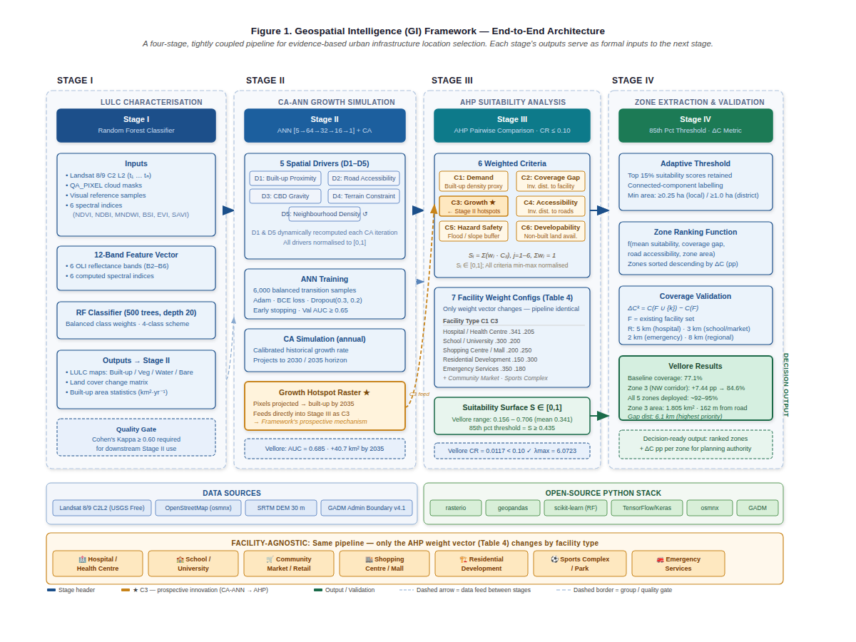

Figure 1. GI Framework—End-to-End Architecture. A four-stage tightly coupled pipeline. Stage I produces LULC maps from Landsat imagery using Random Forest [10,11,12,13]. Stage II uses these maps as inputs to CA-ANN growth simulation [9,16,17,18], producing a growth hotspot raster that feeds directly into Stage III as criterion C3—the prospective integration mechanism. Stage III applies AHP-MCDA [5,24] with facility-specific weights to produce a continuous suitability surface. Stage IV extracts ranked candidate zones and validates population coverage using the ΔC metric. Only the AHP weight vector varies by facility category.
Table 1. GI Framework—Stage-by-Stage Workflow Summary.
Stage | Name | Primary Inputs | Primary Outputs | Method | Facility Dependent?
I | LULC Characterisation | Landsat C2 L2; QA masks; reference samples | LULC maps (t₁–tₙ); change matrix; built-up statistics | Random Forest (500 trees, 12-band features) [10,11] | No — common to all
II | CA-ANN Growth Simulation | Stage I LULC + five spatial drivers (D1–D5) | Projected LULC 2030/2035; growth hotspot raster (→C3) | ANN [5→64→32→16→1] + CA iteration [9,16] | No — common to all
III | AHP Suitability Analysis | Stage I+II outputs + OSM roads & facilities | Continuous suitability surface S ∈ [0,1] | AHP pairwise comparison; CR ≤ 0.10 [24] | Yes — weights vary by facility
IV | Zone Extraction & Validation | Suitability surface + existing facility locations | Ranked candidate zones; marginal coverage gain ΔC | 85th percentile threshold + ΔC metric | Threshold varies by facility

3.2. Stage I—Multi-Temporal LULC Characterisation
3.2.1. Data Acquisition
Multi-temporal Landsat Collection-2 Level-2 surface reflectance imagery is acquired for a minimum of two periods separated by at least five years, with consistent seasonal timing to minimise phenological confounds [12,13,14]. A minimum of three acquisition dates is recommended to support CA-ANN training with sufficient historical transition coverage. Cloud-contaminated pixels are masked using the QA_PIXEL band. Surface reflectance values are converted using the USGS standard scale factor (0.0000275) and additive offset (−0.2).
3.2.2. Feature Engineering
A 12-dimensional feature vector is constructed per pixel comprising six raw OLI surface reflectance bands (B2–B6 for Landsat 8/9) and six derived spectral indices, following the approach validated by Amini et al. [10] and Moharir et al. [13]: (i) NDVI = (B5−B4)/(B5+B4)—discriminates vegetated from non-vegetated surfaces; (ii) NDBI = (B6−B5)/(B6+B5)—enhances built-up areas relative to surrounding land cover [13]; (iii) MNDWI = (B3−B6)/(B3+B6)—isolates water bodies, reducing water/built-up confusion [14]; (iv) BSI = [(B6+B4)−(B5+B2)]/[(B6+B4)+(B5+B2)]—separates bare soil and construction sites [13]; (v) EVI = 2.5×(B5−B4)/(B5+6·B4−7.5·B2+1)—improves vegetation discrimination in high-density canopy areas; (vi) SAVI = 1.5×(B5−B4)/(B5+B4+0.5)—reduces soil background influence in peri-urban fringe zones.
3.2.3. Classification and Accuracy Assessment
A Random Forest classifier [11] (500 trees, maximum depth 20, balanced class weights) is trained independently for each acquisition year following the protocol established by Amini et al. [10] and validated by Tikuye et al. [12] and Maxwell et al. [23]. Training samples are assembled from visually verified reference pixels from Google Earth historical imagery and threshold-based spectrally pure samples (NDVI > 0.4 for vegetation; NDBI > 0.1 and NDVI < 0.1 for built-up; MNDWI > 0.2 for water). A minimum four-class scheme is applied: Built-up/Impervious; Vegetation; Water; Bare/Fallow Land. Classification accuracy is assessed using Cohen’s Kappa coefficient on an independent hold-out set (minimum 20% of samples, spatially stratified) [10,12,23]. Kappa ≥ 0.60 is required as the quality gate for downstream use. Five-fold cross-validation assesses generalisation variance.
3.3. Stage II—CA-ANN Urban Growth Simulation
3.3.1. Spatial Driver Specification
Five spatial drivers are computed from Stage I outputs and ancillary data, forming the ANN’s input layer. This five-driver specification is validated across diverse urban contexts by Gharaibeh et al. [9], Mondal et al. [16], and Aburas et al. [3]. Full driver specifications are presented in Table 2.
Table 2. CA-ANN Spatial Drivers and Rationale.
Driver | Computation | Urban Growth Rationale | Data Source | Updated Each CA Step?
D1: Built-up proximity | Euclidean distance to nearest built-up pixel at t₁, inverted and normalised | Growth is proximity-dependent; cells adjacent to existing fabric convert first due to infrastructure spillover and reduced development cost [3,9] | Stage I LULC | Yes — dynamic
D2: Road accessibility | Distance to OSM road network (all highway classes), inverted and normalised | Roads are the primary catalyst of peri-urban expansion; reduced transport cost opens land for conversion [9,17] | OpenStreetMap | No — static
D3: Urban centre gravity | Distance to CBD centroid, inverted and normalised | Employment and commercial concentration drives residential proximity preference; agglomeration effects create centripetal growth pressure [9] | OSM centroid | No — static
D4: Terrain constraint | Slope in degrees from SRTM DEM, inverted and normalised (flat land = high suitability) | Steep terrain imposes physical and economic construction barriers; flat land converts preferentially across all urban contexts [16,18] | SRTM DEM 30 m | No — static
D5: Neighbourhood density | Proportion of built-up pixels within a 5×5 pixel window, normalised | Local density creates self-reinforcing growth clusters; service co-location and social network effects accelerate infill development [9,18] | Stage I LULC | Yes — dynamic

3.3.2. ANN Architecture and Training
An ANN with architecture [5→64→32→16→1] is trained on land cover transition samples derived from Stage I multi-temporal LULC maps, following the architecture validated by Gharaibeh et al. [9]. Training samples are pixel-level records comprising the five normalised driver values and a binary transition label (1 = converted from non-built to built-up between t₁ and t₂; 0 = remained non-built). A balanced 1:1 positive-to-negative sample ratio (3,000 of each) corrects for class imbalance inherent in urban growth data [16]. Training configuration: ReLU activation for all hidden layers; sigmoid activation for the output layer producing transition probability in [0,1]; binary cross-entropy loss; Adam optimiser (learning rate 0.001); batch normalisation after each hidden layer; dropout regularisation (0.3 and 0.2 after layers 1 and 2); early stopping (patience 15 epochs, monitoring validation AUC). Minimum acceptable validation AUC = 0.65 [9,16].
3.3.3. CA Simulation and Growth Hotspot Generation
The CA simulation iteratively applies the ANN-derived transition probability surface to simulate urban growth toward the planning horizon. At each annual time step, the highest-probability non-built pixels are converted to built-up at a rate calibrated to the observed historical growth rate derived from the Stage I LULC change matrix. Drivers D1 and D5 are dynamically recomputed after each iteration, reflecting the self-reinforcing character of urban growth [18]. The Stage II output—a growth hotspot raster identifying pixels projected to transition to built-up by 2030 or 2035—is encoded directly as criterion C3 in Stage III. This Stage II-to-Stage III connection is the GI framework’s defining contribution: rather than treating growth predictions as background context [9,16,17], the GI framework formalises them as a weighted AHP placement criterion, implementing the integration priority of Gaur and Singh [4].
3.4. Stage III—Spatial MCDA Suitability Analysis
3.4.1. Criteria Specification
Six spatial criteria are computed as normalised rasters from Stage I and II outputs and OpenStreetMap data. All criteria are min-max normalised to [0,1]; criteria where lower raw values indicate higher suitability are inverted as Cₙ = 1 − (x − xₘᵢₙ)/(xₘᵃˣ − xₘᵢₙ). Criterion specifications are presented in Table 3.
Table 3. Placement Criteria Specification and Operationalisation. ★ denotes the novel prospective criterion fed directly from Stage II.
ID | Criterion | Operationalisation | Data Source | Direction | Literature Basis
C1 | Demand Concentration | Built-up density in a 450 m radius moving window as proxy for population density; WorldPop or HRSL raster where available | Stage I LULC or population raster | Maximise | [5,6]
C2 | Coverage Gap | Inverse Euclidean distance to nearest existing facility of target type; cells far from existing facilities receive highest scores | OSM facility point features | Maximise | [5,19]
C3 ★ | Growth Alignment | Inverse Euclidean distance to CA-ANN growth hotspot pixels projected to transition by 2030–2035 — the framework’s prospective integration mechanism (novel) | Stage II hotspot raster | Maximise | [4,9] novel
C4 | Physical Accessibility | Inverse distance to OSM road/transit network; cells proximate to road infrastructure receive highest scores | OpenStreetMap (osmnx) | Maximise | [5,6,20]
C5 | Hazard Safety | Buffered inverse distance from flood-prone zones, water bodies, and steep slope areas identified in Stage I | Stage I LULC water class + DEM | Maximise | [7,19]
C6 | Land Developability | Non-built, non-restricted land classified as bare/fallow receives highest score; vegetation second; built-up and water excluded | Stage I LULC most recent year | Maximise | [20,21]

3.4.2. AHP Weight Derivation and Facility-Agnostic Taxonomy
Criteria weights are derived through Saaty’s [24] Analytical Hierarchy Process pairwise comparison procedure, requiring decision-makers to assess the relative importance of each criterion pair on a 1–9 scale. The Consistency Ratio CR = CI/RI must not exceed 0.10, where CI = (λmax − n)/(n − 1) and RI = 1.24 for n = 6 [24]. Table 4 presents recommended weight configurations for seven facility categories, each informed by evidence from the facility-specific literature [5,6,7,8,19,20,21,22].
Table 4. Recommended AHP Weight Configurations by Facility Category.
Facility Category | C1 Demand | C2 Gap | C3 Growth | C4 Access | C5 Safety | C6 Land | Sum | Primary Rationale
Hospital / Health Centre | 0.341 | 0.205 | 0.205 | 0.123 | 0.076 | 0.050 | 1.000 | Equity; underserved gap closure; population reach [5]
School / University | 0.300 | 0.220 | 0.200 | 0.140 | 0.070 | 0.070 | 1.000 | Student density; safety proximity; enrolment catchment [6,7,22]
Community Market / Retail | 0.280 | 0.150 | 0.220 | 0.220 | 0.050 | 0.080 | 1.000 | Footfall; road accessibility; future demand [8]
Shopping Centre / Mall | 0.200 | 0.120 | 0.250 | 0.250 | 0.060 | 0.120 | 1.000 | Growth zone positioning; catchment size; vehicle access [8]
Residential Development | 0.150 | 0.100 | 0.300 | 0.200 | 0.120 | 0.130 | 1.000 | Growth corridor alignment; buildable land availability
Sports Complex / Park | 0.220 | 0.180 | 0.180 | 0.200 | 0.120 | 0.100 | 1.000 | Population access; amenity value; environmental quality
Emergency Services | 0.350 | 0.250 | 0.180 | 0.180 | 0.030 | 0.010 | 1.000 | Maximum coverage; minimum response time gap

3.4.3. Composite Suitability Index
The composite placement suitability index S for spatial unit i is the weighted linear combination of the six normalised criteria, following Saaty [24]:
Sᵢ = Σⱼ (wⱼ · Cⱼᵢ), j = 1–6, Σwⱼ = 1, 0 ≤ Sᵢ ≤ 1
The resulting continuous suitability surface encodes the joint effect of all six criteria, weighted according to the facility-specific AHP configuration. High suitability values indicate locations where demand is concentrated, coverage gaps are large, future growth is projected, roads are accessible, hazard exposure is low, and developable land is available—in proportions calibrated to the spatial logic of the target facility type.
3.5. Stage IV—Zone Extraction, Ranking, and Coverage Validation
The 85th percentile adaptive threshold (top 15% of suitability scores) is applied to identify high-suitability territory. Connected high-suitability regions meeting a minimum area criterion (≥0.25 ha for neighbourhood-scale; ≥1.0 ha for district-scale facilities) are extracted as discrete candidate zones and ranked using a composite function integrating mean suitability score, coverage gap distance, road accessibility, and zone area. Coverage validation computes the marginal coverage gain ΔCᵏ for each candidate zone k:
ΔCᵏ = C(F ∪ {k}) − C(F)
where F denotes the set of existing facilities of the target type and C(F) is the baseline coverage fraction within service radius R. Recommended service radii: 5 km for hospitals; 3 km for primary schools and community markets; 8 km for regional

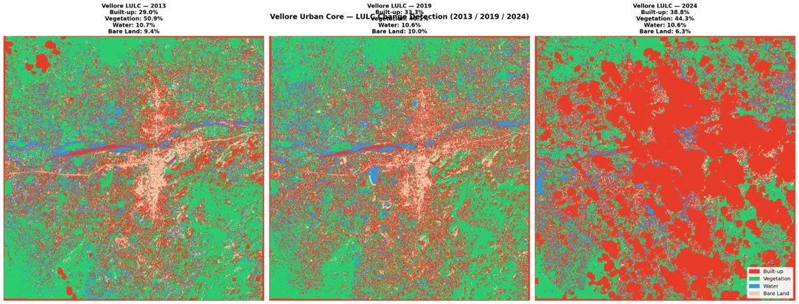

hospitals and secondary schools; 2 km for emergency services. Zones are ranked by ΔC in descending order; the zone delivering the greatest marginal coverage gain receives the highest investment priority.

4. Results
4.1. Study Area and Data Sources
The GI framework is applied in full to hospital location selection in Vellore, Tamil Nadu, India—a secondary city undergoing rapid peri-urban expansion with healthcare infrastructure concentrated in a single central node around the Christian Medical College. The study area encompasses the Vellore urban core (79.02–79.22°E, 12.82–13.02°N; approximately 488 km²; UTM Zone 44N). The Palar River bisects the study area east-west, channelling urban expansion along three road corridors: Katpadi–Kaniyambadi to the northwest, Gudiyatham Road to the southwest, and the Chennai Bypass to the east. The 123 OpenStreetMap healthcare facilities are concentrated within 3 km of the city centre. Data sources are summarised in Table 5.
Table 5. Data Sources—Vellore Hospital Location Application.
Dataset | Source | Specification | Framework Stage
Landsat 8/9 Collection-2 Level-2 | USGS EarthExplorer | Path 143 / Row 051; October 2013, November 2019, December 2024; 30 m spatial resolution | Stage I
Road network | OpenStreetMap (osmnx) | 59,081 edges; 21,978 nodes; all highway classification levels | Stages II and III
Healthcare facilities | OpenStreetMap | 123 point features (hospital, clinic, doctors, health tags); concentrated within 3 km of city centre | Stages III and IV
Administrative boundary | GADM v4.1 | Vellore district polygon used as study area mask across all stages | All stages
Digital Elevation Model | SRTM 1-arc (~30 m) | Terrain constraint driver D4 in Stage II CA-ANN simulation | Stage II

4.2. Stage I: LULC Classification Results
A 12-dimensional feature vector (six OLI bands B2–B6 plus NDVI, NDBI, MNDWI, BSI, EVI, SAVI, and IBI) was constructed per pixel for each of the three acquisition years following Amini et al. [10]. A Random Forest classifier [11] with 500 trees, maximum depth 20, and balanced class weights was trained independently for each year, producing four-class LULC maps across the full 488 km² study area (Figure 2; Table 6).
Figure 2. Stage I output—LULC classification for the Vellore urban core: 2013 (left), 2019 (centre), 2024 (right). Red: Built-up/Impervious; Green: Vegetation; Blue: Water; Beige: Bare/Fallow Land. Progressive expansion of built-up cover along the Katpadi–Kaniyambadi (northwest) and Gudiyatham Road (southwest) corridors is clearly visible across all three periods, consistent with road-driven peri-urban expansion patterns documented by Kumar and Agrawal [17].
Table 6. Stage I Accuracy Assessment—Vellore LULC Classification.
Year | Overall Accuracy (%) | Kappa (Hold-out) | Kappa (5-fold CV) | Built-up Cover (%) | Built-up Area (km²)
2013 | 63% | 0.46 | 0.51 ± 0.02 | 29.0% | ≈141.5
2019 | 70% | 0.58 | 0.58 ± 0.02 | 33.3% | ≈162.5
2024 | 67% | 0.54–0.76 | 0.61 ± 0.09 | 38.8% | ≈189.4

Built-up cover expanded from 29.0% to 38.8% of the study area between 2013 and 2024, adding approximately 87.9 km² at a mean annual rate of approximately 8 km² per year. Vegetation cover declined correspondingly from 50.9% to 44.3%. The 2024 Kappa range (0.54–0.76) reflects the spectral complexity of post-monsoon South Asian imagery at 30 m resolution, consistent with values reported by Moharir et al. [13] for comparable imagery conditions in Maharashtra. The 2013 Kappa of 0.46 falls below the recommended quality gate; however, the 2013 map functions as a historical baseline for CA-ANN training, where spatial pattern fidelity is more important than per-pixel accuracy.
4.3. Stage II: CA-ANN Growth Simulation Results
Five spatial drivers were computed following the protocol of Gharaibeh et al. [9]: D1, Euclidean distance to 2013 built-up pixels, inverted and normalised; D2, distance to the 59,081-edge OSM road network, inverted; D3, distance to the Vellore CBD centroid at 79.13°E, 12.92°N, inverted; D4, terrain gradient derived from SRTM, inverted; and D5, proportion built-up within a 5×5 pixel neighbourhood window. The ANN [5→64→32→16→1] was trained on 6,000 balanced transition samples from the 2013→2019 observed change map. The best-performing model achieved a validation AUC of 0.685, exceeding the minimum 0.65 quality gate applied by comparable studies [9,16]. The CA simulation used a calibrated annual growth rate of 1.05% of study area per year (Figure 3).

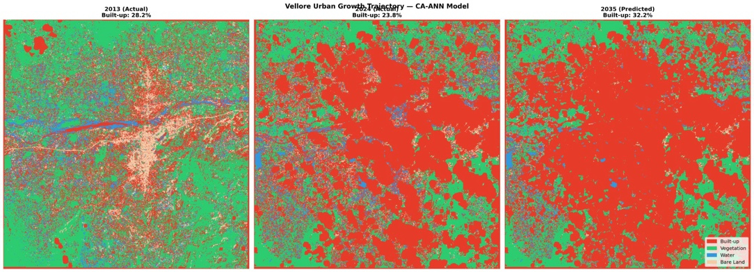
Figure 3. Stage II output—CA-ANN urban growth trajectory for Vellore: 2013 observed, 2024 observed, 2035 projected. Growth hotspots are concentrated along the Katpadi–Kaniyambadi (northwest) and Gudiyatham Road (southwest) corridors, consistent with Stage I observed expansion patterns and comparable to growth trajectories modelled by Kumar and Agrawal [17] for Indore and Mondal et al. [16] for Bihar.
Projected built-up cover: 28.5% by 2030 (+17.2 km² relative to 2024 baseline); 32.2% by 2035 (+40.7 km² relative to 2024 baseline). The 45,255-pixel growth hotspot raster identifying pixels projected to transition to built-up by 2035 was encoded as criterion C3 in Stage III, operationalising the prospective integration mechanism that distinguishes the GI framework from all prior CA-ANN studies [9,16,17].
4.4. Stage III: AHP Suitability Analysis Results
Six criteria were operationalised for the hospital facility configuration. C1 was computed as built-up density in a 450 m radius moving window as a proxy for population demand. C2 was computed as inverse Euclidean distance to the 123 OSM healthcare point features. C3 was computed as inverse distance to the Stage II growth hotspot raster pixels (2030–2035 horizon). C4 was computed as inverse distance to the 59,081-edge road network. C5 was computed as inverse buffered distance from the Stage I water class pixels (300 m flood proxy along the Palar River corridor). C6 was computed as developability scores for non-built, non-water pixels, with bare/fallow land receiving the highest scores. AHP pairwise comparison produced a weight vector with CR = 0.0117 < 0.10 (λmax = 6.0723), confirming matrix consistency [24] (Figure 4; Table 7).
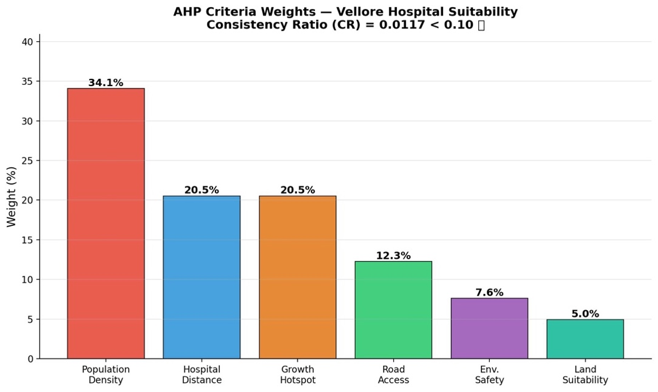

Figure 4. Stage III—AHP criteria weights for hospital location selection in Vellore (CR = 0.0117 < 0.10 [24]). Population demand (C1: 34.1%) and coverage gap (C2: 20.5%) jointly account for 54.6% of the composite index, reflecting the primacy of healthcare equity. Growth alignment (C3: 20.5%) carries equal weight to coverage gap, constituting the framework’s prospective integration mechanism absent from all prior GIS-AHP hospital location studies [5].
Table 7. AHP Weight Configuration—Hospital Location Selection, Vellore (CR = 0.0117; λmax = 6.0723).
Criterion | Weight | Data Source | Operationalisation | Spatial Logic
C1: Population Demand | 34.1% | Stage I LULC 2024 | Built-up density in 450 m radius moving window | High-density areas carry greatest healthcare demand
C2: Coverage Gap | 20.5% | OpenStreetMap | Inverse distance to 123 OSM health facility point features | Areas far from existing facilities are underserved
C3: Growth Alignment ★ | 20.5% | Stage II CA-ANN | Inverse distance to 2030–2035 growth hotspot pixels | Future populations require future-positioned facilities [4]
C4: Road Accessibility | 12.3% | OpenStreetMap | Inverse distance to full OSM road network | Road proximity determines patient access and emergency response time
C5: Hazard Safety | 7.6% | Stage I LULC 2024 | Buffered inverse distance from water class / flood-prone pixels | Flood-prone areas are unsuitable for health infrastructure [7]
C6: Land Developability | 5.0% | Stage I LULC 2024 | Non-built, non-water land; bare/fallow scored highest | Land availability is a prerequisite for construction feasibility

The AHP-weighted overlay produced a continuous suitability surface ranging from 0.156 to 0.706 (mean 0.341, standard deviation 0.089). Application of the 85th percentile threshold (S ≥ 0.435) classified 81,468 pixels, equivalent to 73.3 km² or 15% of the study area, as high suitability (Figure 5).
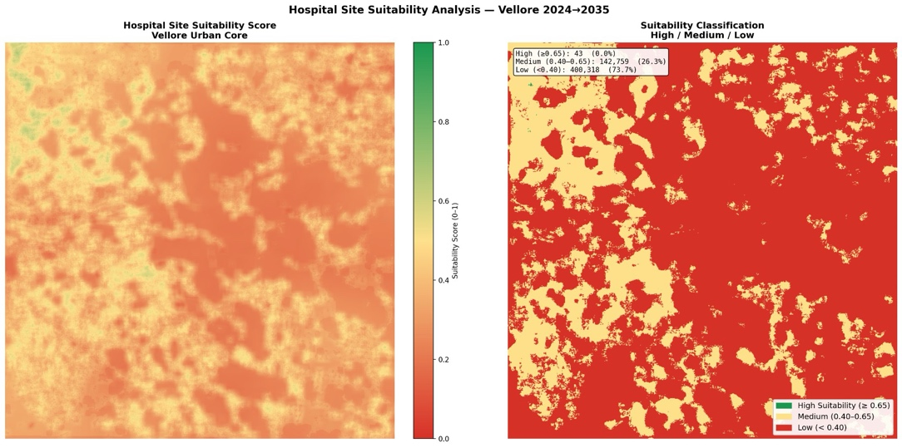

Figure 5. Stage III output—Hospital location suitability surface for Vellore. Left: Continuous suitability score across the full study area (0–1 scale). Right: Suitability zones classified using the 85th percentile adaptive threshold. High suitability zones are concentrated in peri-urban growth corridors away from the existing healthcare facility cluster in central Vellore, reflecting the dominant influence of the coverage gap (C2) and growth alignment (C3) criteria.
4.5. Stage IV: Zone Extraction and Coverage Validation
Watershed segmentation of the thresholded suitability surface identified 3,132 connected high-suitability components. Of these, 980 zones met the minimum area criterion of 0.27 ha (approximately 3 pixels at 30 m resolution). The five top-ranked zones, selected by composite ranking integrating suitability score, coverage gap distance, road accessibility, and zone area, were submitted to full coverage validation against the 5 km hospital service radius (Figure 6; Table 8).

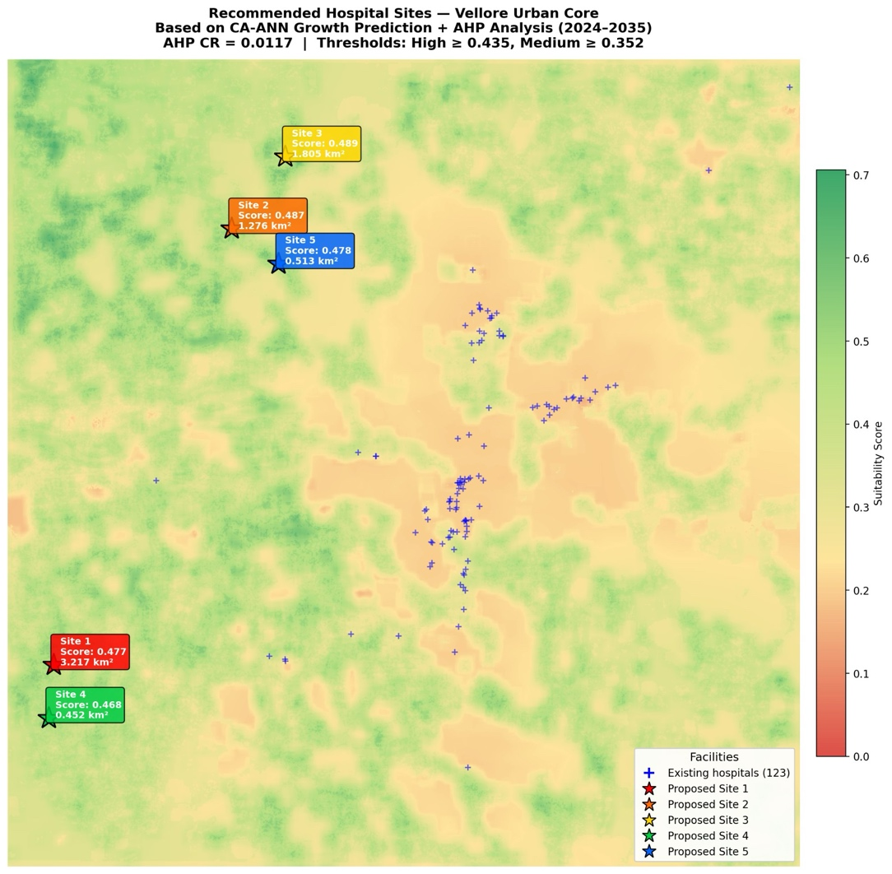
Figure 6. Stage IV output—Final hospital location recommendations for Vellore. Stars denote the five recommended zones; crosses denote the 123 existing OpenStreetMap healthcare facilities. All five recommended zones are positioned in peri-urban growth corridors systematically away from the existing facility concentration in central Vellore, directly reflecting the spatial logic of criteria C2 and C3 operating in conjunction.
Table 8. Stage IV—Zone Attributes and Coverage Validation (5 km service radius).
Zone | Suitability Score | Area (km²) | Road Distance (m) | Gap Distance (km) | ΔC (pp) | Growth Corridor | Priority Rank
Zone 3 | 0.489 | 1.805 | 162 | 6.1 | +7.44 | Northwest (Katpadi–Kaniyambadi) | 1st
Zone 2 | 0.487 | 1.276 | 271 | 6.7 | +6.72 | Southwest (Gudiyatham Road) | 2nd
Zone 5 | 0.478 | 0.513 | 74 | 5.4 | +5.17 | Eastern Bypass | 3rd
Zone 4 | 0.468 | 0.452 | 16 | 6.3 | +4.49 | Northwest fringe | 4th
Zone 1 | 0.477 | 3.217 | 15 | 5.8 | +3.63 | Southwest expansion | 5th

Baseline population coverage within a 5 km radius of an existing healthcare facility stands at 77.1% of the study area. Zone 3, positioned in the northwestern growth corridor at 6.1 km from the nearest existing facility, raises coverage to 84.6%, a marginal gain of 7.44 percentage points—the largest single-zone improvement among all five candidates. Zone 3’s primacy reflects its position at the intersection of the densest CA-ANN growth hotspot cluster and the most significant existing service gap: precisely the spatial condition that criteria C3 and C2 identify in conjunction. Zone 2 provides the second-largest improvement at 6.72 percentage points along the southwestern Gudiyatham Road growth corridor. Collective deployment of all five zones is projected to raise population coverage to approximately 92–95%.
5. Discussion
5.1. Interpretation of Results
The Vellore results demonstrate three properties that collectively validate the GI framework’s design. First, all five recommended zones are positioned in peri-urban sectors systematically distant from the existing concentration of 123 healthcare facilities in central Vellore. This validates the coverage gap criterion (C2): the framework steers recommendations toward geographic gaps rather than reinforcing existing provision. Second, all five zones are aligned with the CA-ANN growth corridors identified in Stage II, validating criterion C3: the framework identifies locations that will serve future populations rather than only present ones. Third, the dominant zones (Zone 3 and Zone 2) are positioned at the intersection of the largest growth hotspot clusters and the greatest service gaps—the exact spatial condition that the joint operation of C3 and C2 is designed to identify, and which a purely present-condition GIS-AHP analysis would not produce.
5.2. The Prospective Dimension
The most consequential methodological distinction of the GI framework is the encoding of future urban growth as a first-order placement criterion. A location selection decision based only on today’s population distribution is systematically misaligned with the actual demand landscape over most of the infrastructure’s working life. A hospital built in 2026 will remain operational until at least 2056 or 2076. The CA-ANN growth simulation projects that an additional 40.7 km² of the Vellore study area will transition to built-up by 2035—territory that will contain significant new residential populations demanding healthcare services. By encoding this projection as criterion C3 with a documented AHP weight of 20.5%, the GI framework ensures that Zone 3’s selection reflects not merely the current service deficit of 6.1 km from the nearest facility, but the trajectory of demand that will intensify and consolidate over the next three decades. This distinction—between static and prospective placement optimisation—constitutes the primary methodological contribution of the framework, directly implementing the integration identified as a research priority by Gaur and Singh [4].
5.3. Facility-Agnostic Design and Cross-Domain Applicability
The weight taxonomy in Table 4 encodes systematic differences in the spatial logics of each facility type. For emergency services, high C1 (0.350) and C2 (0.250) are appropriate because emergency coverage must be maximised over present demand: an ambulance station or fire post cannot defer service to future growth zones not yet populated. For commercial facilities such as shopping centres, higher C3 (0.250) and C4 (0.250) reflect the commercial reality that retail viability depends on future catchment size and vehicle accessibility rather than present equity. For educational facilities, the high C1 (0.300) and C2 (0.220) reflect the equity logic of school provision documented by Meena et al. [6] and Mustaffa et al. [22]. For residential development, the highest C3 (0.300) weight reflects that residential investment must be positioned at the urban growth frontier to be commercially and socially viable. These distinctions enable health planners, education authorities, commercial developers, residential planners, sports departments, and emergency service administrators to apply the same analytical pipeline with only the weight vector changed, requiring no methodological redesign.
5.4. Limitations
Several limitations should be acknowledged. The 2013 LULC Kappa of 0.46 falls below the recommended 0.60 quality gate; while the 2013 map functions as a historical baseline for CA-ANN training rather than a classification product, lower baseline accuracy may affect the precision of driver D1 and training sample derivation. The CA-ANN validation AUC of 0.685 indicates moderate pixel-level predictive accuracy; spatial growth patterns are more reliable than point-level conversion predictions, consistent with findings for comparable models by Gharaibeh et al. [9] and Mondal et al. [16]. The built-up density proxy for criterion C1 introduces uncertainty where informal housing is prevalent; WorldPop or High-Resolution Settlement Layer gridded population data would provide a more accurate demand signal. Euclidean service radius validation (5 km) overestimates accessibility in areas with fragmented or incomplete road networks; network-based travel time analysis would yield a more accurate representation of true spatial accessibility.
5.5. Conditions for Applicability
The GI framework is most directly applicable to secondary cities in low- and middle-income countries characterised by active peri-urban expansion, available Landsat archive coverage spanning at least five years across a minimum of three acquisition dates, OpenStreetMap road network completeness of at least 60% for primary and secondary roads, and existing facility location data available as geocoded point features. The framework is less suited to megacities where network-based travel time accessibility analysis is necessary for realistic service radius estimation, entirely rural settings where peri-urban growth dynamics do not apply, and facility types governed by highly specialised regulatory siting constraints that dominate spatial considerations above the criteria encoded in the framework.
6. Conclusions
This paper has presented the Geospatial Intelligence (GI) Framework—a unified, transferable, facility-agnostic four-stage pipeline for evidence-based urban infrastructure location selection that simultaneously resolves the three deficiencies characterising existing approaches: static orientation, facility specificity, and inaccessibility in resource-constrained planning environments. By formally integrating multi-temporal LULC classification, CA-ANN urban growth simulation, and AHP spatial MCDA within a tightly coupled pipeline in which CA-ANN growth forecasts directly constitute a first-order placement criterion, the GI framework delivers prospectively-oriented, quantitatively validated location recommendations for any urban facility category through a single, reproducible open-source workflow.
Applied to hospital location selection in Vellore, Tamil Nadu, the framework characterises eleven years of urban expansion adding 87.9 km² of built-up area, projects a further 40.7 km² of growth by 2035, and identifies five high-priority placement zones. Collective deployment is projected to raise population coverage from 77.1% to approximately 92–95%. The highest-priority zone—Zone 3 in the northwestern growth corridor—achieves a 7.44 percentage point coverage improvement, derived entirely from open-access satellite imagery, open geographic data, and open-source Python computation.
The framework’s facility-agnostic weight taxonomy enables health planners, education authorities, commercial developers, residential planners, and emergency service administrators to apply the same geospatial intelligence platform across seven documented facility categories without methodological modification. The prospective orientation—uniquely achieved through direct CA-ANN growth integration as criterion C3—ensures that infrastructure placed using the GI framework is positioned for the city that will exist over a 30 to 50 year operational lifetime, not merely the city of today. The framework’s open-access design ensures applicability in the rapidly urbanising secondary cities of the developing world: precisely the environments where the infrastructure placement deficit is most acute, and where proprietary planning tools are least accessible.
Author Contributions
Conceptualisation, D.K.; methodology, D.K.; software, D.K.; validation, D.K.; formal analysis, D.K.; investigation, D.K.; data curation, D.K.; writing—original draft preparation, D.K.; writing—review and editing, D.K., A.B.; visualisation, D.K. All authors have read and agreed to the published version of the manuscript.
Funding
This research received no external funding.
Data Availability Statement
Landsat 8/9 Collection-2 Level-2 imagery is freely available from USGS EarthExplorer (earthexplorer.usgs.gov). OpenStreetMap road network and facility data are available under the Open Database Licence at openstreetmap.org. GADM administrative boundary data are available at gadm.org. The Python source code implementing the GI framework for the Vellore case application is available from the corresponding author upon reasonable request.
Acknowledgments
The authors acknowledge the United States Geological Survey for open access to the Landsat archive; the OpenStreetMap community for road network and facility data; and the developers of the Python libraries rasterio, geopandas, scikit-learn, TensorFlow, and osmnx.
Conflicts of Interest
The authors declare no conflicts of interest.
References
1. Seto, K.C.; Güneralp, B.; Hutyra, L.R. Global forecasts of urban expansion to 2030 and direct impacts on biodiversity and carbon pools. Proc. Natl. Acad. Sci. USA 2012, 109, 16083–16088.
2. United Nations. World Urbanization Prospects: The 2018 Revision. ST/ESA/SER.A/420; UNDESA: New York, NY, USA, 2019.
3. Aburas, M.M.; Ho, Y.M.; Ramli, M.F.; Ash’aari, Z.H. The simulation and prediction of spatio-temporal urban growth trends using cellular automata models: A review. Int. J. Appl. Earth Obs. Geoinf. 2016, 52, 380–389.
4. Gaur, S.; Singh, R. A comprehensive review on land use/land cover (LULC) change modelling for urban development. Sustainability 2023, 15, 903.
5. Tripathi, A.K.; Agrawal, S.; Gupta, R.D. Comparison of GIS-based AHP and fuzzy AHP methods for hospital site selection: Prayagraj City, India. GeoJournal 2022, 87, 3507–3528.
6. Meena, D.K.; Tripathi, R.; Agrawal, S. An evaluation of primary schools and its accessibility using GIS: Prayagraj district, India. GeoJournal 2023, 88, 1921–1951.
7. Sakti, A.D.; Ihsan, K.T.N.; Wikantika, K.; Deliar, A.; Irawan, S. School location analysis integrating accessibility, natural and biological hazards. ISPRS Int. J. Geo-Inf. 2022, 11, 12.
8. Naranjo, I.; Aponte, J.; García, N.; González, Y. AHP as a multicriteria decision tool for facility location. In Proceedings of the CSEI 2023; Springer: Cham, Switzerland, 2024.
9. Gharaibeh, A.; Shaamala, A.; Obeidat, R.; Al-Kofahi, S. Improving land-use change modeling by integrating ANN with CA–Markov Chain. Heliyon 2020, 6, e05092.
10. Amini, S.; Saber, M.; Rabiei-Dastjerdi, H.; Homayouni, S. Urban land use and land cover change analysis using Random Forest classification of Landsat time series. Remote Sens. 2022, 14, 2654.
11. Breiman, L. Random forests. Mach. Learn. 2001, 45, 5–32.
12. Tikuye, B.G.; Rusnak, M.; Haile, A.T.; José-Luis, A.; Berhane, G. Land use and land cover change detection using the Random Forest approach: Upper Blue Nile River Basin, Ethiopia. Glob. Challenges 2023, 7, 2300155.
13. Moharir, K.N.; Pande, C.B.; Gautam, V.K.; Singh, S.K.; Thakare, S. Characterizing LULC change dynamics by an enhanced random forest: A GEE implementation. Environ. Sci. Eur. 2024, 36, 84.
14. El-Zeiny, A.; Effat, H. Environmental monitoring of spatiotemporal change in land use/land cover. Remote Sens. Appl. Soc. Environ. 2017, 8, 266–277.
15. El-Zeiny, A.; Effat, H. Modelling of LULC changes and their impacts using machine learning: El-Fayoum, Egypt. Environ. Monit. Assess. 2023, 195, 637.
16. Mondal, B.; Chakraborti, S.; De, S.K.; Das, D.N. Cellular automata-based ANN model for assessing past, present, and future LULC dynamics. Agronomy 2022, 12, 2772.
17. Kumar, A.; Agrawal, S. Urban growth prediction using CA-ANN for Indore city, India. GeoJournal 2025, 90, 139.
18. Xing, W.; Qian, Y.; Guan, X.; Yang, T.; Wu, H. Integrating ANNs and CA–Markov Chain to simulate urban expansion with annual land use data. Land 2022, 11, 1074.
19. Hariz, H.A.; Dönmez, C.Ç.; Sennaroglu, B. Siting of a central healthcare waste incinerator using GIS-based MCDA. J. Clean. Prod. 2017, 166, 1031–1042.
20. Prasetyo, D.H.; Mohamad, J.; Fauzi, R. A GIS-based MCDA approach for public school site selection in Surabaya, Indonesia. Geomatica 2018, 72, 69–84.
21. Güler, D.; Yomralioglu, T. Suitable location selection for EV fast charging stations with AHP and fuzzy AHP using GIS. Ann. GIS 2020, 26, 169–189.
22. Mustaffa, A.B.; Zulkifli, A.N.; Hasan, R.C.; Tamrin, N.A.M. GIS and multi-criteria analysis for school site selection: Malacca Historical City. Int. J. Integr. Eng. 2021, 13, 234–241.
23. Maxwell, A.E.; Warner, T.A.; Fang, F. Implementation of machine-learning classification in remote sensing: An applied review. Int. J. Remote Sens. 2018, 39, 2784–2817.
24. Saaty, T.L. A scaling method for priorities in hierarchical structures. J. Math. Psychol. 1977, 15, 234–281.

