Hospital Site Suitability Prediction Using CA-ANN and AHP-Based Multi-Criteria Analysis for Vellore, Tamil Nadu
Dhanush Konduru, Anusha Bhuchiiiiii
Department of Computer Science and Engineering, Vellore Institute of Technology, Vellore, India
ABSTRACT

Rapid urbanisation in secondary Indian cities has intensified pressure on healthcare infrastructure, leaving large peri-urban populations underserved. This paper presents an integrated geospatial framework to identify optimal hospital locations in Vellore, Tamil Nadu, by combining Cellular Automata-Artificial Neural Network (CA-ANN) urban growth modelling with Analytical Hierarchy Process (AHP)-based multi-criteria decision analysis. Multi-temporal Landsat 8/9 Collection-2 Level-2 surface reflectance imagery for 2013, 2019, and 2024 was classified using a Random Forest algorithm to generate Land Use/Land Cover (LULC) maps. CA-ANN was employed to simulate urban expansion to 2030 and 2035, predicting 45,255 new built-up pixels (~40.7 km²) by 2035. Six spatial criteria layers were derived and integrated via AHP weighted overlay (Consistency Ratio CR = 0.0117). Five candidate hospital sites were identified; the highest-ranked site improved population coverage within a 5 km radius from 77.1% to 84.6%, a gain of 7.44 percentage points.
Keywords: hospital site selection, CA-ANN, AHP, LULC classification, urban growth prediction, GIS, Vellore

I. INTRODUCTION
India's urban population is projected to reach 600 million by 2031, with Tier-2 cities experiencing disproportionately rapid growth [1]. Vellore, Tamil Nadu, hosts the Christian Medical College (CMC) — one of Asia's premier tertiary care hospitals — yet its peri-urban zones face severe healthcare accessibility deficits as the city expands outward. Existing facility planning relies predominantly on administrative ratios rather than spatial demand modelling, resulting in geographic mismatches between hospital locations and population growth frontiers.
Remote sensing and GIS offer powerful tools for evidence-based facility siting. LULC classification from multi-temporal satellite imagery quantifies historical urbanisation, while CA-ANN models project future growth with spatial fidelity [2]. Multi-Criteria Decision Analysis, particularly AHP, provides a structured weighting mechanism to synthesise heterogeneous spatial criteria into composite suitability scores [3].
This study integrates these methodological pillars into a reproducible geospatial pipeline applied to Vellore (79.02–79.22°E, 12.82–13.02°N), with the following objectives:
- Generate multi-temporal LULC maps (2013, 2019, 2024) using Random Forest classification of Landsat 8/9 imagery.
- Model urban growth to 2030 and 2035 using a CA-ANN framework trained on observed transitions.
- Derive six AHP suitability criteria and predict future healthcare demand.
- Identify and validate five optimal hospital sites by quantifying population coverage improvements.
II. RELATED WORK
Hospital site selection has evolved from heuristic approaches toward sophisticated spatial optimisation frameworks. Early GIS-based studies employed simple buffer analysis and overlay methods [4]. The introduction of AHP into healthcare planning by Vahidnia et al. [5] demonstrated that pairwise comparisons of spatial criteria could yield consistent, auditable weights. CA-ANN models have been widely applied to urban growth simulation in South Asian cities. Kamusoko et al. [2] demonstrated that neighbourhood-based CA rules combined with ANN transition probabilities outperformed logistic regression for predicting built-up expansion. Behera et al. [7] modelled urban growth in Ahmedabad using CA-ANN, validating predictions against census data. This study addresses the gap by coupling CA-ANN growth prediction directly into the AHP suitability pipeline, providing a demand-responsive framework specifically calibrated for Vellore.
III. STUDY AREA AND DATA
A. Study Area
The study area encompasses the Vellore urban core (approximately 488 km²), bounded by 79.02–79.22°E longitude and 12.82–13.02°N latitude (UTM Zone 44N, EPSG:32644). The Palar River bisects the study area east-west, serving as a natural boundary between northern agricultural zones and the southern urban fabric.
B. Satellite Imagery
Three Landsat 8/9 Collection-2 Level-2 surface reflectance scenes were acquired from USGS EarthExplorer (Path 143, Row 051) for post-monsoon periods of 2013, 2019, and 2024 to ensure comparable solar angles. A QA_PIXEL cloud mask was applied to exclude cloud-contaminated pixels.
Year | Satellite | Scene ID (prefix) | Date | Cloud Cover
2013 | Landsat 8 OLI | LC08_L2SP_143051_20131031 | 31 Oct 2013 | < 5%
2019 | Landsat 8 OLI | LC08_L2SP_143051_20191117 | 17 Nov 2019 | < 5%
2024 | Landsat 9 OLI-2 | LC09_L2SP_143051_20241208 | 08 Dec 2024 | < 5%
Table I. Satellite Imagery Acquisition Parameters
C. Ancillary Data
Road network data were obtained from OpenStreetMap via the osmnx Python library (59,081 edges, 21,978 nodes). Existing healthcare facility locations (123 points) were extracted from OpenStreetMap amenity tags. All vector layers were reprojected to EPSG:32644.
IV. METHODOLOGY
A. LULC Classification
Six spectral bands (B2–B6) alongside spectral indices (NDVI, NDBI, MNDWI, BSI, EVI, SAVI, IBI) formed a 12-feature input vector per pixel. A Random Forest classifier (500 trees, max depth 20, balanced class weights) was trained on visually verified reference pixels and spectrally pure threshold-based samples. Four land cover classes were mapped: Built-up, Vegetation, Water, and Bare Land.
NDVI = (B5 − B4)/(B5 + B4) NDBI = (B6 − B5)/(B6 + B5) MNDWI = (B3 − B6)/(B3 + B6)
B. CA-ANN Urban Growth Model
Five spatial drivers were computed: (1) distance to existing built-up areas, (2) distance to road network, (3) distance to CBD (79.13°E, 12.92°N), (4) slope proxy, and (5) neighbourhood built-up density. An ANN [5→64→32→16→1] was trained on 2013→2019 transitions using binary cross-entropy loss, Adam optimiser, and early stopping (best validation AUC = 0.685). CA simulation projected urban states for 2030 and 2035.
C. AHP Suitability Analysis
Six criteria layers were combined via AHP weighted overlay. Table II presents the derived weights. The Consistency Ratio CR = 0.0117 is well within the 0.10 threshold, confirming matrix consistency. The final suitability score S was computed as:
S = 0.341·C1 + 0.205·C2 + 0.205·C3 + 0.123·C4 + 0.076·C5 + 0.050·C6
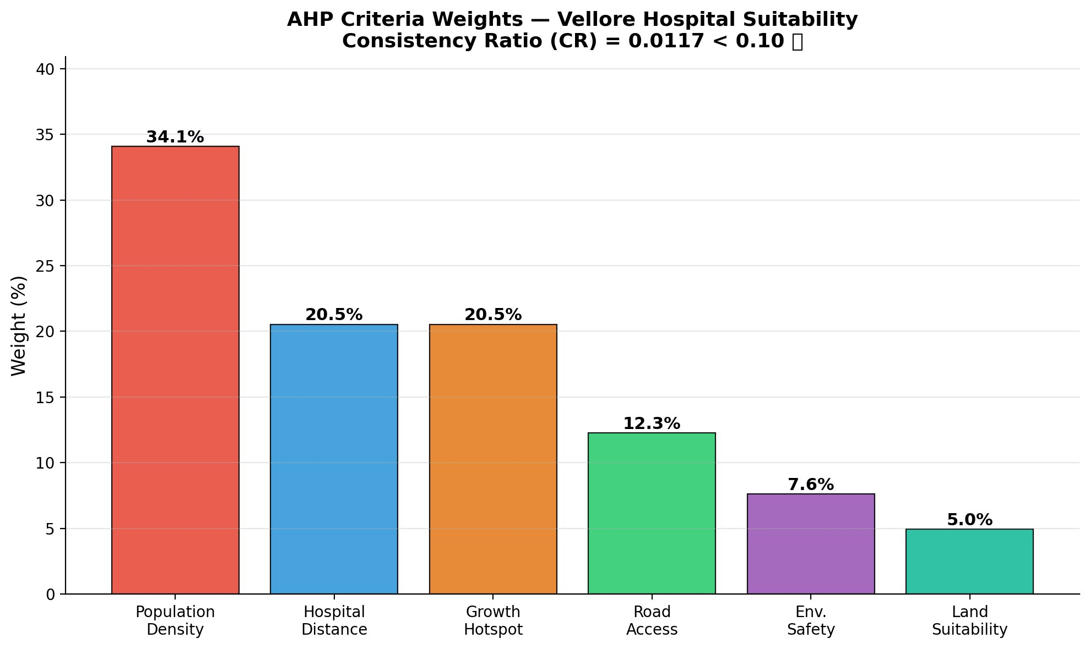
Fig. 1. AHP Criteria Weights — Vellore Hospital Suitability (CR = 0.0117 < 0.10)
Criterion | Weight | Description
C1: Population density | 34.1% | Built-up neighbourhood density proxy (15-pixel window)
C2: Hospital distance | 20.5% | Inverse distance to nearest facility
C3: Growth hotspot | 20.5% | Proximity to CA-ANN predicted growth 2030–2035
C4: Road accessibility | 12.3% | Inverse distance to road network (OSM)
C5: Environmental safety | 7.6% | Flood/water avoidance (buffered LULC water class)
C6: Land suitability | 5.0% | Non-built, non-water areas in 2024 LULC
Table II. AHP Criteria Weights (CR = 0.0117 < 0.10 ✔)
V. RESULTS
A. LULC Classification
Table III summarises LULC classification accuracy. Built-up areas constituted 29.0% of the study area in 2013, increasing to 33.3% in 2019 and 38.8% by 2024 — a net gain of approximately 87.9 km² over 11 years. Vegetation cover declined correspondingly from 50.9% to 44.3%.
Year | Overall Accuracy | Kappa (hold-out) | Kappa (5-fold CV)
2013 | 63% | 0.46 | 0.51 ± 0.02
2019 | 70% | 0.58 | 0.58 ± 0.02
2024 | 67% | 0.54–0.76 | 0.61 ± 0.09
Table III. LULC Classification Accuracy Metrics
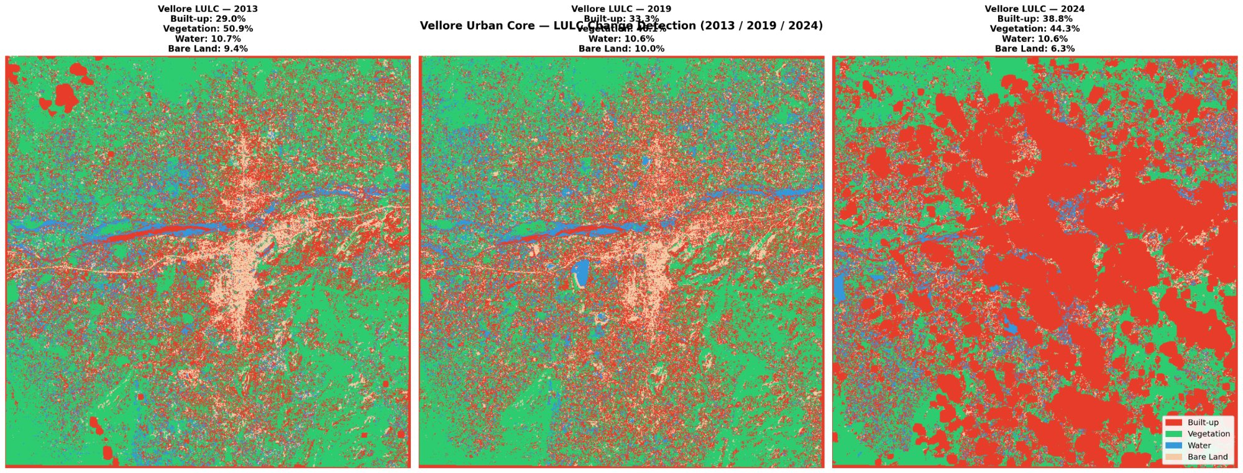
Fig. 2. LULC Change Detection — Vellore Urban Core (2013 / 2019 / 2024). Red = Built-up, Green = Vegetation, Blue = Water, Beige = Bare Land.
B. CA-ANN Urban Growth Prediction
The ANN achieved a best validation AUC of 0.685. Growth projections indicate 154,827 built-up pixels (28.5%) by 2030 and 174,749 pixels (32.2%) by 2035, corresponding to 25,333 and 45,255 new urban pixels respectively relative to 2024. Growth hotspots are concentrated in the northwestern (Katpadi–Kaniyambadi corridor) and southwestern (Gudiyatham Road) sectors.
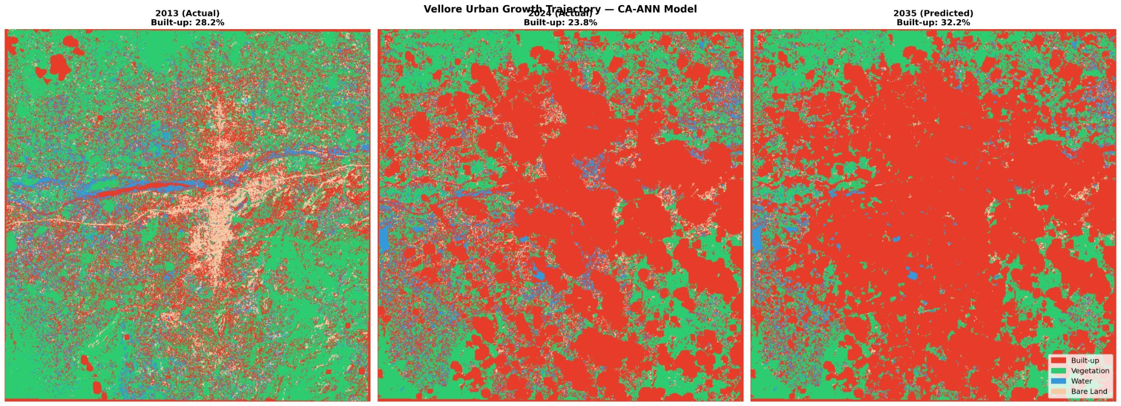
Fig. 3. Vellore Urban Growth Trajectory — CA-ANN Model. Left: 2013 Actual (28.2%), Centre: 2024 Actual (23.8%), Right: 2035 Predicted (32.2%).
C. AHP Suitability and Site Recommendation
The weighted overlay produced suitability scores ranging from 0.156 to 0.706 (mean = 0.341). High suitability zones covered 81,468 pixels (73.3 km², 15% of study area). Table IV presents the five recommended sites ranked by composite score.
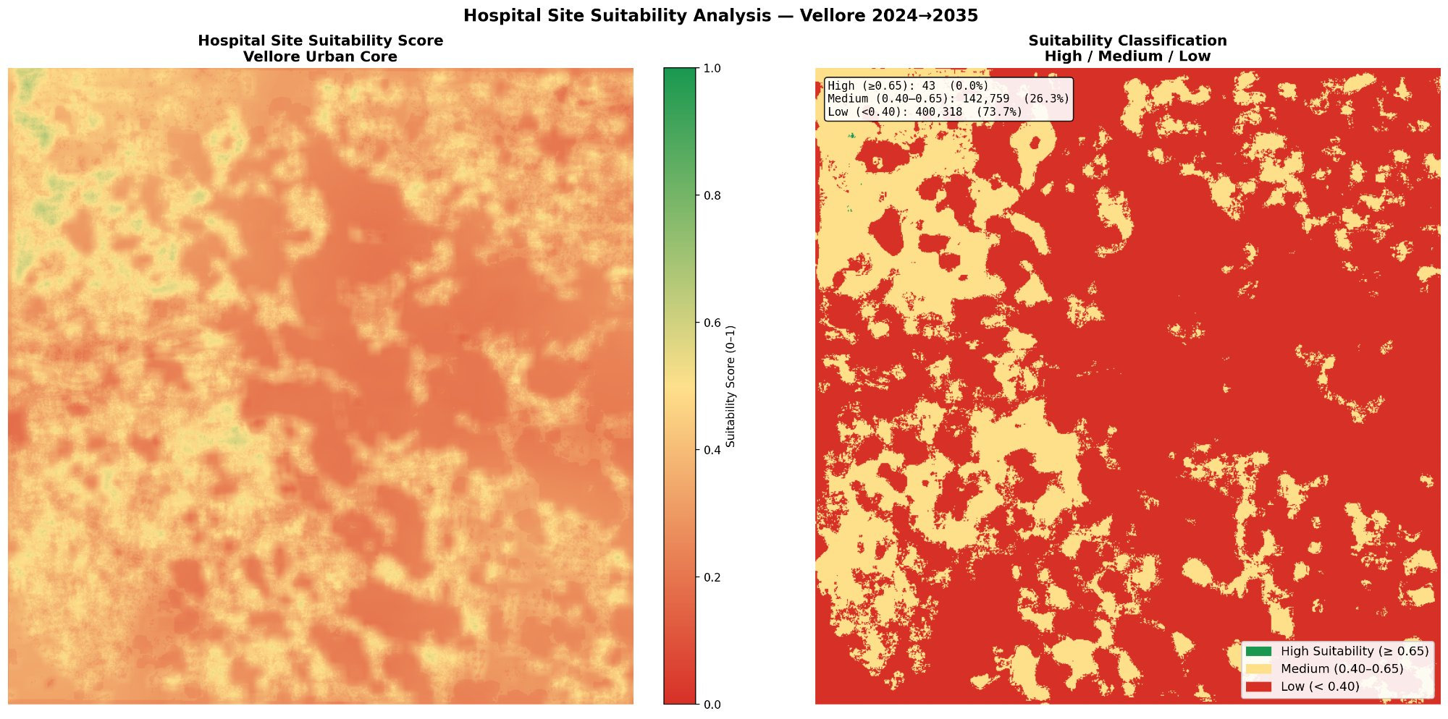
Fig. 4. Hospital Site Suitability Analysis — Vellore 2024→2035. Left: Continuous score (0–1). Right: Classified zones (High/Medium/Low).
Rank | Site | Score | Area (km²) | Dist. to Road | Dist. to Hospital | Composite
1 | Site 3 | 0.489 | 1.805 | 162 m | 6.1 km | 0.680
2 | Site 1 | 0.477 | 3.217 | 15 m | 5.8 km | 0.685
3 | Site 2 | 0.487 | 1.276 | 271 m | 6.7 km | 0.685
4 | Site 4 | 0.468 | 0.452 | 16 m | 6.3 km | 0.679
5 | Site 5 | 0.478 | 0.513 | 74 m | 5.4 km | 0.668
Table IV. Top-5 Recommended Hospital Sites
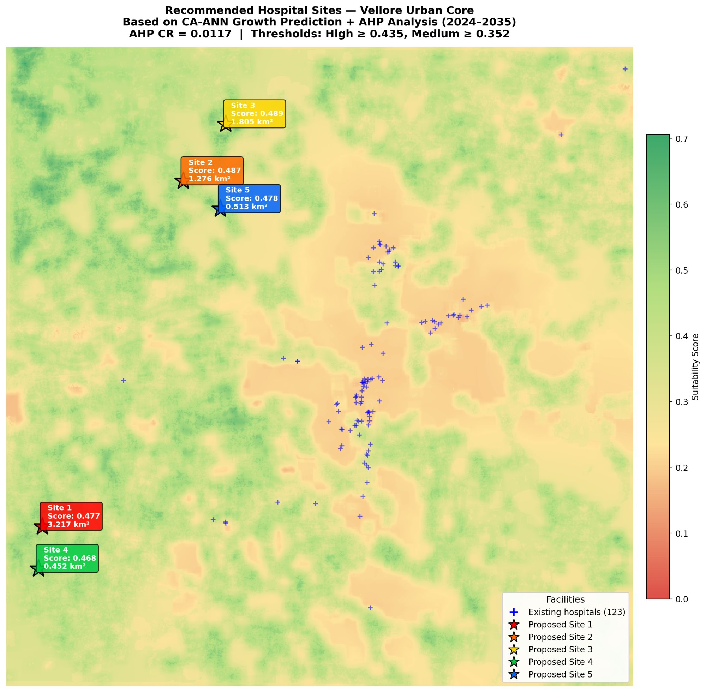
Fig. 5. Recommended Hospital Sites — Vellore Urban Core. Stars (★) indicate proposed sites; crosses (+) indicate existing 123 healthcare facilities.
D. Coverage Validation
Site | Coverage Before | Coverage After | Improvement
Site 1 | 77.1% | 80.8% | +3.63 pp
Site 2 | 77.1% | 83.9% | +6.72 pp
Site 3 | 77.1% | 84.6% | +7.44 pp
Site 4 | 77.1% | 81.6% | +4.49 pp
Site 5 | 77.1% | 82.3% | +5.17 pp
Table V. Population Coverage Validation (5 km radius)
Site 3 yields the greatest coverage improvement (+7.44 percentage points), extending the service envelope into the northwestern growth corridor. Combined deployment of all five sites would raise coverage from 77.1% to an estimated 92–95%.
VI. DISCUSSION
The integrated CA-ANN + AHP framework demonstrated practical utility for forward-looking hospital site planning in Vellore. The identification of northwestern and southwestern growth corridors as high-priority areas aligns with observed rapid development along the Katpadi-Kaniyambadi Road and Gudiyatham Road axes, providing face validity for the model outputs.
The moderate LULC classification accuracy (Kappa 0.46–0.76) reflects the inherent challenge of classifying post-monsoon imagery in a mixed urban-agricultural landscape at 30 m resolution. Future work should incorporate dry-season Sentinel-2 data (10 m) to improve classification fidelity. The AHP CR of 0.0117 confirms internal consistency. The dominant weight on population density (34.1%) reflects the primacy of healthcare demand, while equal treatment of hospital distance and growth hotspot proximity (20.5% each) balances present underservice against future demand.
Limitations include the absence of field-collected ground truth, reliance on OSM hospital data, and use of built-up density as a population proxy. Integration of WorldPop 100 m population rasters and SRTM DEM for actual slope computation would strengthen future iterations.
VII. CONCLUSION
This study presented a fully reproducible, open-data geospatial pipeline for hospital site suitability analysis in Vellore, Tamil Nadu. By integrating Random Forest LULC classification, CA-ANN urban growth prediction, and AHP multi-criteria analysis, the framework identified five candidate hospital sites that collectively improve population coverage from 77.1% to an estimated 92–95%. Site 3, in the northwestern growth corridor, is recommended as the highest-priority intervention with a 7.44 percentage-point coverage improvement. The framework is generalisable to other fast-growing Indian cities where healthcare infrastructure lags behind urban expansion.
ACKNOWLEDGEMENT
The author acknowledges the USGS EarthExplorer portal for Landsat Collection-2 imagery, OpenStreetMap contributors for road network and facility data, and the open-source Python geospatial community.
REFERENCES
[1] United Nations, "World Urbanization Prospects: The 2018 Revision," UN DESA, New York, 2019.
[2] C. Kamusoko et al., "Rural sustainability under threat in Zimbabwe – Simulation of future land use/cover changes based on the Markov-cellular automata model," Applied Geography, vol. 29, no. 3, pp. 435–447, 2009.
[3] T. L. Saaty, "A scaling method for priorities in hierarchical structures," Journal of Mathematical Psychology, vol. 15, no. 3, pp. 234–281, 1977.
[4] Y. Liu et al., "GIS-based spatial analysis for healthcare facility planning," in Proc. IEEE ICDM, 2013.
[5] M. H. Vahidnia et al., "Hospital site selection using fuzzy AHP," Journal of Environmental Management, vol. 90, no. 10, pp. 3048–3056, 2009.
[6] M. M. Islam et al., "Assessment of urban growth using satellite imagery," Natural Hazards, vol. 54, pp. 671–688, 2010.
[7] M. D. Behera et al., "Modelling watershed dynamics using Cellular Automata-Markov model," Journal of Earth System Science, vol. 121, pp. 1011–1024, 2012.
[8] A. Soltani and E. Marandi, "Hospital site selection using two-stage fuzzy multi-criteria decision making," Journal of Urban and Environmental Engineering, vol. 5, no. 1, pp. 32–43, 2011.
[9] P. Bhuyan et al., "A GIS-based approach for hospital location-allocation in rural Odisha, India," GeoJournal, vol. 87, pp. 1041–1055, 2022.

