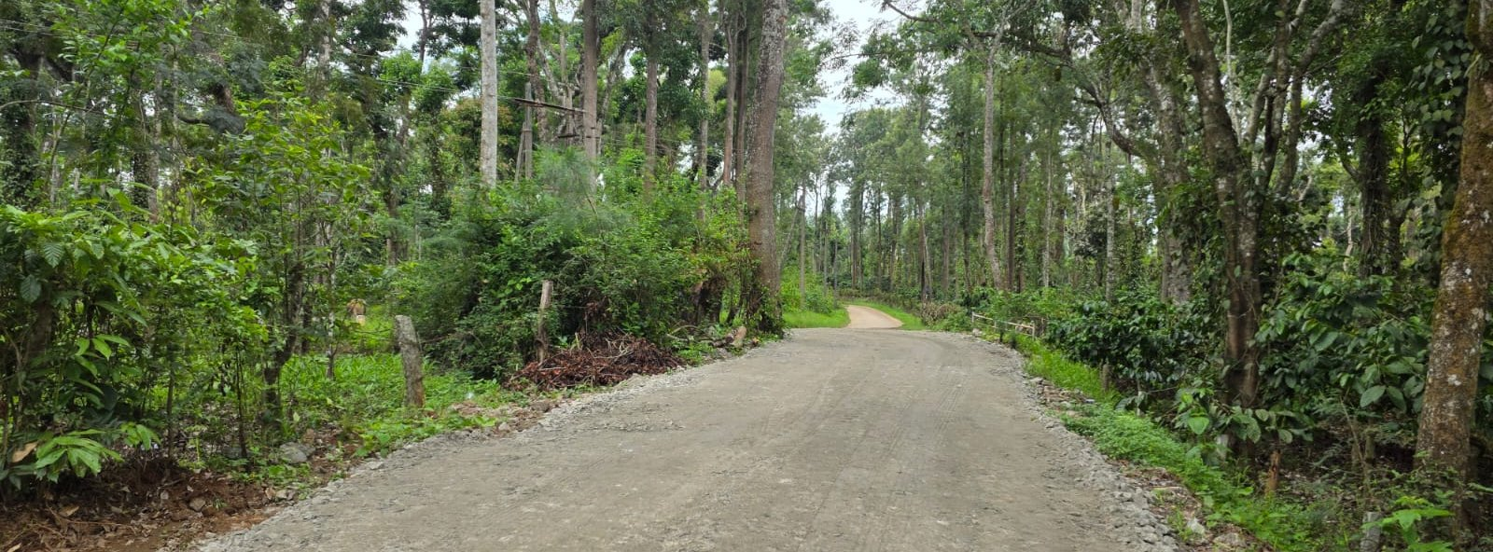
LAND IN COORG
Client Data Extraction & Asset Mapping
Prepared from client-supplied notes, photos, videos, layout graphics, DOCX and PDF source material
STATUS: WORKING MASTER. Do not convert ambiguous prices, acreage, legal details, property-media associations, or projected revenue into public website claims until confirmed by the client.

1. Purpose of this document
This file is the source-of-truth brief for the Land in Coorg website. It separates client-supplied facts from assumptions, groups the available media, and tells the website/content agent which assets can be safely associated with which property.
- Use confirmed client facts exactly as supplied; do not silently invent missing details.
- Do not assume that a price such as “₹45 lakh” or “₹60 lakh” means “per acre” unless the client confirms the basis.
- Do not mix photos/videos across properties merely because they look similar.
- Where association is uncertain, keep the asset tagged TBC rather than publishing a false claim.
- Treat 3D/AI/rendered visuals as illustrative material, not as proof of completed development.

2. Source material register
Website / brand reference | Land in Coorg — landincoorg.com
Detailed Coorg plantation source | SLN Plantations, Madapur.pdf (4 pages)
Detailed Bangalore property source | Hoodi Property details April 2026.docx (2 pages)
Still images | 21 WhatsApp photographs / graphics in the supplied batch
Videos | 7 WhatsApp MP4 clips; includes duplicates/alternate resolution footage
Maps | Two Google Maps links / coordinate sets supplied in the client notes
Social reference | Instagram Reel: DbIyM2LTr5k
Planning documents | Hand-drawn parcel sketch + photographed technical layout/blueprint

3. Media association overview
Asset Group | Association Confidence | Files / Notes
Villa / pool property | High | 14.12.26; 14.12.28 (1); 14.12.28; 14.12.29; 14.12.30; 14.12.32 + videos 14.12.24 and 14.12.33
ABBELON Estates | High | 14.14.32 (1); 14.14.32 (2); 14.14.33 + photographed layout/blueprint
Forest / plantation / land cluster | Medium | 14.14.28; 14.14.31; 14.14.32; 14.14.33 (1); 14.14.33 (3); 14.14.34; 14.14.35 + videos 14.14.31/34/37/40
Hand-drawn parcel sketch | Low / TBC | 14.14.33 (2) — property association not explicit
SLN Plantations PDF imagery | High for SLN only | Lychee/avocado/estate imagery embedded in the PDF
Hoodi property | Document only | No clearly associated Hoodi image set in the supplied WhatsApp batch

4. Property Record A — Probable Coorg Villa / Resort Property
ASSOCIATION CONFIDENCE: MEDIUM-HIGH
The first photo/video cluster clearly shows the same gated villa compound with swimming pool and wooded Kodagu surroundings. The client’s 26-cent / ₹4.5 crore / bed-count notes appear alongside this cluster, but the client did not explicitly label the media with the property name.
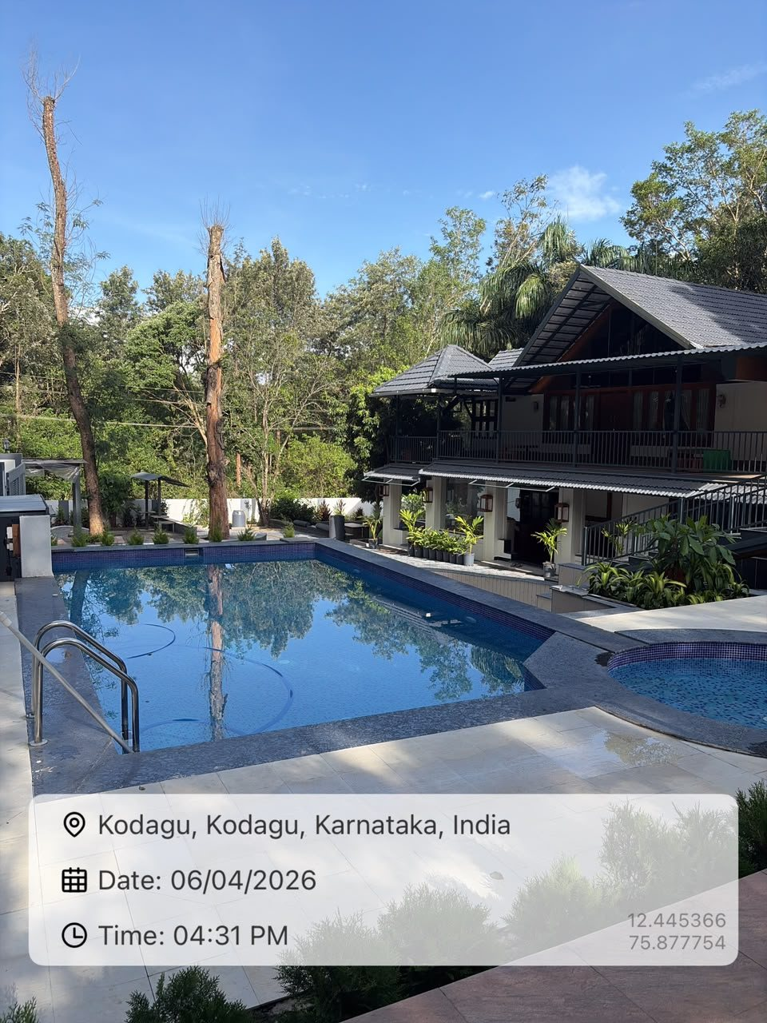 | 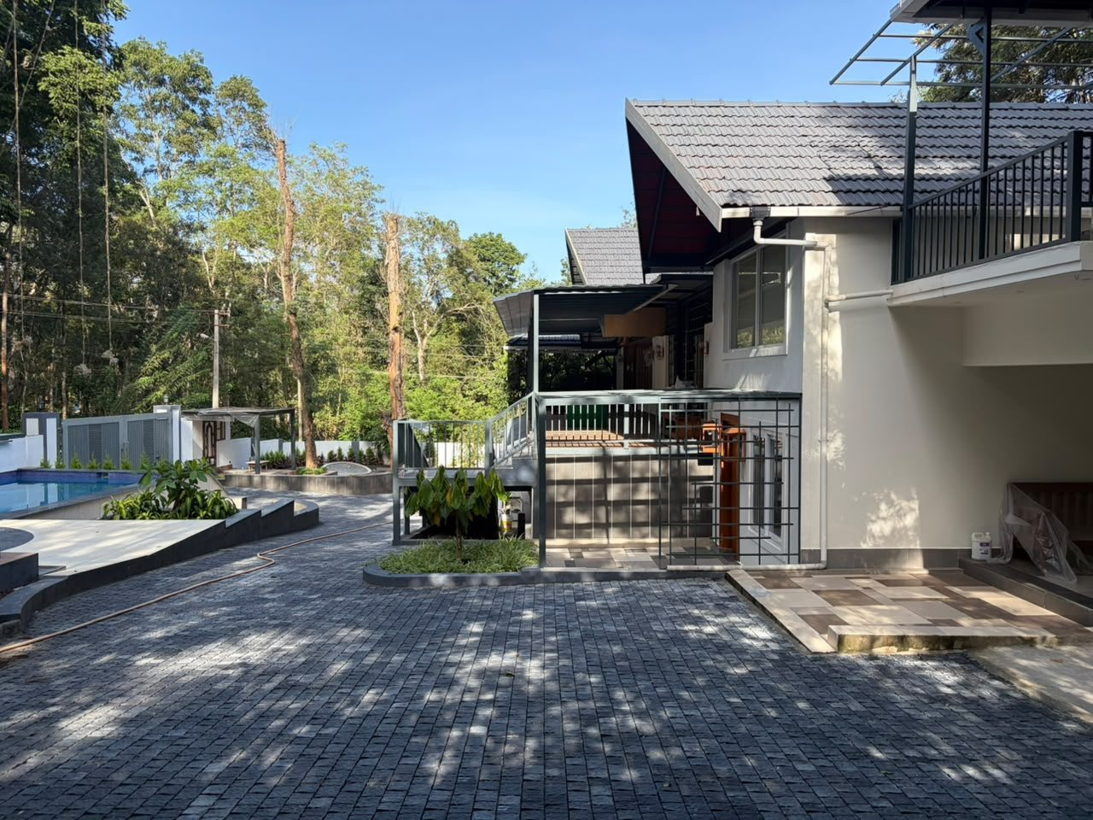
Pool / villa view with Kodagu location stamp | Paved driveway and villa exterior
Area | 26 cents
Quoted price | ₹4.5 crore
Property type | Villa / resort / homestay-style property — exact classification TBC
Location evidence | Kodagu, Karnataka, India (visible on client photo)
GPS visible in photos | Approx. 12.445366, 75.877754 and 12.445074, 75.877756
Date visible | 06/04/2026
Key visible features | Gated compound, swimming pool, smaller circular pool/spa, paved driveways, balconies, multiple structures, dense trees

Accommodation / bed data
Queen beds | 10
King beds | 1
Extra single beds | 10
Room 1 | 3 beds
Room 2 | 2 beds
Room 3 | 2 beds
Room 4 | 1 bed
Room 5 | 1 bed
Separate house | 2 beds
Consistency check: room-by-room main beds total 11, matching the separate note of 10 Queen + 1 King. Which room contains the King bed is not supplied. Do not advertise guest capacity from bed count alone.

Recommended website assets
Hero still | WhatsApp Image 2026-08-27 at 14.12.28 (1).jpeg — strongest pool + villa composition
Secondary still | 14.12.30.jpeg — driveway / exterior
Location proof still | 14.12.32.jpeg or 14.12.28 (1).jpeg — visible Kodagu/GPS stamp
Entrance | 14.12.26.jpeg — gate/arrival
Video | WhatsApp Video 2026-08-27 at 14.12.24.mp4 or 14.12.33.mp4 — nearly duplicate villa walkthroughs; use only the better-quality one
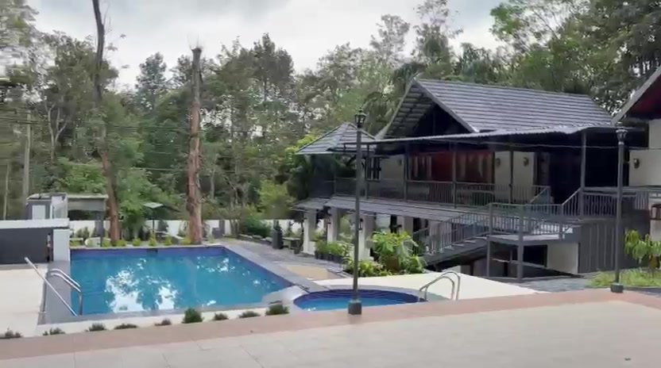
Representative frame from the villa video cluster

Client confirmations required
- Confirm the 26 cents and ₹4.5 crore belong to this exact villa/pool property.
- Confirm the official property name and whether it is a private villa, operational homestay/resort, or investment property.
- Confirm exact room count, bathroom count, built-up area, parking, access road, title/approvals and public contact person.

5. Property Record B — “50 caree” / ₹55 lakh
STATUS: INCOMPLETE
Area | Client wrote “50 caree” — likely 50 acres, but must be confirmed
Price | ₹55 lakh
Price basis | Unknown — total vs per acre not stated
Location | Not supplied
Media | No safe property-specific association
Do not publish this as “50 acres at ₹55 lakh/acre” until both the acreage wording and price basis are confirmed.

6. Property Record C — 12-acre Villa Property
STATUS: INCOMPLETE
Area | 12 acres
Type | Villa property
Price | Not supplied / not safely associated
Location | Not supplied
Media | TBC

7. Property Record D — 6-acre “Kisan JV”
STATUS: INCOMPLETE
Area | 6 acres
Deal wording | Kisan JV (client wording)
Additional figure | 6,000 sq ft
Rate | ₹2,000 / sq ft
Duplicate note | The same 6-acre / 6,000 sq ft / ₹2,000 sq ft text appears twice
Location | Not supplied
The 6,000 sq ft figure may refer to built-up area, allocation, plot area, entitlement or proposed construction. The source does not say. Do not calculate a total value until the basis is confirmed.

8. Property Record E — 23.50-acre Property
STATUS: INCOMPLETE
Area | 23.50 acres
Price / rate note | ₹60 lakh
Price basis | TBC — total or per acre not stated
Instagram reference | https://www.instagram.com/reel/DbIyM2LTr5k/
Media relationship | Reel may be associated by sequence, but client did not explicitly confirm

9. Property Record F — 23-acre Property
STATUS: PARTIAL
Area | 23 acres
Price / rate note | ₹45 lakh
Price basis | Not stated
Coordinates | 12.5529731, 75.7950978
Map | https://www.google.com/maps?q=12.5529731,75.7950978&z=17&hl=en
Property type | Not explicitly supplied

10. Property Record G — 20-acre Basavanahalli Property
STATUS: PARTIAL
Area | 20 acres
Contact | Computer Raju
Mobile | +91 9481202280
Client-provided address | CWWG+94Q, Basavanahalli, Karnataka 571234, India
Coordinate visible in map URL | Approx. 12.445624652349654, 75.92473067343235
Price | Not supplied
This Basavanahalli coordinate is distinct from the villa/pool property coordinates. Do not merge the two listings.

11. Property Record H — SLN Plantations, Madhapur / Madapur
STRONGEST DETAILED COORG LISTING
Source: client-supplied “SLN Plantations, Madapur.pdf”. The PDF describes a high-altitude plantation estate in Garwale, Madhapur, Coorg, Karnataka.
Location | Garwale, Madhapur, Coorg, Karnataka
Altitude | Over 3,900 ft above sea level
Annual rainfall | Over 110 inches
Total area | 80 acres (79.86 acres stated)
Estate positioning | Operational plantation / investment estate

Crop profile
Avocado | 50 acres; 3,800 total trees; 3,000 currently yielding; stated average yield 100 kg/plant
Litchi | 10 acres; crop expected from upcoming season
Robusta coffee | 10 acres
Arecanut | 15 acres interplanted; 15,000+ trees
Other crops referenced later | Pepper is also mentioned in the revenue section

Infrastructure and development
- Israeli Netafim fertigation / irrigation technology.
- Irrigation and fertigation coverage across the estate.
- RCC labour quarters for approximately 20 workers.
- Developed/tarred roads and pathways.
- Scenic high point presented as suitable for a proposed 5,000 sq ft luxury estate bungalow with 360-degree views.

Investment themes supplied by client
- Turnkey operating estate
- Multiple crop revenue streams
- High-altitude Coorg location
- Advanced irrigation/fertigation
- Eco-tourism potential
- Luxury residential / estate bungalow potential
- Farm-to-table and boutique agricultural export potential
Revenue inconsistency in source PDF: one passage connects 300 MT avocado yield to ₹2.5 crore annual revenue at ₹100/kg, while another passage states ₹3 crore at the same 300 MT and ₹100/kg. ₹3 crore is the arithmetic result of 300,000 kg × ₹100/kg, but the website should use only a client-confirmed current/projected revenue figure and clearly label the projection year.

Website asset guidance
Use only imagery embedded in the SLN PDF as confirmed SLN-specific farm imagery unless the client confirms that any WhatsApp forest/drone footage belongs to SLN. The PDF contains estate vegetation plus lychee and avocado images.
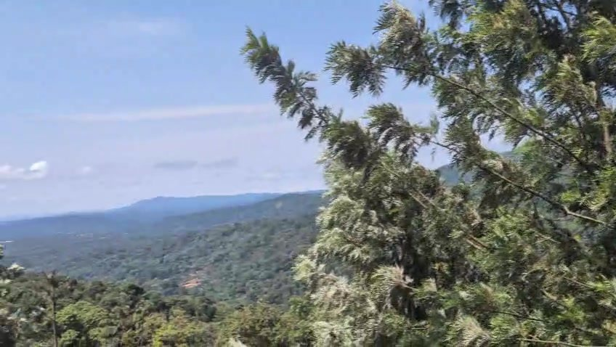
Scenic mountain video frame supplied separately — attractive for Coorg storytelling, but property association is TBC

Client confirmations required
- Actual asking price / sale structure.
- Correct spelling and official address: Madapur vs Madhapur.
- Current verified crop yields and current revenue.
- Projected yield/revenue year and assumptions.
- Whether WhatsApp drone/forest/waterfall footage is SLN-specific and whether reuse rights are cleared.

12. Property Record I — ABBELON Estates
HIGH-CONFIDENCE VISUAL CLUSTER
The client supplied three polished 3D layout graphics branded “ABBELON ESTATES — Premium Residential Layout”, plus a photographed technical layout/blueprint. These assets should be grouped together.
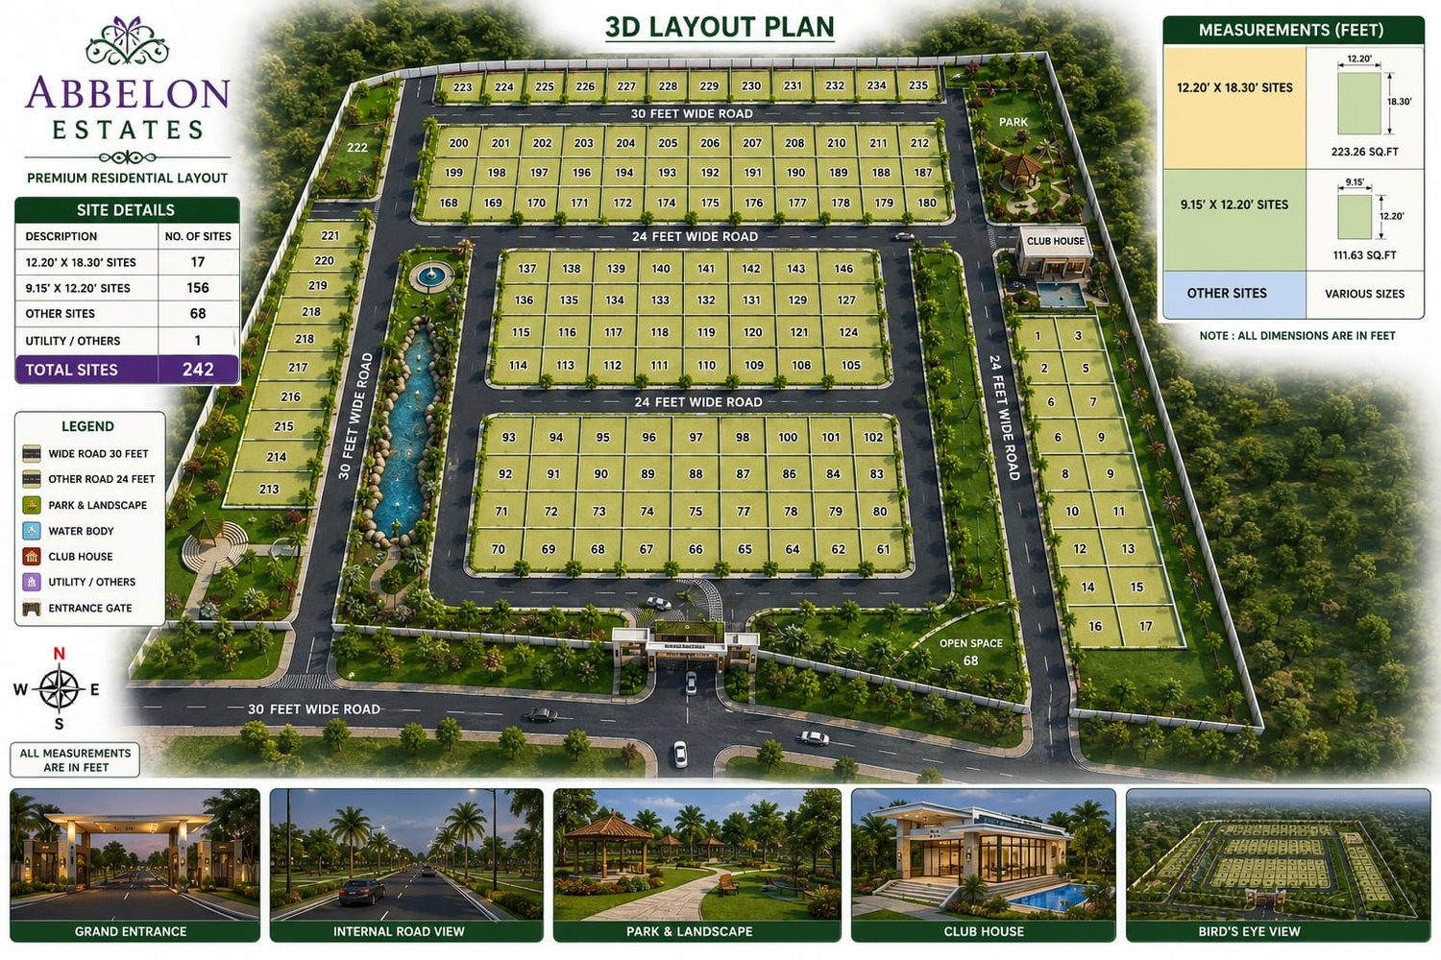 | 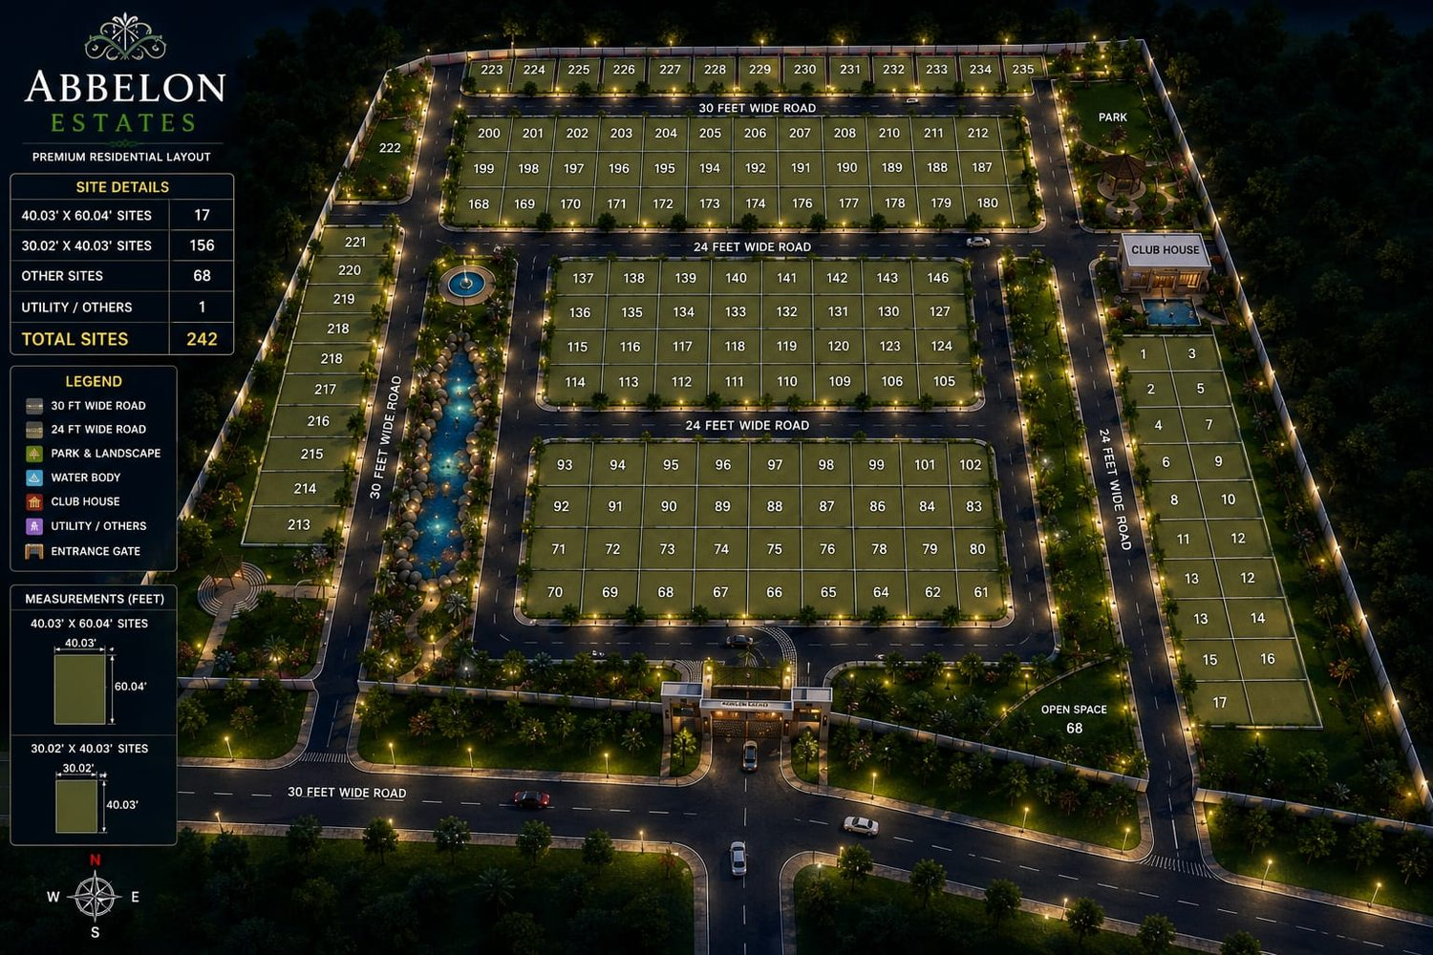
Daytime 3D layout graphic | Night-time 3D layout graphic
Project name | ABBELON Estates
Positioning | Premium Residential Layout
Total sites | 242
Approx. 40 × 60 ft category | 17 sites
Approx. 30 × 40 ft category | 156 sites
Other sites | 68
Utility / others | 1

Features shown in the marketing graphics
- Approx. 30 ft / 9 m main road
- 24 ft internal roads
- Park & landscaped areas
- Water body
- Club house
- Entrance gate
- Utility / other area
- Open space
- Underground drainage
- Electricity with street lights
- Avenue plantation
The supplied 3D graphics contain inconsistent units and plot-numbering. One graphic labels 12.20 × 18.30 as FEET even though those values correspond to metres for an approximately 40 × 60 ft plot. Treat all 3D graphics as illustrative marketing renders. Use the original sanctioned/approved legal plan for authoritative dimensions, numbering and approvals.
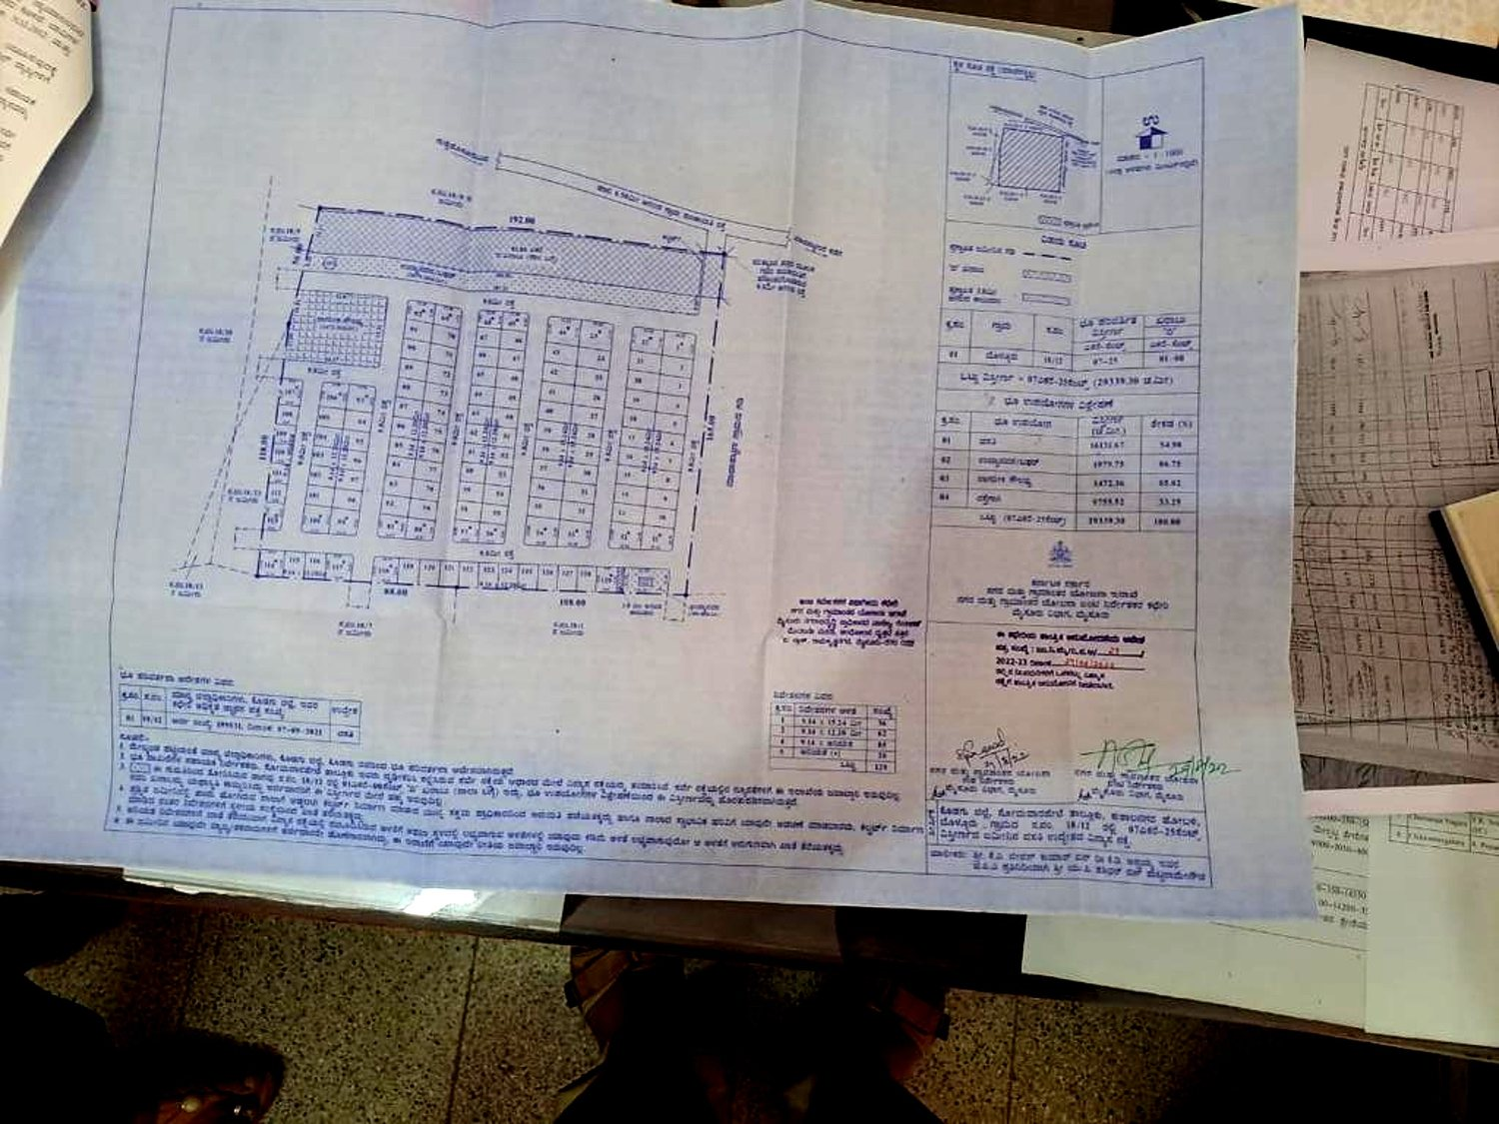
Enhanced rotation of the photographed technical layout/blueprint. Readable only in part; request the original PDF/scan before publishing legal plan data.

Missing for public listing
- Exact project location and map pin
- Pricing / rate and price basis
- Approval authority and approval number
- Survey numbers / title details
- Original sanctioned plan PDF or high-resolution scan
- Current availability / sold sites
- Developer / promoter contact and public enquiry number

13. Forest / Plantation / Land Media Cluster — Asset Bank
PROPERTY ASSOCIATION: TBC
The following media is visually strong for a Coorg land website, but the client has not explicitly tied each item to the 12-acre, 23-acre, 23.5-acre, 20-acre, 50-acre or SLN listing. Keep these as an unassigned asset bank until property ownership/association is confirmed.
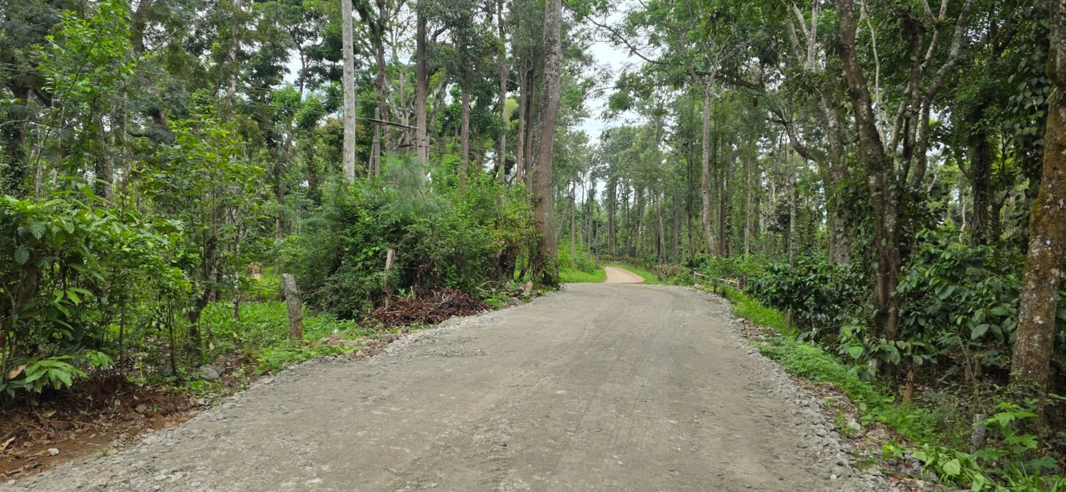 | 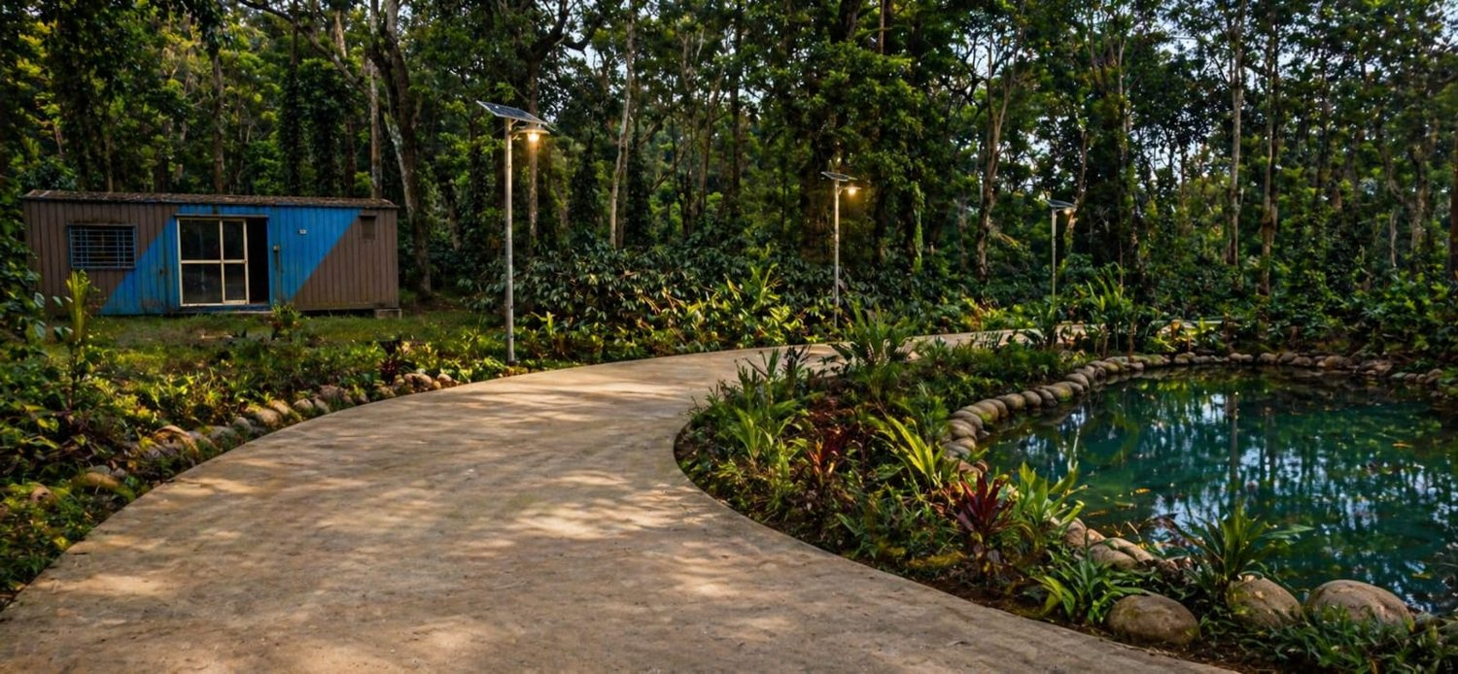
Internal estate road through dense plantation | Landscaped pond / curved internal road
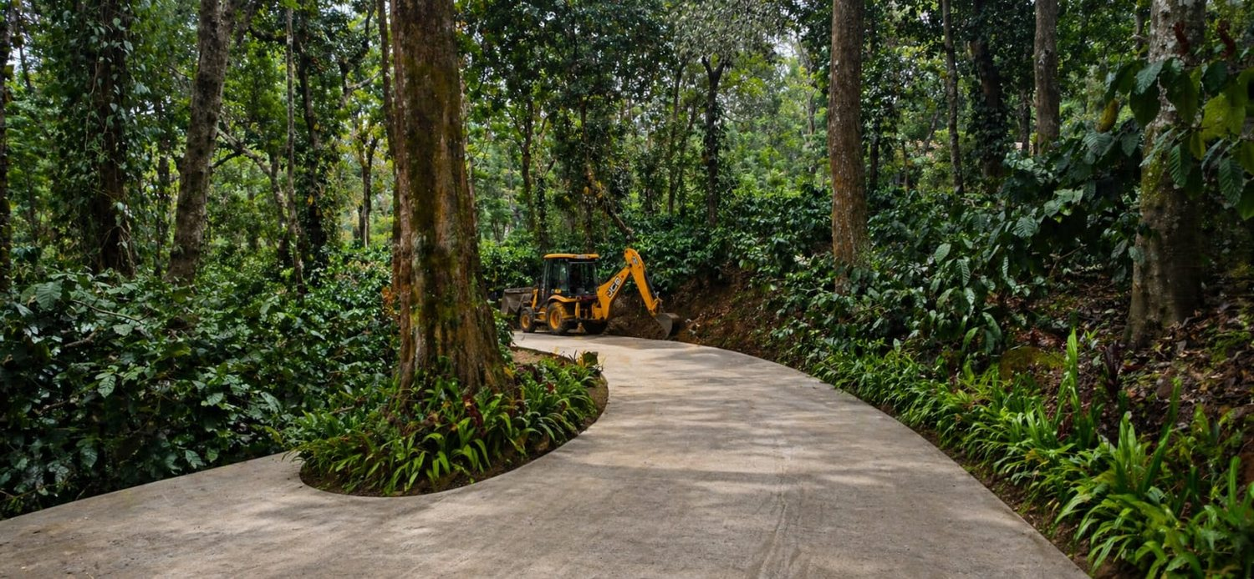 | 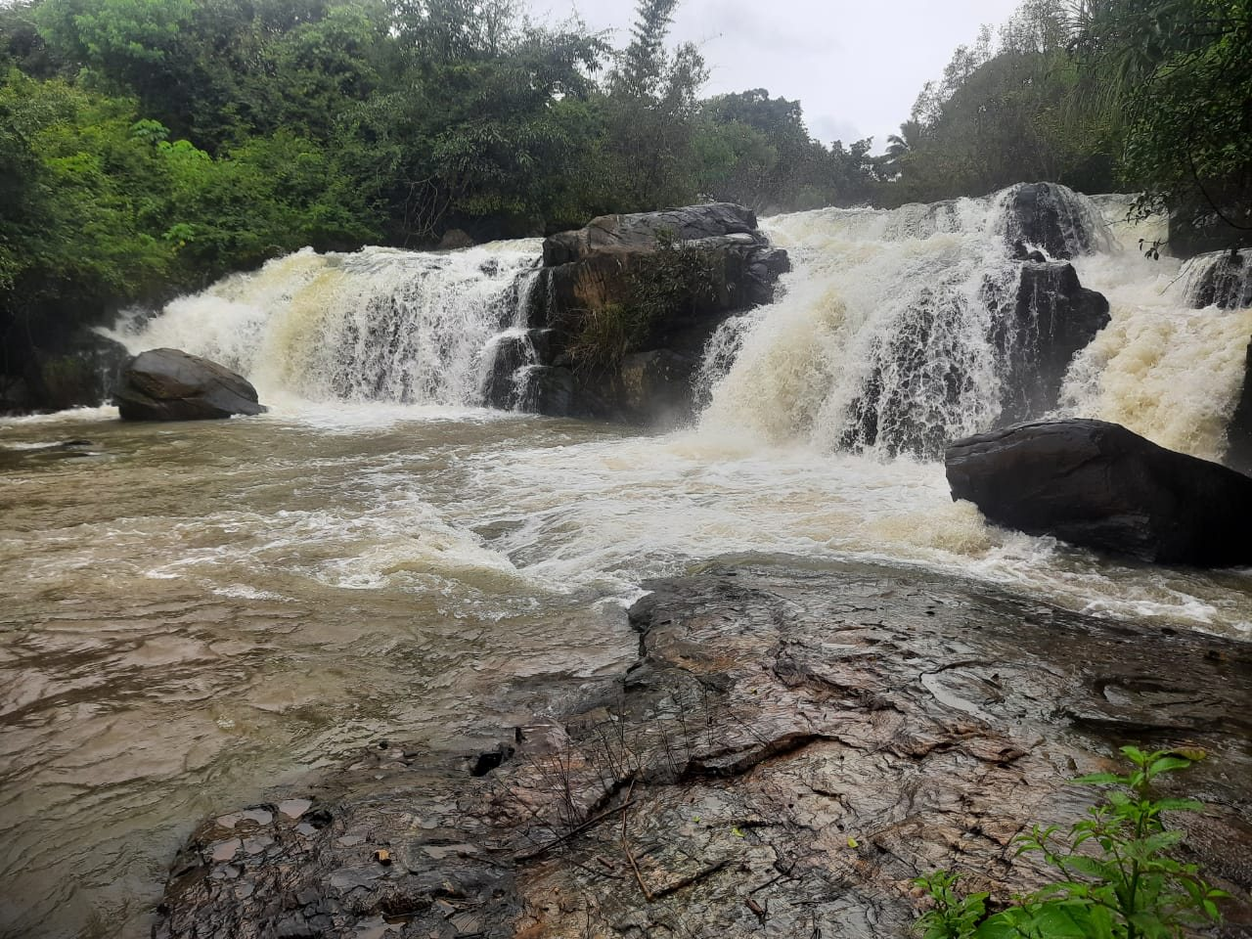
Road-development/JCB scene | Waterfall image supplied by client
Road / forest stills | 14.14.28.jpeg; 14.14.31 (1).jpeg; 14.14.31.jpeg; 14.14.32.jpeg; 14.14.33 (1).jpeg
Landscaped pond / road | 14.14.33 (3).jpeg
Roadwork / JCB | 14.14.34.jpeg and 14.14.34(1).jpeg variants
Waterfall | 14.14.35.jpeg / 14.14.35(1).jpeg + 14.14.34 (1).mp4 waterfall clip
Mountain/scenic clip | 14.14.31.mp4
Plantation walkthrough | 14.14.34.mp4
Drone promotional footage | 14.14.37.mp4 and 14.14.40.mp4 — appear to be same/similar footage; prefer 14.14.40 because it is higher resolution
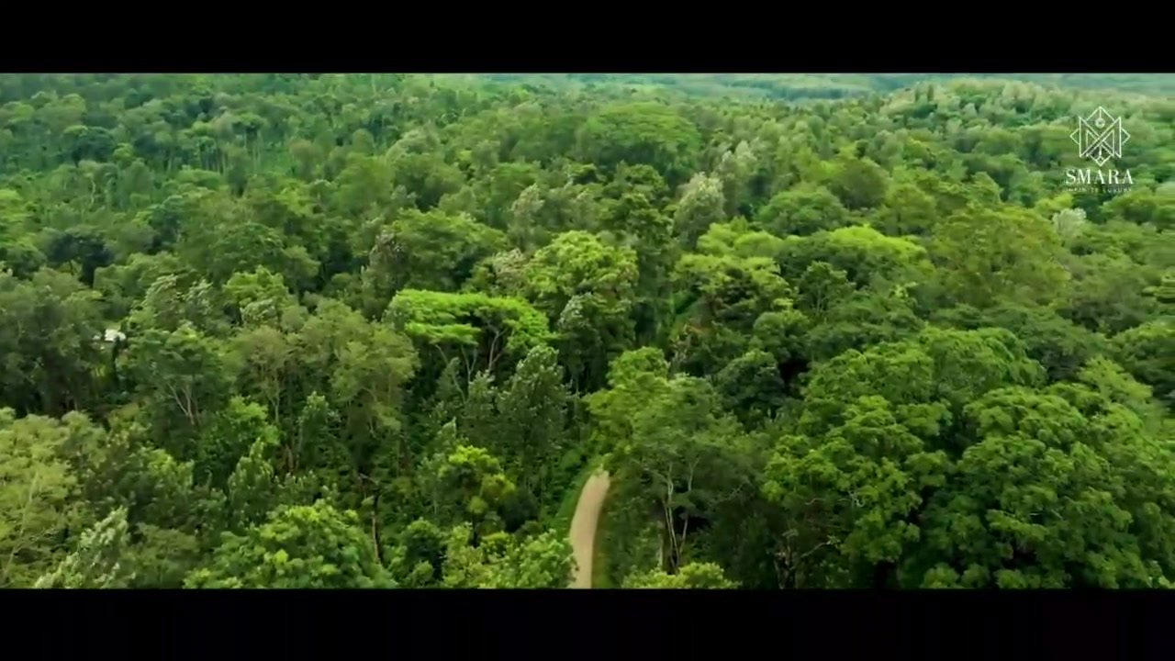
Representative frame from the higher-resolution drone video. Footage carries a visible SMARA mark; reuse rights must be confirmed.
Do not claim “private waterfall”, “waterfall inside property”, “tar road throughout”, “completed landscaping”, or similar statements purely from these images. First confirm the exact property and whether the feature is on-site, adjacent, proposed or nearby.

14. Survey / sketch documents
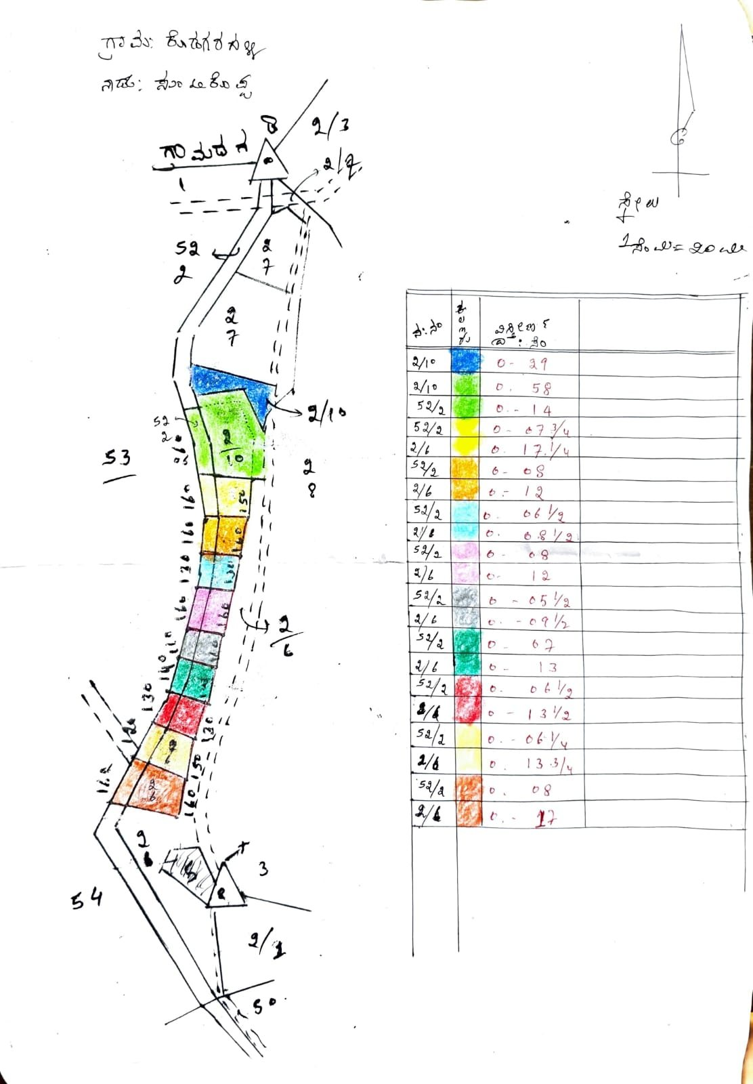
Hand-drawn coloured parcel sketch — association TBC | Photographed technical layout / plan
- Hand-drawn sketch: useful as an internal lead reference only unless the client supplies survey numbers and confirms the parcel/listing.
- Technical blueprint: request an original scan/PDF. Do not transcribe approval numbers or legal dimensions from this angled low-resolution photograph.

15. Out-of-Coorg Source — Hoodi, Bangalore Two-Villa Property
SEPARATE FROM LAND IN COORG INVENTORY
Source: client-supplied “Hoodi Property details April 2026.docx”. This listing is in Hoodi, Bangalore 560048, so it should not be mixed into Coorg inventory unless the client intentionally wants a broader “Other Properties” section.
Location | Hoodi, Bangalore 560048; SJR Eternity Phase 1
Site area | 5,236 sq ft
Site dimensions | 59.5 ft × 88 ft
Frontage / facing | 59.5 ft; North facing
Road width | 30 ft
Total built-up area | Approx. 10,000 sq ft across 2 villas
Villa 1 | 5,500 sq ft; 4 bedrooms; 2 living rooms; swimming pool; home theatre; entertainment/bar room
Villa 2 | 4,500 sq ft; 4 bedrooms; 2 living rooms; entertainment/bar room
Quoted total | ₹9.5 crore — source breakdown: land ₹7.85 crore + building ₹1.65 crore
Land rate in source | ₹15,000/sq ft
Building rate in source | ₹1,670/sq ft
Water / utility | 10,000-litre sump per villa; Cauvery water connection stated
Documentation claims | e-Khatha, DC conversion approval with B-khatha, registered deeds, loans closed — exact current Khatha status should be reconfirmed
The Hoodi source simultaneously references e-Khatha and B-khatha. Obtain the exact current Khatha status before publishing legal/documentation claims.

16. Client Verification Checklist — Must Resolve Before Website Launch
Item | Question to client | Status
Pricing basis | Is ₹55 lakh, ₹60 lakh and ₹45 lakh total property price or per-acre rate? | TBC
“50 caree” wording | Confirm whether this means exactly 50 acres. | TBC
26-cent villa association | Confirm the 26-cent / ₹4.5Cr / 11-main-bed notes belong to the pool/villa media cluster. | TBC
Villa details | Official name, property type, built-up area, bathroom count, approvals, access road, parking and public contact. | TBC
12-acre listing | Location, price, map pin, property type, photos/videos and title details. | TBC
6-acre Kisan JV | Explain JV structure, 6,000 sq ft figure and what ₹2,000/sq ft applies to. | TBC
23.50-acre listing | Confirm price basis and whether Instagram reel/media belongs to this property. | TBC
23-acre listing | Confirm ₹45 lakh basis and property type. | TBC
20-acre listing | Confirm price, title, access, water/electricity, survey number and whether Computer Raju should be displayed publicly. | TBC
SLN | Asking price, correct location spelling, current yield/revenue, projected figures and associated media. | TBC
ABBELON | Exact location, price, approval number, sanctioned plan, survey numbers and current site availability. | TBC
Waterfall | Inside property, boundary feature, nearby attraction or generic area footage? | TBC
Drone footage | Confirm ownership/reuse rights; visible SMARA mark is present. | TBC
All properties | Survey numbers, ownership/title, conversion/approvals, access/frontage, water, electricity and exact map pin. | TBC
Public contact | Confirm the official Land in Coorg enquiry phone/WhatsApp/email and who should receive leads. | TBC

17. Instructions for Website / AI Agent
- Treat this document as the master content map, not as permission to invent details.
- Use only assets assigned with High confidence directly on a property page without further confirmation.
- Medium-confidence assets may be used only as generic Coorg/estate atmosphere until client confirms the property relationship.
- Low/TBC assets must not be assigned to a specific listing.
- Preserve the client’s exact acreage and price wording until the price basis is confirmed.
- Never turn rendered/AI imagery into claims about completed amenities or current site condition.
- Do not publish investment-return or crop-revenue claims until current/projected figures and assumptions are confirmed.
- Use the higher-quality duplicate video when footage is repeated; do not load duplicate media into the final site.
- Keep Hoodi/Bangalore separate from Coorg inventory unless the client explicitly expands the site scope.

