GO DIGITAL MARKETING
Automobile CRM
Final Technical Product Requirements Document
Lead capture • unified communication • test rides • vehicle inventory • booking • billing • delivery • registration/RC • post-sale lifecycle

Document item | Locked decision
Version | 4.0 – 10/10 implementation master baseline
Prepared | July 31, 2026
Product model | Multi-tenant internal CRM operated by Go Digital Marketing for approved Indian automobile dealerships
Initial scale | 1,000 registered users; 50–100 concurrent active sessions
Growth target | 10,000 registered users without rewriting core business logic
Applications | Next.js web dashboard + NestJS API/worker + React Native/Expo Android app
Web design system | shadcn/ui only, initialized on Base UI; no competing web UI library
Approval scope | Google Play, Meta/WhatsApp Business Platform, Google Business Profile API, Google Ads lead forms and provider onboarding
Status | Final master PRD for estimation, architecture, UX, sprint planning, pilot onboarding and release approval. Provider policies, quotas, pricing and legal obligations must be re-validated before production launch.

Primary product decision
Office and management roles use the web dashboard. Salesperson, Test Ride Executive and Delivery Executive use the Android mobile app. Customers do not need an app; they communicate through the dealership’s official phone, WhatsApp, email, SMS and secure document links.

Document Map
1. Executive decision and scope
2. Goals, boundaries and terminology
3. Organization, roles and permissions
4. Role-by-role workflows
5. End-to-end lifecycle and ownership
6. Lead sources, deduplication and attribution
7. Lead lifecycle, assignment and SLA
8. Telephony and call outcomes
9. Unified inbox and customer timeline
10. Test ride operations
11. Vehicle inventory and allocation
12. Booking, billing, payment and finance tracking
13. Delivery operations
14. Registration and RC follow-up
15. Customer-owned vehicle and post-sale reminders
16. Documents, consent, privacy and retention
17. Integration architecture and provider approvals
18. UI/UX design system – shadcn only
19. Technical architecture and selected stack
20. Data model, APIs, events and background jobs
21. Security, audit, observability and recovery
22. Performance, offline behavior and rate limits
23. Environments, deployment, costs and AWS migration
24. Repository structure
25. Testing, release gates and acceptance criteria
26. Delivery phases, risks and definition of done
27. Configuration, approval limits and governance
28. State machines and transition contracts
29. Logical data model and data dictionary
30. API standards, concurrency and webhook contracts
31. Screen inventory, accessibility and UX contract
32. Data migration and client onboarding
33. Analytics and KPI dictionary
34. Operations, support, threat controls and recovery
35. Traceability, RACI, delivery estimate and sign-off
36. Appendices and official research references

Research Review: Changes from v2.0 and Final Completeness Upgrade
Finding | Final v4.0 decision
Role flow coverage | Added a complete workflow chart, entry condition, actions, handoff and exit condition for every role, including an optional Inventory & Vehicle Allocation Executive.
Inventory gap | Added basic vehicle inventory, VIN/engine tracking, demo stock, reservation expiry, allocation, transfer and PDI handoff to the MVP.
Workflow clarity | Separated sales relationship ownership, operational process ownership and conversation ownership; added explicit handoff gates.
UI component rule | Locked the web app to shadcn/ui only and pinned Base UI for a new project. Custom screens compose project-owned shadcn code; no Material UI, Ant Design, Chakra or Bootstrap.
React Native exception | shadcn/ui is web component code and cannot be used directly in React Native. Mobile uses project-owned native primitives with the same design tokens and no third-party full UI kit.
Google Play | Production plan targets Android 16/API 36 for submissions on or after August 31, 2026; permission and foreground-service review is mandatory.
Location tracking | Tracking is user-started, job-bound and visibly active. No off-duty tracking. Background-location permission is excluded unless a validated device test proves it is necessary and Play review is approved.
Google Business Profile | Removed universal hard-coded quota assumptions. The client connection reads actual project quotas; quota 0 triggers access request. Pub/Sub is supported with reconciliation.
WhatsApp | Kept client-owned WABA and Cloud API. Multi-client scale uses the Tech Provider/Embedded Signup path. Pricing is not hard-coded because Meta charges and categories change.
Indian compliance | Added DPDP Rules 2025 rollout readiness, consent/rights/incident controls and a launch-time TRAI/DLT legal review. Draft 2026 telecom amendments are not treated as final law.
Automation scope | MVP includes fixed SLA, reminder, notification and outbox automations. A visual no-code automation builder remains Phase 2.
Service scope | MVP creates customer-vehicle and reminder plans; full service-centre/job-card operations remain Phase 2.
State-machine precision | Added allowed transition matrices for Lead, Test Ride, Inventory, Booking/Payment, Delivery and Registration/RC, including actor, evidence, side effects and invalid-transition behavior.
Implementation data contract | Added a logical ERD, implementation-level data dictionary, required tenant keys, uniqueness constraints, indexing rules, PII classification and retention behavior.
API consistency | Added API versioning, error envelope, cursor pagination, idempotency, optimistic concurrency, webhook contracts, deprecation and provider-adapter compliance rules.
Screen completeness | Added web/mobile screen inventory, role navigation, shared loading/empty/error/offline states, shadcn component mapping, accessibility and localization requirements.
Client onboarding | Added controlled discovery, import mapping, dry run, validation, provider setup, cutover, reconciliation, rollback and hypercare workflow.
Analytics truth | Added KPI definitions and formulas so dashboards use one source of truth and never invent campaign ROI or combine incompatible lifecycle denominators.
Operational readiness | Added severity model, incident process, threat controls, restore targets, lost-device handling, provider outage runbooks and support ownership.
Traceability and sign-off | Added goal-to-epic traceability, RACI, realistic one-developer delivery range and formal product/engineering/operations/client approval gates.

1. Executive Decision and Product Boundaries

1.1 Locked architecture
- Build a Next.js web dashboard, a NestJS modular-monolith API plus BullMQ worker, and an Android-first React Native/Expo application.
- Use provider-neutral adapters for telephony, WhatsApp, Meta lead ads, Google Ads lead forms, Google Business Profile, email, SMS, maps and storage.
- Each client dealership owns its connected provider accounts and customer communication consent unless a later reseller agreement is approved.
- Keep PostgreSQL as the source of truth. Redis accelerates queues, locks, rate limits and cache but must never be required to preserve business state.
- Use an event/outbox pattern for lead assignment, notifications, provider calls, status history, audit and retries.
- Preserve a controlled migration path from Vercel/Render/Supabase/Upstash/Tigris to AWS without changing domain contracts.

1.2 MVP includes
- Client, branch, department, team, user, role and permission management.
- Lead capture from META, WHATSAPP_AD, GOOGLE_ADS, WEBSITE, WALK_IN and OTHER; manual entry/import as creation methods.
- Deduplication, assignment, first-response SLA, follow-ups, accepted/rejected/lost/reopened flow and append-only history.
- Click-to-call/preview dialer, provider call logs and outcomes, WhatsApp inbox and continuous customer timeline.
- Test-ride scheduling, demo-vehicle allocation, job-bound foreground location, checklist and feedback.
- Basic vehicle catalog and inventory: VIN/chassis, engine, model/variant/colour, branch, status, reservation, allocation, transfer and demo stock.
- Booking, discount approval reference, payment-status/finance/invoice/insurance tracking and secure document handling.
- Delivery scheduling, PDI/readiness gate, active tracking, checklist, OTP/signature/photo and completion/delay proof.
- Registration/RTO/RC tracking, secure RC sharing and aging/escalation.
- Customer-owned vehicle profile and configurable service, insurance, PUC, warranty, AMC, exchange and upgrade reminders.
- Operational dashboards, reports, exports, integration health, audit logs, backup/restore and pilot release approvals.

1.3 MVP excludes
- Customer mobile application, public self-signup, subscription billing and commercial SaaS plans.
- Payment gateway processing, dealership accounting ledger, loan origination, OEM DMS/ERP replacement and unauthorised RTO automation.
- Predictive dialer, personal WhatsApp automation, universal SIM call recording, accessibility-based call capture and unsupported Android permissions.
- Full service-centre job cards, technician/workshop scheduling, parts procurement and OEM warranty adjudication.
- Visual workflow builder, visual automation builder, advanced custom report builder, AI voice agent, AI credit purchase and predictive lead scoring.
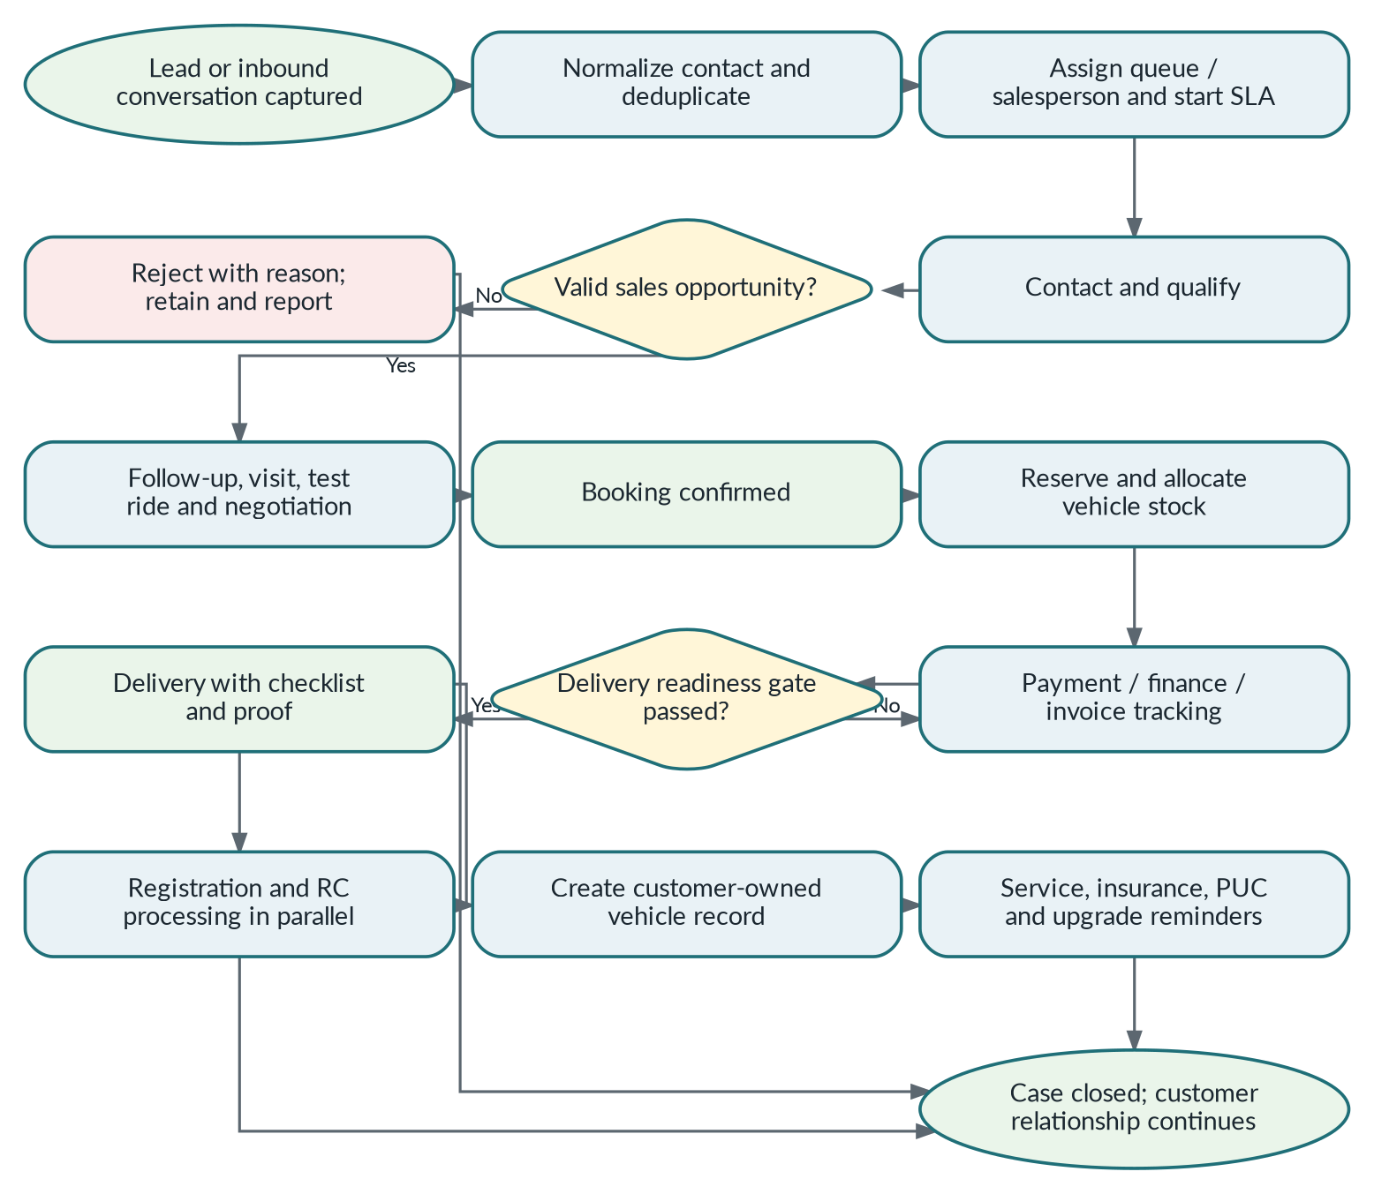
Figure 1. End-to-end customer lifecycle and primary process gates.

2. Product Goals, Non-Goals and Terminology

2.1 Goals
- Capture every authorised lead without losing attribution or creating unnecessary duplicate contacts.
- Give the sales team one customer timeline across calls, official messaging, notes, tasks, test rides, bookings, delivery and RC events.
- Give managers near-real-time operational visibility without continuous off-duty employee surveillance.
- Prevent a vehicle from being promised twice through reservation, allocation and release controls.
- Track commercial status without representing the CRM as an accounting, banking, insurance, government or RTO system.
- Preserve source, owner, status and correction history for audit, reporting and dispute resolution.
- Launch on low-cost managed infrastructure while meeting tenant-isolation, security, recovery and approval gates.

2.2 Core terminology
Term | Definition
Contact | Canonical person record inside one client organization. A contact may have multiple opportunities over time.
Lead / Opportunity | A specific enquiry linked to source, campaign, branch, vehicle interest, stage and owner.
Rejected | Invalid, duplicate, spam or out-of-scope initial enquiry; retained and inactive.
Lost | An accepted opportunity that exits the active sales process later.
Relationship Owner | Salesperson credited with and responsible for the long-term customer relationship.
Current Process Owner | Employee responsible for the active operational work such as test ride, billing, delivery or RC.
Conversation Owner | Person or queue responsible for customer replies in the unified inbox.
Reservation | Temporary hold on an inventory unit with expiry and booking/reference context.
Allocation | Binding association between a specific vehicle/VIN and a confirmed booking, subject to authorised release.
Tenant | Client dealership boundary preventing cross-client data access.
Provider Adapter | Common domain interface that hides vendor-specific API and webhook behavior.
Feature Flag | Per-client switch controlling a module or integration without branching core code.

3. Organization, Roles and Permission Model
Role | Application | Scope | Primary responsibility
Agency Admin / Super Admin | Web | All clients | Client lifecycle, global defaults, module flags, integration health, audited support and platform governance.
Client Admin | Web | One client | Branches, users, roles, settings, integrations, catalog, stock, retention, reports and onboarding approval.
Manager | Web | Client-wide | End-to-end funnel, exceptions, active-job map, stock/payment/RC aging, approvals and escalations.
Sales Manager | Web | Assigned branches/teams | Assignment, queues, SLA, coaching, discounts/booking exceptions, follow-ups and team reporting.
Telecaller – optional | Web | Assigned queues | First contact, preview dialer, qualification, rejection and handoff.
Salesperson | Android | Assigned leads | Calls/messages, qualification, visits, test rides, negotiation, booking request and relationship ownership.
Test Ride Executive | Android | Assigned rides | Demo vehicle, customer confirmation, active tracking, checklist, feedback and ride outcome.
Inventory & Vehicle Allocation Executive – optional | Web | Assigned branches | Stock intake, VIN verification, reservation, allocation, transfer, block/release and PDI handoff.
Billing & Documentation Executive | Web | Booked cases | Price/payment/finance/invoice/insurance/document verification and delivery readiness.
Delivery Executive | Android | Assigned deliveries | Preparation checklist, active tracking, proof and completion/delay.
RC & Registration Executive | Web | Registration cases | RTO submission, number/RC status, aging, customer updates, secure sharing and closure.

3.1 Role simplification
A small dealership may combine Telecaller with Salesperson, Test Ride Executive with Salesperson, Inventory with Billing, or Billing with RC. Capabilities remain separate in the permission model so the dealership can split responsibilities later without a database migration.

3.2 Authorization principles
- Default deny: every API request validates tenant, membership, role, branch/team scope, object scope and current membership status.
- Mobile field users see only assigned leads/jobs and the minimum customer/financial information required for the task.
- Billing cannot modify negotiation history; Delivery cannot change payment; RC cannot change booking amount; Inventory cannot confirm payment.
- Manager and Client Admin correction actions require a reason and write old value, new value, actor, timestamp and request correlation ID.
- Agency support access is short-lived, reasoned, visibly indicated, revocable and immutable in audit logs.
- Exports, private documents, recordings and location history require explicit permissions and download/audit events.

4. Role-by-Role Workflows
Workflow standard
Every role flow below defines an entry condition, allowed actions, mandatory evidence, handoff and exit condition. State transitions are validated by the NestJS backend; the UI cannot bypass them.

Agency Admin / Super Admin
Role control summary
Entry: Platform monitoring, client lifecycle, safe support
Exit: Client created/suspended/restored or issue resolved
Critical control: Support elevation expires automatically and never grants silent access.

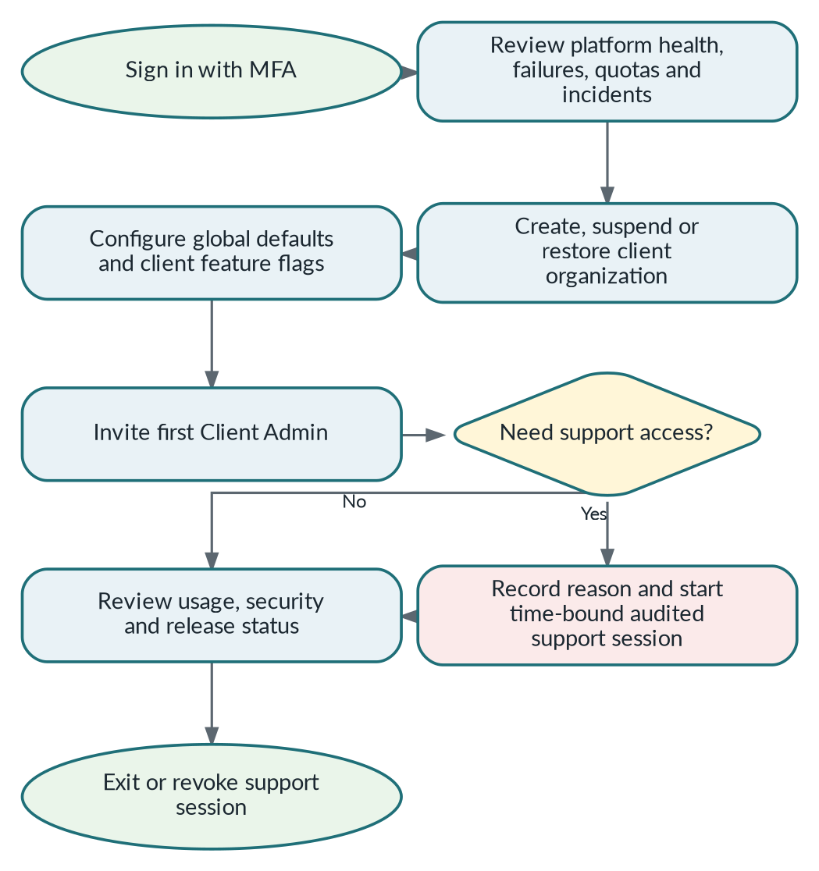
Agency Admin / Super Admin end-to-end workflow.

Client Admin
Role control summary
Entry: Approved client invitation
Exit: Client passes onboarding checklist and is activated
Critical control: Cannot view another client; integration secrets remain backend-only.

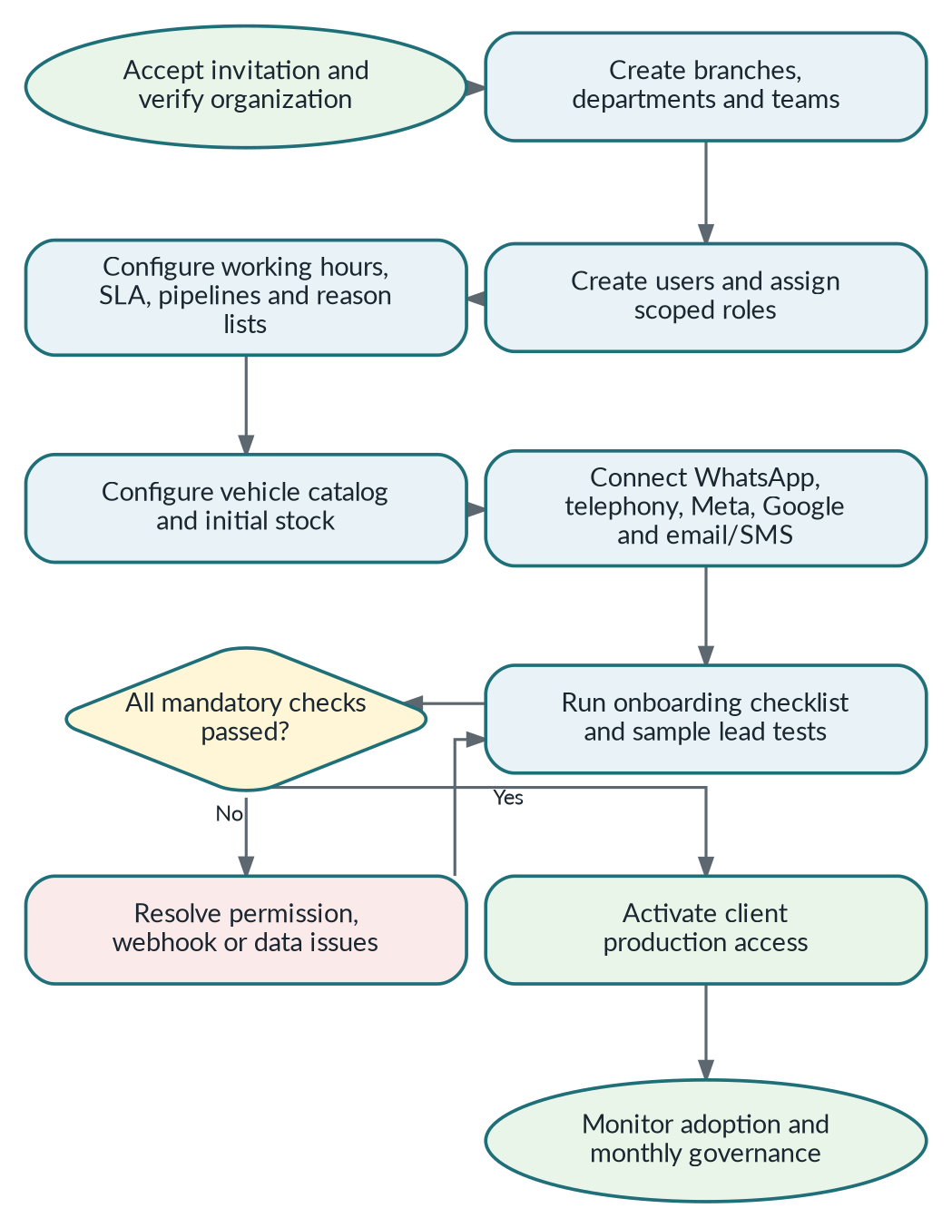
Client Admin end-to-end workflow.

Manager
Role control summary
Entry: Client-wide operational access
Exit: Exceptions resolved or assigned with deadlines
Critical control: Cannot directly overwrite immutable financial/status history.

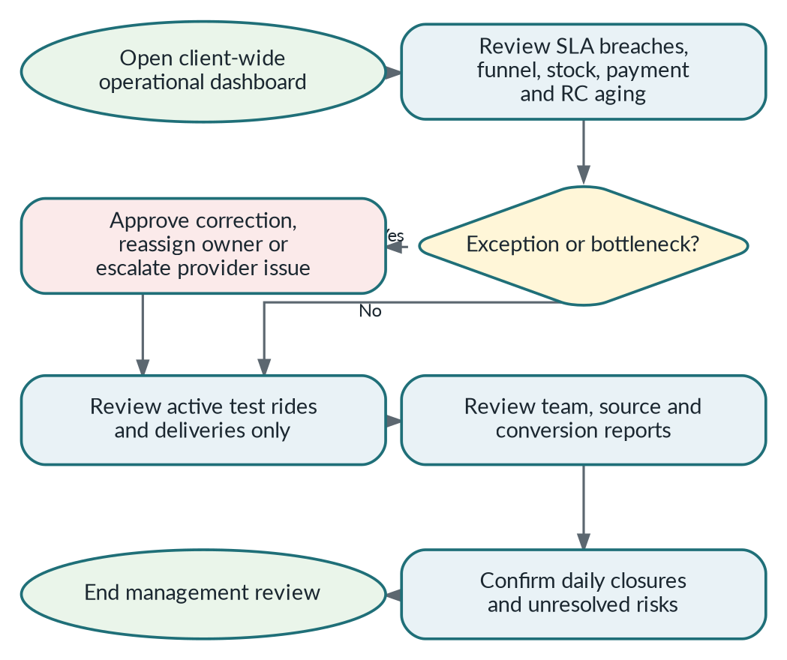
Manager end-to-end workflow.

Sales Manager
Role control summary
Entry: Assigned branch/team
Exit: Queue is assigned and SLA/escalations are controlled
Critical control: Reassignment, discount and cancellation exceptions require reasons.

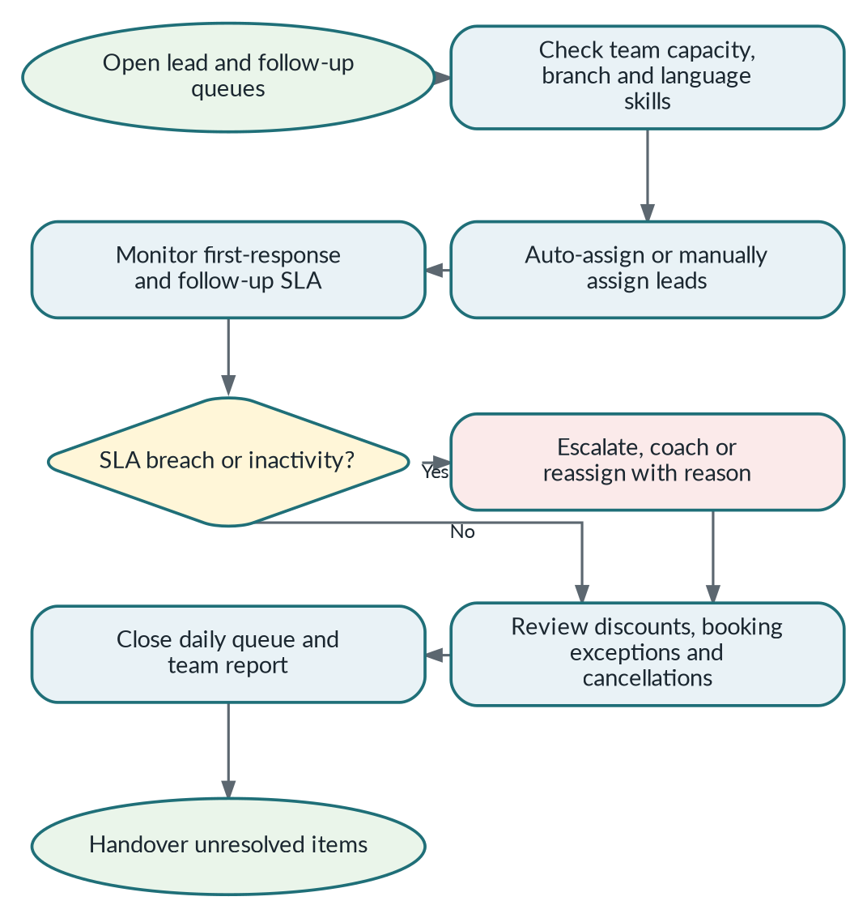
Sales Manager end-to-end workflow.

Telecaller (Optional)
Role control summary
Entry: Assigned pending-review queue
Exit: Lead rejected with reason or accepted and handed off
Critical control: Cannot create booking or modify inventory allocation.

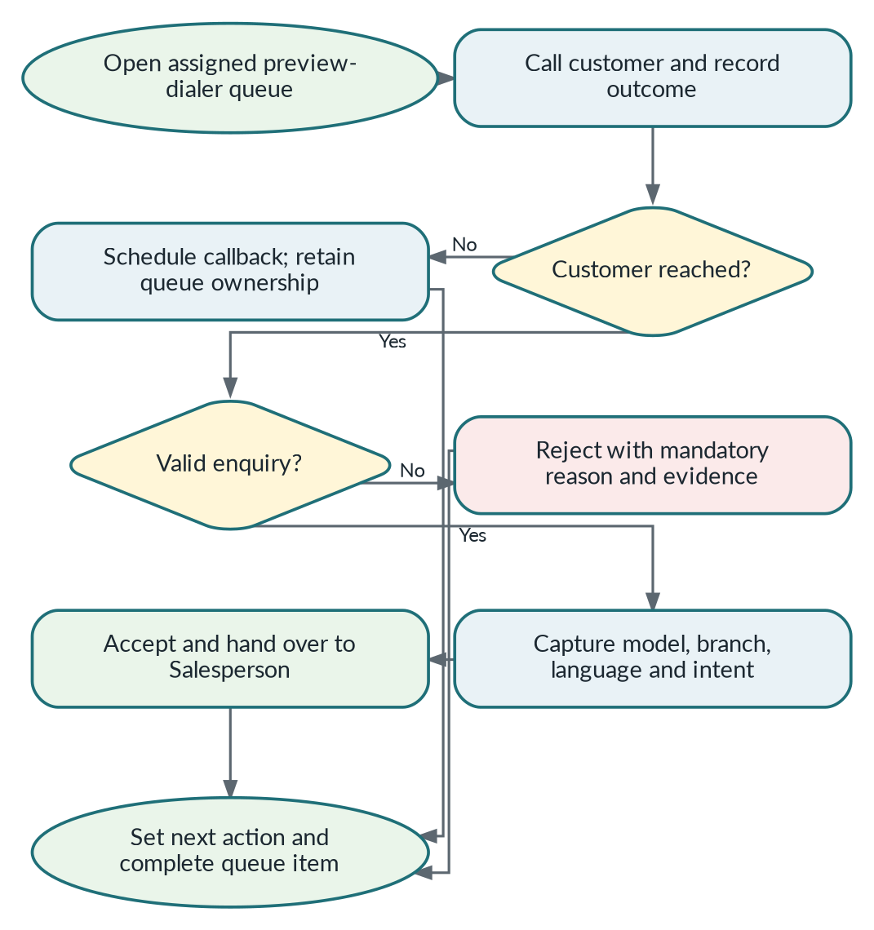
Telecaller (Optional) end-to-end workflow.

Salesperson
Role control summary
Entry: Assigned lead/opportunity
Exit: Booking request, lost outcome or next follow-up created
Critical control: Remains relationship owner unless an authorised reassignment occurs.

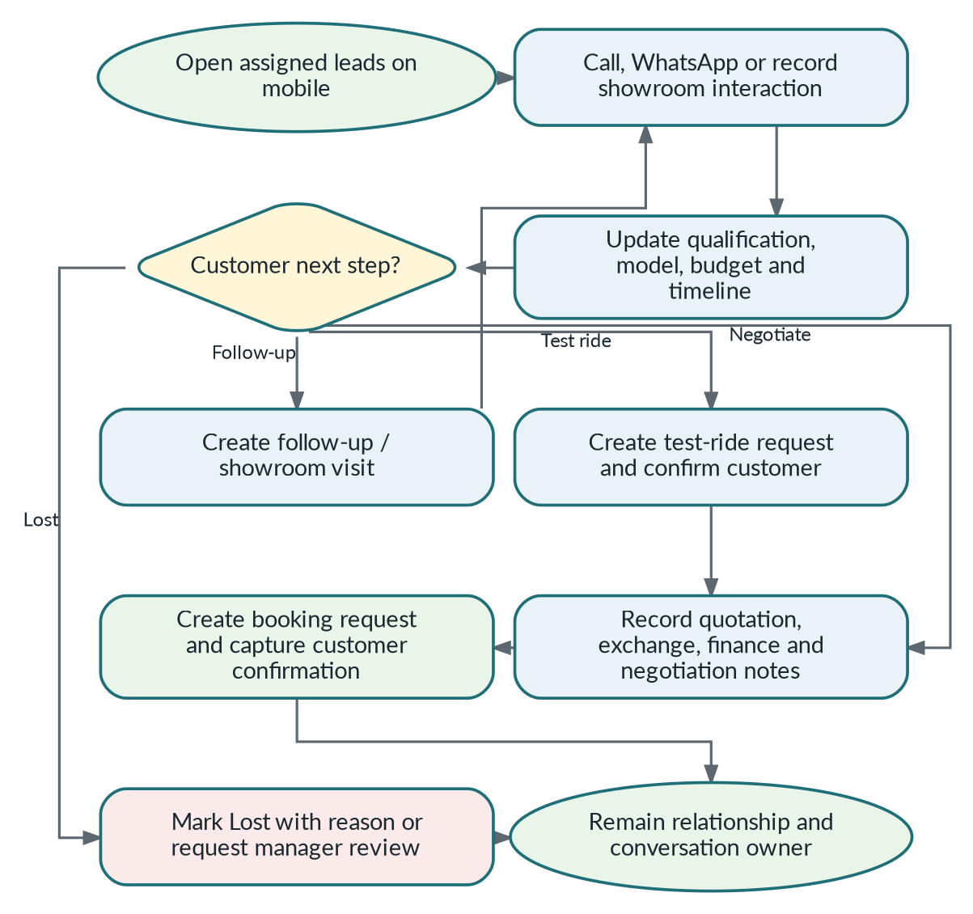
Salesperson end-to-end workflow.

Test Ride Executive
Role control summary
Entry: Assigned confirmed test ride
Exit: Ride completed/cancelled/no-show; tracking stopped
Critical control: No location collection outside an active user-started job.

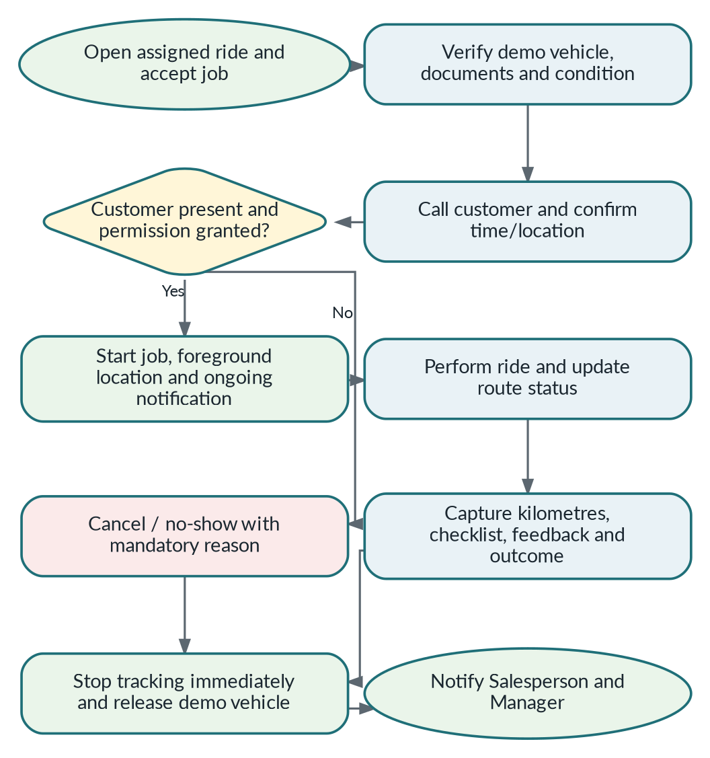
Test Ride Executive end-to-end workflow.

Inventory & Vehicle Allocation Executive (Optional)
Role control summary
Entry: Stock intake or booking allocation request
Exit: Vehicle allocated/released/transferred with history
Critical control: Cannot allocate the same active VIN to more than one booking.

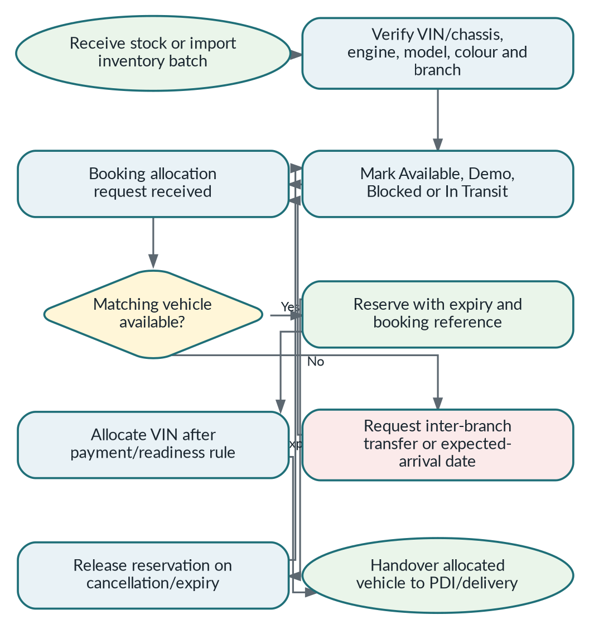
Inventory & Vehicle Allocation Executive (Optional) end-to-end workflow.

Billing & Documentation Executive
Role control summary
Entry: Confirmed booking
Exit: Delivery readiness passed or explicit hold created
Critical control: Cannot mark paid without payment entry/reference and verifier.

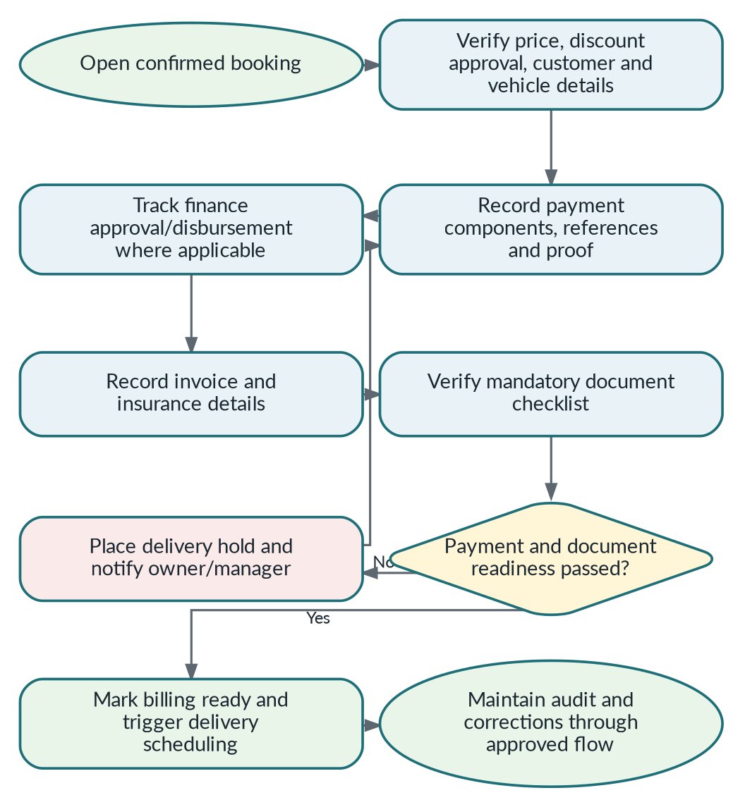
Billing & Documentation Executive end-to-end workflow.

Delivery Executive
Role control summary
Entry: Scheduled and assigned delivery
Exit: Delivered/delayed/failed with proof; tracking stopped
Critical control: Cannot start when mandatory readiness gate is blocked.

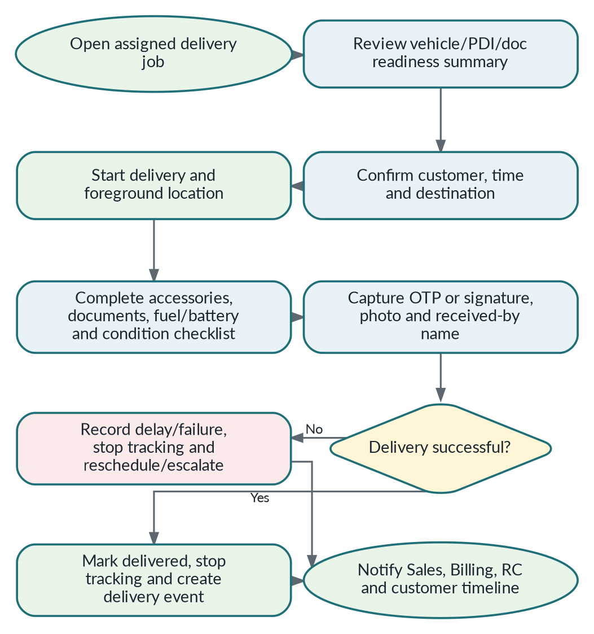
Delivery Executive end-to-end workflow.

RC & Registration Executive
Role control summary
Entry: Registration documents ready
Exit: RC shared/collected and case closed
Critical control: Cannot delete prior RTO/RC events; corrections are append-only.

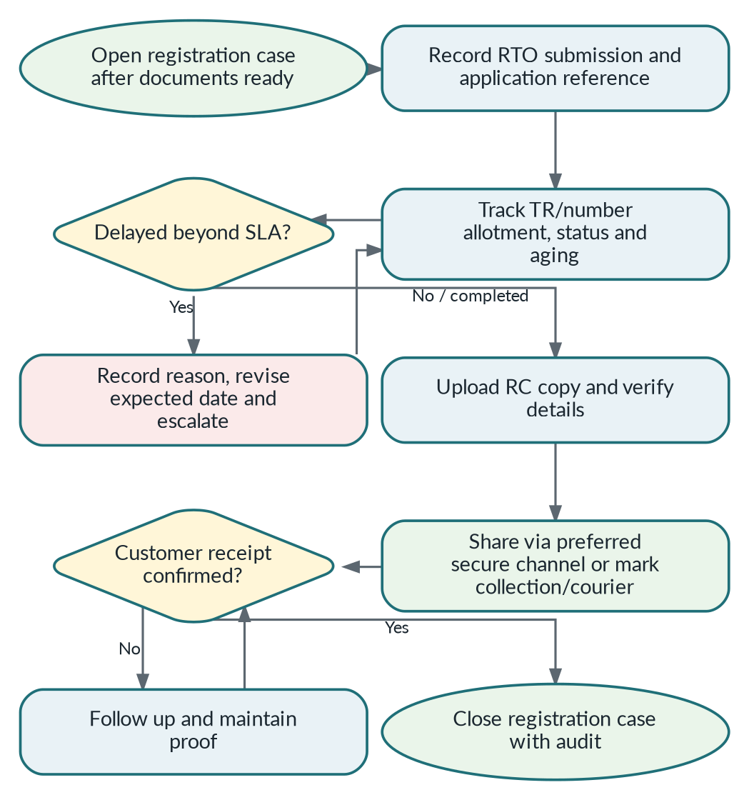
RC & Registration Executive end-to-end workflow.

5. End-to-End Lifecycle, Handoffs and Ownership

5.1 Ownership fields
Field | Purpose | Example
relationship_owner_id | Long-term relationship and sales attribution | Salesperson Ravi
current_process_owner_id | Person responsible for the current operational work | RC Executive Priya
conversation_owner_id | Person/queue responsible for customer replies | Sales Team / Ravi

5.2 Handoff rules
Trigger | From | To | What changes | What does not change
Lead accepted | Telecaller | Salesperson | Primary sales work and current process owner | Original source, contact, rejection history
Test ride assigned | Salesperson | Test Ride Executive | Current process owner for ride | Relationship and conversation owner
Booking confirmed | Salesperson | Billing / Inventory | Parallel process owners and readiness tasks | Sales relationship owner
Delivery scheduled | Billing / Inventory | Delivery Executive | Delivery job owner | Payment truth and RC process
Registration starts | Billing | RC Executive | Registration case owner | Delivery may proceed independently when gate allows
Post-sale reminder reply | Automation | Configured Sales/Service queue | Conversation routing | Customer vehicle and original booking history

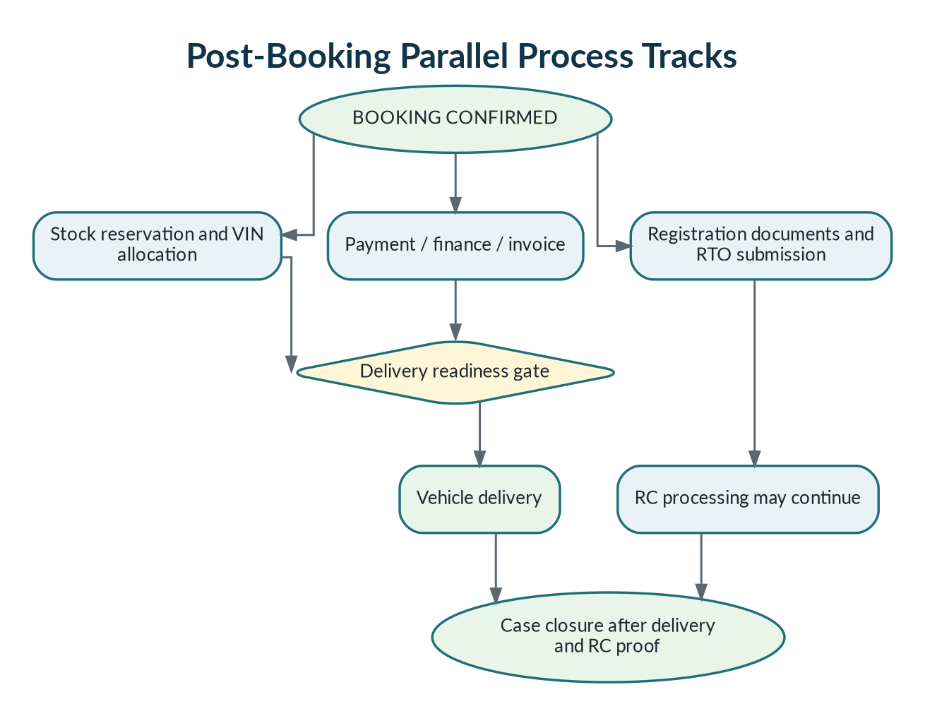
Figure 2. Booking creates parallel stock, billing, delivery and registration tracks.

6. Lead Sources, Deduplication and Attribution

6.1 Final source codes
Code | Visible source | Creation method | Attribution rule
META | Facebook/Instagram instant form | Automatic webhook | Store campaign, ad set, ad, form and external lead ID when supplied.
WHATSAPP_AD | Click-to-WhatsApp advertisement | First inbound customer message | Create/link lead only after message/referral webhook; do not treat a click alone as a CRM lead.
GOOGLE_ADS | Google lead form, website form or tracked call | Webhook/form/telephony/manual | Store GCLID/UTM/campaign where available; never invent campaign attribution.
WEBSITE | Organic/direct form or website call | Form webhook/manual call | Store page URL and UTM; calls need tracking numbers for automatic source detail.
WALK_IN | Showroom visitor | Manual | Record branch, vehicle interest and “heard about us” when known.
OTHER | Referral, event, OEM, marketplace, roadshow, partner | Manual/import | Keep source_code=OTHER and an editable source_name.

6.2 Deduplication
- Normalize Indian phone numbers to E.164 and store a keyed lookup hash. Phone numbers are not globally unique across tenants.
- Within a client, search contacts by normalised phone, alternate phone and email before creating a new contact.
- A duplicate contact can still receive a new opportunity for a different campaign, vehicle or time period.
- Provider external event IDs are unique per tenant/provider and enforce idempotent ingestion.
- Potential duplicates appear in a merge/review queue. Automated destructive merge is not permitted in MVP.
- When a lead is rejected as Duplicate, link it to the canonical contact/opportunity and preserve source-quality reporting.

6.3 Public website endpoint
POST /v1/public/lead-forms/{clientFormKey}
Input minimum
name, phone, vehicle/model interest, branch or branch resolver, consent evidence, page URL and UTM/GCLID fields. The endpoint validates, rate-limits, bot-checks when enabled, deduplicates and commits the lead plus outbox event atomically.

7. Lead Lifecycle, Assignment and SLA
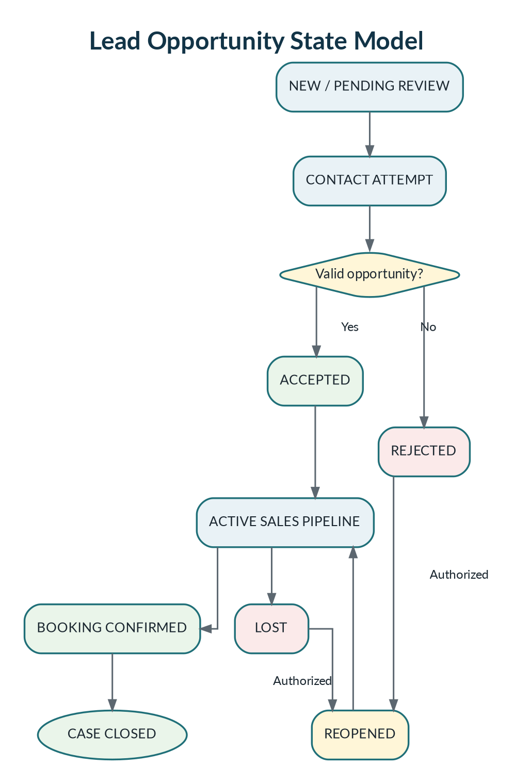
Figure 3. Lead state model. Rejected and Lost are inactive states, not deletion.

7.1 Rejected versus Lost
State | Use | Mandatory reason examples
REJECTED | Before the enquiry meaningfully enters sales | Invalid number, duplicate, spam, wrong enquiry, outside service area, already purchased, not interested at first contact.
LOST | After the lead was accepted into sales | Price, finance rejected, model unavailable, competitor purchase, postponed, no response, family decision, other.

7.2 Assignment rules
- New leads enter a configurable queue by client, branch, vehicle category, source, language and working hours.
- Auto-assignment options: round robin, weighted capacity, source/team routing or named owner. Manual assignment remains available to authorised managers.
- Assignment is atomic and writes an append-only assignment event. Reassignment requires a reason.
- First-response SLA begins at durable lead creation; outside-hours policy may pause or use next-business-hour logic.
- SLA warning and breach events notify Salesperson, Sales Manager and then Manager according to escalation configuration.
- An accepted lead freezes sales attribution to the Relationship Owner unless an authorised reassignment explicitly transfers attribution.

7.3 Follow-up controls
- Every active opportunity must have a next action unless it is in a manager-approved waiting state.
- Follow-ups have due time, channel, priority, outcome, notes and owner. Overdue tasks are visible in dashboard and mobile home.
- Completed calls require an outcome or supervisor exception. No-answer/busy outcomes may create configured retry follow-ups.
- Reopening Rejected/Lost requires a reason and creates a new status event without overwriting original source/history.

8. Calling, Dialer and Telephony Integration
MVP dialer
Click-to-Call + Preview Dialer. A controlled Power Dialer may be added later. Predictive dialing and unsupported call recording are excluded.

Mode | CRM behavior | Limit
Cloud telephony API | Automatic provider call ID, status, duration, agent, virtual number and recording reference where enabled | Client/provider account, consent and legal controls required.
Provider browser/mobile voice SDK | In-app voice when a selected provider officially supports it | Adds microphone permission and provider-specific testing.
Android tel: fallback | Launch normal dialer; user records outcome | Exact duration, answered status and recording are not guaranteed.

8.1 Provider adapter contract
The provider interface supports startCall, verifyWebhook, parseCallEvent, getRecording, syncCalls, normalizeStatus and healthCheck. Provider-specific payloads never leak into lead/business modules.

8.2 Call evidence and outcomes
- Store provider call ID, client, virtual number, caller/callee, user, lead, timestamps, duration, status and recording reference.
- Outcomes: interested, callback, test ride, showroom visit, no answer, busy, wrong number, not interested, already purchased and other.
- Provider webhooks are authoritative; reconciliation jobs repair missing or out-of-order events.
- Recordings remain private, are retrieved through authorised backend flow and follow client-configured retention.
- Do not request READ_CALL_LOG, READ_SMS, READ_CONTACTS or accessibility privileges for core MVP.

9. Unified Inbox and Customer Communication Timeline

9.1 Supported timeline channels
Channel | MVP timeline content
WhatsApp Business Platform | Inbound/outbound message, template, media, referral context and sent/delivered/read/failed status.
Instagram professional messaging | Inbound/outbound only after official permissions and client connection are approved.
Facebook Messenger | Inbound/outbound only after official Page permissions are approved.
Calls | Provider status, recording reference, call outcome and follow-up.
Email/SMS | Notification send/delivery and inbound reply only where provider supports it.
Internal events | Notes, tasks, assignment, status, stock, payment, delivery, RC, audit and system automation.

9.2 Ownership and routing
- Sales remains the default customer-facing conversation owner throughout the journey.
- Billing, Delivery and RC users update operational modules; automated updates and customer replies still appear in the same customer timeline.
- Intent routing may assign a message to Billing, Delivery or RC queue while keeping Sales visibility.
- Outside the WhatsApp service window, the sender must select an approved template. Marketing and operational consent remain separate.
- Every outbound message records tenant, number, category/template, actor/automation, consent reference, provider ID and delivery status.

10. Test Ride Operations and Active Location
State | Entry requirement | Exit evidence
REQUESTED | Customer interest and preferred model/time/location | Booked or cancelled reason
BOOKED | Branch, demo vehicle or vehicle class, date/time | Customer confirmation
EXECUTIVE ASSIGNED | Eligible executive and vehicle availability | Acceptance / manager override
ACTIVE | Explicit Start action, permission and foreground notification | Stop/completion/cancel/timeout
COMPLETED | Kilometres, checklist and feedback | Salesperson notified
CANCELLED / NO-SHOW | Mandatory reason and actor | Demo vehicle released

10.1 Location rules
- Location starts only when the assigned executive taps Start after an in-context prominent disclosure.
- Android foreground-service type location and an ongoing notification are mandatory during active tracking.
- No off-duty tracking. Tracking stops on completion, cancellation, manual stop, timeout or revoked permission.
- Target update frequency is 30–60 seconds during ACTIVE, subject to OS, network and battery behavior.
- The manager map shows active jobs, last update, accuracy and stale indicator; it is not a continuous employee-history screen.
- Background-location permission is not requested in the initial build unless device testing proves foreground-service tracking cannot meet the approved use case and Google Play review is completed.

11. Vehicle Catalog, Inventory and Allocation
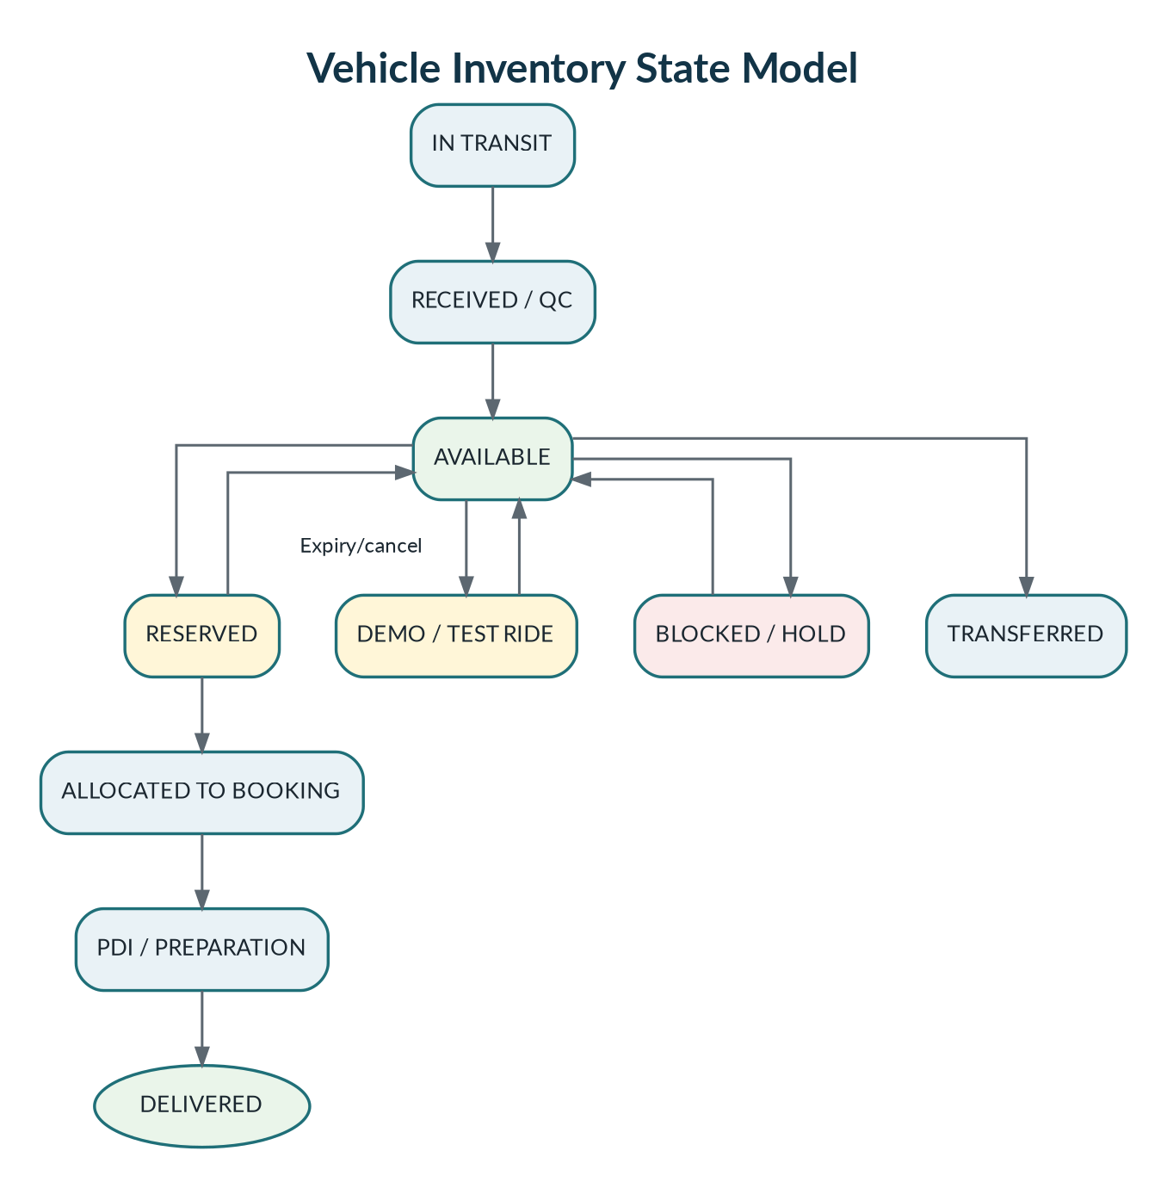
Figure 4. Inventory states and safe reservation/allocation transitions.

11.1 Inventory unit fields
- Client, branch, vehicle catalog ID, model, variant, colour, fuel/powertrain and model year.
- VIN/chassis number and engine/motor number stored with masking in lists and full access only for authorised roles.
- Stock status, acquisition/reference number, arrival date, expected arrival date, ownership type and notes.
- Demo/test-ride flag, current odometer, condition, service/maintenance due and availability calendar.
- Reservation ID, booking ID, reservation expiry, allocation timestamp, PDI status and delivery status.
- Every transfer, block, release, correction and allocation creates an append-only inventory event.

11.2 Reservation and allocation rules
- A vehicle may have at most one active reservation and one active allocation.
- A reservation has an expiry and may be extended only by an authorised role with reason.
- Expired or cancelled reservations return the unit to AVAILABLE unless it is blocked or transferred.
- Allocation requires a confirmed booking and client-configured payment/readiness rule.
- Changing an allocated VIN requires manager approval, reason, customer communication decision and audit.
- Demo vehicles cannot be allocated for retail delivery until converted to saleable stock through an approved process.

12. Booking, Billing, Payment and Finance Tracking

12.1 Booking confirmation
- Booking captures customer, opportunity, branch, vehicle configuration, quotation version, price components, expected delivery and salesperson.
- Discount above the salesperson threshold requires Sales Manager/Manager approval reference before confirmation.
- Booking cancellation requires reason, refund/settlement note if applicable, stock release and notification decisions.
- The CRM tracks payment status; it does not move customer money or replace the accounting ledger in MVP.
Payment type | Tracking rule
FULL | Total paid equals payable amount; balance is zero.
PARTIAL | Multiple payment entries with references and remaining balance.
FINANCE | Finance partner, application, approval/rejection, sanction and disbursement status.
INSTALLMENT | Dealership-approved schedule and due confirmation only; legal/accounting approval required.
MIXED | Separate cash/online/finance/exchange components and references.

12.2 Delivery readiness gate
Gate item | Owner | Blocking rule
Booking verified | Billing | Customer, model, amount and approvals are complete.
Vehicle allocated | Inventory | Specific VIN/unit allocated or manager-approved exception.
Payment status | Billing | Client-configured threshold met; proof and verifier recorded.
Finance disbursement | Billing | Required finance milestone reached.
Invoice/insurance | Billing | Required references and documents recorded.
PDI / vehicle preparation | Inventory/Delivery | Checklist passed; no unresolved blocking issue.
Registration documents | Billing/RC | Required documents ready or approved delivery exception.
Customer confirmation | Sales/Delivery | Date/time/location confirmed.

13. Delivery Operations
- Delivery job is created only after the readiness gate passes or an authorised exception is recorded.
- The mobile job shows only required customer, vehicle, document/readiness and route information; unnecessary financial details are hidden.
- Start Delivery activates job-bound location and an ongoing notification.
- Checklist includes PDI confirmation, accessories, documents, keys, fuel/battery, odometer and visible condition.
- Completion requires customer OTP or signature according to client policy, delivery photo where allowed, received-by name and timestamp.
- Delay/failed delivery requires reason, next action, tracking stop and manager escalation.
- Successful delivery creates/updates the Customer Vehicle record and reminder plan.

13.1 Delivery statuses
VEHICLE_ALLOCATED → VEHICLE_PREPARATION → READY_FOR_DELIVERY → DELIVERY_SCHEDULED → OUT_FOR_DELIVERY → DELIVERED / DELAYED / FAILED / RESCHEDULED

14. Registration and RC Follow-up
Parallel process rule
Registration may start before delivery and permanent RC may finish after delivery. Delivery and RC are parallel tracks linked to the same booking; neither overwrites the other.

DOCUMENTS_READY → REGISTRATION_STARTED → RTO_SUBMITTED → TR/NUMBER_ALLOTTED → RC_PENDING → RC_RECEIVED → RC_SHARED/COLLECTED → CASE_CLOSED
- Store RTO name/code, application number, submission date, expected date, TR, permanent registration number and current status.
- Calculate aging from the active status and compare against client-configured SLA.
- Delay updates require reason and revised expected date. Managers see aging and escalation queues.
- RC copy is private. Sharing uses a short-lived signed link, optional OTP and send/download audit.
- Customer preference may be WhatsApp, email, SMS secure link, courier, pickup or ask-every-time.
- Every event is append-only; corrections reference the previous event rather than deleting it.

15. Customer-Owned Vehicle and Post-Sale Lifecycle
- Create a Customer Vehicle after delivery. Authorised users may also register a vehicle purchased elsewhere for future service/insurance/exchange campaigns.
- Store ownership source, brand/model/variant/colour, VIN/engine/registration, booking/invoice/delivery/purchase dates and current branch relationship.
- Store insurance, warranty, AMC, roadside assistance, service plan version, due date/kilometre and reminder preferences.
- Service schedules are configurable by manufacturer/model/variant/year and delivery date; never hard-code one month for every vehicle.
- Reminder types are independent: service, insurance, PUC, warranty, AMC, roadside assistance, RC pending, exchange eligibility and upgrade offer.
- Operational reminders and promotional messages use separate template categories and consent rules.

15.1 MVP reminder engine
- Fixed rule templates configured per client/model, not a visual automation builder.
- Worker materialises reminder instances and sends configured 30/15/7/1-day or kilometre-threshold notifications.
- Each instance has due time, channel, template, consent reference, status, retry count and suppression reason.
- Replies route to the configured service contact or Relationship Owner. Full service job-card flow is Phase 2.

16. Documents, Consent, Privacy, Telecom Compliance and Retention

16.1 Document centre
- Upload once to private S3-compatible object storage through presigned upload; never expose provider credentials or public bucket URLs.
- Document metadata includes type, entity, client, version, verification status, uploader, checksum, expiry, sensitivity and retention class.
- Statuses: PENDING, VERIFIED, REJECTED, SUPERSEDED, EXPIRED and DELETED/ANONYMISED under approved retention workflow.
- Download uses a short-lived signed URL after tenant/object permission checks and logs the access.
- SMS sends a secure link rather than attaching a PDF. Sensitive links may require OTP.

16.2 Consent evidence
Consent/purpose | Evidence stored
Sales contact | Source, notice text/version, affirmative action, timestamp and withdrawal.
Call recording | Provider/agent notice, purpose, timestamp and recording-enabled flag.
WhatsApp operational updates | Number, opt-in source, notice version, timestamp and withdrawal.
Marketing | Separate promotional consent, preferences, source and revocation.
Employee location | Prominent disclosure, job, policy version, Start/Stop actions and active timestamps.
Document delivery | Preferred channel and secure-link/OTP evidence where required.

16.3 DPDP and rights readiness
- Maintain clear notice versions, purpose mapping, data minimisation, role-based access, correction/erasure workflow, grievance contact and consent withdrawal.
- Build an incident register and breach-response runbook with containment, impact assessment, provider notification and legal/regulatory review.
- Data retention is client/legal configurable. Automated retention jobs produce preview reports and use approved deletion/anonymisation workflows.
- DPDP Rules 2025 have staggered commencement; implement controls now and perform legal readiness review before each applicable commencement date.
- This PRD defines technical controls, not legal advice. The dealership and Go Digital must obtain counsel for final role allocation as Data Fiduciary/processor and contractual terms.

16.4 TRAI/DLT controls
- Bulk SMS/voice launches require applicable Principal Entity, sender/header, content template, consent and telemarketer/provider registration.
- Store template/header/consent references, provider delivery status, complaint/suppression state and campaign audit.
- Operational and promotional communication are separated; suppression and withdrawal must prevent future promotional sends.
- TRAI rules and amendments must be rechecked at launch. A 2026 consultation draft is not treated as final regulation in this PRD.

16.5 Default retention recommendations
Data | Default recommendation
Rejected/Lost opportunities | Client/legal configured; support anonymisation/deletion request workflow.
Raw provider webhook payload | 7–30 days for debugging; retain normalised event longer.
Call recordings | Client/legal configured, commonly 90–180 days when permitted.
Active location points | Current position upsert; route samples short retention; business event retained.
Payment/RC documents | Client/legal configured; private access and audit.
Generated exports | Expire after 7–30 days.
Audit/security logs | At least the client/security policy period; write-protected access.

17. Integration Architecture and Provider Approvals

17.1 WhatsApp Business Platform
- Use Meta-hosted WhatsApp Business Platform/Cloud API; no personal WhatsApp Web automation.
- Each client connects its own WABA and business number. WABA ID, phone-number ID, token/reference, template state, webhook state and quality metadata are tenant-scoped and encrypted.
- Use a Tech Provider/Embedded Signup onboarding path when Go Digital onboards multiple clients at scale.
- Inbound message/referral webhook creates a WHATSAPP_AD opportunity on the first customer message; a click alone is not counted unless Meta provides an explicit lead event.
- Webhook receipt verifies signature, stores durably, acknowledges quickly and processes asynchronously with idempotency.
- Pricing and category rules are not hard-coded. The platform currently distinguishes marketing, utility, authentication and service messages and may change rates/policies.

17.2 Meta production approval gates
- Verified legal business portfolio, website, privacy policy, terms, data-deletion instructions and two-factor authentication.
- Meta business app, app domains, OAuth redirects, webhook callback/verify token and secure secret management.
- Test number, inbound/outbound messages, statuses, media, templates, errors and retry behavior demonstrated.
- Required permissions/advanced access submitted with clear reviewer video, test credentials and narration.
- Tech Provider/Embedded Signup eligibility and onboarding completed for multi-client connections.
- One pilot WABA runs successfully before broader onboarding; template quality and webhook reliability are monitored.

17.3 Google Business Profile
- Use a Go Digital-owned Google Cloud project approved for Business Profile APIs and OAuth 2.0.
- Client Admin explicitly consents and selects authorised accounts/locations. Store refresh tokens encrypted and support revocation.
- Sync permitted location information, verification state, performance data and reviews; review reply requires explicit authorised action.
- Configure the My Business Notifications API to a Pub/Sub topic for new/updated reviews and location events, plus periodic reconciliation.
- If project quota is 0, request API access. Read actual project quotas at runtime/console; do not assume one universal quota.
- There is no general sandbox. Use validateOnly where supported and controlled real locations for testing.
- Business Profile is not an instant chat or call-history source; lead calls require telephony/call tracking.

17.4 Google Ads and website
- Website forms post to the public lead endpoint and preserve UTM/GCLID values.
- Google lead-form assets may deliver submissions to an advertiser webhook with anti-spoofing secret; validate and deduplicate them.
- Direct phone calls are automatically attributable only when Google/third-party call reporting, dynamic number insertion or separate tracking numbers provide the data.
- Unknown campaign attribution is valid and reportable. The system must never fabricate campaign identity.

17.5 Integration centre
Connection state | Meaning | Required action
NOT_CONNECTED | No client credentials/consent | Show setup guide.
PENDING_APPROVAL | Provider/project review not complete | Feature flag; show owner and next action.
ACTIVE | Token/webhook/health checks pass | Normal operation.
DEGRADED | Retryable errors, quota or stale sync | Queue, backoff and operational alert.
ACTION_REQUIRED | Expired token, verification or policy issue | Client Admin/Agency Admin remediation.
SUSPENDED | Security, billing, fraud or provider action | Stop sends/calls and preserve inbound evidence where allowed.

18. UI/UX Design System – shadcn Only
Non-negotiable web rule
The web application uses shadcn/ui as its only reusable UI component system. Tailwind CSS is allowed for layout, spacing and responsive composition. No second full UI library may be introduced without a written architecture decision.

18.1 Web implementation
- Initialize shadcn/ui on Base UI for the new project and pin the chosen base in repository configuration to prevent accidental mixing.
- Components are copied into apps/web/components/ui or a shared web-only package and become project-owned code.
- Use shadcn Sidebar, Breadcrumb, Card, Tabs, Dialog, Sheet, Drawer, Command, Data Table patterns, Form, Select/Combobox, Calendar, Badge, Alert, Sonner, Dropdown Menu, Pagination, Skeleton and Chart components.
- Charts use the shadcn Chart composition. Tables use TanStack Table through project-owned shadcn patterns.
- All forms use React Hook Form + Zod and shadcn form controls. Error, loading, empty and permission-denied states are mandatory.
- Accessibility target: keyboard navigation, visible focus, semantic labels, sufficient contrast, reduced motion support and screen-reader announcements for async actions.

18.2 Mobile design-system exception
Technical reality
shadcn/ui components render web elements and cannot run directly in React Native. The mobile app therefore uses project-owned React Native primitives styled with NativeWind and the same tokens, spacing, typography, states and interaction principles. No third-party full mobile UI kit is used.

- Shared design tokens: colour roles, typography, radius, spacing, shadows, status semantics and motion durations.
- Native components: Button, Input, Select/Picker, Card, Badge, Sheet/Modal, Tabs, Alert, Toast, Skeleton, Empty State, List Row and permission disclosure.
- Mobile screens prioritise one-handed use, offline status, large touch targets and explicit Start/Stop actions for tracking.
- Web-specific UI code is never imported into mobile; only contracts, schemas and tokens are shared.

18.3 Dashboard information architecture
Role | Default landing page | Primary widgets
Agency Admin | Platform overview | Client status, integration failures, webhook backlog, incidents, usage and release status.
Client Admin | Client setup/operations | Onboarding progress, branches/users, connections, stock, funnel and compliance tasks.
Manager | Operations command centre | Funnel, SLA, active rides/deliveries, stock/payment/RC aging and escalations.
Sales Manager | Sales queue | Unassigned/new/overdue leads, team capacity, follow-ups, test rides and booking approvals.
Billing/Inventory/RC | Work queues | Readiness blockers, reservations, payments, documents, registrations and aging.

19. Technical Architecture and Selected Stack
Layer | Technology | Decision
Monorepo | pnpm workspaces + Turborepo | Shared contracts, design tokens, validation and repeatable builds.
Web | Next.js App Router + TypeScript | Office dashboard on Vercel; shadcn/ui Base UI only.
Web state/forms | TanStack Query + React Hook Form + Zod | Server-state, validation and resilient forms.
Mobile | React Native + Expo prebuild + Expo Router | Android-first, native permissions and custom foreground location support.
Mobile offline | TanStack Query + Zustand + expo-sqlite | Cached work queues, outbox and replay.
Backend | NestJS + TypeScript + REST/OpenAPI | Authoritative modular monolith and provider adapters.
Database | Supabase PostgreSQL + Drizzle ORM | Portable PostgreSQL, migrations and constraints.
Queue/cache | Upstash Redis + BullMQ | Rate limits, locks, retries, delayed jobs and workers.
Storage | Tigris via AWS SDK S3 interface | Private files now; AWS S3 later.
Push | Firebase Cloud Messaging / expo-notifications | Task, follow-up and active-job notifications.
Maps | Google Maps Platform / approved native map implementation | Geocoding, route links and active-job maps only where needed.
Observability | Pino + Sentry + OpenTelemetry-ready correlation IDs | Structured logs, errors, traces and audit correlation.

19.1 Backend ownership
Next.js and mobile are presentation clients. NestJS owns authorization, tenant policy, workflow transitions, assignment, stock reservation/allocation, payment/readiness rules, webhooks, provider calls, notification selection, audit and domain events.

19.2 Modular-monolith boundaries
- Modules expose application services and domain events, not direct table access.
- Cross-module writes use application services or outbox events; avoid circular imports and shared “god” services.
- Provider adapters implement domain interfaces and live under integrations, isolated from core workflow logic.
- Future service extraction is based on measured scale/ownership needs, not speculative microservices.

20. Data Model, APIs, Events and Background Processing

20.1 Core table groups
Domain/table group | Purpose
agencies / client_organizations / branches / departments / teams | Platform and dealership hierarchy.
users / memberships / roles / permissions / reporting_lines | Identity, scoped access and effective dates.
contacts / contact_channels / consent_records / privacy_requests | Customer identity, channels, consent and rights workflow.
lead_opportunities / lead_sources / campaigns / lead_attribution | Enquiry, source and campaign truth.
lead_assignments / status_history / rejection_events / lost_events | Append-only ownership and lifecycle.
activities / tasks / followups / calls / recordings | Sales activity and telephony evidence.
conversations / conversation_participants / messages / templates | Official-channel inbox and timeline.
vehicle_catalog / inventory_units / inventory_events / reservations / allocations | Stock and vehicle allocation.
test_ride_jobs / ride_events / demo_vehicle_bookings / active_locations | Test ride scheduling, tracking and proof.
bookings / quotations / approvals / payment_entries / finance_cases / invoices | Commercial tracking.
delivery_jobs / readiness_checks / delivery_checklists / delivery_proofs | Delivery flow and evidence.
registration_cases / rc_events | RTO/RC status and aging.
customer_vehicles / service_plans / reminder_instances | Post-sale vehicle lifecycle.
integration_connections / webhook_events / outbox_events / provider_failures | Encrypted connections and reliable processing.
files / document_versions / audit_logs / exports / incidents | Private files, governance and recovery evidence.

20.2 Tenant isolation
- Every client-owned row contains client_organization_id NOT NULL; branch-scoped records also contain branch_id where applicable.
- Composite foreign keys prevent cross-tenant relationships. Repository methods require TenantContext.
- Unscoped queries are allowed only in audited platform modules and automated cross-tenant tests cover every API group.
- Phone/email lookup hashes are keyed and tenant-scoped; encrypted/sealed fields are used for tokens and selected sensitive identifiers.
- Exports, support access and bulk corrections are always audited.

20.3 Representative REST routes
Module | Representative routes
Auth | POST /v1/auth/login, /refresh, /logout; GET /v1/me; sessions/devices.
Clients/users | /v1/clients, /branches, /users, /memberships, /roles.
Leads | GET/POST /v1/leads; /accept; /reject; /lost; /reopen; /assignments.
Calls/inbox | /v1/calls/start; /outcome; /conversations; /messages; /templates/send.
Test rides | /v1/test-rides; /assign; /confirm; /start; /location; /complete; /cancel.
Inventory | /v1/inventory; /receive; /reserve; /release; /allocate; /transfer; /block.
Bookings/billing | /v1/bookings; /approvals; /payment-entries; /finance; /invoice; /readiness.
Delivery | /v1/deliveries; /start; /location; /checklist; /complete; /delay.
RC | /v1/registration-cases; /events; /rc-copy; /share; /close.
Vehicles/reminders | /v1/customer-vehicles; /service-plans; /reminders.
Files | /v1/files/presign-upload; /complete; /download; /verify; /supersede.
Integrations | OAuth/connect/status/sync/webhook endpoints per provider.

20.4 Domain events
LeadCaptured, LeadAssigned, LeadAccepted, LeadRejected, LeadLost, FollowupDue, TestRideBooked, TestRideStarted, TestRideCompleted, InventoryReserved, VehicleAllocated, BookingConfirmed, PaymentRecorded, DeliveryReadinessPassed, DeliveryCompleted, RegistrationStatusChanged, RcShared, CustomerVehicleCreated and ReminderDue.

20.5 Queue design
Queue | Jobs
lead-ingestion | Verify, normalize, deduplicate, attribute, assign and notify.
communications | WhatsApp/email/SMS send, status reconciliation and inbound routing.
telephony | Call sync, recording retrieval and reconciliation.
location | Validate active job, current-position upsert and stale timeout.
inventory | Reservation expiry, allocation checks and transfer notifications.
reminders | Follow-up, service, insurance, RC and delivery reminders.
google-integrations | GBP Pub/Sub processing, reconciliation, performance sync and Google Ads lead forms.
exports | Asynchronous CSV/XLSX/PDF generation.
maintenance | Retention, stale sessions, orphan files, integrity checks and dead-letter recovery.

21. Security, Audit, Observability and Recovery

21.1 Authentication and session security
- Backend-issued short-lived access token and rotating refresh token; secure storage appropriate to web/mobile client.
- MFA required for Agency Admin and recommended/tenant-configurable for office admins/managers.
- Password hashing with a modern memory-hard algorithm; rate limits, lockout/backoff and breached-password screening where available.
- Device/session list, remote revocation, logout-all and user deactivation invalidation.
- Integration OAuth state/PKCE where applicable; secrets encrypted and never returned to clients.

21.2 Audit model
- Immutable audit event includes tenant, actor, effective role, action, entity, old/new summary, reason, IP/device, request ID and timestamp.
- High-risk actions: support impersonation, role change, export, document download, payment correction, VIN change, booking cancellation, stock release and retention deletion.
- Audit Explorer supports filters and export only for authorised roles; audit records cannot be edited through product APIs.

21.3 Observability
- Correlation ID from ingress through API, database transaction, outbox, worker and provider call.
- Dashboards: API latency/errors, queue age, dead letters, webhook verification failures, provider failures, message/call status, active-location staleness and database health.
- Alerts distinguish client configuration issues from platform incidents and include runbook links.
- PII and secrets are redacted from logs. Raw provider payload access is restricted and short-lived.

21.4 Backup and recovery
- Database backups/PITR according to selected Supabase plan; quarterly restore exercise before production scale.
- Object inventory and checksum reconciliation to detect orphan/missing files.
- Dead-letter replay tooling with idempotency and dry-run preview.
- Provider reconciliation repairs missed webhooks without duplicating business events.
- Documented RPO/RTO target for pilot: RPO ≤ 24 hours on low-cost tier and ≤ 1 hour on production paid tier; RTO ≤ 8 hours pilot and ≤ 4 hours production target, subject to chosen provider plans.

22. Performance, Offline Behavior and Rate Limits
Behavior | Target
Verified webhook acknowledgement | Under 2 seconds after durable receipt.
New lead visible to assigned user | Normally 2–5 seconds on paid always-on infrastructure.
Standard API p95 | Read under 500 ms; write under 700 ms excluding provider latency.
Active map update | 30–60 second target; stale after configured threshold.
Mobile queue open | Cached list visible immediately; background refresh when online.
Reminder dispatch | Normally within 2 minutes of due time.
Report/export | Small reports interactive; large exports asynchronous.
Concurrent scale gate | 75 concurrent API requests plus representative webhook/location load for MVP release.

22.1 Idempotency and resilience
- Unique client/provider/external-event IDs and caller-supplied idempotency key on critical create operations.
- Exponential backoff with jitter, per-provider/client concurrency caps, circuit breakers and dead-letter queues.
- PostgreSQL transaction + outbox for changes that must publish events.
- Redis failure may delay work but cannot lose accepted business state.
- UI displays queued, sending, sent, delivered, read, failed, stale and offline-pending states rather than pretending operations are instant.

22.2 Mobile offline rules
- Cache assigned leads/jobs and required reference data in SQLite with encryption/platform storage controls as appropriate.
- Offline writes enter a local outbox with client-generated ID and base version. Replay is ordered and idempotent.
- High-risk transitions—payment verification, VIN allocation, delivery completion and RC closure—require online server confirmation.
- Location points may buffer briefly during an active job and upload when connectivity returns; retention and battery caps apply.
- Conflicts are resolved by server rules; the user sees a clear conflict/retry state and cannot silently overwrite another actor.

23. Environments, Deployment, Costs and AWS Migration

23.1 Environments
Environment | Purpose | Data rule
Local | Developer services and provider fixtures | Synthetic data only.
Development | Shared integration work | No production customer data.
Staging | Release candidate, app review and pilot rehearsal | Masked/synthetic; provider test accounts where possible.
Production | Approved dealerships | Full controls, monitoring, backup and incident response.
DR/Restore workspace | Periodic recovery exercise | Restricted, temporary and documented.

23.2 Initial deployment
Component | Initial provider | Portability rule
Web | Vercel | No business logic dependent on Vercel-only database features.
API/worker | Render Docker services | Containerised, health checks, graceful shutdown and external config.
PostgreSQL | Supabase | Standard PostgreSQL and migrations; no irreversible vendor-specific assumptions.
Redis | Upstash | Standard Redis/BullMQ-compatible behavior with failure fallbacks.
Object storage | Tigris S3-compatible | AWS SDK interface and bucket abstraction.
Mobile builds | Expo prebuild / EAS or controlled native CI | Source owns native config; Play release keys controlled by Go Digital organization.
Monitoring | Sentry + logs + uptime monitor | Exportable dashboards/runbooks and correlation IDs.

23.3 Cost boundaries
- Core hosting, database, Redis, storage, maps, monitoring and app-build plans are selected per pilot load and availability requirements.
- Telephony, WhatsApp, email, SMS, Google Maps and other provider usage are variable costs owned by the client or separately contracted.
- No fixed provider price is embedded in the PRD. Pricing, taxes, quotas, free tiers and policy must be refreshed during procurement and before each commercial proposal.
- Production should not depend on free sleeping backend infrastructure when a 2–5 second lead-delivery target is promised.

23.4 AWS migration mapping
Current | AWS target | Code-change expectation
Vercel Next.js | AWS Amplify/CloudFront + ECS/Lambda as selected | Deployment/config changes; preserve web contracts.
Render API/worker | ECS Fargate/EKS | Container and infrastructure changes; domain code unchanged.
Supabase PostgreSQL | Amazon RDS/Aurora PostgreSQL | Migration, extensions and connection tuning; Drizzle schema retained.
Upstash Redis | ElastiCache/MemoryDB | Connection/config and queue tuning.
Tigris | Amazon S3 | Endpoint/credentials and data migration through same S3 adapter.
Sentry/logs | CloudWatch/X-Ray/OpenTelemetry platform | Observability exporter/config changes.

24. Repository and Directory Structure
automobile-crm/
├── apps/
│ ├── web/ # Next.js + shadcn/ui web dashboard
│ ├── mobile/ # React Native/Expo Android app
│ ├── api/ # NestJS REST API
│ └── worker/ # BullMQ jobs and schedules
├── packages/
│ ├── contracts/ # API/domain DTO contracts
│ ├── validation/ # Zod schemas and normalizers
│ ├── database/ # Drizzle schema/migrations/seeds
│ ├── permissions/ # RBAC/ABAC policies
│ ├── workflows/ # State machines and transition rules
│ ├── design-tokens/ # Shared semantic tokens only
│ ├── web-ui/ # Project-owned shadcn web components
│ ├── mobile-ui/ # Project-owned native primitives
│ ├── integrations/
│ │ ├── meta-leads/
│ │ ├── whatsapp/
│ │ ├── google-ads/
│ │ ├── google-business-profile/
│ │ ├── telephony/
│ │ ├── email/
│ │ └── sms/
│ ├── object-storage/
│ ├── observability/
│ └── config/
├── infrastructure/
│ ├── docker/
│ ├── render/
│ ├── vercel/
│ ├── local/
│ └── aws/
└── docs/
├── api/
├── role-flows/
├── integration-guides/
├── app-approval/
├── runbooks/
└── adr/

24.1 NestJS modules
auth, tenancy, clients, branches, users, permissions, contacts, leads, assignments, activities, followups, telephony, inbox, test-rides, vehicle-catalog, inventory, reservations, allocations, bookings, approvals, payments, finance, deliveries, registrations, customer-vehicles, reminders, files, integrations, webhooks, reports, audit, notifications, privacy, incidents and health.

25. Testing, Release Gates and Acceptance Criteria

25.1 Test layers
- Unit: state transitions, source mapping, normalisation, duplicate rules, assignment, reservation/allocation, payment calculations, permissions and template selection.
- Integration: PostgreSQL constraints, outbox/queues, signed uploads, provider adapters, webhook signatures/idempotency and encrypted connection storage.
- Contract: Meta/WhatsApp, telephony, GBP, Google Ads, email/SMS, maps and storage fixtures/mocks.
- End-to-end web/mobile: every role flow, lead lifecycle, test ride, stock allocation, booking, billing, delivery, RC and reminders.
- Security: tenant isolation, privilege escalation, support elevation, token revocation, signed URL ownership, webhook replay and export controls.
- Performance: 75 concurrent requests, webhook bursts, active location updates, inbox lists, reservation expiry and report exports.
- Recovery: database restore, dead-letter replay, provider reconciliation, object inventory and audit continuity.
- Accessibility: keyboard/focus/screen-reader checks for web and touch/permission disclosure checks for mobile.

25.2 Mandatory release acceptance
- All six lead sources create correctly attributed or explicitly Unknown opportunities and do not duplicate provider events.
- WhatsApp Ads create an opportunity on the first inbound message and retain referral metadata when supplied.
- Rejected/Lost reasons are mandatory, retained, searchable and reopenable with history.
- Role/object scope is enforced: Sales sees assigned leads; ride/delivery users see assigned jobs; cross-tenant tests pass.
- First-response SLA warning, breach and escalation work across business hours and reassignment.
- Test Ride Executive can start/stop tracking; the manager sees a stale-aware active map; no off-duty points are collected.
- Inventory prevents double reservation/allocation and safely releases expired/cancelled reservations.
- Booking supports full, partial, finance, installment and mixed tracking with references, verifier and audit.
- Delivery readiness gate blocks incomplete jobs unless an authorised exception is recorded.
- Delivery captures checklist, OTP/signature/photo as configured and stops tracking on every terminal state.
- RC remains a parallel process after delivery and supports secure customer sharing and aging escalation.
- Unified inbox preserves one customer timeline while process owners change.
- Customer Vehicle supports purchased-from-us and external ownership plus configurable reminder plans.
- WhatsApp, GBP, Google Ads and telephony failures appear in operational dashboards and retry safely.
- Web uses only project-owned shadcn/ui components; no competing UI library is present in dependencies.
- Android targets the current Play requirement, passes permission/disclosure tests and is accepted in production or approved internal distribution path.
- Meta/WhatsApp production permissions and at least one client WABA pilot are approved.
- GBP API access is approved or feature-flagged as unavailable; Pub/Sub/reconciliation tests pass.
- DPDP/privacy, DLT/telecom, retention and incident checklists receive client/legal sign-off.
- Restore, load, security, audit and pilot-user acceptance gates pass.

25.3 Role acceptance traceability
Role | Must demonstrate before release
Agency Admin | Create/suspend client, view health, use time-bound audited support and revoke it.
Client Admin | Complete onboarding, roles, integrations, catalog/stock and production checklist.
Manager | Resolve exception, inspect active jobs, review aging and produce operational report.
Sales Manager | Assign/reassign, monitor SLA and approve controlled exception.
Telecaller | Call/outcome, reject or accept/handoff with mandatory evidence.
Salesperson | Qualify, follow-up, test ride, negotiate and create booking request from mobile.
Test Ride Executive | Accept, precheck, start/stop tracking, complete/cancel and release demo unit.
Inventory Executive | Receive, reserve, allocate, release and transfer without double allocation.
Billing Executive | Verify booking/payment/finance/invoice/documents and pass/block readiness.
Delivery Executive | Start, checklist, proof, complete/delay and stop tracking.
RC Executive | Submit, update, escalate, upload/share RC and close with audit.

26. Delivery Phases, Risks and Definition of Done

26.1 Recommended phases
Phase | Scope | Exit gate
Phase 0 – Foundation | Monorepo, CI/CD, environments, shadcn design system, auth, tenancy, permissions, database, audit, files and observability. | Tenant/security tests and deployment pipeline pass.
Phase 1 – Leads & Sales | Sources, webhooks/manual entry, dedupe, accepted/rejected/lost, assignment, SLA, follow-ups, telephony and inbox. | Pilot lead-to-follow-up flow and provider fixtures pass.
Phase 2 – Test Ride & Inventory | Mobile ride role, foreground location, demo booking, catalog, inventory, reservation and allocation. | No double allocation; location/Play disclosure tests pass.
Phase 3 – Booking & Billing | Booking, approval, payment/finance/invoice/insurance, documents and readiness gate. | Commercial tracking and correction audit pass.
Phase 4 – Delivery & RC | Delivery mobile flow, active map, proof, registration/RC, secure sharing and customer vehicle. | End-to-end booking-to-close pilot passes.
Phase 5 – Integrations & Approvals | WhatsApp production, Meta/Google integrations, GBP Pub/Sub, Google Ads forms and operational dashboards. | Provider approvals or explicit feature flags; pilot WABA/location pass.
Phase 6 – Hardening & Launch | Performance, backup/restore, accessibility, privacy/legal, Play production and support runbooks. | All mandatory acceptance criteria signed off.

26.2 Principal risks and mitigations
Risk | Impact | Mitigation
Provider approval delay | Feature unavailable at launch | Feature flags, early applications, test fixtures and pilot milestones.
Scope expansion | MVP slips | Locked exclusions; changes require impact estimate and written approval.
Incorrect role handoff | Lost ownership or unauthorised changes | Three ownership fields, state machines, RACI and audited transitions.
Inventory mismatch | Double promise/delivery delay | Unique active reservation/allocation constraints, expiry and reconciliation.
Android location rejection | Play launch blocked | User-started foreground service, minimum permissions, disclosure video and policy review.
WhatsApp quality/policy issue | Messaging restriction | Client-owned WABA, opt-in evidence, template governance and gradual rollout.
Cross-tenant data leak | Critical security incident | Composite tenant keys, TenantContext repositories, tests and support-elevation controls.
Free-tier sleep/capacity | Slow lead delivery | Paid always-on production tier, queue metrics and realistic SLO.
Offline conflict | Incorrect status | Server-authoritative transitions, version checks and explicit conflict UI.
Legal/regulatory change | Non-compliant communication/data handling | Launch-time legal review, configurable consent/retention and policy refresh checklist.

26.3 Definition of done
☐ Product requirement has role/scope acceptance tests and a mapped workflow/state transition.
☐ API contract, validation, database migration and OpenAPI documentation are versioned.
☐ Tenant constraints, indexes, audit event and permission policy are implemented.
☐ Loading, empty, error, offline, retry, conflict and permission-denied UI states are implemented.
☐ No competing web UI library is added; shadcn composition and accessibility review pass.
☐ Idempotency, outbox, background retry, dead-letter and reconciliation behavior are tested.
☐ Privacy disclosure, consent, retention, secure documents and incident behavior are reviewed.
☐ Provider approval evidence, credentials, test users and runbooks are stored securely.
☐ Observability dashboards, alerts, support and restore procedures exist.
☐ Google Play, Meta/WhatsApp and GBP release checklists are signed off or feature-flagged.
☐ Load, security, restore and pilot acceptance tests pass.
☐ Product owner, engineering, operations and client pilot owner approve the release.

27. Configuration, Approval Limits and Governance
Configuration principle
No commercial threshold, SLA, retention period, location interval or approval amount is hardcoded. Every tenant configuration is versioned, has an effective date, records the actor/approver and can be rolled back through an audited change.

27.1 Tenant configuration registry
Rule key | Default recommendation | Owner | Enforcement
TIMEZONE / WORKING_HOURS | Asia/Kolkata; branch calendar | Client Admin | Used for SLA, reminders and reports; changes are effective-dated.
FIRST_ACTION_SLA_MIN | 15 minutes recommended pilot value | Sales Manager + Client Admin | Starts on durable lead receipt; pauses only for configured closed hours.
FOLLOWUP_OVERDUE_MIN | Configurable by lead stage | Sales Manager | Creates escalation, never silently reassigns without policy.
MAX_ACTIVE_LEADS_PER_USER | Capacity by role/team | Client Admin | Used by round-robin; manager override requires reason.
INVENTORY_RESERVATION_TTL | 24 hours recommended | Inventory Manager/Client Admin | Expiry worker releases unconfirmed reservations and records event.
DISCOUNT_APPROVAL_LIMITS | Role/branch/model-specific | Client Admin + Manager | Amounts stored in minor currency units; no frontend-only enforcement.
DELIVERY_PAYMENT_GATE | Completed / configured approved threshold | Client Admin + Finance owner | Backend blocks delivery start until gate passes or approved override exists.
LOCATION_UPDATE / STALE | 30–60 sec / configurable stale threshold | Client Admin | Active jobs only; foreground disclosure and battery/network tolerance.
RC_ESCALATION_DAYS | Stage-specific aging thresholds | Manager | Creates task/escalation; does not invent RTO completion date.
RETENTION_POLICY_ID | Client/legal-approved policy | Client Admin + privacy owner | Applies to recordings, webhook payloads, exports, location and documents.

27.2 Approval and exception matrix
Action | Initiator | Approver | Evidence | Backend result
Discount above role limit | Salesperson / Sales Manager | Configured next-level approver | Quotation, reason, before/after amount | Booking cannot confirm until approved.
Booking cancellation after payment | Sales / Billing | Manager + Billing owner | Customer request, payment impact, cancellation reason | Booking closes; refund is tracked externally unless integrated.
Payment correction/reversal | Billing | Manager or configured finance approver | Original entry, correction reason, proof | Append-only correction; original entry is never overwritten.
VIN reallocation after confirmation | Inventory | Manager | Old/new VIN, customer impact, reason | Old allocation released atomically; duplicate allocation blocked.
Delivery readiness override | Billing/Inventory | Manager | Blocked gate, risk acceptance and expiry | One-time scoped override; Delivery cannot edit gate data.
RC closure without RC copy | RC Executive | Manager | Reason and alternative evidence | Case marked exception-closed and remains reportable.
Bulk export / high-volume download | Authorized office role | Client Admin policy | Purpose, filters, record count | Short-lived export, watermark/audit and automatic expiry.
Agency support impersonation | Agency Admin | Time-bound platform policy | Ticket, reason, duration | Visible banner, immutable audit and automatic revocation.

27.3 Change governance
- Configuration changes are written through command APIs; direct production database edits are prohibited except an incident runbook with two-person review.
- Workflow, permission and template changes are drafted, validated, approved and activated as a version. Historical records retain the version that governed them.
- Feature flags are tenant-scoped and environment-scoped. A disabled provider feature must show a clear reason and must not expose incomplete UI actions.
- Scope changes after baseline require a written impact note covering product behavior, data model, permissions, mobile/web UI, integrations, testing, cost and timeline.

28. State Machines and Transition Contracts
Universal transition contract
Every business transition executes in the NestJS backend with tenant authorization, expected entity version, mandatory evidence, a status-history record, an audit event and an outbox/domain event in one database transaction. Invalid transitions return a conflict response and never partially update related records.

28.1 Lead and opportunity transitions
Transition | Allowed actor | Required evidence | Side effects / guards
NEW → PENDING_REVIEW | System ingestion | Normalized phone/source/branch and durable webhook/form receipt | Start SLA; dedupe before assignment.
PENDING_REVIEW → CONTACT_ATTEMPT | Telecaller/Salesperson | Call/message action or manual attempt note | Record first-action timestamp.
PENDING_REVIEW / CONTACT_ATTEMPT → ACCEPTED | Telecaller/Salesperson; manager override | Qualification, model interest and next action | Assign/freeze relationship owner; create sales task.
PENDING_REVIEW / CONTACT_ATTEMPT → REJECTED | Telecaller/Salesperson | Mandatory rejection reason and evidence | Inactive but searchable; duplicate link retained.
ACCEPTED → CONTACTED / INTERESTED | Salesperson | Successful customer interaction and qualification update | Update funnel timestamps; keep source unchanged.
ACCEPTED/CONTACTED/INTERESTED → FOLLOW_UP | Salesperson | Future due date, purpose and channel | Create reminder; no lead may remain active without next action.
INTERESTED/FOLLOW_UP → SHOWROOM_VISIT | Salesperson | Visit date/branch/result | Create visit event; owner unchanged.
INTERESTED/FOLLOW_UP/SHOWROOM_VISIT → TEST_RIDE_REQUESTED | Salesperson | Model, time/location preference and confirmation state | Create test-ride job request.
Any accepted active stage → NEGOTIATION | Salesperson | Quotation/version and notes | Discount approvals enforced separately.
NEGOTIATION → BOOKING_CONFIRMED | Salesperson + booking rules | Customer confirmation, approved price and booking evidence | Create booking, parallel billing/inventory tasks.
Any accepted active stage → LOST | Salesperson; manager review policy | Mandatory lost reason and note | Inactive; original owner/source/history retained.
REJECTED/LOST → REOPENED/ACCEPTED | Sales Manager/authorized role | Reopen reason and new next action | New lifecycle event; old outcome remains immutable.

28.2 Test ride transitions
Transition | Allowed actor | Required evidence | Side effects / guards
REQUESTED → BOOKED | Salesperson/Sales Manager | Branch, time, vehicle class/unit and customer preference | Conflict check; no double-booked demo unit.
BOOKED → CUSTOMER_CONFIRMED | Salesperson/System | Confirmation timestamp/channel | Notify assigned queue.
CUSTOMER_CONFIRMED → EXECUTIVE_ASSIGNED | Manager/Sales Manager | Eligible executive and demo unit | Create mobile task/push.
EXECUTIVE_ASSIGNED → ACTIVE | Assigned Ride Executive | Explicit Start, permission, foreground notice, optional OTP/checklist | Start active location session.
ACTIVE → COMPLETED | Assigned Ride Executive | End km, checklist, feedback and completion time | Stop tracking immediately; notify Salesperson.
REQUESTED/BOOKED/ASSIGNED/ACTIVE → CANCELLED | Authorized actor by stage | Cancellation reason | Release demo reservation and stop tracking.
BOOKED/ASSIGNED → NO_SHOW | Ride Executive/Manager | Wait/attempt evidence and reason | Release vehicle; create Sales follow-up.

28.3 Inventory and vehicle-unit transitions
Transition | Allowed actor | Required evidence | Side effects / guards
IN_TRANSIT → RECEIVED | Inventory role | Supplier/OEM reference, branch, receipt date | Create stock intake event.
RECEIVED → AVAILABLE | Inventory role | VIN/engine verification and intake checklist | VIN unique inside client; searchable stock.
AVAILABLE → RESERVED | Inventory role/System | Booking/lead, expiry and model match | One active reservation per unit.
RESERVED → AVAILABLE | System/Inventory role | Expiry, cancellation or manual release reason | Reservation history retained.
RESERVED → ALLOCATED | Inventory role | Confirmed booking and approved variant/colour | One active allocation per booking and unit.
AVAILABLE ↔ DEMO | Inventory Manager | Demo designation and effective date | Demo unit excluded from sale allocation unless released.
AVAILABLE/RESERVED → BLOCKED | Inventory/Manager | Damage/compliance/hold reason | Cannot allocate or deliver.
ALLOCATED → PDI | Inventory/Delivery prep role | Readiness task and planned delivery | Delivery gate tracks PDI separately.
PDI → DELIVERED | Delivery completion event | Signed/OTP/photo proof and booking match | Unit becomes customer-owned vehicle; immutable VIN link.
AVAILABLE/BLOCKED → TRANSFERRED/RETURNED | Inventory Manager | Destination/reference and approval | Atomic branch/status update and audit.

28.4 Booking, payment and finance transitions
Transition | Allowed actor | Required evidence | Side effects / guards
DRAFT → CONFIRMED | Salesperson + approval policy | Customer, price components, model, branch and confirmation | Create billing/inventory/registration tasks.
CONFIRMED → CANCELLED | Authorized Sales/Billing | Cancellation reason, payment impact and approval | Release stock; preserve financial history.
PAYMENT_PENDING → PARTIAL | Billing | Verified payment entry | Recompute balance from append-only entries.
PAYMENT_PENDING/PARTIAL → COMPLETED | Billing | Verified entries equal payable amount or configured gate | Payment gate passes; emit event.
Any payment state → CORRECTION_POSTED | Billing + approver | Linked original entry and reason | Original remains immutable; totals recompute.
FINANCE_APPLIED → APPROVED | Billing | Partner approval/reference and sanctioned amount | Expected disbursement tracked.
FINANCE_APPLIED → REJECTED | Billing | Partner response/reason | Sales follow-up and alternate payment task.
FINANCE_APPROVED → DISBURSED | Billing | Disbursement reference/date/amount | Finance gate passes according to policy.
Readiness blocked → READY_FOR_DELIVERY | Backend after all gates | Booking, vehicle, payment/finance, invoice/insurance/document checks | Delivery may be scheduled/started.

28.5 Delivery transitions
Delivery transition | Allowed actor | Required evidence | Side effects / guards
VEHICLE_ALLOCATED → PREPARATION | Delivery prep/Inventory | Allocated VIN and checklist owner | Create readiness tasks.
PREPARATION → READY | Backend/authorized role | All mandatory readiness gate items pass | Schedule enabled.
READY → SCHEDULED | Manager/Billing/Delivery coordinator | Date/time/address and assigned executive | Customer notification queued.
SCHEDULED → OUT_FOR_DELIVERY | Assigned Delivery Executive | Explicit Start and readiness re-check | Start foreground tracking.
OUT_FOR_DELIVERY → DELIVERED | Assigned Delivery Executive | OTP/signature/photo, recipient and completion time | Stop tracking; create customer vehicle/reminders.
SCHEDULED/OUT_FOR_DELIVERY → DELAYED/FAILED | Delivery Executive/Manager | Reason, next action and customer update | Stop tracking if job ended; reschedule task.
DELAYED/FAILED → RESCHEDULED | Manager/Delivery coordinator | New time and issue resolution | New assignment notification.

28.6 Registration and RC transitions
Registration transition | Allowed actor | Required evidence | Side effects / guards
DOCUMENTS_READY → REGISTRATION_STARTED | RC Executive | Document checklist and application initiation | Start aging clock.
REGISTRATION_STARTED → RTO_SUBMITTED | RC Executive | RTO/application reference and date | Notify customer if configured.
RTO_SUBMITTED → NUMBER_ALLOTTED | RC Executive/authorized integration | Temporary/permanent number evidence | Update customer vehicle identity.
RTO_SUBMITTED/NUMBER_ALLOTTED → RC_PENDING | System/RC Executive | Expected date or pending reason | Aging/escalation rules apply.
RC_PENDING → RC_RECEIVED | RC Executive | Received date and secure RC file/reference | Customer delivery task created.
RC_RECEIVED → RC_SHARED/COLLECTED | RC Executive | Channel, recipient and delivery/download evidence | Customer notification timestamp stored.
RC_SHARED/COLLECTED → CASE_CLOSED | RC Executive; exception may need Manager | All mandatory fields or approved exception | Closure immutable except reopen command.
CASE_CLOSED → REOPENED | Manager/RC Executive policy | Reason and next action | New event; prior close retained.

29. Logical Data Model and Implementation Data Dictionary
The ERD below is the implementation-level logical baseline. Physical migrations may split high-volume history tables or add provider-specific extension tables, but the tenant key, ownership links, append-only history and unique business constraints must remain intact.
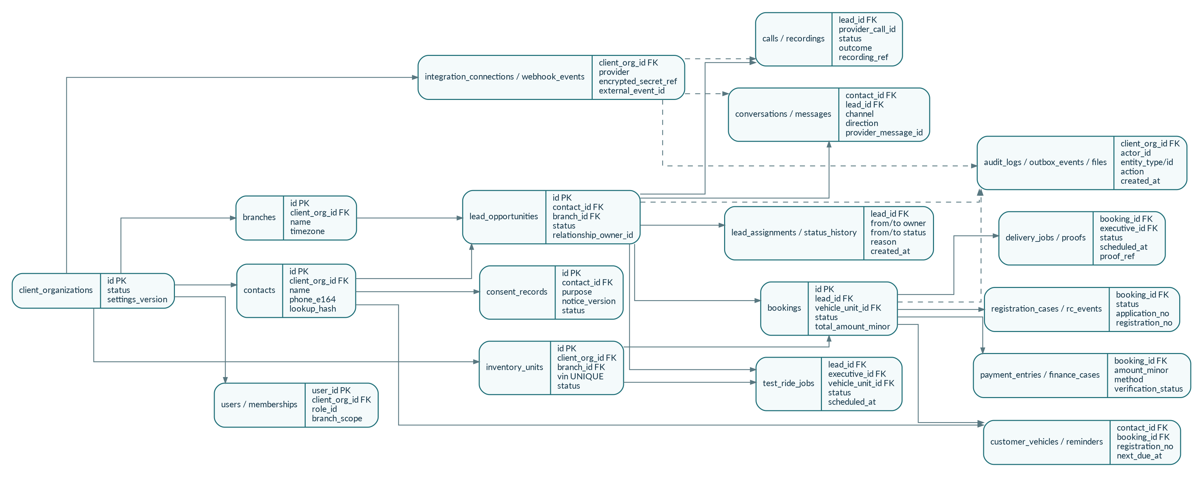
Figure 29-1. Logical multi-tenant ERD and principal lifecycle relationships.

29.1 Required data conventions
- Primary identifiers use UUID/ULID-compatible values generated server-side; all timestamps use timestamptz and are stored in UTC while displaying the branch timezone.
- Currency values use BIGINT minor units plus ISO currency code. Floating-point monetary storage is prohibited.
- Customer phone numbers are normalized to E.164 where possible. Duplicate lookup uses a tenant-scoped keyed hash; phone/email are not globally unique across clients.
- Mutable business entities carry version INTEGER for optimistic concurrency. Status history, financial corrections, consent, audit and provider events are append-only.
- Every client-owned table includes client_organization_id NOT NULL, and composite foreign keys prevent cross-client relationships.
- Files store metadata and object keys only; private documents are accessed through short-lived signed URLs and authorization is re-checked before signing.

29.2 Key entity dictionary
Entity/group | Required keys and fields | Constraints / indexes | Classification / lifecycle
client_organizations | id, status, legal_name, settings_version, timezone | Unique legal/display keys as required; status index | Confidential; retain tenant audit after closure.
branches / teams | id, client_org_id, code, name, timezone, active | UNIQUE(client_org_id, code); active/scope index | Internal business data.
users / memberships | user_id, client_org_id, role_id, branch/team scope, effective dates | Unique active membership; session/device indexes | Personal employee data; deactivate, do not delete audit.
contacts | id, client_org_id, name, phone_e164, email, lookup_hash | Index(client_org_id, lookup_hash); fuzzy duplicate support | Customer PII; rights/retention workflow.
consent_records | contact_id, purpose, status, notice_version, source, captured_at, withdrawn_at | Append-only; index(contact_id, purpose, captured_at) | Restricted compliance evidence.
lead_opportunities | contact_id, branch_id, source, status, owners, next_action_at, version | Index(client_org_id,status,owner,next_action); unique external lead | Customer/business record.
lead_assignments/status_history | entity_id, from/to owner/status, actor, reason, created_at | Append-only chronological index | Audit-critical; no normal edits.
conversations/messages | contact/lead, channel, direction, provider ids, content/media refs, status | Unique provider message id per client; timeline index | Communication PII; retention/channel policy.
calls/recordings | lead, provider_call_id, parties, status, duration, outcome, recording_ref | Unique provider call id; outcome/due indexes | Restricted; recording consent and retention.
test_ride_jobs | lead, executive, demo unit, schedule, status, start/end, version | No overlapping active demo booking; assigned/status index | Operational + limited location.
active_locations | job_type/id, user_id, lat/lng, accuracy, captured_at, expires_at | One current position per active job; TTL/history policy | Highly sensitive employee location.
inventory_units | branch, model/variant/colour, VIN, engine no, status, version | UNIQUE(client_org_id,VIN); active status/branch/model indexes | Confidential stock data.
reservations/allocations | inventory_unit, lead/booking, status, expires_at, actor | Partial unique active reservation/allocation indexes | Commercial operational data.
bookings | lead/contact, branch, amounts, status, selected unit, expected delivery | Unique active booking reference; status/date indexes | Customer financial/business data.
payment_entries/finance_cases | booking, amount_minor, method, reference, verifier, status | Append-only; unique client/reference when reliable | Restricted financial evidence.
delivery_jobs/proofs | booking, executive, schedule, status, checklist, proof refs | One active delivery job per booking; status/date index | Customer address/proof; restricted.
registration_cases/rc_events | booking, RTO, application, numbers, status, expected dates, RC ref | One active case per booking; status/aging indexes | Government identity/document data; restricted.
customer_vehicles/reminders | contact, booking, VIN/registration, coverage dates, next due | Unique client+VIN/registration when known; due index | Customer asset data.
integration_connections/webhook_events | client, provider, encrypted secret ref, status, external event id | Unique(client,provider,external_event_id); retry/status indexes | Secrets restricted; raw payload short retention.
audit_logs/outbox_events/files/exports | client, actor, entity/action, correlation, object key, expiry | Append-only; entity/time and pending outbox indexes | Security/compliance; export auto-expiry.

29.3 Mandatory database constraints
Control | Required database behavior
External ingestion | UNIQUE(client_organization_id, provider, external_event_id) prevents duplicate webhook processing.
Lead source | UNIQUE(client_organization_id, source_code, external_lead_id) WHERE external_lead_id IS NOT NULL.
Vehicle identity | UNIQUE(client_organization_id, vin) and optional unique engine number after client validation.
Active stock allocation | Only one ACTIVE reservation/allocation per inventory unit and only one ACTIVE allocated unit per booking.
Conversation messages | UNIQUE(client_organization_id, channel, provider_message_id) where provider_message_id exists.
Financial evidence | Payment entries are never UPDATE/DELETE in normal workflow; corrections link to original_entry_id.
Tenant links | Composite foreign keys include client_organization_id for contact→lead→booking→delivery/RC relationships.
Audit/outbox | Business command commits entity mutation, history, audit and outbox record atomically.

30. API Standards, Concurrency and Webhook Contracts

30.1 REST contract
Concern | Mandatory contract
Versioning | All production routes use /v1. Breaking behavior requires /v2 or an explicitly announced compatibility window.
Authentication | Bearer access token; rotating refresh/session; every request resolves TenantContext, membership, scope and object authorization.
Correlation | Accept/generate X-Correlation-Id and propagate it through API, worker, provider call, audit and logs.
Idempotency | POST commands that create/send/pay/transition accept Idempotency-Key scoped to tenant+actor+route; replay returns the original result.
Concurrency | Mutable resources expose version/ETag. Commands require expected version; stale writes return 409 CONFLICT with current summary.
Pagination | Cursor pagination for timeline/large lists; bounded page size. Offset pagination only for small administrative tables.
Filtering/sorting | Allowlisted fields only; server-side validation; stable secondary sort by id/time.
Money/time | Amounts are minor-unit integers; timestamps ISO-8601 UTC; branch timezone returned as metadata when relevant.
Files | Presign-upload → complete/scan → authorized download; never accept public object URLs as trusted evidence.
Deprecation | Document deprecation date, replacement and telemetry; remove only after supported clients migrate.

30.2 Standard error envelope
{
"error": {
"code": "INVALID_TRANSITION",
"message": "Delivery cannot start while payment gate is blocked.",
"correlation_id": "01J...",
"details": [{"field": "payment_status", "reason": "required"}],
"retryable": false
}
}
Stable error codes include VALIDATION_ERROR, UNAUTHENTICATED, FORBIDDEN, NOT_FOUND, CONFLICT, INVALID_TRANSITION, IDEMPOTENCY_MISMATCH, RATE_LIMITED, PROVIDER_UNAVAILABLE and INTERNAL_ERROR. User-facing text may be localized, but code semantics remain stable.

30.3 Webhook ingestion contract
Stage | Required behavior
1. Verify | Validate provider signature/token, timestamp/replay policy and expected endpoint/client mapping before business processing.
2. Persist | Store normalized envelope and minimal raw payload within a short transaction; assign unique external event key.
3. Acknowledge | Return provider-required 2xx normally within two seconds after durable receipt.
4. Process async | Worker normalizes, deduplicates, resolves tenant/contact/lead and executes domain command.
5. Retry/DLQ | Exponential backoff with jitter, provider/client concurrency cap and dead-letter reason.
6. Reconcile | Scheduled provider sync repairs missing callbacks; reconciliation is idempotent.
7. Observe | Dashboard shows received, processed, duplicate, failed, dead-letter and last-success state per client/provider.

30.4 Provider adapter compliance
- Every adapter provides connect/health, credential validation, webhook verification, normalization, send/start action, status reconciliation, rate-limit mapping and test fixtures.
- Domain services receive canonical commands/events only. Provider-specific fields remain in adapter metadata and never determine core authorization or workflow rules.
- Contract tests run the same behavior suite against each adapter, including duplicate webhook, timeout, 429, 5xx, malformed payload and delayed status cases.

31. Screen Inventory, Accessibility and UX Contract
shadcn-only web contract
Every reusable web control is project-owned shadcn/ui code. Tailwind composes layout and design tokens. No competing component library may be installed. Complex screens are compositions of shadcn primitives rather than custom inaccessible widgets.

31.1 Web screen inventory
Role/group | Required screens | Primary actions | shadcn composition
Agency Admin | Platform overview; clients; client detail; integration health; webhook/DLQ; incidents; support elevation; global feature flags | Create/suspend client, inspect health, approve/revoke support session | Sidebar, Data Table, Tabs, Sheet, Dialog, Alert, Chart
Client Admin | Onboarding; branches/teams; users/roles; catalog/stock settings; integrations; templates; retention; audit; reports | Configure client, invite users, connect providers, approve go-live | Stepper, Form, Data Table, Command, Select, Dialog, Badge
Manager | Operations command centre; funnel; active map; stock/payment/delivery/RC aging; approvals; exception queue; reports | Resolve bottlenecks, approve controlled exceptions, reassign with reason | Cards, Chart, Data Table, Map container, Drawer, Alert Dialog
Sales Manager | Lead queue; team capacity; SLA; follow-ups; test rides; quotations/discount approvals; booking review | Assign/reassign, coach, approve, escalate | Data Table, Kanban composition, Calendar, Popover, Dialog
Telecaller | Pending-review queue; lead detail; call panel; qualification; callback; reject/accept handoff | Call, classify, schedule, handoff | Resizable panels, Form, Radio Group, Date Picker, Sonner
Billing/Inventory/RC | Role work queues; booking detail; payment/finance; inventory allocation; readiness; registration/RC; document centre | Verify evidence, transition owned process, raise exception | Tabs, Data Table, File upload, Badge, Timeline composition
Shared | Login/MFA; notifications; global search; profile/devices; help; audit-visible errors; secure download | Find, act, recover and understand permission/state | Command, Breadcrumb, Dropdown, Alert, Skeleton, Empty state

31.2 Android mobile screen inventory
Role | Required screens | Critical contract
All mobile roles | Login/device registration; Home; assigned work; notifications; offline status; profile/logout | JWT/session, FCM, SQLite outbox, permission education
Salesperson | Lead queue; lead detail; timeline/inbox; call outcome; follow-up; test-ride request; quotation/booking request | Assigned leads only; offline notes/outcomes replay idempotently
Test Ride Executive | Today/upcoming rides; ride detail; customer call/navigation; start disclosure; active tracking; checklist; complete/cancel/no-show | Foreground location only for explicit active ride
Delivery Executive | Today/upcoming deliveries; readiness summary; customer call/navigation; start disclosure; active tracking; checklist; proof/OTP/signature; delay/fail | Cannot edit payment/inventory truth; offline proof upload queue

31.3 Mandatory UI states and accessibility
- Every data surface implements loading/skeleton, empty, filtered-empty, error, retry, stale, offline, syncing, conflict, permission-denied and feature-disabled states.
- Target WCAG 2.2 AA for web: semantic headings/landmarks, keyboard navigation, visible focus, labels/descriptions, error association, contrast and reduced-motion support.
- Do not communicate state by colour alone. Charts provide text summaries and accessible data tables or downloadable equivalents.
- Mobile touch targets prefer at least 44 dp; permission prompts are preceded by a plain-language explanation and are requested only at the action that needs them.
- English is the initial product language, with string keys and layout prepared for Kannada/Hindi and longer translated labels. Customer template language is stored per contact/tenant.
- Destructive or irreversible actions require impact summary, reason and explicit confirmation; normal corrections use append-only events rather than hidden overwrite.

32. Data Migration and Client Onboarding
Onboarding is a controlled production workflow, not a one-time spreadsheet upload. Every imported record has a batch ID, source row reference, validation result and actor approval so the client can reconcile or roll back the cutover.
Figure 32-1. Client onboarding, migration and pilot cutover flow.

32.1 Onboarding phases
Phase | Owner | Required work | Exit evidence
1. Discovery | Client owner + Go Digital | Branches, roles, current systems, providers, consent, data sets, volume and go-live date | Signed discovery checklist and scope.
2. Tenant setup | Client Admin + Platform | Tenant, branches, teams, working hours, SLAs, permissions and feature flags | Configuration version approved.
3. Mapping | Migration owner | Column mapping, normalization, status/source mapping, duplicate rules and document strategy | Mapping specification and sample file.
4. Dry run | Migration worker | Import synthetic/copy, validate, dedupe preview, rejected-row report and totals | No production mutation; client receives report.
5. Client validation | Client business owners | Sample records, balances, stock/VIN, owner assignment, open tasks and totals | Written approval or corrected mapping.
6. Provider setup | Client Admin + Integration owner | WhatsApp/telephony/Google/email/SMS connections, templates, webhooks and test messages | Health checks and approval state recorded.
7. Pilot cutover | Go Digital + pilot branch | Freeze window, final delta import, user activation and one-branch production flow | Lead-to-RC pilot acceptance.
8. Reconciliation/hypercare | Operations | Counts, duplicates, failed jobs, provider delivery, user support and daily sign-off | Production acceptance and rollback window closed.

32.2 Supported import domains
Domain | Minimum migration rules
Users/branches/teams | Unique employee email/phone, role and scope; inactive users excluded or marked inactive.
Contacts/leads | Name/phone/source/status/owner/created time; normalize phone; preserve legacy ID and source row.
Open follow-ups | Lead/contact match, owner, due time, purpose and source system.
Vehicle inventory | Model/variant/colour, branch, VIN/engine, status, allocation/hold and source reference.
Bookings/payments/finance | Booking reference, customer, price, verified entries, balance and current finance state; totals must reconcile.
Delivery/RC cases | Booking/VIN match, stage, dates, current owner, expected date and document references.
Customer vehicles/reminders | VIN/registration, delivery/purchase date, coverage expiries and consent/preferences.

32.3 Cutover and rollback controls
- Production import is idempotent by client + source_system + legacy_id + batch. Re-running a batch cannot duplicate accepted records.
- Before cutover, create database backup/snapshot and store approved source files with checksum in restricted storage.
- Rollback means reversing the import batch through linked import events or restoring the agreed snapshot during the defined window; manual row deletion is prohibited.
- After go-live, all corrections use CRM workflows. Legacy systems become read-only according to the client cutover plan.
- A client is not marked LIVE until role acceptance, provider health, migration reconciliation, privacy notices, support contacts and release checklist are signed.

33. Analytics and KPI Dictionary
Analytics truth rule
Every KPI has one formula, one event source, one timezone and explicit inclusion/exclusion rules. Dashboards never treat unknown attribution as a known campaign and never show ROI unless verified spend/revenue data is available.
KPI | Formula | Source of truth | Inclusion / interpretation
New lead volume | Count distinct lead_id by captured_at | lead_opportunities | Exclude test/synthetic; group by original source/branch.
First action time | first_agent_action_at − captured_at; p50/p90 | activity/call/message events | First valid staff action, not assignment notification.
First successful contact time | first_successful_contact_at − captured_at; p50/p90 | call outcome or inbound/outbound conversation result | No-answer attempts do not count as successful contact.
SLA compliance | Leads with first action within configured SLA ÷ eligible leads | lead + SLA calendar | Respect branch working hours and approved paused states.
Acceptance rate | Accepted initial decisions ÷ reviewed leads | lead status history | Rejected duplicates may be reported separately.
Contact rate | Accepted leads with successful contact ÷ accepted leads | call/message outcomes | Use fixed cohort and observation window.
Test ride booking rate | Leads with booked ride ÷ accepted leads | test_ride_jobs | Deduplicate multiple rides per opportunity.
Test ride completion rate | Completed rides ÷ booked rides due in period | test_ride state history | No-show/cancel reported separately.
Booking conversion | Confirmed bookings ÷ accepted leads in cohort | bookings + lead cohort | Cohort by lead captured/accepted date; show lag.
Retail/delivery conversion | Delivered customer vehicles ÷ confirmed bookings | delivery/customer_vehicle | Cancelled bookings excluded only in a separately labelled view.
On-time delivery | Delivered on/before committed date ÷ delivered with commitment | booking/delivery events | Committed date changes are versioned; use last customer-approved date.
Stock aging | Current date − received_at for available/reserved/blocked units | inventory_units | Report by model/branch/status; delivered/transferred excluded.
Payment aging | Current date − booking confirmed for unpaid balance | bookings/payment entries | Finance expected disbursement can be a separate bucket.
RC aging | Current date − RTO submitted date for open cases | registration_cases | Separate stage and documented external delay reason.
Source conversion | Confirmed bookings or deliveries ÷ leads by original source | lead attribution + booking/delivery | Unknown campaign remains Unknown; no reassignment of original source.
Source ROI | (verified attributable gross value − verified spend) ÷ verified spend | Ads spend + approved revenue field | Hide when spend/revenue linkage is incomplete; do not infer from ordinary calls.

33.1 Reporting controls
- All reports show the selected period, timezone, cohort basis, filters, last refresh time and data completeness warning.
- Manager corrections do not rewrite historical KPI events; corrected events carry reason and effective timestamp.
- Scheduled exports use permission re-check at execution time, a short-lived secure link, row count, purpose and download audit.
- Operational dashboards may be near-real-time; marketing cost and GBP performance follow provider availability and are labelled with sync time.

34. Operations, Support, Threat Controls and Recovery

34.1 Incident severity and response targets
Severity | Examples | Recommended target | Required action
SEV-1 Critical | Cross-tenant exposure, auth bypass, confirmed data loss/corruption, broad production outage | Acknowledge 15 min; contain 60 min target | Incident commander; disable affected path; preserve evidence; executive/client/privacy escalation.
SEV-2 Major | Core lead/booking/delivery workflow unavailable, major provider failure without workaround | Acknowledge 30 min; restore/workaround 4 h target | Engineering + Operations; status updates; reconciliation after recovery.
SEV-3 Moderate | Partial degradation, delayed jobs, limited role/module issue | Acknowledge 4 business h | Ticket owner, workaround and planned fix.
SEV-4 Low | Cosmetic/reporting issue or non-urgent request | Acknowledge 1 business day | Normal backlog and release process.
Response targets are recommended internal baselines and become contractual only when a client support agreement explicitly adopts them. Security/privacy notification timing follows applicable law and approved legal procedure.

34.2 Required operational runbooks
Runbook | Minimum actions
Provider outage | Feature flag/degraded state, queue safely, pause non-idempotent retries, communicate workaround, reconcile after recovery.
Webhook backlog/DLQ | Inspect by provider/client/error, repair credential/schema issue, replay idempotently, verify totals and close incident.
Database restore | Declare freeze, select recovery point, restore isolated copy, validate tenant counts/constraints, approve cutover, reconcile provider events.
Lost/stolen mobile device | Revoke device/session/refresh token, disable user if needed, review audit, remote OS action by client policy, re-enrol new device.
Compromised provider token | Revoke/rotate at provider, update encrypted secret, validate webhook/send, inspect misuse, notify client owner.
Suspected cross-tenant access | Immediately disable affected route/support access, preserve logs, assess scope, rotate credentials, legal/privacy escalation.
Bad import | Stop downstream jobs, identify batch, rollback/reverse linked records or restore snapshot within window, re-run corrected dry run.
Mass export concern | Revoke link/session, inspect purpose/filter/download logs, notify client security owner and apply privacy incident process.

34.3 Threat-control matrix
Threat | Failure mode | Required controls
Cross-tenant data access | Missing tenant filter, object ID guessing, support misuse | TenantContext repositories, composite FKs, policy tests, short-lived support elevation, audit alerts.
Webhook spoof/replay | Forged provider callbacks or repeated valid payloads | Signature/token/timestamp validation, unique event IDs, raw payload retention, idempotent processing.
Token/session theft | Leaked refresh token or lost device | Secure storage, rotation, device sessions, revoke-all, short access TTL, anomaly logging.
File abuse/malware | Unsafe upload or public sensitive URL | Allowlist type/size, scan/quarantine hook, private bucket, signed URL, content disposition and audit.
CSV formula injection | Exported value begins with formula control characters | Escape/sanitize exported cells and warn before spreadsheet export.
Location misuse | Off-duty or hidden employee tracking | Explicit active job start, foreground notification, immediate stop, short retention and manager-visible audit.
Privilege abuse | Unauthorized corrections, discounts, exports or deletion | Default deny, approval matrix, reason/evidence, append-only history and alerts.
Provider/data outage | Delayed or missing external events | Durable outbox, retry/DLQ, circuit breaker, health state and reconciliation jobs.

34.4 Recovery targets and drills
Asset | Target | Validation
PostgreSQL business data | RPO target ≤15 minutes; RTO target ≤4 hours | Provider plan must support it; quarterly restore drill validates schema, tenant counts and critical workflows.
Object storage documents | Versioning/replication per selected plan; RTO target ≤8 hours | Quarterly sample restore and signed-link authorization check.
Redis/queues | No business-state RPO dependency | Rebuild from PostgreSQL outbox/pending jobs; verify no duplicate external side effects.
Configuration/secrets | Recover encrypted connection metadata and environment config | Versioned secret manager backup/rotation procedure; never store plaintext in repository.

35. Traceability, RACI, Delivery Estimate and Sign-off

35.1 Goal-to-epic traceability
Product goal | Epic | PRD source | Release evidence
Capture every lead with attribution | Lead ingestion, dedupe, assignment, SLA | Sections 6–7, 20, 28, 30 | Webhook/manual/form, duplicate and SLA acceptance tests.
One customer timeline | Telephony, WhatsApp/inbox, activity events | Sections 8–9, 17, 30 | Provider fixtures, message status, call outcome and tenant tests.
Controlled test rides | Scheduling, demo stock, foreground location | Sections 10–11, 22, 28 | No double booking; explicit start/stop; stale/offline tests.
Reliable booking-to-delivery | Booking, payment/finance, inventory, readiness, delivery | Sections 11–13, 27–29 | Gate, correction, VIN allocation and delivery proof tests.
Registration/RC closure | RC state machine, documents and customer update | Sections 14, 16, 28 | Aging, evidence, secure share and reopen tests.
Post-sale lifecycle | Customer vehicle and reminders | Section 15 | Plan creation, consent/template and due-time tests.
Safe multi-tenant scale | Auth, tenancy, audit, queues, observability, recovery | Sections 19–23, 29–34 | Cross-tenant, load, retry, restore and incident drills.
Approved production release | Play/Meta/Google/client onboarding and sign-off | Sections 17, 25–26, 32, 35 | Approval evidence or feature flag; pilot acceptance.

35.2 RACI
Deliverable | Go Digital Product | Engineering | Operations/Support | Pilot Client Owner
Product scope and acceptance | A/R | C | C | C
Architecture, code and migrations | C | A/R | C | I
Provider onboarding/health | A | R | R | C
Client configuration and data mapping | C | C | R | A/R
Security/privacy/legal sign-off | A | R for controls | C | A for client obligations
Pilot cutover and hypercare | A | R | R | R
Production release | A | R | R | C/Approve client readiness
Incident response | A | R | R | C/Notified by scope
Legend: R = Responsible, A = Accountable, C = Consulted, I = Informed. Legal/privacy counsel is engaged where required and is not replaced by this technical PRD.

35.3 Realistic single-developer delivery range
Phase | Engineering range | Scope
Phase 0 Foundation | 3–4 weeks | Monorepo, CI/CD, shadcn tokens, auth, tenancy, permissions, audit, files, observability.
Phase 1 Leads & Sales | 5–7 weeks | Sources, dedupe, assignment/SLA, telephony, unified timeline/inbox foundations.
Phase 2 Test Ride & Inventory | 5–6 weeks | Android ride role, offline basics, foreground location, catalog, reservation/allocation.
Phase 3 Booking & Billing | 5–6 weeks | Booking, approvals, payment/finance/invoice/insurance, documents and readiness.
Phase 4 Delivery & RC | 5–6 weeks | Delivery mobile flow/proofs/tracking, registration/RC and secure customer updates.
Phase 5 Integrations & Post-sale | 4–6 weeks | WhatsApp/Google/provider production hardening, customer vehicles and reminders.
Phase 6 Hardening & Pilot | 3–4 weeks | Migration, load/security/offline/restore tests, Play release, pilot cutover and hypercare.
Planning reality
A stable single-developer implementation is approximately 30–39 engineering weeks (about 7–9 months), excluding external provider-review waiting time and major client scope changes. A 3-month target must be a narrower pilot with fewer production integrations and simplified reporting.

35.4 Final release sign-off
Approver | Name / signature | Date | Approval scope
Go Digital Product Owner |  |  | Scope, acceptance and change control
Engineering Lead / Developer |  |  | Architecture, quality, migrations and runbooks
Operations / Support Owner |  |  | Monitoring, onboarding, incident and hypercare readiness
Security / Privacy Reviewer |  |  | Controls and applicable compliance review
Pilot Client Owner |  |  | Configuration, imported data, users, provider accounts and business acceptance
The baseline becomes production-approved only when all mandatory release gates in Section 25, onboarding exit evidence in Section 32 and the signatures above are complete, or the unavailable feature is explicitly disabled by a documented release decision.

Appendix A. Permission Matrix
Module | Agency | Client Admin | Manager | Sales Mgr | Telecaller | Sales | Ride | Inventory | Billing | Delivery | RC
Clients/branches | M | M | V | V | – | – | – | – | – | – | –
Users/roles | M | M | V | V | – | – | – | – | – | – | –
Leads | S | V | V/M | V/M | V/E | A/E | V | V | V | V | V
Assignments | S | M | M | M | H | H | – | – | – | – | –
Calls/inbox | S | V | V | V | A/E | A/E | V | V | V | V | V
Test rides | S | V | V/M | V/M | V | C/E | A/E | V | V | V | V
Inventory | S | M | V/M | V | V | V | V | A/E | V | V | V
Bookings | S | V | V/M | V/M | V | C/E | V | V | A/E | V | V
Payments/finance | S | V | V/M | V | – | V | – | – | A/E | V | V
Delivery | S | V | V/M | V | V | V | V | V | V | A/E | V
Registration/RC | S | V | V/M | V | V | V | V | V | V | V | A/E
Reports/exports | V | V | V | V | L | L | L | L | L | L | L
Integrations | M | M | V | V | – | – | – | – | – | – | –
Audit | V | V | V | V | L | L | L | L | L | L | L

Legend: M = manage; S = platform support/health; V = view; A/E = act/edit within scope; C/E = create/edit; H = handoff; L = limited own/assigned view; – = no access. Final permissions are policy-code and tenant/branch/object scoped, not role-name checks alone.

Appendix B. Status Codes
Domain | Status codes
Lead | NEW, PENDING_REVIEW, CONTACT_ATTEMPT, ACCEPTED, CONTACTED, INTERESTED, FOLLOW_UP, SHOWROOM_VISIT, TEST_RIDE_REQUESTED, TEST_RIDE_BOOKED, TEST_RIDE_COMPLETED, NEGOTIATION, BOOKING_CONFIRMED, REJECTED, LOST, REOPENED.
Test ride | REQUESTED, BOOKED, CUSTOMER_CONFIRMED, EXECUTIVE_ASSIGNED, ACTIVE, COMPLETED, CANCELLED, NO_SHOW.
Inventory | IN_TRANSIT, RECEIVED, AVAILABLE, RESERVED, ALLOCATED, DEMO, BLOCKED, PDI, DELIVERED, TRANSFERRED, RETURNED.
Booking/payment | DRAFT, CONFIRMED, CANCELLED; PAYMENT_PENDING, PARTIAL, COMPLETED; FINANCE_APPLIED, APPROVED, REJECTED, DISBURSED.
Delivery | VEHICLE_PREPARATION, READY_FOR_DELIVERY, SCHEDULED, OUT_FOR_DELIVERY, DELIVERED, DELAYED, FAILED, RESCHEDULED.
Registration | DOCUMENTS_READY, REGISTRATION_STARTED, RTO_SUBMITTED, TR_ALLOTTED, NUMBER_ALLOTTED, RC_PENDING, RC_RECEIVED, RC_SHARED, COLLECTED, CLOSED.
Integration | NOT_CONNECTED, PENDING_APPROVAL, ACTIVE, DEGRADED, ACTION_REQUIRED, SUSPENDED.

Appendix C. Phase 2 Backlog
- Full service-centre module: appointment, job card, technician/bay, parts, warranty, invoice integration and feedback.
- Visual workflow builder and no-code automation builder with versioning, approvals and sandbox testing.
- Custom field/form builder and embeddable lead-form/QR tooling.
- Advanced BI/report builder, scheduled reports and source-spend ROI integration.
- AI transcription, summarisation, sentiment, suggested reply, document OCR and lead scoring behind a provider-neutral AI service.
- AI voice agent and credit-based usage ledger only after telephony/provider/legal controls are complete.
- DMS/ERP/OEM/RTO/payment integrations through authorised APIs and contracts.
- Customer portal/mobile app and digital signatures.

Appendix D. Official Research References
R1. shadcn/ui introduction and ownership model: https://ui.shadcn.com/docs
R2. shadcn/ui Base UI default for new projects (July 2026): https://ui.shadcn.com/docs/changelog/2026-07-base-ui-default
R3. Google Play target API requirement: https://developer.android.com/google/play/requirements/target-sdk
R4. Android foreground-service types: https://developer.android.com/about/versions/14/changes/fgs-types-required
R5. Android location permissions: https://developer.android.com/develop/sensors-and-location/location/permissions
R6. Expo Location: https://docs.expo.dev/versions/latest/sdk/location/
R7. Expo permissions: https://docs.expo.dev/guides/permissions/
R8. WhatsApp Business Platform: https://business.whatsapp.com/products/business-platform
R9. WhatsApp partner/Tech Provider and Embedded Signup: https://business.whatsapp.com/partners/become-a-partner
R10. WhatsApp developer hub: https://business.whatsapp.com/developers/developer-hub
R11. WhatsApp current pricing model overview: https://business.whatsapp.com/products/platform-pricing
R12. Google Business Profile basic setup/access: https://developers.google.com/my-business/content/basic-setup
R13. Google Business Profile notification settings: https://developers.google.com/my-business/reference/notifications/rest/v1/NotificationSetting
R14. Google Business Profile Notifications API: https://developers.google.com/my-business/reference/notifications/rest
R15. Google Ads lead-form asset/webhook sample: https://developers.google.com/google-ads/api/samples/add-lead-form-asset
R16. Digital Personal Data Protection Rules, 2025 – MeitY: https://www.meity.gov.in/documents/act-and-policies/digital-personal-data-protection-rules-2025-gDOxUjMtQWa
R17. TRAI TCCCPR 2018: https://www.trai.gov.in/sites/default/files/2024-09/RegulationUcc19072018.pdf
R18. TRAI TCCCPR Second Amendment 2025: https://www.trai.gov.in/sites/default/files/2025-02/Regulation_12022025.pdf
R19. TRAI UCC resources: https://www.trai.gov.in/ucc
R20. Google Business Profile API quota limits and approval status: https://developers.google.com/my-business/content/limits
R21. Google Business Profile API policies and end-user authorization: https://developers.google.com/my-business/content/policies
R22. Google Business Profile OAuth requirements: https://developers.google.com/my-business/content/implement-oauth
R23. Digital Personal Data Protection Act, 2023 – MeitY: https://www.meity.gov.in/static/uploads/2024/06/2bf1f0e9f04e6fb4f8fef35e82c42aa5.pdf
R24. DPDP Rules 2025 and official enforcement material – MeitY: https://www.meity.gov.in/documents/act-and-policies/digital-personal-data-protection-rules-2025-gDOxUjMtQWa
Research checked July 31, 2026. Provider documentation, prices, quotas, target SDK rules and regulatory requirements are changeable; the release checklist must refresh them immediately before production launch.

Appendix E. Source Review and Completeness Note
This v4.0 document was produced after reviewing the uploaded v2.0 baseline and the completed v3.0 role-flow edition. It preserves the validated role, tenancy, provider-adapter, consent, lifecycle, inventory and shadcn decisions while adding the implementation contracts required for estimation, sprint planning, data migration, analytics, operations and auditable release sign-off.
The v4.0 completeness upgrade adds the state, data, API, screen, migration, analytics, operations, traceability and sign-off contracts required to treat the PRD as the final implementation master baseline. Detailed UI designs, physical database migrations and provider-specific credentials remain controlled implementation artifacts derived from this PRD.

