**Indexers:**

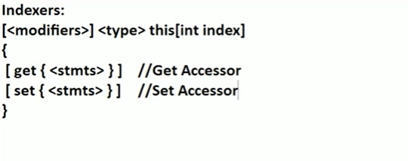

Indexer -by defining indexer in you class , by making class as virtual array.

When you want to access the properties of class outside the environment , use indexer .

Index make our class behave like virtual array and we can start the value with help of index position.