**Schema to be Created**

*CREATE TABLE Customers (*

*CustomerID NUMBER PRIMARY KEY,*

*Name VARCHAR2(100),*

*DOB DATE,*

*Balance NUMBER,*

*LastModified DATE*

*);*

*CREATE TABLE Accounts (*

*AccountID NUMBER PRIMARY KEY,*

*CustomerID NUMBER,*

*AccountType VARCHAR2(20),*

*Balance NUMBER,*

*LastModified DATE,*

*FOREIGN KEY (CustomerID) REFERENCES Customers(CustomerID)*

*);*

*CREATE TABLE Transactions (*

*TransactionID NUMBER PRIMARY KEY,*

*AccountID NUMBER,*

*TransactionDate DATE,*

*Amount NUMBER,*

*TransactionType VARCHAR2(10),*

*FOREIGN KEY (AccountID) REFERENCES Accounts(AccountID)*

*);*

*CREATE TABLE Loans (*

*LoanID NUMBER PRIMARY KEY,*

*CustomerID NUMBER,*

*LoanAmount NUMBER,*

*InterestRate NUMBER,*

*StartDate DATE,*

*EndDate DATE,*

*FOREIGN KEY (CustomerID) REFERENCES Customers(CustomerID)*

*);*

*CREATE TABLE Employees (*

*EmployeeID NUMBER PRIMARY KEY,*

*Name VARCHAR2(100),*

*Position VARCHAR2(50),*

*Salary NUMBER,*

*Department VARCHAR2(50),*

*HireDate DATE*

*);*

**Example Scripts for Sample Data Insertion**

*INSERT INTO Customers (CustomerID, Name, DOB, Balance, LastModified)*

*VALUES (1, 'John Doe', TO_DATE('1985-05-15', 'YYYY-MM-DD'), 1000, SYSDATE);*

*INSERT INTO Customers (CustomerID, Name, DOB, Balance, LastModified)*

*VALUES (2, 'Jane Smith', TO_DATE('1990-07-20', 'YYYY-MM-DD'), 1500, SYSDATE);*

*INSERT INTO Accounts (AccountID, CustomerID, AccountType, Balance, LastModified)*

*VALUES (1, 1, 'Savings', 1000, SYSDATE);*

*INSERT INTO Accounts (AccountID, CustomerID, AccountType, Balance, LastModified)*

*VALUES (2, 2, 'Checking', 1500, SYSDATE);*

*INSERT INTO Transactions (TransactionID, AccountID, TransactionDate, Amount, TransactionType)*

*VALUES (1, 1, SYSDATE, 200, 'Deposit');*

*INSERT INTO Transactions (TransactionID, AccountID, TransactionDate, Amount, TransactionType)*

*VALUES (2, 2, SYSDATE, 300, 'Withdrawal');*

*INSERT INTO Loans (LoanID, CustomerID, LoanAmount, InterestRate, StartDate, EndDate)*

*VALUES (1, 1, 5000, 5, SYSDATE, ADD_MONTHS(SYSDATE, 60));*

*INSERT INTO Employees (EmployeeID, Name, Position, Salary, Department, HireDate)*

*VALUES (1, 'Alice Johnson', 'Manager', 70000, 'HR', TO_DATE('2015-06-15', 'YYYY-MM-DD'));*

*INSERT INTO Employees (EmployeeID, Name, Position, Salary, Department, HireDate)*

*VALUES (2, 'Bob Brown', 'Developer', 60000, 'IT', TO_DATE('2017-03-20', 'YYYY-MM-DD'));*

**Exercise 1: Control Structures**

**Scenario 1:** The bank wants to apply a discount to loan interest rates for customers above 60 years old.

* + **Question:** Write a PL/SQL block that loops through all customers, checks their age, and if they are above 60, apply a 1% discount to their current loan interest rates.

**Scenario 2:** A customer can be promoted to VIP status based on their balance.

* + **Question:** Write a PL/SQL block that iterates through all customers and sets a flag IsVIP to TRUE for those with a balance over $10,000.

**Scenario 3:** The bank wants to send reminders to customers whose loans are due within the next 30 days.

* + **Question:** Write a PL/SQL block that fetches all loans due in the next 30 days and prints a reminder message for each customer.

**Solution:**

**Scenario 1:**

BEGIN

    FOR cust_rec IN (

        SELECT c.CustomerID, c.DOB, l.LoanID, l.InterestRate

        FROM Customers c

        JOIN Loans l ON c.CustomerID = l.CustomerID

    ) LOOP

        IF MONTHS_BETWEEN(SYSDATE, cust_rec.DOB) / 12 > 60 THEN

            UPDATE Loans

            SET InterestRate = InterestRate - 1

            WHERE LoanID = cust_rec.LoanID;

            DBMS_OUTPUT.PUT_LINE('1% discount applied to LoanID: ' || cust_rec.LoanID);

        END IF;

    END LOOP;

END;

**Output:**

There are no records of age greater than 60

PL/SQL procedure successfully completed.  
Elapsed: 00:00:00.090

**Scenario 2:**

**Query:**

ALTER TABLE Customers ADD (IsVIP CHAR(1));

**Output:**

Table CUSTOMERS altered.

Elapsed: 00:00:00.027

**Query:**

BEGIN

    FOR cust_rec IN (

        SELECT CustomerID, Balance FROM Customers

    ) LOOP

        IF cust_rec.Balance > 10000 THEN

            UPDATE Customers

            SET IsVIP = 'Y'

            WHERE CustomerID = cust_rec.CustomerID;

            DBMS_OUTPUT.PUT_LINE('CustomerID ' || cust_rec.CustomerID || ' marked as VIP');

        END IF;

    END LOOP;

END;

**Output:**

PL/SQL procedure successfully completed.

Elapsed: 00:00:00.011

**Scenario 3:**

BEGIN

    FOR loan_rec IN (

        SELECT l.LoanID, l.CustomerID, l.EndDate, c.Name

        FROM Loans l

        JOIN Customers c ON l.CustomerID = c.CustomerID

        WHERE l.EndDate BETWEEN SYSDATE AND SYSDATE + 30

    ) LOOP

        DBMS_OUTPUT.PUT_LINE('Reminder: Loan ID ' || loan_rec.LoanID || ' for Customer ' || loan_rec.Name || ' is due on ' || TO_CHAR(loan_rec.EndDate, 'YYYY-MM-DD'));

    END LOOP;

END;

**Output:**

PL/SQL procedure successfully completed.

Elapsed: 00:00:00.006

**Exercise 3: Stored Procedures**

**Scenario 1:** The bank needs to process monthly interest for all savings accounts.

* + **Question:** Write a stored procedure **ProcessMonthlyInterest** that calculates and updates the balance of all savings accounts by applying an interest rate of 1% to the current balance.

**Scenario 2:** The bank wants to implement a bonus scheme for employees based on their performance.

* + **Question:** Write a stored procedure **UpdateEmployeeBonus** that updates the salary of employees in a given department by adding a bonus percentage passed as a parameter.

**Scenario 3:** Customers should be able to transfer funds between their accounts.

* + **Question:** Write a stored procedure **TransferFunds** that transfers a specified amount from one account to another, checking that the source account has sufficient balance before making the transfer.

**Scenario 1:**

CREATE OR REPLACE PROCEDURE ProcessMonthlyInterest IS

BEGIN

    FOR acc_rec IN (

        SELECT AccountID, Balance

        FROM Accounts

        WHERE AccountType = 'Savings'

    ) LOOP

        UPDATE Accounts

        SET Balance = Balance + (Balance * 0.01),

            LastModified = SYSDATE

        WHERE AccountID = acc_rec.AccountID;

        DBMS_OUTPUT.PUT_LINE('Interest added to AccountID: ' || acc_rec.AccountID);

    END LOOP;

END;

**Output:**

EXEC ProcessMonthlyInterest;

Interest added to AccountID: 1

PL/SQL procedure successfully completed.

Elapsed: 00:00:00.013

**Scenario 2:**

CREATE OR REPLACE PROCEDURE UpdateEmployeeBonus (

    p_department IN VARCHAR2,

    p_bonus_percent IN NUMBER

) IS

BEGIN

    FOR emp_rec IN (

        SELECT EmployeeID, Salary

        FROM Employees

        WHERE Department = p_department

    ) LOOP

        UPDATE Employees

        SET Salary = Salary + (Salary * p_bonus_percent / 100)

        WHERE EmployeeID = emp_rec.EmployeeID;

        DBMS_OUTPUT.PUT_LINE('Bonus applied to EmployeeID: ' || emp_rec.EmployeeID);

    END LOOP;

END;

**Output:**

EXEC UpdateEmployeeBonus('IT', 10);

Bonus applied to EmployeeID: 2

PL/SQL procedure successfully completed.

Elapsed: 00:00:00.016

**Scenario 3:**

CREATE OR REPLACE PROCEDURE TransferFunds (

    p_from_account IN NUMBER,

    p_to_account IN NUMBER,

    p_amount IN NUMBER

) IS

    v_from_balance NUMBER;

BEGIN

    -- Get source account balance

    SELECT Balance INTO v_from_balance

    FROM Accounts

    WHERE AccountID = p_from_account;

    IF v_from_balance < p_amount THEN

        RAISE_APPLICATION_ERROR(-20001, 'Insufficient balance in source account.');

    END IF;

    -- Deduct from source

    UPDATE Accounts

    SET Balance = Balance - p_amount,

        LastModified = SYSDATE

    WHERE AccountID = p_from_account;

    -- Add to target

    UPDATE Accounts

    SET Balance = Balance + p_amount,

        LastModified = SYSDATE

    WHERE AccountID = p_to_account;

    DBMS_OUTPUT.PUT_LINE('Transferred ' || p_amount ||

                         ' from Account ' || p_from_account ||

                         ' to Account ' || p_to_account);

END;

**Output:**

EXEC TransferFunds(1, 2, 100);

Transferred 100 from Account 1 to Account 2

PL/SQL procedure successfully completed.

Elapsed: 00:00:00.010

**JUnit**

**Exercise 1: Setting Up JUnit**

Scenario:

You need to set up JUnit in your Java project to start writing unit tests.

Steps:

1. Create a new Java project in your IDE (e.g., IntelliJ IDEA, Eclipse).

2. Add JUnit dependency to your project. If you are using Maven, add the following to your

pom.xml:

<dependency>

<groupId>junit</groupId>

<artifactId>junit</artifactId>

<version>4.13.2</version>

<scope>test</scope>

</dependency>

1. Create a new test class in your project.

**Solution:**

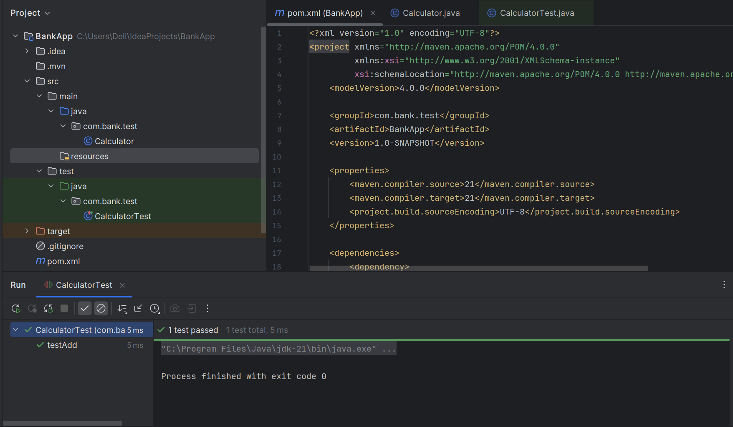

<?xml version="1.0" encoding="UTF-8"?>  
<project xmlns="http://maven.apache.org/POM/4.0.0"  
 xmlns:xsi="http://www.w3.org/2001/XMLSchema-instance"  
 xsi:schemaLocation="http://maven.apache.org/POM/4.0.0 http://maven.apache.org/xsd/maven-4.0.0.xsd">  
 <modelVersion>4.0.0</modelVersion>  
  
 <groupId>com.bank.test</groupId>  
 <artifactId>BankApp</artifactId>  
 <version>1.0-SNAPSHOT</version>  
  
 <properties>  
 <maven.compiler.source>21</maven.compiler.source>  
 <maven.compiler.target>21</maven.compiler.target>  
 <project.build.sourceEncoding>UTF-8</project.build.sourceEncoding>  
 </properties>  
  
 <dependencies>  
 <dependency>  
 <groupId>junit</groupId>  
 <artifactId>junit</artifactId>  
 <version>4.13.2</version>  
 <scope>test</scope>  
 </dependency>  
 </dependencies>  
  
</project>

**Exercise 3: Assertions in JUnit**

Scenario:

You need to use different assertions in JUnit to validate your test results.

Steps:

1. Write tests using various JUnit assertions.

Solution Code:

public class AssertionsTest {

@Test

public void testAssertions() {

// Assert equals

assertEquals(5, 2 + 3);

// Assert true

assertTrue(5 > 3);

// Assert false

assertFalse(5 < 3);

// Assert null

assertNull(null);

// Assert not null

assertNotNull(new Object());

}

}

**Output:**

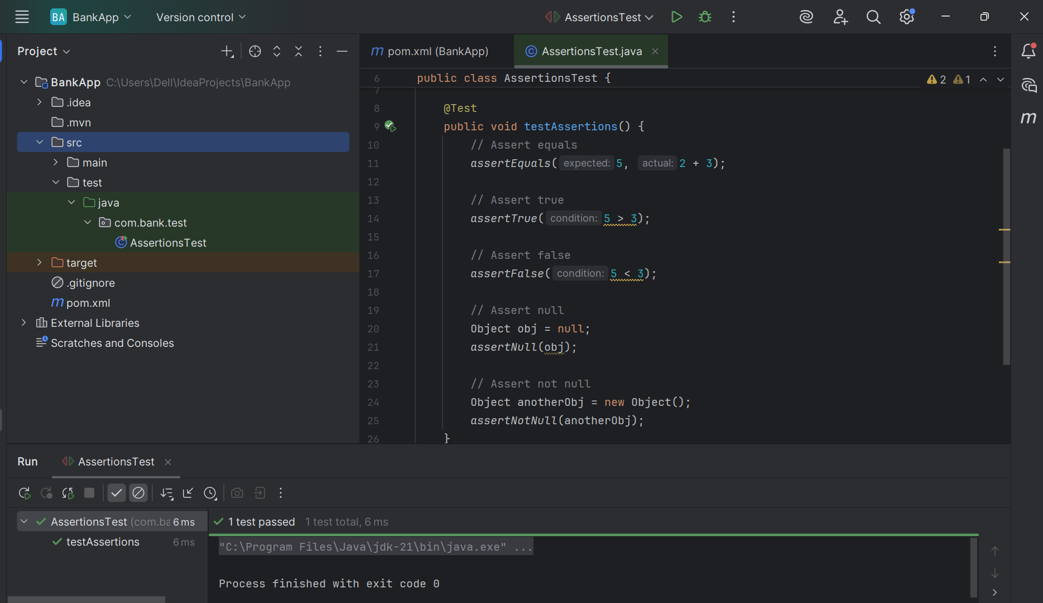

**Exercise 4: Arrange-Act-Assert (AAA) Pattern, Test Fixtures, Setup and**

**Teardown Methods in JUnit**

Scenario:

You need to organize your tests using the Arrange-Act-Assert (AAA) pattern and use setup

and teardown methods.

Steps:

1. Write tests using the AAA pattern.

2. Use @Before and @After annotations for setup and teardown methods.

**Solutions:**

**Calculator.java**

package com.bank.test;  
  
public class Calculator {  
 public int add(int a, int b) {  
 return a + b;  
 }  
  
 public int subtract(int a, int b) {  
 return a - b;  
 }  
}

**CalculatorTest.java**

package com.bank.test;  
  
import org.junit.After;  
import org.junit.Before;  
import org.junit.Test;  
import static org.junit.Assert.*assertEquals*;  
  
public class CalculatorTest {  
  
 private Calculator calc;  
  
 @Before  
 public void setUp() {  
 calc = new Calculator();  
 System.*out*.println("Setup: Calculator object created");  
 }  
  
 @After  
 public void tearDown() {  
 calc = null;  
 System.*out*.println("Teardown: Calculator object destroyed");  
 }  
  
 @Test  
 public void testAdd() {  
  
 int result = calc.add(10, 5);  
  
 *assertEquals*(15, result);  
 }  
  
 @Test  
 public void testSubtract() {  
  
 int result = calc.subtract(10, 3);  
  
 *assertEquals*(7, result);  
 }  
}

**Output:**

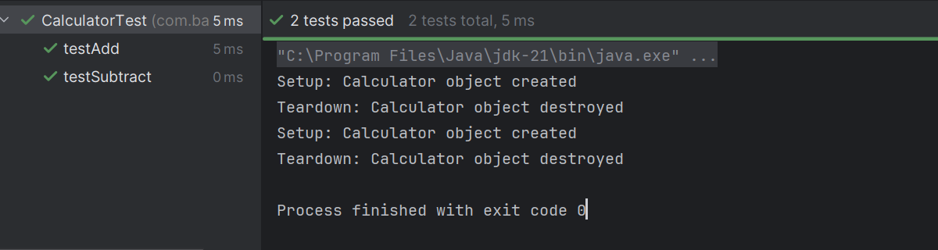

**Exercise 1: Mocking and Stubbing**

Scenario:

You need to test a service that depends on an external API. Use Mockito to mock the

external API and stub its methods.

Steps:

1. Create a mock object for the external API.

2. Stub the methods to return predefined values.

3. Write a test case that uses the mock object.

Solution Code:

import static org.mockito.Mockito.*;

import org.junit.jupiter.api.Test;

import org.mockito.Mockito;

public class MyServiceTest {

@Test

public void testExternalApi() {

ExternalApi mockApi = Mockito.mock(ExternalApi.class);

when(mockApi.getData()).thenReturn("Mock Data");

MyService service = new MyService(mockApi);

String result = service.fetchData();

assertEquals("Mock Data", result);

}

}

**Pom.xml**

<?xml version="1.0" encoding="UTF-8"?>  
<project xmlns="http://maven.apache.org/POM/4.0.0"  
 xmlns:xsi="http://www.w3.org/2001/XMLSchema-instance"  
 xsi:schemaLocation="http://maven.apache.org/POM/4.0.0 http://maven.apache.org/xsd/maven-4.0.0.xsd">  
 <modelVersion>4.0.0</modelVersion>  
  
 <groupId>com.bank.test</groupId>  
 <artifactId>Services</artifactId>  
 <version>1.0-SNAPSHOT</version>  
  
 <properties>  
 <maven.compiler.source>21</maven.compiler.source>  
 <maven.compiler.target>21</maven.compiler.target>  
 <project.build.sourceEncoding>UTF-8</project.build.sourceEncoding>  
 </properties>  
  
 <dependencies>  
 <dependency>  
 <groupId>org.junit.jupiter</groupId>  
 <artifactId>junit-jupiter</artifactId>  
 <version>5.10.0</version>  
 <scope>test</scope>  
 </dependency>  
  
 <dependency>  
 <groupId>org.mockito</groupId>  
 <artifactId>mockito-core</artifactId>  
 <version>5.11.0</version>  
 <scope>test</scope>  
 </dependency>  
 </dependencies>  
  
  
</project>

**ExternalApi.java**

package com.bank.test;  
  
public interface ExternalApi {  
 String getData();  
}

**MyService.java**

package com.bank.test;  
  
public class MyService {  
 private ExternalApi api;  
  
 public MyService(ExternalApi api) {  
 this.api = api;  
 }  
  
 public String fetchData() {  
 return api.getData();  
 }  
}

**MyServiceTest.java**

package com.bank.test;  
  
import org.junit.jupiter.api.Test;  
import static org.mockito.Mockito.*;  
import static org.junit.jupiter.api.Assertions.*;  
  
public class MyServiceTest {  
  
 @Test  
 public void testExternalApi() {  
  
 ExternalApi mockApi = *mock*(ExternalApi.class);  
  
  
 *when*(mockApi.getData()).thenReturn("Mock Data");  
  
  
 MyService service = new MyService(mockApi);  
  
  
 String result = service.fetchData();  
 *assertEquals*("Mock Data", result);  
 }  
}

**Output:**

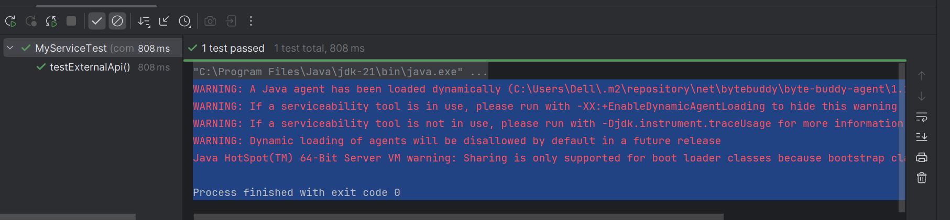

**Exercise 2: Verifying Interactions**

Scenario:

You need to ensure that a method is called with specific arguments.

Steps:

1. Create a mock object.

2. Call the method with specific arguments.

3. Verify the interaction.

Solution Code:

import static org.mockito.Mockito.*;

import org.junit.jupiter.api.Test;

import org.mockito.Mockito;

public class MyServiceTest {

@Test

public void testVerifyInteraction() {

ExternalApi mockApi = Mockito.mock(ExternalApi.class);

MyService service = new MyService(mockApi);

service.fetchData();

verify(mockApi).getData();

}

}

**ExternalApi.java**

package com.bank.test;  
  
public interface ExternalApi {  
 String getData();  
}

**Myservice.java**

package com.bank.test;  
  
public class MyService {  
 private ExternalApi api;  
  
 public MyService(ExternalApi api) {  
 this.api = api;  
 }  
  
 public String fetchData() {  
 return api.getData();  
 }  
}

MyServiceTest.java

package com.bank.test;  
  
import org.junit.jupiter.api.Test;  
import static org.mockito.Mockito.*;  
import static org.junit.jupiter.api.Assertions.*;  
  
public class MyServiceTest {  
  
 @Test  
 public void testVerifyInteraction() {  
  
 ExternalApi mockApi = *mock*(ExternalApi.class);  
  
 MyService service = new MyService(mockApi);  
  
 service.fetchData();  
  
 *verify*(mockApi).getData();  
 }  
}

**Output:**

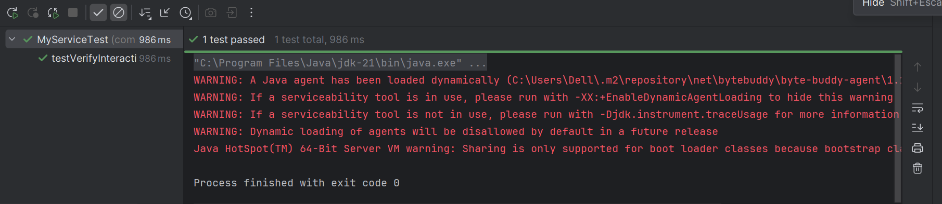

**Exercise 1: Logging Error Messages and Warning Levels**

Task: Write a Java application that demonstrates logging error messages and warning levels

using SLF4J.

Step-by-Step Solution:

1. Add SLF4J and Logback dependencies to your `pom.xml` file:

<dependency>

<groupId>org.slf4j</groupId>

<artifactId>slf4j-api</artifactId>

<version>1.7.30</version>

</dependency>

<dependency>

<groupId>ch.qos.logback</groupId>

<artifactId>logback-classic</artifactId>

<version>1.2.3</version>

</dependency>

2. Create a Java class that uses SLF4J for logging:

import org.slf4j.Logger;

import org.slf4j.LoggerFactory;

public class LoggingExample {

private static final Logger logger = LoggerFactory.getLogger(LoggingExample.class);

public static void main(String[] args) {

logger.error("This is an error message");

logger.warn("This is a warning message");

}

}

**pom.xml**

<?xml version="1.0" encoding="UTF-8"?>  
<project xmlns="http://maven.apache.org/POM/4.0.0"  
 xmlns:xsi="http://www.w3.org/2001/XMLSchema-instance"  
 xsi:schemaLocation="http://maven.apache.org/POM/4.0.0 http://maven.apache.org/xsd/maven-4.0.0.xsd">  
 <modelVersion>4.0.0</modelVersion>  
  
 <groupId>com.bank.test</groupId>  
 <artifactId>Services</artifactId>  
 <version>1.0-SNAPSHOT</version>  
  
 <properties>  
 <maven.compiler.source>21</maven.compiler.source>  
 <maven.compiler.target>21</maven.compiler.target>  
 <project.build.sourceEncoding>UTF-8</project.build.sourceEncoding>  
 </properties>  
  
 <dependencies>  
 <dependency>  
 <groupId>org.slf4j</groupId>  
 <artifactId>slf4j-api</artifactId>  
 <version>1.7.30</version>  
 </dependency>  
 <dependency>  
 <groupId>ch.qos.logback</groupId>  
 <artifactId>logback-classic</artifactId>  
 <version>1.2.3</version>  
 </dependency>  
 </dependencies>  
  
  
  
</project>

**LoggingExample.java**

import org.slf4j.Logger;  
import org.slf4j.LoggerFactory;  
  
public class LoggingExample {  
 private static final Logger *logger* = LoggerFactory.*getLogger*(LoggingExample.class);  
  
 public static void main(String[] args) {  
 *logger*.error("This is an error message");  
 *logger*.warn("This is a warning message");  
 }  
}

**Output:**

