Google Colab Document Explanation

1. Changing the version of **tensorflow** to make the environment compatible.

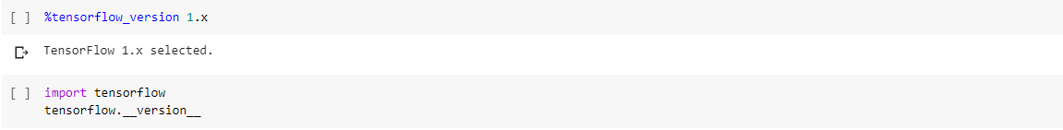

1. Mount the colab with the drive to access the data

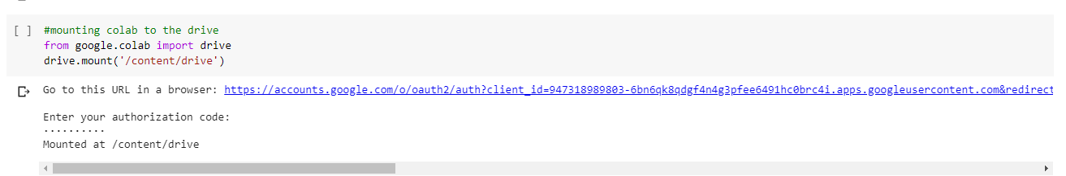

1. Get the path of data in variable **path**. Sort the list of all images so that labeling of data can be easier. Check by printing the **listing** variable.

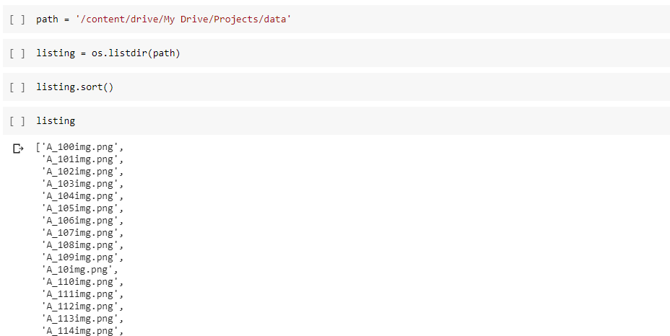

1. Convert the images as **np** array. There are total 784 images (size: 125*125)

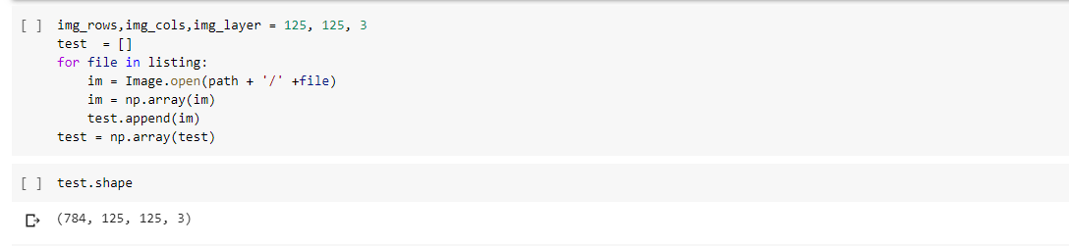

1. Create an **np** array of size 784 for the labels and assign the value from 0-4 (5 types of images)

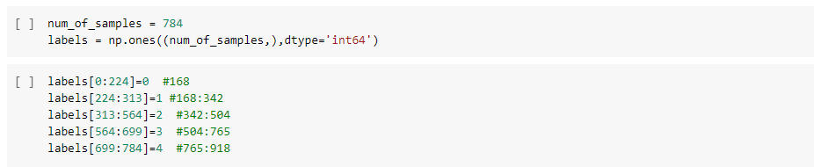

1. Shuffle the data as well as label for unbiased training of the model. Split the data in training and testing (size of 80% -20%)

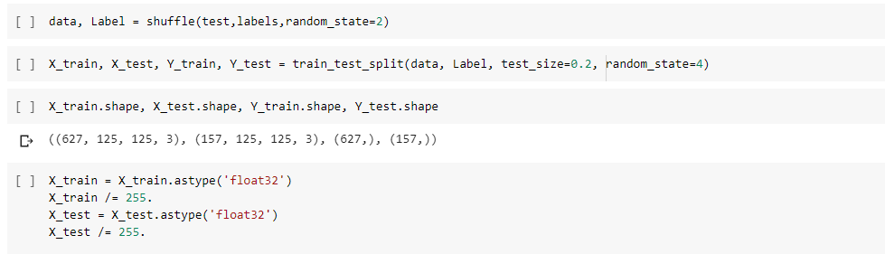

1. Checking the distribution of data in the five classes.

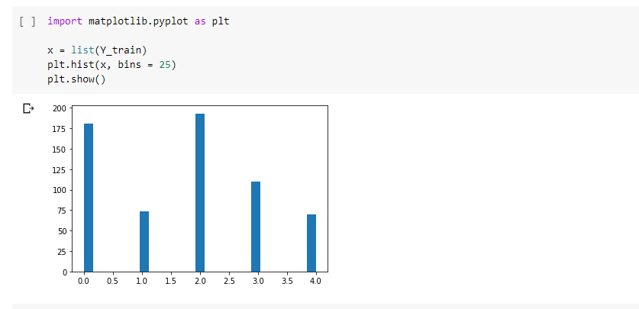

1. Reshaping the X variable

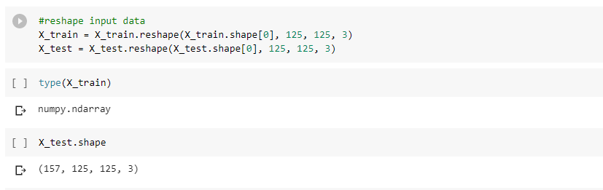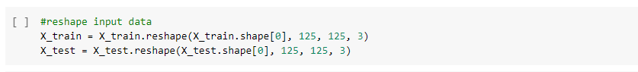

1. Convert the Y independent variable to the categorical data

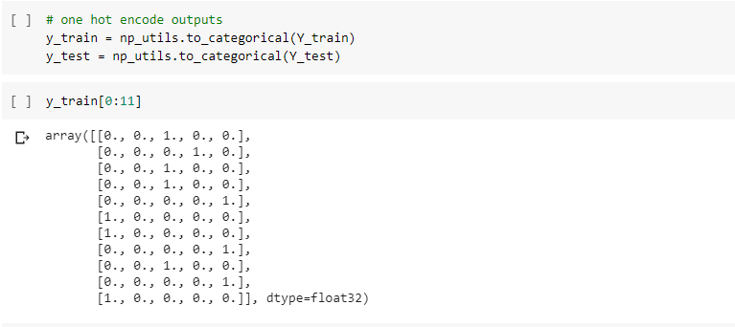

1. Model is designed with 5 convolution layer and two fully connected layer, dropout is used of 0.25 .The final layer is softmax function.

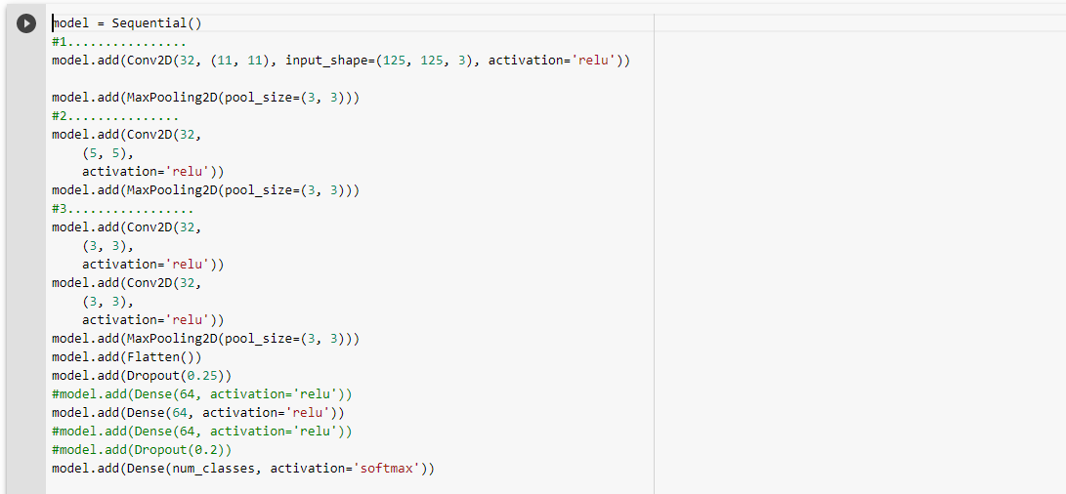

1. RsmProp Optimizer is used

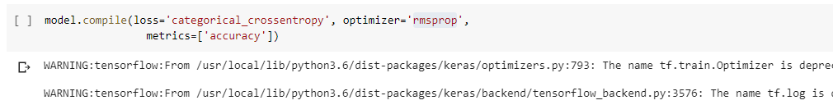

1. The model summary can be seen as

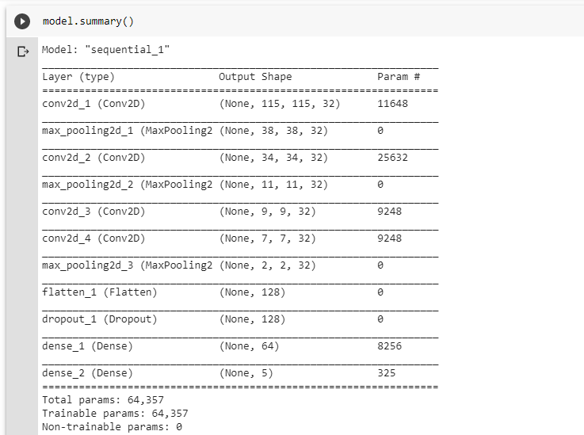

1. Train the model with 100 epochs

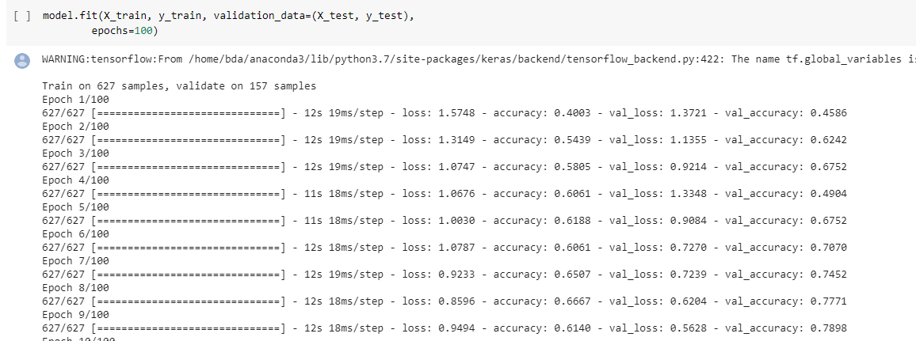

1. Save the model

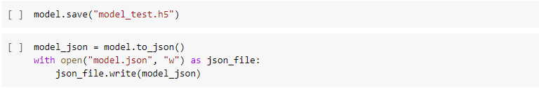

1. Load the model in **model** variable.

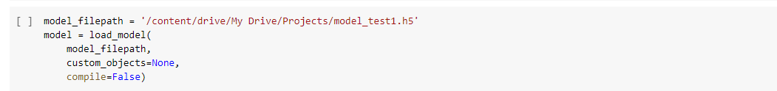

1. Calculate the predicted value of Y variable in **y_pred**

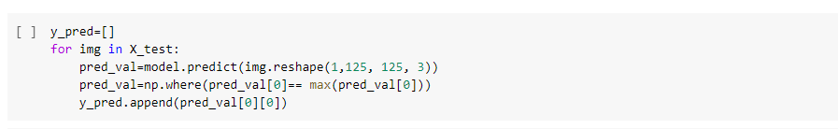

1. Similarity can be seen in actual and predicted vales of output

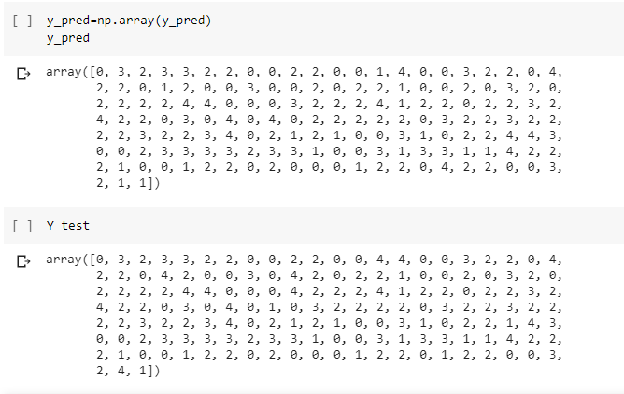

1. Predicting the new image

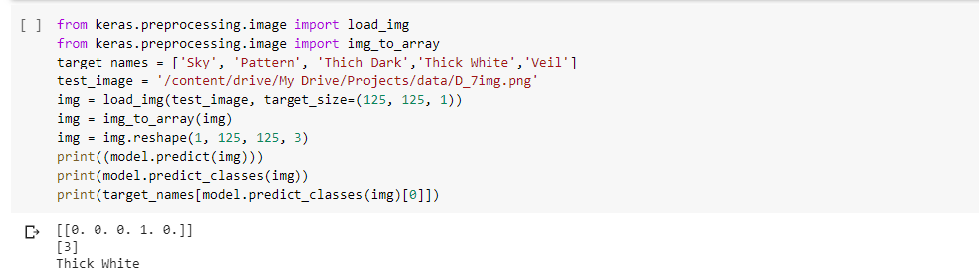

1. Calculation confusion matrix

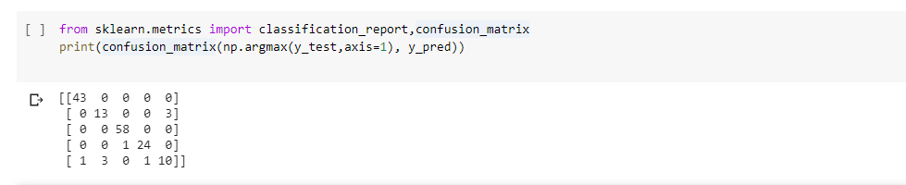

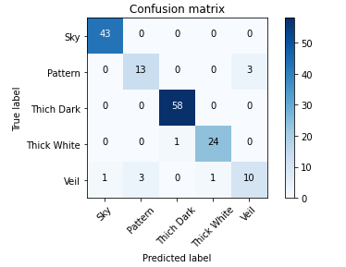

1. Precision recall n F-measure

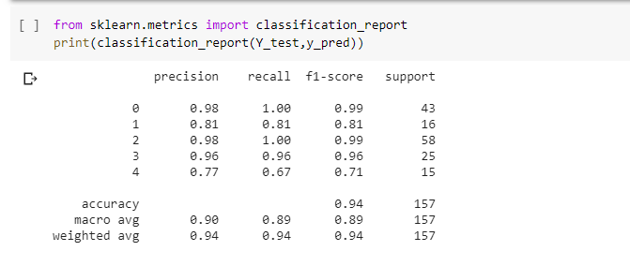

1. Plot the model in block diagram format



