**NAAN MUDHALVAN**

**Artificial Intelligence**

**PHASE -2**

**Sentiment analysis for marketing**

**Introduction:**

The sentiment analysis process mainly focuses on polarity, i.e., positive, negative, or neutral. Apart from polarity, it also considers the feelings and emotions(happy, sad, angry, etc.),

**What is a sentiment analysis in marketing:**

Sentiment analysis is an automated process that attaches an emotional label or subjective opinion to text. For example, sentiment analysis may examine a social media post and determine that it carries a positive, negative or neutral opinion.

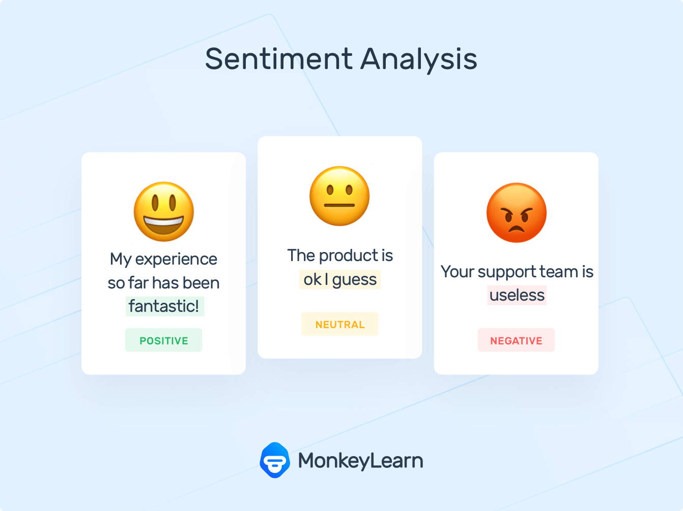

**Different machine learning techniques to use for sentiment analysis:**

Sentiment analysis can be done using techniques related to natural language processing (NLP) and [machine learning](https://vitalflux.com/category/machine-learning). NLP techniques such as [bag-of-words (BoW)](https://vitalflux.com/text-classification-bag-of-words-model-python-sklearn/) and term frequency-inverse document frequency (TF-IDF) can be used.

**Techniques of sentiment analysis of marketing:**

1. **Image Recognition:**

* Object Detection,
* Facial Recognition,
* Logo Recognition,

**Object Detection:**

Identify objects, people, or scenes in the image to understand the context.

**Facial Recognition:**

Analyze facial expressions to gauge emotions of individuals in the images.

**Logo Recognition:**

Identify logos of products or brands to track brand sentiment.

**2. Deep Learning Models:**

Convolutional Neural Networks (CNNs): Train CNNs to recognize patterns and features in images, helping in sentiment classification.

Transfer Learning: Use pre-trained CNN models like VGG, ResNet, or Inception, fine-tuned on specific marketing image datasets.

**3. Text Extraction from Images:**

Optical Character Recognition (OCR): Extract text from images, which can then be analyzed for sentiment using natural language processing techniques.

**4. Emotion Recognition:**

Facial Emotion Recognition: Detect emotions like happiness, sadness, anger, etc., from facial expressions in images.

Body Language Analysis: Analyze body language and gestures in images to understand the emotional context.

**5. Data Augmentation:**

Image Augmentation Techniques: Generate variations of images (rotation, scaling, flipping) to increase the diversity of the training dataset, improving model accuracy.

**6. Natural Language Processing (NLP) Techniques:**

Aspect-Based Sentiment Analysis: Combine image analysis with NLP to understand specific aspects of products or services that customers have positive or negative sentiments about.

Text Sentiment Analysis: If there is text associated with the image (captions, comments), perform sentiment analysis on that text to complement the image analysis.

**7. Sentiment Analysis Tools:**

Pre-built APIs: Leverage services like Google Cloud Vision, Amazon Rekognition, or Microsoft Azure Computer Vision for basic sentiment analysis of images.

Custom Models: Train custom machine learning models tailored to the specific marketing domain for more accurate sentiment analysis.

**8. User-Generated Content Analysis:**

Social Media Mining*: Analyze images shared on social media platforms,* considering likes, comments, and emojis as indicators of sentiment.

Review Mining: Extract sentiment from images shared in product/service reviews to understand customer opinions.

**9. Sentiment Visualization:**

Heatmaps: Create heatmaps of images, highlighting areas where people focus the most, indicating positive or negative sentiment.

Visual Dashboards: Develop interactive dashboards that visually represent the sentiment analysis results for easy interpretation.

**10. Continuous Model Improvement:**

Feedback Loop: Continuously collect feedback on the accuracy of sentiment predictions and use this data to retrain and improve the models.

Remember, the effectiveness of sentiment analysis in marketing with images often depends on the quality and quantity of the data used for training the models. Regularly updating and refining the models based on new data and feedback is crucial for maintaining accuracy and relevance.

**Algorithm is used for sentiment analysis:**

Overall, Sentiment analysis may involve the following types of classification algorithms: Linear Regression, Naive Bayes. Support Vector Machines.

**ADVANCED OF SENTIMENT ANALYSIS OF MARKETING**

**1. Pre-trained Language Models:**

BERT and RoBERTa are pre-trained language models designed to understand the context of words in a sentence. They are trained on massive amounts of text data and can capture complex language patterns and nuances

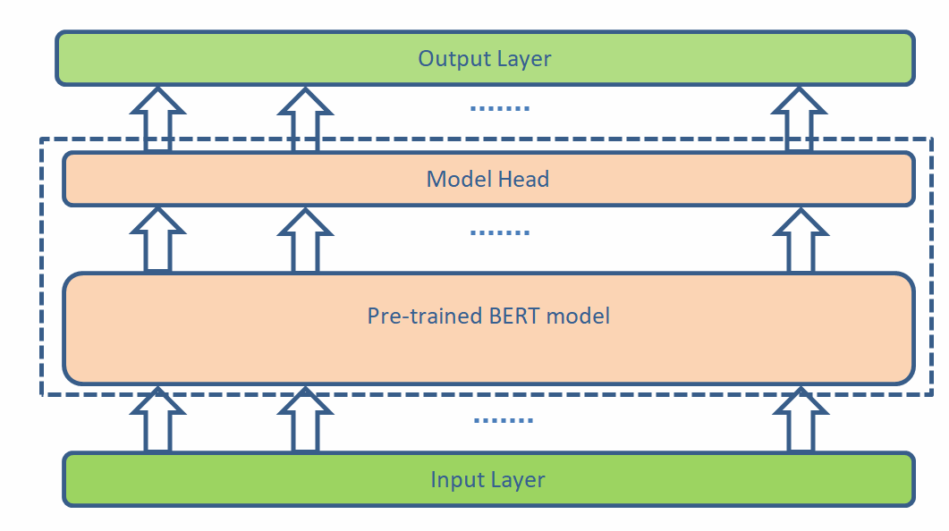

**2.Aspect-Based Sentiment Analysis:**

Instead of analyzing overall sentiment, this technique breaks down opinions into specific aspects. For instance, in a smartphone review, aspects could include battery life, camera quality, and user interface. This granular analysis provides deeper insights for product improvement.

**3. Emotion Detection:**

Sentiment analysis has evolved to recognize emotions like happiness, anger, sadness, etc. This nuanced understanding helps in gauging customer emotions accurately. Emotion detection is vital for understanding how customers truly feel about a product or service.

**4. Fine-Tuning with Industry-Specific Data:**

Generic sentiment models can be fine-tuned with industry-specific data. For example, a model trained on general data can be fine-tuned using data from a specific industry like hospitality or tech. This customization enhances accuracy in industry-specific contexts.

**5. Deep Learning Techniques:**

Deep learning models, especially recurrent neural networks (RNNs) and transformers like BERT, have shown significant improvements in sentiment analysis. These models can capture complex language patterns and contexts, leading to more accurate sentiment analysis results.

**6. Multimodal Sentiment Analysis:**

With the rise of social media and visual content, combining text analysis with image and video analysis has become crucial. Multimodal sentiment analysis combines information from various sources, providing a comprehensive view of customer sentiment.

**7. Sentiment Analysis for Social Listening:**

Marketers use sentiment analysis tools for social listening to monitor brand mentions and customer sentiments in real-time. Advanced sentiment analysis algorithms help in filtering through massive amounts of social data to identify trends and customer preferences quickly.

**8. Sarcasm and Irony Detection:**

Sentiment analysis models are being trained to detect sarcasm and irony in text. Understanding these nuances is vital as they can completely reverse the polarity of a statement, leading to misinterpretation if not detected accurately.

**9. Contextual Sentiment Analysis:**

Understanding the context of a conversation or review is crucial. Words can have different meanings based on the context in which they are used. Advanced algorithms consider the context surrounding words to determine the accurate sentiment of a sentence.

**10. Real-Time Sentiment Analysis:**

Advancements in processing power and algorithms enable real-time sentiment analysis. Marketers can now analyze sentiments as data streams in, allowing for immediate responses to customer feedback and market trends.

**11. Ethical Considerations:**

As sentiment analysis becomes more sophisticated, there's a growing focus on ethical concerns. Ensuring privacy, avoiding biases in algorithms, and being transparent about data usage are essential aspects of advanced sentiment analysis in marketing.

**Conclusion:**

Sentiment analysis in marketing has evolved significantly, incorporating advanced techniques and technologies to analyze customer emotions, opinions, and attitudes effectively. Leveraging methods such as lexicon-based analysis, machine learning algorithms, deep learning models, aspect-based analysis, rule-based systems, and social media analysis, businesses can gain valuable insights from customer feedback.