Lab 2: Agile Backlog Creation & Sprint Simulation in Jira
Problem Statement #60 — Podcast Guest Scheduling & Outline Builder
Dhanush S · PES1UG24AM360 · Section F
1. Backlog with Epics and User Stories
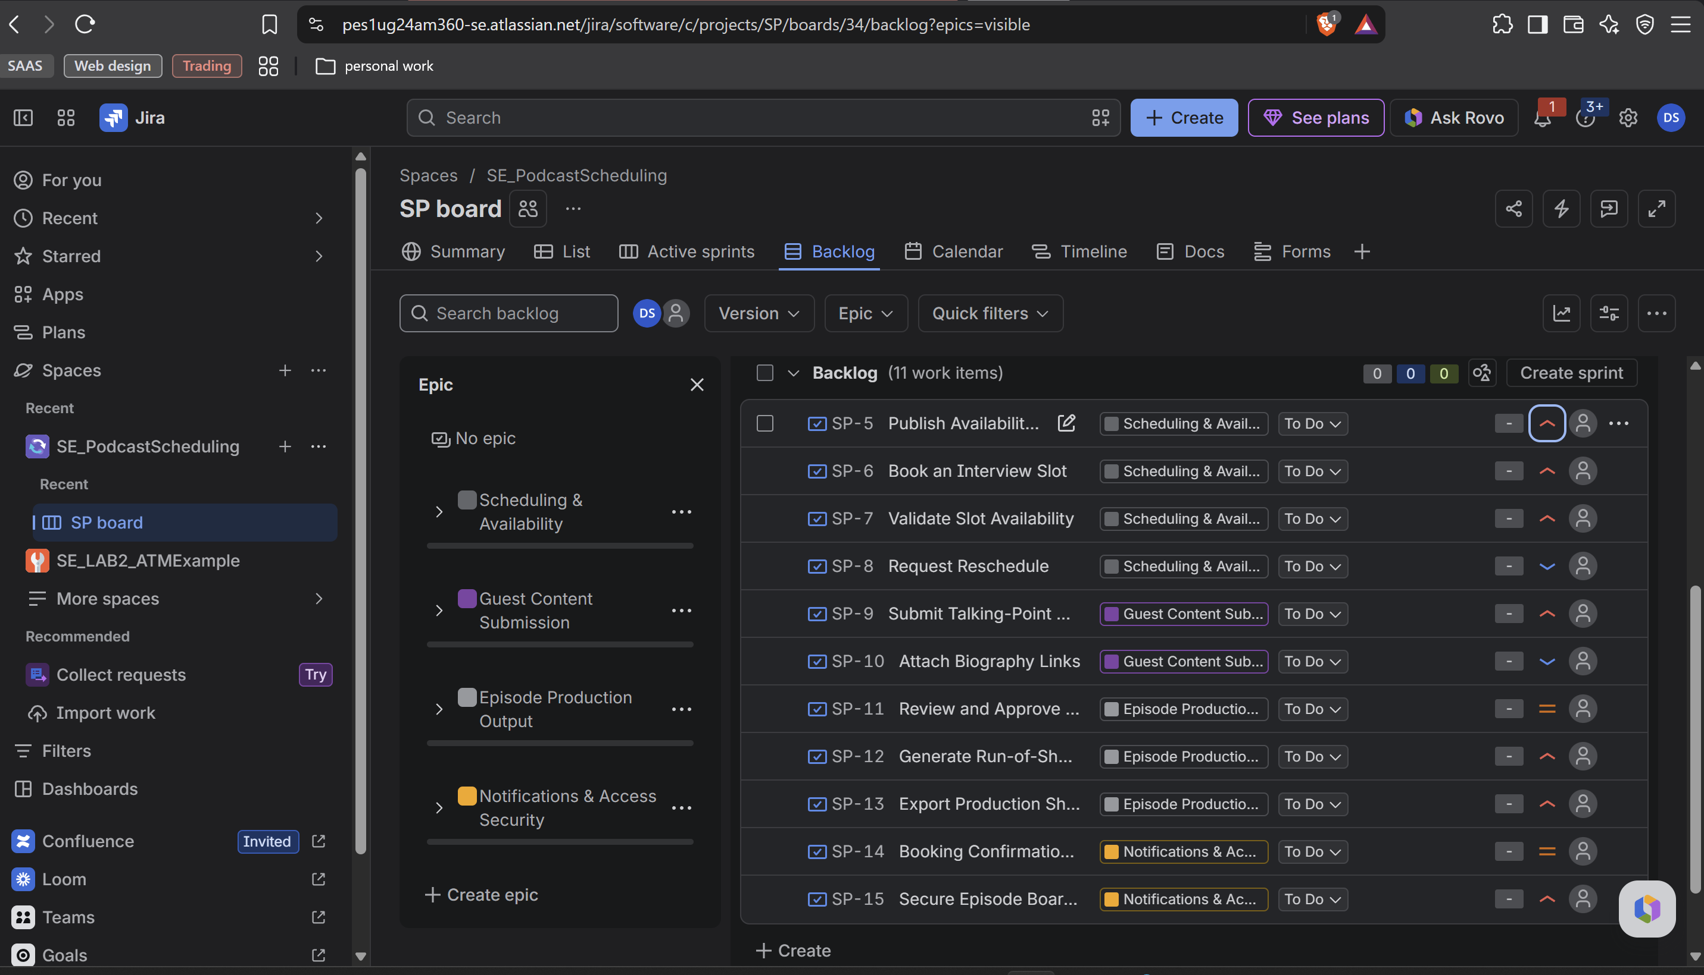

2. Story Point Assignments
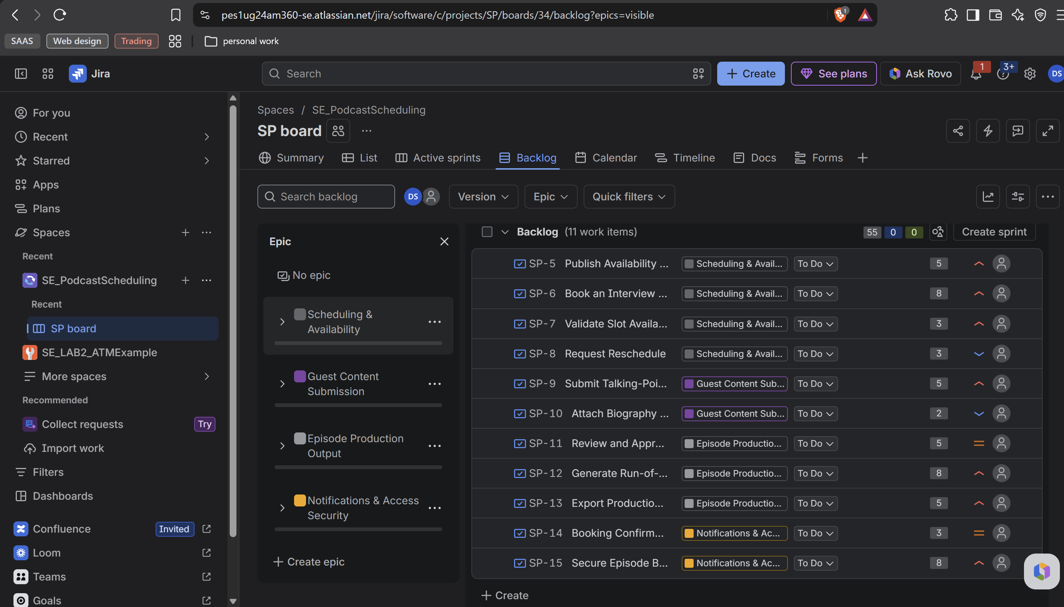

3. Sprint 1 — Active Sprint Board
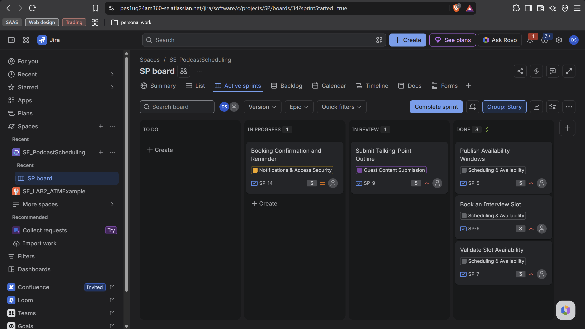

4. Sprint 1 — Burndown Chart
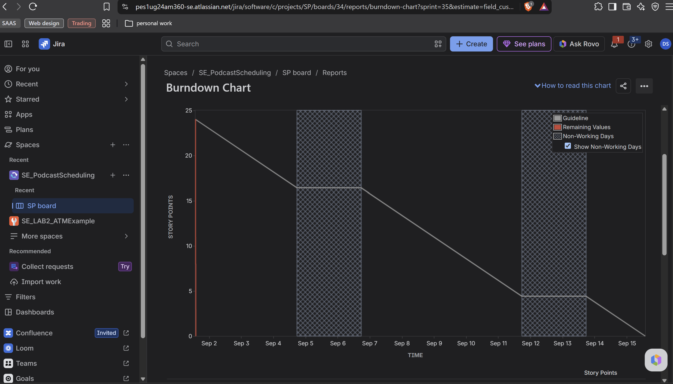

5. Sprint 2 — Active Sprint Board
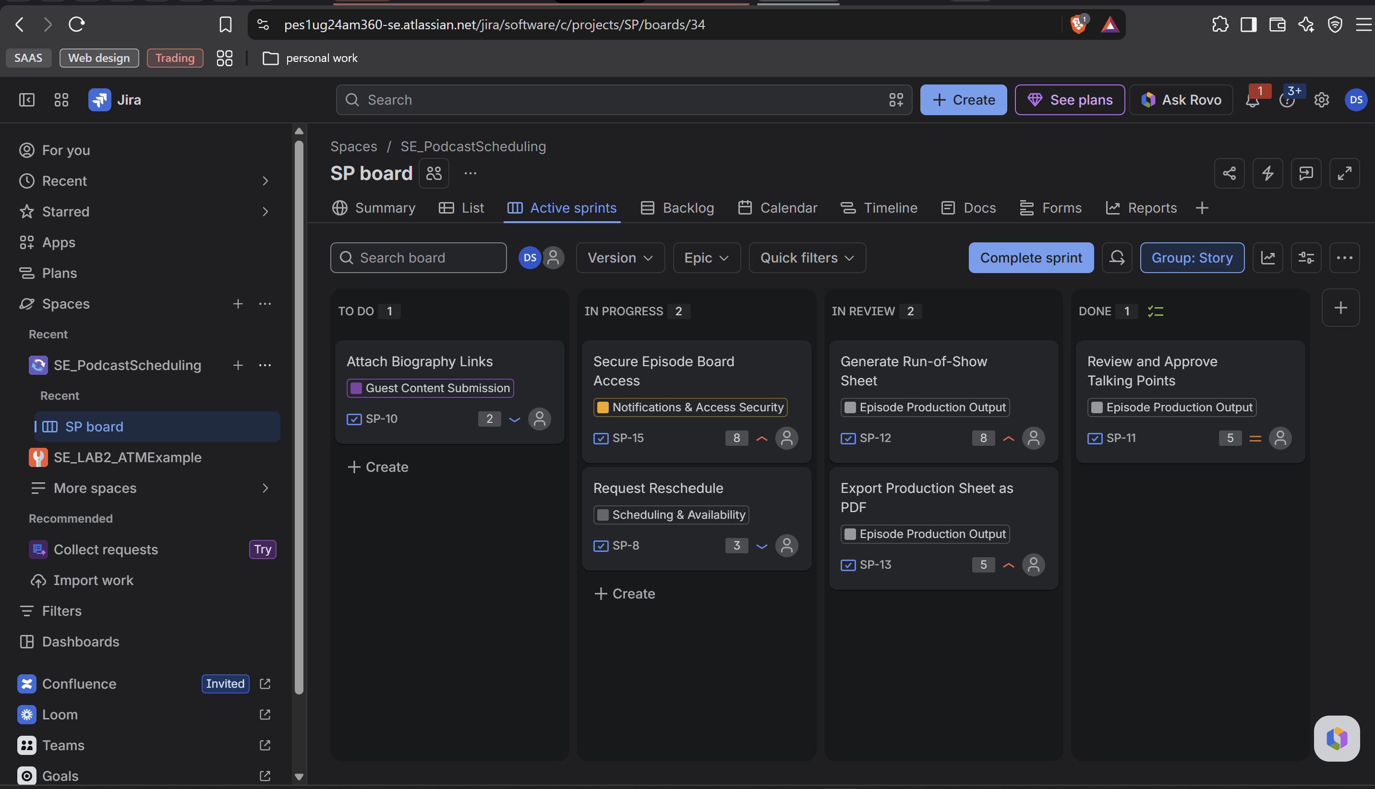

6. Sprint 2 — Burndown Chart
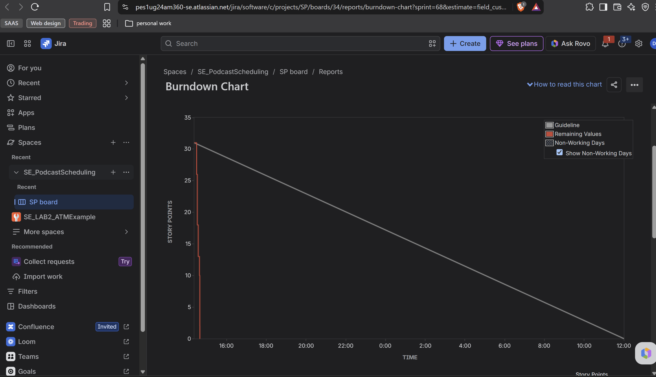

Reflection Questions
Q1. Did your estimations reflect the actual effort?
Not fully, because this was a simulated sprint so there was no real coding effort to compare against. But the relative sizing worked. I gave 8 points to Book an Interview Slot and Secure Episode Board Access because they had the most uncertainty, and only 2 to Attach Biography Links since it is just one field. In both sprints the work finished before the guideline, so my estimates were probably a bit high.
Q2. Was your backlog well-prioritized?
Yes. I put the basic booking flow in Sprint 1 so a guest could book a slot and submit topics end to end. That was 24 points and all of it was High or Medium priority. The Low priority stories like Request Reschedule and Attach Biography Links went to Sprint 2 because the system still works without them. One thing I would change is Secure Episode Board Access — it is High priority but I kept it in Sprint 2.
Q3. How did your simulated sprint align with your plan?
The scope matched my plan. Sprint 1 had 5 stories and 24 points, Sprint 2 had 6 stories and 31 points, and everything got done in both. The duration did not match though. Sprint 1 used Jira's default of 2 weeks, so all the work finished on day one and the chart stayed flat after that. For Sprint 2 I used a 1 day sprint, which is the shortest Jira allows.
Q4. What insights did the burndown chart give about your team's capacity?
Sprint 1's chart drops straight down from 24 to 0 at the start and then stays flat. That happens when everything is marked done at once. Sprint 2's chart is better — it goes down in steps, and each step is one story finishing. The 8 point stories made the biggest steps, which shows why smaller stories give a clearer chart. In both sprints the red line was below the grey line, so I could have taken more work. Since both sprints were simulated it does not show real capacity, but I now have a velocity of about 27 points per sprint.

