MedVision-AI
Deep Learning-Based Chest X-ray Image Classification
Student: Divya T
Institution: RV University
Technology: Python | PyTorch | DenseNet121 | Streamlit
Report prepared: October 2026
IMPORTANT DISCLAIMER
Educational research prototype only. Not clinically validated; do not use to diagnose, treat, or rule out pneumonia.
Document Notes
This report uses project details and metrics reported during implementation discussions. The workflow, architecture, confusion matrix, and metric chart are generated explanatory figures, not screenshots of the actual application. Screenshot sections are placeholders because authentic screenshots from the local computer were not provided. Insert genuine screenshots before submission. Verify all values against current output files before submitting.
Contents
1. Abstract
2. Introduction
3. Problem Statement and Objectives
4. Background
5. Dataset and Quality Audit
6. Methodology
7. Model Architecture
8. Implementation
9. Training and Validation
10. Evaluation Results
11. Error Analysis
12. Streamlit Application
13. Screenshot Evidence Record
14. Limitations and Responsible Use
15. Future Work
16. Conclusion
17. Reproducibility Checklist
18. References
1. Abstract
MedVision-AI is a deep-learning project that classifies chest X-ray images into two dataset labels: NORMAL and PNEUMONIA. It uses Python, PyTorch, a DenseNet121-based classifier, training/validation, held-out test evaluation, and a Streamlit interface. Images are resized to 224 × 224 pixels, converted to tensors, and normalized using ImageNet channel statistics; random horizontal flipping is applied during training as a basic augmentation. On the reported test set of 624 images, the model achieved 85.42% accuracy, weighted F1-score of 84.55%, and ROC-AUC of 0.9449. The confusion matrix includes 147 correct NORMAL predictions, 386 correct PNEUMONIA predictions, 87 NORMAL images predicted as PNEUMONIA, and 4 PNEUMONIA images predicted as NORMAL. Class-level errors show why aggregate metrics alone are insufficient. This is a student research prototype, not a medical device.
2. Introduction
Convolutional neural networks learn visual features from images and are widely used for supervised image classification. Chest X-ray classification is an educational task for studying preprocessing, transfer learning, training, evaluation, and inference interfaces. MedVision-AI combines these stages into a structured project and includes audit and misclassification outputs to encourage analysis beyond accuracy.
2.1 Scope
Two labels only: NORMAL and PNEUMONIA, as defined by the dataset.
Image-level classification; no segmentation or localization is claimed.
Results describe one available test split and do not establish generalization to other hospitals, scanners, or populations.
The interface is a demonstration, not a clinical workflow.
3. Problem Statement and Objectives
3.1 Problem statement
Build an end-to-end image-classification pipeline that accepts a chest X-ray and predicts one of two dataset labels, while recording metrics, reviewing mistakes, and presenting a simple interface. Document data handling, implementation evidence, limitations, and reproducibility.
3.2 Objectives
Organize dataset handling, model code, scripts, artifacts, reports, and tests.
Apply consistent resizing and normalization.
Train a DenseNet121-based classifier and select a checkpoint using validation performance.
Evaluate accuracy, precision, recall, F1-score, ROC-AUC, loss, and confusion matrix.
Inspect class-specific errors and export misclassified examples.
Provide a Streamlit demo.
Document data-quality checks, limitations, and real screenshots.
3.3 Deliverables
Deliverable | Purpose
Training pipeline | Fit model parameters and monitor validation performance.
Prediction script | Run inference outside the UI.
Evaluation outputs | Metrics, confusion matrix, and misclassification records.
Streamlit app | Interactive demonstration.
Dataset audit | Record duplicate checks and caveats.
Project report | Methods, results, limitations, and evidence.
4. Background and Related Concepts
4.1 Convolutional neural networks
CNNs apply learnable filters to local image regions. Early layers can respond to edges and textures, while deeper layers combine them into more complex features. A classification head maps learned features to class scores.
4.2 DenseNet121 and transfer learning
DenseNet connects layers within dense blocks so later layers can reuse features from earlier ones. DenseNet121 is a commonly used CNN architecture. Transfer learning initializes a model from parameters learned on a larger image dataset and adapts it to a target task. Verify the exact pretrained-weight setting and classifier-head implementation in the current source code before submission.
4.3 Evaluation concepts
Accuracy is the proportion of correct predictions. Precision measures the correctness of predictions for a class; recall measures how many actual examples of that class are found; F1-score balances precision and recall. ROC-AUC describes ranking discrimination across thresholds. These descriptive metrics do not establish clinical safety or probability calibration.
5. Dataset and Quality Audit
5.1 Reported split counts
Split | Images | Purpose
Training | 4,172 | Parameter learning
Validation | 1,044 | Development monitoring and checkpoint selection
Test | 624 | Reported final evaluation
Total | 5,840 | Sum of reported split counts
The reported test set contains 234 NORMAL images and 390 PNEUMONIA images. The validation split is reported as stratified from the training directory with random seed 42; the designated test directory is used for evaluation. Add the exact dataset title, source, version, license, and citation before submission.
5.2 Preprocessing
Resize images to 224 × 224 pixels.
Convert images to tensors.
Normalize channels using ImageNet mean and standard deviation.
Apply random horizontal flipping to training images only, as configured.
Use deterministic transformations for validation and test data.
5.3 Quality-audit findings
The reported audit found zero exact-hash duplicates across splits. Within-split duplicate copies were reported as train/NORMAL 1, train/PNEUMONIA 25, validation/NORMAL 0, validation/PNEUMONIA 0, test/NORMAL 3, and test/PNEUMONIA 3: 32 within-split duplicate copies in total. Exact hashes detect byte-identical files only; they cannot prove patient-level independence or detect resized/recompressed copies.
Audit item | Finding | Interpretation
Exact-hash duplicates across splits | 0 detected | Not proof of patient-level independence.
Train NORMAL | 1 | Review duplicate handling.
Train PNEUMONIA | 25 | Repeated examples may affect effective weighting.
Validation | 0 | No exact-hash duplicates reported.
Test | 6 total | Repeated copies may affect effective sample size.
Recommended follow-up: document dataset provenance, check for patient grouping where permitted, and use patient-level splits if metadata allows. Do not call the dataset leakage-free solely based on this hash audit.
6. Proposed Methodology
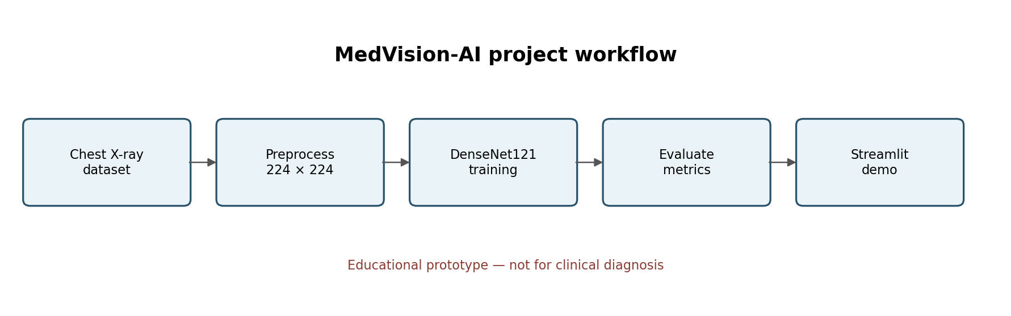
Figure 1. End-to-end project workflow (generated explanatory diagram).
Load class-labeled images from the dataset directory.
Keep training, validation, and test roles separate.
Preprocess images and augment training data only.
Train the DenseNet121-based classifier using the configured loss and optimizer.
Track validation performance and save the selected checkpoint.
Run the selected checkpoint on the held-out test set.
Compute aggregate and per-class metrics and save the confusion matrix.
Inspect errors and test inference through Streamlit.
6.1 Reproducibility
Record seeds, package versions, split definitions, checkpoint identity, training parameters, and exact evaluation command. If source code or data changes, rerun evaluation rather than reusing previous metrics.
7. Model Architecture
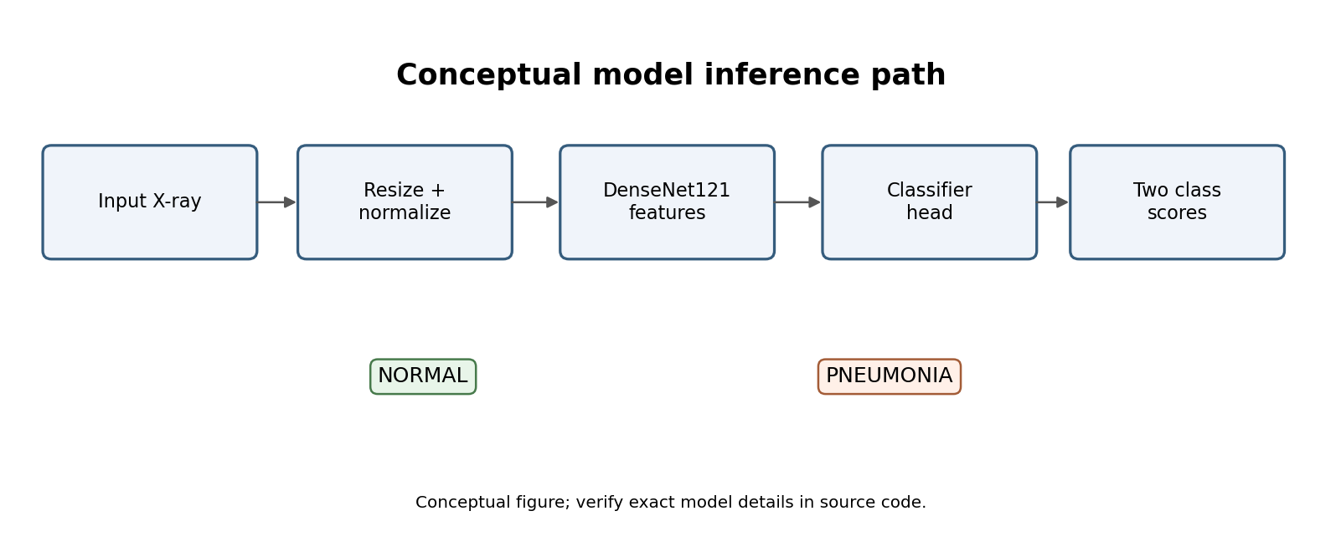
Figure 2. Conceptual inference path; verify exact details in source code.
The conceptual path consists of an X-ray input, preprocessing, DenseNet121 feature extraction, a classifier head, and two output scores. Keep class ordering consistent between the dataset loader, model, evaluation, prediction script, and UI. Output is a model estimate, not a definitive medical finding.
7.1 Design rationale
DenseNet121 is an established CNN architecture for image classification.
A two-class output matches the dataset labels.
Consistent preprocessing aligns training and inference input.
A saved checkpoint enables inference without retraining.
7.2 Details to verify in code
Whether ImageNet pretrained weights are enabled.
Exact loss function, optimizer, learning rate, batch size, epoch count, and checkpoint-selection rule.
Whether the UI shows a softmax score, calibrated probability, or another score. Do not call it calibrated unless calibration was evaluated.
8. Implementation and Project Structure
The project was developed in VS Code on Windows using PowerShell. The reported environment used CPU execution, with CUDA unavailable. PyTorch and torchvision support model training and inference; Streamlit provides the local browser interface.
Path / file | Role
train.py | Training entry point.
evaluate.py | Evaluate checkpoint and write outputs.
predict.py | Run inference.
app/app.py | Streamlit interface.
src/medvision/data/dataset.py | Dataset loading and preprocessing.
src/medvision/models/densenet.py | DenseNet121 model definition.
artifacts/checkpoints/best_model.pth | Selected checkpoint.
reports/evaluation/metrics.json | Evaluation metrics.
reports/evaluation/confusion_matrix.png | Confusion-matrix figure.
reports/evaluation/baseline_metrics.json | Baseline metrics, if generated in current run.
reports/dataset_quality_audit.md | Dataset audit notes.
reports/misclassified/misclassified_images.csv | Misclassified image records.
requirements.txt | Python dependencies.
README.md | Project overview and setup notes.
8.1 Environment
Item | Reported configuration
OS / shell | Windows / PowerShell
Editor | Visual Studio Code
Python | 3.13 virtual environment
Compute | CPU; CUDA unavailable
PyTorch | 2.14.1+cpu
torchvision | 0.29.1+cpu
Interface | Streamlit
Checkpoint | artifacts/checkpoints/best_model.pth
8.2 Running locally
Open PowerShell in the project root and activate the environment. These are typical commands; use the exact arguments required by the current scripts.
cd D:\MedVision-AI
.\.venv\Scripts\Activate.ps1
python .\train.py
python .\evaluate.py
python .\predict.py --help
python -m streamlit run .\app\app.py --server.port 8502
The local app was previously tested at http://localhost:8502. Keep the development server private unless secure deployment is configured.
9. Training and Validation
Training updates model parameters from labeled batches. Validation monitors generalization and supports checkpoint selection. Repeated tuning on the test set makes the final estimate less independent, so reserve test data for final reporting.
Initialize the model and select the available compute device.
Load shuffled training batches and deterministic validation batches.
Run forward propagation and compute the configured classification loss.
Backpropagate gradients and update trainable parameters.
Track training and validation loss/metrics.
Save the checkpoint selected by the validation rule.
Load the checkpoint for final test evaluation.
CPU training may take longer than GPU training. Preserve logs and record the final command, run date, checkpoint, and exact settings. Copy optimizer and epoch details from the current source code rather than guessing.
10. Evaluation Metrics and Results
10.1 Overall reported performance
Metric | Reported result
Test images | 624
Test loss | 0.60577
Accuracy | 85.4167%
Weighted precision | 87.51085%
Weighted recall | 85.4167%
Weighted F1-score | 84.54598%
ROC-AUC | 0.944943
These results describe the available test split. Aggregate metrics conceal different class-level behavior, including a notable number of NORMAL images predicted as PNEUMONIA.
10.2 Confusion matrix
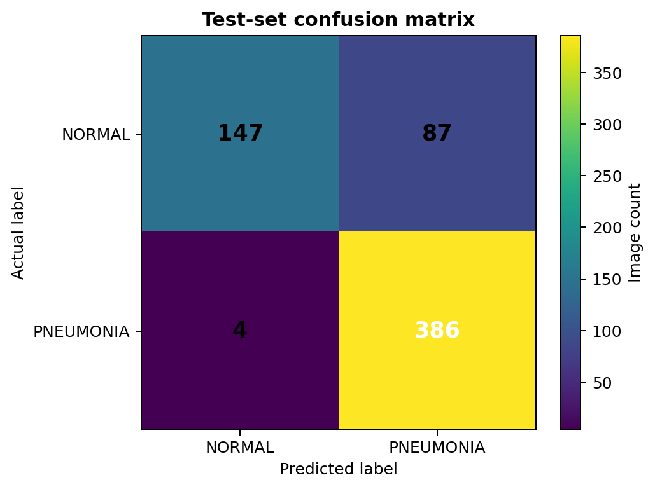
Figure 3. Confusion matrix recreated from the reported test counts.
Actual class | Predicted NORMAL | Predicted PNEUMONIA | Total
NORMAL | 147 | 87 | 234
PNEUMONIA | 4 | 386 | 390
Total | 151 | 473 | 624
Correct predictions: 147 + 386 = 533. Incorrect predictions: 87 + 4 = 91. Accuracy = 533 / 624 ≈ 85.42%. Rows are actual labels; columns are predicted labels.
10.3 Per-class metrics
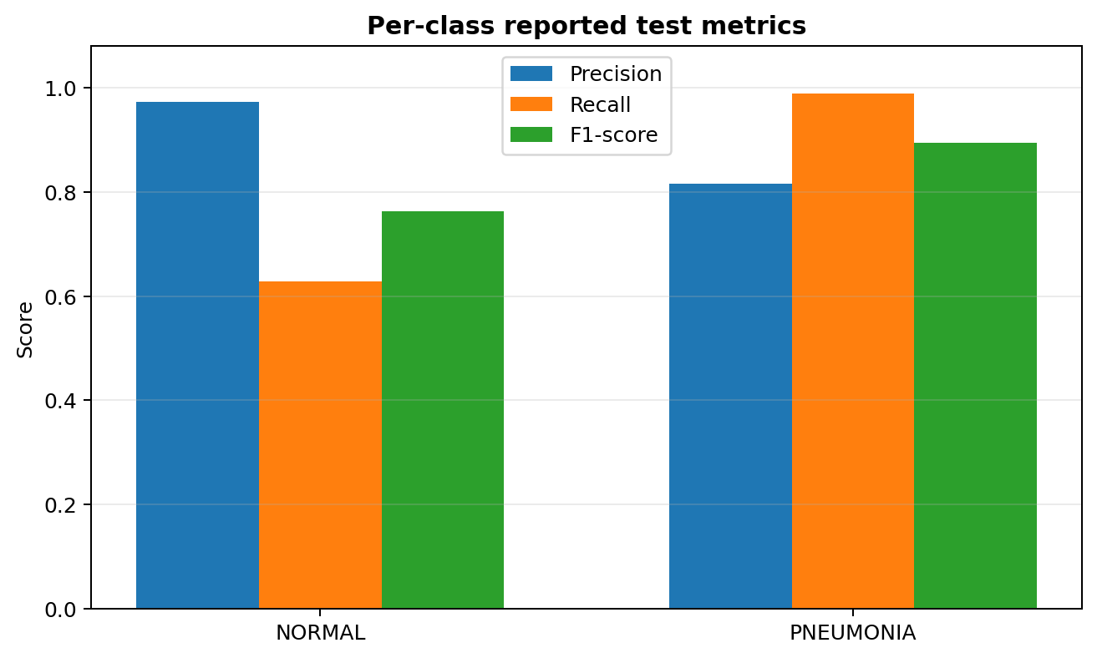
Figure 4. Per-class precision, recall, and F1-score from the reported evaluation.
Class | Precision | Recall | F1-score | Support
NORMAL | 0.973510 | 0.628205 | 0.763636 | 234
PNEUMONIA | 0.816068 | 0.989744 | 0.894554 | 390
10.4 Interpretation
NORMAL precision is about 97.35%: NORMAL predictions were usually correct within this test set.
NORMAL recall is about 62.82%: 147 of 234 NORMAL examples were identified correctly; 87 were predicted as PNEUMONIA.
PNEUMONIA recall is about 98.97%: 386 of 390 PNEUMONIA examples were correctly predicted.
PNEUMONIA precision is about 81.61%: some PNEUMONIA predictions correspond to NORMAL-labeled images.
ROC-AUC 0.9449 describes ranking discrimination on this test set, not calibration, clinical utility, or external validity.
11. Error Analysis
The main observed error pattern is 87 NORMAL images predicted as PNEUMONIA compared with 4 PNEUMONIA images predicted as NORMAL. This is a class-specific asymmetry and does not prove safety or clinical usefulness.
11.1 Potential factors to investigate
Class imbalance: 390 PNEUMONIA and 234 NORMAL images in the test set.
Dataset-specific image acquisition patterns or shortcuts may influence predictions.
Some images may be ambiguous, low quality, or mislabeled.
Repeated images within a split may affect effective sample counts.
The model may rely on cues unrelated to pathology; external evaluation is needed to investigate.
11.2 Recommended analysis
Review reports/misclassified/misclassified_images.csv and inspect a sample of errors.
Confirm class order across the loader, model, metrics script, and UI.
Report per-class precision and recall alongside accuracy.
Select thresholds using validation data only, not the test set.
Where permitted, evaluate on a separate dataset and use patient-level splits.
Consider calibration analysis and confidence intervals before making stronger claims.
12. Streamlit Application
The Streamlit app is a demonstration layer around the saved checkpoint. The intended flow is to launch the app, upload a supported image, view the predicted dataset label, and inspect the output exposed by the current UI. Keep the educational-use disclaimer visible.
Activate the virtual environment and start Streamlit.
Open the local URL shown in the terminal.
Capture the home page and disclaimer.
Upload an approved sample image if permitted by the dataset license.
Capture the output and disclaimer together.
Retain relevant terminal output as execution evidence.
13. Screenshot Evidence Record
The boxes below are placeholders, not real screenshots. Insert genuine screenshots from your current project before submitting. Generated diagrams in this report must not be presented as screenshots of the running application.
13.1 Project folder and VS Code
Capture: Explorer showing MedVision-AI root and key folders/scripts.

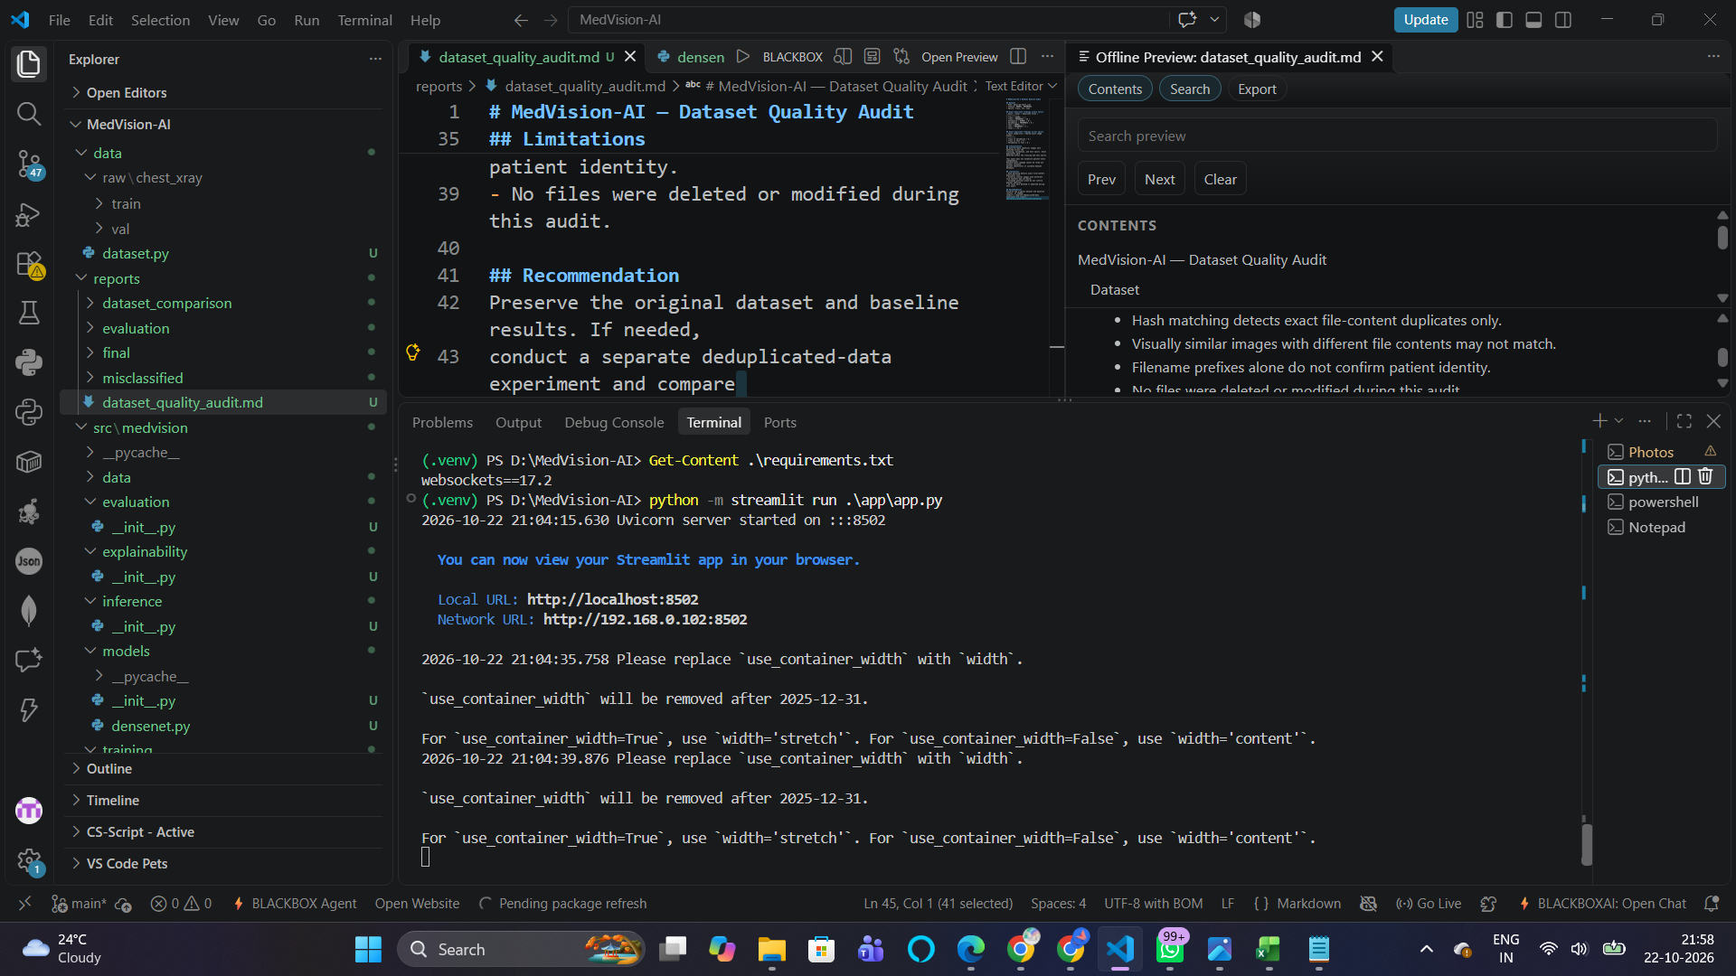

13.2 Dataset organization
Capture: Folder or terminal view showing train/validation/test and class folders.
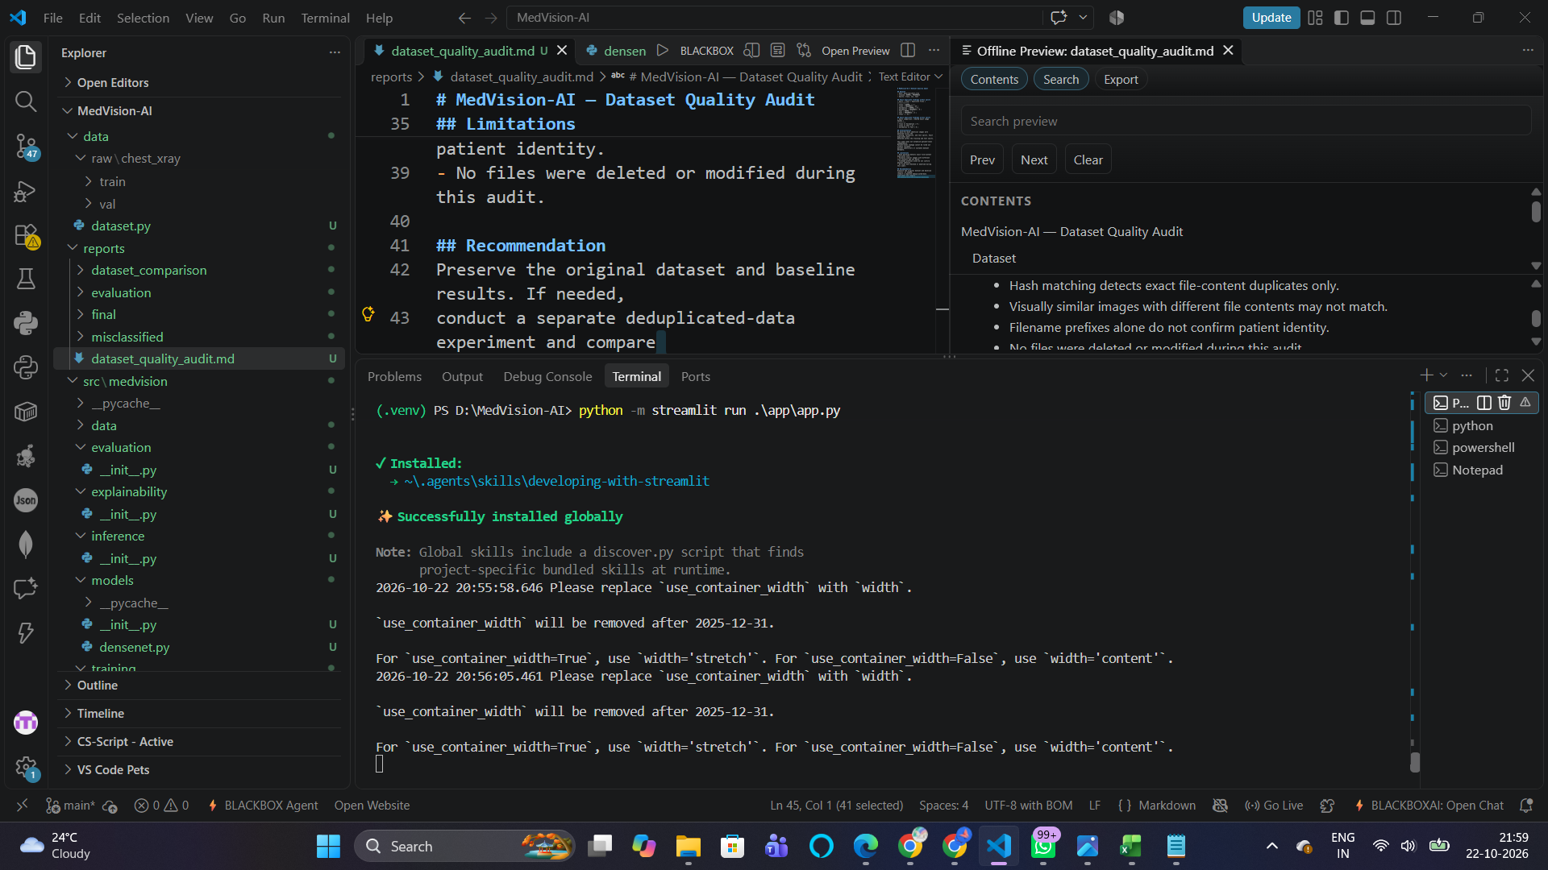

14. Limitations, Ethics, and Responsible Use
14.1 Technical limitations
Only one reported dataset and split are evaluated; external generalization is not established.
Hash-based duplicate checking does not prove patient-level separation.
NORMAL recall is 62.82% in the reported test set; accuracy hides this class-specific behavior.
No clinical validation, prospective evaluation, or expert radiologist assessment is reported.
Calibration and uncertainty estimation are not reported.
Runtime and reproducibility depend on package compatibility and environment.
14.2 Responsible-use statement
MedVision-AI is for learning and research demonstration only. It must not be used to make decisions about health, delay professional care, or replace qualified clinicians. Do not upload identifiable patient images without appropriate authorization and compliance with privacy requirements. Future research requires data governance, independent evaluation, and expert oversight.
15. Future Work
Patient-level splits and stronger duplicate detection using perceptual hashes or image similarity.
External validation on a separate, appropriately licensed dataset.
Threshold analysis on validation data and probability calibration.
Explainability experiments such as Grad-CAM, with limitations documented.
Training curves, per-epoch logs, and a complete baseline comparison.
Unit tests for preprocessing, class mapping, checkpoint loading, and predictions.
Versioned experiment configurations and run metadata.
Containerized deployment with tested dependencies and secure upload handling.
A model card documenting intended use, provenance, evaluation, and risks.
16. Conclusion
MedVision-AI implements an educational chest X-ray classification workflow using PyTorch, DenseNet121, evaluation scripts, dataset audit outputs, and a Streamlit demo. Reported test accuracy is 85.42%, ROC-AUC 0.9449, and weighted F1-score 84.55%. Class-level results show NORMAL recall of 62.82% and PNEUMONIA recall of 98.97%, highlighting the importance of error analysis. Conclusions must remain limited to the available dataset and implementation; this is not a clinically validated diagnostic system.
17. Reproducibility Checklist
☐ Activate the intended .venv and confirm Python version.
☐ Install requirements in a clean environment and resolve compatibility issues.
☐ Verify dataset source, license, structure, and split counts.
☐ Run training and preserve logs plus the selected checkpoint.
☐ Run evaluation and verify metrics.json and confusion_matrix.png.
☐ Confirm class ordering throughout loader, model, evaluation, and UI.
☐ Review misclassified records and document findings.
☐ Launch Streamlit and test an approved sample image.
☐ Replace every screenshot placeholder with genuine screenshots.
☐ Add exact dataset citation, training settings, report date, and verified repository URL if applicable.
☐ Recheck all metrics against current output files before submission.
18. References
PyTorch documentation. https://pytorch.org/docs/stable/
Torchvision documentation. https://pytorch.org/vision/stable/
Streamlit documentation. https://docs.streamlit.io/
Scikit-learn model evaluation documentation. https://scikit-learn.org/stable/modules/model_evaluation.html
Huang, G., Liu, Z., van der Maaten, L., & Weinberger, K. Q. (2017). Densely Connected Convolutional Networks. Proceedings of CVPR.
Dataset citation: add the exact dataset title, source, version, authors/maintainers, license, and access date. Verify citation requirements before submission.

