Software Architecture and Design Specification
Collaborative Study Material and Online Quiz Platform (StudyHub)
Prepared following IEEE Std 1016-2009 (Software Design Descriptions) and ISO/IEC/IEEE 42010 viewpoints
Team Members:
Sanjith K S (PES1UG24CS613)
Fathima Zahra (PES1UG24CS664)
Dhanush S Shekhar (PES1UG24CS662)
Version 2.0 | 7 November 2026 | Describes the system as built at the end of Sprint 2
Version | Date | Description
1.0 | 19 Oct 2026 | Initial architecture at the start of Sprint 1 (11 modules, planned web UI).
2.0 | 7 Nov 2026 | Updated to the delivered system after Sprint 2: 14 modules, full web UI, security architecture, API design, error handling, traceability and deviations.

Contents. 1 Introduction · 2 Stakeholders and design concerns · 3 Architectural representation · 4 Goals and constraints · 5 Architectural pattern · 6 Context view · 7 Component view · 8 Data view · 9 Interaction view (sequence diagrams) · 10 API design · 11 Error handling protocols · 12 Security architecture · 13 Deployment view · 14 Quality attributes · 15 Traceability · 16 Deviations from the SRS and the initial SAD · Appendix A Module dependency matrix

1. Introduction

1.1 Purpose
This Software Architecture and Design (SAD) specification describes the architecture and the detailed design of StudyHub, the Collaborative Study Material and Online Quiz Platform, as delivered at the end of Sprint 2 (30 October 2026). It explains how the system is structured, why it is structured that way, how its parts interact, how it is secured and deployed, and how every requirement in the SRS is realised. It is written for the development team, the course evaluators and anyone who maintains the system.

1.2 Scope
The document covers the whole system: the browser-based web UI, the FastAPI application server with its fourteen feature modules, the PostgreSQL database, the external LLM service and the GitHub-based build and deployment pipeline. It covers functional requirements FR-01 to FR-14, non-functional requirements NFR-01 to NFR-07 and security requirements SEC-01 to SEC-13. Where the delivered system differs from the SRS or from version 1.0 of this document, the difference is recorded in section 16.

1.3 Definitions, acronyms and abbreviations
Term | Meaning
API | The REST/JSON application programming interface under /api/v1.
Module | A Python package under app/modules/ that owns its database tables and exposes one public interface, service.py.
Service interface | The functions and data classes in a module's service.py. Other modules may call only these.
Capability | A single permitted action such as material:upload or user:manage. Routes are guarded by capability, not by role name.
Domain event | An in-process notification (for example ATTEMPT_SCORED) that lets one module react to another without importing it.
ORM / migration | SQLAlchemy 2 object-relational mapping; Alembic manages versioned, reversible schema migrations.
LLM | Large Language Model: the external AI service used for question generation, answer evaluation and explanations.
JWT / HS256 | JSON Web Token signed with HMAC-SHA256, used as the bearer access token.
CI | Continuous Integration: GitHub Actions job lint-and-test, required before any merge into main.
CSP | Content Security Policy: a browser header restricting where a page may load code and data from.
FR / NFR / SEC | Functional, non-functional and security requirement identifiers from the SRS and the Security Requirements Specification.

1.4 References
- IEEE Std 1016-2009, IEEE Standard for Information Technology: Software Design Descriptions.
- ISO/IEC/IEEE 42010:2011, Systems and software engineering: Architecture description.
- SRS Document (Documents/SRS Document.docx) and Use Case Flow / Use Case Diagram (Documents/UseCaseFlow.docx, UseCaseDiagram.drawio).
- Test Plan Document (Documents/Test Plan Document.docx) and the updated test case document and reports in docs/.
- Security Requirements Specification (Documents/Security_Requirements_Document.pdf).
- Repository: README.md, docs/architecture.md, docs/module-interfaces.md, docs/api/openapi-v1.json, docs/performance.md, docs/test-execution-log.md.

1.5 Overview
Sections 2 to 5 set out the stakeholders, the viewpoints used, the goals and constraints and the chosen architectural pattern. Sections 6 to 13 describe the architecture view by view: context, components, data, interactions, API, error handling, security and deployment. Section 14 shows how the quality attributes are met, section 15 traces requirements to design and tests, and section 16 records deviations. Every diagram has its own legend that defines its boxes and lines.

2. Stakeholders and design concerns
Stakeholder | Main concerns | Addressed in
Students | Find materials and quizzes quickly; fair, instant scoring; privacy of their data | 6, 9, 12, 14
Authorized users (faculty, mentors) | Publish official content; control AI-generated questions before students see them | 7, 9.3, 12
Administrators and moderators | Approve channels, act on reports, suspend users, audit actions | 7, 12, 15
Development team (3 members) | Work in parallel on separate modules; change one module without breaking others; fast feedback from CI | 5, 7.3, 13, 14
Course evaluators | Standard format, traceability to the SRS, justified architectural choices, test evidence | 3, 5, 15, 16
Operators | Simple deployment, no secrets in the repository, recovery after failures | 11, 13

3. Architectural representation
The architecture is described through the IEEE 1016 / ISO 42010 viewpoints below. Each diagram fits on one page, decomposes the system hierarchically and carries its own legend.
Viewpoint | What it shows | Notation | Section
Context | System boundary, users and external systems | Context diagram | 6
Composition (logical) | The three layers and every component in them; module dependencies | UML component diagram; dependency graph | 7
Information | Tables, keys, relationships and owning module | Entity-relationship diagram | 8
Interaction | Run-time collaboration for key scenarios | UML sequence diagrams | 9
Interface | Endpoints, conventions, status codes, contract | Tables; OpenAPI 3 document | 10, 11
Security | Trust boundaries and controls on the request path | Security architecture diagram | 12
Deployment | Nodes, containers, storage, CI/CD | UML deployment-style diagram | 13

4. Architectural goals and constraints

4.1 Goals
Goal | Source | How the architecture meets it
Fast common operations: pages and search within 2 s, quiz submission within 3 s at the 95th percentile with 50 concurrent users | NFR-01 | Stateless API, indexed query paths, admission control sized to the connection pool, in-process deterministic scoring.
Credentials protected and access enforced on the server | NFR-02, SEC-01..13 | Six-stage request path: admission, validation, authentication, capability and membership checks, service rules, response schemas (section 12).
Intuitive navigation and visual analytics | NFR-03 | Dashboard landing page, one-click navigation, SVG charts; the UI holds no rules of its own.
No committed attempt or upload is ever lost | NFR-04 | One transaction per request, answers autosaved, domain-event handlers isolated in savepoints, transient failures reported as 503 with nothing half-written.
Performance holds as data and users grow | NFR-05 | Work per request independent of data volume, hot paths indexed, stateless servers can be replicated.
Trustworthy AI content | NFR-06 | Review gate for generated questions, validation of every LLM answer, reporting of AI output, scoring never uses the LLM.
Change one feature without touching others | NFR-07 | Modules own their data and expose one interface; dependency rules enforced by an automated test; documented interfaces.

4.2 Constraints
- Team and schedule: three developers, two one-week sprints (19–23 and 26–30 October 2026), one pull request per story.
- Technology: Python 3.12, FastAPI, SQLAlchemy 2, Alembic, PostgreSQL 16 (SQLite allowed for local development), plain HTML/CSS/JavaScript, Docker.
- Process: main is protected; a pull request merges only after the lint-and-test check passes.
- Security: no secret in the repository; all secrets come from environment variables.
- External dependency: the LLM is a third-party service with variable latency; the platform must keep working when it is slow, failing or switched off.

5. Architectural pattern and rationale
Chosen style. StudyHub combines four patterns:
- Client-server: browsers are thin clients; the server holds all business rules, security checks and data.
- Layered: user interface, frontend logic and backend. Inside the backend, the layers are API, services, data access and infrastructure, and each layer calls only the layers below it.
- Modular monolith: one deployable process split into fourteen feature modules with enforced boundaries.
- In-process event-driven integration: a module publishes a domain event and subscribers react in the same transaction without being imported.
Alternative | Why it was not chosen
Microservices (one service per feature) | Network calls, distributed transactions and separate deployments would cost a three-person team more than the two sprints allow, and would make NFR-04 (no lost attempts) much harder. The module boundaries keep this option open: any module can be extracted later because it already talks to others only through its service interface.
Classic MVC monolith without module boundaries | Fast to start, but every feature could reach every table, so a change to chat could break quiz scoring. That fails NFR-07 and the SRS requirement that modules be independently maintainable.
Server-rendered pages (templates) | A separate static frontend over a documented API lets the UI and API be built and tested in parallel and keeps every rule on the server.

Consequences. Low coupling: modules exchange plain data classes, never ORM objects. High cohesion: each module groups one feature's rules and tables. Shared transactions make reliability simple. The cost is that the whole application scales as one unit. That is acceptable at the measured load: 50 concurrent users stay well inside target (section 14).

6. Context view
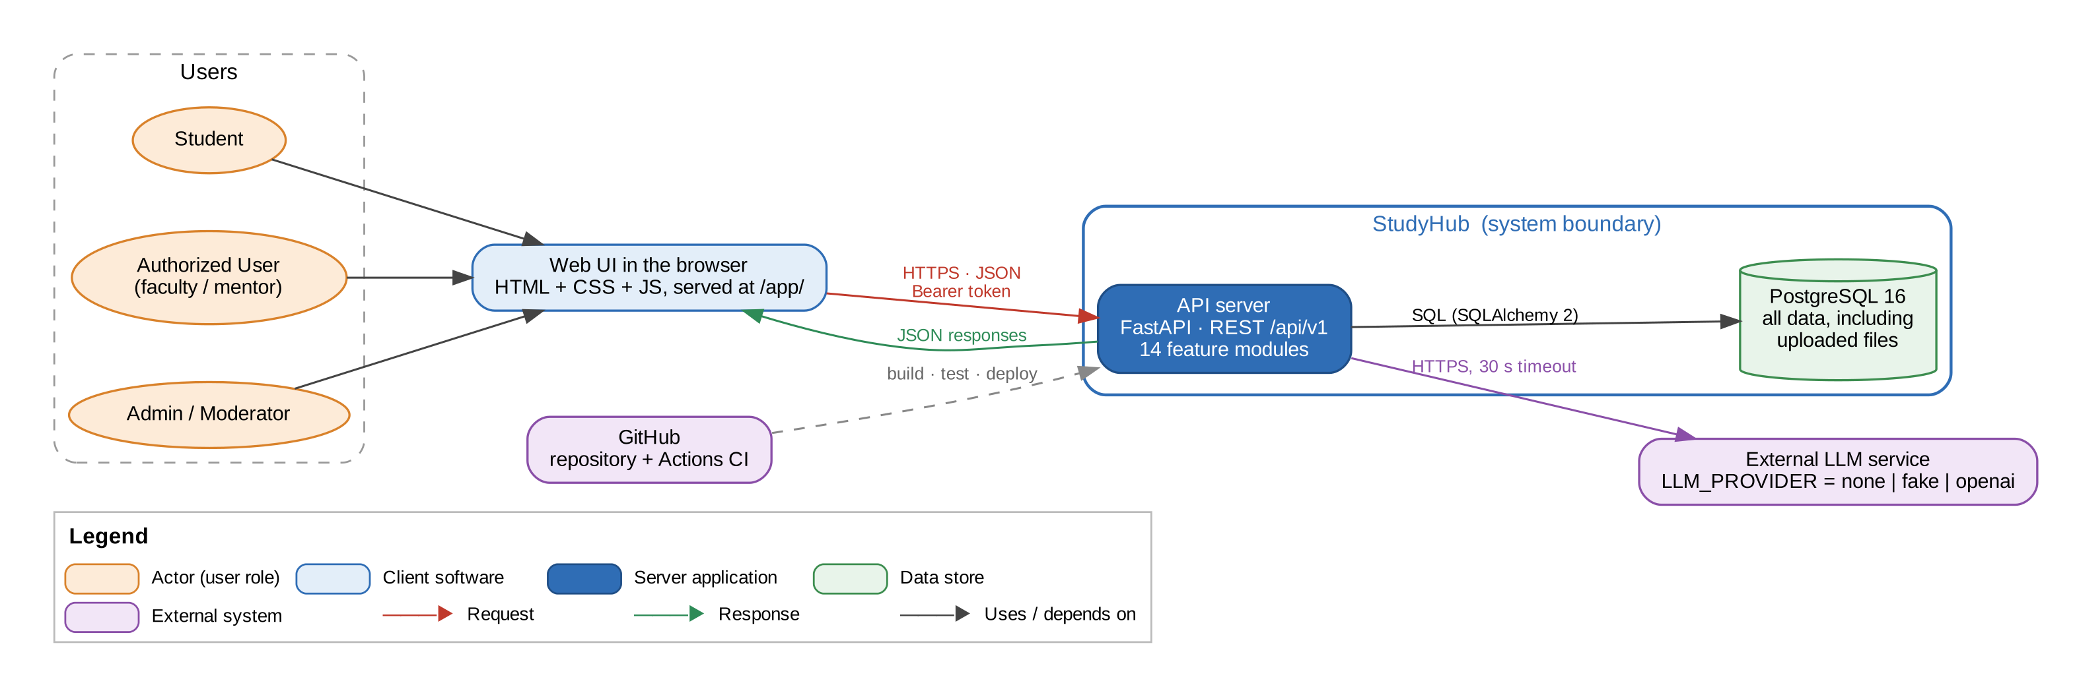
Figure 1: Context: users, the system boundary and external systems
Three kinds of users reach StudyHub through the web UI, which the API server itself serves at /app/. The browser sends HTTPS requests with a JSON body and a bearer token. The API server is the only component that touches the database or the LLM service. Uploaded files are stored in PostgreSQL, so every API instance sees the same files. The LLM provider is chosen by configuration (none, fake for offline demos and tests, or an OpenAI-compatible service), and the rest of the platform keeps working when it is unavailable.

7. Component view

7.1 Component diagram
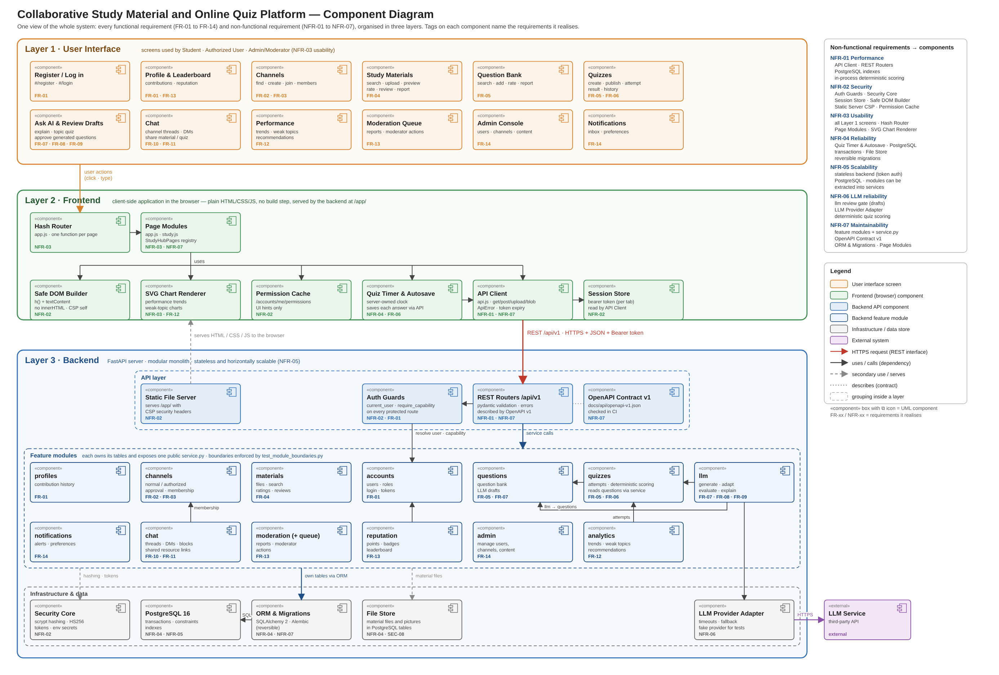
Figure 2: UML component diagram: user interface, frontend and backend layers with requirement tags

7.2 Component descriptions
Layer | Component | Responsibility | Requirements
User interface | Screens | Register/log in, dashboard, channels, materials, question bank, quizzes and attempts, quiz history, Ask AI and draft review, performance and recommendations, chat and direct messages, leaderboard, notifications, moderation queue, admin console. | FR-01..FR-14, NFR-03
Frontend | Hash Router, Page Modules | app.js and study.js map each #/route to a page function that builds the screen from API responses. | NFR-03, NFR-07
Frontend | API Client, Session Store | api.js wraps fetch with the bearer token, JSON and file uploads, and turns error responses into ApiError messages. The token is kept per browser tab. | NFR-01, NFR-02
Frontend | Safe DOM Builder, SVG Charts, Quiz Timer, Permission Cache | Builds elements with textContent only (no innerHTML), draws analytics charts, shows the server-owned countdown and autosaves answers, and caches capabilities to hide controls the user cannot use (the server still enforces them). | NFR-02, NFR-03, NFR-04, FR-12
Backend: API | REST routers, validation, error handlers | 18 routers under /api/v1. Pydantic schemas validate every request, and uniform handlers produce the error format in section 11. | NFR-07, SEC-07
Backend: API | Auth guards, RequestLimit, static server | current_user and require_capability on protected routes; admission control sized to the database pool; /app/ served with CSP and nosniff headers. | NFR-01, NFR-02
Backend: services | 14 feature modules | Business rules per feature. See the table below and Appendix A. | FR-01..FR-14
Backend: infrastructure | Database, ORM and migrations, security core, events, LLM provider | PostgreSQL via SQLAlchemy sessions (one per request), Alembic migrations, scrypt hashing and HS256 tokens, in-process domain events with savepoints, LLM adapter with a 30 s timeout. | NFR-02, NFR-04, NFR-06

Module | Responsibility | Owns tables | FR
accounts | Registration, login, tokens, roles and capabilities, route guards, profile pictures | users, profile_pictures | FR-01
profiles | Profile page with contribution history | - | FR-01
channels | Normal and Authorized channels, approval, membership, discussion posts | channels, channel_memberships, channel_posts | FR-02, FR-03
materials | Upload, search, preview, download, rating and reviews of study materials | study_materials, material_files, material_reviews | FR-04
questions | Question bank: contribute, search, rate, report | questions, question_ratings | FR-05
quizzes | Quiz assembly and publishing, attempts, timer, deterministic scoring, history | quizzes, quiz_questions, quiz_attempts, attempt_answers | FR-05, FR-06
llm | Question generation with review, adaptive difficulty, descriptive evaluation, Ask AI | llm_requests, adaptive_sessions | FR-07, FR-08, FR-09
chat | Channel chat with threads, direct messages, blocking, shared resources | channel_messages, conversations, conversation_participants, direct_messages, user_blocks | FR-10, FR-11
analytics | Performance by subject and topic, strengths and weak areas, recommendations | performance_attempts, performance_topics, recommendation_opens | FR-12
reputation | Reputation points, badges, leaderboard | reputation_events, badges, user_badges | FR-13
moderation | Reports and the moderation action log | reports, moderation_actions | FR-13, FR-14
moderation_queue | Assembles the moderation queue from the modules that own the content | - | FR-13
notifications | In-app notifications and per-category preferences | notifications, notification_preferences | FR-14
admin | Admin dashboard, user suspension, channel approval, content removal | - | FR-14

7.3 Module dependencies
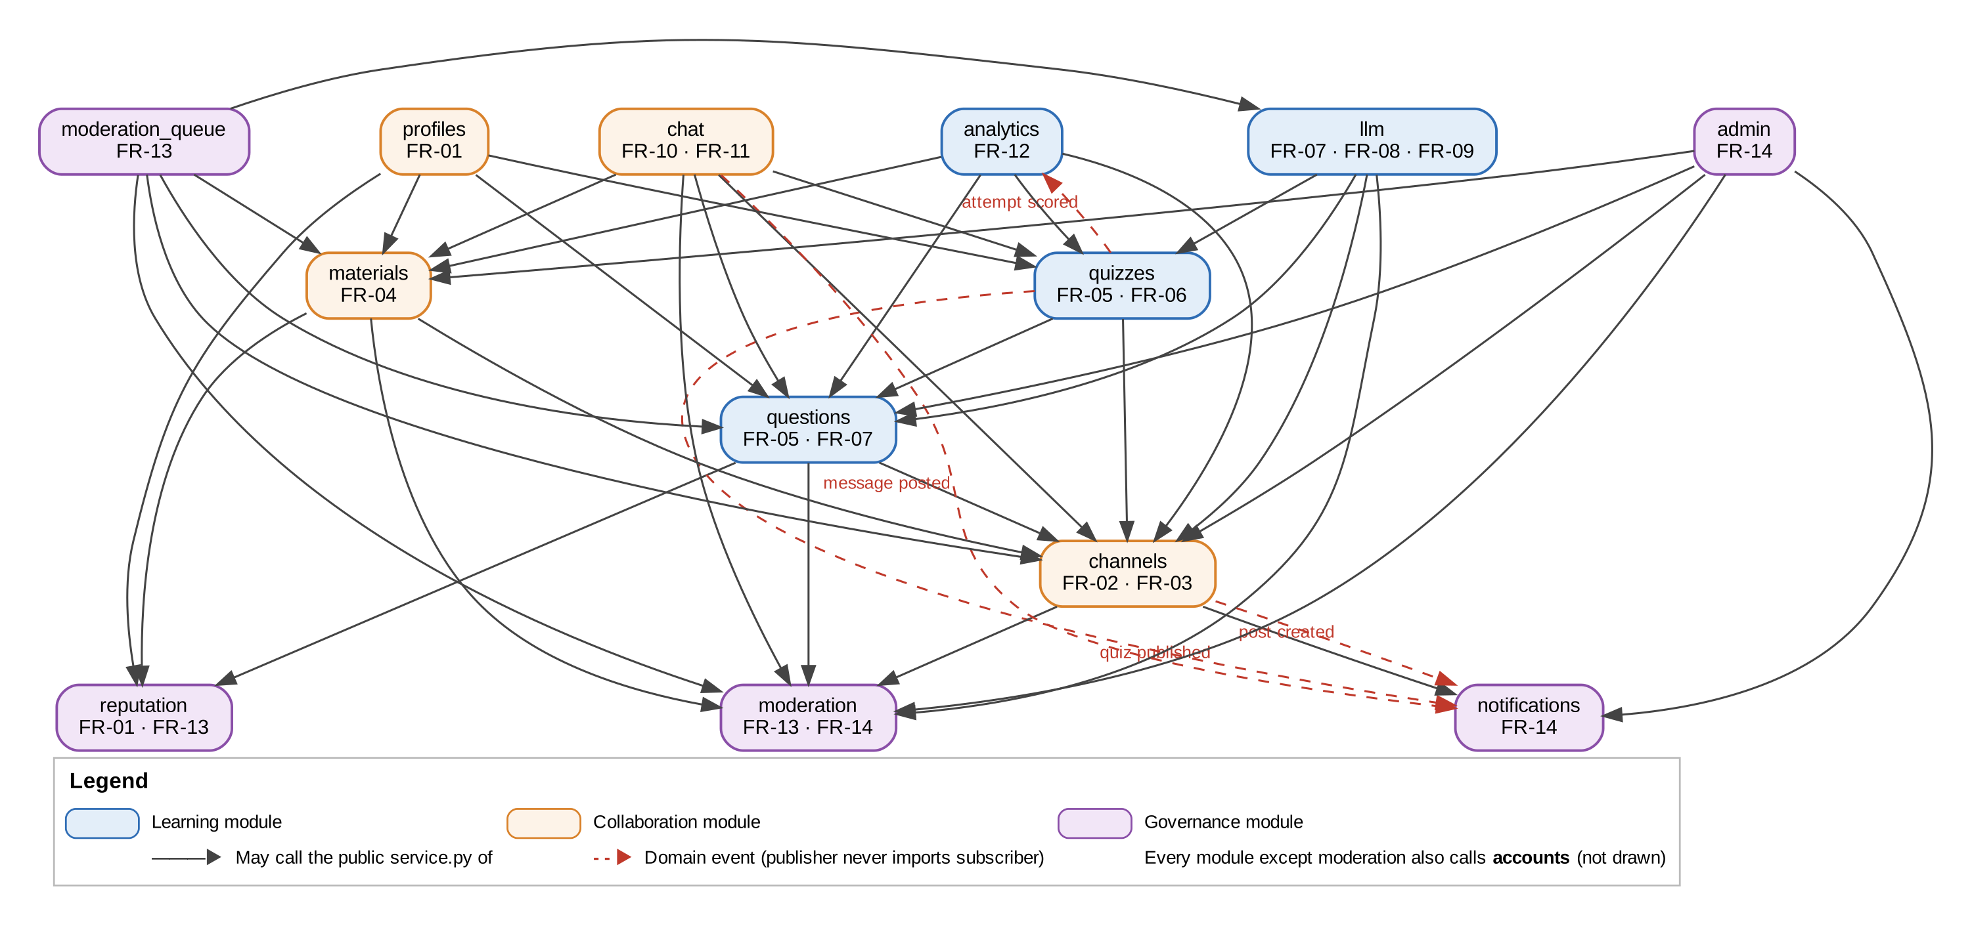
Figure 3: Module dependency view: allowed service calls and domain events
Rules: a module may import app.core, its own package and the service.py of the modules listed for it in ALLOWED_DEPENDENCIES (Appendix A). It never imports another module's models. Reactions that would create a cycle use domain events instead: quizzes publishes ATTEMPT_SCORED and analytics subscribes; quizzes, chat and channels publish events that notifications subscribes to. tests/test_module_boundaries.py fails the build if a rule is broken, and docs/module-interfaces.md is generated from the code so the documented interfaces cannot drift.

8. Data view
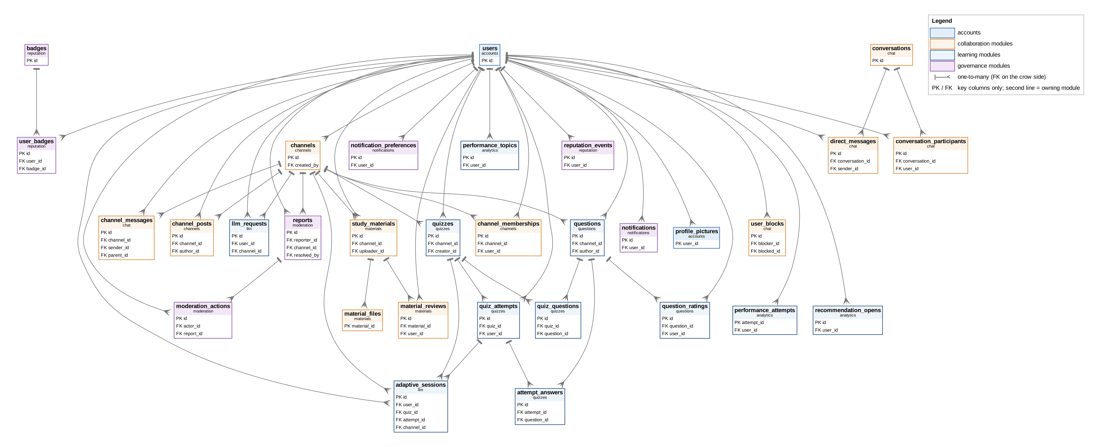
Figure 4: Entity-relationship diagram generated from the ORM metadata (31 tables, 48 foreign keys)
All data lives in one PostgreSQL database, but every table belongs to exactly one module. Foreign keys keep the data consistent across modules without Python imports between them. Links that can point at any kind of content, such as a report target or a resource shared in chat, are stored as a type plus an id. Enumerations are stored as VARCHAR with CHECK constraints so the same migrations run on PostgreSQL and SQLite. Uploaded files and profile pictures are stored in tables with deferred loading, so listings never read file bytes. Schema changes are Alembic migrations that are tested to upgrade and downgrade cleanly on both databases.

9. Interaction view: sequence diagrams
Solid arrows are calls or requests, dashed arrows are returns, numbers give the order, and alt and loop frames show alternatives and repetition. Notes state the rule the scenario protects.

9.1 Log in and open a protected resource (FR-01, FR-02, SEC-03..06)
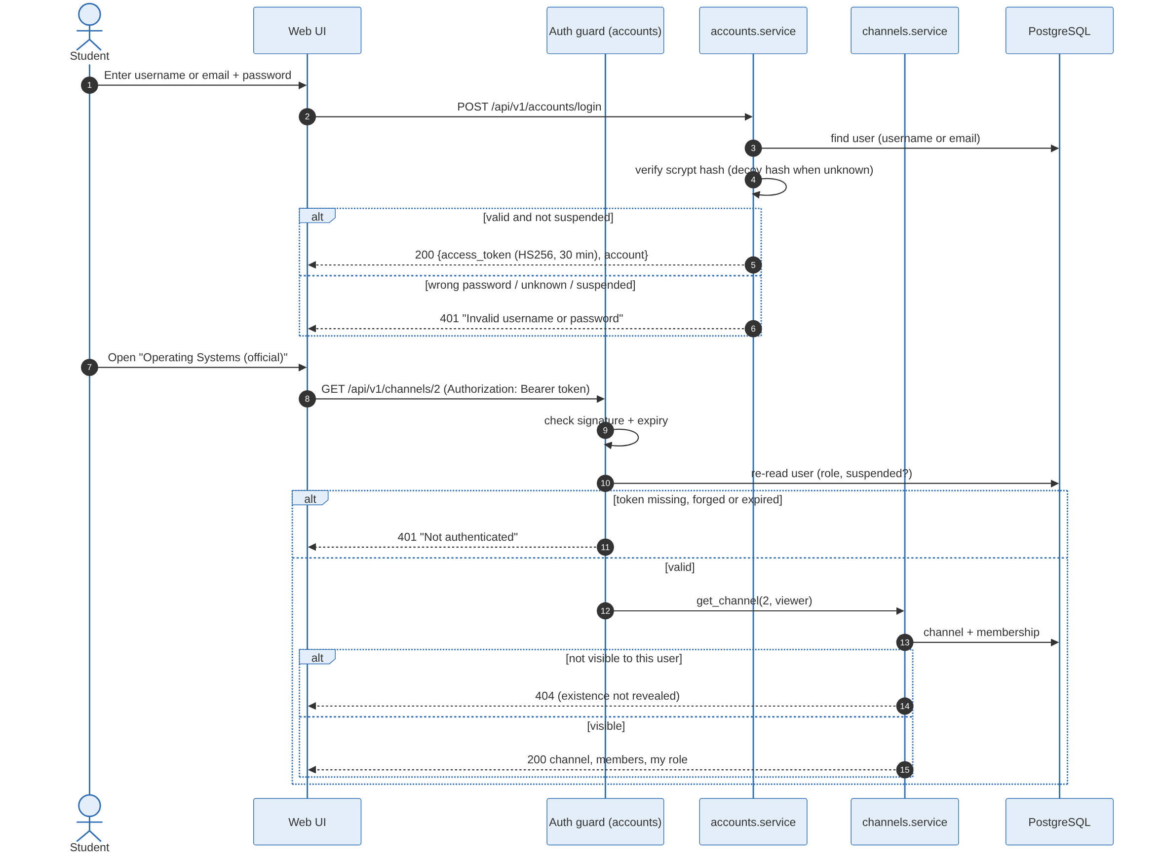
Figure 5: Sequence: login, token check, capability and visibility check

9.2 Attempt, submit and score a quiz (FR-06, FR-08, NFR-01, NFR-04)
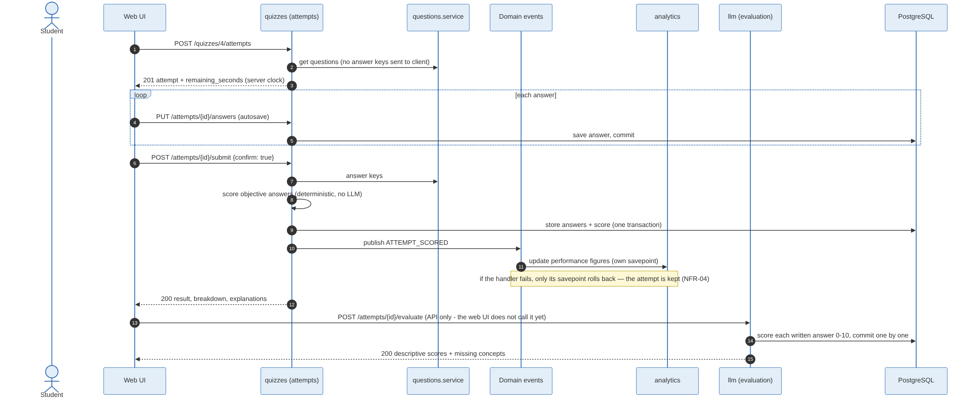
Figure 6: Sequence: attempt with autosave, deterministic scoring, domain event, written-answer evaluation

9.3 Generate questions with the LLM behind a review gate (FR-07, NFR-06)
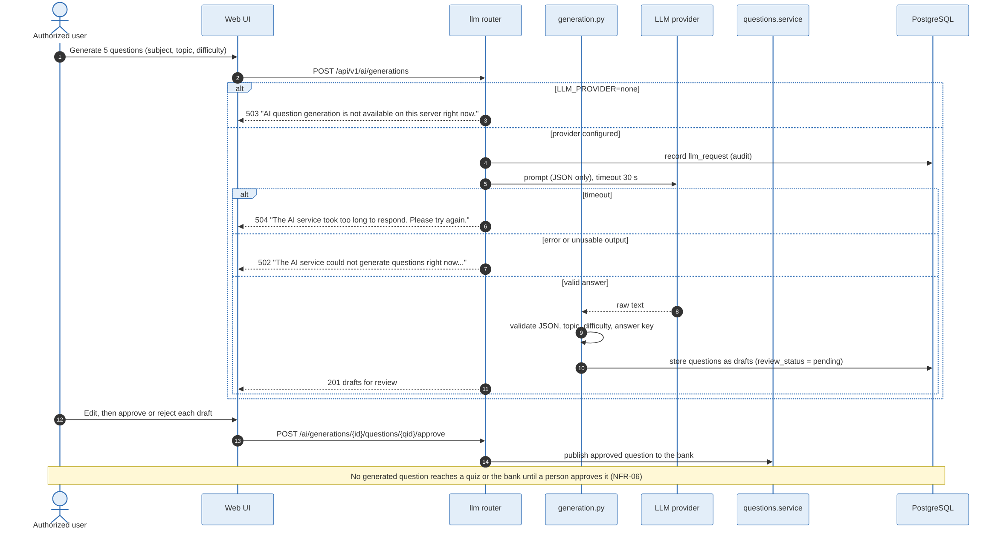
Figure 7: Sequence: LLM generation, failure handling and human approval

10. API design

10.1 Principles
- Resource-oriented REST over HTTPS with JSON. Nouns for resources (/channels, /materials, /quizzes, /attempts), HTTP verbs for actions; sub-resources for ownership (/channels/{id}/messages); a few explicit action endpoints where a state change is not a plain update (/quizzes/{id}/publish, /attempts/{id}/submit, /moderation/reports/{id}/remove).
- Versioned. Every route is under /api/v1. A breaking change gets a new prefix and a new contract file; v1 is never changed incompatibly.
- Contract first-class. The OpenAPI 3 document docs/api/openapi-v1.json is generated from the code, committed, and checked in CI: a pull request that changes the API without updating the contract fails.
- Authentication. Authorization: Bearer <token> on every route except /health, /accounts/register and /accounts/login. Authorization is declared per route by capability.
- Requests and responses. Request bodies are pydantic schemas with field-level validation. Responses are explicit schemas that never include password hashes, and never include answer keys before an attempt is submitted. List endpoints filter by query parameters (subject, topic, channel, difficulty, q). Files use multipart/form-data upload and are downloaded with Content-Disposition, nosniff and a restrictive CSP.
- Status codes. 201 for creation, 200 for reads and updates, 204 for deletes with no body, and 4xx/5xx as defined in section 11.

10.2 Endpoint groups
The v1 API has 108 operations on 91 paths. The groups, their main endpoints and the requirement each serves:
Group (router) | Ops | Main endpoints | FR
accounts | 6 | POST /accounts/register · POST /accounts/login · GET /accounts/me · GET /accounts/me/permissions | FR-01
profiles | 6 | GET/PATCH /profiles/me · PUT/DELETE /profiles/me/picture · GET /profiles/{user_id} · GET /profiles/{user_id}/picture | FR-01
channels | 15 | POST/GET /channels · GET /channels/mine · GET /channels/requests · POST /channels/{id}/approve · /reject · /join · /leave · GET /channels/{id}/members · DELETE .../members/{user_id} · posts (CRUD) | FR-02, FR-03
materials | 12 | POST/GET /materials · GET/PATCH/DELETE /materials/{id} · GET .../preview · GET .../download · PUT .../review · GET .../reviews · PUT/DELETE .../helpful · POST .../reports | FR-03, FR-04
questions | 5 | POST/GET /questions · GET /questions/{id} · PUT /questions/{id}/rating · POST /questions/{id}/reports | FR-03, FR-05
quizzes | 5 | POST /quizzes/preview · POST/GET /quizzes · GET /quizzes/{id} · POST /quizzes/{id}/publish | FR-05
quiz attempts | 5 | POST /quizzes/{id}/attempts · GET /attempts · GET /attempts/{id} · PUT /attempts/{id}/answers · POST /attempts/{id}/submit | FR-06
ai (generation, adaptive, AI reports) | 11 | POST/GET /ai/generations · PUT .../questions/{qid} · POST .../approve · /reject · POST .../quiz · POST /ai/adaptive-quizzes · POST .../answers · POST /ai/responses/{id}/reports | FR-07, FR-09
descriptive evaluation | 2 | POST /evaluations/descriptive · POST /attempts/{id}/evaluate | FR-08
ask ai | 2 | POST /ai/ask · POST /ai/ask/{id}/start (turn the answer into a quiz) | FR-09
chat | 3 | POST/GET /channels/{id}/messages · GET .../messages/{mid}/replies | FR-10
direct messages | 9 | GET/POST /conversations · GET /conversations/{id} · GET/POST .../messages · POST .../messages/{mid}/reports · GET /blocks · PUT/DELETE /blocks/{user_id} | FR-11
analytics | 4 | GET /analytics/dashboard · GET /analytics/recommendations · POST /analytics/recommendations/opened · GET /analytics/reconciliation | FR-12
reputation | 3 | GET /leaderboard · GET /reputation/me · GET /badges | FR-13
moderation | 5 | GET /moderation/queue · GET /moderation/reports/mine · GET /moderation/reports/{id} · POST .../remove · POST .../dismiss | FR-13
notifications | 6 | GET /notifications · GET /notifications/unread-count · GET/PUT /notifications/preferences · POST /notifications/read-all · POST /notifications/{id}/read | FR-14
admin | 8 | GET /admin/dashboard · GET /admin/users · POST /admin/users/{id}/suspend · /reinstate · GET /admin/channel-requests · GET /admin/reports · POST /admin/content/{type}/{id}/remove · GET /admin/audit-log | FR-14
operations | 1 | GET /health (no authentication, no internal details) | -

10.3 Example
POST /api/v1/attempts/42/submit {"confirm": true}
200 {"id": 42, "status": "submitted", "result": {"display": "2/3 (66.7%)", "correct": 2, "incorrect": 1, "breakdown": {...}}, "questions": [...]}

11. Error handling protocols

11.1 Error response format
Every error response is JSON with a human-readable detail string that the web UI shows as is. Validation errors add a per-field list:
422 {"detail": "Enter a valid email address", "errors": [{"field": "email", "message": "Enter a valid email address"}]}
Messages are written for users and match the Test Plan's expected wording (for example "Invalid username or password", "Unauthorized", "Only authorized users/admins can create Authorized Channels"). Responses never contain stack traces, SQL or configuration.

11.2 Status code catalogue
Code | Meaning in StudyHub | Example
400 | The request is well-formed but not allowed as sent | "Use Leave Channel to leave a channel yourself"; "Confirm removal of this member"
401 | No token, forged or expired token, or wrong login (sends WWW-Authenticate: Bearer) | "Not authenticated"; "Invalid username or password"
403 | Authenticated but lacking the capability or membership | "Unauthorized"; a student creating an Authorized channel
404 | Not found, or not visible to this user (existence is not revealed) | A pending channel opened by a non-member
409 | Conflict with existing state | Duplicate username; "This attempt has already been submitted"; submit with unanswered questions before confirm: true
413 / 415 | Upload too large (over 20 MB) or of a type not allowed | An .exe renamed to .pdf (magic bytes do not match)
422 | Request body or parameters fail validation | Missing correct answer on a new question; blank chat message
502 / 504 | LLM provider failed or timed out (30 s) | "The AI service took too long to respond. Please try again."
503 | Feature unavailable or a transient database failure; nothing was saved | "AI question generation is not available on this server right now."; "Temporary problem saving your data..."

11.3 Server-side protocol
- One transaction per request. get_db opens a session per request and rolls it back on any exception, so a failed request never leaves partial data.
- Transient database failures (lost connection, lock timeout) are caught globally and returned as 503. The client may simply retry, and work committed earlier, such as autosaved answers, is kept (NFR-04).
- Domain-event handlers run in their own savepoint. If a reaction such as an analytics update or a notification fails, only its writes are undone. The triggering change, for example a submitted attempt, still commits, and analytics can reconcile later.
- External calls fail fast and clearly. LLM calls have a 30 s timeout and are recorded in llm_requests with their outcome. Invalid LLM output is rejected before anything is stored. Ask AI and generation report 502/503/504, and the rest of the platform is unaffected.
- Overload. RequestLimit admits at most as many API requests as there are database connections; the rest wait in arrival order instead of failing (NFR-01).

11.4 Client-side protocol
- api.js converts any non-2xx response into an ApiError carrying detail and the field errors; pages show the message next to the form or action that caused it.
- A 401 while signed in clears the stored token and raises a studyhub:signed-out event, which returns the user to the login page.
- Quiz answers are autosaved one by one, so a network error loses at most the answer being typed; the timer is owned by the server, so a reload resumes the same attempt.

12. Security architecture
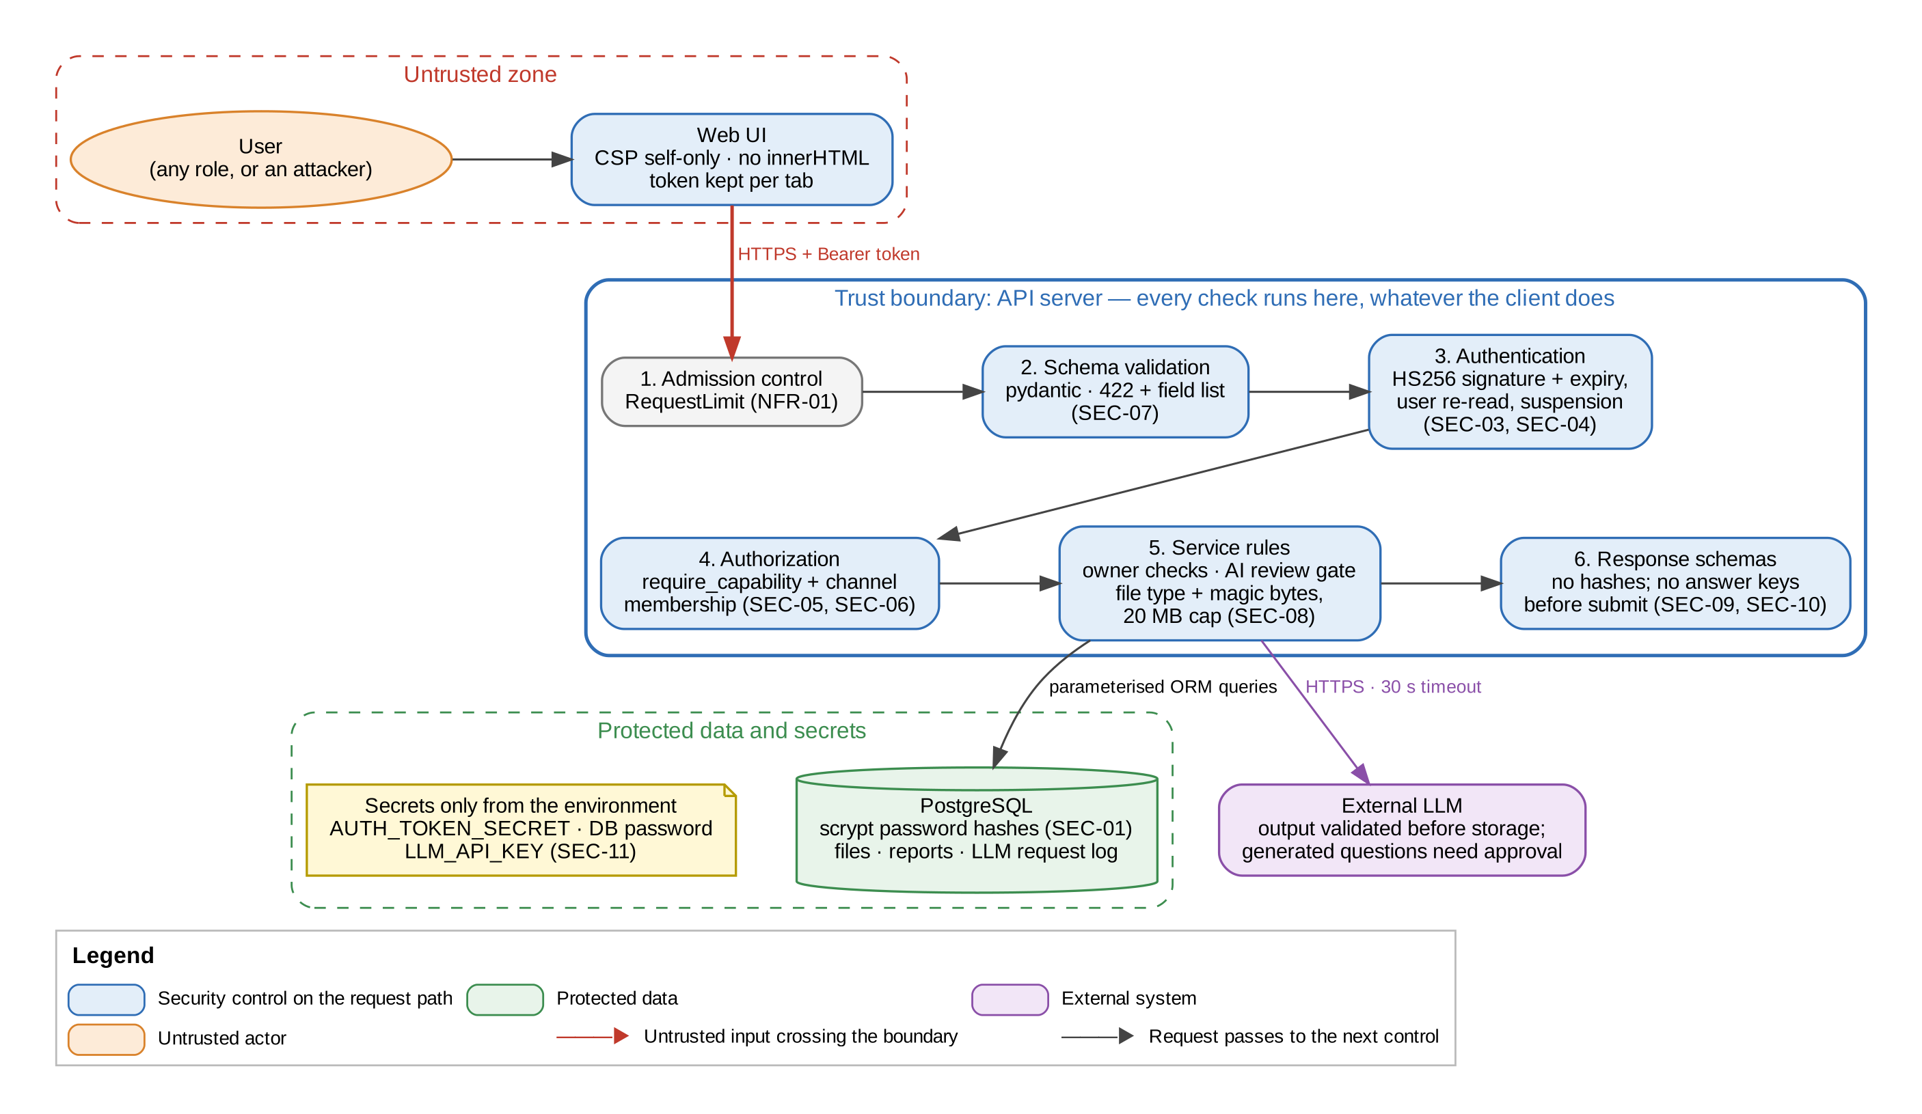
Figure 8: Security architecture: trust boundary and the controls on every request
The browser and everything it sends are untrusted. Every request crosses one trust boundary, the API server, and passes six controls in order: admission control, schema validation, authentication, authorization, service rules and response filtering. Hiding a button in the UI is never what makes an action safe, because every protected route declares the capability it needs. Secrets come only from the environment, and passwords are stored only as salted scrypt hashes.
Requirement | Control (component) | Status
SEC-01 Passwords hashed, minimum 8 characters | scrypt with per-password salt (app/core/security.py); length validated at registration | Implemented
SEC-02 At most 5 failed logins per account in 15 minutes | Not built; login returns the same 401 for every failure and uses a decoy hash against user enumeration | Deviation (16)
SEC-03 Tokens signed with a secret of at least 32 bytes, short-lived | HS256 with constant-time signature check, 30 min expiry, user re-read on every request; secret length is not checked at start-up | Partly (16)
SEC-04 Every endpoint except health, register and login needs a token | current_user dependency; a test walks all 102 protected routes with bad tokens (1,020 calls, all refused) | Implemented
SEC-05 Roles enforced on the server; no self-promotion | Capabilities per role (accounts/permissions.py), require_capability on routes; role ignored in registration input | Implemented
SEC-06 Membership-based access to channel content | channels.service visibility and membership checks; 404 hides non-visible channels | Implemented
SEC-07 All input validated; no stored script | Pydantic schemas; Safe DOM Builder (no innerHTML); CSP self-only on /app/ | Implemented
SEC-08 Safe uploads | Extension allow-list confirmed by magic bytes; 20 MB cap; nosniff and CSP on downloads | Implemented
SEC-09 No answer keys before submission | Attempt schemas omit correct answers until the attempt is submitted | Implemented
SEC-10 Minimal data in responses | Explicit response schemas; email only to the owner and admins; no password hash ever | Implemented
SEC-11 Secrets out of the repository | Environment variables only, .env git-ignored, repository hygiene test scans tracked files | Implemented
SEC-12 One rating per user per item | Unique (item, user) constraints; a second rating updates the first | Implemented
SEC-13 Dependency scan on every pull request | Not yet in the CI workflow | Deviation (16)

13. Deployment view
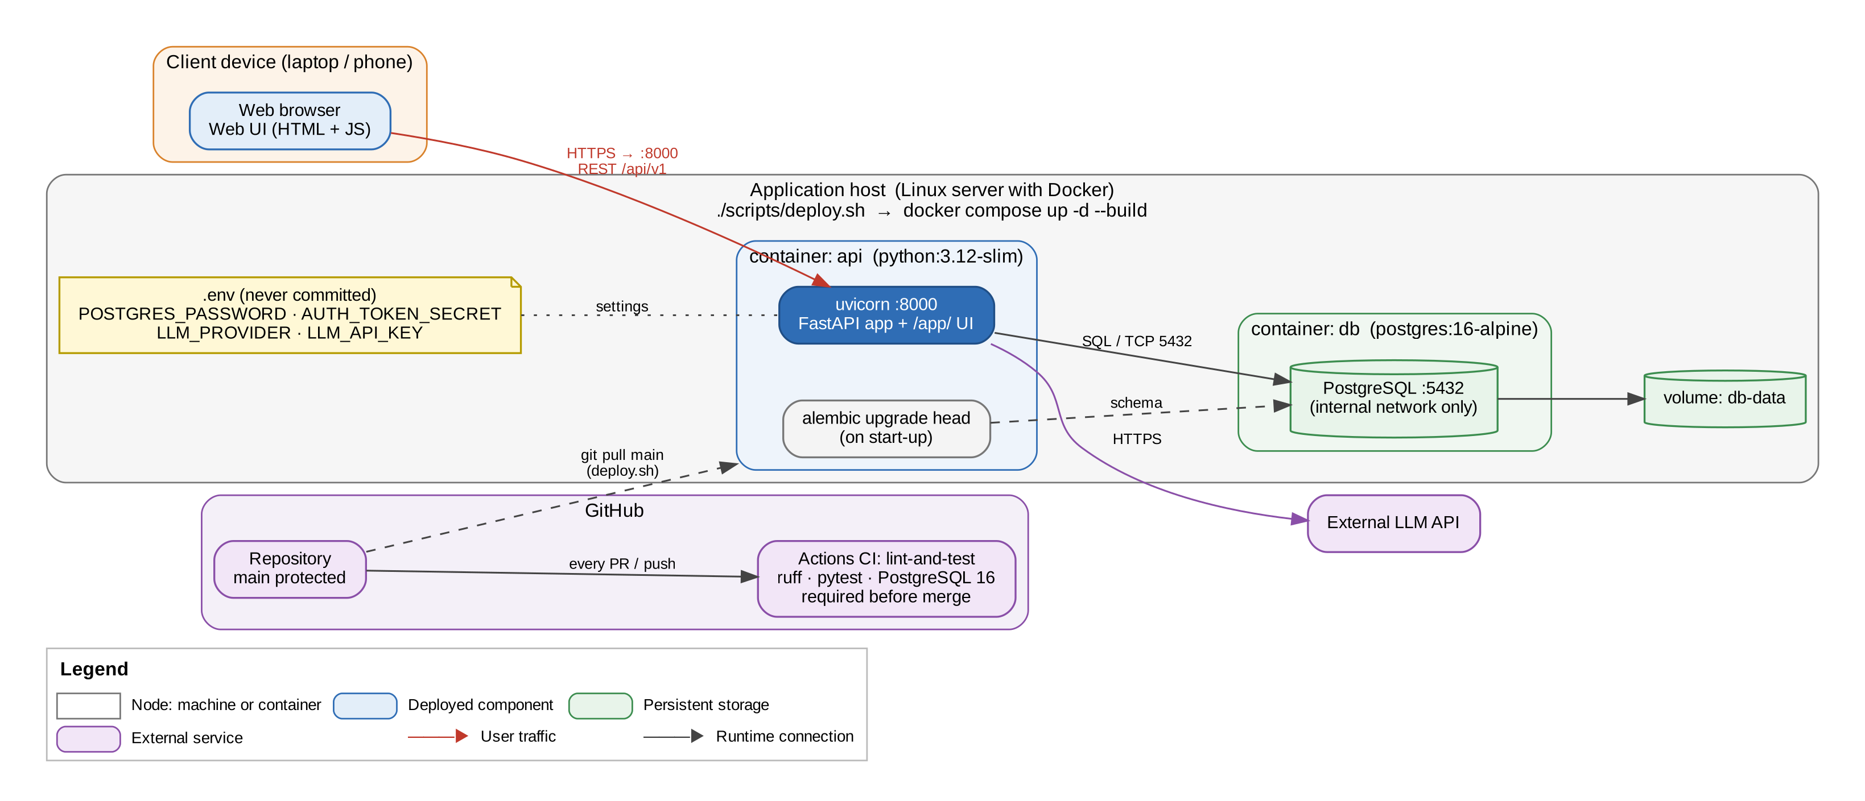
Figure 9: Deployment: client, application host, containers, storage and CI/CD
Node | Description
Client device | Any modern browser; nothing to install. The UI is served by the platform at /app/.
Application host | A Linux server with Docker. scripts/deploy.sh pulls main and runs docker compose up -d --build. Secrets are read from a .env file on the host that is never committed.
api container | python:3.12-slim. Runs alembic upgrade head at start-up, then uvicorn on port 8000 serving both the API and the web UI.
db container | postgres:16-alpine on the internal Docker network only, with a health check; data on the db-data volume, so it survives restarts and redeploys.
GitHub | Repository with protected main. GitHub Actions job lint-and-test runs ruff and the full pytest suite, including migration tests against a PostgreSQL 16 service, on every pull request and push.
External LLM API | Reached over HTTPS from the llm module only, with LLM_API_KEY from the environment. With LLM_PROVIDER=none or fake, no external call is made.

14. Quality attributes
NFR | Architectural mechanisms | Evidence (automated tests, docs/test-execution-log.md)
NFR-01 Performance | Stateless API, indexes on hot paths, RequestLimit admission control, in-process scoring | 50 concurrent users: page p95 0.67 s (SQLite) and 1.11 s (PostgreSQL) against a 2 s target; bursts larger than the pool do not fail
NFR-02 Security | Section 12 | Hashed passwords; 1,020 bad-token calls on 102 protected routes all refused; role and membership negative tests
NFR-03 Usability | Dashboard landing, one-click navigation, SVG charts, messages in plain language | Core flows reachable within three clicks; analytics shown as charts (browser tests)
NFR-04 Reliability | Transactions per request, autosave, savepoint-isolated event handlers, 503 on transient failure | No committed attempt or upload lost under simulated failures; recovery to a consistent state
NFR-05 Scalability | Constant work per request, indexed queries, stateless replicas, extractable modules | With 10x data, 28 hot paths stay under 1 s and the query count per request stays flat
NFR-06 LLM reliability | Review gate, output validation, AI-answer reporting, request log, scoring without LLM | Generated questions never published without approval; reports reach moderation; scores identical with LLM off
NFR-07 Maintainability | Module boundaries, generated interface docs, OpenAPI contract, migrations | A change to chat needs no change to quiz code; boundary and contract tests in CI
Test totals at the end of Sprint 2 (docs/unit-test-report.docx): 832 automated tests, 97.2% line coverage and 88.7% branch coverage of the app package.

15. Traceability

15.1 Functional requirements to design and tests
Requirement | Modules | API | UI screens | Test Plan cases
FR-01  Accounts, authentication, profile | accounts, profiles, reputation | /accounts, /profiles | Register, Log in, Profile | UT_01, UT_02  IT_01, IT_02  ST_01, ST_02
FR-02  Channel creation, classification, membership | channels | /channels | Channels, My Channels | UT_03, UT_04  IT_03, IT_04  ST_03, ST_04
FR-03  Authorized vs Normal channel content | channels, materials, questions | /channels, /materials, /questions | Channel page, Materials | UT_05, UT_06  IT_05, IT_06  ST_05, ST_06
FR-04  Material sharing, search, rating, reporting | materials, moderation | /materials | Materials, material page | UT_07, UT_08  IT_07, IT_08  ST_07, ST_08
FR-05  Question bank and peer quiz creation | questions, quizzes | /questions, /quizzes | Question bank, Quizzes | UT_09, UT_10  IT_09, IT_10  ST_09, ST_10
FR-06  Quiz attempt and automated evaluation | quizzes | /quizzes/{id}/attempts, /attempts | Attempt, Result, Quiz History | UT_11, UT_12  IT_11, IT_12  ST_11, ST_12
FR-07  LLM quiz generation and adaptive difficulty | llm, questions, quizzes | /ai/generations, /ai/adaptive-quizzes | Ask AI, Review drafts | UT_13, UT_14  IT_13, IT_14  ST_13, ST_14
FR-08  LLM descriptive answer evaluation | llm, quizzes | /evaluations/descriptive, /attempts/{id}/evaluate | Result (evaluation) | UT_15, UT_16  IT_15, IT_16  ST_15, ST_16
FR-09  LLM learning assistance, channel-scoped AI | llm, channels, questions | /ai/ask | Ask AI | UT_17, UT_18  IT_17, IT_18  ST_17, ST_18
FR-10  Channel chat | chat, notifications | /channels/{id}/messages | Channel page (chat) | UT_19, UT_20  IT_19, IT_20  ST_19, ST_20
FR-11  Direct chat and in-chat sharing | chat, moderation | /conversations | Messages | UT_21, UT_22  IT_21, IT_22  ST_21, ST_22
FR-12  Performance analysis and recommendations | analytics | /analytics | Performance, Recommended, Dashboard | UT_23, UT_24  IT_23, IT_24  ST_23, ST_24
FR-13  Peer reputation and content moderation | reputation, moderation, moderation_queue | /leaderboard, /reputation, /moderation | Leaderboard, Moderation | UT_25, UT_26  IT_25, IT_26  ST_25, ST_26
FR-14  Notifications and admin management | notifications, admin | /notifications, /admin | Notifications, Admin console | UT_27, UT_28  IT_27, IT_28  ST_27, ST_28
Every Test Plan case is an automated test whose name contains its case ID; the updated test case document (docs/test-cases-updated.docx) lists the test and its result for all 84 cases. Non-functional requirements trace to mechanisms and evidence in section 14, and security requirements to controls in section 12.

16. Deviations from the SRS and from SAD version 1.0
Item | Planned | As built | Reason / impact
Number of modules | 11 modules (SAD 1.0) | 14: profiles, admin and moderation_queue split out | Kept each module cohesive as features grew; no requirement affected.
Analytics data | No tables, derived on request | Stores derived figures (performance_attempts, performance_topics) updated by an event, rebuildable from attempts | Needed for NFR-01 and NFR-05 response times at scale.
File storage | Docker volume for uploads | Files and pictures stored in PostgreSQL tables (deferred loading) | Every API instance serves the same files and nothing is lost on redeploy (NFR-04, NFR-05).
Module integration | Direct service calls only | Direct calls plus in-process domain events | Avoids dependency cycles (quizzes to analytics, notifications); keeps attempts safe if a reaction fails.
Written-answer scoring in the UI | Scored after submission (FR-08) | API POST /attempts/{id}/evaluate works; the web UI does not call it yet, so answers show "Waiting for evaluation" | Small UI change remaining; demo triggers it through the API.
Adaptive quiz screen | Web screen for adaptive quizzes (FR-07) | Fully working API; no dedicated web screen | Time; demonstrated through the API.
Login lockout (SEC-02) | 5 failed logins in 15 minutes | Not implemented | Open security item; uniform 401s and decoy hashing still limit enumeration.
Token secret length (SEC-03) | At least 32 bytes, checked | Required but its length is not validated at start-up | Open hardening item.
Dependency scan (SEC-13) | Scan on every pull request | Not in the CI workflow | Open item.
Test data | Password Pass@123 in the Test Plan | Pass@1234 | The platform requires at least 8 characters (SEC-01).
Test execution | Manual execution of test steps on screens | All 84 cases automated against the API; screens covered by browser tests | Repeatable in CI; same expected messages.
LLM in the demo | Real LLM provider | Built-in offline provider (LLM_PROVIDER=fake) in demos | No API key available; the provider is switchable by configuration only.

Appendix A. Module dependency matrix
Each row lists the modules whose public service.py that module may call (app/modules/__init__.py, ALLOWED_DEPENDENCIES). Domain events (section 7.3) are not dependencies.
Module | May call | Subscribes to events
accounts | none | -
channels | accounts, moderation, notifications | -
materials | accounts, channels, moderation, reputation | -
questions | accounts, channels, moderation, reputation | -
quizzes | accounts, channels, questions | -
llm | accounts, channels, moderation, questions, quizzes | -
chat | accounts, channels, materials, moderation, questions, quizzes | -
analytics | accounts, channels, materials, questions, quizzes | ATTEMPT_SCORED (quizzes)
moderation | none | -
moderation_queue | accounts, channels, llm, materials, moderation, questions | -
reputation | accounts | -
notifications | accounts | CHANNEL_MESSAGE_POSTED (chat), QUIZ_PUBLISHED (quizzes), CHANNEL_POST_CREATED (channels)
profiles | accounts, materials, questions, quizzes, reputation | -
admin | accounts, channels, materials, moderation, notifications, questions | -

