PES UNIVERSITY, BENGALURU
Database Management Systems · Experiential Learning — Level 3 Project
KREEDA
Sports Complex Access, Equipment & Talent Intelligence System
PROJECT SYNOPSIS
S.No | Student Name | SRN | Primary Responsibility
1 | Dhanush | PES______________ | Database design, PL/pgSQL layer, vector & search subsystem
2 | ________________ | PES______________ | Next.js application, API routes, auth & RBAC, dashboards
Course Instructor: Dr. Nagasundari S

1. Problem Statement
The PES University Department of Physical Education & Sports currently runs the entire sports complex on paper. Field interaction with the department confirmed the following ground reality:
- Identity verification is manual — the only way a member is verified at the counter is by physically showing an ID card and having a staff member write the entry into a register.
- Locker keys are tracked in one register — name, ID number, department, semester, contact number, in-time, out-time, key section and a signature are handwritten for every single issue. Out-times are frequently left blank or struck through, so there is no reliable record of which keys are currently outside the counter.
- Equipment issue is tracked in a completely separate register — there is no link between the person holding a locker key and the person holding a bat, racket or ball, and no stock position is derivable at any point in time.
- No digital system has ever been attempted — the department confirmed that no team or vendor has previously approached them, so there is no legacy system to replace and no existing data model to copy.
- Membership cards are issued without a backing database — card number, name, registration number, semester and validity are printed on the card, with a small buffer stock of blank cards held by the department, but nothing is stored centrally to check whether a card presented at the counter is still valid.
- Engagement is invisible — the department explicitly asked for the ability to see when a member who holds an active gym membership has stopped turning up, which is impossible to derive from a paper register.
- Campus sporting talent is undiscoverable — when a coach needs players for an inter-collegiate tournament, there is no searchable record of which students across the university play which sport, at what level, and with what achievements.
The consequence is that a resource used by hundreds of students daily has no accountability trail, no stock visibility, no concurrency safety (two staff can issue the same key), and no analytical capability whatsoever.

2. Objectives
- Replace the locker-key and equipment registers with a single transactional database that makes double-issue physically impossible through database-level constraints.
- Digitise the membership card lifecycle — issue, validity, buffer stock, expiry and revocation — and enforce card validity at the point of entry.
- Maintain an auditable, timestamped record of every facility entry, key issue, equipment loan and return, attributable to the staff member who authorised it.
- Derive engagement analytics (visit streaks, lapse detection, defaulter lists, stock utilisation) directly in SQL using window functions and materialised views, rather than in application code.
- Provide semantic discovery of campus sporting talent by matching free-text coach requirements against free-text student sporting profiles using vector embeddings and similarity search.
- Expose all of the above through a role-based Next.js web application for Admin, Counter Staff and Member.

3. Scope

3.1 In Scope
- Member, staff and membership-card master data with validity enforcement.
- Facility master (gym, indoor hall, courts, track) with locker-key inventory per facility.
- Key issue and return workflow with transactional state transitions and an open-issue uniqueness guarantee.
- Equipment inventory, issue/return with quantity reconciliation, overdue detection and fine computation.
- Facility check-in/check-out with card verification at entry.
- Slot booking for shared facilities with overlap prevention.
- Talent profile registry, coach requirement postings, embedding generation and cosine-similarity shortlisting.
- Rule-driven alert generation (inactivity, overdue key, overdue equipment, card expiry) and a trigger-based audit trail.

3.2 Out of Scope
- Physical hardware integration (RFID readers, turnstiles, biometric devices). Card verification is by card number entry; the schema is designed so that an RFID UID can later be added to MEMBERSHIP_CARD without structural change.
- Payment gateway integration for fines. Fines are computed and recorded but settled offline.
- Mobile applications. The deliverable is a responsive web interface.
- Fitness/training-programme prescription and any health data.

4. Functional Requirements
Ref | Role | Requirement
FR-01 | Staff | Issue a locker key to a member by scanning/entering card number; system rejects an expired card or an already-issued key.
FR-02 | Staff | Record key return; system stamps out-time and returns the key to available stock atomically.
FR-03 | Staff | Issue equipment in a given quantity; system decrements available stock and rejects issues exceeding availability.
FR-04 | Staff | Record equipment return with condition, auto-computing a fine when returned past due time.
FR-05 | Staff | Check a member into a facility and out again, creating a visit record.
FR-06 | Staff | Raise a maintenance report against a damaged item and search past reports by free text.
FR-07 | Admin | Create, renew, revoke and mark buffer membership cards; view cards nearing expiry.
FR-08 | Admin | View live dashboard: keys currently out, equipment outstanding, facility occupancy against capacity.
FR-09 | Admin | View engagement report: visits per member per month, current streak, and members inactive beyond N days.
FR-10 | Admin | Post a team requirement in free text and receive a ranked shortlist of matching talent profiles.
FR-11 | Admin | Record a select/reject decision against each shortlisted candidate.
FR-12 | Admin | Inspect the audit trail of any modified key-issue or equipment-issue record.
FR-13 | Member | View own membership card status, validity and visit history.
FR-14 | Member | Create and edit own talent profile (sport, role, experience, bio, achievements).
FR-15 | Member | Book an available slot for a shared facility and cancel a booking.
FR-16 | Member | View own alerts (inactivity, overdue item, card expiring).

5. Database Choice and Justification
The project uses two database paradigms in line with Option 2 of the course requirement: a relational engine as the system of record and a vector store for semantic retrieval.

5.1 PostgreSQL — relational core
- The data is inherently relational. A key issue is meaningless without the key, the member and the authorising staff member; nearly every fact in this domain is a join across three or more entities. A document model would force denormalisation of the same member into thousands of issue documents.
- Correctness under concurrency is the whole point of the system. Two counter staff issuing the same locker key at the same instant is exactly the failure the paper register permits. This requires ACID transactions and a partial unique index on open issues — guarantees the application layer cannot provide on its own.
- The critical invariants are declarative. available_qty between 0 and total_qty, valid_upto after issued_on, out_time after in_time, non-overlapping slot bookings — all enforceable as CHECK and EXCLUDE constraints so that no code path, including direct SQL, can violate them.
- The analytics are set-based. Streaks, lapse detection, ranked utilisation and monthly rollups are natural window-function and materialised-view workloads.

5.2 pgvector — semantic layer
- The talent data is unstructured by nature. A student writes “played district-level cricket, mostly opening the batting, decent right-arm medium pace”. A coach writes “need an all-rounder who can bowl seam and bat in the top order”. These describe the same person and share almost no keywords.
- Keyword and full-text search structurally fail here. Exact-match and tsvector search cannot bridge “right-arm medium” to “bowl seam”, or “opening the batting” to “bat in the top order”. This is a synonymy and paraphrase problem, which is precisely what dense embeddings solve.
- Rigid attributes are not a workable substitute. Forcing every sport across the university into a fixed set of dropdown columns is impossible in practice, and the free-text achievements field carries the signal a coach actually cares about.
- pgvector keeps the semantic layer inside the transactional boundary. A shortlist row must reference a live talent profile with referential integrity; storing vectors in the same PostgreSQL instance keeps the vector search and the foreign-key guarantee in one transaction, and is the option explicitly permitted by the course requirement.
Full-text search (GIN over tsvector on MAINTENANCE_LOG) is used deliberately alongside vector search to demonstrate the distinction: maintenance reports are short, literal and keyword-driven, so lexical search is the correct tool there, while talent matching is semantic.

6. System Architecture
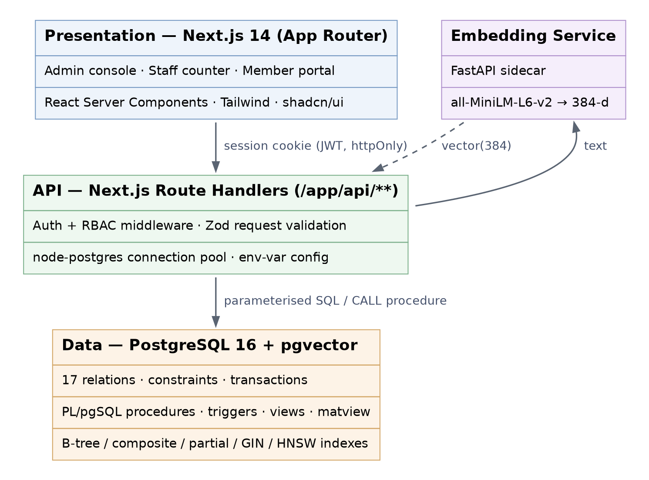

- Credential handling — all connection parameters read from environment variables via a typed config module; no secrets in source. User passwords stored as bcrypt hashes (cost 12), never plaintext.
- Embedding generation — sentence-transformers all-MiniLM-L6-v2 (384 dimensions) invoked through a small FastAPI sidecar, called once on profile save and once on requirement post. Vectors are persisted; nothing is embedded at query time except the incoming requirement text.
- Business logic placement — state-changing workflows (key issue/return, equipment issue/return) are implemented as PL/pgSQL procedures so the invariant holds regardless of which client calls it. The API layer orchestrates and validates; it does not own correctness.

7. ER Model to Relational Schema Conversion
The conceptual ER model (Annexure A) is mapped to the relational schema (Annexures B and C) using the standard conversion rules. The resulting design has 18 relations.
ER construct | Conversion rule applied | Result
Strong entity (11) | One relation per entity; entity key becomes the primary key | MEMBER, STAFF, APP_USER, MEMBERSHIP_CARD, FACILITY, LOCKER_KEY, EQUIPMENT, MAINTENANCE_LOG, TALENT_PROFILE, TEAM_REQUIREMENT, AUDIT_LOG
Weak entity ALERT | Relation includes the owner's key; primary key = owner key + partial key | ALERT, keyed naturally on (member_id, alert_type, generated_on); surrogate alert_id added for convenience
1:1 relationship (AUTHENTICATES) | Foreign key placed on the side with total participation | APP_USER.member_id / APP_USER.staff_id with CHECK (exactly one non-null)
1:N relationships (10) | Foreign key on the N side; no new relation | HOLDS, ISSUES_CARD, CONTAINS, STORES, REPORTED_IN, RAISES, REGISTERS, POSTS, NOTIFIED_BY, TRIGGERS
M:N relationships (2) | New relation holding both keys plus descriptive attributes | SLOT_BOOKING (from BOOKS), SHORTLIST (from MATCHED_IN)
Ternary relationships (3) | New relation holding all three participating keys plus descriptive attributes | KEY_ISSUE, EQUIPMENT_ISSUE, FACILITY_VISIT
Composite attribute (contact) | Decomposed into its simple components; the composite itself is not stored | MEMBER.contact_no, MEMBER.email
Multivalued attribute (achievements) | Separate relation keyed on the owner plus the value | ACHIEVEMENT(achievement_id, profile_id, achievement_text, level, achieved_on)
Total participation | NOT NULL on the corresponding foreign key | Applied on CARD, LOCKER_KEY, EQUIPMENT, MAINTENANCE_LOG, TALENT_PROFILE, TEAM_REQUIREMENT, ALERT, AUDIT_LOG
Derived attributes (5) | Computed in views where cheap; materialised with trigger maintenance where read-heavy | available_qty stored and trigger-maintained; fine_amount computed on return; duration_minutes, hours_held, is_valid_today exposed through views
Two conversions are worth calling out at the demonstration. First, KEY_ISSUE, EQUIPMENT_ISSUE and FACILITY_VISIT are relationships in the ER model, not entities — they become relations only because a ternary relationship with its own descriptive attributes has no other relational representation. Second, FACILITY_VISIT additionally carries card_id, which does not appear in the conceptual model; it is introduced during conversion so that the system records which physical card instance was presented at the gate, which is the audit question the department actually asks.

8. Advanced Database Features
The requirement asks for at least four advanced concepts. Eight are implemented:
Concept | Where it is used | Why it is necessary
Transactions | sp_issue_key, sp_return_key, sp_issue_equipment | Key status change and issue-row insert must both succeed or neither; prevents phantom stock
Triggers | trg_key_status_sync, trg_equipment_qty, trg_audit_dml, trg_tsv_update | Keeps derived state consistent and writes the audit trail regardless of client
Stored procedures / functions | sp_issue_key, fn_generate_inactivity_alerts, fn_match_talent | Encapsulates multi-statement invariants inside the database boundary
Views | vw_keys_currently_out, vw_overdue_equipment, vw_card_expiry_watch | Presents the counter dashboards without repeating join logic in the app
Materialised view | mv_member_engagement (visits/month, streak, last_seen) | Streak computation over the full visit history is too costly to run per page load
Indexing | B-tree, composite, partial (WHERE out_time IS NULL), GIN, HNSW | Five index types chosen per access pattern, each justified with EXPLAIN ANALYZE
Full-text search | GIN on MAINTENANCE_LOG.search_tsv | Literal keyword retrieval over short maintenance reports
Vector similarity search | HNSW cosine index on TALENT_PROFILE.profile_embedding | Semantic matching of coach requirements to student sporting profiles

9. Vector / Semantic Search Design
Aspect | Design decision
Data embedded | Concatenation of sport, playing_role, bio and achievements per TALENT_PROFILE; requirement_text per TEAM_REQUIREMENT
Model | sentence-transformers/all-MiniLM-L6-v2 — 384 dimensions, runs locally on CPU, no API cost or rate limit
Storage | vector(384) columns inside PostgreSQL via the pgvector extension, co-located with the relational rows they describe
Similarity metric | Cosine distance (pgvector <=> operator); embeddings are L2-normalised, so cosine is the correct measure of semantic direction independent of text length
Index | HNSW (m = 16, ef_construction = 64) on both vector columns; ANN search avoids a full scan as profiles grow
Retrieval strategy | Hybrid: filter first on sport and member.is_active in SQL, then order the surviving rows by embedding distance, take top-k, and persist the result set with its score into SHORTLIST
Why the result is persisted | SHORTLIST resolves the many-to-many between requirements and profiles and lets an admin record a select/reject decision — the similarity score becomes auditable data, not a transient query result

SELECT tp.profile_id, m.full_name, m.reg_no,
1 - (tp.profile_embedding <=> $1::vector) AS similarity
FROM talent_profile tp
JOIN member m ON m.member_id = tp.member_id
WHERE tp.sport = $2 AND m.is_active
ORDER BY tp.profile_embedding <=> $1::vector
LIMIT 10;

10. Authentication and Authorisation
Role | Who | Permissions
ADMIN | Department head / PE faculty | Full read-write on all entities; card issue and revocation; talent matching; audit log; all reports
STAFF | Counter operator | Key and equipment issue/return; facility check-in-out; maintenance reports; read-only on member master; no card issue, no audit access
MEMBER | Student, faculty, alumni member | Own card status, own visit history, own talent profile, own alerts, own slot bookings only
APP_USER carries a role enum and exactly one of member_id or staff_id, enforced by a CHECK constraint so an account cannot be simultaneously a member and a staff identity. Authorisation is enforced at three layers: Next.js middleware on the route group, a role assertion inside each route handler, and row-scoping in the SQL itself for member-owned resources.

11. Representative Queries
- Keys currently outstanding beyond two hours (JOIN + aggregate + HAVING):
SELECT lk.key_code, m.full_name, m.reg_no, ki.in_time,
EXTRACT(EPOCH FROM (now() - ki.in_time))/3600 AS hours_out
FROM key_issue ki
JOIN locker_key lk USING (key_id)
JOIN member m USING (member_id)
WHERE ki.out_time IS NULL
AND ki.in_time < now() - INTERVAL '2 hours';

- Members inactive for 14+ days despite a valid card (subquery + NOT EXISTS):
SELECT m.member_id, m.full_name, MAX(fv.check_in) AS last_visit
FROM member m
JOIN membership_card mc ON mc.member_id = m.member_id
LEFT JOIN facility_visit fv ON fv.member_id = m.member_id
WHERE mc.status = 'active' AND mc.valid_upto >= CURRENT_DATE
GROUP BY m.member_id, m.full_name
HAVING COALESCE(MAX(fv.check_in), '-infinity') < now() - INTERVAL '14 days';

- Facility utilisation ranked by month (GROUP BY + window function):
SELECT f.name, date_trunc('month', fv.check_in) AS mth, COUNT(*) AS visits,
RANK() OVER (PARTITION BY date_trunc('month', fv.check_in)
ORDER BY COUNT(*) DESC) AS rnk
FROM facility_visit fv JOIN facility f USING (facility_id)
GROUP BY f.name, mth;

12. Why This Is Not a CRUD Application
- State transitions are enforced by the database, not the form. A locker key moves available → issued → available through procedures with a partial unique index guaranteeing at most one open issue per key; no sequence of HTTP requests can corrupt it.
- Derived facts are computed, not stored by hand. Fines, streaks, lapse alerts, stock positions and shortlist scores are all produced by queries, triggers and scheduled functions.
- Two retrieval paradigms coexist with a justified split. Lexical (GIN/tsvector) for maintenance text, semantic (HNSW/cosine) for talent — chosen on the nature of the text, not for demonstration.
- The matching subsystem produces new relational data. Vector search output is written into SHORTLIST with its score and a human decision, so an AI result becomes an auditable record.
- Every mutation is attributable. Trigger-driven audit rows capture the prior JSONB state and the acting user for the tables that matter.

13. Individual Contribution
Area | Dhanush | Teammate
Database design | ER model, normalisation to 3NF, relational schema, constraint design | Review, data dictionary, seed data generation
SQL implementation | DDL, triggers, PL/pgSQL procedures, indexes, EXPLAIN tuning | Views, materialised view, reporting queries
Vector subsystem | Embedding service, pgvector schema, HNSW tuning, hybrid retrieval query | Shortlist UI and decision workflow
Application | API route handlers for key/equipment workflows, transaction orchestration | Next.js pages, RBAC middleware, dashboards, forms and validation
Testing & docs | Concurrency and constraint test cases, query plans | UI test cases, screenshots, README, final report assembly
Both members commit to the shared GitHub repository throughout; commit history will evidence the split above.

14. Conclusion and Future Enhancements
KREEDA converts a fully manual, register-based sports complex operation into a transactional, auditable and analytical system, and adds a capability the department does not currently have in any form — semantic discovery of campus sporting talent. Planned extensions:
- RFID / NFC card reading at the counter, replacing manual card-number entry (schema already accommodates a card UID column).
- Row-level security policies in PostgreSQL to push member-scoping from the API layer into the database itself.
- Table partitioning of FACILITY_VISIT by month once the visit volume makes full scans expensive.
- Automated fine settlement through a campus payment integration.
- Attendance forecasting per facility per hour to guide staffing, using the accumulated visit history.

Annexure A — Entity–Relationship Diagram (Chen Notation)
Printable full-resolution copies are supplied as KREEDA_ER_Chen.pdf and KREEDA_Schema_Diagram.pdf. Conceptual model: 11 strong entities, 1 weak entity, 17 relationships (2 many-to-many, 3 ternary). Foreign keys deliberately do not appear — relationship diamonds carry that information. Notation legend is on the diagram.

Annexure B — Relational Schema Diagram
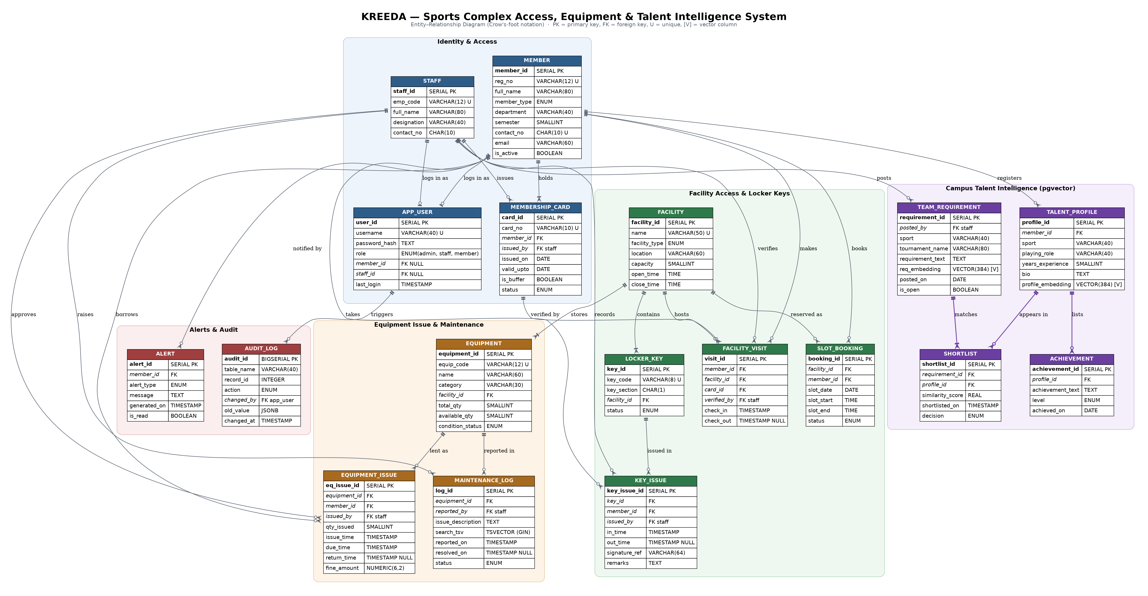
Logical model after conversion, in crow's-foot notation. Bar = exactly one, bar+crow = one-or-many, circle+crow = zero-or-many. 18 relations across five subsystems.

Annexure C — Relational Schema (Textual)
Underline = primary key, italic FK notation = foreign key. All relations are in 3NF.
MEMBER(member_id, reg_no, full_name, member_type, department, semester,
contact_no, email, is_active)
PK member_id · UNIQUE reg_no, contact_no

STAFF(staff_id, emp_code, full_name, designation, contact_no)
PK staff_id · UNIQUE emp_code

MEMBERSHIP_CARD(card_id, card_no, member_id, issued_by, issued_on,
valid_upto, is_buffer, status)
PK card_id · UNIQUE card_no · FK member_id → MEMBER
FK issued_by → STAFF · CHECK (valid_upto > issued_on)

APP_USER(user_id, username, password_hash, role, member_id, staff_id, last_login)
PK user_id · UNIQUE username · FK member_id → MEMBER
FK staff_id → STAFF · CHECK (num_nonnulls(member_id, staff_id) = 1)

FACILITY(facility_id, name, facility_type, location, capacity, open_time, close_time)
PK facility_id · UNIQUE name · CHECK (close_time > open_time)

LOCKER_KEY(key_id, key_code, key_section, facility_id, status)
PK key_id · UNIQUE key_code · FK facility_id → FACILITY

KEY_ISSUE(key_issue_id, key_id, member_id, issued_by, in_time, out_time,
signature_ref, remarks)
PK key_issue_id · FK key_id → LOCKER_KEY · FK member_id → MEMBER
FK issued_by → STAFF · CHECK (out_time IS NULL OR out_time > in_time)
UNIQUE INDEX (key_id) WHERE out_time IS NULL

FACILITY_VISIT(visit_id, member_id, facility_id, card_id, verified_by,
check_in, check_out)
PK visit_id · FK member_id → MEMBER · FK facility_id → FACILITY
FK card_id → MEMBERSHIP_CARD · FK verified_by → STAFF

SLOT_BOOKING(booking_id, facility_id, member_id, slot_date, slot_start,
slot_end, status)
PK booking_id · FK facility_id → FACILITY · FK member_id → MEMBER
EXCLUDE overlapping (facility_id, slot_date, [slot_start, slot_end))

EQUIPMENT(equipment_id, equip_code, name, category, facility_id,
total_qty, available_qty, condition_status)
PK equipment_id · UNIQUE equip_code · FK facility_id → FACILITY
CHECK (available_qty BETWEEN 0 AND total_qty)

EQUIPMENT_ISSUE(eq_issue_id, equipment_id, member_id, issued_by, qty_issued,
issue_time, due_time, return_time, fine_amount)
PK eq_issue_id · FK equipment_id → EQUIPMENT · FK member_id → MEMBER
FK issued_by → STAFF · CHECK (qty_issued > 0)

MAINTENANCE_LOG(log_id, equipment_id, reported_by, issue_description,
search_tsv, reported_on, resolved_on, status)
PK log_id · FK equipment_id → EQUIPMENT · FK reported_by → STAFF
GIN INDEX on search_tsv

TALENT_PROFILE(profile_id, member_id, sport, playing_role, years_experience,
bio, profile_embedding)
PK profile_id · FK member_id → MEMBER · UNIQUE (member_id, sport)
HNSW INDEX on profile_embedding (vector_cosine_ops)

ACHIEVEMENT(achievement_id, profile_id, achievement_text, level, achieved_on)
PK achievement_id · FK profile_id → TALENT_PROFILE
(converted from the multivalued attribute 'achievements' in the ER model)

TEAM_REQUIREMENT(requirement_id, posted_by, sport, tournament_name,
requirement_text, req_embedding, posted_on, is_open)
PK requirement_id · FK posted_by → STAFF

SHORTLIST(shortlist_id, requirement_id, profile_id, similarity_score,
shortlisted_on, decision)
PK shortlist_id · FK requirement_id → TEAM_REQUIREMENT
FK profile_id → TALENT_PROFILE · UNIQUE (requirement_id, profile_id)

ALERT(alert_id, member_id, alert_type, message, generated_on, is_read)
PK alert_id · FK member_id → MEMBER

AUDIT_LOG(audit_id, table_name, record_id, action, changed_by,
old_value, changed_at)
PK audit_id · FK changed_by → APP_USER

