FORWARD DEPLOYED AI ENGINEERING
Capstone Project
Stage Two: Requirements
The product requirements document you write from your findings
Everything here must trace back to your discovery workbook. A requirement that
cannot be traced is a preference, and preferences do not belong in a PRD.
WEEK ONE · DAYS FOUR AND FIVE

What this document is and why it matters
A product requirements document states what is being built, for whom, and how anyone will know when it is finished. It is not a design document and it is not a plan. It should be specific enough that two different engineers reading it would build broadly the same thing, and general enough that it does not dictate how they do it.
You will write version one at the end of week one and you will revise it during week two. That revision is compulsory. Write this version with the expectation that parts of it will turn out to be wrong, and record your assumptions clearly so that you can tell which ones failed when they do.
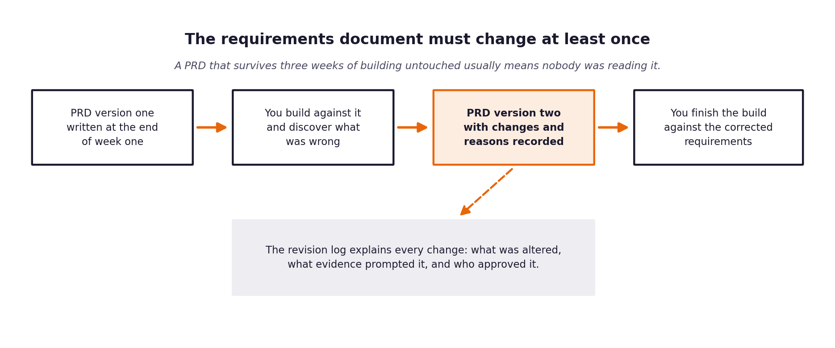
Figure 1. The requirements document is expected to change once building starts.

1 Document control
Field | Value
Version | 1.0
Written by | Dhanush Varanasi
Date | 2026-09-16
Status | Draft for review -- v1, written before the build; revision compulsory once evaluation results exist
Approved by | Self (individual project)

2 The problem in one paragraph
Copy across the paragraph you wrote at the end of your discovery workbook. If you find yourself wanting to improve it as you copy, go back and improve it in the workbook first, so that the two do not drift apart.
Problem statement
CloudServe's support failure isn't a shortage of answers or of agents -- it's that agents can't reliably find answers that already exist (Sofia, Ines), and escalations arrive as raw forwards with no indication of what was already tried or how confident anyone was (Daniel). A chatbot that answers customers directly doesn't fix either of those. A system that retrieves and grounds answers against the real documentation with calibrated confidence, auto-resolves what it can defend, and escalates the rest with a draft, sources, and an explicit statement of uncertainty attached -- is what would have actually helped Sofia and Daniel, not just Marcus's response-time number. [Copied from the Stage 1 workbook -- keep the two in sync if you edit either.]

3 Who this is for
Describe each group of users separately. A requirement that serves everybody usually serves nobody particularly well.
User group | What they need from this system | What they currently do instead | How you will know it worked for them
Customers raising tickets | Fast answers when low-stakes; honesty about what's automated so they can calibrate trust (Ravi) | Wait 8-12h, or self-serve against the docs and often get the same answer later having burned hours | Time-to-first-reply drops; customers know when a reply is automated
Tier one support agents | Fewer from-scratch answers; when one does reach them, less time spent searching (Sofia) | Keep a personal, unreviewed file of past answers because internal search doesn't work | FCR rises; agents stop needing personal snippet files
Tier two and specialist agents | Escalations that arrive with a summary, retrieved sources, and a stated point of low confidence (Daniel) | Read the whole thread from scratch and re-ask the customer what they were already asked | Daniel's self-reported 'twice as fast' on escalations that do reach him
The head of support | Response time and FCR to move without more headcount; an explainable system ahead of an autumn compliance review (Marcus) | Reports a red response-time number to the executive team every quarter with no lever to pull | Time-to-first-reply and FCR move toward target; every decision has a logged reason

4 Functional requirements
Each requirement gets an identifier, a statement, a priority and a link back to the discovery evidence that produced it. The identifiers matter because your specifications, your prompts and your test cases will all refer to them.
Use the priority scale consistently. Must means the system is not acceptable without it. Should means it is expected but could be deferred with a stated consequence. Could means it would add value if time allows. Will not means it has been considered and deliberately excluded, and recording those is as useful as recording the rest.
ID | Requirement | Priority | Discovery evidence | Acceptance criteria
FR-01 | Ingest tickets from all four channels (email, chat, docs_comment, forum) into one normalised representation, preserving original text and channel | Must | Discovery Sec 2 (channel split); Build Spec A2 | A ticket from each channel is passed in and handled without channel-specific breakage
FR-02 | Classify every ticket against the real 22-class intent taxonomy | Must | Dataset_Guide schema; Discovery Sec 2 (near-uniform intent distribution) | Output carries one of the 22 defined classes
FR-03 | Attach a calibrated confidence score and up to 2 alternatives to every classification | Must | Build Spec A3; Evaluation Framework calibration requirement | Confidence is numeric 0-1; calibration table shows stated vs. observed accuracy within 5 points
FR-04 | Retrieve ranked, identifiable documentation passages; return nothing rather than something irrelevant | Must | Discovery Sec 1 (Ines: search is the failure, not coverage); Build Spec A4 | Returned doc_ids resolve to real corpus entries; empty result when nothing clears the relevance threshold
FR-05 | Generate answers grounded only in retrieved passages, never outside knowledge | Must | Discovery Sec 1 (Marcus: 'I would rather it said nothing than said something wrong') | No claim in a generated answer lacks a supporting retrieved passage
FR-06 | Attach citations to generated claims; citations must resolve to passages actually retrieved | Must | Discovery Sec 1 (Ines wants to trace answers to articles); Build Spec A6 | grounding guardrail blocks any citation that doesn't resolve
FR-07 | Decline explicitly ('I don't know') when ungrounded, rather than filling the gap | Must | Discovery Sec 1 (Ravi: acceptable only 'provided it is honest') | declined=true with a stated reason when retrieval returns nothing usable
FR-08 | Route deterministically: always-escalate for compliance_request/security_incident/feature_request/unclear_request regardless of confidence; otherwise threshold-based | Must | Discovery Sec 2 (these 4 classes escalated 100% historically, 87/500 tickets); Build Spec A5 | Same ticket run twice produces the same routing decision
FR-09 | Validate every generated response against 5 blocking guardrails before release | Must | Governance_Framework Sec 4; Build Spec A7 | A ticket engineered to trigger each guardrail is blocked, not merely warned about
FR-10 | Log every automated decision with the minimum record schema | Must | Governance_Framework Sec 1; Marcus's compliance review | Decision count reconciles exactly against tickets processed
FR-11 | Escalations carry the drafted summary, retrieved sources, and the specific point of low confidence to the human agent | Must | Discovery Sec 1 (Daniel: 'I need it to show its working') | escalation_summary field is populated on every escalated ticket
FR-12 | Evaluation harness accepts --input/--output paths and processes a full ticket set unattended, producing a metrics report with no manual work | Must | Build Spec A9/A10 -- the hidden 120-ticket set is never seen before grading | Harness runs against an arbitrary file path and writes metrics_report.json

5 Non-functional requirements
These describe how well the system must do the things it does. They are frequently what distinguishes a demonstration from something that could actually be deployed.
ID | Category | Requirement | How it will be verified
NFR-01 | Latency | 95th percentile response latency under 3 seconds | Measured end-to-end per ticket, reported in metrics_report.json
NFR-02 | Availability | Graceful degradation under provider outage, rate limiting, timeout, or malformed input -- no crash | Provider disconnected mid-run in testing; system continues and escalates (A11)
NFR-03 | Accuracy | Intent classification precision 85%+; citation accuracy 95%+ | sklearn precision/recall per class against ground truth; citation resolution check
NFR-04 | Privacy | Zero private-data occurrences in outbound responses | private_data guardrail on every response + governance metric count
NFR-05 | Auditability | Every automated decision reconstructable months later | Decision log coverage check: logged decisions == tickets processed
NFR-06 | Fairness | Under 5 percentage points of quality variation across customer segments | fairness_segments() in every evaluation run, by tier and language fluency
NFR-07 | Cost | Free tier only (Groq); no paid capacity | No billing configured; stack constrained to free/open-source components

6 What is deliberately out of scope
Recording what you are not building is one of the most valuable things a requirements document does, because it is the section that prevents an argument in week three.
Not building | Why not | What would have to change for this to be reconsidered
Non-English generation | Answers are produced in English even for non-fluent-English tickets in v1 | If the fairness audit shows a real quality gap for this segment, this becomes the headline PRD revision finding
A full agent-facing review UI for Tier 2 | The context Daniel asked for (summary, sources, confidence) is in scope; the UI to browse it is not -- delivered via the decision log and API response | If time remains after the core build and evaluation are solid
Auto-updating the documentation corpus | The 29 articles are treated as a fixed snapshot | A staleness-detection pipeline using last_reviewed_days_ago is a natural v2
Proactive/outbound outreach | No discovery evidence supports building outbound flows -- everything is inbound-ticket-driven | New discovery evidence surfacing a real need
Payment/refund/contractual commitments | Explicitly blocked by the tone_and_scope guardrail, never a build target | Not reconsidered -- this is a permanent boundary, not a time-driven cut

7 Assumptions and their consequences
Every assumption you are making is a place where this document could turn out to be wrong. Listing them now is what makes the revision in stage five a considered update rather than a scramble.
Assumption | Why you believe it | What happens if it is false | How you will find out
The hidden 120-ticket evaluation set uses the identical schema to validation_tickets.json | Stated explicitly in the pack (Build Spec, Dataset_Guide) | Harness would need a schema-compatibility fix | Ingest already tolerates missing/malformed fields as a safeguard
Groq's free tier has sufficient throughput to process ~100-500 tickets in one unattended run | Groq is named in the pack as having a free tier sufficient for this work | Run stalls or rate-limits mid-way | Retry/backoff + A11 graceful degradation; documented as a finding if it happens
The 29-article documentation corpus is representative of what a correct answer needs | It's the corpus ground_truth_responses.json's expected_doc_ids were written against | Low retrieval hit-rate against ground truth | Chunking/embedding strategy becomes a candidate PRD revision
Non-fluent-English tickets can be reasonably served by an English-only generator in v1 | No evidence yet either way -- explicitly a hypothesis, not a confirmed assumption | Fairness audit shows a real, large gap | Becomes the headline finding of the Stage 5 PRD revision

8 Success measures
State the measures this system will be judged on, with the baseline and the target for each, and say who is accountable for reporting them.
Measure | Baseline | Target | Measured how | Reported by
First contact resolution | 42% | 60% or better | auto_respond count / total tickets, computed by the harness | Dhanush Varanasi
Time to first reply | 8 to 12 hours | Under 5 minutes (system latency is a proxy in this offline evaluation -- no live customers) | Pipeline latency_seconds, mean and median | Dhanush Varanasi
Customer satisfaction | 3.2 / 5 | 4.0 or better (proxy -- human review of a response sample against a rubric) | Rubric-scored sample, method and n stated in the report | Dhanush Varanasi
Escalation rate | 58% | 30% or lower | escalate count / total tickets, computed by the harness | Dhanush Varanasi

9 Open questions
The things you do not yet know. Each one needs an owner and a date by which it will be resolved, otherwise it will still be open in week three.
Question | Why it matters | Owner | Resolve by
Does the confidence threshold (0.80) need to move once real classifier calibration data exists? | Routing quality and the FCR/escalation-rate targets depend directly on it | Dhanush Varanasi | Before the final evaluation run against the hidden set
Is the non-fluent-English fairness gap real once tested against this system's own retrieval, not just historical human-handled data? | Candidate headline finding for the compulsory PRD revision and the governance fairness audit | Dhanush Varanasi | After the first full evaluation run

The review before you move on
Read your finished PRD and ask, for each requirement in turn, whether an engineer who had not attended any of your interviews could build it from what is written. Where the answer is no, the requirement is not finished. This check takes twenty minutes and it is the single highest-value thing you can do at the end of week one.

