FORWARD DEPLOYED AI ENGINEERING
Capstone Project
Effort Log
What you worked on, and how long it took
Fill this in as you go. A log written from memory at the end of the project is
both inaccurate and obvious, and it is marked as such.
FILL IN EVERY SECOND DAY

Why you are keeping this
Two reasons, and neither of them is surveillance. The first is that estimating your own work is a professional skill you will be asked to exercise constantly, and the only way to get better at it is to compare what you predicted against what actually happened. The second is that the reflection section of your report needs material, and a log that shows discovery took half the time you expected while evaluation took twice as long gives you something genuinely worth writing about.
Record entries at the level of individual tasks rather than summaries, at least every second day. Record the hours you actually worked, including the ones that produced nothing useful. A task that took four hours and ended in a dead end is a real cost and belongs here.
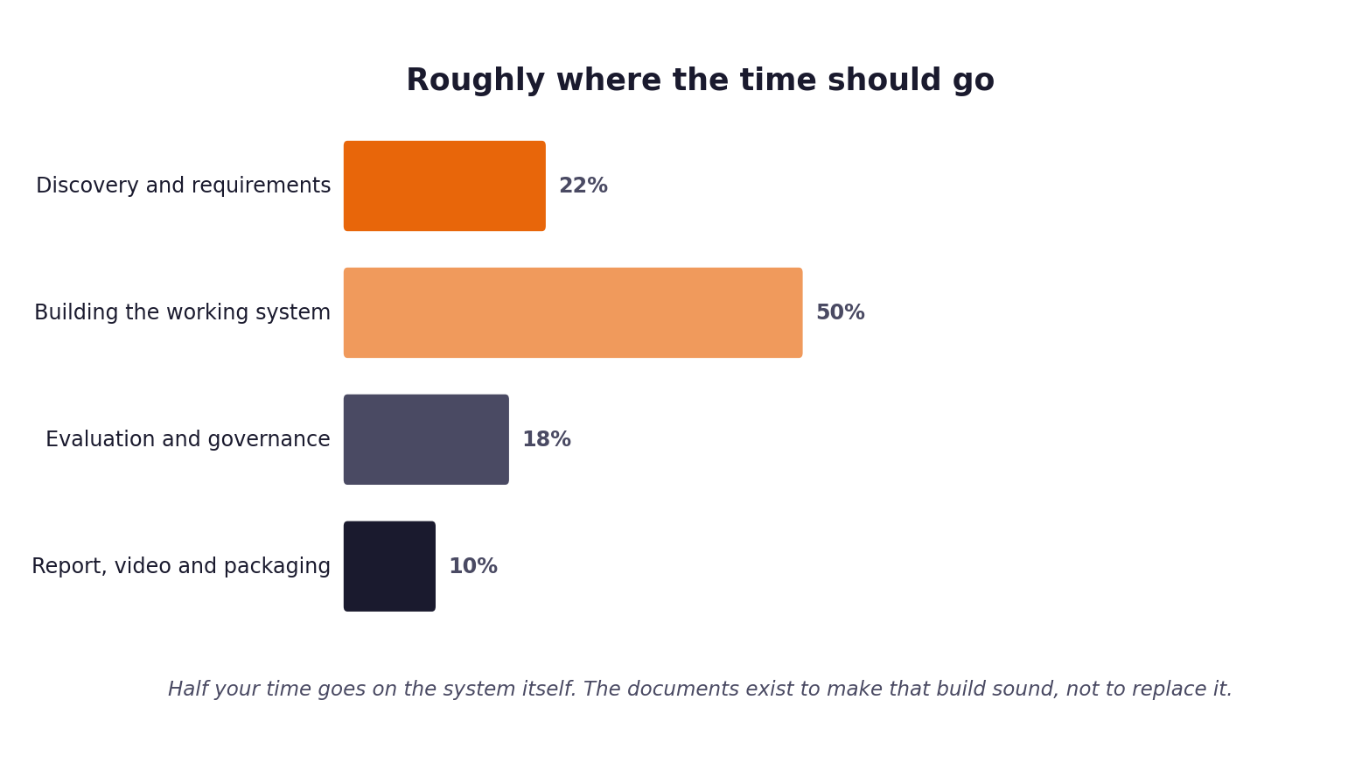
Figure 1. Roughly how the hours are expected to distribute. Compare yours against this at the end of each week.
1 Your details
Field | Value
Full name | Dhanush Varanasi
Project start date | 2026-09-16 for repository work (all commits and this session's tool history start ~13:15 UTC that day). You mentioned some earlier reading or thinking about the capstone pack on a prior day. ADD THAT DATE HERE if you want it reflected, since there is no artifact evidence of it to derive a date or hour count from.
Target submission date | 2026-09-20 (the real remaining-time deadline established in the Stage 4 Sprint Plan; the template's printed 13 September is the pack's generic placeholder date, superseded per that workbook's Section 1)
Hours available per week | Under 10 hours per week (full-time role at EY; evenings and weekends only)

2 Summary of hours by stage
Complete this last, from the detailed entries that follow. The totals must reconcile with your daily records.
Stage | Planned hours | Actual hours | Difference | Why the difference
1. Discovery | No separate per-stage estimate existed; the Stage 4 Sprint Plan's 3-week horizon collapsed into one session (see that workbook, Section 1), so stage-level planning happened informally rather than as a written estimate. | 0.3 | N/A | See note in Planned hours.
2. Requirements | No separate per-stage estimate existed; the Stage 4 Sprint Plan's 3-week horizon collapsed into one session (see that workbook, Section 1), so stage-level planning happened informally rather than as a written estimate. | 0.4 | N/A | See note in Planned hours.
3. Prompt library | No separate per-stage estimate existed; the Stage 4 Sprint Plan's 3-week horizon collapsed into one session (see that workbook, Section 1), so stage-level planning happened informally rather than as a written estimate. | 0.3 | N/A | See note in Planned hours.
4. Sprint plan | No separate per-stage estimate existed; the Stage 4 Sprint Plan's 3-week horizon collapsed into one session (see that workbook, Section 1), so stage-level planning happened informally rather than as a written estimate. | 0.3 | N/A | See note in Planned hours.
5. Build and revision | No separate per-stage estimate existed; the Stage 4 Sprint Plan's 3-week horizon collapsed into one session (see that workbook, Section 1), so stage-level planning happened informally rather than as a written estimate. | 4.4 | N/A | See note in Planned hours. This stage covers the core pipeline build, governance doc, both dependency fixes, the Groq model deprecation fix, both evaluation runs, the decision log bug fix, the PRD revision log workbook, the submission-checklist audit, and creating docs/PRD_REVISION_LOG.md.
6. Report, video, packaging | No separate per-stage estimate existed; the Stage 4 Sprint Plan's 3-week horizon collapsed into one session (see that workbook, Section 1), so stage-level planning happened informally rather than as a written estimate. | 2.3 | N/A | Report drafting is done, all 10 sections, the AI tool use declaration, and a revision incorporating a same-day clean evaluation run. Video recording, final PDF export, and zip packaging have not started; deferred until the report review is finished.
Total |  | 8.0

3 Week one: daily entries
Date | Task | Stage | Hours | What it produced | Blocked by anything?
2026-09-16 | Read the capstone pack: project brief, build specification, dataset guide, all five stakeholder interview transcripts, evaluation framework, governance framework, and all five stage workbook templates. | 1. Discovery | 0.3 | Understanding of the problem and the evidence base later used in the Stage 1 workbook and the version one PRD. | None
2026-09-16 | Scaffolded the repository and built the core pipeline end to end: ingest, classify, retrieve, route, generate, validate, decision log, evaluation harness, API, 51 unit tests, CI, README, version one PRD and architecture docs. AI assisted pair programming against the Build Specification. | 2. Requirements / 5. Build and revision | 1.3 | Working repository, 51 passing tests, version one PRD. | None
2026-09-16 | Wrote the governance doc: decision logging schema, risk register, fairness audit plan, guardrails, incident response, kill switch, declaration. | 5. Build and revision | 0.3 | docs/governance.md | None
2026-09-16 | Filled Stage 1 Discovery Workbook and Stage 2 PRD Template with evidence drawn from the interview transcripts and dataset statistics. | 1. Discovery / 2. Requirements | 0.5 | Stage 1 and Stage 2 completed workbooks. | None
2026-09-16 | Fixed a dependency conflict: groq==0.11.0 passes a proxies keyword argument that httpx 0.28+ removed. | 5. Build and revision | 0.2 | requirements.txt pin (httpx==0.27.2), confirmed locally. | Import error on first real Groq call.
2026-09-16 | Filled Stage 3 Prompt Library and Stage 4 Sprint Plan, including the honest re-scoping of the sprint plan to the real 5 day remaining timeline instead of the template's 3 week one. | 3. Prompt library / 4. Sprint plan | 0.5 | Stage 3 and Stage 4 completed workbooks. | None
2026-09-16 | Diagnosed and fixed a Groq model deprecation: llama-3.3-70b-versatile and llama-3.1-8b-instant were retired on 2026-08-16; switched to openai/gpt-oss-120b and openai/gpt-oss-20b. | 5. Build and revision | 0.3 | Working live Groq calls again. | 100 percent of tickets were escalating; traced to a 404 from the provider, not a bug in the pipeline.
2026-09-16 | Ran the evaluation harness live, unattended, against the 500 ticket development set. | 5. Build and revision | 0.7 | evaluation/results/metrics_report.json (500 tickets processed, 0 ingest errors). | Groq's daily token quota was exhausted partway through the run (32.2 percent of tickets fell back to forced escalation).
2026-09-16 | Ran the evaluation harness live, in your own terminal, against the 80 ticket validation set. | 5. Build and revision | 0.2 | evaluation/results/validation_run/metrics_report.json. | The same day's Groq quota was already almost fully spent before this run started (90 percent of tickets fell back).
2026-09-16 | Investigated why two different sized runs both reported the identical decisions_logged count of 580, found a decision log cross-run reconciliation bug, fixed it, added 2 regression tests. | 5. Build and revision | 0.3 | 53 of 53 tests passing; fix documented in docs/governance.md. | None
2026-09-16 | Filled Stage 5 PRD Revision Log with verified findings from both evaluation runs and the decision log fix. | 5. Build and revision | 0.3 | Stage 5 completed workbook. | None
2026-09-16 | Cleaned formatting across every report and workbook, and filled the fairness audit table in the governance doc with the real 500 ticket run numbers. | 5. Build and revision | 0.2 | Clean reports; filled fairness audit table. | None
2026-09-17 | Wrote sections 3 through 10 of the capstone report (discovery, requirements, architecture, implementation, evaluation, governance, requirements revision, conclusions) and the AI tool use declaration, grounded in the real PRD, architecture and governance docs, both live evaluation runs, the Stage 5 revision log, and the stakeholder interview notes. | 6. Report, video, packaging | 1.5 | DhanushVaranasi_Capstone_Report.docx (22 pages), verified section by section via PDF render. | None
2026-09-17 | Audited the repository against the submission guide: commit history, credential scan, CI workflow, and whether all five stage workbooks and the effort log were genuinely complete. Caught and corrected a mistaken claim that Stage 1 and Stage 2 were blank, made from checking the wrong folder; the real committed workbooks were already filled. | 5. Build and revision | 0.4 | Submission-checklist findings; two mistakenly generated duplicate workbook files identified and disregarded. | None
2026-09-17 | Wrote docs/PRD_REVISION_LOG.md so the two existing references to it, in docs/PRD.md and README.md, resolve to real content, rendered from the already-completed Stage 5 workbook rather than new analysis. | 5. Build and revision | 0.2 | docs/PRD_REVISION_LOG.md | None
2026-09-17 | Incorporated a third, clean evaluation run (a same-day rerun of the 80-ticket validation set with zero fallbacks) into the report and the PRD revision log: rewrote report section 7 and updated sections 1, 8, 9 and 10, corrected the NFR-01 latency root-cause claim (generation-call inference time, not retry backoff, per a final-action latency split), and added a dated addendum to docs/PRD_REVISION_LOG.md recording the clean run's findings, including a newly surfaced customer-tier fairness question the earlier 500-ticket run had appeared to settle. | 6. Report, video, packaging | 0.8 | DhanushVaranasi_Capstone_Report.docx (24 pages), docs/PRD_REVISION_LOG.md addendum. | None

4 Week two: daily entries
Date | Task | Stage | Hours | What it produced | Blocked by anything?
2026-09-16 | Not applicable. This project's real remaining timeline (5 calendar days to the 2026-09-20 deadline) fit inside what the templates call "week one", so there is no separate week two of work to log. See Stage 4 Sprint Plan, Section 1, for the reasoning.

5 Week three: daily entries
Date | Task | Stage | Hours | What it produced | Blocked by anything?
2026-09-16 | Not applicable, for the same reason as week two above.

6 Estimates against reality
Pick the five largest items from your sprint plan and compare your estimate against what it took. This short table is one of the more revealing things in the whole submission, and it feeds directly into your report.
Item | Estimated hours | Actual hours | Why the difference
B-04: Vector store and retrieval | 4 | part of ~1.3h combined | Built together with the other four items in this table as one integrated pipeline in a single AI assisted session (~1.3 hours combined, see Table 3 row 2), not sequentially, so no honest per item split of that 1.3 hours exists. The Sprint Plan's estimates assumed sequential manual implementation against the 3 week template; building directly against an already-written Build Specification with AI assisted pair programming changed that shape rather than just its speed.
B-05: Evaluation harness | 5 | part of ~1.3h combined | Built together with the other four items in this table as one integrated pipeline in a single AI assisted session (~1.3 hours combined, see Table 3 row 2), not sequentially, so no honest per item split of that 1.3 hours exists. The Sprint Plan's estimates assumed sequential manual implementation against the 3 week template; building directly against an already-written Build Specification with AI assisted pair programming changed that shape rather than just its speed.
B-06: Intent and urgency classifier | 4 | part of ~1.3h combined | Built together with the other four items in this table as one integrated pipeline in a single AI assisted session (~1.3 hours combined, see Table 3 row 2), not sequentially, so no honest per item split of that 1.3 hours exists. The Sprint Plan's estimates assumed sequential manual implementation against the 3 week template; building directly against an already-written Build Specification with AI assisted pair programming changed that shape rather than just its speed.
B-08: Answer generation with citations | 4 | part of ~1.3h combined | Built together with the other four items in this table as one integrated pipeline in a single AI assisted session (~1.3 hours combined, see Table 3 row 2), not sequentially, so no honest per item split of that 1.3 hours exists. The Sprint Plan's estimates assumed sequential manual implementation against the 3 week template; building directly against an already-written Build Specification with AI assisted pair programming changed that shape rather than just its speed.
B-09: Guardrails and validation | 4 | part of ~1.3h combined | Built together with the other four items in this table as one integrated pipeline in a single AI assisted session (~1.3 hours combined, see Table 3 row 2), not sequentially, so no honest per item split of that 1.3 hours exists. The Sprint Plan's estimates assumed sequential manual implementation against the 3 week template; building directly against an already-written Build Specification with AI assisted pair programming changed that shape rather than just its speed.

7 Where the time went unexpectedly
Answer these in full sentences. They are short, and they will save you writing the reflection section from a blank page in your final week.
Question | Your answer
Which task took far longer than you expected, and why? | Not the code itself but the 500 ticket evaluation run: 42.7 minutes of wall clock time, and partway through it Groq's daily token quota was exhausted, which was not budgeted for at all since the free tier was assumed to simply work for a run of that size.
Which task was easier than you expected, and why? | Building the core pipeline, ingest through guardrails, 51 passing tests, took under 1.5 hours end to end with AI assisted pair programming against a Build Specification that was already concrete and criterion by criterion. Most of the usual design decisions were already made by the spec.
What would you allocate differently if you started again on Monday? | Budget a small canary run, 10 to 20 tickets, before committing to any large unattended run, to check the day's remaining Groq quota headroom first.
What did you spend time on that turned out not to matter? | Nothing identified yet as of this session. Every hour logged above fed directly into a workbook, a working fix, or a documented finding.

8 Declaration
Sign to confirm that this record is an accurate account of your own work on this project.
Full name | Signature | Date | Total hours recorded
Dhanush Varanasi | [SIGN HERE: this assistant cannot sign on your behalf] | 2026-09-17 | 8.0 (through 2026-09-17; add any earlier unlogged prep hours here and above if applicable)

