University of South-Eastern Norway

Faculty of Technology, Natural Sciences and Maritime Sciences

Electrical Power Engineering

Power Electronics and Electrical Drives

**LAB REPORT**

Participants:

|  |  |  |  |
| --- | --- | --- | --- |
| **No.** | **First Name** | **Last Name** | **Student ID** |
| 01 | Dhanush | Wagle | 238810 |
| 02 | Md Abdullah Al | Jobayer | 238813 |
| 03 | Benedict Ugochukwu | Okolie | 238805 |

Lab date: 15/04/2021

Submission date: 19/04/2021

**Task 5.1 LTSpice Simulation**

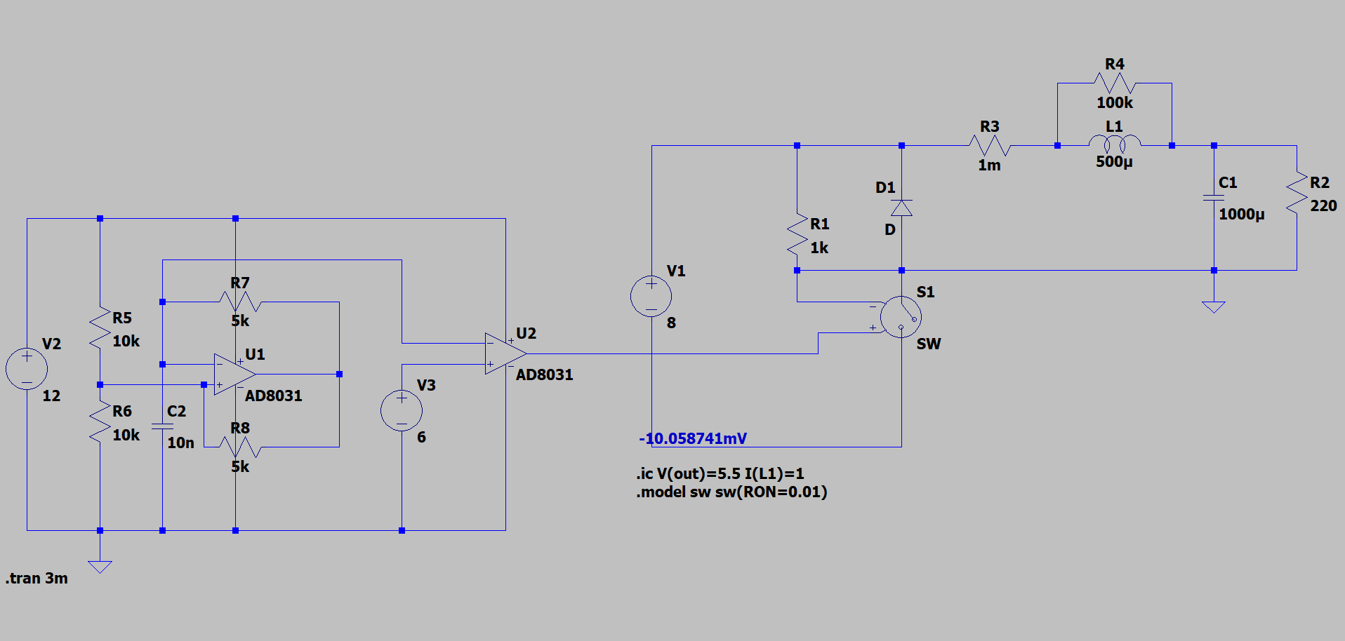

Figure 1: PWM Simulation

Figure 1 shows the simulation in LTSpice, the stop time is 3 minutes and model for the switch is .model sw sw(RON =0.01). In the first part of the simulation, the triangular voltage generator and the 6V reference voltage is used in the comparator and the output is fed to the switch. In the second part of the simulation the pulse width modulation is obtained across the load resistor.

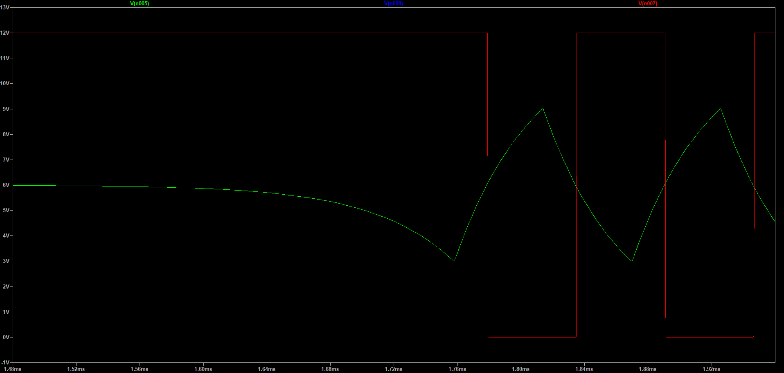

Figure 2: Comparing the triangular voltage with a reference level

The comaprision of voltages is shown in Figure 2, where blue line represents the reference voltage 6V, blue line represents the triangular voltage and the red line represents the PWM.

**Task 5.2 Experiment**

# Triangular Voltage Generator

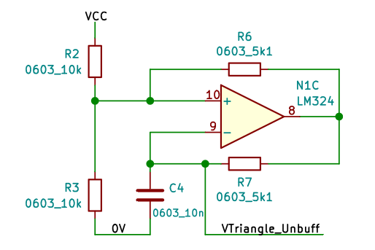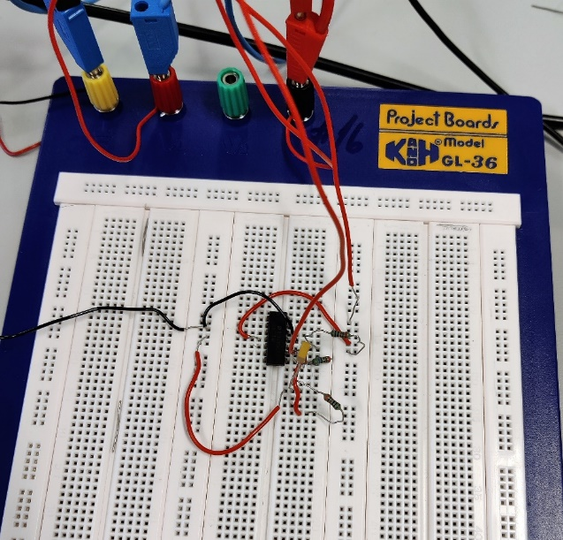

Figure : Triangular voltage generator

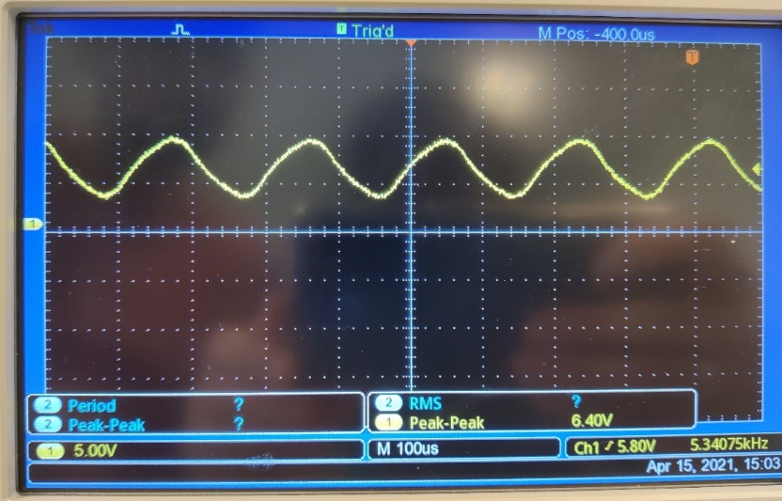 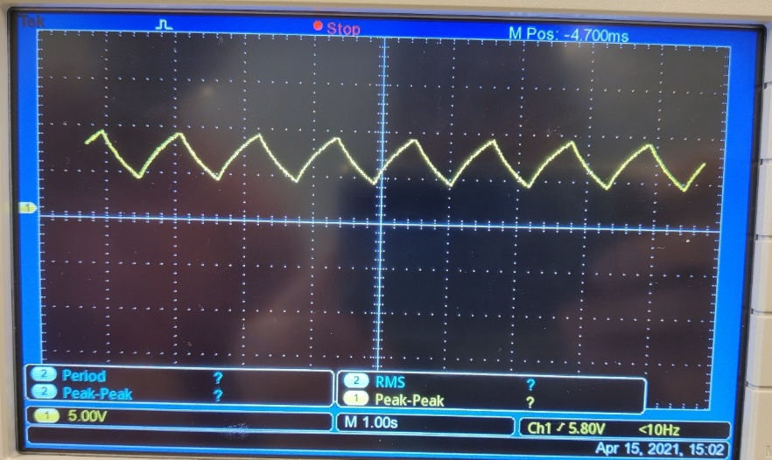

Figure : Triangluar Voltage Wave

The output is taken form the pin 8 of the op-amp(N1C LM324) across the capacitor. The capacitor with is charged through resistor with two different voltage levels. The output obtained is not exactly triangular wave, from the Figure 4 its clear that the wave is little curvy at the edges because of the low frequency of the capacitor. The voltage range of triangular wave is 6V. Then, replacing the capacitor by new capacitor with magnitude the waveform becomes triangular shown in the Figure 4. The output is more like triangular wave with new capacitor because of high frequency of the capacitor which has high reactance to voltage than the ceramic capacitor used at first.

# Comparator

We have now triangular voltage which can be compared to reference voltage to produce PWM signal, this is done by using pin 1, 2 and 3 of the same op-amp(N1C LM324). The triangular wave form is then compared with reference voltage using the circuit as in Figure 5.

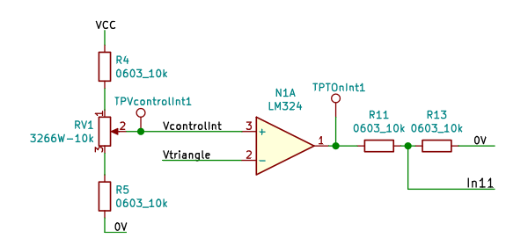 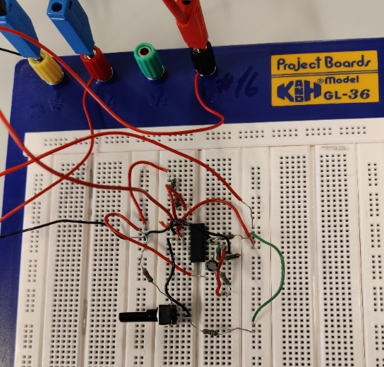

Figure 5: Comparing Triangular voltage with reference level

Figure 6: Square waveform

When the voltage Vcontroller is higher than the Vtriangle, the outpur is at Vcc and when the voltage Vcontroller is lower than the Vtriangle, the outpur is at 0V as shown in in Figure 6. The duty cycle is 0.446 when the control voltage is 12V.

# Buck Converter

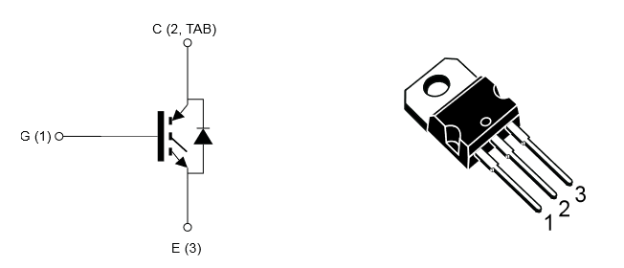

Figure 7: Buck Converter Figure 8: Transistor Switch device

Now, we have obtained a driver signal suitable to control our switch. Since the driver signal is referenced to 0V, the emitter of the IGBT should also be connectedto 0V. As our switch we’ll use the STGP5H60DF IGBT that is shown in Figure 8.

The step-down converter (or Buck converter) is shown in Figure 7. Here we used a 500µH inductance (the Bourns 5256). Use a 100µF capacitor(note that the negative terminal, often marked with a line, must face away from theinductance). As a load resistor, use a decade resistor with an initial setting of 20 Ohms. As diode, we use the VS-12CWQ10FNPBF.

Figure 9: Output of Buck Converter

Figure 9 shows the waveform of the PWM. The waveform is in discontinuous mode. This discontinuity is because of the characteristics the diode and the capacitor, when the capacitor discharges, the diode goes to the reverse bias mode and is not operated during short period of time, but if we change the potentiometer to adjust the resistance value, it becomes continuous where capacitor charges and discharges with almost equal ON and OFF time.

References

[1] Kjetil Svendsen, “Lab Assignment EPE2116: Power Electronics and Electrical Drives”, March 30th, 2019.