**Assignment 2: Transient Stability – Critical Fault Clearing Time**

## Task 1:

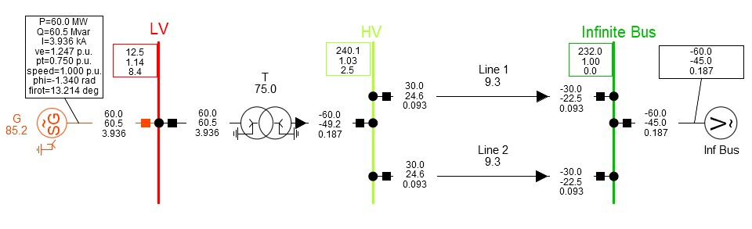

Figure : SMIB

## Task 2:

At Bus 1(LV), the short circuit event is added and time is set to. After execution of the DPL, critical fault clearing time obtained is . Hence the system will be stable if the fault is removed before however, removing the fault after just a millisecond later will make the system lose its synchronism.

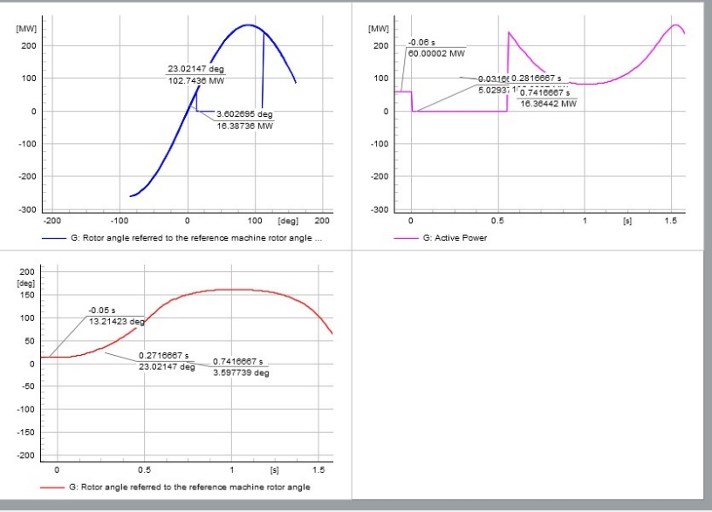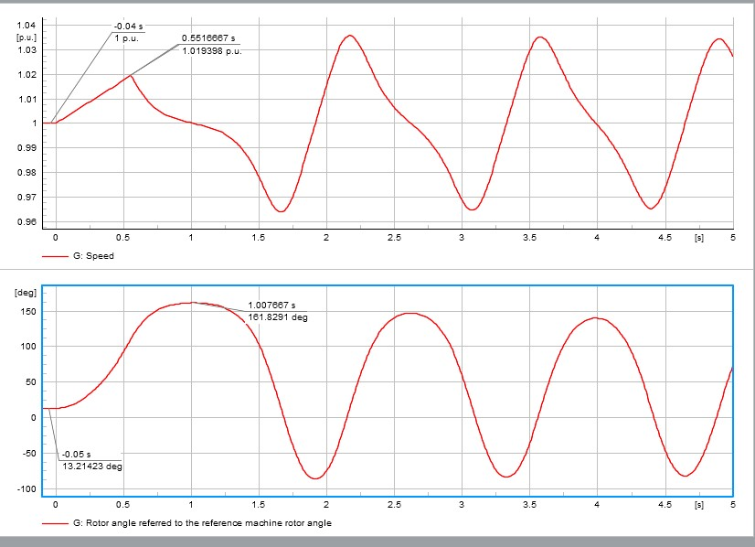

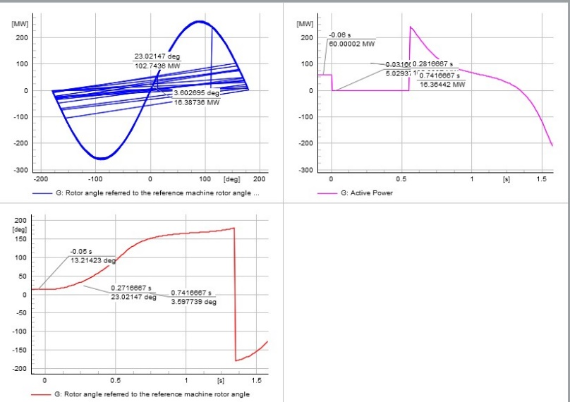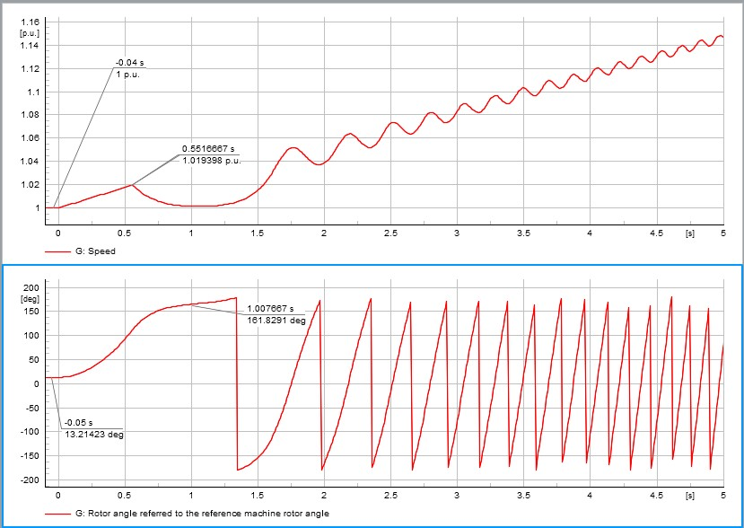

Figure 2: Graphs showing short circuit event at bus 1

At Bus 2(HV) running the critical fault clearing time bus DPL gives the as CCT. The fault is cleared within to make the system rotor angle stable.

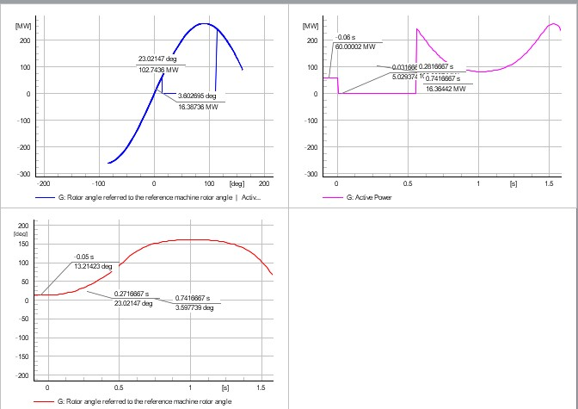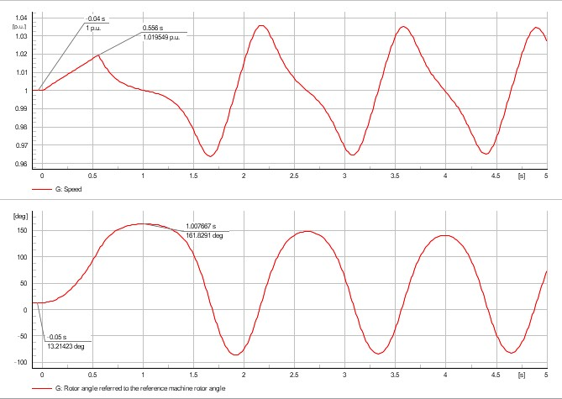

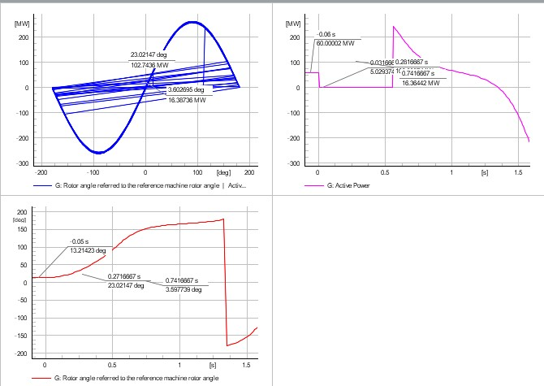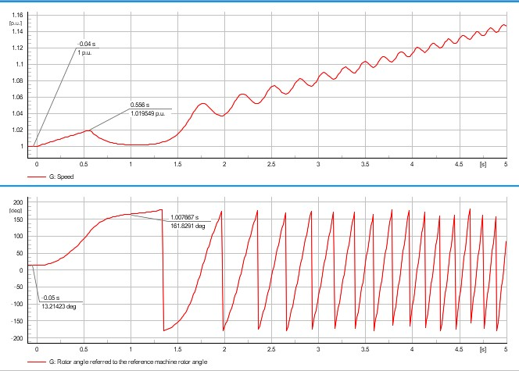

Figure 3: Graphs showing short circuit event at bus 2

Critical fault clearing time in the both Bus bars is.When the short circuit is in the busbar either Bus1 or Bus2, the system will lose its stability fast so the disturbance should be cleared within 0.556s to keep the system stable.

## Task 3:

In this task, the short circuit is placed in different location ranging from 5 to 95% of transmission line and critical fault clearing time is calculated using critical fault clearing DPL for the transmission line.

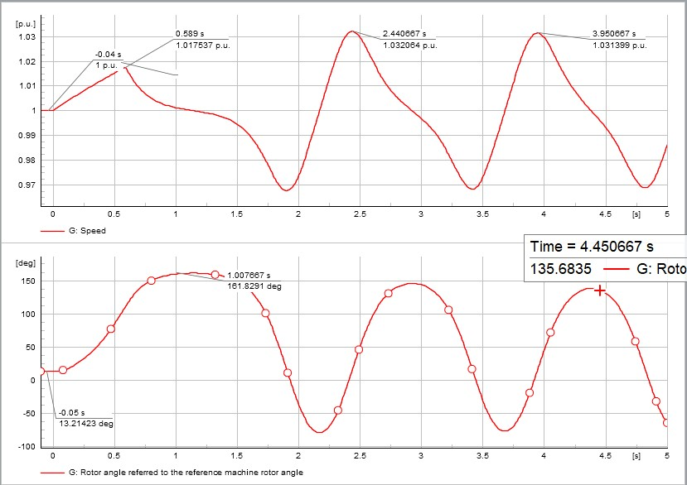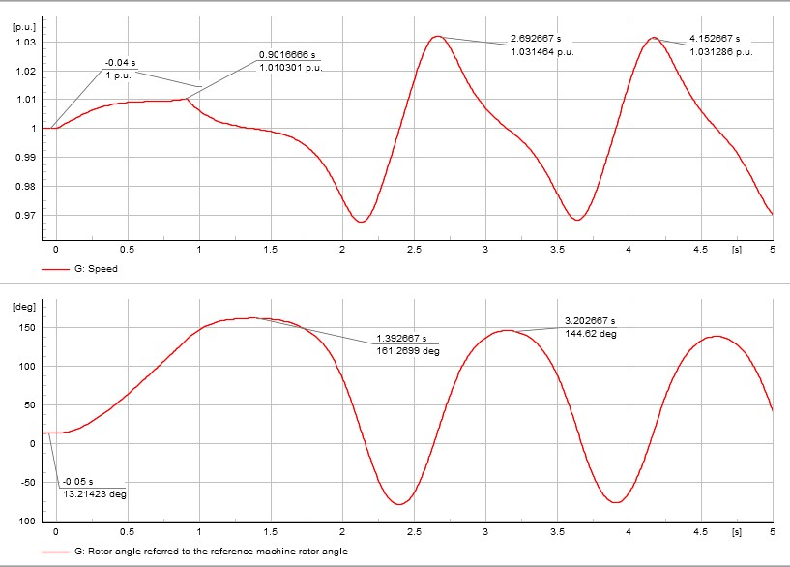

Figure 4: SC at 5% Figure 5: SC at 25%

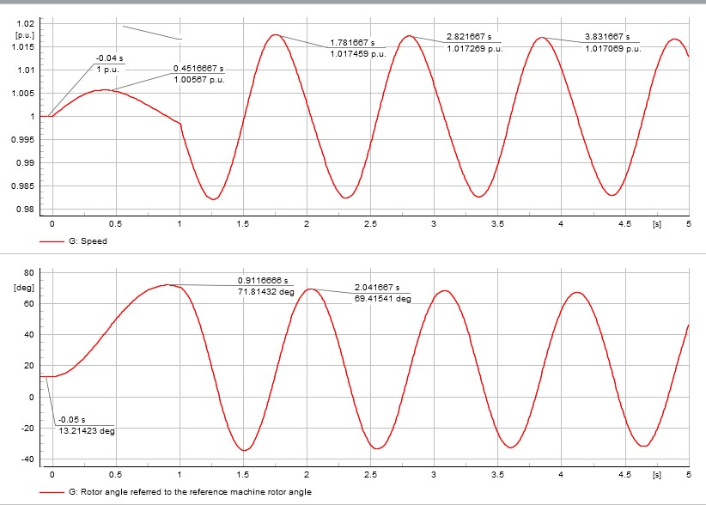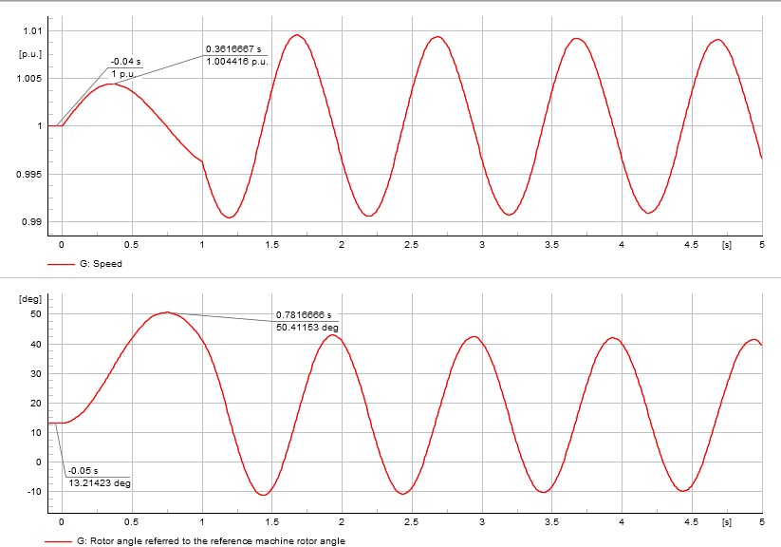

Figure 6: SC at 50% Figure 7: SC at 75%

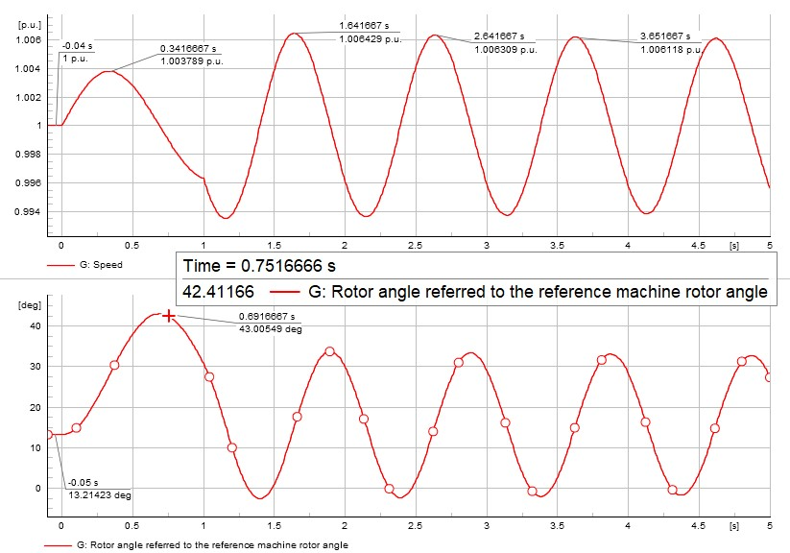

Figure 8: SC at 95%

Table . Critical Fault Clearing Time at Different Location of

|  |  |
| --- | --- |
| **Distances** | **Critical Fault Clearing Time** |
| 5% | 0.5896s |
| 25% | 0.9115s |
| 50% | 1s |
| 75% | 1s |
| 95% | 1s |

The system becomes stable rapidly when the fault is very near to the generator i.e for 5% and 25% and takes a little bit more time to return to stability for the faults far away for the generator i.e for 50% to 100%.

## Task 4:

**Table 2.** **Critical fault clearing time with different value of fault resistance**

|  |  |
| --- | --- |
| **Fault Resistance R_f [Ω]** | **Critical Fault Clearing Time CCT**  **[Sec]** |
| 0.00 | 0.5667 |
| 0.50 | 0.5799 |
| 1.00 | 0.6060 |
| 1.50 | 0.6350 |
| 2.00 | 0.6703 |
| 2.50 | 0.7095 |
| 3.00 | 0.7573 |
| 5.00 | 1 |
| 10.00 | 1 |

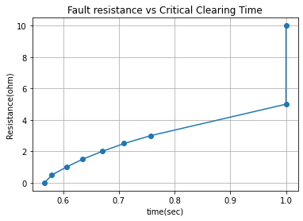

**Figure 2. Plot of Critical Clearing Time versus fault resistance**

From Table 2 and Figure 2, it is seen that, as the value of fault resistance increased the fault clearing time also got larger. When the system did not have any resistance value then the CCT was 0.5667s as the resistance started increasing the system’s ability to hold the disturbance without losing its stability improved as well with rising of CCT. At fault resistance , CCT was 0.7573s, and for the resistances larger than the 3 the value of CCT is 1s due to the set up of maximum fault clearing time in the script of DPL. When the fault resistance values are larger then the system can withstand the short circuit fault for a longer duration.

## Task 5:

**Table 3. Critical Fault Clearing Time with different values of rotational inertia**

|  |  |
| --- | --- |
| **Rotational Inertia H [Mjoule/MVA]** | **Critical Fault Clearing Time CCT**  **[Sec]** |
| 0.845 | 0.1777 |
| 2.1125 | 0.2802 |
| 4.225 | 0.3938 |
| 6.3375 | 0.4827 |
| 8.45 | 0.5567 |

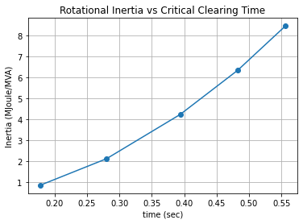

**Figure 3. Plot of Critical Fault Clearing Time versus rotational inertia**

From table 3 or figure 3 its clear that the critical fault clearing time increases with surge of the rotational inertia. When the value of interia is just then the short circuit should be cleared within 0.177s otherwise the system loses it’s stablilty. However as the value reaches the CCT reaches 0.556s. For the larger values of rotational inertia, the system will have greater stability under fault condition as the critical fault clearing time increases with inertia, finally reaching the constant CCT for very large value of rotataional inerita.

## References

1. Prof FGL “Assignment:Transient Stability – Critical fault clearing time.” 2021.
2. Prof FGL. *Github Repository*: [https://github.com/fglongatt/My_DIgSILENT_PowerFactory/tree/master/Time-Domain-rms (Links to an external site.)](https://github.com/fglongatt/My_DIgSILENT_PowerFactory/tree/master/Time-Domain-rms)
3. Prof FGL. *YouTube*: <https://www.youtube.com/channel/UCWq0TLOcCa2lNBi7ZBJFZZw>.
4. Prof FGL, Lecture Notes, Topic:”Rotor Angle Stability-Equal Area Criterion.”,2021.