**Assignment 3:** [**Small**](https://usn.instructure.com/courses/22857/assignments/51599) **Signal Stability**

## [Q1]

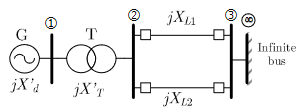

Figure 1: Single Line Diagram of SMIB

## We have;

f = 50 Hz

X’d = 0.20 pu

XT = 0.20 pu

XL1 = 0.15 pu

XL2 = 0.15 pu

p.f = 0.8 lagging

H = 8.45 MJoule/MVA

Pelec = 0.6 p.u

$\left|V_{∞}\right|$ = 1.0 p.u

**Task 1:**

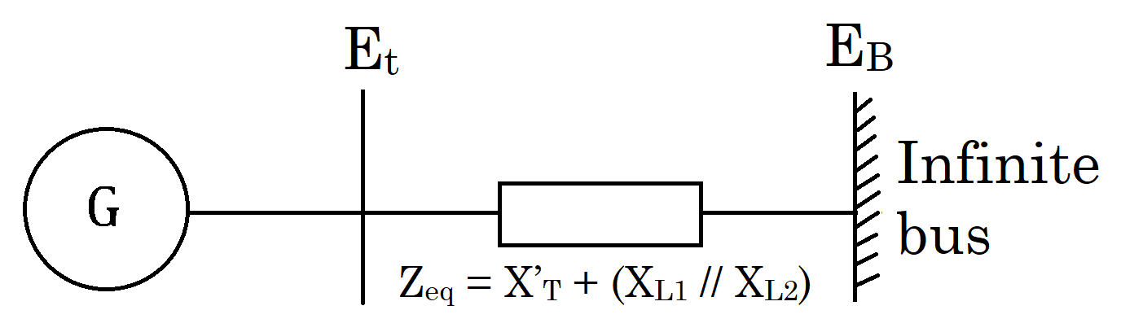

Figure 2: Thevenin Equivalent Circuit

Considering synchronous generator G represented by the classical model

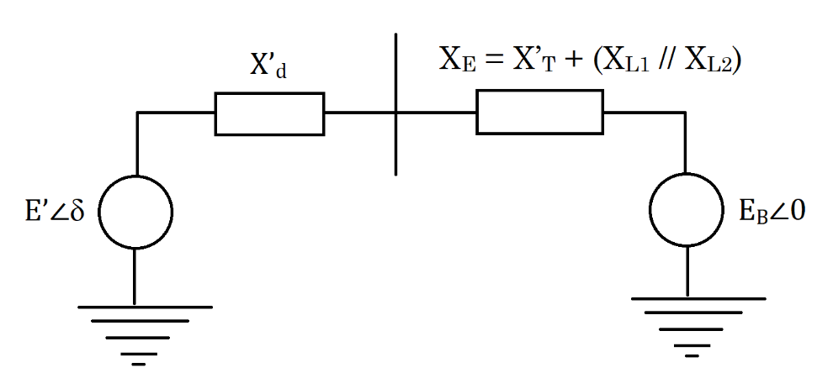

Figure 3: Equivalent Circuit

In the Figure 3, EB is the voltage of the infinite bus and E’ is the voltage of generator, and δ is the angle by which E’ leads EB.

Taking E’ as a reference, we can write,

$${\tilde{I}}_{t}=\frac{E^{'}∠0-E_{∞}∠δ}{jX_{t}}= \frac{E^{'}-E_{∞}(cosδ-jsinδ)}{jX_{t}}$$

Also,

$$\tilde{E'}= {\tilde{E^{'}}}_{t0}+jX_{d}^{'}{\tilde{I}}_{t0}$$

And, total reactance is,

$$X_{T}=X_{d}^{'}+X_{E}=X_{d}^{'}+(X_{T}+X_{L1}||X_{L2})$$

Apparent power of the generator is,

$$S^{'}=P+jQ=\tilde{E'}{\tilde{{I }^{*}}}_{t}=\frac{E^{'}E_{∞}Sinδ}{X_{T}}+j\frac{E^{'}(E^{'}-E_{∞}Cos δ)}{X_{T}}$$

$$S^{'}=\tilde{E^{'}}{\tilde{{I }^{*}}}_{t}$$

$$∴S^{'}=\frac{E^{'}E_{∞}Sinδ}{X_{T}}+j\frac{E^{'}(E^{'}-E_{∞}Cos δ)}{X_{T}}$$

Terminal power is same as active power when the resistance of the stator is neglected,

$$i.e T_{e}=P$$

$$∴T_{e}=\frac{E^{'}E_{∞}}{X_{T}}Sinδ$$

Linearinzing it we get,

$$∆T_{e}=\frac{∂T_{e}}{∂δ}∆δ$$

$$∴∆T_{e}=\frac{E^{'}E_{∞}}{X_{T}}Cosδ_{0}\left(∆δ\right)$$

From the equation of the motion,

$$p∆ω_{r}=\frac{1}{2H}(T_{m}-T_{e}-K_{D}Δω_{r})$$

$$pδ= ω_{0}Δω_{r}$$

Where, $$Δω_{r}=per unit speed deviation$$

$$δ=rotor angle (elec rad)$$

$$ω_{0}=rotor electrical speed (rad per sec⁡)$$

Linearizing the equation of motion and replacing value of $ΔT_{e}$ we get,

$$p∆ω_{r}=\frac{1}{2H}(ΔT_{m}-K_{s}Δδ-K_{D}Δω_{r})$$

Where, $K_{s}$ is synchronizing torque coefficient and is given by,

$$K_{s}=\frac{E^{'}E_{∞}}{X_{T}}Cosδ_{0}$$

Linearizing $2^{nd}$ equation,

$$p∆δ= ω_{0}Δω_{r}$$

Which results in,

$$\frac{d}{dt}\left[\begin{matrix}Δω_{r} \\ Δδ\end{matrix}\right]=\left[\begin{matrix}-\frac{K_{D}}{2H} & -\frac{K_{s}}{2H} \\ ω_{0} & 0\end{matrix}\right]\left[\begin{matrix}Δω \\ Δδ\end{matrix}\right]+\left[\begin{matrix}\frac{1}{2H} \\ 0\end{matrix}\right]ΔT_{m}$$

**Task 2:**

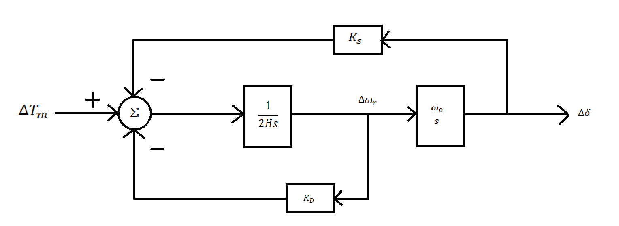

Figure 4: Block Diagram showing the performance of small signal

We have,

$$A=\left[\begin{matrix}-\frac{K_{D}}{2H} & -\frac{K_{s}}{2H} \\ ω_{0} & 0\end{matrix}\right]$$

$$B= \left[\begin{matrix}\frac{1}{2H} \\ 0\end{matrix}\right]$$

And from Figure 4,

$$∆δ=\frac{ω_{0}}{s}\left[\frac{1}{2Hs}\left(-K_{s}Δδ-K_{D}Δω_{r}+ΔT_{m}\right)\right]$$

$$or, ∆δ=\frac{ω_{0}}{s}\left[\frac{1}{2Hs}\left(-K_{s}Δδ-K_{D}\frac{sΔδ}{ω_{0}}+ΔT_{m}\right)\right]$$

$$∴s^{2}\left(Δδ\right)+\frac{K_{D}}{2H}s\left(Δδ\right)+\frac{K_{s}}{2H}ω_{0}\left(Δδ\right)=\frac{ω_{0}}{2H}ΔT_{m}$$

We have the characteristic equation,

$$s^{2}+\frac{K_{D}}{2H}s+\frac{K_{s}ω_{0}}{2H}=0$$

$$∴ s^{2}+2ζω_{n}s+ω_{n}^{2}=0$$

Where, $ω_{n}$ = Undamped natural frequency in $rad/s$ is given by,

$$ω_{n}= \sqrt{K_{s}\frac{ω_{0}}{2H} }$$

And $ζ$ = damping ratio is given by,

$$ζ=\frac{1}{2}\frac{K_{D}}{2Hω_{n}}=\frac{1}{2}\frac{K_{D}}{\sqrt{K_{s}2Hω_{0}}}$$

Eigenvalues of matrix A is,

$$λ_{1}= -ζω_{n}+ ω_{n}\sqrt{1- ζ^{2}}$$

$$λ_{2}= -ζω_{n}- ω_{n}\sqrt{1- ζ^{2}}$$

**Task 3:**

Given, $$λ_{i}=\left(σ_{i} ± jω_{i}\right), i=1,2$$

We know apparent power as,

$$S=\frac{P_{elec}}{pf}∠\cos^{-1}{(pf)}=\frac{0.6}{0.8}∠\cos^{-1}\left(0.8\right)=0.6+j0.45=0.75∠36.869 pu$$

And current and reactance are,

$$I=\frac{S^{*}}{V_{∞}^{*}}=\frac{0.75∠-36.869}{1}=0.75∠-36.869 pu$$

$$X_{T}=X_{d}^{'}+ X_{T}^{'}+(X_{L1}||X_{L2})=0.2+0.2+\left(\frac{0.15*0.15}{0.15+0.15 }\right)=0.475 pu$$

$$E^{'}=V_{∞}+jX_{T}I=\left(1∠0\right)+j0.475*\left(0.75∠-36.869\right)=1.214+j0.285=1.247∠13.214 pu$$

$$δ_{0}=13.214$$

$$ω_{0}=2πf=2π*50=314.159 Hz$$

$$K_{D}=0$$

$$K_{s}=\frac{E^{'}V_{∞}}{X_{T}}cosδ_{0}=\frac{1.247*1}{0.475}cos⁡(13.214)=2.555 pu torque/rad$$

We know,

$$A=\left[\begin{matrix}-\frac{K_{D}}{2H} & -\frac{K_{s}}{2H} \\ ω_{0} & 0\end{matrix}\right]$$

For $H=10\%H_{0}=0.1*8.45=0.845 MJoule/MVA$

$$A=\left[\begin{matrix}-\frac{K_{D}}{2H} & -\frac{K_{s}}{2H} \\ ω_{0} & 0\end{matrix}\right]=\left[\begin{matrix}0 & -\frac{2.555}{2*0.845} \\ 314.159 & 0\end{matrix}\right]=\left[\begin{matrix}0 & -0.151 \\ 314.159 & 0\end{matrix}\right]$$

i.e

$$\left[\begin{matrix}-λ & -0.151 \\ 314.159 & -λ\end{matrix}\right]=0$$

$$λ^{2}+47.438=0$$

Comparing above equation with $λ^{2}+2ζω_{n}λ+ω_{n}^{2}=0$

We get,

$$ζ=0$$

$$ω_{n}=\sqrt{47.438}=6.8875$$

So, the eigen values are,

$$λ_{1}, λ_{2}= -ζω_{n} ± ω_{n}\sqrt{1- ζ^{2}}$$

$$∴ λ_{1}, λ_{2}=0 ± 6.8875$$

Similarly,

For $H=25\%H_{0}=0.25*8.45=2.1125 MJoule/MVA$

$$A=\left[\begin{matrix}-\frac{K_{D}}{2H} & -\frac{K_{s}}{2H} \\ ω_{0} & 0\end{matrix}\right]=\left[\begin{matrix}0 & -\frac{1.684}{2*2.1125} \\ 314.159 & 0\end{matrix}\right]=\left[\begin{matrix}0 & -0.398 \\ 314.159 & 0\end{matrix}\right]$$

the eigen values are,

$$λ_{1}, λ_{2}= -ζω_{n} ± ω_{n}\sqrt{1- ζ^{2}}$$

$$∴ λ_{1}, λ_{2}=0 ± 11.19$$

For $H=50\%H_{0}=0.5*8.45=4.225 MJoule/MVA$

$$A=\left[\begin{matrix}-\frac{K_{D}}{2H} & -\frac{K_{s}}{2H} \\ ω_{0} & 0\end{matrix}\right]=\left[\begin{matrix}0 & -\frac{1.684}{2*4.225} \\ 314.159 & 0\end{matrix}\right]=\left[\begin{matrix}0 & -0.199 \\ 314.159 & 0\end{matrix}\right]$$

The eigenvalues are,

$$λ_{1}, λ_{2}= -ζω_{n} ± ω_{n}\sqrt{1- ζ^{2}}$$

$$∴ λ_{1}, λ_{2}=0 ± 7.913$$

For $H=75\%H_{0}=0.75*8.45=6.3375 MJoule/MVA$

$$A=\left[\begin{matrix}-\frac{K_{D}}{2H} & -\frac{K_{s}}{2H} \\ ω_{0} & 0\end{matrix}\right]=\left[\begin{matrix}0 & -\frac{1.684}{2*6.3375} \\ 314.159 & 0\end{matrix}\right]=\left[\begin{matrix}0 & -0.133 \\ 314.159 & 0\end{matrix}\right]$$

The eigenvalues are,

$$λ_{1}, λ_{2}= -ζω_{n} ± ω_{n}\sqrt{1- ζ^{2}}$$

$$∴ λ_{1}, λ_{2}=0 ± 6.46$$

For $H=100\%H_{0}=1*8.45=8.45 MJoule/MVA$

$$A=\left[\begin{matrix}-\frac{K_{D}}{2H} & -\frac{K_{s}}{2H} \\ ω_{0} & 0\end{matrix}\right]=\left[\begin{matrix}0 & -\frac{1.684}{2*8.45} \\ 314.159 & 0\end{matrix}\right]=\left[\begin{matrix}0 & -0.099 \\ 314.159 & 0\end{matrix}\right]$$

The eigenvalues are,

$$λ_{1}, λ_{2}= -ζω_{n} ± ω_{n}\sqrt{1- ζ^{2}}$$

$$∴ λ_{1}, λ_{2}=0 ± 5.595$$

Table 1: Eigen values of different rotational inertia

|  |  |  |
| --- | --- | --- |
| **H [Mjoule/MVA]** | **λ1** | **λ2** |
| 0.845 | j17.693 | - j17.693 |
| 2.1125 | j11.19 | - j11.19 |
| 4.225 | j7.913 | - j7.913 |
| 6.3375 | j6.46 | - j6.46 |
| 8.45 | j5.595 | - j5.595 |

Figure 5. Eigenvalues vs Rotational inertia

**Task 4:**

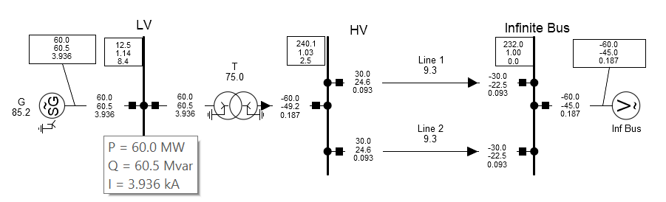

Figure 6: Powerfactory Model of SMIB

**Task 5:**

**(i)**

Table 2: Results from PowerFactory

|  |  |  |  |  |
| --- | --- | --- | --- | --- |
| Name | Real part (1/s) | Imaginary part (rad/s) | Damped Frequency (Hz) | Damping Ratio |
| Mode 00001 | -0.017751504 | 6.892037899 | 1.0969019 | 0.002575645 |
| Mode 00002 | -0.017751504 | -6.892037899 | 1.0969019 | 0.002575645 |

**(ii)**

From simulation of SMIB in DigSILENT PowerFactory, the A matrix is,

$$A=\left[\begin{matrix}-0.0355 & -0.1512 & 0.1512 \\ 314.1593 & 0 & 0 \\ 0 & 0 & 0\end{matrix}\right]$$

And A matrix from Task 2 calculation is:

$$A=\left[\begin{matrix}0 & -0.099 \\ 314.159 & 0\end{matrix}\right]$$

There is a different in the A matrix from simulation and calculation because the damping torque coeffiecient is considered zero in Task 3 calculations.

**(iii)**

Table 3: Results comparision PowerFactory and calculations

|  |  |  |
| --- | --- | --- |
| **Eigenvalues** | **Real Part** | **Imaginary Part** |
| **λ1 from calculation** | 0 | 5.595 |
| **λ2 from calculation** | 0 | **-** 5.595 |
| **λ1 from simulation** | -0.018 | 6.892 |
| **λ2 from simulation** | -0.018 | -6.892 |

There is a different in the eigenvalues from simulation and calculation because in the calculations done in Task 3, the real part of the eigenvalues are zero but in the simulations it is not hence the matrix is different in both the cases.

**References**

[1] Prabha Kundra, “Power System Stability and Control”, McGraw-Hill, Inc. 1994

[2] Prof FGL, “Assignment 3: Small signal stability”, 2021