**Problem statement:**

**In urban areas, traffic congestion significantly delays emergency response times for vehicles such as ambulances and fire services. Traditional traffic light systems are static and do not have the capability to dynamically prioritize emergency vehicles. As a result, emergency vehicles often get stuck at intersections, losing valuable time in critical situations.The challenge is to develop an intelligent traffic signal control system that can identify approaching emergency vehicles and automatically adjust traffic signals to give them priority.**

**Implementation:**

Implementing an intelligent traffic signal system that prioritizes emergency vehicles, such as ambulances, involves several steps. Below is a comprehensive guide that outlines the process, protocols, and considerations for integrating NodeMCU, MAX78000, and other necessary components.

Step 1: Define the System Architecture

Components:

1. NodeMCU (ESP8266/ESP32): Used in the ambulance for communication and GPS tracking.
2. MAX78000: Installed at the traffic signal for processing and control.
3. GPS Module: For the NodeMCU to determine the ambulance's location.
4. Traffic Signal Controller: The hardware that manages the traffic lights.

**Communication Protocol:**

Wireless Communication: Use Wi-Fi, LoRa, or radio frequency (e.g., MQTT over Wi-Fi) for communication between the NodeMCU and MAX78000.

Step 2: Set Up NodeMCU

Hardware Connections:

1. Connect the GPS module to the NodeMCU.
2. Ensure the NodeMCU has power and is properly configured.

**Image capture: Example -stone paper siser:**

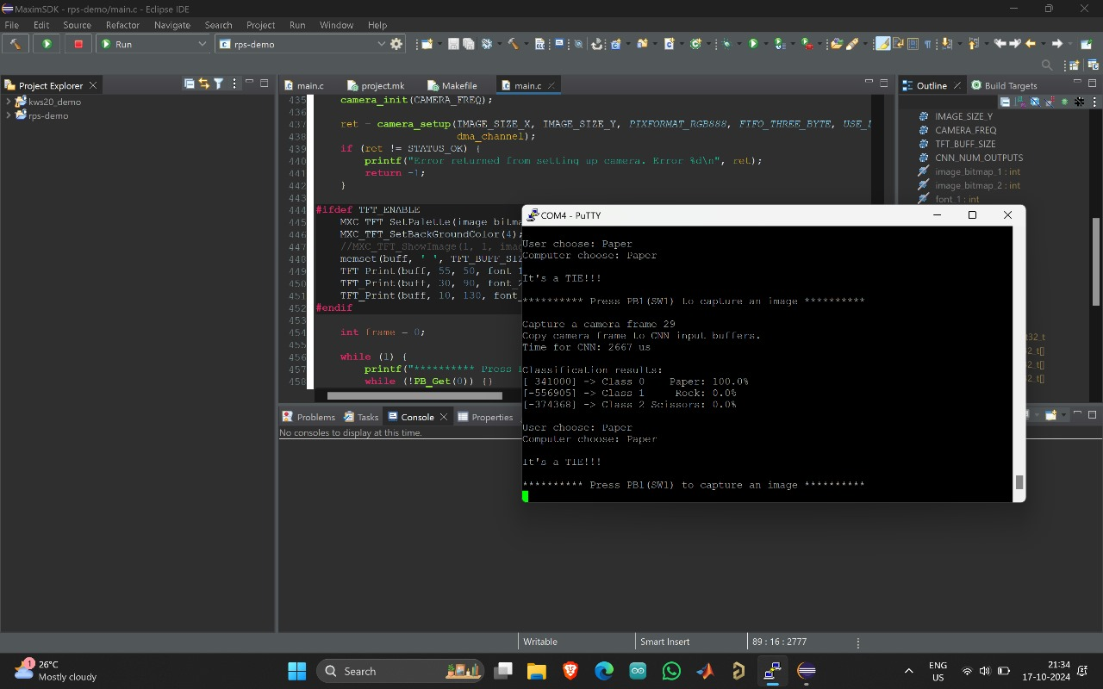

**Audio listner:Example -word :**

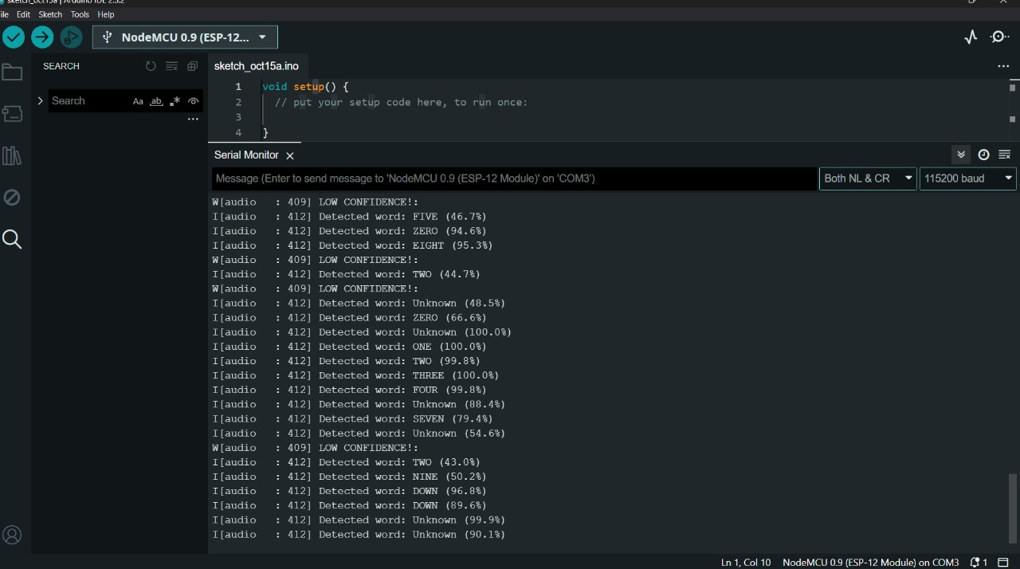

**How the System Works:**

**NodeMCU in Ambulance:**

**Continuously tracks the ambulance's GPS location.**

**When the ambulance approaches a traffic signal (within 100 meters), the NodeMCU sends a message (e.g., over Wi-Fi or radio) to the MAX78000 at the traffic signal.**

**MAX78000 at Traffic Signal:**

**Receives the message from the ambulance (via NodeMCU) and changes the traffic light to green for the ambulance’s lane.**

**Optionally, the MAX78000 can also run sound or image recognition models to detect an ambulance and override regular traffic signal timings if necessary.**

**Communication Between NodeMCU and MAX78000:**

**Wireless Communication (Wi-Fi or Radio): The NodeMCU in the ambulance will use wireless communication (like Wi-Fi, LoRa, or radio frequency) to notify the MAX78000 at the traffic signal controller.**

**Proximity Detection: The NodeMCU calculates the distance to the signal using GPS, and when within the proximity range (e.g., 100 meters), it sends a "proximity alert" to the MAX78000 to change the light to green.**

**Optional: Adding Backup Detection at Traffic Signals**

**In case the GPS communication from the NodeMCU fails, you can use:**

**Sound Detection: The MAX78000 at the traffic signal can detect ambulance sirens using its AI processing.**

**Image Recognition: You can deploy a camera near the traffic signal, and the MAX78000 can run image recognition to detect approaching ambulances visually.**

**Final Setup:**

**NodeMCU in the Ambulance:**

**Connected to GPS for location tracking.**

**Sends the ambulance location and proximity alert to the traffic signal controller when the ambulance is near.**

**MAX78000 at the Traffic Signal:**

**Receives proximity alerts from the ambulance.**

**Controls the traffic signal lights based on proximity or AI-based detection of the ambulance.**