**NCC MANAGEMENT**

Submitted by

### DHANUSHYA S

### (1P20MC012)

In partial fulfillment of the requirements for the award of the Degree of

### MASTER OF COMPUTER APPLICATIONS

From Bharathiar University, Coimbatore.

Under the internal supervision of

##### Dr. G. Pandiyan, M.Sc., M.Phil., B.Ed., Ph.D.,

### Associate Professor

****

**SCHOOL OF COMPUTER STUDIES MASTER OF COMPUTER APPLICATIONS**

**RATHNAVEL SUBRAMANIAM COLLEGE OF ARTS AND SCIENCE (AUTONOMOUS)**

**Sulur, Coimbatore – 641 402.**

**March 2022.**

**RATHNAVEL SUBRAMANIAM COLLEGE OF ARTS AND SCIENCE (AUTONOMOUS)**

**Sulur, Coimbatore – 641 402.**

**School of Computer Studies Department of Computer Applications (MCA)**

****

**March 2022.**

**Register Number: 1P20MC012**

Certified bona fide original record work done by **DHANUSHYA S**

**Guide HoD**

Submitted for the project Evaluation and Viva voce held on

## Internal Examiner External Examiner

# CERTIFICATE

This is to certify that the project work titled **“NCC MANAGEMENT”** using **React Native and** **Node.**  is a bona fide work of

**DHANUSHYA (1P20MC012)**

He / She has successfully completed the project work at **<Company Name>** during the period from Feb 2022 to May 2022 towards the partial fulfilment of the requirement for the award of MCA prescribed by RVS College of Arts and Science, Sulur.

**<Authorized Signature>**

**<Company Seal>**

# DECLARATION

I, **DHANUSHYA S**, hereby declare that the project entitled **NCC MANAGEMENT,** submitted to the School of Computer Studies, RathnavelSubramaniam College of Arts and Science, in partial fulfillment of the requirements for the award of the Degree of Master of Computer Applications is a record of original project work done by me during the period Feb 2022 - May2022 under the internal supervision of **<Internal Supervisor Name with Qualification>, ASSOCIATE PROFESSOR, RATHNAVEL SUBRAMANIAM COLLEGEOF ARTS AND SCIENCE (AUTONOMOUS)** From Bharathiar University, Coimbatore.

Signature of the Candidate

# ACKNOWLEDGEMENTS

I express my sincere thanks to our Managing trustee **Dr.K.Senthil Ganesh MBA (USA)., MS (UK)., Ph.D.,** for providing us with the adequate faculty and laboratory resources for completing my project successfully.

I take this as a fine opportunity to express my sincere thanks to **Dr. T. Sivakumar M.Sc., M. Phil., Ph.D., Principal,** RathnavelSubramaniam College of Arts And Science (Autonomous) for giving me the opportunity to undertake this project.

I express my sincere thanks to **Dr.D.Francis Xavier Christopher., M.Sc(CS)., M.Phil.,Ph.D., Director (Administration), Department of Computer Science** for the help and advice throughout the project.

I express my sincere thanks to **Dr. S. Yamini., M. Sc(CC)., M. Phil., Ph.D., Director (Academic), Department of Computer Science** for her valuable guidance and prompt correspondence throughout the curriculum to complete the project.

I express my sincere thanks to **Mrs. Grace Padma C., MCA., M.Phil., MBA., Head of the Department(MCA)** for her support and advice throughout the project.

I express my gratitude to **<Internal Supervisor Name with Qualification>Associate Professor(MCA)** for his valuable guidance, support, encouragement and motivation rendered by her throughout this project.

Finally, I express my sincere thanks to all other staff members and my dear friends, and all dear and near for helping me to complete this project.

### DHANUSHYA S

# ABSTRACT

Unity and Discipline is the motto of the NCC and in living up to its motto, the NCC strives the biggest cohesive forces of the nation. Its primary focus is to bring together the

youth coming from different parts of the country and moulding them to be a worthy .

Now a days mobile applications have become a part of every human being’s day-to-day aspect of life. All mobile applications are specifically designed for a purpose and each it has its own advantages and disadvantages.

In this project , I have planned the NCC management recorded the data in digitally using this app.

The data will be stored manually.

Now a days all comes in digitally. so we have to update our requirement that’s why I create this app.

In this project admin only can register the cadet details .cadet can login and view the details.

Admin can add and update cadet details . This project have achievement banner .

This banner view all the years of cadet achievements are placed.

This project have a event management form .this from is used to where the event was conducted and participants and chief guest details are stored in data .

Then how much they are spend by this event all are recoded.

The uses of NCC management is stored the cadet details ,event management data maintain and achievements details are stored.

Mobile applications refer to applications for mobile devices that require only a Web browser to be installed on the device but are not written specifically for the device.

The future is widely unknown with opportunities for marketing, networking, and research to evolve in the coming decades.

Frontend Tools/ Technology: React Native

Backend Tools/ Technology: Node js

DataBase Technology: Mongodb

Git repository link:

Figma link: https://www.figma.com/file/yCCuvuBJRxdFI12wZkIuDS/Untitled?node-id=0%3A

**CONTENTS**

Certificate 3

Declaration 4

Acknowledgements 5

Abstract 6

**CHAPTER 1**

1.Introduction 9

1.1 An overview of the project 9

1.2 Mission of the project 11

1.3 Background study 12

1.3.1 A study of the existing system 12

**CHAPTER 2**

2.System Analysis 13

2.1 A study of the proposed system 13

2.2 User requirement specification 14

2.2.1 Major modules 15

2.2.2 Sub modules 16

2.3 Software requirement specification 18

2.4 System specification 27

2.4.1 React.js 27

2.4.2 Node.js 29

2.4.3 Hardware configuration 32

2.4.4 Software configuration 32

**CHAPTER 3**

3.System design and development 33

3.1 Fundamentals of design concepts 33

3.1.1 Abstraction 33

3.1.2 Refinement 33

3.1.3 Modularity 34

3.2 Usecase Diagram 35

3.3 Table design 42

3.4 Input design 48

3.5 Output design 49

3.6 Development approach 49

**CHAPTER 4**

4.Testing and implementation 50

4.1 Testing 50

4.1.1 System testing 50

4.1.2 White box testing 50

4.1.3 Unit testing 51

4.2 System implementation 51

4.2.1 System maintenance 52

**CHAPTER 5**

5.Conclusion

5.1 Directions for future enhancements references 53

BIBLIOGRAPHY 53

**ANNEXURE**

ANNEXURE - A - Output design 55

ANNEXURE - B - Source code 74

# 

# CHAPTER 1

**CHAPTER 1**

## INTRODUCTION

### An Overview of the Project

In this project had basic features such as store cadet details and event management conducted by NCC management ,Achievement banners are there to view every year of cadet achievements and more.

These are the basic application features, after created this we are going to add some limitation to improve this application for managing content to display to student’s account. Like visible only education related contents and user can post only relate to those contents.

In this project , I have planned the NCC management recorded the data in digitally using this app. The data will be stored manually.

Now a days all comes in digitally. so we have to update our requirement that’s why I create this app.

In this project admin only can register the cadet details .cadet can login and view the details.

Admin can add and update cadet details . This project have achievement banner .

This banner view all the years of cadet achievements are placed.

This project have a event management form .

This from is used to where the event was conducted and participants and chief guest details are stored in data .

Then how much they are spend by this event all are recoded.

The uses of NCC management is stored the cadet details ,event management data maintain and achievements details are stored.

There are many different types of mobile apps out there, some are static and rarely updated, while others are responsive and have a great deal of interactivity.

Mobile applications refer to applications for mobile devices that require only a Web browser to be installed on the device but are not written specifically for the device.

We are going to build this application with React native for User interface and Node Js

for Backend.

React native works with existing code, is used by developers and organizations around the world, and is free and open source.

It is a like SaaS (software as a service) solution and stores all your data in the Mongodb(secure servers). This means you can access all your materials via on our NCC MANAGEMENT anytime, anywhere with ease.

### Mission of the Project

In this project , I have planned the NCC management recorded the data in digitally using this app.

The data will be stored manually.

This project have one from is used to where the event was conducted and participants and chief guest details are stored in data.

In this project had basic features such as store cadet details and event management conducted by NCC management ,Achievement banners are there to view every year of cadet achievements and more.

### Background Study

There are many different types of mobile apps out there, some are static and rarely updated, while others are responsive and have a great deal of interactivity. Apps, specifically, function like downloadable apps, but all from the comfort of our phone’s browser.

These are the basic application features, after created this we are going to add some limitation to improve this application for managing content to display to student’s account. Like visible only education related contents and user can post only relate to those contents.

In this project , I have planned the NCC management recorded the data in digitally using this app. The data will be stored manually.

Now a days all comes in digitally. so we have to update our requirement that’s why I create this app.

### A Study of the Existing System

# The NCC management system have a studies related training app .In this app I have to planned to store the cadet details and store the event management work organized by NCC management

These are the basic application features, after created this we are going to add some limitation to improve this application for managing content to display to student’s account. Like visible only education related contents and user can post only relate to those contents.

# CHAPTER 2

# 

**CHAPTER 2**

## SYSTEM ANALYSIS

### A Study of the Proposed System

The aim of proposed system is to develop NCC MANAGEMENT app with system of improved facilities. The proposed system can overcome all the limitations of the existing system. The existing system has several disadvantages and many more difficulties to work well. The proposed system tries to eliminate or reduce these difficulties up to some extent. The proposed system will help the cadet and admin to reduce the workload. The advantages are

* + 1. The system is very simple in design and the system requires very low system resources.
    2. Minimum time needed for the various processing

1. Greater efficiency
2. Better service
3. User friendliness and interactive

### User Requirement Specification

This document is prepared in order to determine the user requirement specification for **NCC MANAGEMENT**. We can connect to the students via this system. For all these first we have to create an account in our application by providing required data needed for it.

In this section the background description of the system should have will provided.

##### Product Prospective:

This is an independent and wide network system. Every cadet can use it without any cost. People from different places of the area can connect to each other via this system.

##### Product Function:

After creating an account using this app cadet can login and view all the details them. After login cadet can view the profile they view their own details .then see the every year of cadet achievements banners .

##### User Characteristics:

This app does not require any computer knowledge to use it. Anyone can use it very easily.

##### Design And Implementation:

Being a NCC MANAGEMENT APP it's design should be perfect an attractive. It should be secure enough So that the cadet’s data and their personal information’s should not be leaked and those should be securely preserved in the system.

### Major Modules

##### ADMIN

A social media administrator serves as the brains behind an organization's social media platforms. He writes and curates content designed to engage followers and promote the brand in a positive manner. A combination of marketing skills and social media expertise is required to do the job well. Admin has a separate application to manage users / users’ data.

##### CADET

Social media users on education refers to the practice of using [social](https://en.wikipedia.org/wiki/Social_media) [media](https://en.wikipedia.org/wiki/Social_media) platforms as a way to enhance the [education](https://en.wikipedia.org/wiki/Education) of students. Social media is defined as a group of Internet-based applications that build on the ideological and technological foundations of [Web 2.0](https://en.wikipedia.org/wiki/Web_2.0), and that allow the creation and exchange of [user-generated content](https://en.wikipedia.org/wiki/User-generated_content). User has a separate app to explore their contents.

### 

### Sub Modules

**ADMIN SUB MODULES**

* + - * Create / Login account
      * Register cadet details
      * Event management form
      * Achievement banner
      * View Cadet Details

### CADET SUB MODULES

* + - * + Login account
        + Achievement banner
        + Change password

### Software Requirement Specification

##### ADMIN

In this section all software requirements will be explain some information to the admin.

* Create / Login account

The admin can simply sign in using click tech admin application account or create a new account by providing required personal information about himself/herself. After creating the account, it will display account create successfully.

* Register cadet details

The admin only can register and update the cadet details using cadet enrollment screen .Cadet can not register the personal details. If admin register the cadet details it gives the default password .then cadet login to change the password

* + - * Event management form

# This project have a event management form .this from is used to where the event was conducted and participants and chief guest details are stored in data .

* + - * Achievement banner

The achievement banner is view all the every year of cadet achievement images are viewed . The images are stored by admin only .

* + - * View Cadet Details

Admin have to view every cadet details separately and view one by one .if any changes admin only update the cadet details . In this very section the admin can update edit their profile information.

##### CADET

In this section all software requirements will be explain some information to the user.

* + - * Login Account

The admin have to register the cadet details. Admin give the default id and password. Cadet login then change the new password from the security purpose.

* + - * Achievement banner

The achievement banner is view all the every year of cadet achievement images are viewed . The images are stored by admin only .

* + - * + Change password

The change password is if the user only know the id and password so the default password will changed by cadet then it will worked.

### System Specification

### Hardware Configuration

##### MOBILE:

Device : Mobile

Type : Android

RAM : 2GB

ROM : 32GB

### Software Configuration

##### MOBILE:

Operating System : Android

Android Version : 12

Click Tech Application version : 1.0.0

**CHAPTER 3**

**CHAPTER 3**

## 3. SYSTEM DESIGN AND DEVELOPMENT

### Fundamentals of Design Concept

The design concepts provide the software designer with a foundation from which more sophisticated methods can be applied. A set of fundamental design concepts has evolved. They are as follows:

### Abstraction

Abstraction is the process or result of generalization by reducing the information content of a concept or an observable phenomenon, typically in order to retain only information which is relevant for a particular purpose.

### Refinement

It is the process of elaboration. A hierarchy is developed by decomposing a macroscopic statement of function in a step-wise fashion until programming language statements are reached. In each step, one or several instructions of a given program are decomposed into more detailed instructions. Abstraction and Refinement are complementary concepts.

### Modularity

Software architecture is divided into components called modules.

USECASE DIAGRAM

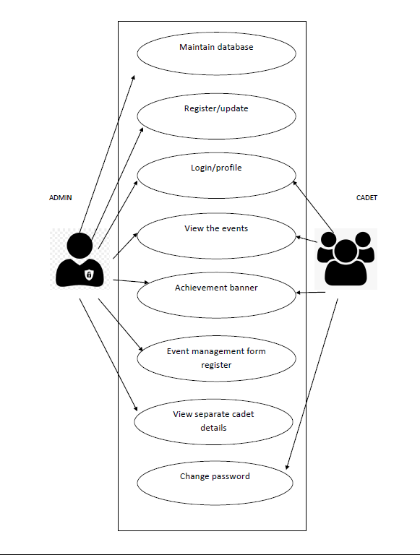

* 1. **Input Design**

In an information system, input is the raw data that is processed to produce output. During the input design, the developers must consider the input devices such as PC, MICR, OMR, etc.

Therefore, the quality of system input determines the quality of system output. Well- designed input forms and screens have following properties

* + - * + It should serve specific purpose effectively such as storing, recording, and retrieving the information.
        + It ensures proper completion with accuracy.
        + It should be easy to fill and straightforward.
        + It should focus on user’s attention, consistency, and simplicity.
        + All these objectives are obtained using the knowledge of basic design principles regarding

##### ADMIN LOGIN SCREEN:

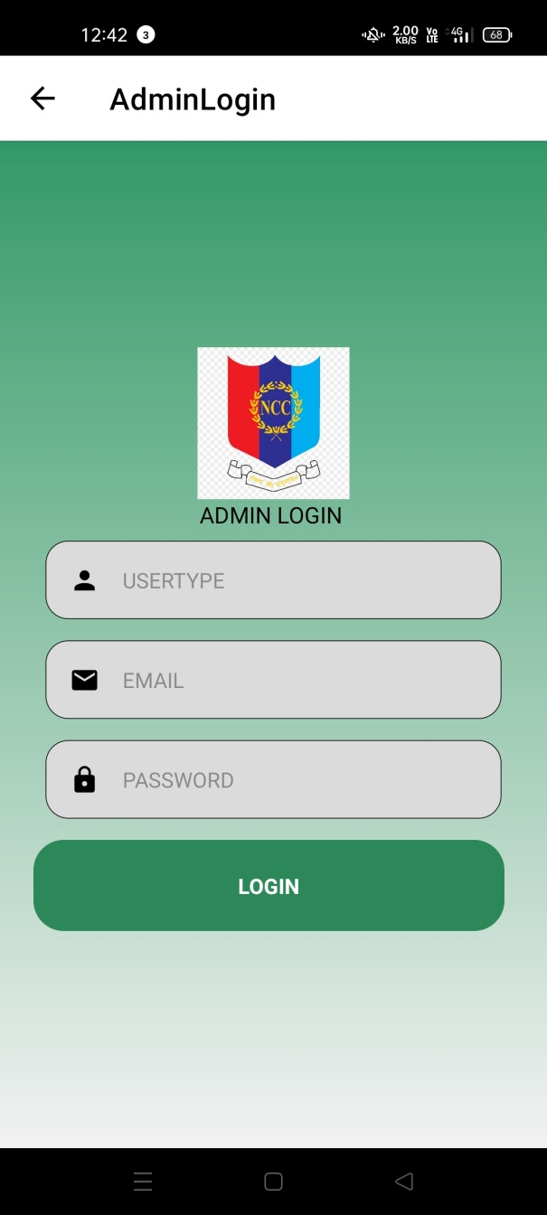

* Enter the correct emailId and password and then login have usertype if usertype is user means navigate the admin profile screen
* Click login button to login to your account
* Admin have a separate login page.

##### CADET LOGIN SCREEN:

##### Screenshot_2022-04-19-12-42-39-60_f73b71075b1de7323614b647fe394240.jpg Screenshot_2022-04-19-12-41-39-17_f73b71075b1de7323614b647fe394240.jpg

* Enter the correct Regiment and password and then login have usertype if usertype is cadet means navigate the cadet profile screen
* Click login button to login to your account .
* It have change password screen, admin give a default password screen if cadet have to change the password.
* Cadet have a separate login page.

##### CADET RENROLLMENT SCREEN AND UPDATE SCREEN:

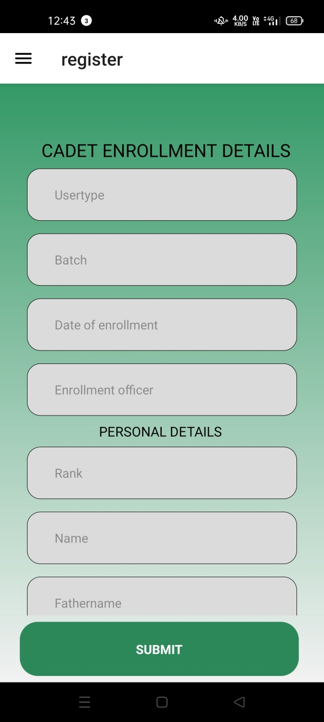 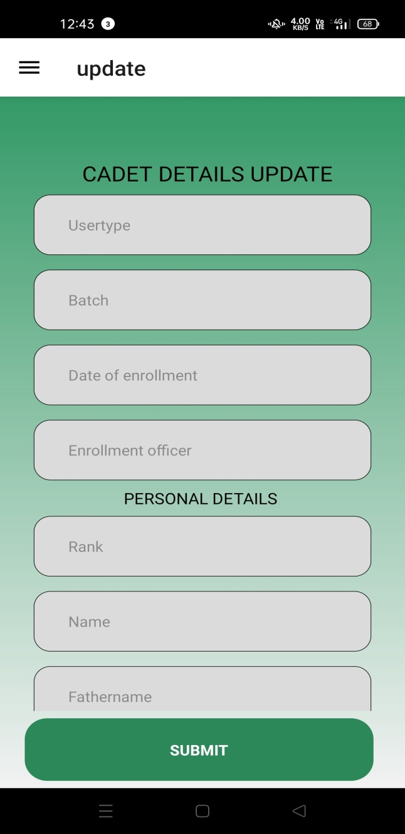

* Enter all the details in the textbox and click registered button to register a new cadet
* Admin only add the cadet register and update cadet only view login screen

##### Objectives for Input Design

The objectives of input design are

* To design data entry and input procedures
* To design source documents for data capture or devise other data capture methods
* To design input data records, data entry screens, user interface screens, etc.
* To use validation checks and develop effective input controls.

##### Data Input Methods

It is important to design appropriate data input methods to prevent errors while entering data. These methods depend on whether the data is entered by customers in forms manually and later entered by data entry operators, or data is directly entered by users on the PCs.

A system should prevent user from making mistakes by

* + - * + Clear form design by leaving enough space for writing legibly.
        + Clear instructions to fill form.
        + Clear form design.

Some of the popular data input methods are

* Online data input method
* Computer readable forms
* Interactive data input

##### Input Integrity Controls

Input integrity controls include a number of methods to eliminate common input errors by end-users. They also include checks on the value of individual fields; both for format and the

completeness of all inputs.

Audit trails for data entry and other system operations are created using transaction logs which gives a record of all changes introduced in the database to provide security and means of recovery in case of any failure.

### Output Design

The design of output is the most important task of any system. During output design, developers identify the type of outputs needed, and consider the necessary output controls and prototype report layouts.

##### Objectives of Output Design

The objectives of input design are

* + - * + To develop output design that serves the intended purpose
        + To develop the output design that meets the end user’s requirements.
        + To deliver the appropriate quantity of output.
        + To form the output in appropriate format and direct it to the right person.
        + To make the output available on time for making good decisions.

Let us now go through various types of outputs

ADMIN AND CADET PROFILE SCREEN:

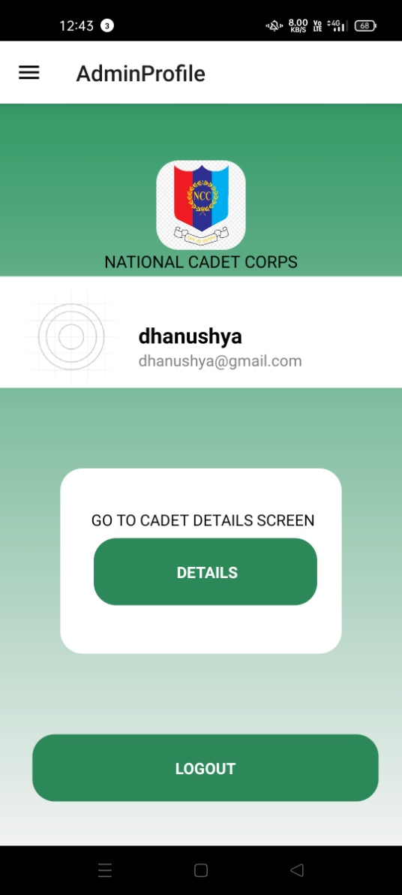 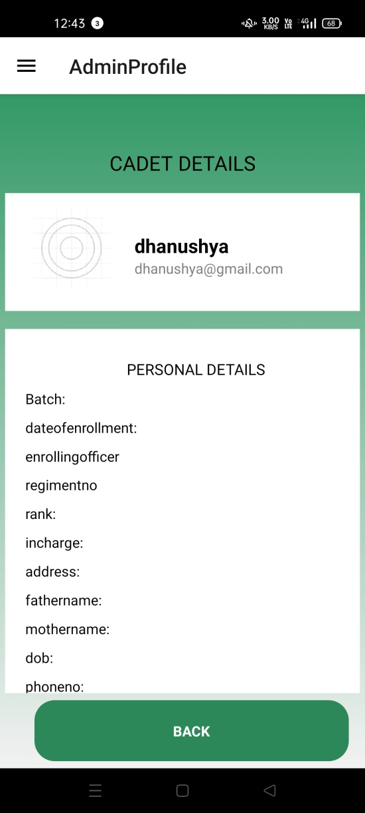

 

* With profile page you can see your details and you can logout
*   have separate profile for admin and cadet because it have different content

CADET LIST AND CADET DETAILS:

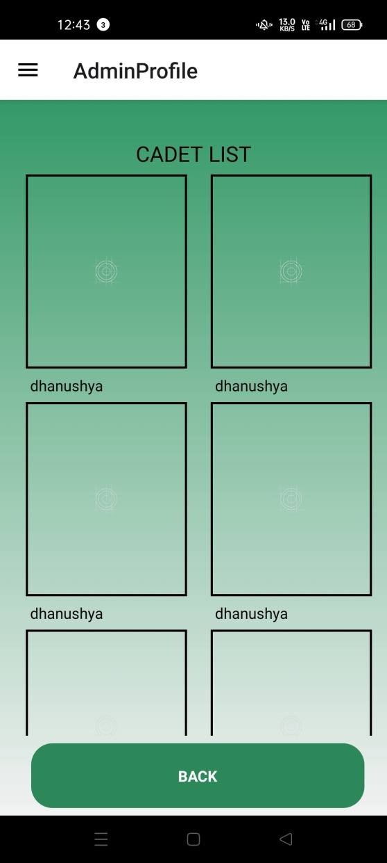 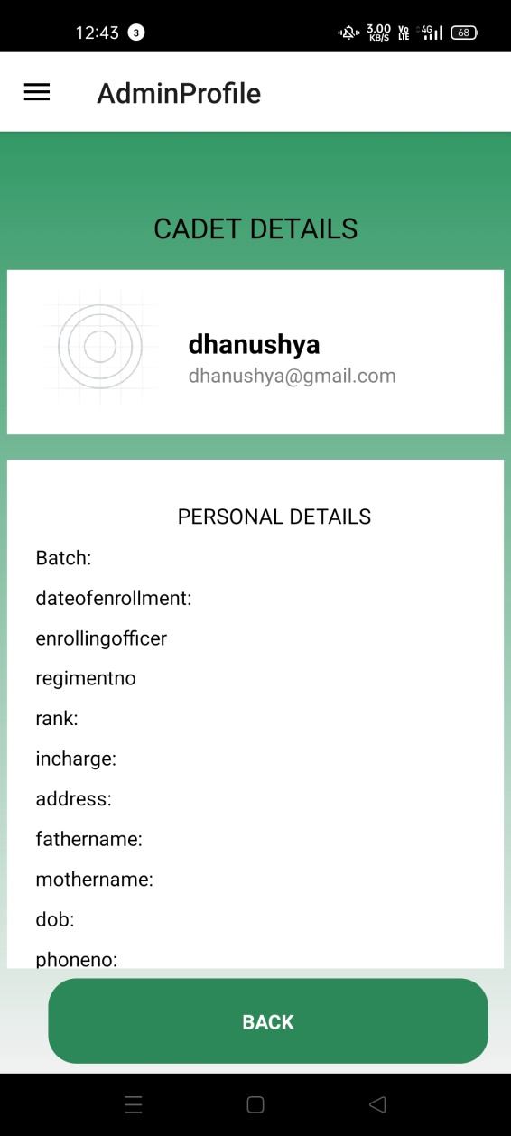

* This screen is view all the cadet list
* if it click then go to the cadet details screen that display the cadet full details

##### External Outputs

Manufacturers create and design external outputs for printers. External outputs enable the system to leave the trigger actions on the part of their recipients or confirm actions to their recipients.

Some of the external outputs are designed as turnaround outputs, which are implemented as a form and re-enter the system as an input.

##### Internal outputs

Internal outputs are present inside the system, and used by end-users and managers.

They support the management in decision making and reporting.

There are three types of reports produced by management information −

**Detailed Reports** − They contain present information which has almost no filtering or restriction generated to assist management planning and control.

**Summary Reports** − They contain trends and potential problems which are categorized and summarized that are generated for managers who do not want details.

**Exception Reports** − They contain exceptions, filtered data to some condition or standard before presenting it to the manager, as information.

### Development Approach

##### [Agile Model](https://www.javatpoint.com/software-engineering-agile-model)

Agile methodology is a practice which promotes continues interaction of development and testing during the SDLC process of any project. In the Agile method, the entire project is divided into small incremental builds. All of these builds are provided in iterations, and each iteration lasts from one to three weeks.

Any agile software phase is characterized in a manner that addresses several key assumptions about the bulk of software projects:

* It is difficult to think in advance which software requirements will persist and which will change. It is equally difficult to predict how user priorities will change as the project proceeds.
* For many types of software, design and development are interleaved. That is, both activities should be performed in tandem so that design models are proven as they are created. It is difficult to think about how much design is necessary before construction is used to test the configuration.
* Analysis, design, development, and testing are not as predictable (from a planning point of view) as we might like.

##### [Iterative Model](https://www.javatpoint.com/software-engineering-iterative-model)

It is a particular implementation of a software development life cycle that focuses on an initial, simplified implementation, which then progressively gains more complexity and a broader feature set until the final system is complete. In short, iterative development is a way of breaking down the software development of a large application into smaller pieces.

# 

# CHAPTER 4

**CHAPTER 4**

## TESTING AND IMPLEMENTATION

**CHAPTER 5**

**CHAPTER 5**

## 5.CONCLUSION

* + - * + The project entitled " NCC MANAGEMENT" is developed using React native front end and Node Js is back end.
        + This project covers only the basic features required. Moreover, extra features can be identified and incorporated in the future.
        + This project was aimed at this and it successfully achieved within the limited time period.

### Directions for Future Enhancement References

* The future enhancement of NCC management is now the admin only can add and update the cadet details .The cadet only can login and view the data .
* This project I was developed the event management form. In future i will develop event condected expenses process also added . that expenses details handled by admin that data stored in database

# BIBLIOGRAPHY

<https://www.w3schools.blog/difference-between-reactnative-and-reactjs>

<https://codesandbox.io/s/q4qymyp2l6>

<https://stackoverflow.com/questions/tagged/react-native>

<https://reactnative.dev/docs/getting-started>

# ANNEXURE

## ANNEXURE – A: OUTPUT DESIGN

### MOBILE

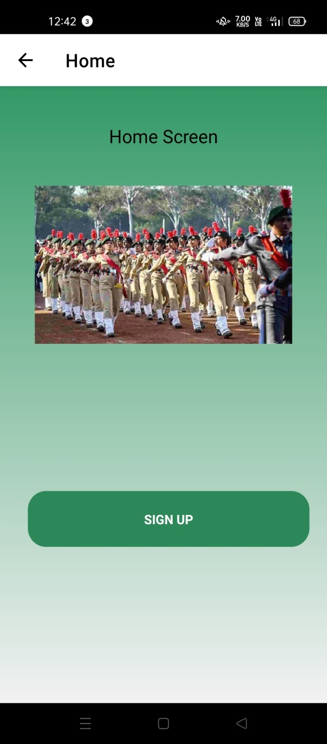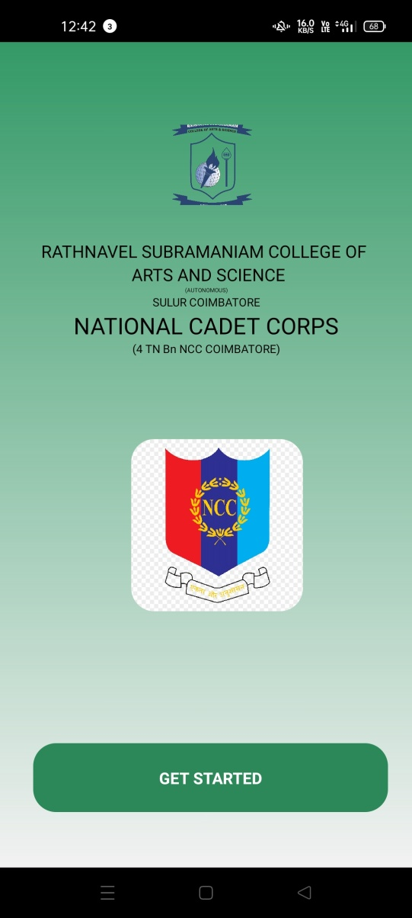

WELCOME SCREEN HOME SCREEN

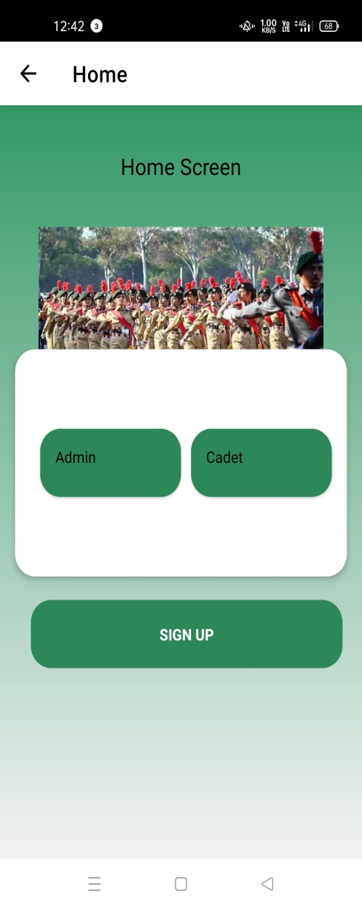 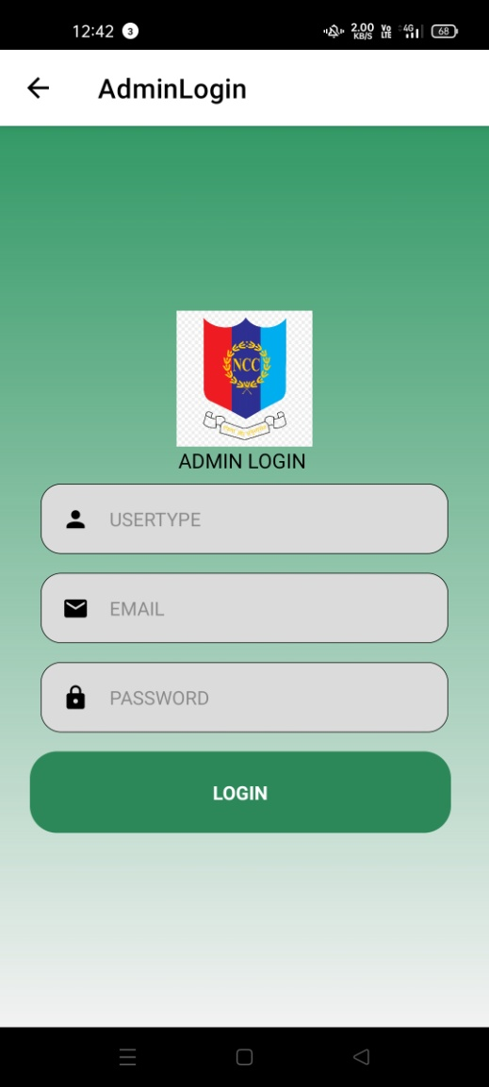

HOME SCREEN ADMIN LOGIN

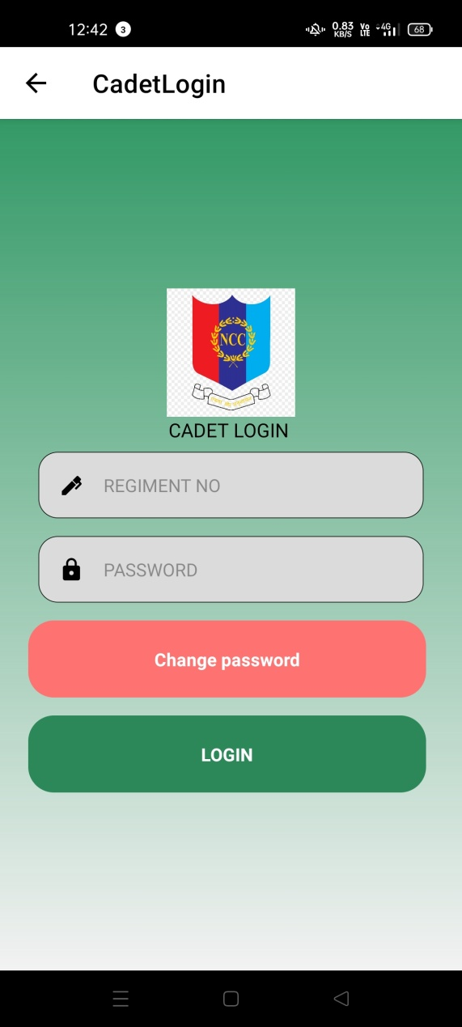 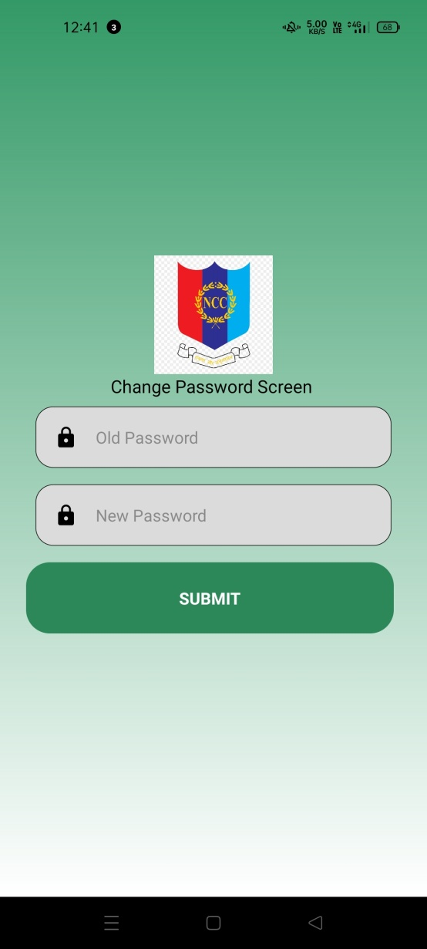CADET LOGIN CHANGE PASSWORD SCREEN

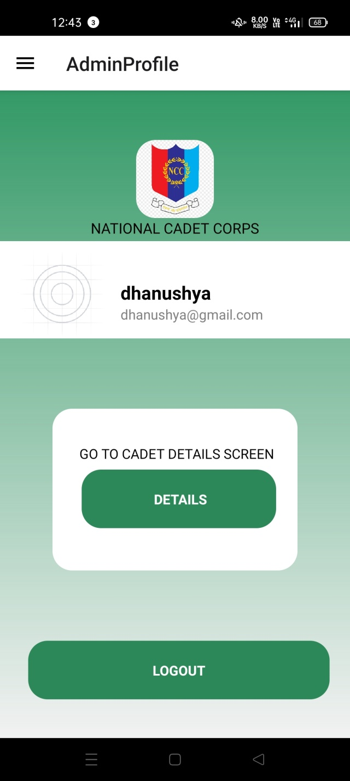 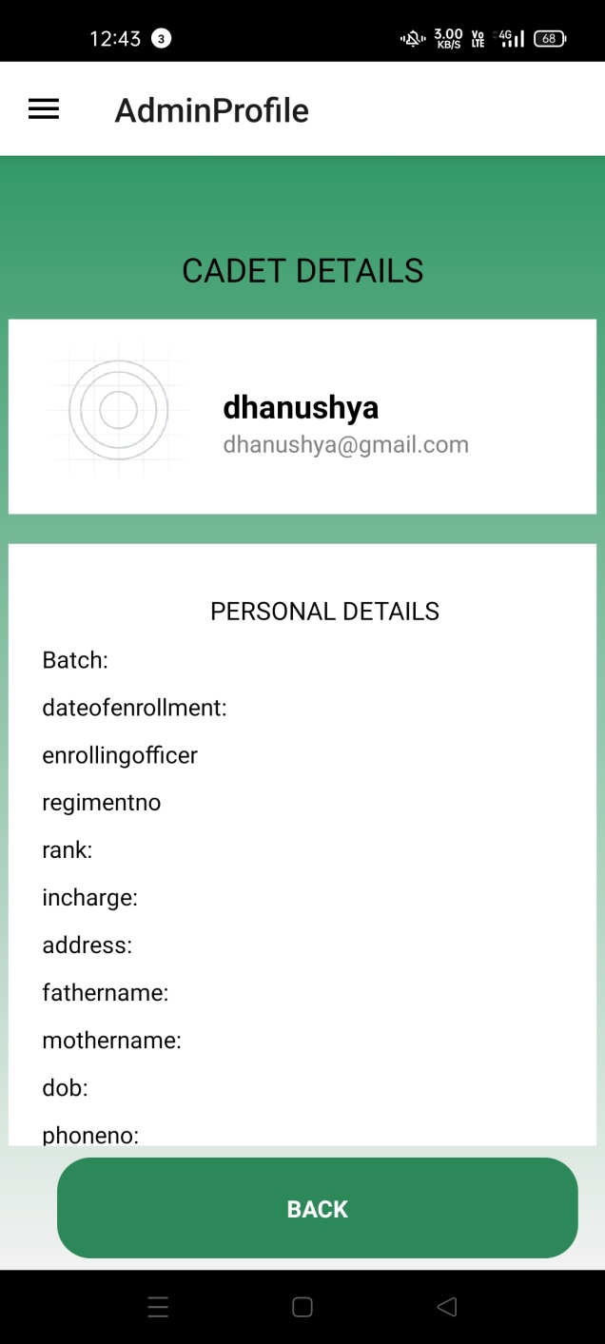

ADMIN PROFILE CADET PROFILE

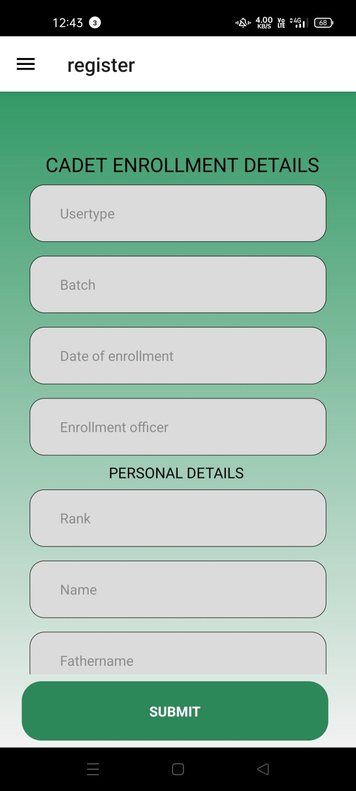 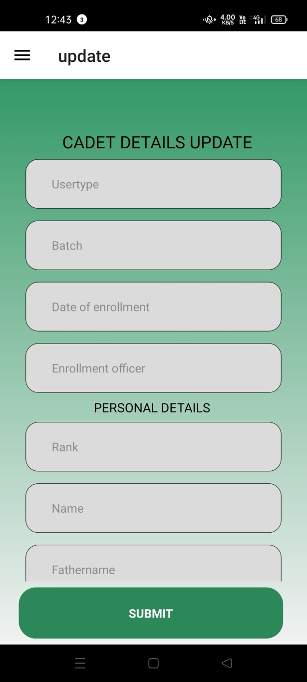

CADET ENROLLMENT CADET UPDATE SCREEN

SCREEN

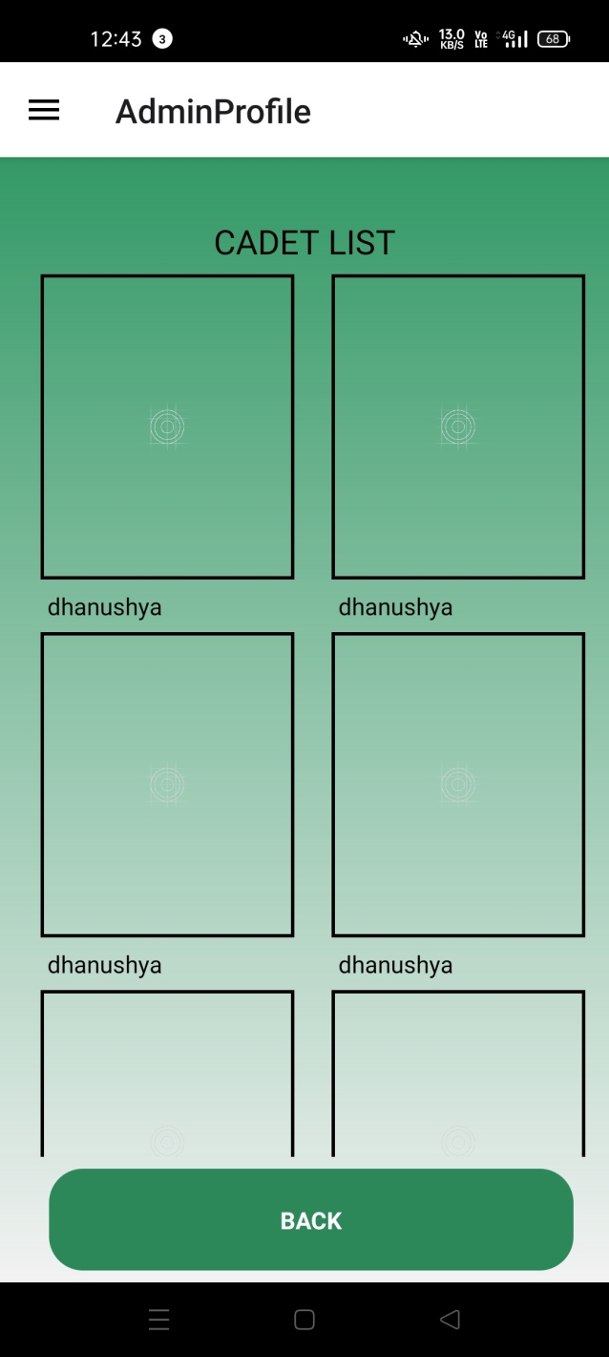 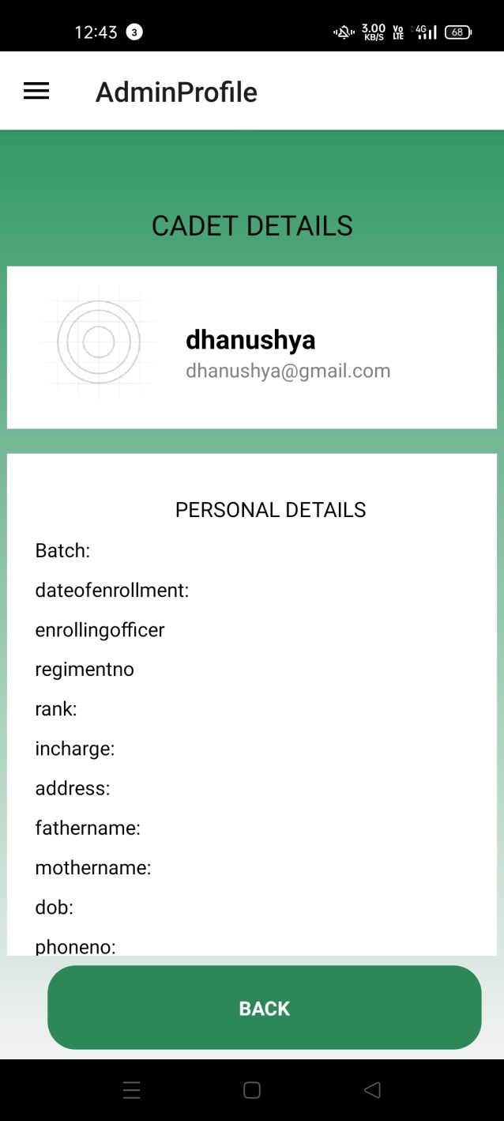

CADET LIST CADET DETAIL SCREEN

SCREEN