CITIZEN DOCIFY

Abstract

Citizen Docify is a MERN-based intelligent web application designed to simplify and streamline interactions with government documents for everyday citizens. Government forms are often lengthy, complex, and difficult to interpret, resulting in confusion, errors, repeated submissions, and reliance on intermediaries. As digital governance expands, there is a growing need for a system that can provide clarity, accessibility, and guided assistance throughout the document-handling process.

Citizen Docify addresses this need by offering AI-assisted document processing, text simplification, eligibility checking, multilingual support, and step-by-step form-filling guidance. Built using MongoDB Atlas, Express.js, React, and Node.js, the platform integrates secure JWT-based authentication, structured data management, and robust file upload pipelines using multer. Additionally, it supports optional integration with advanced AI models such as Google Gemini to enhance text extraction, summarization, and translation capabilities.

The problem this project solves is rooted in the difficulty citizens face when understanding and completing government paperwork. Many official documents contain technical language that is hard to interpret, making it challenging to determine eligibility, identify required attachments, or recognize which sections of a form apply to a specific user. Outdated forms frequently circulate online, leading to rejections or delays when submitted. Furthermore, there is no unified digital system where citizens can upload documents, receive simplified summaries, check form versions, and follow personalized procedural guidance. These challenges collectively create barriers to accessibility, efficiency, and compliance in interacting with government processes.

Citizen Docify aims to overcome these challenges by providing an application that can automatically analyze government PDFs, generate simplified summaries, identify required supporting documents, and guide users through each step of form completion in a structured, user-friendly manner. The platform also evaluates user-provided information to determine eligibility and explains the reasons behind acceptance or rejection. In addition, the application supports multilingual translation of summaries to increase accessibility for users across different regions. Technically, it seeks to implement secure authentication, modular API design, clean data models, protected routes, and scalable code structures, while incorporating AI-ready stubs that can be expanded into full integration with real large language models.

The methodology of Citizen Docify follows a layered architecture in which the backend manages authentication, file handling, document parsing stubs, eligibility logic, and version tracking using Express and MongoDB Atlas. Multer is used to validate and store uploaded PDFs and images, while stubbed functions simulate text extraction, summarization, form section detection, and translation logic.

The frontend, built with React, provides pages for login, signup, document upload, summaries, form guidance, eligibility checking, and document dashboards. It maintains sessions through JWT, displays simplified outputs, and offers a guided interface that adapts to user inputs. Features such as PDF preview, file resizing options, outdated form warnings, and a multilingual toggle improve user experience and accessibility. Together, these layers create a cohesive, secure, and extensible system capable of evolving into a fully AI-powered government document assistant.

INTRODUCTION

Government forms and official documents are often difficult for citizens to understand due to their complex structure, technical language, and detailed procedural requirements. As a result, individuals frequently struggle with identifying the correct form, determining their eligibility, understanding required attachments, and completing the form without errors. Citizen Docify is developed to address these challenges by providing an intelligent, user-friendly digital platform that analyzes, simplifies, and guides users through government documentation.

Built using the MERN stack—MongoDB, Express, React, and Node.js—the system leverages secure authentication, structured data management, and AI-assisted processing to make government documents more accessible. Through features such as PDF text extraction, simplified summaries, multilingual translation, AI-driven eligibility checks, and step-by-step guided form filling, Citizen Docify aims to reduce complexity, eliminate confusion, and help users complete official procedures with clarity and confidence.

Overview of the Project

Citizen Docify is an AI-supported web application designed to streamline how users interact with government PDFs and official forms. The application allows users to upload government documents, which are then processed through a simulated AI pipeline capable of extracting text, generating simplified summaries, identifying required attachments, and determining which parts of the form apply to the user. A built-in eligibility checker evaluates user information and provides clear acceptance or rejection reasons.

The React frontend offers a clean and intuitive interface featuring document previews, progressive form-filling assistance, outdated form alerts, and multilingual support. The backend, built on Node.js and Express, manages authentication using JWT, file uploads through multer, database operations via MongoDB Atlas, and modular APIs for parsing, translating, and version verification. With optional integration points for advanced large language models such as Google Gemini, Citizen Docify is structured to scale into a fully automated smart documentation assistant capable of analyzing complex forms, supporting multiple languages, and guiding users throughout the entire application or submission process.

Technologies Used

HTML (HyperText Markup Language)

HTML is the standard markup language used to structure content on the web. It defines the layout of pages, elements, headings, input fields, and the overall skeleton of the user interface for the application.

CSS (Cascading Style Sheets)

CSS is used to style and design web pages. It controls layout, colors, fonts, spacing, and responsiveness, ensuring the interface is visually consistent across devices and screen sizes.

JavaScript

JavaScript is a client-side scripting language that enables dynamic behavior on web pages. It allows interactive components, form validations, event handling, and real-time updates within the browser.

Node.js

Node.js is a JavaScript runtime environment used to build fast and scalable server-side applications. It allows developers to run JavaScript on the backend and handle APIs, authentication, database operations, and other server logic.

Express.js

Express is a lightweight backend framework for Node.js that simplifies API development. It provides routing, middleware support, request/response handling, and serves as the foundation for building RESTful services.

React.js

React is a powerful frontend JavaScript library used for building interactive and component-based user interfaces. It supports virtual DOM rendering, state management, and reusable UI components for efficient client-side experiences.

WEB APPLICATION ARCHITECTURE

Client-Side Architecture (Frontend Layer)

The Citizen Docify frontend is built using React as a single-page application. It manages user interactions such as login, signup, document upload, form-filling assistance, and displaying simplified summaries. The frontend stores JWT tokens securely, performs basic client-side validations, and communicates with the backend through protected REST API calls.

Server-Side Architecture (Backend Layer)

The backend is developed using Node.js and Express, providing the core business logic of the application. It handles authentication (JWT), file uploads via multer, PDF/image processing using stubbed AI modules, eligibility checking, translation, and form-version validation. The backend also manages middleware for security, logging, validation, and error handling, ensuring reliable and secure communication between all layers.

Data Storage Architecture (Database Layer)

MongoDB Atlas serves as the primary database for storing user information, document metadata, parsed summaries, attachment checklists, version details, and translation outputs. Data is structured in a flexible schema to support rapid updates and AI integration. Temporary uploaded files are stored locally or in cloud object storage, while long-term metadata is maintained in MongoDB.

System Design (Modularity & Scalability)

The entire architecture is built using a modular approach, allowing individual components such as AI parsers, OCR tools, and translation engines to be replaced or upgraded without affecting the system. This design ensures scalability, easy maintenance, and future integration with advanced AI services like Google Gemini for automated document analysis

MangoDB

MongoDB Atlas stores user accounts, document details, summaries, version information, translations, and eligibility results. The system follows a modular design where AI, OCR, and translation logic can be upgraded without affecting other components. This architecture ensures scalability, security, and easy integration with advanced AI services for complete automation of government document analysis.

CODING & IMPLEMENTATION
Frontend

App.jsx

import React from 'react';

import { BrowserRouter as Router, Routes, Route } from 'react-router-dom';

import Navbar from './components/Navbar';

import Login from './pages/Login';

import Signup from './pages/Signup';

import Upload from './pages/Upload';

import Dashboard from './pages/Dashboard';

import Summary from './pages/Summary';

import Eligibility from './pages/Eligibility';

import Profile from './pages/Profile'; // 👈 Import Profile Page

import { AuthProvider } from './context/AuthContext';

function App() {

return (

<AuthProvider>

<Router>

<div className="min-h-screen bg-gray-100">

<Navbar />

<Routes>

<Route path="/" element={<Login />} />

<Route path="/login" element={<Login />} />

<Route path="/signup" element={<Signup />} />

<Route path="/upload" element={<Upload />} />

<Route path="/dashboard" element={<Dashboard />} />

<Route path="/summary/:id" element={<Summary />} />

<Route path="/eligibility" element={<Eligibility />} />

{/* 👇 Added the Profile Route here */}

<Route path="/profile" element={<Profile />} />

</Routes>

</div>

</Router>

</AuthProvider>

);

}

export default App;

index.css

@import url('https://fonts.googleapis.com/css2?family=Inter:wght@300;400;500;600;700&display=swap');

@tailwind base;

@tailwind components;

@tailwind utilities;

/* Custom fonts */

/* Global styles */

body {

font-family: 'Inter', sans-serif;

@apply bg-gray-100 text-gray-900 min-h-screen;

}

/* Custom button styles */

.btn-primary {

@apply bg-blue-600 text-white px-4 py-2 rounded hover:bg-blue-700 transition duration-200;

}

.btn-secondary {

@apply bg-gray-600 text-white px-4 py-2 rounded hover:bg-gray-700 transition duration-200;

}

.btn-success {

@apply bg-green-600 text-white px-4 py-2 rounded hover:bg-green-700 transition duration-200;

}

.input-field {

@apply w-full border border-gray-300 p-2 rounded focus:outline-none focus:ring-2 focus:ring-blue-500;

}

.card {

@apply bg-white rounded shadow-md;

}

.page-container {

@apply max-w-7xl mx-auto px-4 sm:px-6 lg:px-8 py-8;

}

.page-title {

@apply text-2xl font-bold text-gray-900 mb-2;

}

.page-subtitle {

@apply text-gray-600 mb-6;

}

.section-title {

@apply text-xl font-semibold text-gray-800 mb-4;

}

/* Animation classes */

.fade-in {

animation: fadeIn 0.3s ease-in;

}

@keyframes fadeIn {

from { opacity: 0; transform: translateY(5px); }

to { opacity: 1; transform: translateY(0); }

}

Index.jsx

import React from 'react';
import ReactDOM from 'react-dom/client';
import App from './App';
import './index.css';

ReactDOM.createRoot(document.getElementById('root')).render(
<React.StrictMode>
<App />
</React.StrictMode>,
);

Login.jsx

import React, { useState, useContext } from 'react';

import { AuthContext } from '../context/AuthContext';

import { useNavigate, Link } from 'react-router-dom';

const Login = () => {

const [form, setForm] = useState({ email: '', password: '' });

const { login } = useContext(AuthContext);

const navigate = useNavigate();

const handleSubmit = async (e) => {

e.preventDefault();

try {

await login(form.email, form.password);

navigate('/dashboard');

} catch (err) {

console.error('Login error:', err);

// Show more detailed error message

const errorMessage = err.response?.data?.message ||

err.message ||

'Login failed. Please try again.';

alert(`Login Failed: ${errorMessage}`);

}

};

return (

<div className="flex justify-center items-center h-screen bg-gray-100">

<form onSubmit={handleSubmit} className="bg-white p-8 rounded shadow-md w-96">

<h2 className="text-2xl font-bold mb-4 text-center">Login</h2>

<div className="mb-4">

<label className="block text-gray-700 text-sm font-bold mb-2" htmlFor="email">

Email

</label>

<input

id="email"

className="w-full border p-2 rounded focus:outline-none focus:ring-2 focus:ring-blue-500"

placeholder="Email"

type="email"

value={form.email}

onChange={e => setForm({...form, email: e.target.value})}

required

/>

</div>

<div className="mb-6">

<label className="block text-gray-700 text-sm font-bold mb-2" htmlFor="password">

Password

</label>

<input

id="password"

className="w-full border p-2 rounded focus:outline-none focus:ring-2 focus:ring-blue-500"

placeholder="Password"

type="password"

value={form.password}

onChange={e => setForm({...form, password: e.target.value})}

required

/>

</div>

<button

className="w-full bg-blue-600 text-white p-2 rounded hover:bg-blue-700 font-bold transition duration-200"

type="submit"

>

Login

</button>

<p className="text-center text-sm mt-4">

Don't have an account? <Link to="/signup" className="text-blue-600 hover:text-blue-800">Sign Up</Link>

</p>

</form>

</div>

);

};

export default Login;

Eligibility.jsx

import React, { useState } from 'react';

import API from '../services/api';

const Eligibility = () => {

const [formData, setFormData] = useState({

docType: 'Aadhar Card',

age: '',

nationality: 'Indian',

income: '',

category: 'General'

});

const [result, setResult] = useState(null);

const handleChange = (e) => {

setFormData({ ...formData, [e.target.name]: e.target.value });

};

const handleSubmit = async (e) => {

e.preventDefault();

try {

const res = await API.post('/docs/check-eligibility', formData);

setResult(res.data);

} catch (err) {

alert("Error checking eligibility");

}

};

return (

<div className="max-w-2xl mx-auto mt-10 p-8 bg-white rounded-lg shadow-lg">

<h2 className="text-3xl font-bold mb-6 text-gray-800 border-b pb-4">Check Eligibility</h2>

<form onSubmit={handleSubmit} className="space-y-6">

{/* Document Selection */}

<div>

<label className="block text-gray-700 font-semibold mb-2">Select Document</label>

<select

name="docType"

value={formData.docType}

onChange={handleChange}

className="w-full border p-3 rounded focus:ring-2 focus:ring-blue-500 bg-gray-50"

>

<option>Aadhar Card</option>

<option>PAN Card</option>

<option>Voter ID</option>

<option>Driving License</option>

<option>Ration Card</option>

<option>Student Scholarship</option>

<option>Income Certificate</option>

<option>Caste Certificate</option>

<option>Birth Certificate</option>

<option>Death Certificate</option>

<option>Income Tax Filing</option>

<option>Passport</option>

<option>EWS Certificate</option>

</select>

</div>

<div className="grid grid-cols-1 md:grid-cols-2 gap-6">

{/* Age */}

<div>

<label className="block text-gray-700 font-semibold mb-2">Age</label>

<input

type="number"

name="age"

value={formData.age}

onChange={handleChange}

className="w-full border p-3 rounded focus:ring-blue-500"

placeholder="e.g. 24"

required

/>

</div>

{/* Nationality */}

<div>

<label className="block text-gray-700 font-semibold mb-2">Nationality</label>

<select

name="nationality"

value={formData.nationality}

onChange={handleChange}

className="w-full border p-3 rounded bg-white"

>

<option value="Indian">Indian</option>

<option value="Foreigner">Foreigner</option>

<option value="NRI">NRI</option>

</select>

</div>

{/* Income */}

<div>

<label className="block text-gray-700 font-semibold mb-2">Annual Family Income (₹)</label>

<input

type="number"

name="income"

value={formData.income}

onChange={handleChange}

className="w-full border p-3 rounded focus:ring-blue-500"

placeholder="e.g. 150000"

/>

</div>

{/* Category */}

<div>

<label className="block text-gray-700 font-semibold mb-2">Social Category</label>

<select

name="category"

value={formData.category}

onChange={handleChange}

className="w-full border p-3 rounded bg-white"

>

<option value="General">General</option>

<option value="OBC">OBC</option>

<option value="SC">SC</option>

<option value="ST">ST</option>

<option value="EWS">EWS</option>

</select>

</div>

</div>

<button className="w-full bg-blue-600 text-white py-3 rounded-lg font-bold text-lg hover:bg-blue-700 transition shadow-md">

Check Eligibility Status

</button>

</form>

{/* Results Section */}

{result && (

<div className={`mt-8 p-6 rounded-lg border-l-8 shadow-sm ${result.eligible ? 'bg-green-50 border-green-500' : 'bg-red-50 border-red-500'}`}>

<div className="flex items-center mb-3">

<span className={`text-3xl mr-3 ${result.eligible ? 'text-green-600' : 'text-red-600'}`}>

{result.eligible ? '✅' : '❌'}

</span>

<h3 className={`text-2xl font-bold ${result.eligible ? 'text-green-800' : 'text-red-800'}`}>

{result.eligible ? 'You are Eligible!' : 'Not Eligible'}

</h3>

</div>

<ul className="space-y-2 mt-2">

{result.reasons.map((r, idx) => (

<li key={idx} className="flex items-start text-gray-800 text-lg">

<span className="mr-2 mt-1">•</span>

<span>{r}</span>

</li>

))}

</ul>

</div>

)}

</div>

);

};

export default Eligibility;

Dashboard.jsx

import React, { useEffect, useState, useContext } from 'react';
import API from '../services/api';
import Sidebar from '../components/Sidebar';
import { AuthContext } from '../context/AuthContext';
import { useNavigate, Link } from 'react-router-dom';
import {
UploadCloud,
FileCheck,
AlertTriangle,
Clock,
Search,
Eye
} from 'lucide-react';

const Dashboard = () => {
const { user, logout } = useContext(AuthContext);
const [docs, setDocs] = useState([]);
const [loading, setLoading] = useState(true);
const navigate = useNavigate();

useEffect(() => {
API.get('/docs/my-documents')
.then(res => {
setDocs(res.data);
setLoading(false);
})
.catch(err => {
console.error(err);
setLoading(false);
});
}, []);

const handleLogout = () => {
logout();
navigate('/login');
};

const totalDocs = docs.length;
const outdatedDocs = docs.filter(d => d.version && d.version.toLowerCase().includes('unknown')).length;
const pendingActions = docs.filter(d => d.requiredAttachments && d.requiredAttachments.length > 0).length;

const getStatus = (doc) => {
if (doc.version === 'Unknown') return { label: 'Outdated', color: 'bg-red-100 text-red-700' };
if (doc.requiredAttachments?.length > 0) return { label: 'Action Needed', color: 'bg-yellow-100 text-yellow-700' };
return { label: 'Ready', color: 'bg-green-100 text-green-700' };
};

return (
<div className="flex min-h-screen bg-gray-50 font-sans">
{/* Sidebar */}
<Sidebar logout={handleLogout} />

{/* Main Content */}
<main className="ml-64 flex-1 p-8">
<header className="flex justify-between items-end mb-8">
<div>
<h1 className="text-3xl font-bold text-gray-800">Hello, {user?.name || 'User'}! </h1>
<p className="text-gray-500 mt-1">Welcome to your document command center.</p>
</div>
<Link to="/upload" className="flex items-center gap-2 bg-blue-600 text-white px-5 py-2.5 rounded-lg hover:bg-blue-700 transition shadow-sm font-medium">
<UploadCloud size={18} /> Upload New
</Link>
</header>

{/* Status Cards */}
<div className="grid grid-cols-1 md:grid-cols-2 lg:grid-cols-4 gap-6 mb-8">
<div className="bg-white p-5 rounded-xl shadow-sm border border-gray-100">
<div className="flex justify-between items-start mb-4"><div className="p-3 rounded-lg bg-blue-50"><FileCheck className="text-blue-600"/></div></div>
<h4 className="text-gray-500 text-sm font-medium">Total Documents</h4>
<h2 className="text-3xl font-bold text-gray-800 mt-1">{totalDocs}</h2>
</div>
<div className="bg-white p-5 rounded-xl shadow-sm border border-gray-100">
<div className="flex justify-between items-start mb-4"><div className="p-3 rounded-lg bg-green-50"><Search className="text-green-600"/></div></div>
<h4 className="text-gray-500 text-sm font-medium">Parsed Successfully</h4>
<h2 className="text-3xl font-bold text-gray-800 mt-1">{totalDocs}</h2>
</div>
<div className="bg-white p-5 rounded-xl shadow-sm border border-gray-100">
<div className="flex justify-between items-start mb-4"><div className="p-3 rounded-lg bg-red-50"><AlertTriangle className="text-red-600"/></div></div>
<h4 className="text-gray-500 text-sm font-medium">Outdated Forms</h4>
<h2 className="text-3xl font-bold text-gray-800 mt-1">{outdatedDocs}</h2>
</div>
<div className="bg-white p-5 rounded-xl shadow-sm border border-gray-100">
<div className="flex justify-between items-start mb-4"><div className="p-3 rounded-lg bg-orange-50"><Clock className="text-orange-600"/></div></div>
<h4 className="text-gray-500 text-sm font-medium">Pending Actions</h4>
<h2 className="text-3xl font-bold text-gray-800 mt-1">{pendingActions}</h2>
</div>
</div>

{/* Table */}
<div className="bg-white rounded-xl shadow-sm border border-gray-200 overflow-hidden">
<div className="p-6 border-b border-gray-100">
<h2 className="text-lg font-bold text-gray-800">Recent Documents</h2>
</div>
<div className="overflow-x-auto">
<table className="w-full text-left border-collapse">
<thead className="bg-gray-50 text-gray-500 text-xs uppercase font-semibold">
<tr>
<th className="px-6 py-4">Document Name</th>
<th className="px-6 py-4">Type</th>
<th className="px-6 py-4">Status</th>
<th className="px-6 py-4 text-right">Actions</th>
</tr>
</thead>
<tbody className="divide-y divide-gray-100 text-sm">
{docs.map((doc) => {
const status = getStatus(doc);
return (
<tr key={doc._id} className="hover:bg-gray-50 transition">
<td className="px-6 py-4 font-medium text-gray-800">{doc.originalName}</td>
<td className="px-6 py-4 text-gray-600">{doc.docType}</td>
<td className="px-6 py-4">
<span className={`px-2.5 py-1 rounded-full text-xs font-medium ${status.color}`}>
{status.label}
</span>
</td>
<td className="px-6 py-4 text-right">
<button
onClick={() => navigate(`/summary/${doc._id}`, { state: { doc } })}
className="p-2 hover:bg-blue-50 text-blue-600 rounded-lg transition"
>
<Eye size={18} />
</button>
</td>
</tr>
);
})}
</tbody>
</table>
</div>
</div>
</main>
</div>
);
};

export default Dashboard;

Upload.jsx

import React, { useState, useContext } from 'react';

import API from '../services/api';

import { useNavigate } from 'react-router-dom';

import Sidebar from '../components/Sidebar';

import { AuthContext } from '../context/AuthContext';

import { UploadCloud, FileText, AlertCircle, CheckCircle2, XCircle, AlertTriangle } from 'lucide-react';

const Upload = () => {

const { logout } = useContext(AuthContext);

const [file, setFile] = useState(null);

const [loading, setLoading] = useState(false);

const [error, setError] = useState('');

const navigate = useNavigate();

const handleUpload = async (e) => {

e.preventDefault();

if (!file) return alert('Please select a file');

// Clear previous errors

setError('');

const formData = new FormData();

formData.append('document', file);

setLoading(true);

try {

const res = await API.post('/docs/upload', formData);

setLoading(false);

navigate(`/summary/${res.data._id}`, { state: { doc: res.data } });

} catch (err) {

console.error(err);

setLoading(false);

const serverMessage = err.response?.data?.message || err.message || "Unknown Error";

setError(serverMessage);

// Only show alert for actual errors, not simulated data

if (!serverMessage.includes("simulated")) {

alert(`UPLOAD FAILED: ${serverMessage}`);

}

}

};

const handleLogout = () => {

logout();

navigate('/login');

};

return (

<div className="flex min-h-screen bg-gray-50 font-sans">

<Sidebar logout={handleLogout} />

<main className="ml-64 flex-1 p-8">

<h1 className="text-3xl font-bold text-gray-800 mb-2">Upload Document</h1>

<p className="text-gray-500 mb-8">Upload a government form (PDF/Image) to let AI simplify it for you.</p>

<div className="max-w-3xl bg-white rounded-xl shadow-sm border border-gray-200 p-10 text-center">

<form onSubmit={handleUpload} className="space-y-6">

<div className="border-2 border-dashed border-blue-200 bg-blue-50 rounded-2xl p-10 transition hover:border-blue-400 hover:bg-blue-100 flex flex-col items-center justify-center cursor-pointer relative">

<input

type="file"

accept=".pdf,.png,.jpg,.jpeg"

onChange={(e) => {

setFile(e.target.files[0]);

setError(''); // Clear error when selecting new file

}}

className="absolute inset-0 w-full h-full opacity-0 cursor-pointer"

/>

<div className="bg-white p-4 rounded-full shadow-sm mb-4">

<UploadCloud className="text-blue-600" size={32} />

</div>

{file ? (

<div className="flex items-center gap-2 text-green-700 font-medium">

<CheckCircle2 size={20} />

{file.name}

</div>

) : (

<>

<p className="text-lg font-semibold text-gray-700">Click to upload or drag and drop</p>

<p className="text-sm text-gray-500 mt-1">PDF, PNG, JPG (Max 10MB)</p>

</>

)}

</div>

{/* Error Display */}

{error && !error.includes("simulated") && (

<div className="bg-red-50 border border-red-200 p-4 rounded-lg flex gap-3 text-left">

<XCircle className="text-red-600 shrink-0" size={20} />

<div>

<p className="font-medium text-red-800">Upload Error</p>

<p className="text-sm text-red-700">{error}</p>

{(error.includes('API key') || error.includes('unavailable')) && (

<p className="text-xs text-red-600 mt-1">Please contact the administrator for assistance.</p>

)}

</div>

</div>

)}

{/* Simulated Data Warning */}

{error && error.includes("simulated") && (

<div className="bg-yellow-50 border border-yellow-200 p-4 rounded-lg flex gap-3 text-left">

<AlertTriangle className="text-yellow-600 shrink-0" size={20} />

<div>

<p className="font-medium text-yellow-800">Using Simulated Data</p>

<p className="text-sm text-yellow-700">AI service is temporarily unavailable. The system is using sample data for demonstration.</p>

</div>

</div>

)}

<div className="bg-yellow-50 border border-yellow-100 p-4 rounded-lg flex gap-3 text-left">

<AlertCircle className="text-yellow-600 shrink-0" size={20} />

<p className="text-sm text-yellow-800">

<strong>Privacy Note:</strong> Your documents are processed securely. Do not upload sensitive financial passwords.

</p>

</div>

<button

disabled={loading || !file}

className={`w-full py-4 rounded-xl font-bold text-lg flex items-center justify-center gap-2 transition ${

loading || !file

? 'bg-gray-200 text-gray-400 cursor-not-allowed'

: 'bg-blue-600 text-white hover:bg-blue-700 shadow-md hover:shadow-lg'

}`}

>

{loading ? (

/* 👇 UPDATED TEXT HERE */

<>Analysing... <span className="animate-pulse">⏳</span></>

) : (

<><FileText size={20} /> Analyze & Simplify</>

)}

</button>

</form>

</div>

</main>

</div>

);

};

export default Upload;

Signup.jsx

import React, { useState, useContext } from 'react';
import { AuthContext } from '../context/AuthContext';
import { useNavigate } from 'react-router-dom';

const Signup = () => {
const [form, setForm] = useState({ name: '', email: '', password: '' });
const { register } = useContext(AuthContext);
const navigate = useNavigate();

const handleSubmit = async (e) => {
e.preventDefault();
try {
await register(form.name, form.email, form.password);
navigate('/dashboard');
} catch (err) {
console.error(err);
// 👇 THIS IS THE FIX: Show the real error from the backend
const errorMessage = err.response?.data?.message || "Registration failed. Please check the backend terminal.";
alert(errorMessage);
}
};

return (
<div className="flex justify-center items-center h-screen bg-gray-100">
<form onSubmit={handleSubmit} className="bg-white p-8 rounded shadow-md w-96">
<h2 className="text-2xl font-bold mb-4 text-center">Sign Up</h2>
<input
className="w-full border p-2 mb-4"
placeholder="Full Name"
type="text"
value={form.name}
onChange={e => setForm({...form, name: e.target.value})}
required
/>
<input
className="w-full border p-2 mb-4"
placeholder="Email"
type="email"
value={form.email}
onChange={e => setForm({...form, email: e.target.value})}
required
/>
<input
className="w-full border p-2 mb-4"
placeholder="Password"
type="password"
value={form.password}
onChange={e => setForm({...form, password: e.target.value})}
required
/>
<button className="w-full bg-blue-600 text-white p-2 rounded hover:bg-blue-700 font-bold transition">
Create Account
</button>
</form>
</div>
);
};

export default Signup;

Backend

server.js
require('dotenv').config();
const express = require('express');
const cors = require('cors');
const connectDB = require('./config/db');
const fs = require('fs');
const path = require('path');

const app = express();

// 1. Connect to Database
connectDB();

// 2. AUTO-FIX: Create 'uploads' folder if it doesn't exist
const uploadDir = path.join(__dirname, 'uploads');
if (!fs.existsSync(uploadDir)) {
fs.mkdirSync(uploadDir);
console.log("✅ Auto-Created 'uploads' folder!");
}

// 3. Middleware
app.use(cors());
app.use(express.json());

// 4. Routes
app.use('/api/auth', require('./routes/auth'));
app.use('/api/docs', require('./routes/docs'));

// 5. Start Server
const PORT = process.env.PORT || 8060;
app.listen(PORT, () => console.log(`Backend Server running on port ${PORT}`));

controllers/authController.js

const User = require('../models/User');

const bcrypt = require('bcryptjs');

const jwt = require('jsonwebtoken');

exports.register = async (req, res) => {

const name = req.body.name;

const email = req.body.email.toLowerCase().trim();

const password = req.body.password;

try {

console.log("--- REGISTERING ---");

console.log("Email:", email);

let user = await User.findOne({ email });

if (user) {

return res.status(400).json({ message: 'User already exists' });

}

const salt = await bcrypt.genSalt(10);

const hashedPassword = await bcrypt.hash(password, salt);

user = new User({

name,

email,

password: hashedPassword

});

await user.save();

console.log("✅ User Saved Successfully");

const payload = { user: { id: user.id } };

jwt.sign(payload, process.env.JWT_SECRET_TOKEN, { expiresIn: '1h' }, (err, token) => {

if (err) throw err;

res.json({ token });

});

} catch (err) {

console.error("Server Error:", err.message);

res.status(500).send('Server Error');

}

};

exports.login = async (req, res) => {

const email = req.body.email.toLowerCase().trim();

const password = req.body.password;

try {

console.log("--- LOGGING IN ---");

console.log("Email:", email);

let user = await User.findOne({ email });

if (!user) {

return res.status(400).json({ message: 'Invalid Credentials (User not found)' });

}

// Check Password

const isMatch = await bcrypt.compare(password, user.password);

if (!isMatch) {

return res.status(400).json({ message: 'Invalid Credentials (Wrong Password)' });

}

console.log("✅ Login Successful");

const payload = { user: { id: user.id } };

jwt.sign(payload, process.env.JWT_SECRET_TOKEN, { expiresIn: '1h' }, (err, token) => {

if (err) throw err;

res.json({ token });

});

} catch (err) {

console.error("Server Error:", err.message);

res.status(500).send('Server Error');

}

};

exports.getProfile = async (req, res) => {

try {

const user = await User.findById(req.user.id).select('-password');

if (!user) return res.status(404).json({ message: 'User not found' });

res.json(user);

} catch (err) {

console.error(err);

res.status(500).send('Server Error');

}

};

exports.updateProfile = async (req, res) => {

try {

const {

name, dob, mobile, aadhaar, pan,

district, state, pincode, category

} = req.body;

// Build profile object dynamically

const profileFields = {};

if (name) profileFields.name = name;

if (dob) profileFields.dob = dob;

if (mobile) profileFields.mobile = mobile;

if (aadhaar) profileFields.aadhaar = aadhaar;

if (pan) profileFields.pan = pan;

if (district) profileFields.district = district;

if (state) profileFields.state = state;

if (pincode) profileFields.pincode = pincode;

if (category) profileFields.category = category;

// Update the user

const user = await User.findByIdAndUpdate(

req.user.id,

{ $set: profileFields },

{ new: true }

).select('-password');

res.json(user);

} catch (err) {

console.error(err);

res.status(500).send('Server Error');

}

};

controllers/docController.js

const Document = require('../models/Document');
const { analyzeDocument, translateText } = require('../utils/aiService');
const { stubParse } = require('../utils/parserStubs');

// 1. Upload Document
exports.uploadDocument = async (req, res) => {
try {
if (!req.file) {
console.log('No file uploaded in request');
return res.status(400).json({ message: 'No file uploaded' });
}

console.log('File received:', req.file);

let analysis;
try {
// Try to use Gemini to analyze the uploaded file
console.log('Analyzing document with AI service...');
analysis = await analyzeDocument(req.file.path);
console.log('AI analysis result:', analysis);
} catch (aiError) {
console.error('AI Analysis failed, using fallback:', aiError);

// Fallback to simulated AI processing
console.log('Using simulated AI processing as fallback...');
analysis = stubParse(req.file.originalname);
console.log('Simulated analysis result:', analysis);

// Add a note that this is simulated data
analysis.isSimulated = true;
analysis.warning = "AI service unavailable. This is simulated data.";
}

const newDoc = new Document({
user: req.user.id,
filename: req.file.filename,
originalName: req.file.originalname,
docType: analysis.docType,
summary: analysis.summary,
requiredAttachments: analysis.requiredAttachments,
version: analysis.version,
isSimulated: analysis.isSimulated || false,
warning: analysis.warning || undefined
});

console.log('Saving document to database...');
await newDoc.save();
console.log('Document saved successfully:', newDoc._id);
res.json(newDoc);
} catch (err) {
console.error('Upload error:', err);
res.status(500).json({ message: 'Upload failed: ' + err.message });
}
};

// 2. Get User Documents
exports.getMyDocuments = async (req, res) => {
try {
const docs = await Document.find({ user: req.user.id }).sort({ createdAt: -1 });
res.json(docs);
} catch (err) {
console.error(err);
res.status(500).json({ message: 'Server error' });
}
};

// 3. Get Document by ID
exports.getDocumentById = async (req, res) => {
try {
const doc = await Document.findById(req.params.id);
if (!doc) {
return res.status(404).json({ message: 'Document not found' });
}
if (doc.user.toString() !== req.user.id) {
return res.status(401).json({ message: 'User not authorized' });
}
res.json(doc);
} catch (err) {
console.error(err);
res.status(500).json({ message: 'Server error' });
}
};

// 4. Translate Document Summary
exports.translateSummary = async (req, res) => {
try {
const { text, targetLang } = req.body;
let translated;

try {
translated = await translateText(text, targetLang);
} catch (translationError) {
console.error('Translation failed, using fallback:', translationError);
// If translation fails, return the original text with a note
translated = text + " [Translation service unavailable]";
}

res.json({ translatedText: translated });
} catch (err) {
console.error(err);
res.status(500).json({ message: 'Translation failed: ' + err.message });
}
};

// 5. Check Eligibility (The New 13-Rule Logic)
exports.checkEligibility = (req, res) => {
const { docType, age, nationality, income, category } = req.body;

const userAge = parseInt(age) || 0;
const userIncome = parseInt(income) || 0;
const isIndian = nationality && nationality.toLowerCase() === 'indian';

let eligible = false;
let reasons = [];

switch (docType) {
case 'Aadhar Card':
if (isIndian) {
eligible = true;
reasons.push("✅ Eligible: You are an Indian resident.");
} else {
reasons.push("❌ Residency: Aadhar is for residents who have stayed in India for 182+ days.");
}
reasons.push("ℹ️ Requirement: Physical presence at enrolment center is mandatory.");
break;

case 'PAN Card':
eligible = true;
reasons.push("✅ Eligible: Any citizen or entity can apply.");
if (!isIndian) reasons.push("ℹ️ Note: Foreign citizens must use Form 49AA.");
reasons.push("ℹ️ Requirement: Valid ID, Address, and DOB proof required.");
break;

case 'Voter ID':
if (userAge >= 18 && isIndian) {
eligible = true;
reasons.push("✅ Eligible: You meet the age (18+) and citizenship criteria.");
} else {
eligible = false;
if (userAge < 18) reasons.push("❌ Age: You must be at least 18 years old.");
if (!isIndian) reasons.push("❌ Citizenship: Only Indian citizens can vote.");
}
break;

case 'Driving License':
if (userAge >= 18) {
eligible = true;
reasons.push("✅ Eligible: You meet the minimum age for a standard vehicle (MCWG/LMV).");
} else if (userAge >= 16) {
eligible = true;
reasons.push("✅ Eligible (Restricted): You can apply for a gearless scooter (50cc) only.");
} else {
eligible = false;
reasons.push("❌ Age: Minimum age is 18 (16 for gearless scooters).");
}
break;

case 'Ration Card':
if (isIndian) {
eligible = true;
reasons.push("✅ Eligible: Indian residents can apply.");
if (userIncome < 150000) {
reasons.push("ℹ️ Likely eligible for Priority/BPL card (Income-based).");
} else {
reasons.push("ℹ️ Likely eligible for Non-Priority/APL card (White Card).");
}
} else {
eligible = false;
reasons.push("❌ Residency: Must be an Indian resident.");
}
break;

case 'Student Scholarship':
if (userIncome < 250000) {
eligible = true;
reasons.push("✅ Income: Your family income is within common scholarship limits (< ₹2.5L).");
} else {
eligible = false;
reasons.push("❌ Income: Family income often must be below ₹2.5L.");
}
break;

case 'Income Certificate':
if (isIndian) {
eligible = true;
reasons.push("✅ Eligible: Residents can apply to prove income.");
} else {
eligible = false;
reasons.push("❌ Residency: Must be a resident of the state.");
}
break;

case 'Caste Certificate':
if (category && category !== 'General') {
eligible = true;
reasons.push(`✅ Eligible: Application valid for ${category} category.`);
} else {
eligible = false;
reasons.push("❌ Category: 'General' category does not require a Caste Certificate.");
}
break;

case 'Birth Certificate':
eligible = true;
reasons.push("✅ Eligible: Can be applied for any child born in India.");
break;

case 'Death Certificate':
eligible = true;
reasons.push("✅ Eligible: Can be applied for by immediate relatives.");
break;

case 'Income Tax Filing':
if (userIncome > 250000) {
eligible = true;
reasons.push("✅ Mandatory: Your income exceeds the basic exemption limit (₹2.5L).");
} else {
reasons.push("ℹ️ Optional: Income is below taxable limit, but filing is recommended.");
}
break;

case 'Passport':
if (isIndian) {
eligible = true;
reasons.push("✅ Eligible: Indian citizens can apply.");
} else {
eligible = false;
reasons.push("❌ Citizenship: Must be an Indian citizen.");
}
break;

case 'EWS Certificate':
if (category === 'General' || category === 'EWS') {
if (userIncome < 800000) {
eligible = true;
reasons.push("✅ Eligible: Income is below ₹8 Lakhs and category is General.");
} else {
eligible = false;
reasons.push("❌ Income: Family income must be less than ₹8 Lakhs.");
}
} else {
eligible = false;
reasons.push("❌ Category: EWS is only for General category (not SC/ST/OBC).");
}
break;

default:
eligible = false;
reasons.push("Unknown document type.");
}

res.json({ eligible, reasons });
};

middleware/auth.js

const jwt = require('jsonwebtoken');
module.exports = function (req, res, next) {
const authHeader = req.header('Authorization');
if (!authHeader) {
return res.status(401).json({ message: 'No token, authorization denied' });
}
try {
const token = authHeader.startsWith('Bearer ')
? authHeader.slice(7, authHeader.length)
: authHeader;

const decoded = jwt.verify(token, process.env.JWT_SECRET_TOKEN);
req.user = decoded.user;
next();
} catch (err) {
console.error('Token verification error:', err.message);
if (err.name === 'JsonWebTokenError') {
return res.status(401).json({ message: 'Invalid token format' });
} else if (err.name === 'TokenExpiredError') {
return res.status(401).json({ message: 'Token has expired' });
}
res.status(401).json({ message: 'Token is not valid' });
}
};

Upload.js
const multer = require('multer');
const path = require('path');
const fs = require('fs');
if (!fs.existsSync('uploads/')) { fs.mkdirSync('uploads/'); }
const storage = multer.diskStorage({
destination: (req, file, cb) => { console.log('Setting destination for file:', file.originalname); cb(null, 'uploads/'); },
filename: (req, file, cb) => { const uniqueName = `${Date.now()}-${file.originalname}`; console.log('Generated filename:', uniqueName); cb(null, uniqueName); }
});
const fileFilter = (req, file, cb) => {
console.log('Checking file type:', file.mimetype);
if (file.mimetype === 'application/pdf' || file.mimetype.startsWith('image/')) { console.log('File type accepted'); cb(null, true); }
else { console.log('File type rejected'); cb(new Error('Only PDF and Image files are allowed'), false); }
};
const upload = multer({ storage, limits: { fileSize: 5 * 1024 * 1024 }, fileFilter });
const handleMulterError = (err, req, res, next) => {
if (err instanceof multer.MulterError) {
if (err.code === 'LIMIT_FILE_SIZE') return res.status(400).json({ message: 'File too large. Maximum size is 5MB.' });
return res.status(400).json({ message: 'Upload error: ' + err.message });
} else if (err) return res.status(400).json({ message: 'Upload error: ' + err.message });
next();
};
module.exports = { upload: upload, handleMulterError };

Models/document.js

const mongoose = require('mongoose');

const DocumentSchema = new mongoose.Schema({
user: { type: mongoose.Schema.Types.ObjectId, ref: 'User' },
filename: String,
originalName: String,
docType: String,
summary: String, // Simplified explanation
requiredAttachments: [String],
version: String,
createdAt: { type: Date, default: Date.now }
});

module.exports = mongoose.model('Document', DocumentSchema);

Models/User.js

const mongoose = require('mongoose');

const UserSchema = new mongoose.Schema({
name: { type: String, required: true },
email: { type: String, required: true, unique: true },
password: { type: String, required: true },
isAdmin: { type: Boolean, default: false },

// New Profile Fields
photo: { type: String, default: '' }, // Stores URL or Base64 string
dob: { type: String, default: '' },
mobile: { type: String, default: '' },
aadhaar: { type: String, default: '' },
pan: { type: String, default: '' },
district: { type: String, default: '' },
state: { type: String, default: '' },
pincode: { type: String, default: '' },
category: { type: String, default: 'General' },

createdAt: { type: Date, default: Date.now }
});

module.exports = mongoose.model('User', UserSchema);

RESULTS

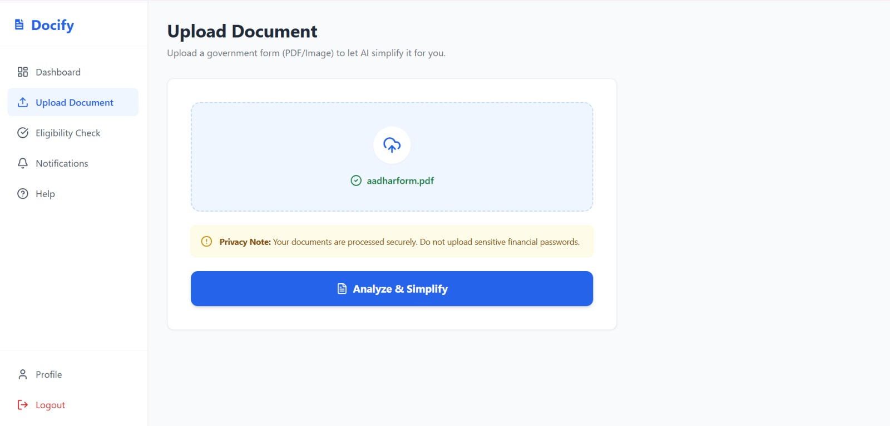

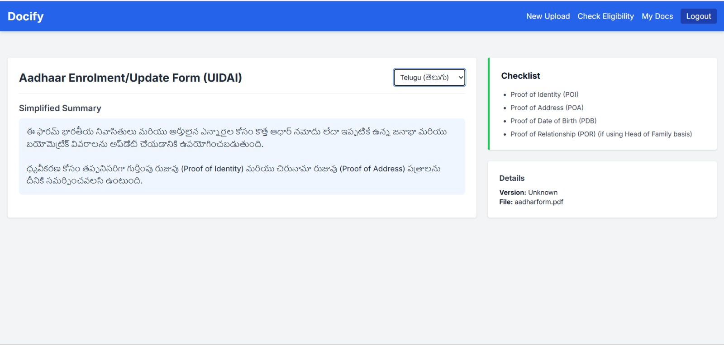

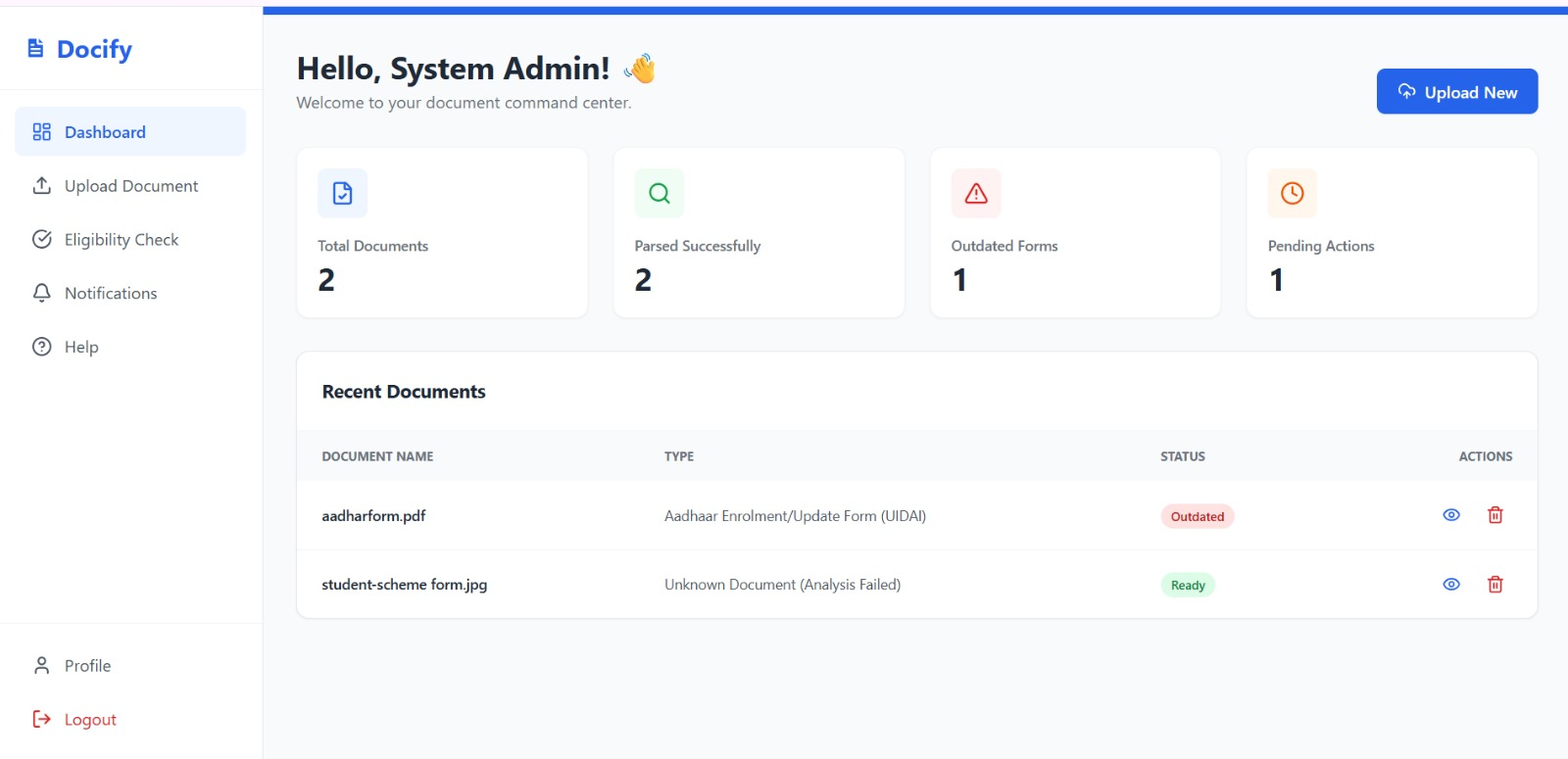

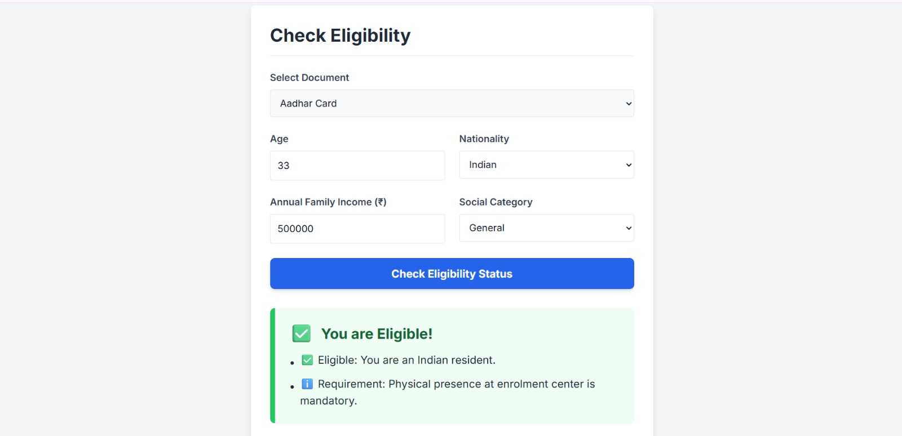

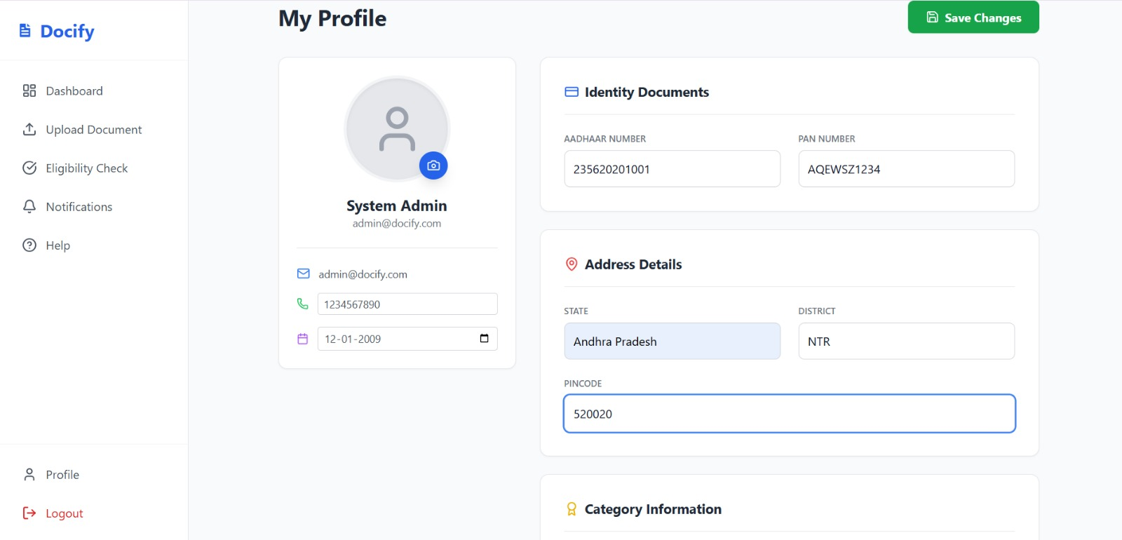

Conclusion

Citizen Docify represents a significant step toward modernizing and simplifying the way individuals interact with government documentation. By combining the strengths of the MERN stack with AI-assisted processing, the system transforms traditionally complex and time-consuming bureaucratic tasks into a streamlined digital experience. The platform not only enables citizens to upload and interpret government forms but also intelligently breaks down dense PDF content into simplified summaries, identifies the required supporting documents, and guides users with personalized form-filling instructions. This reduces dependency on manual agents and promotes greater transparency and accuracy in official submissions.

One of the key achievements of Citizen Docify is its modular and scalable architecture. The backend, powered by Node.js and Express, incorporates secure authentication, structured API routing, sophisticated file-handling mechanisms, and well-defined AI processing stubs. These stubs allow the system to integrate seamlessly with advanced models such as Google Gemini, enabling future expansion into real-time OCR, automated translations, and deeper semantic understanding of document structures. The use of MongoDB Atlas further enhances performance and reliability by supporting flexible data models, fast query execution, and cloud-based scalability.

The frontend plays a crucial role in making government documentation accessible to all users, regardless of technical expertise. Through React’s component-driven interface, Citizen Docify provides a clean, intuitive environment where users can preview files, track document versions, navigate eligibility requirements, view step-by-step instructions, and switch between multiple languages effortlessly. This human-centered design ensures that the system is not only technologically advanced but also practical and inclusive.

Overall, Citizen Docify fulfills its mission of bridging the gap between citizens and government documentation by offering clarity, automation, and intelligent support. It stands as a robust foundation for future enhancements, such as full AI-driven form completion, chatbot-based assistance, integration with government APIs, and mobile accessibility. With its scalable design and strong technical foundation, Citizen Docify has the potential to evolve into a comprehensive digital public-service assistant capable of transforming the user experience across a wide range of government-related wo

