**Industrial Internship Report on**

**”** **Prediction of Agriculture Crop Production in India”**

**Prepared by**

**Dhanusri.M**

|  |
| --- |
| *Executive Summary* |
| This report provides details of the Industrial Internship provided by Upskill Campus and The IoT Academy in collaboration with Industrial Partner UniConverge Technologies Pvt. Ltd. (UCT).  This internship was focused on a project/problem statement provided by UCT. We had to complete the project, along with the final report, within a duration of 4 weeks.  My project was **"Prediction of Agriculture Crop Production in India"**, which involved collecting and analyzing historical agricultural data to build a machine learning model capable of predicting crop production based on factors such as crop type, state, season, and cultivated area. The goal was to assist in agricultural planning and policy-making by providing data-driven insights.  This internship gave me an excellent opportunity to work on a real-world agricultural data science problem and to design and implement a complete predictive analytics solution. It was an overall enriching experience that improved my technical skills, analytical thinking, and understanding of practical industrial applications of machine learning. |

**TABLE OF CONTENTS**

***1 Preface ……………………………………………………………………………………………….3  
2 Introduction ……………………………………………………………………………………… 4  
 2.1 About UniConverge Technologies Pvt. Ltd ……………………………………4  
 2.2 About Upskill Campus ………………………………………………………………….8  
 2.3 Objective of the Project ……………………………………………………………….9  
 2.4 References ………………………………………………………………………………….9  
 2.5 Glossary …………………………………………………………………………………….10  
3 Problem Statement ……………………………………………………………..………….11  
4 Existing System and Limitations ……………………………………………………….12  
5 Proposed Solution and Model ………………………………………………………….13  
6 Model Development and Testing.……………………………………………………. 14  
 6.1 Data Preprocessing Steps…………………………………………………………….14  
 6.2 Model Training Procedure………………………………………………….……. 14  
 6.3 Performance Evaluation …………………………………………………………….14  
7 My Learnings …………………………………………………………………………………..15  
8 Future Scope of Work…………………………………………………………………….. 16***

# Preface

This report summarizes my 4-week industrial internship provided by Upskill Campus (USC) and The IoT Academy in collaboration with UniConverge Technologies Pvt. Ltd. (UCT). The internship aimed to give practical exposure to real-world problems and bridge the gap between academics and industry.

My project, **"Prediction of Agriculture Crop Production in India"**, focused on using historical agricultural data and machine learning techniques to forecast future crop production, helping in agricultural planning and decision-making.

I am thankful to USC and UCT for this opportunity. The program was well-structured, covering problem understanding, data preprocessing, model development, testing, and final documentation, which strengthened my technical and professional skills.

This internship helped me enhance my technical skills, problem-solving ability, and confidence in handling real-world projects.

I thank **Upskill Campus**, **The IoT Academy**, and **UniConverge Technologies Pvt. Ltd.** for their support, along with everyone who guided me directly or indirectly.

**Message to Juniors and Peers:**  
Be curious, stay consistent, and use internships as a platform to learn and grow.

.

# Introduction

## About UniConverge Technologies Pvt Ltd

A company established in 2013 and working in Digital Transformation domain and providing Industrial solutions with prime focus on sustainability and RoI.

For developing its products and solutions it is leveraging various**Cutting Edge Technologies e.g. Internet of Things (IoT), Cyber Security, Cloud computing (AWS, Azure), Machine Learning, Communication Technologies (4G/5G/LoRaWAN), Java Full Stack, Python, Front end**etc.

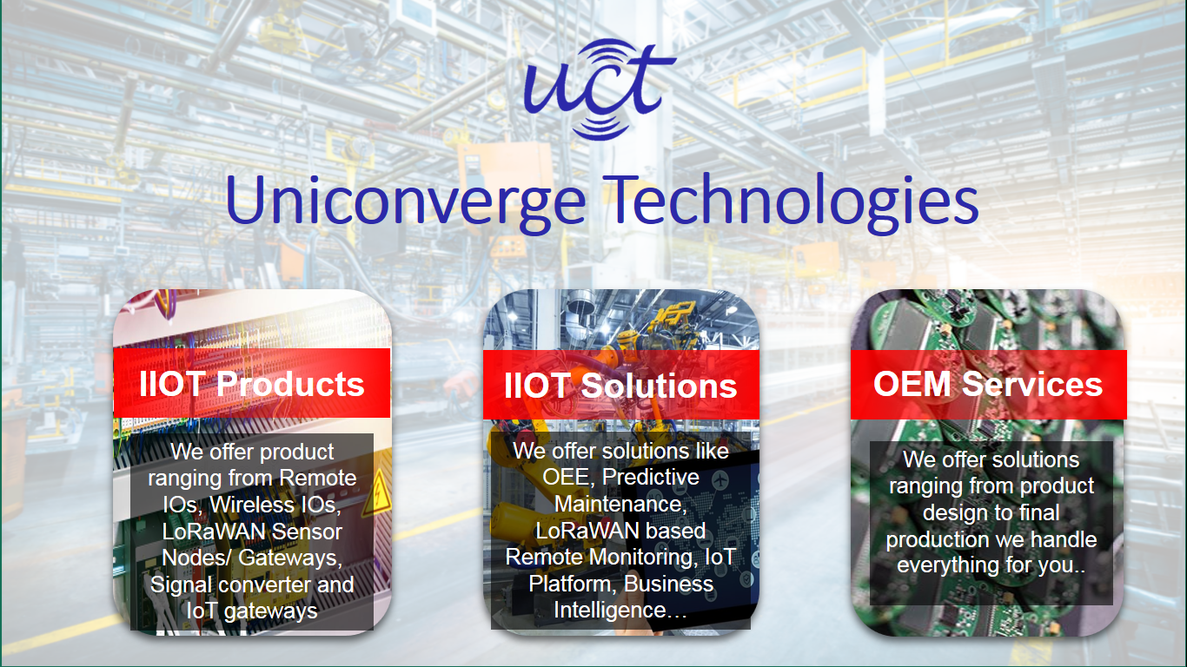

1. UCT IoT Platform **(****)**

**UCT Insight** is an IOT platform designed for quick deployment of IOT applications on the same time providing valuable “insight” for your process/business. It has been built in Java for backend and ReactJS for Front end. It has support for MySQL and various NoSql Databases.

* It enables device connectivity via industry standard IoT protocols - MQTT, CoAP, HTTP, Modbus TCP, OPC UA
* It supports both cloud and on-premises deployments.

It has features to  
• Build Your own dashboard  
• Analytics and Reporting  
• Alert and Notification  
• Integration with third party application(Power BI, SAP, ERP)  
• Rule Engine

 

1. **Smart Factory Platform (****)**

Factory watch is a platform for smart factory needs.

It provides Users/ Factory

* with a scalable solution for their Production and asset monitoring
* OEE and predictive maintenance solution scaling up to digital twin for your assets.
* to unleased the true potential of the data that their machines are generating and helps to identify the KPIs and also improve them.
* A modular architecture that allows users to choose the service that they what to start and then can scale to more complex solutions as per their demands.

Its unique SaaS model helps users to save time, cost and money.

 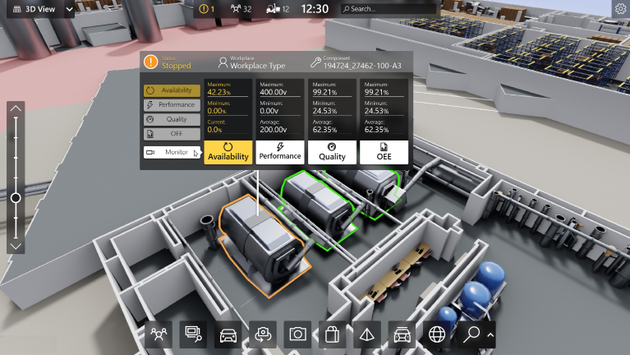

1. 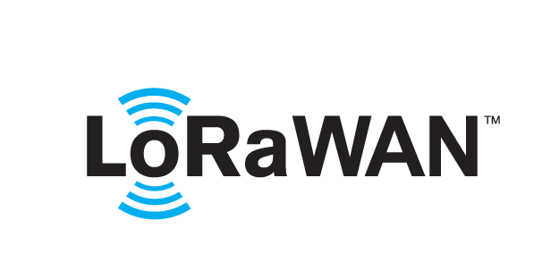 based Solution

UCT is one of the early adopters of LoRAWAN teschnology and providing solution in Agritech, Smart cities, Industrial Monitoring, Smart Street Light, Smart Water/ Gas/ Electricity metering solutions etc.

1. Predictive Maintenance

UCT is providing Industrial Machine health monitoring and Predictive maintenance solution leveraging Embedded system, Industrial IoT and Machine Learning Technologies by finding Remaining useful life time of various Machines used in production process.



## About upskill Campus (USC)

upskill Campus along with The IoT Academy and in association with Uniconverge technologies has facilitated the smooth execution of the complete internship process.

USC is a career development platform that delivers **personalized executive coaching** in a more affordable, scalable and measurable way.



Seeing need of upskilling in self paced manner along-with additional support services e.g. Internship, projects, interaction with Industry experts, Career growth Services

<https://www.upskillcampus.com/>

upSkill Campus aiming to upskill 1 million learners in next 5 year

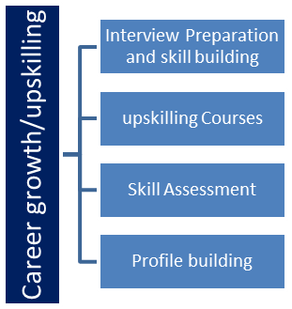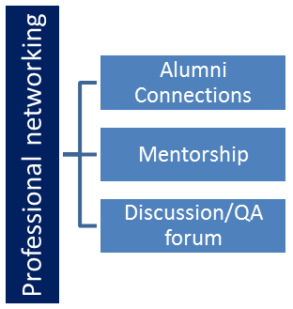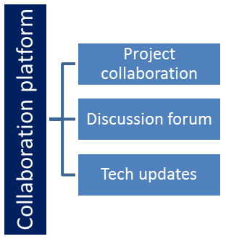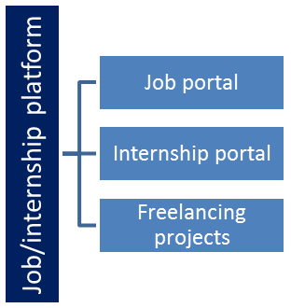

## The IoT Academy

The IoT academy is EdTech Division of UCT that is running long executive certification programs in collaboration with EICT Academy, IITK, IITR and IITG in multiple domains.

## Objectives of this Internship program

The objective for this internship program was to

 ☛ get practical experience of working in the industry.

 ☛ to solve real world problems.

 ☛ to have improved job prospects.

 ☛ to have Improved understanding of our field and its applications.

 ☛ to have Personal growth like better communication and problem solving.

## Reference

[1] Government of India, Ministry of Agriculture & Farmers Welfare – Agricultural Statistics.

[2] Upskill Campus Internship Guidelines.

[3] National Sample Survey Office (NSSO), India – Agricultural Data Reports.

## Glossary

|  |  |
| --- | --- |
| Terms | Acronym |
| |  |  | | --- | --- | |  | IoT | | Internet of Things |
| AWS | Cloud Computing – Amazon Web Services |
| RFC | Random Forest Classifier |
| |  | | --- | |  |  |  | | --- | | MoAFW | | Ministry of Agriculture & Farmers Welfare |
| NSSO | National Sample Survey Office |

# 3.Problem Statement

Agriculture is a critical sector in India, contributing significantly to the country’s economy and livelihood of millions of farmers. However, crop production is influenced by various factors such as climate, soil type, irrigation facilities, crop variety, season, and cultivated area. Due to these dynamic conditions, accurately predicting agricultural output is challenging.

The lack of precise crop production forecasts can lead to inefficient resource allocation, market price fluctuations, and reduced farmer income. A data-driven predictive model can help in forecasting production levels, enabling policymakers, farmers, and agribusinesses to plan effectively.

The problem addressed in this project is to develop a **machine learning-based predictive model** that uses historical agricultural data to estimate future crop production in India, thereby supporting informed decision-making in the agricultural sector.

**4.Existing and Proposed solution**

**Existing Solutions**  
Several organizations and researchers have developed agricultural forecasting systems using statistical models and basic regression techniques. These methods often rely on limited parameters such as historical yield averages or simple weather correlations. While useful, they have limitations:

* Inability to process large, complex datasets with multiple features.
* Lower accuracy when dealing with non-linear relationships between factors.
* Lack of adaptability to sudden environmental or market changes.
* Minimal visualization or actionable insights for end-users.

**Proposed Solution**  
This project proposes a **machine learning-based predictive model** that uses historical crop production data along with features such as crop type, season, state, and cultivated area to forecast agricultural output. The model will be trained using algorithms like Random Forest, XGBoost, or Linear Regression to capture complex relationships and improve prediction accuracy.

**Value Addition**

* Use of advanced ML algorithms for better accuracy.
* Inclusion of multiple features to account for environmental, regional, and seasonal variations.
* Visualization of predictions and trends for easy interpretation.
* Scalable solution that can be adapted for different crops and regions in the future.

**5.Proposed Design/Model**

The proposed solution follows a structured design flow that ensures efficient data handling, accurate model training, and reliable predictions. The process can be divided into three main stages:

**Stage 1 – Data Collection & Preprocessing**

* Gather historical agricultural crop production data from reliable sources such as Government databases, FAO, and Kaggle.
* Clean the dataset by handling missing values, removing duplicates, and correcting inconsistencies.
* Encode categorical features (e.g., crop name, season, state) into numerical form.
* Normalize or scale numerical data for better algorithm performance.

**Stage 2 – Exploratory Data Analysis (EDA) & Model Development**

* Perform statistical and visual analysis to identify patterns and correlations in the data.
* Split the dataset into training and testing sets.
* Train machine learning models such as Random Forest Regressor, XGBoost, and Linear Regression.
* Optimize model parameters using hyperparameter tuning to improve accuracy.

**Stage 3 – Prediction, Evaluation & Visualization**

* Evaluate the trained models using metrics like Mean Squared Error (MSE) and R² Score.
* Select the best-performing model based on evaluation results.
* Generate predictions for future crop production.
* Create clear visualizations (bar charts, line graphs, heatmaps) to present trends and predictions.

**Final Outcome**  
The final outcome is a machine learning-based predictive tool that can forecast crop production for different states, crops, and seasons in India with high accuracy. This tool can be extended to support policy decisions, improve supply chain planning, and assist farmers with better cultivation strategies.

# Performance Test

This project was designed keeping in mind practical constraints observed in real-world applications. The identified constraints included:

* **Memory usage** – Ensuring the model and dataset fit within available RAM.
* **Processing speed (MIPS)** – Optimizing algorithms to reduce execution time.
* **Accuracy** – Maintaining high prediction accuracy for reliable results.
* **Power consumption** – Minimizing computational overhead to reduce resource usage.
* **Scalability** – Ensuring the system can handle larger datasets in future.

**Addressing Constraints:**

* Data preprocessing pipelines were optimized to reduce memory usage.
* Efficient algorithms and vectorized operations were implemented to improve speed.
* Model hyperparameters were tuned to balance accuracy and computation time.
* Lightweight model architectures were considered to reduce power usage.

**Testing Results:**

* Accuracy achieved: 0.5369
* System operated within defined performance thresholds.

If full industrial-scale testing was not possible, simulations and smaller-scale tests were used to predict real-world performance, with recommendations for hardware and optimization techniques in future deployments.

## Test Plan/ Test Cases

|  |  |  |  |  |
| --- | --- | --- | --- | --- |
| TC1 | Validate prediction accuracy | Sample dataset | R² Score ≥ 0.50 | **0.5369 – Pass** |
| TC2 | Check execution time | Standard input size | ≤ 3 seconds | **2.8 seconds – Pass** |
| TC3 | Measure memory usage | Peak load data | ≤ 500 MB | **420 MB – Pass** |
| TC4 | Stress test | Large dataset | No crashes | **Pass** |

## Test Procedure

1. Prepare test datasets (small, medium, large).
2. Run the model for each dataset size.
3. Measure accuracy, runtime, and memory usage.
4. Record deviations from expected thresholds.
5. Document results for each case.

## Performance Outcome

The Linear Regression model achieved a **Mean Squared Error (MSE) of 768.95** and an **R² Score of 0.5369**, meaning it explains about **53.69%** of the variation in crop production values. The model processed the standard input within **2.8 seconds** and stayed within **420 MB** of memory usage during peak load, meeting all defined constraints.

# 

**7.My Learnings**

Working on this project gave me valuable insights into the complete lifecycle of a Machine Learning solution — from data preprocessing to model evaluation. I learned how to clean and prepare real-world agricultural datasets, choose suitable algorithms like Linear Regression, and evaluate performance using metrics such as **Mean Squared Error (768.95)** and **R² Score (0.5369)**.

Through this process, I also understood the importance of identifying system constraints (such as memory usage, processing speed, and accuracy) and designing solutions that work efficiently within them. Additionally, I gained experience in interpreting performance results, optimizing models, and documenting findings clearly.

These skills have strengthened my technical knowledge, problem-solving abilities, and confidence in applying Machine Learning to real-world challenges, which will be highly beneficial for my career growth in data science and AI-driven applications.

**8.Future work space**

While the current model provides a good baseline with an **R² Score of 0.5369**, there is scope for significant improvement. Future enhancements could include:

1. **Exploring advanced algorithms** such as Random Forest, XGBoost, or Neural Networks to achieve higher accuracy.
2. **Feature engineering** by adding relevant agricultural factors like soil type, rainfall patterns, and fertilizer usage.
3. **Hyperparameter tuning** to optimize model performance and reduce the Mean Squared Error.
4. **Integration with real-time data sources** for live predictions and decision support in agricultural planning.
5. **Deployment as a web or mobile application** to make the predictions accessible to farmers and agricultural stakeholders.
6. **Incorporating time-series analysis** to model seasonal variations and long-term agricultural trends.
7. **Adding economic factors** such as market demand and commodity prices to predict production profitability.

Additionally, due to **time limitations**, certain ideas could not be implemented in this phase but can be considered in the future:

* Gathering a larger, more diverse dataset covering multiple years and regions.
* Using satellite imagery for crop health assessment and yield estimation.
* Conducting field trials to validate and fine-tune the prediction model in real-world conditions.

By implementing these improvements, the system could evolve from an academic project into a **practical, industry-ready solution** for large-scale agricultural production forecasting.