Project Proposal: Design of a Vision-Language Model for 3D Medical Image Analysis
Project title | Design of a Vision-Language Model for 3D Medical Image Analysis
Submitted by | Thripthika M P, Research Scholar, NITK Surathkal (Lecturer, KPT Mangalore)
Course | Deep Learning — Mini Project (PhD Coursework)
Base papers | Med3DVLM: An Efficient Vision-Language Model for 3D Medical Image Analysis [5]; Diagnostic Captioning by Cooperative Task Interactions and Sample-Graph Consistency [6]
Date | October 2026
This project designs a small vision-language model that recognises organs in 3D CT scans by matching each scan with a text description of the organ.

1. Introduction
Computed tomography (CT) produces 3D images of the body, and recognising the organs in these images is a basic step in medical image analysis. Deep learning models, especially 3D convolutional neural networks (CNNs), can learn to do this automatically.
A standard CNN learns only from class numbers (0, 1, 2, …) and does not know what the classes mean. A vision-language model (VLM) learns from images and text together, so it also learns the meaning of words such as “liver” or “left kidney”. Recent 3D medical VLMs such as Med3DVLM [5] show strong results, but they need very large datasets and many GPUs.
This project builds a small and simple 3D VLM that can be trained on a single GPU, using a public CT dataset of 11 organs.

2. Objective
To design and train a simple vision-language model that classifies 3D CT scans into 11 organ classes by matching each scan with a text description of the organ, and to compare it with a standard 3D CNN classifier.

3. Literature survey
Paper | Method | Relevance to this project
MedMNIST v2 — Yang et al., 2023 [1] | A benchmark of small, standardised 2D and 3D medical images with CNN baselines such as ResNet | Provides the dataset and the CNN baseline
CLIP — Radford et al., 2021 [2] | Trains an image encoder and a text encoder together; an image is classified by finding the most similar text description | Core idea of the proposed model
SigLIP — Zhai et al., 2023 [3] | Replaces CLIP’s softmax loss with a pairwise sigmoid loss that works well with small batches | Training loss of the proposed model
M3D — Bai et al., 2024 [4] | A large 3D CT vision-language model (M3D-LaMed) trained on 120,000 image-text pairs | Shows that VLMs work on 3D CT, but needs heavy computation
Med3DVLM — Xin et al., 2026 [5] (base paper) | An efficient 3D VLM using a lightweight 3D encoder (DCFormer) and SigLIP image-text alignment; improves image-text retrieval Recall@1 from 19.10% to 61.00% over M3D-LaMed | Image-text alignment approach followed in this project
Diagnostic Captioning — Wang et al., 2025 [6] (base paper) | Adds an image-text matching task to medical report generation so the image features capture fine clinical differences | Shows that aligning image and text features improves medical image understanding
Research gap: existing 3D medical vision-language models need large datasets and multiple high-end GPUs. This project studies whether a small 3D VLM, trainable on a single GPU, can match or improve a standard 3D CNN on organ classification.

4. Dataset
The project uses OrganMNIST3D, a public 3D CT dataset from the MedMNIST v2 benchmark [1].
Item | Details
Dataset | OrganMNIST3D (MedMNIST v2) [1]
Image type | 3D abdominal CT volumes, grayscale
Source | 201 CT scans from the Liver Tumor Segmentation (LiTS) benchmark, cropped around each organ
Volume size | 28 × 28 × 28 voxels
Total no. of samples | 1,742
Training / validation / test | 971 / 161 / 610
No. of classes | 11
Class names | Liver, right kidney, left kidney, right femur, left femur, bladder, heart, right lung, left lung, spleen, pancreas
Licence and access | CC BY 4.0; downloaded with the medmnist Python package
The official training, validation and test split is used, so the results can be compared with published MedMNIST baselines.

5. Methodology
The existing method is a standard 3D CNN classifier, as used in the MedMNIST v2 benchmark [1]. It is built first and serves as the baseline.
- Data preparation. Load OrganMNIST3D with the medmnist package and scale voxel values to the range 0–1. During training, apply random flips and small rotations to increase variety.
- 3D CNN model. Four convolution blocks, each with a 3 × 3 × 3 convolution, batch normalisation, ReLU activation and max pooling, with 32, 64, 128 and 256 filters. Global average pooling and a fully connected layer then give 11 class scores. The model has about 1.17 million parameters.
- Training. Cross-entropy loss, Adam optimiser, learning rate 0.001, batch size 32, 50 epochs. The model with the best validation accuracy is kept.
- Testing. Measure accuracy and AUC on the 610 test volumes.
Tools: Python, PyTorch, Hugging Face Transformers and the medmnist package. Training runs on a single GPU; a free Google Colab GPU is sufficient for this dataset size.

6. Modification in methodology
The modification turns the 3D CNN into a simple vision-language model, following the image-text alignment idea of the base paper Med3DVLM [5]. The final fully connected layer is replaced by matching each scan against text descriptions of the 11 organs.
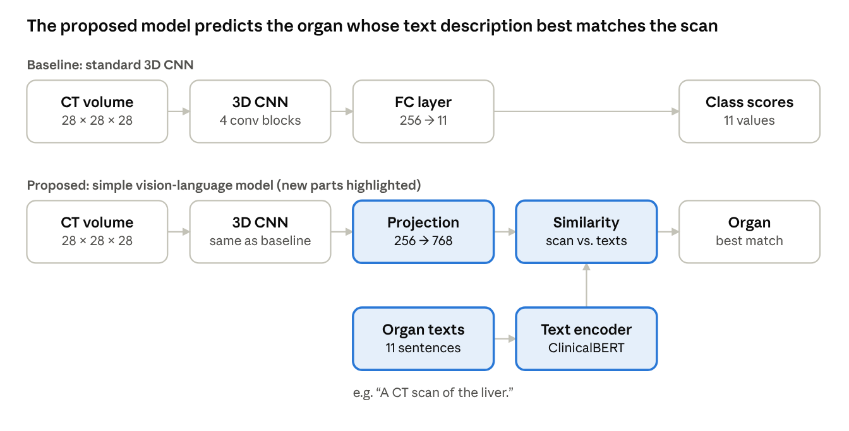
Figure 1. Baseline 3D CNN and the proposed vision-language model
- Organ descriptions. Write one short sentence for each organ, for example “A CT scan of the liver.” This gives 11 sentences.
- Text encoder. A pretrained ClinicalBERT model [7] turns each sentence into a vector of 768 numbers. It is kept frozen, so it is not retrained.
- Image encoder. The same 3D CNN as the baseline, followed by a projection layer that maps its 256 features to a vector of 768 numbers.
- Training. The SigLIP loss [3] pulls each scan’s vector towards the vector of its correct organ sentence and pushes it away from the other 10 sentences.
- Prediction. The organ whose sentence vector is most similar to the scan vector is the predicted class.
The training loss and the prediction rule are given below. For scan i and organ sentence j, s is the cosine similarity of their vectors, z is +1 for the correct organ and −1 otherwise, σ is the sigmoid function, N is the number of scans in a batch, and t and b are learnable scale and bias values. The predicted organ is the sentence with the highest similarity.

Aspect | Baseline (existing method) | Proposed (modified method)
Labels used | Class numbers 0–10 | A text description of each organ
Final layer | Fully connected layer with 11 outputs | Projection layer + similarity with 11 text vectors
Loss function | Cross-entropy | SigLIP (sigmoid image-text loss)
Model type | Image-only CNN | Vision-language model
Trainable parameters | About 1.17 million | About 1.36 million (text encoder frozen)
This modification lets the model learn the meaning of each organ name instead of a bare class number, applies the base paper’s image-text alignment at a scale that one GPU can train, and allows new text descriptions to be added later without changing the network.

7. Evaluation and expected outcome
The baseline and the proposed model are trained on the same 971 training volumes and tested on the same 610 test volumes.
- Accuracy: percentage of test volumes assigned to the correct organ.
- AUC: area under the ROC curve, averaged over the 11 classes.
- Confusion matrix: shows which organs are confused with each other, for example the left and right kidney.
Expected outcome: a working 3D vision-language model for organ recognition that reaches equal or higher test accuracy than the standard 3D CNN, together with a comparison of the two approaches.

References
- J. Yang, R. Shi, D. Wei, Z. Liu, L. Zhao, B. Ke, H. Pfister and B. Ni, “MedMNIST v2 – A large-scale lightweight benchmark for 2D and 3D biomedical image classification,” Scientific Data, vol. 10, Art. no. 41, 2023. doi:10.1038/s41597-022-01721-8
- A. Radford et al., “Learning transferable visual models from natural language supervision,” in Proc. Int. Conf. Machine Learning (ICML), 2021, pp. 8748–8763.
- X. Zhai, B. Mustafa, A. Kolesnikov and L. Beyer, “Sigmoid loss for language image pre-training,” in Proc. IEEE/CVF Int. Conf. Computer Vision (ICCV), 2023, pp. 11975–11986.
- F. Bai, Y. Du, T. Huang, M. Q.-H. Meng and B. Zhao, “M3D: Advancing 3D medical image analysis with multi-modal large language models,” arXiv:2404.00578, 2024.
- Y. Xin, G. C. Ates, K. Gong and W. Shao, “Med3DVLM: An efficient vision-language model for 3D medical image analysis,” IEEE J. Biomedical and Health Informatics, vol. 30, no. 3, pp. 2524–2536, Mar. 2026. doi:10.1109/JBHI.2025.3604595
- Z. Wang, L. Wang, X. Li and L. Zhou, “Diagnostic captioning by cooperative task interactions and sample-graph consistency,” IEEE Trans. Pattern Analysis and Machine Intelligence, vol. 47, no. 8, pp. 6585–6598, Aug. 2025. doi:10.1109/TPAMI.2025.3562866
- E. Alsentzer, J. Murphy, W. Boag, W.-H. Weng, D. Jindi, T. Naumann and M. McDermott, “Publicly available clinical BERT embeddings,” in Proc. 2nd Clinical Natural Language Processing Workshop, 2019, pp. 72–78. doi:10.18653/v1/W19-1909

