**Documentation**

The project is mainly of taking a survey. This survey is created by an admin and after publishing the survey, users are able to respond to the survey So the admin has the privileges to create questions for a survey with different type of inputs.

**Types of users**

* **Admin :** Creates the survey
* **User :** Response to the survey

**Stack used :**

* HTML, CSS, JS,
* Spring Boot
* MongoDB

**Admin view**

Here, the admin creates the survey for a particular purpose,

* Create a survey
* Edit the survey
* Delete the survey
* Views and manages their responses from the survey by the user

Question in the survey

* Add questions with the required types and the type of questions like
  + paragraph,
  + multiple choice,
  + drop down
  + file upload
  + date and time
  + check box
* Edit question
* Delete question

After creating the survey and inserting the questions the admin should be able to publish the survey and thus the survey will be available for the users to respond

On the admin is able to see the response by the individual users

**By creating a new survey**

* Title and the description of the survey on needed to be filled

**Description**

Input Type: Text

Placeholder: Enter The Description

Minimum Character: 5

Maximum Character: nil

Required: no

Allowed Characters:

* Alphanumeric
* Spaces
* Special Characters

And Basic Validations

**Title**

Input Type: Text

Value: Untitled

Minimum Character: 5

Maximum Character: 100

Required: Yes

Allowed Characters:

* Alphanumeric
* Spaces
* Special Characters

And Basic Validations

**A slider**

The slider will be containing a

* Plus symbol
* Delete symbol,

Which are used to create a new question and delete the current active question. By default, all questions will be in editable form.

This slider will be automatically tracking the active question

**Creating a question**

* The input box for the question
* A button includes the list of types of input and which is used for the users to select the type of input for that particular question
* After the type of the question the particular input type will be displayed under the question.

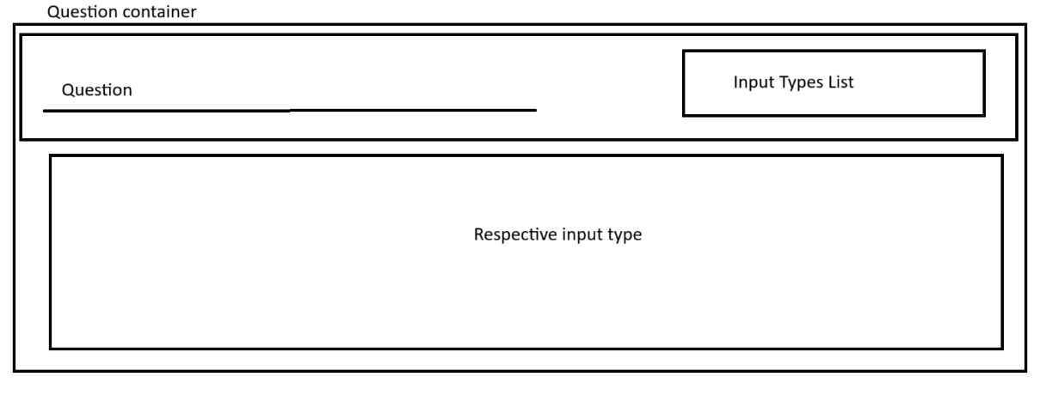

**Question type selection**

Input Type: Drop Down

value: The first input type in the list of Inputs .

Required: Yes

**Question**

Input Type: Text

Placeholder: Enter the question

Minimum Character: 5

Maximum Character: nil

Required: Yes

Allowed Characters:

* Alphanumeric
* Spaces
* Special Characters

And Basic Validations

Drop down, check box, multiple choice - So for these types of questions the options are added and these options can be also deleted

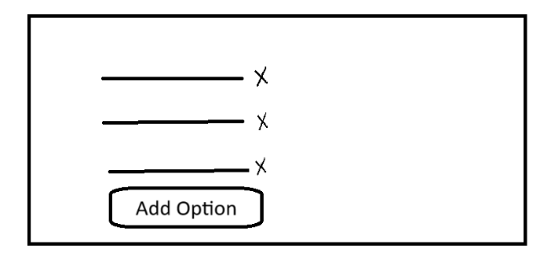

Each option is of input type text and they will be having a minimum character 5. And maximum character as 100. So for these type of postings, options should be one or more than one

Each question will be containing a footer for the element. So which has two buttons such as copy and required.

Required button is used to make the user who responds to the particular question making it as mandatory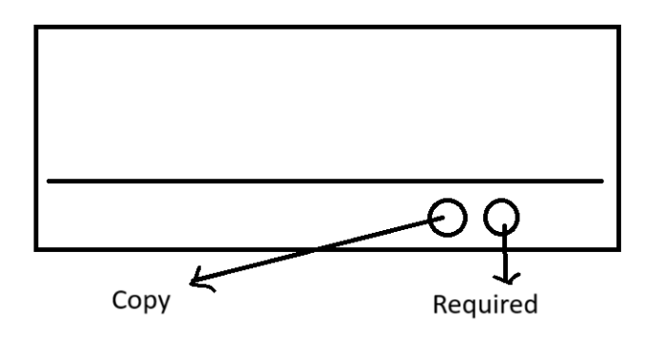.

Coffee. Button here is used to copy the question again and making a new question below it.  
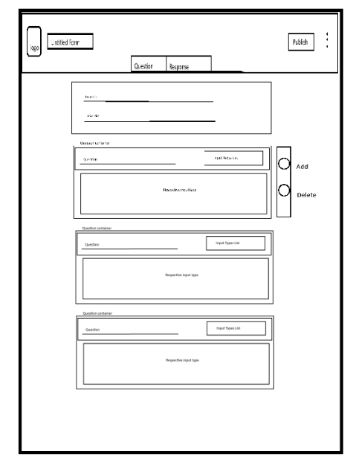

.

After adding the questions for the particular survey. Admin can publish this survey.

By publishing it, the questions are going to be saved in the database. Through the back end process and now the admin is able to create a new survey or edit survey exists and delete it whenever he/ she wants and users are now able to respond to the survey so the user will be having different layout of front end as the questions are passed from the database as a form.