**Creating Microservices for account and loan**

**AccountServiceApplication.java**

package com.cognizant.account;

import org.springframework.boot.SpringApplication;

import org.springframework.boot.autoconfigure.SpringBootApplication;

import org.springframework.web.bind.annotation.*;

@SpringBootApplication

@RestController

@RequestMapping("/accounts")

public class AccountServiceApplication {

public static void main(String[] args) {

SpringApplication.run(AccountServiceApplication.class, args);

}

@GetMapping("/{number}")

public String getAccount(@PathVariable String number) {

return "{ \"number\": \"" + number + "\", \"type\": \"savings\", \"balance\": 1000 }";

}

}

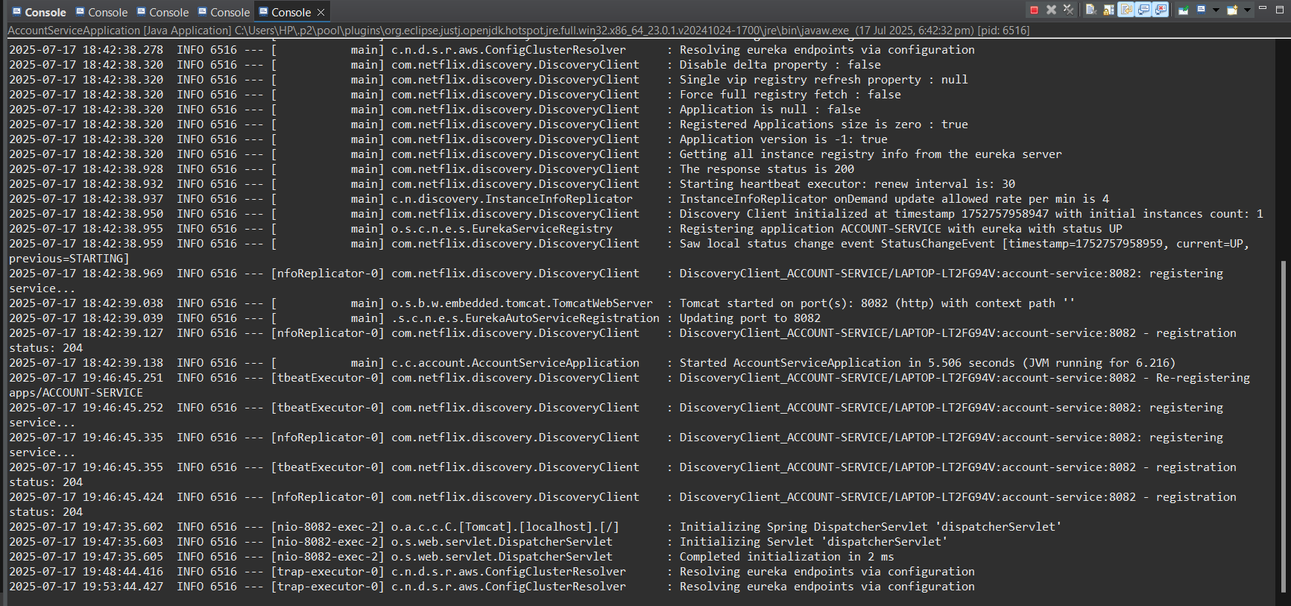

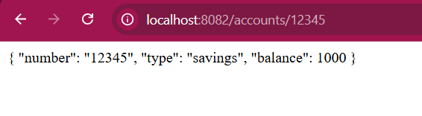

**LoanServiceApplication.java**

package com.cognizant.loan;

import org.springframework.boot.SpringApplication;

import org.springframework.boot.autoconfigure.SpringBootApplication;

import org.springframework.web.bind.annotation.*;

@SpringBootApplication

@RestController

@RequestMapping("/loans")

public class LoanServiceApplication {

public static void main(String[] args) {

SpringApplication.run(LoanServiceApplication.class, args);

}

@GetMapping("/{number}")

public String getLoan(@PathVariable String number) {

return "{ number: \"" + number + "\", type: \"car\", loan: 400000, emi: 3258, tenure: 18 }";

}

}

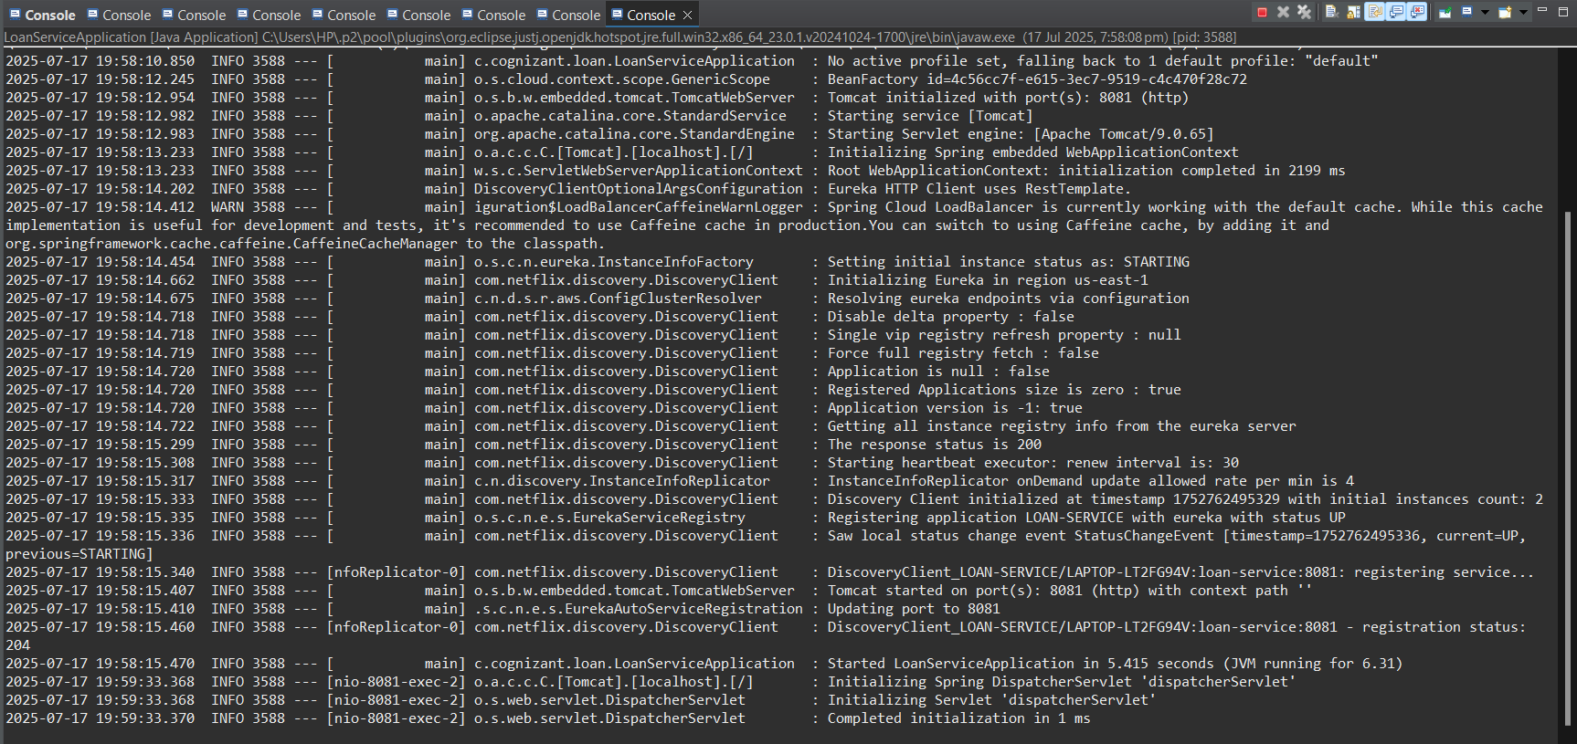

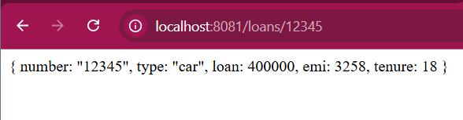

**Create Eureka Discovery Server and register**

**EurekaDiscoveryServerApplication.java**

package com.cognizant.discovery;

import org.springframework.boot.SpringApplication;

import org.springframework.boot.autoconfigure.SpringBootApplication;

import org.springframework.cloud.netflix.eureka.server.EnableEurekaServer;

@SpringBootApplication

@EnableEurekaServer

public class EurekaDiscoveryServerApplication {

public static void main(String[] args) {

SpringApplication.run(EurekaDiscoveryServerApplication.class, args);

}

}

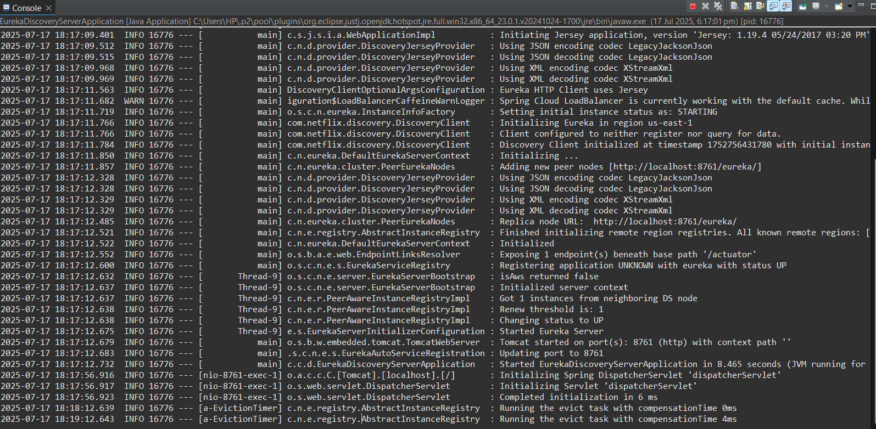

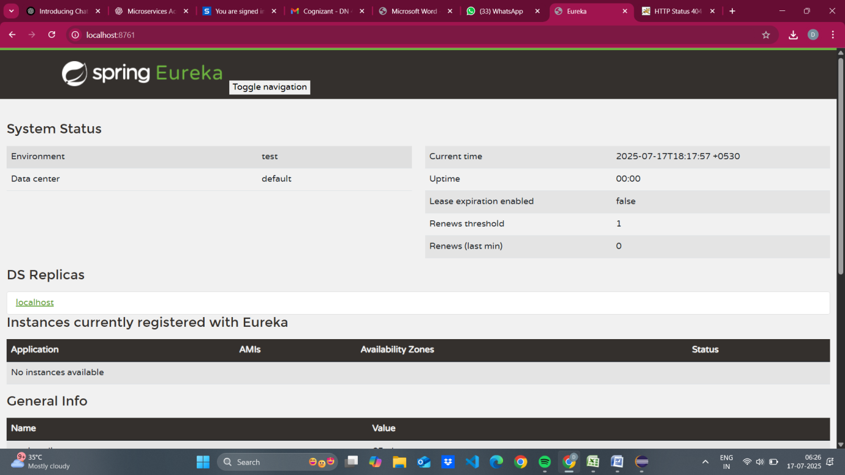

**ApiGatewayApplication.java**

package com.cognizant.gateway;

import org.springframework.boot.SpringApplication;

import org.springframework.boot.autoconfigure.SpringBootApplication;

import org.springframework.cloud.gateway.filter.GlobalFilter;

import org.springframework.stereotype.Component;

import org.springframework.web.server.ServerWebExchange;

import reactor.core.publisher.Mono;

import org.slf4j.Logger;

import org.slf4j.LoggerFactory;

@SpringBootApplication

public class ApiGatewayApplication {

public static void main(String[] args) {

SpringApplication.run(ApiGatewayApplication.class, args);

}

}

@Component

class LogFilter implements GlobalFilter {

private Logger logger = LoggerFactory.getLogger(LogFilter.class);

public Mono<Void> filter(ServerWebExchange exchange, org.springframework.cloud.gateway.filter.GatewayFilterChain chain) {

logger.info("Request path: " + exchange.getRequest().getPath());

return chain.filter(exchange);

}

}

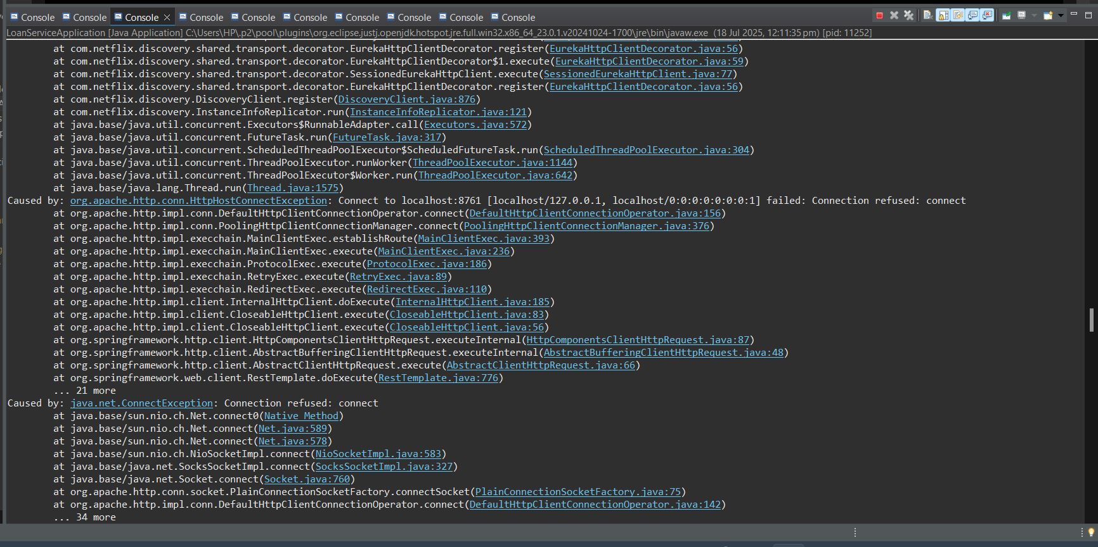

Account Service

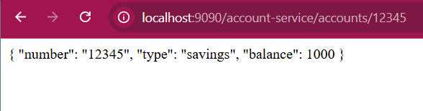

Loan Service

