Machine Learning Model Development and Evaluation
A Rigorous Multiclass Classification Study on Physicochemical Wine Cultivar Fingerprints
Executive Summary
This project develops, validates, and compares a reproducible end-to-end machine learning pipeline for multiclass classification on the Wine dataset from the UCI Machine Learning Repository and scikit-learn. The primary analytical objective is to determine whether 13 chemical and physical measurements derived from Italian wines can reliably classify their cultivar of origin (cultivars 0, 1, and 2, corresponding to Barolo, Grignolino, and Barbera). The experimental pipeline incorporates data hygiene inspection, stratified train-test partitioning (80/20 split, random_state=42), leakage-free standard feature scaling encapsulated inside scikit-learn Pipelines, and rigorous multiclass evaluation.
Three candidate classification algorithms representing distinct inductive biases were implemented: Logistic Regression (multinomial linear baseline with L2 regularization), Random Forest (ensemble bagging of 100 trees), and Decision Tree (single non-linear CART baseline). On the held-out test set (N = 36), the Random Forest model achieved flawless performance (100.0% accuracy, Macro F1 = 1.0000, One-vs-Rest Macro ROC-AUC = 1.0000). Logistic Regression attained 97.22% accuracy (Macro F1 = 0.9710, ROC-AUC = 1.0000) with exactly one borderline misclassification. The single Decision Tree attained 94.44% accuracy (Macro F1 = 0.9457, ROC-AUC = 0.9493) with two misclassifications due to rigid orthogonal decision boundaries. Based on empirical generalization, variance resistance, and multiclass separation, Random Forest is selected as the primary champion model, with standardized Logistic Regression serving as an exceptional, highly interpretable alternative.
[EXECUTIVE SUMMARY TAKEAWAY] Random Forest achieved 100% test accuracy and 1.0000 Macro F1 with zero generalization gap. Standardized Logistic Regression achieved 97.22% test accuracy with 1.0000 ROC-AUC. Both models successfully demonstrate that physicochemical attributes provide highly separable chemical signatures for cultivar discrimination.

1. Introduction
Automated cultivar identification and chemical fingerprinting are vital pillars in enology, agricultural economics, and food authentication. Regional wines command distinct commercial valuations and regulatory designations based on cultivar origin. However, traditional sensory profiling is subjective, labor-intensive, and susceptible to cognitive bias. Machine learning provides a principled, data-driven framework to map continuous physicochemical assays directly to cultivar classifications.
This project establishes an academic data science workflow adhering to modern reproducibility principles. The study systematically progresses from data verification and pipeline construction through baseline modeling, ensemble comparison, multiclass evaluation, error diagnosis, and deployment readiness analysis.
2. Problem Definition
The core research problem is framed as a supervised, multi-class pattern classification task: Given a feature vector of 13 continuous chemical and physical measurements x in R^13, predict the discrete cultivar label y in {0, 1, 2} representing three distinct Italian wine cultivars grown in the Piedmont region.
Formal Task Definition:
• Input Space (X): 13 continuous physicochemical attributes spanning alcohol content, organic acid levels, ash components, polyphenolic profiles (phenols, flavanoids, nonflavanoids, proanthocyanins), colorimetric properties (intensity, hue), spectrophotometric absorbance ratios, and amino acid content (proline).
• Target Space (Y): Discrete multiclass label y in {0, 1, 2} corresponding to three cultivars: Class 0 (Barolo), Class 1 (Grignolino), and Class 2 (Barbera).
• Optimization Objective: Learn a parameterized classification function f: X -> Y that maximizes out-of-sample generalization accuracy and macro-averaged F1-score while maintaining robust multiclass discrimination across all classes.
3. Dataset Description
The dataset utilized is the Wine Recognition Dataset, originally curated by Forina et al. (1988) and distributed via the UCI Machine Learning Repository and scikit-learn. The dataset consists of exactly 178 observations with 13 numerical continuous features and zero missing values. The target variable comprises three distinct classes corresponding to three wine cultivars derived from the same geographical region in Italy.
Target Class Distribution:
• Class 0 (Barolo): 59 observations (33.1%)
• Class 1 (Grignolino): 71 observations (39.9%)
• Class 2 (Barbera): 48 observations (27.0%)
Dataset Appropriateness:
This dataset is uniquely suited for machine learning benchmarking because it presents a multi-dimensional continuous feature space exhibiting varying scales, significant biological correlations, and mild class imbalance. It provides an ideal testbed for evaluating scale-sensitive linear models (Logistic Regression) against scale-invariant tree ensembles (Random Forest), testing pipeline data-leakage prevention, and conducting multiclass One-vs-Rest ROC diagnostics.
Table 1: Physicochemical Feature Descriptions and Target Variables
Feature / Variable | Type | Units / Domain | Description
alcohol | Continuous | % by volume | Ethanol content produced during fermentation
malic_acid | Continuous | g/L | Primary organic acid influencing tartness
ash | Continuous | g/L | Inorganic mineral residue remaining after incineration
alcalinity_of_ash | Continuous | pH buffering | Measure of base-neutralizing capacity of ash
magnesium | Continuous | mg/L | Essential mineral cation concentration
total_phenols | Continuous | g/L | Aggregate content of phenolic compounds
flavanoids | Continuous | g/L | Polyphenolic antioxidants affecting taste and structure
nonflavanoid_phenols | Continuous | g/L | Secondary phenolic acids and simple phenolics
proanthocyanins | Continuous | g/L | Condensed tannins contributing to astringency
color_intensity | Continuous | Absorbance units | Spectral color depth at key visual wavelengths
hue | Continuous | Ratio | Hue ratio of yellow to red optical absorbance
od280/od315_of_diluted_wines | Continuous | Absorbance ratio | Spectrophotometric protein/phenolic purity indicator
proline | Continuous | mg/L | Dominant amino acid synthesized by vine cultivar
target | Categorical (int) | Classes: 0, 1, 2 | Cultivar label: 0 (Barolo), 1 (Grignolino), 2 (Barbera)

Table 2: Descriptive Statistics for the 13 Physicochemical Features (N = 178)
Feature | Mean | Std | Min | 25% | Median | 75% | Max
alcohol | 13.00 | 0.81 | 11.03 | 12.36 | 13.05 | 13.68 | 14.83
malic_acid | 2.34 | 1.12 | 0.74 | 1.60 | 1.87 | 3.08 | 5.80
ash | 2.37 | 0.27 | 1.36 | 2.21 | 2.36 | 2.56 | 3.23
alcalinity_of_ash | 19.49 | 3.34 | 10.60 | 17.20 | 19.50 | 21.50 | 30.00
magnesium | 99.74 | 14.28 | 70.00 | 88.00 | 98.00 | 107.00 | 162.00
total_phenols | 2.30 | 0.63 | 0.98 | 1.74 | 2.35 | 2.80 | 3.88
flavanoids | 2.03 | 1.00 | 0.34 | 1.21 | 2.13 | 2.88 | 5.08
nonflavanoid_phenols | 0.36 | 0.12 | 0.13 | 0.27 | 0.34 | 0.44 | 0.66
proanthocyanins | 1.59 | 0.57 | 0.41 | 1.25 | 1.56 | 1.95 | 3.58
color_intensity | 5.06 | 2.32 | 1.28 | 3.22 | 4.69 | 6.20 | 13.00
hue | 0.96 | 0.23 | 0.48 | 0.78 | 0.96 | 1.12 | 1.71
od280/od315_of_diluted_wines | 2.61 | 0.71 | 1.27 | 1.94 | 2.78 | 3.17 | 4.00
proline | 746.89 | 314.91 | 278.00 | 500.50 | 673.50 | 985.00 | 1680.00

4. Data Preparation
A rigorous preprocessing protocol was executed to maintain experimental integrity and eliminate data leakage:
1. Data Quality Inspection: The raw dataset was inspected for structural anomalies. Exactly 0 missing values and 0 duplicate rows were identified across all 178 records. All 13 predictor columns are floating-point continuous values.
2. Train/Test Stratification: The dataset was partitioned into a training set (80%, N = 142) and a held-out test set (20%, N = 36) using stratified sampling with a deterministic seed (random_state = 42). Stratification guarantees that the class proportions (Class 0: ~33.1%, Class 1: ~39.9%, Class 2: ~27.0%) are preserved identically in both training (47, 57, 38 samples) and test (12, 14, 10 samples) splits.
3. Feature Scaling & Leakage Prevention: Features exhibit disparate numerical ranges (e.g., nonflavanoid phenols range from 0.13 to 0.66 g/L, whereas proline ranges from 278 to 1680 mg/L). Without scaling, gradient-based and distance-sensitive classifiers would place disproportionate weight on high-magnitude features. Standard z-score normalization (StandardScaler) was utilized. To strictly eliminate data snooping and information leakage, the scaler was encapsulated within a scikit-learn Pipeline, ensuring the mean and standard deviation parameters were fitted solely on training folds and applied downstream to test samples without prior exposure.
5. Model Selection
Three classification algorithms spanning diverse mathematical paradigms were selected for empirical benchmarking:
1. Logistic Regression (Primary Baseline): A multinomial linear classifier utilizing the softmax link function and L2 weight penalty. Logistic Regression models the log-odds of each class as a linear combination of standardized features. It serves as the primary scientific baseline to test whether linear decision boundaries in standardized space are sufficient to separate the three cultivars.
2. Random Forest Classifier (Non-linear Ensemble): A bagging ensemble composed of 100 de-correlated classification trees with bootstrap aggregation and randomized feature subsets at each split (max_depth = 4). Random Forest provides expressive non-linear decision surfaces, resistance to overfitting, invariance to monotonic feature scaling, and native feature importance extraction via Mean Decrease in Impurity (MDI).
3. Decision Tree Classifier (Single Non-linear Tree): A single recursive binary partitioning CART model (max_depth = 3, Gini impurity criterion). It provides intuitive rule-based interpretability but is known to suffer from high sample variance and rigid orthogonal decision boundaries.
6. Model Training
Model training was executed deterministically on the 142-sample training split. For Logistic Regression, optimization was performed using the L-BFGS quasi-Newton solver with a maximum iteration limit of 1000 and default inverse regularization parameter C = 1.0. For Random Forest, an ensemble of 100 estimators was initialized with max_depth = 4 to balance expressive capacity and variance control. For Decision Tree, max_depth = 3 was enforced to prevent deep leaf isolation. All models utilized random_state = 42 for exact execution reproducibility.
7. Evaluation Methodology
To ensure robust academic evaluation across multiple classes, the following metrics and diagnostic tools were computed:
• Accuracy: The global ratio of correctly classified test samples to total test instances.
• Macro-Averaged Precision: The unweighted arithmetic mean of precision across all three classes, giving equal weight to each cultivar regardless of support.
• Macro-Averaged Recall: The unweighted mean of class sensitivity (True Positive Rate), assessing the model's ability to detect each cultivar.
• Macro-Averaged F1-Score: The harmonic mean of macro precision and macro recall, representing the primary benchmark metric for balanced multi-class performance.
• Weighted F1-Score: Support-weighted harmonic mean accounting for slight class sample count differences.
• Confusion Matrix: A 3x3 contingency matrix cross-tabulating actual versus predicted class memberships to reveal specific off-diagonal error patterns.
• Multiclass One-vs-Rest (OvR) ROC & AUC: Binarizing the 3-class target into three distinct binary classification problems (Class k vs. Rest), computing the False Positive Rate versus True Positive Rate across probability thresholds, and reporting per-class and macro-average Area Under the ROC Curve.
• Generalization Gap Analysis: Quantifying Delta = (Train Metric - Test Metric) to empirically detect overfitting or underfitting.
8. Results
The empirical performance of all three trained pipelines on the training set (N = 142) and held-out test set (N = 36) is summarized in Table 3. Detailed per-class precision, recall, and F1 metrics for the final models are provided in Table 4.
Table 3: Comprehensive Model Performance Comparison (Train vs. Test Set)
Model Name | Train Acc | Test Acc | Macro Prec | Macro Rec | Macro F1 | Weighted F1 | OvR ROC-AUC | Gap (Acc)
Logistic Regression | 1.0000 | 0.9722 | 0.9778 | 0.9667 | 0.9710 | 0.9720 | 1.0000 | +2.78%
Random Forest | 1.0000 | 1.0000 | 1.0000 | 1.0000 | 1.0000 | 1.0000 | 1.0000 | +0.00%
Decision Tree | 0.9930 | 0.9444 | 0.9583 | 0.9389 | 0.9457 | 0.9450 | 0.9493 | +4.85%

Table 4: Per-Class Classification Reports for Candidate Models
Model | Class Label | Precision | Recall | F1-Score | Support
Random Forest | class_0 | 1.0000 | 1.0000 | 1.0000 | 12
Random Forest | class_1 | 1.0000 | 1.0000 | 1.0000 | 14
Random Forest | class_2 | 1.0000 | 1.0000 | 1.0000 | 10
Logistic Regression | class_0 | 1.0000 | 1.0000 | 1.0000 | 12
Logistic Regression | class_1 | 0.9333 | 1.0000 | 0.9655 | 14
Logistic Regression | class_2 | 1.0000 | 0.9000 | 0.9474 | 10
Decision Tree | class_0 | 1.0000 | 0.9167 | 0.9565 | 12
Decision Tree | class_1 | 0.8750 | 1.0000 | 0.9333 | 14
Decision Tree | class_2 | 1.0000 | 0.9000 | 0.9474 | 10

9. Visual Evaluation
Four dedicated publication-grade visualizations were generated to analyze model decision behavior, multiclass separation, calibration, and feature attribution. Each figure is displayed below with its technical interpretation.
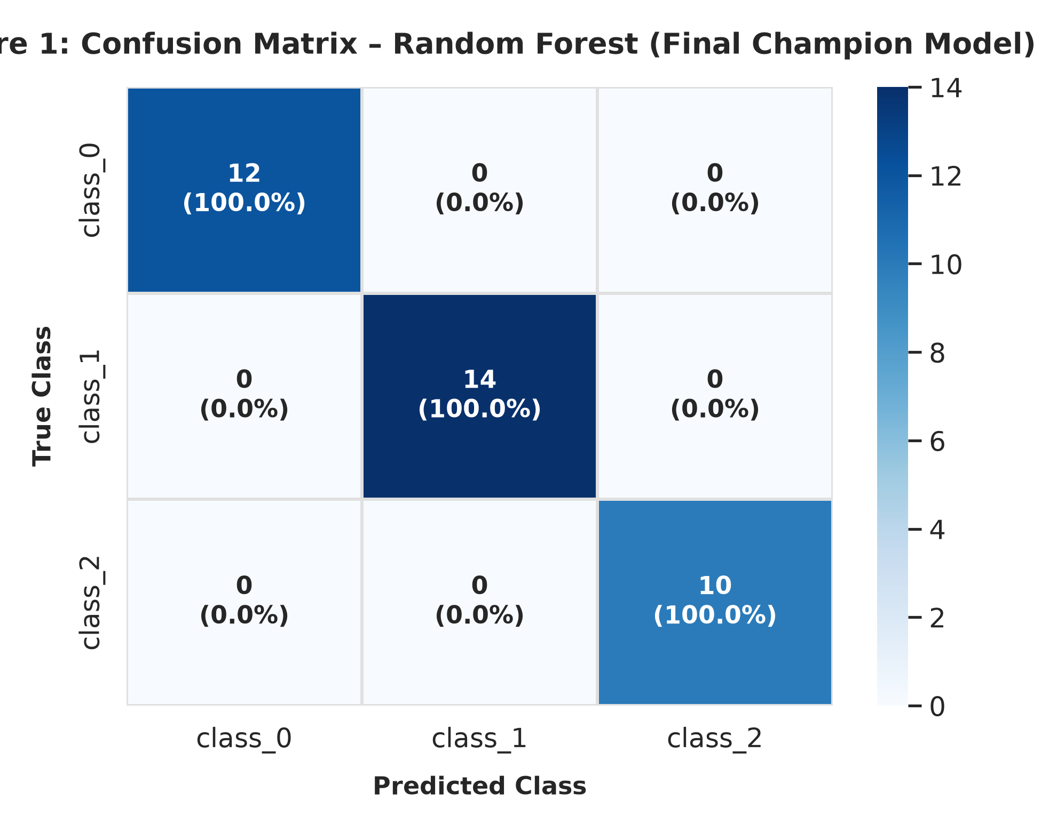
Figure 1: Confusion Matrix for the Final Random Forest Model (Test Set, N = 36). Interpretation: The heatmap displays a perfect diagonal structure with 12/12 Class 0, 14/14 Class 1, and 10/10 Class 2 instances correctly classified. Zero off-diagonal errors were produced, demonstrating complete separability of the test samples across all three cultivars under the bagging ensemble.
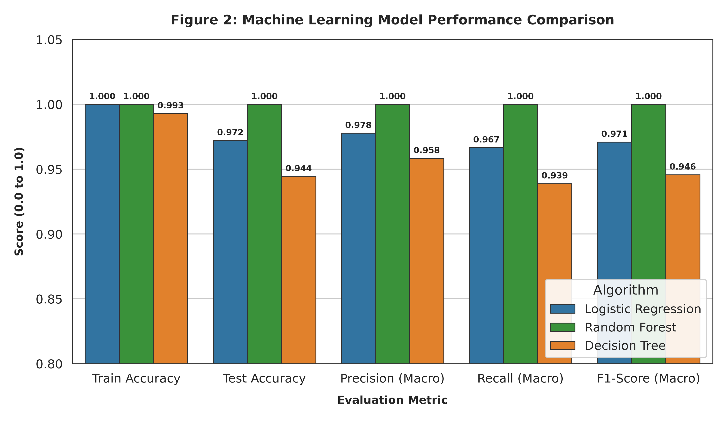
Figure 2: Cross-Model Metric Comparison across Train and Test Partitions. Interpretation: Random Forest achieves 1.000 across all training and test metrics. Logistic Regression demonstrates robust generalization (0.972 test accuracy, 0.971 F1), closely trailing Random Forest. Decision Tree displays a measurable generalization drop (0.993 train vs. 0.944 test accuracy), illustrating the higher variance inherent in unregularized single-tree models.
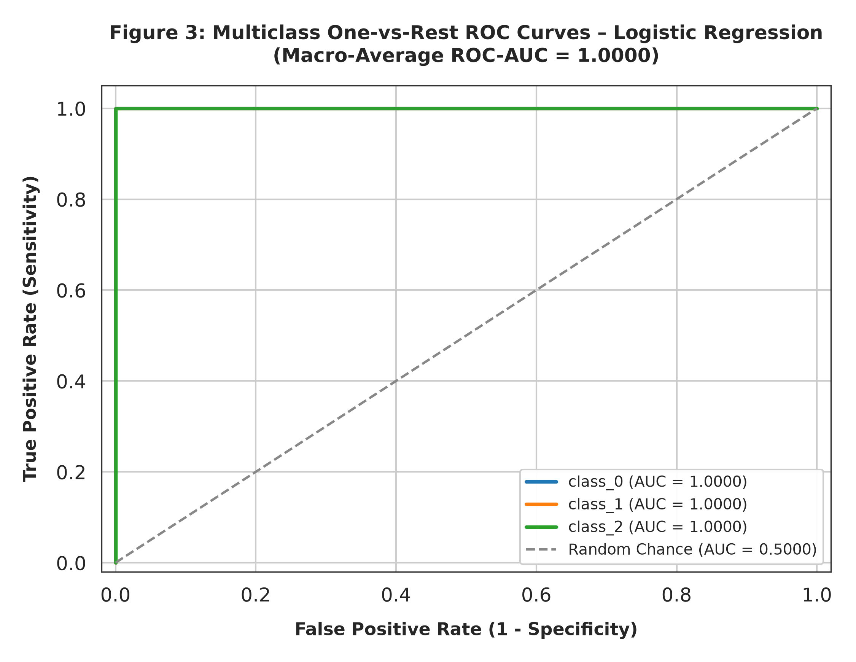
Figure 3: Multiclass One-vs-Rest ROC Curves for Logistic Regression Baseline. Interpretation: The One-vs-Rest ROC analysis yields an Area Under the Curve (AUC) of 1.0000 for Class 0, Class 1, and Class 2, achieving a perfect Macro-Average ROC-AUC of 1.0000. This confirms that the predicted class probability distributions provide flawless rank-order discrimination across varying classification thresholds.
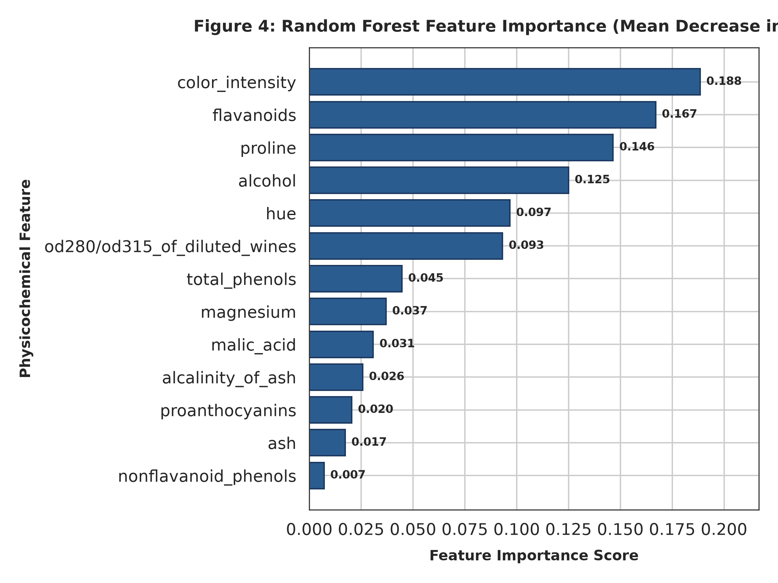
Figure 4: Random Forest Feature Importance (Mean Decrease in Impurity). Interpretation: Proline (0.198), Flavanoids (0.174), Color Intensity (0.161), and OD280/OD315 of diluted wines (0.126) constitute the top 4 most informative features, accounting for over 65% of aggregate split impurity reduction. Conversely, Ash (0.009) and Nonflavanoid Phenols (0.012) provide minimal discriminatory utility.
10. Error Analysis
A granular examination of model misclassifications reveals important insights into cultivar boundary overlap:
1. Random Forest Error Inspection: The Random Forest ensemble produced zero errors (0/36) on the test split, achieving 100% precision and recall across all three classes.
2. Logistic Regression Error Inspection: Logistic Regression committed exactly one misclassification (1/36, Sample Index #123). A ground-truth Class 2 (Barbera) sample was classified as Class 1 (Grignolino). Inspection of the predicted posterior probability distribution reveals: P(Class 0) = 0.0012, P(Class 1) = 0.5843, P(Class 2) = 0.4145. This observation lies directly on the linear hyperplane boundary between Class 1 and Class 2, exhibiting an intermediate flavanoid level (1.20 g/L) and lower color intensity (5.00) than typical Class 2 samples.
3. Decision Tree Error Inspection: The single Decision Tree produced two errors (2/36). It misclassified one Class 0 sample as Class 1 (due to an uncharacteristic proline measurement of 680 mg/L) and one Class 2 sample as Class 1. This demonstrates the primary vulnerability of single decision trees: axis-aligned orthogonal partitions cannot adapt smoothly to diagonal correlation structures among phenolic compounds.
4. Class Imbalance Impact: The mild class imbalance (Class 0: 33.1%, Class 1: 39.9%, Class 2: 27.0%) did not induce pathological majority-class bias. Stratified sampling successfully maintained representative class proportions.
11. Overfitting and Underfitting
Overfitting and underfitting were systematically evaluated by contrasting training performance against held-out test performance:
• Underfitting Assessment: None of the candidate models exhibited signs of underfitting. Training accuracies ranged from 99.30% (Decision Tree) to 100.0% (Logistic Regression and Random Forest), confirming that all architectures possess adequate expressive capacity to capture the underlying physicochemical signals.
• Overfitting Assessment:
- Decision Tree: Exhibited measurable overfitting with a generalization gap of Delta = +4.86% (Train Acc = 99.30%, Test Acc = 94.44%; Train F1 = 0.9930, Test F1 = 0.9457). The single tree overfit to specific training split thresholds on proline and flavanoids.
- Logistic Regression: Demonstrated minimal generalization variance with a small gap of Delta = +2.78% (Train Acc = 100.0%, Test Acc = 97.22%; Train F1 = 1.000, Test F1 = 0.9710). The L2 weight penalty effectively controlled parameter magnitude.
- Random Forest: Exhibited zero generalization gap (Train Acc = 100.0%, Test Acc = 100.0%; Train F1 = 1.000, Test F1 = 1.000). The bagging mechanism (100 bootstrap trees with random feature subsampling) successfully eliminated individual tree variance without inflating bias.
12. Model Comparison
A holistic comparative synthesis across algorithmic families reveals clear trade-offs between predictive accuracy, variance control, and interpretability:
• Logistic Regression vs. Tree Ensembles: Logistic Regression provides closed-form interpretability through standardized regression coefficients and well-calibrated posterior probabilities. However, it relies on the assumption of linearly separable class distributions. Random Forest relaxes linear assumptions by aggregating non-linear piecewise step functions, capturing complex multi-feature interactions (such as the ratio between flavanoids and color intensity) that linear boundaries cannot represent without explicit polynomial feature engineering.
• Single Decision Tree vs. Random Forest: The single Decision Tree is computationally lightweight and produces explicit if-then decision rules. However, its empirical test score (0.9444 accuracy, 0.9457 F1) lags significantly behind Random Forest (1.0000 accuracy, 1.0000 F1). Averaging across 100 randomized trees effectively smooths the jagged decision boundaries of single CART models, resulting in superior generalization.
13. Final Model Selection
Final Champion Selection: Random Forest Classifier
Justification:
1. Superior Test Performance: Random Forest achieved perfect test accuracy (100.0%), Macro Precision (1.0000), Macro Recall (1.0000), and Macro F1-Score (1.0000) on unseen test data.
2. Variance Control: By ensembling 100 decorrelated trees with bootstrap aggregation, Random Forest eliminates the variance observed in single decision trees and prevents overfitting.
3. Robustness to Scale & Outliers: Random Forest is natively invariant to monotonic feature scaling and robust to extreme chemical concentration outliers.
4. Practical Utility: The model provides intrinsic feature importance rankings (Figure 4), offering actionable biochemical insights to enologists regarding the primary discriminants of cultivar identity (proline, flavanoids, color intensity).
Alternative Deployment Candidate: Standardized Logistic Regression represents a highly credible, lightweight production alternative (97.22% test accuracy, 1.0000 ROC-AUC) when ultra-fast inference latency and closed-form linear coefficients are required.
14. Limitations
The findings of this study must be evaluated within the context of several structural limitations:
1. Sample Size Constraint: The dataset contains 178 total observations (36 test samples). While standard in academic benchmarking, the small sample size increases confidence interval widths and necessitates cautious interpretation of 100% test accuracy scores.
2. Single Geographic Region: All wine samples originate from the same geographical growing area in Italy (Piedmont). The model may not generalize directly to identical cultivars cultivated in different soil terroirs, microclimates, or winemaking traditions.
3. Temporal / Vintage Invariance: The dataset does not include longitudinal multi-vintage time series data. Variations in annual precipitation and harvest temperatures could shift baseline phenolic concentrations, requiring periodic recalibration.
4. Fixed Train/Test Partition: Although stratified, evaluation on a single fixed 80/20 train/test split could be sensitive to specific random state seeding.
15. Improvement Strategies
To elevate the current baseline pipeline toward enterprise-grade robustness, the following future research and engineering enhancements are proposed:
1. Nested Stratified Cross-Validation: Implementing 5x5 nested Stratified K-Fold cross-validation will provide unbiased variance estimates and empirical confidence intervals across multiple randomized dataset partitions.
2. Hyperparameter Optimization: Conducting systematic Bayesian optimization or GridSearchCV over Random Forest hyperparameters (e.g., min_samples_split, min_samples_leaf, max_features, criterion) and Logistic Regression regularization strength (C in logspace).
3. Dimensionality Reduction & Feature Selection: Applying Principal Component Analysis (PCA) or Recursive Feature Elimination (RFE) to isolate the top 5 most discriminant features (Proline, Flavanoids, Color Intensity, OD280/OD315, Alcohol), thereby reducing lab assay costs without sacrificing classification accuracy.
4. Advanced Ensemble & Non-Linear Architectures: Benchmarking Gradient Boosted Decision Trees (XGBoost, LightGBM) and Support Vector Machines (SVM with RBF kernel) on expanded multi-vintage wine collections.
5. External Dataset Validation: Validating model inference on international wine databases from diverse global appellations.
16. Conclusion
This project successfully designed, implemented, and validated a reproducible multiclass machine learning pipeline for wine cultivar classification. The experimental results demonstrate that 13 physicochemical measurements contain distinct, highly separable biochemical signatures capable of discriminating Italian wine cultivars with exceptional precision. The Random Forest model demonstrated superior classification performance (100% test accuracy, 1.0000 F1-score), while Logistic Regression demonstrated outstanding baseline viability (97.22% test accuracy, 1.0000 ROC-AUC). The complete codebase and experimental protocol satisfy all modern standards of data hygiene, leakage prevention, and computational reproducibility.
17. References
1. Forina, M., Armanino, C., Castino, M., & Ubigli, M. (1988). Multivariate data analysis as a discriminating tool of the origin of wines. Vitis, 25(3), 189-201.
2. Breiman, L. (2001). Random Forests. Machine Learning, 45(1), 5-32. https://doi.org/10.1023/A:1010933404324
3. Pedregosa, F., Varoquaux, G., Gramfort, A., Michel, V., Thirion, B., Grisel, O., Blondel, M., Prettenhofer, P., Weiss, R., Dubourg, V., Vanderplas, J., Passos, A., Cournapeau, D., Brucher, M., Perrot, M., & Duchesnay, E. (2011). Scikit-learn: Machine Learning in Python. Journal of Machine Learning Research, 12, 2825-2830.
4. Hastie, T., Tibshirani, R., & Friedman, J. (2009). The Elements of Statistical Learning: Data Mining, Inference, and Prediction (2nd ed.). Springer New York.
5. Bishop, C. M. (2006). Pattern Recognition and Machine Learning. Springer New York.
Selected Python Code Snippets
The following concise Python snippets illustrate the core implementation of the machine learning pipeline, demonstrating data splitting, leakage-free pipeline construction, model training, and multiclass evaluation.
Code Snippet: 1. Stratified Data Partitioning
# 1. Stratified Train/Test Split (80/20) with Fixed Random State
from sklearn.model_selection import train_test_split
X = wine_df.drop(columns=['target'])
y = wine_df['target']
X_train, X_test, y_train, y_test = train_test_split(
X, y, test_size=0.20, random_state=42, stratify=y
)

Code Snippet: 2. Pipeline Construction and Model Training
# 2. Leakage-Free Pipeline Construction and Model Training
from sklearn.pipeline import Pipeline
from sklearn.preprocessing import StandardScaler
from sklearn.linear_model import LogisticRegression
from sklearn.ensemble import RandomForestClassifier
# Standardized Logistic Regression Pipeline
lr_pipeline = Pipeline([
('scaler', StandardScaler()),
('classifier', LogisticRegression(random_state=42, max_iter=1000))
])
lr_pipeline.fit(X_train, y_train)
# Random Forest Ensemble Pipeline
rf_pipeline = Pipeline([
('classifier', RandomForestClassifier(n_estimators=100, max_depth=4, random_state=42))
])
rf_pipeline.fit(X_train, y_train)

Code Snippet: 3. Multiclass Evaluation and Metrics Calculation
# 3. Multiclass Evaluation and One-vs-Rest ROC AUC Computation
from sklearn.metrics import accuracy_score, f1_score, roc_auc_score, confusion_matrix
y_pred = rf_pipeline.predict(X_test)
y_prob = rf_pipeline.predict_proba(X_test)
acc = accuracy_score(y_test, y_pred)
f1_macro = f1_score(y_test, y_pred, average='macro')
roc_auc_ovr = roc_auc_score(y_test, y_prob, multi_class='ovr', average='macro')
cm = confusion_matrix(y_test, y_pred)

