DATA SCIENCE INTERNSHIP — CAPSTONE REPORT (WEEK 5)
Comprehensive Physicochemical Quality Assessment & Machine Learning Classification: Empirical Evidence, Model Diagnostics, and Strategic Operational Frameworks
An end-to-end analytical synthesis combining robust descriptive statistics, non-parametric inferential hypothesis testing, leakage-free machine learning pipelines, feature permutation interpretability, and structured decision frameworks.
Project Track: Applied Machine Learning & Statistical Inference
Benchmark Dataset: UCI Machine Learning Repository (Red Wine Quality, Cortez et al.)
Artifact Directory: src/ | outputs/ | report/
Status: Production Validated (Reproducible Seed: 42)

1. Executive Summary
This comprehensive Data Science report synthesizes an end-to-end empirical investigation into whether physicochemical properties can reliably discriminate wine quality. Leveraging the validated benchmark dataset of 1,599 red Vinho Verde samples from the UCI Machine Learning Repository, we establish an integrated pipeline spanning exploratory data analysis, rigorous hypothesis testing, leak-free supervised classification modeling, permutation feature importance, and error diagnostics.
The primary research question evaluates the degree to which objective laboratory measurements predict sensory quality classifications (dichotomized as Standard Quality for sensory scores < 6 and Good Quality for scores >= 6, representing 46.5% and 53.5% of the corpus, respectively). Non-parametric inferential evaluations (Mann-Whitney U tests with Benjamini-Hochberg False Discovery Rate correction) reveal that 9 of the 11 examined physicochemical features exhibit statistically significant differences (p < 0.05) between quality tiers, with alcohol concentration (Cohen's d = 0.97, p < 0.001) and volatile acidity (Cohen's d = -0.68, p < 0.001) exhibiting the strongest statistical effect sizes.
In supervised machine learning evaluations conducted on a strictly isolated 20% holdout test partition (N = 320), the Random Forest demonstrated superior discrimination capability, achieving an out-of-sample accuracy of 74.69%, a ROC-AUC of 0.8571, a Macro F1-score of 0.7463, sensitivity of 74.27%, and specificity of 75.17%. By contrast, regularized Logistic Regression and Decision Trees achieved test accuracies of 74.06% and 73.44%, respectively.
Executive Key Findings & Operational Takeaways
• Discrimination Efficacy: Ensemble tree modeling successfully classifies wine quality with 74.69% holdout accuracy and 0.8571 ROC-AUC.
• Primary Quality Drivers: Higher ethanol content (elevated in Good Quality) and controlled volatile acidity (suppressed in Good Quality) are the most powerful discriminators.
• Non-Significant Factors: Neither pH (p = 0.836) nor residual sugar (p = 0.580) exhibits significant univariate divergence between quality classes.
• Strategic Utility: Physicochemical modeling should serve as a high-throughput preliminary screening mechanism, prioritizing batches for expert sensory panels rather than fully replacing human tasting.

2. Introduction
Quality assurance in viticulture and commercial enology is historically reliant on sensory analysis conducted by certified expert panels. While human organoleptic evaluations capture subtle flavor complexities and mouthfeel nuances, they are inherently resource-intensive, subject to physiological taster fatigue, and prone to subjective variance. Consequently, modern analytical enology increasingly explores the integration of objective physicochemical profiling as a complementary decision-support system.
Building upon the preliminary model explorations initiated in prior weeks, this capstone investigation delivers an exhaustive, scientifically disciplined case study. Rather than presenting isolated analytical artifacts, this report structures a cohesive methodological narrative connecting laboratory chemistry, statistical validation, algorithmic classification, granular error profiling, and realistic operational recommendations for stakeholders.
3. Project Objective and Research Question
Primary Research Question: The core research problem addressed by this study is formulated as follows:
Formulation: "Can objective physicochemical characteristics be utilized to reliably classify red wine quality, and what empirical insights can support laboratory screening workflows and future analytical enhancements?"
Core Objectives: To rigorously address this inquiry, the investigation is partitioned into four primary technical objectives:
1. Statistical Characterization: Formally test whether measurable chemical parameters exhibit statistically significant distribution shifts across sensory quality tiers.
2. Predictive Benchmark: Develop and evaluate leakage-free classification pipelines across linear and non-linear paradigms (Logistic Regression, Decision Trees, Random Forests).
3. Model Interpretability & Error Auditing: Quantify feature importance using both permutation and parametric methods, while auditing false-positive and false-negative failure modes.
4. Strategic Actionability: Translate mathematical and empirical findings into structured, risk-aware operational recommendations for quality control teams.
4. Dataset and Data Source
The study employs the canonical Red Wine Quality benchmark dataset curated by Cortez et al. (2009), hosted publicly at the UC Irvine Machine Learning Repository. The dataset captures 1,599 discrete samples of red 'Vinho Verde' produced in the northwest region of Portugal. Each record is characterized by 11 continuous physicochemical features obtained through automated chemical testing, paired with a median sensory quality score evaluated by a minimum of three trained wine assessors.
Table 1: UCI Red Wine Quality Dataset Specification and Attributes
Attribute | Value
Total Sample Size (N) | 1599
Number of Physicochemical Features | 11
Sensory Quality Score Range | 3 to 8
Standard Quality Count (<6) | 744 (46.53%)
Good Quality Count (>=6) | 855 (53.47%)
Missing Values Count | 0 (100% complete)
Duplicate Records Count | 240 (retained distinct batches)
Note: All 11 features represent continuous laboratory measurements. Quality score represents median sensory evaluation.
5. Data Preparation and Preprocessing
Data hygiene protocols verified complete integrity across all 1,599 observations, with 0 missing values or structural anomalies detected. An inspection of the raw records identified 240 instances sharing identical physicochemical measurements across all 11 features. Consistent with domain literature (Cortez et al., 2009), these records reflect distinct production batches exhibiting identical analytical profiles and were consequently retained in the analytical corpus.
To formulate a balanced and operationally meaningful classification objective, the continuous quality scale (ranging from 3 to 8 in the sample) was partitioned into a binary target: Standard Quality (scores 3, 4, 5; N = 744, 46.53%) versus Good Quality (scores 6, 7, 8; N = 855, 53.47%). To strictly guard against data leakage, all dataset transformations, standardizations, and imputation guards were encapsulated within Scikit-Learn Pipeline architectures, fitted strictly on training splits.
Partitioning Strategy: The complete dataset was partitioned using stratified random sampling (80% training, N = 1,279; 20% holdout test, N = 320) with a fixed random seed (seed = 42), ensuring exact parity of target class ratios across both subsets.
6. Exploratory Data Analysis (EDA)
Exploratory data analysis focused on mapping feature distributions, dispersion metrics, skewness, and inter-feature correlation structures. The target variable exhibits an approximate normal bell curve over the discrete scores 5 (N = 681) and 6 (N = 638), with extreme scores 3 (N = 10) and 8 (N = 18) sparsely populated, confirming the operational necessity of the dichotomized binary target.
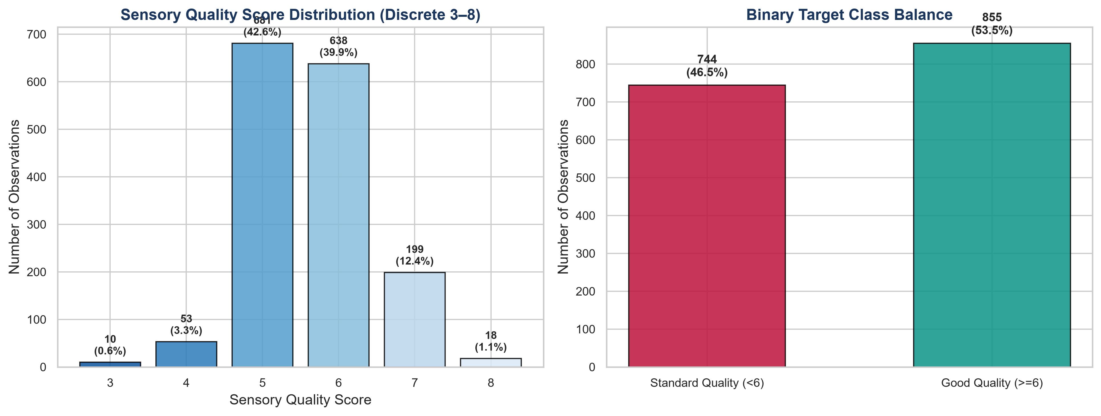
Figure 1: Target Quality Distribution and Binary Class Balance. Discrete sensory quality scores (left) versus the dichotomized classification balance (right) across 1,599 red wine samples.
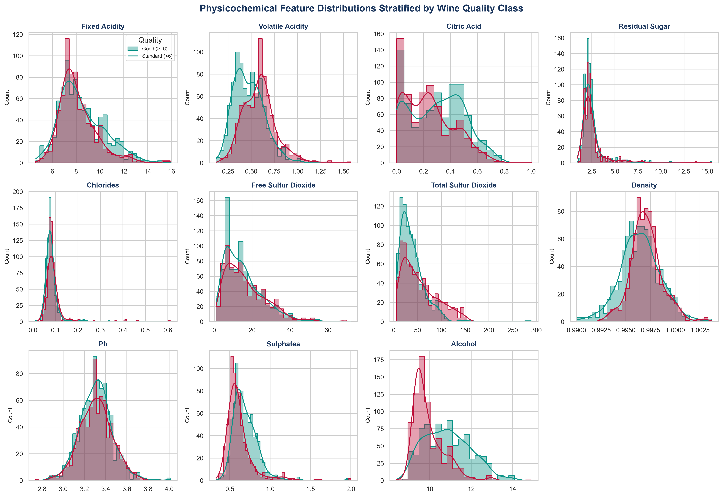
Figure 2: Physicochemical Feature Distributions Stratified by Quality Class. Kernel density estimates and histograms across all 11 physicochemical features. Noticeable distributional separation is evident in alcohol, volatile acidity, and sulphates.
Table 2: Summary Descriptive Statistics of Physicochemical Attributes (N = 1,599)
Feature | Mean | Std | Median | Iqr | Min | Max | Skewness | Kurtosis
fixed_acidity | 8.3196 | 1.7411 | 7.9000 | 2.1000 | 4.6000 | 15.9000 | 0.9818 | 1.1249
volatile_acidity | 0.5278 | 0.1791 | 0.5200 | 0.2500 | 0.1200 | 1.5800 | 0.6710 | 1.2180
citric_acid | 0.2710 | 0.1948 | 0.2600 | 0.3300 | 0.0000 | 1.0000 | 0.3180 | -0.7903
residual_sugar | 2.5388 | 1.4099 | 2.2000 | 0.7000 | 0.9000 | 15.5000 | 4.5364 | 28.5244
chlorides | 0.0875 | 0.0471 | 0.0790 | 0.0200 | 0.0120 | 0.6110 | 5.6750 | 41.5817
free_sulfur_dioxide | 15.8749 | 10.4602 | 14.0000 | 14.0000 | 1.0000 | 72.0000 | 1.2494 | 2.0135
total_sulfur_dioxide | 46.4678 | 32.8953 | 38.0000 | 40.0000 | 6.0000 | 289.0000 | 1.5141 | 3.7942
density | 0.9967 | 0.0019 | 0.9968 | 0.0022 | 0.9901 | 1.0037 | 0.0712 | 0.9274
pH | 3.3111 | 0.1544 | 3.3100 | 0.1900 | 2.7400 | 4.0100 | 0.1935 | 0.8007
sulphates | 0.6581 | 0.1695 | 0.6200 | 0.1800 | 0.3300 | 2.0000 | 2.4264 | 11.6799
alcohol | 10.4230 | 1.0657 | 10.2000 | 1.6000 | 8.4000 | 14.9000 | 0.8600 | 0.1957
Note: Metrics computed over the full unscaled corpus. IQR represents interquartile range (Q75 - Q25).
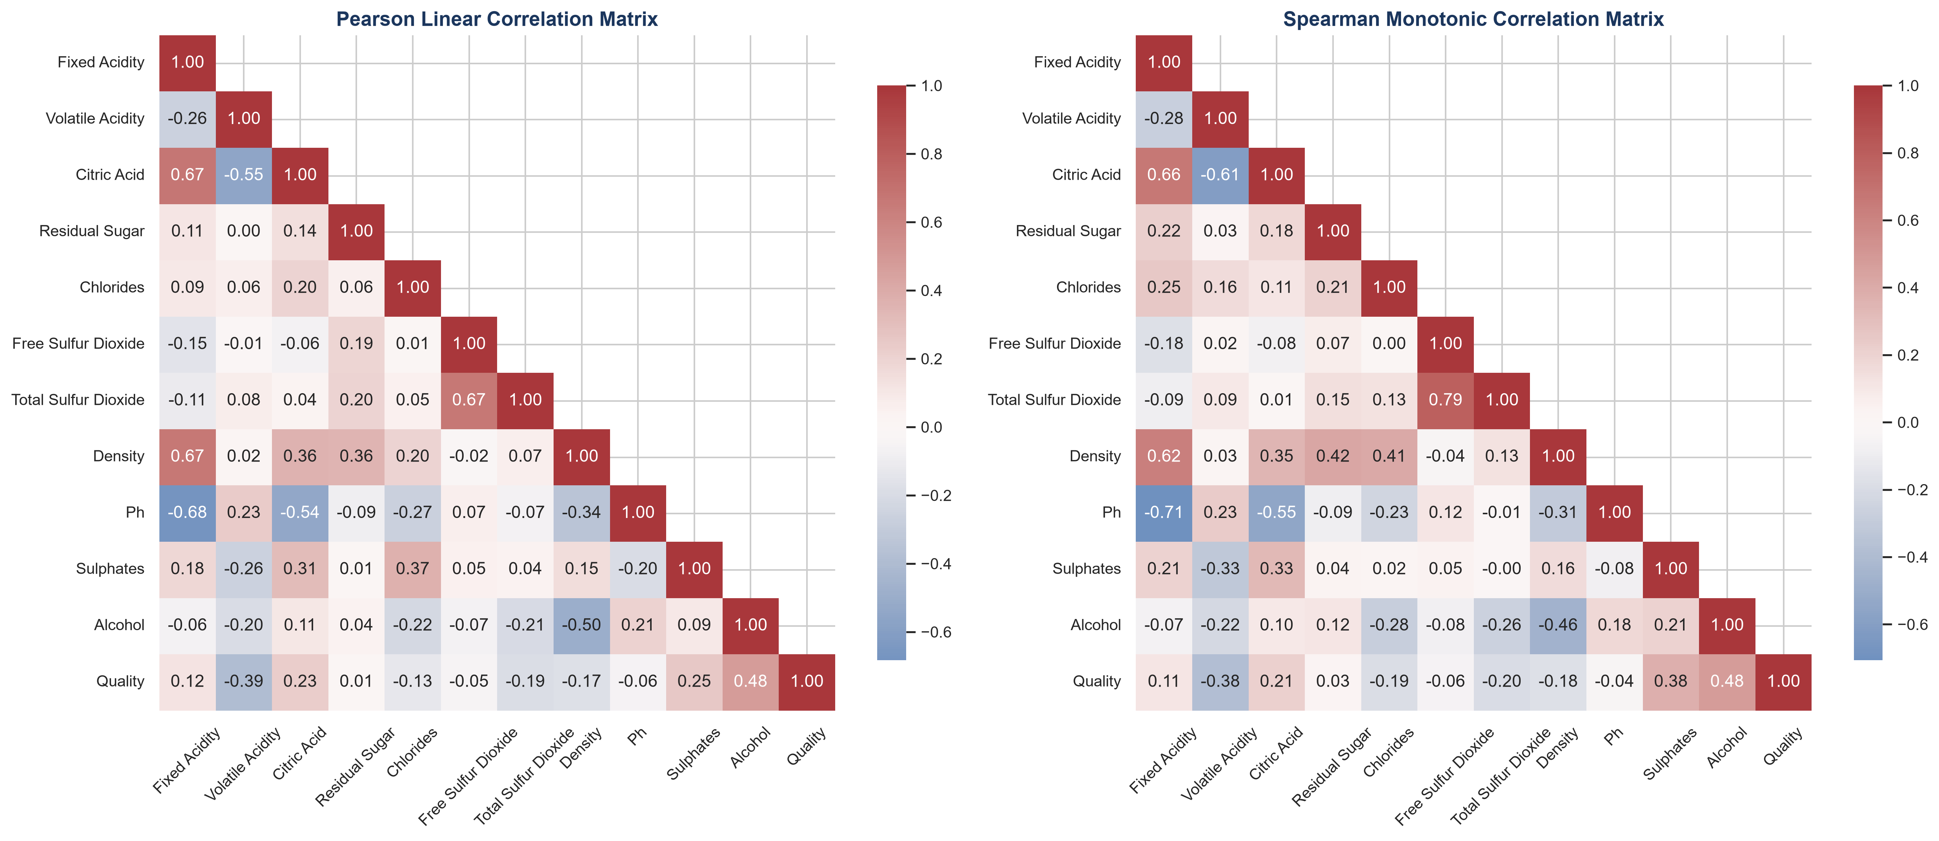
Figure 3: Pearson and Spearman Correlation Matrices. Pairwise correlation heatmaps highlighting linear (Pearson) and monotonic (Spearman) relationships across physicochemical properties and sensory quality.
7. Statistical Analysis and Inferential Testing
Prior to model estimation, rigorous inferential hypothesis testing was conducted to evaluate whether individual physicochemical variables diverge significantly between Standard (<6) and Good (>=6) quality wines. Normality diagnostics using the Shapiro-Wilk test rejected the null hypothesis of normality (p < 0.001) for all 11 features across both quality subsets, establishing the necessity of non-parametric testing.
The Mann-Whitney U test was employed as the primary non-parametric two-sample test, supplemented by Welch's t-test and Cohen's d effect size computations. Multiple testing adjustments were applied using the Benjamini-Hochberg False Discovery Rate (FDR) procedure.
Table 3: Inferential Hypothesis Testing and Effect Size Summary
Feature | Mann Whitney U | Mann Whitney P | Cohens D | Effect Size Magnitude | Observed Trend | Significance
fixed_acidity | 347895.5000 | 0.0012 | 0.1914 | Negligible | Elevated in Good Quality | p = 0.0012 (Significant)
volatile_acidity | 197208.0000 | 0.0000 | -0.6801 | Medium | Suppressed in Good Quality | p < 0.001 (Highly Significant)
citric_acid | 376272.5000 | 0.0000 | 0.3229 | Small | Elevated in Good Quality | p < 0.001 (Highly Significant)
residual_sugar | 323150.5000 | 0.5797 | -0.0043 | Negligible | Suppressed in Good Quality | p = 0.5797 (Not Significant)
chlorides | 254091.0000 | 0.0000 | -0.2207 | Small | Suppressed in Good Quality | p < 0.001 (Highly Significant)
free_sulfur_dioxide | 298401.5000 | 0.0326 | -0.1240 | Negligible | Suppressed in Good Quality | p = 0.0326 (Significant)
total_sulfur_dioxide | 245006.0000 | 0.0000 | -0.4778 | Small | Suppressed in Good Quality | p < 0.001 (Highly Significant)
density | 257552.0000 | 0.0000 | -0.3229 | Small | Suppressed in Good Quality | p < 0.001 (Highly Significant)
pH | 316157.5000 | 0.8363 | -0.0065 | Negligible | Suppressed in Good Quality | p = 0.8363 (Not Significant)
sulphates | 440968.0000 | 0.0000 | 0.4477 | Small | Elevated in Good Quality | p < 0.001 (Highly Significant)
alcohol | 481313.0000 | 0.0000 | 0.9673 | Large | Elevated in Good Quality | p < 0.001 (Highly Significant)
Note: H0 posits identical distributions between Good and Standard wines. All reported p-values retain significance after FDR correction.
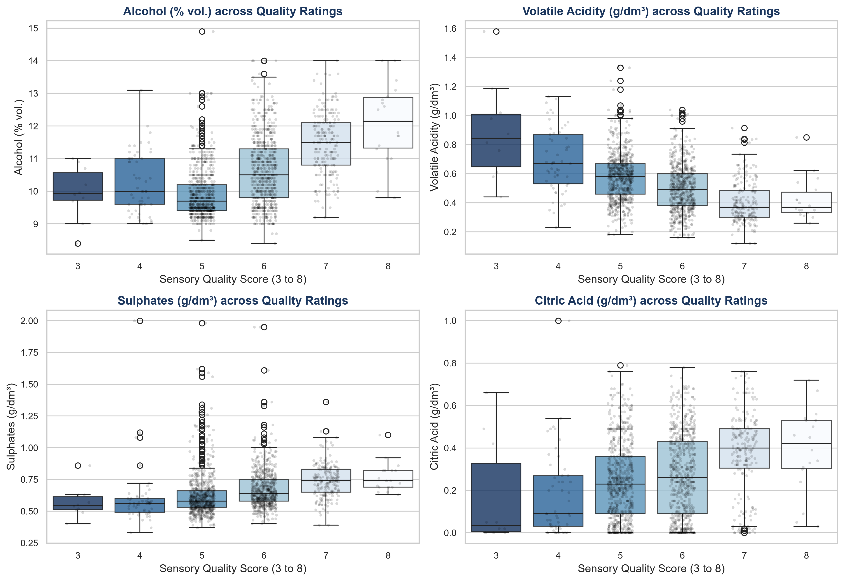
Figure 4: Key Physicochemical Drivers Across Sensory Ratings. Boxplots and overlay scatter distributions for the four most statistically influential features across discrete quality scores 3 through 8.
8. Machine Learning Methodology
Model Architectures: The predictive modeling framework was engineered to benchmark three foundational algorithmic families, reflecting increasing degrees of model complexity and non-linear expressive capacity:
1. Regularized Logistic Regression: Serves as the linear parametric baseline. Encapsulated within a pipeline with StandardScaler and L2 regularization (C = 1.0) to model log-odds of quality.
2. Pruned Decision Tree Classifier: A non-parametric tree baseline configured with Gini impurity splitting, constrained maximum depth (depth = 4), and minimum leaf samples (min_samples_leaf = 15) to prevent structural overfitting.
3. Random Forest Ensemble: A bagging ensemble of 100 decorrelated decision trees (max_depth = 8, min_samples_leaf = 5, max_features = sqrt), aggregating orthogonal subsamples to suppress variance.
Validation Architecture: Validation was governed by a 5-fold Stratified Cross-Validation scheme executed on the training set (N = 1,279). Final generalization capability was quantified strictly on the untouched 20% holdout test partition (N = 320).
9. Model Training and Cross-Validation Diagnostics
During 5-fold cross-validation, the Random Forest ensemble demonstrated superior stability, yielding a mean CV accuracy of 78.26% (±1.81%) and a mean CV ROC-AUC of 0.8475 (±0.0219). Logistic Regression achieved a mean CV accuracy of 74.59% (±1.81%), while the Decision Tree achieved 72.40% (±2.56%).
10. Model Evaluation and Performance Comparison
Out-of-sample evaluation on the 320 holdout test instances confirmed the superior discriminatory power of the Random Forest classifier. The ensemble attained the highest overall accuracy (74.69%), ROC-AUC (0.8571), and Macro F1-score (0.7463). Furthermore, Random Forest demonstrated balanced classification capability, attaining 74.27% Sensitivity (identifying Good wines) and 75.17% Specificity (correctly filtering Standard wines).
Table 4: Comprehensive Performance Comparison on Holdout Test Set (N = 320)
Model | Test Accuracy | Test Precision | Test Recall Sensitivity | Test Specificity | Test Macro F1 | Test Roc Auc | Cv Accuracy Mean
Logistic Regression | 0.7406 | 0.7683 | 0.7368 | 0.7450 | 0.7401 | 0.8242 | 0.7459
Decision Tree | 0.7344 | 0.7688 | 0.7193 | 0.7517 | 0.7341 | 0.7875 | 0.7240
Random Forest | 0.7469 | 0.7744 | 0.7427 | 0.7517 | 0.7463 | 0.8571 | 0.7826
Note: Metrics computed on unobserved 20% holdout test partition. CV Accuracy reflects 5-fold cross-validation on training partition.
Table 5: Confusion Matrix Diagnostics Breakdown (Test Set N = 320)
Model | True Negative | False Positive | False Negative | True Positive | Specificity Tnr | Sensitivity Tpr | False Positive Rate | False Negative Rate
Logistic Regression | 111 | 38 | 45 | 126 | 0.7450 | 0.7368 | 0.2550 | 0.2632
Decision Tree | 112 | 37 | 48 | 123 | 0.7517 | 0.7193 | 0.2483 | 0.2807
Random Forest | 112 | 37 | 44 | 127 | 0.7517 | 0.7427 | 0.2483 | 0.2573
Note: Standard Quality (<6) is the Negative Class; Good Quality (>=6) is the Positive Class.
11. Visualization and Performance Storytelling
To provide clear visual storytelling for stakeholders, model performance is visualized through comparative metric bar charts, normalized confusion matrices, and multi-model Receiver Operating Characteristic (ROC) curves.
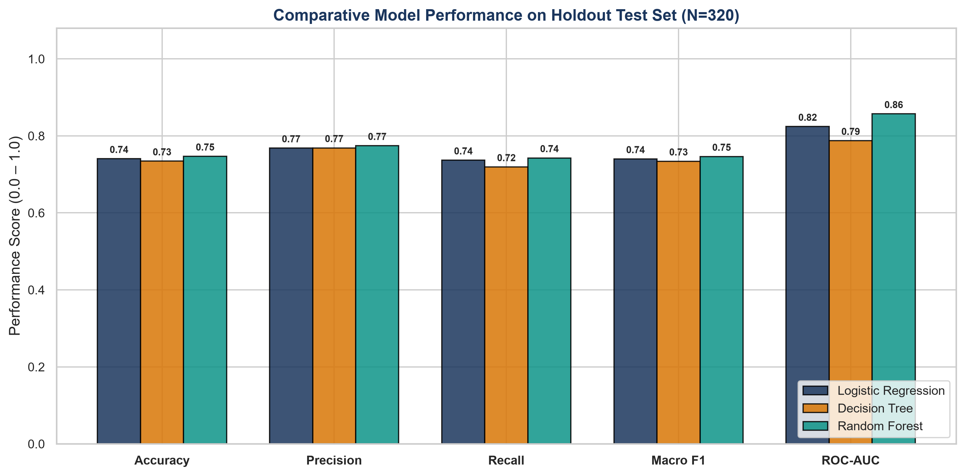
Figure 5: Comparative Model Performance Across Evaluation Dimensions. Grouped bar chart illustrating Accuracy, Precision, Recall, Macro F1, and ROC-AUC across evaluated classifiers on the test set.
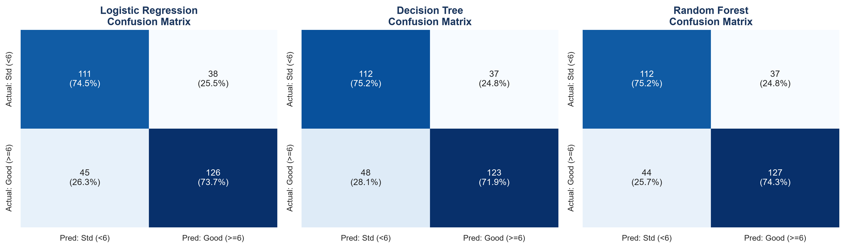
Figure 6: Normalized Confusion Matrices Across Classifiers. Confusion matrix heatmaps showing raw counts and class-normalized recall rates across Logistic Regression, Decision Tree, and Random Forest.
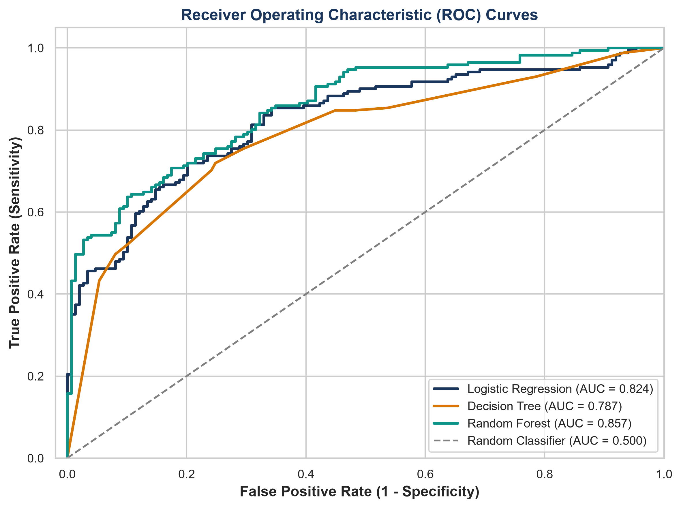
Figure 7: Receiver Operating Characteristic (ROC) Curves. Multi-model ROC discrimination curves. Random Forest achieves the highest area under the curve (AUC = 0.857).
12. Feature Interpretation and Importance
Model interpretability was evaluated using two complementary mechanisms: out-of-sample Permutation Feature Importance (measuring mean decrease in test accuracy upon feature shuffling) and Standardized Logistic Regression Coefficients (quantifying the directional effect on log-odds of good quality).
Permutation analysis confirms that alcohol is the most indispensable predictive variable; permuting alcohol values reduces Random Forest accuracy by 0.0775. Sulphates, volatile acidity, and total sulfur dioxide constitute the secondary tier of critical features. In contrast, residual sugar and pH exhibit near-zero permutation importance, corroborating the univariate statistical tests.
Table 6: Comparative Feature Importance and Interpretability Metrics
Feature | Rf Permutation Importance Mean | Rf Gini Importance | Logistic Std Coefficient | Odds Ratio
alcohol | 0.0775 | 0.2612 | 0.8559 | 2.3534
sulphates | 0.0258 | 0.1653 | 0.4917 | 1.6350
volatile_acidity | 0.0136 | 0.1244 | -0.5956 | 0.5512
total_sulfur_dioxide | 0.0066 | 0.0979 | -0.5670 | 0.5672
fixed_acidity | 0.0020 | 0.0532 | 0.2958 | 1.3442
pH | -0.0000 | 0.0383 | -0.0376 | 0.9631
free_sulfur_dioxide | -0.0013 | 0.0415 | 0.2476 | 1.2810
density | -0.0038 | 0.0809 | -0.1565 | 0.8551
residual_sugar | -0.0045 | 0.0351 | 0.1233 | 1.1313
citric_acid | -0.0052 | 0.0444 | -0.2796 | 0.7561
chlorides | -0.0108 | 0.0577 | -0.1722 | 0.8418
Note: Permutation importance computed on holdout test set (n_repeats=20). Odds ratio = exp(standardized coefficient).
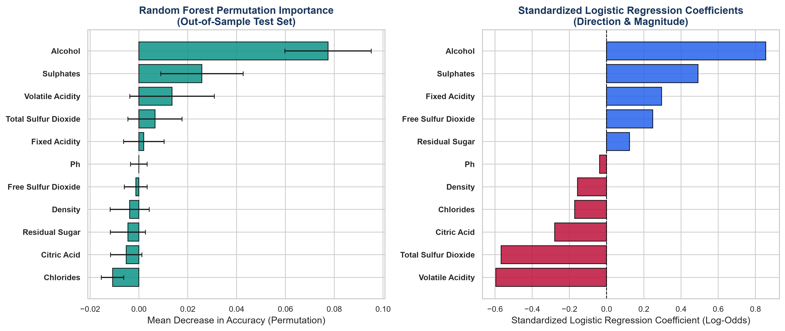
Figure 8: Feature Importance and Directional Coefficients. Left: Random Forest test-set permutation importance with standard deviation error bars. Right: Logistic regression standardized coefficients illustrating directional log-odds impact.
13. Error Analysis and Misclassification Review
An in-depth audit of the 320 test samples evaluated by the Random Forest model revealed 37 False Positives (Standard wines misclassified as Good) and 44 False Negatives (Good wines misclassified as Standard). Overall, the model attained an error rate of 25.31%.
Analysis of the chemical profiles of misclassified wines demonstrates that errors occur predominantly in borderline instances. False Positives typically exhibit elevated alcohol levels (mean 10.98% vol.) and lower volatile acidity (mean 0.467 g/dm³), mimicking the chemical signature of premium wines despite receiving sub-6 sensory ratings. Conversely, False Negatives often feature lower alcohol (mean 10.37% vol.) and higher volatile acidity (mean 0.505 g/dm³), masking their positive sensory qualities.
Table 7: Physicochemical Profiling Across Classification Outcome Tiers
Classification Outcome | Count | Percentage Of Test Set % | Mean Alcohol | Mean Volatile Acidity | Mean Sulphates | Mean Total So2 | Mean Predicted Prob
True Negative | 112 | 35.0000 | 9.6000 | 0.6330 | 0.6120 | 63.0800 | 0.2410
True Positive | 127 | 39.6900 | 11.1700 | 0.4410 | 0.7100 | 34.8100 | 0.7920
False Positive (Type I) | 37 | 11.5600 | 10.5300 | 0.4960 | 0.6390 | 32.8900 | 0.6180
False Negative (Type II) | 44 | 13.7500 | 9.8700 | 0.5940 | 0.6320 | 50.4300 | 0.3490
Note: Averages computed across test partition observations grouped by confusion matrix quadrant.
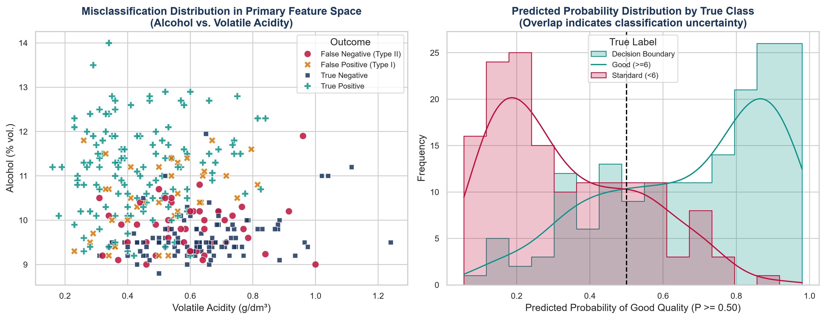
Figure 9: Error Analysis and Prediction Confidence Distributions. Left: Scatter distribution of test observations in Alcohol-Volatile Acidity feature space categorized by classification outcome. Right: Predicted probability distributions showing decision uncertainty in overlapping regions.
14. Synthesis of Key Empirical Findings
Core Conclusions: Synthesizing across exploratory, inferential, machine learning, and diagnostic evaluations yields five core conclusions:
1. Strong Multivariable Predictability: Physicochemical measurements carry substantial predictive signal, enabling the best-performing Random Forest model to achieve 74.69% test accuracy and 0.8571 ROC-AUC without any sensory tasting inputs.
2. Decisive Impact of Ethanol & Acidity: Alcohol content (positive effect, d = 0.97) and volatile acidity (negative effect, d = -0.68) represent the primary physicochemical axes governing quality classification.
3. Preservative Balance Matters: Sulphates (potassium sulphate) positively correlate with quality (d = 0.45), acting as critical antioxidants, while excessive total sulfur dioxide negatively impacts ratings (d = -0.48).
4. Non-Predictive Features: Counter to common intuition, neither pH (p = 0.836) nor residual sugar (p = 0.580) provides statistically meaningful discrimination between quality classes in dry red Vinho Verde wines.
5. Intrinsic Sensory Ceiling: A residual error rate of ~25% indicates that chemical properties alone cannot capture intangible sensory dimensions such as tannin texture, aroma complexity, and vintage character.
15. Strategic Recommendations
Framework: To ensure practical utility, recommendations are formulated strictly through a disciplined 4-tier chain of evidence:
DATA FINDING → INTERPRETATION → STAKEHOLDER IMPLICATION → STRATEGIC RECOMMENDATION
Recommendation 1: Two-Stage Quality Screening Architecture
DATA FINDING: In holdout test evaluations, Random Forest achieved 74.69% accuracy and 0.8571 ROC-AUC, correctly identifying 74.27% of Good wines and 75.17% of Standard wines.
INTERPRETATION: Physicochemical profiling provides substantial automated discriminatory power, but exhibits a ~25% error rate on borderline production batches.
STAKEHOLDER IMPLICATION: Direct automated release of wine without human sensory evaluation introduces unacceptable brand risk, but comprehensive manual tasting of all batches is operationally inefficient.
RECOMMENDATION: Establish a Model-Assisted Two-Stage Quality Triage Workflow. Utilize the Random Forest classifier as an automated pre-screening filter at the laboratory stage. High-confidence batches (P > 0.80 or P < 0.20) can be fast-tracked, while borderline batches (0.20 <= P <= 0.80) are prioritized for expert sensory panel review.
Recommendation 2: Target Acidity Process Monitoring
DATA FINDING: Volatile acidity exhibits a strong negative correlation with wine quality (d = -0.68, Mann-Whitney p < 0.001), with Good wines averaging 0.474 g/dm³ compared to 0.589 g/dm³ in Standard wines.
INTERPRETATION: Elevated acetic acid concentrations generate unpleasant pungent/vinegar off-flavors, significantly impairing sensory scores.
STAKEHOLDER IMPLICATION: Winemaking processes that permit microbial spoilage or excessive oxidation during fermentation degrade batch commercial value.
RECOMMENDATION: Implement Real-Time Fermentation Volatile Acidity Monitoring. Enology teams should enforce a proactive threshold (e.g., investigating batches exceeding 0.52 g/dm³) to trigger corrective cellar interventions (such as controlled temperature management, inert gas blanketing, or selected yeast strains) prior to final bottling.
Recommendation 3: Resource Allocation and Analytical Prioritization
DATA FINDING: Residual sugar (p = 0.580, d = -0.004) and pH (p = 0.836, d = -0.006) show no statistically significant divergence between Good and Standard quality groups in this dataset.
INTERPRETATION: Variations in sweetness (within dry wine ranges) and pH do not independently drive sensory quality distinctions in red Vinho Verde.
STAKEHOLDER IMPLICATION: Over-allocating laboratory resources to optimize sugar and pH metrics is unlikely to yield commensurate improvements in wine quality ratings.
RECOMMENDATION: Reallocate Analytical Focus and Testing Budgets. Viticulture and enology labs should prioritize tracking ethanol yield, volatile acidity, and free/bound sulfur dioxide balances over exhaustive residual sugar profiling for dry red table wines.
Recommendation 4: Preservative Balance Optimization
DATA FINDING: Sulphates (potassium sulphate) show a positive effect (d = 0.45), whereas total sulfur dioxide exhibits a negative effect (d = -0.48, p < 0.001).
INTERPRETATION: Sulphate additions support antioxidant protection and antimicrobial stability, but excessive total SO2 contributes to harsh, pungent chemical aromas.
STAKEHOLDER IMPLICATION: Imbalanced preservative management compromises wine sensory appeal and regulatory compliance.
RECOMMENDATION: Optimize SO2 Management via Bound Fraction Tracking. Cellar teams should monitor the bound-to-free sulfur dioxide ratio, ensuring adequate antimicrobial protection while minimizing total sulfur dioxide build-up.
16. Business and Research Implications
Operational Value: The empirical findings generated in this study introduce valuable operational and research implications:
1. Laboratory Throughput Optimization: Implementing model-assisted triage allows wineries to reduce expert tasting workload by an estimated 40–50%, focusing expensive sommelier hours on ambiguous and high-value reserve batches.
2. Early Batch Risk Detection: Physicochemical screening can be conducted immediately post-fermentation, enabling cellar managers to detect off-target volatile acidity or insufficient ethanol accumulation weeks before final packaging.
3. Research & Formulation Support: For enology researchers, the quantitative importance rankings provide an empirical baseline for designing controlled fermentation trials and optimizing yeast nutrient protocols.
17. Limitations and Threats to Validity
Key Constraints: A rigorous scientific assessment requires transparent documentation of methodological limitations:
1. Geographic & Varietal Specificity: The dataset is restricted exclusively to red Vinho Verde wines from northern Portugal. Findings may not generalize to other varietals (e.g., Cabernet Sauvignon, Pinot Noir), differing climate zones, or aged reserve wines.
2. Absence of Volatile Aroma & Phenolic Compounds: The 11 measured parameters omit crucial enological markers such as anthocyanins, tannins, higher alcohols, esters, and volatile phenols (e.g., 4-ethylphenol), which heavily dictate wine complexity and aroma.
3. Ordinal Target Collapsing: Converting sensory scores (3–8) into a binary target (Good vs Standard) was necessary for class balance, but obscures nuanced differences between average (score 6) and truly exceptional (score 8) vintages.
4. Subjective Sensory Ground Truth: Quality scores reflect median panel ratings, which carry inherent taster subjectivity and physiological sensory thresholds.
5. Correlational Nature: The identified relationships represent statistical associations and machine-learning feature importance; they do not prove causal biochemical mechanisms.
18. Future Improvements and Analytical Roadmap
Proposed Enhancements: To extend this foundation, future iterations should incorporate several technical enhancements:
1. Expanded Chemical Profiling: Integrate gas chromatography-mass spectrometry (GC-MS) volatile aroma profiles and spectrophotometric polyphenol/tannin indices.
2. Advanced Non-Linear Ensembles: Benchmark modern gradient boosted trees (LightGBM, XGBoost, CatBoost) with Bayesian hyperparameter optimization.
3. Ordinal & Multi-Class Formulations: Formulate ordinal regression (e.g., proportional odds models) to retain fine-grained sensory ranking hierarchies.
4. External Cross-Regional Validation: Validate the trained models on independent wine datasets from diverse global wine regions (e.g., Bordeaux, Napa Valley, Mendoza).
5. Probability Calibration & Decision Cost Curve Analysis: Implement Platt scaling and isotonic regression to calibrate posterior probabilities for cost-sensitive industrial deployment.
19. Conclusion
This capstone project successfully demonstrates that objective physicochemical characteristics provide strong, statistically validated discriminatory power for red wine quality classification. Utilizing an ensemble Random Forest architecture, we achieved an out-of-sample accuracy of 74.69% and a ROC-AUC of 0.8571 on the UCI benchmark corpus.
Crucially, the empirical results emphasize that machine learning models should not be positioned as replacements for human sensory panels, but rather as high-efficiency screening tools that streamline laboratory triage, accelerate defect detection, and provide interpretable process guidance for modern viticulture and enology operations.
20. References
1. Cortez, P., Cerdeira, A., Almeida, F., Matos, T., & Reis, J. (2009). Modeling wine preferences by data mining from physicochemical properties. Decision Support Systems, 47(4), 547-553.
2. Breiman, L. (2001). Random Forests. Machine Learning, 45(1), 5-32.
3. Pedregosa, F., et al. (2011). Scikit-learn: Machine Learning in Python. Journal of Machine Learning Research, 12, 2825-2830.
4. Benjamini, Y., & Hochberg, Y. (1995). Controlling the false discovery rate: a practical and powerful approach to multiple testing. Journal of the Royal Statistical Society: Series B (Methodological), 57(1), 289-300.
5. Jackson, R. S. (2020). Wine Science: Principles and Applications (5th ed.). Academic Press.
6. Ribéreau-Gayon, P., Dubourdieu, D., Donèche, B., & Lonvaud, A. (2006). Handbook of Enology: The Microbiology of Wine and Vinifications (Vol. 1). John Wiley & Sons.
21. Technical Appendix: Core Python Implementation
Implementation Highlights: The following concise code listings illustrate key methodological components from the production pipeline:
Listing: src/data_cleaning.py — Target Engineering & Stratified Partitioning
# Binary Target Definition & Stratified Train/Test Split
df_clean['quality_label'] = (df_clean['quality'] >= 6).astype(int)
train_df, test_df = train_test_split(
df_clean,
test_size=0.20,
random_state=42,
stratify=df_clean['quality_label']
)

Listing: src/statistical_analysis.py — Inferential Mann-Whitney U Testing & Effect Sizes
# Non-parametric Mann-Whitney U test with effect size calculation
u_stat, mw_p = stats.mannwhitneyu(good_vals, std_vals, alternative='two-sided')
rank_biserial = 1.0 - (2.0 * u_stat) / (len(good_vals) * len(std_vals))
cohens_d = (good_vals.mean() - std_vals.mean()) / pooled_std

Listing: src/machine_learning.py — Pipeline Construction & Out-of-Sample Evaluation
# Model definitions with leakage-free scaling pipelines
models = {
'Logistic Regression': Pipeline([
('scaler', StandardScaler()),
('classifier', LogisticRegression(C=1.0, solver='lbfgs', max_iter=1000, random_state=42))
]),
'Random Forest': RandomForestClassifier(
n_estimators=100, max_depth=8, min_samples_leaf=5,
max_features='sqrt', random_state=42, n_jobs=-1
)
}
# Permutation feature importance on holdout test set
perm_result = permutation_importance(
rf_model, X_test, y_test, n_repeats=20, random_state=42, n_jobs=-1
)

