SMART WILD PIG DETECTION
AND
ALERT SYSTEM USING IoT SENSORS.

Phase 2 - Ideation & Concept Development
- Deliverables
- Brainstorming Report
- Idea Prioritization Matrix
- Empathy Map
- User Persona (if applicable)
- Proposed Solution
- Functional Requirements
- Non-functional Requirements
- Project Planning (Gantt Chart or Timeline)
- Risk Analysis

TEAM MEMBERS:
- Dhanyasri J
- Lavanya v
- Arunachalam M
- Sujith N
INTRODUCTION:
Agriculture is one of the primary sources of livelihood for many farmers. One of the major challenges faced by farmers is crop damage caused by wild pigs. Traditional protection methods such as manual guarding, scarecrows, and fencing are often ineffective, expensive, or require continuous human effort. The brainstorming session focused on identifying these problems and developing an affordable, automated, and animal-friendly solution using IoT technology and embedded systems.
Problem Identification
The team identified the following major problems:
- Frequent crop destruction by wild pigs.
- Financial losses due to reduced crop yield.
- Farmers cannot monitor fields 24 hours a day.
- Traditional crop protection methods are unreliable.
- Manual guarding requires significant time and effort.
- Existing smart monitoring systems are expensive for small-scale farmers.
Brainstorming Objectives
The brainstorming session aimed to:
- Identify the root causes of crop damage by wild pigs.
- Develop a low-cost IoT-based monitoring system.
- Detect wild pig intrusion automatically.
- Alert farmers immediately when a wild pig is detected.
- Repel wild pigs without causing harm.
- Minimize farmer intervention through automation.
- Improve crop protection and agricultural productivity.
Final Selected Solution : After evaluating the proposed ideas, the team selected an IoT-based embedded system consisting of:
- ESP32-CAM for monitoring and capturing images.
- PIR sensor for detecting movement.
- IoT communication for sending alerts to farmers.
- Ultrasonic sound/alarm to repel wild pigs.
- Power supply for continuous system operation.
The system continuously monitors the agricultural field. When movement is detected, the camera captures the image, an alert is sent to the farmer, and the ultrasonic alarm is activated to scare away the wild pig without causing harm.
Idea | Advantages | Limitations
Manual field guarding | Immediate response | Labour-intensive and costly
Scarecrow | Low cost | Animals become accustomed over time
Electric fencing | Effective | Expensive and may injure animals
PIR sensor-based detection | Automatic movement detection | Cannot identify specific animals
Camera-based monitoring | Real-time image capture | Requires image processing
IoT-based alert system | Sends alerts to farmers | Requires network connectivity
Ultrasonic sound/alarm | Non-harmful animal deterrent | Effectiveness may reduce over time
ESP32-CAM with IoT sensors | Smart, automated, and affordable | Requires stable power supply

Why This Solution Was Selected
- Affordable compared to existing smart farming systems.
- Easy to install and maintain.
- Provides continuous (24×7) field monitoring.
- Automatically detects wild pig intrusion.
- Sends instant alerts to farmers.
- Protects crops without harming wildlife.
- Reduces farmers' workload.
- Improves agricultural productivity.
Expected Benefits
- Reduction in crop damage caused by wild pigs.
- Increased agricultural productivity.
- Improved farmer income.
- Less dependence on manual monitoring.
- Real-time alerts for quick farmer response.
- Safe and eco-friendly crop protection.
Conclusion
The brainstorming process enabled the team to evaluate various crop protection methods and select the most practical solution. By combining IoT sensors, ESP32-CAM, a PIR sensor, an alert mechanism, and an ultrasonic alarm, the proposed system provides an affordable, automated, and non-invasive approach to protecting agricultural fields from wild pig intrusion. The system overcomes the limitations of traditional methods while supporting farmers through continuous monitoring, instant alerts, and timely animal deterrence.

Idea prioritization matrix:
Idea | Effectiveness (5) | Cost (5) | Feasibility (5) | Total Score | Priority
Manual Field Guarding | 3 | 2 | 3 | 8 | Low
Scarecrow | 2 | 5 | 5 | 12 | Medium
Electric Fencing | 5 | 1 | 2 | 8 | Low
PIR Sensor-Based Detection | 4 | 4 | 5 | 13 | High
Camera-Based Monitoring | 4 | 3 | 4 | 11 | Medium
IoT Alert System | 5 | 4 | 4 | 13 | High
Ultrasonic Sound/Alarm | 4 | 4 | 5 | 13 | High
ESP32-CAM with IoT Sensors | 5 | 5 | 5 | 15 | Highest (Selected Solution)

Empathy map:
A farmer who is experiencing crop damage due to wild pigs and needs an affordable, automated system that can detect wild pig intrusion, send alerts, and protect crops without harming the animals.

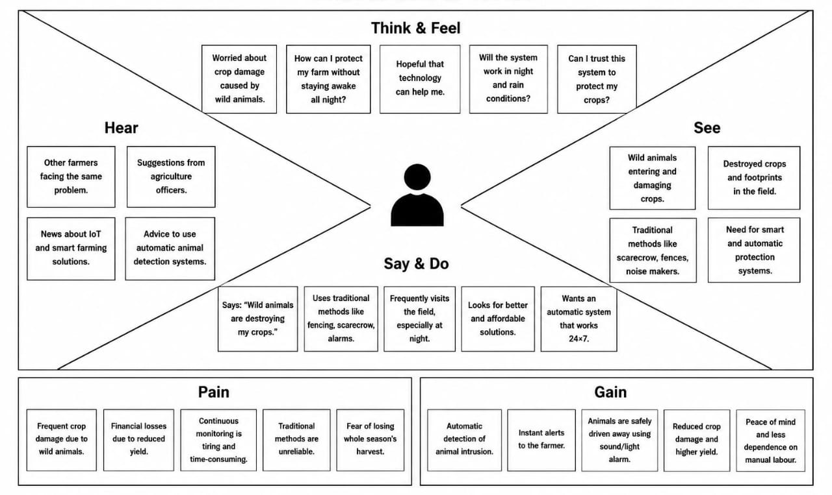
PAINS:
- Frequent crop damage caused by wild pigs.
- Financial losses due to reduced crop yield.
- Continuous manual monitoring is difficult and time-consuming.
- Traditional protection methods are unreliable.
- Delayed information about animal intrusion.
- Fear of losing an entire season's harvest.
GAINS
- Automatic detection of wild pig intrusion.
- Instant alerts sent to the farmer.
- Continuous 24×7 field monitoring.
- Ultrasonic sound/alarm safely repels wild pigs.
- Reduced crop damage and improved productivity.
- Less dependence on manual labour.
- Affordable, eco-friendly, and easy-to-maintain solution.
NEEDS
- Reliable wild pig detection.
- Real-time alert notification.
- Continuous day-and-night monitoring.
- Low-cost IoT-based implementation.
- Easy installation and maintenance.
- Non-harmful animal repellent system.
- Low power consumption and reliable operation.
Proposed solution:
Wild pig intrusion is one of the major causes of crop damage in agricultural fields. Traditional methods such as manual monitoring, scarecrows, and firecrackers are time-consuming, less effective, and require continuous human effort. To overcome these limitations, this project proposes a Smart Wild Pig Detection and Alert System Using IoT Sensor.
The system uses an ESP32-CAM as the main sensing device to continuously monitor the agricultural field by capturing real-time images. The captured images are transmitted to a Python-based Artificial Intelligence (AI) model, which has been trained using images of wild pigs. The AI model analyzes each image and determines whether a wild pig is present.
If the AI model confirms the presence of a wild pig, the system immediately activates a loud alarm and a high-intensity flashing light. These deterrents are intended to scare the animal away from the field without causing any physical harm. When the wild pig leaves the monitored area, the alarm and flashing light are automatically switched off, and the system returns to normal monitoring mode.
The proposed system is based on IoT technology, enabling smart monitoring and automated operation with minimal human intervention. It reduces the need for farmers to guard their fields throughout the day and night, thereby saving time and labour. Compared to traditional methods, the system provides faster response, improved detection accuracy, and more reliable crop protection.

The solution is designed to be cost-effective, energy-efficient, easy to install, and simple to maintain, making it suitable for small and medium-scale farmers. The use of AI minimizes false detections, ensuring that the alarm is triggered only when a wild pig is detected. This improves the overall efficiency and reliability of the system.

Functional Requirements:
Requirement ID | Functional Requirement | Priority
FR-01 | Monitor the agricultural field using ESP32-CAM. | High
FR-02 | Capture real-time images of the field. | High
FR-03 | Process captured images using the Python AI model. | High
FR-04 | Detect the presence of wild pigs accurately. | High
FR-05 | Activate the alarm when a wild pig is detected. | High
FR-06 | Turn on the flashing light to repel the wild pig. | High
FR-07 | Stop the alarm and flashing light after the pig leaves the field. | Medium
FR-08 | Resume continuous monitoring automatically. | High
FR-09 | Minimize false detections using the trained AI model. | Medium
FR-10 | Allow future integration with additional IoT sensors or mobile alerts. | Low

Non-Functional Requirements:
Requirement ID | Non-Functional Requirement | Priority
NFR-01 | High detection accuracy. | High
NFR-02 | Fast response time after detection. | High
NFR-03 | Low power consumption. | High
NFR-04 | Reliable continuous operation. | High
NFR-05 | Easy installation and maintenance. | Medium
NFR-06 | Weather-resistant hardware enclosure. | High
NFR-07 | User-friendly operation for farmers. | Medium
NFR-08 | Scalable design for future upgrades. | Medium
NFR-09 | Cost-effective implementation. | High
NFR-10 | Secure and stable communication between hardware and AI processing system. | Medium

Time line: 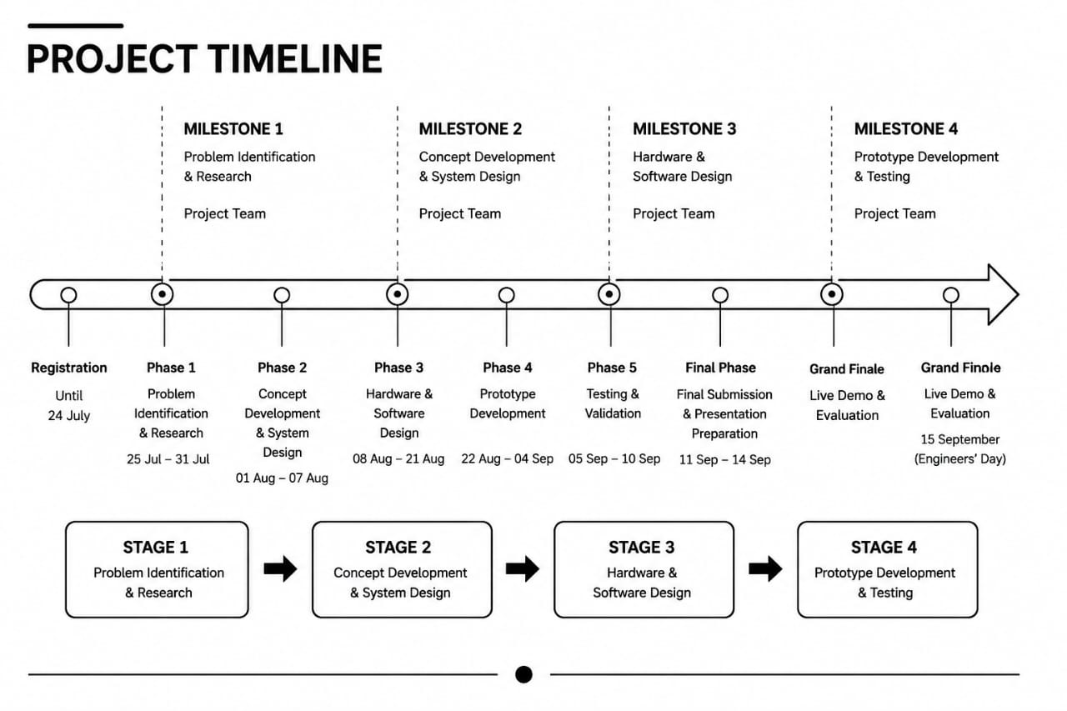
Risk Analysis:
The proposed system may encounter several risks during development and implementation. One possible risk is the false detection of humans or other animals, which may activate the alert system unnecessarily. This can be minimized by improving the image detection process and validating the detected object before triggering the alarm.
Another risk is poor lighting conditions during nighttime, which may reduce the camera's ability to detect wild pigs accurately. This can be addressed by using appropriate lighting or a camera capable of operating in low-light environments.
Power supply interruptions may cause the system to stop functioning, resulting in a lack of protection for the crops. To reduce this risk, a rechargeable battery or backup power source can be provided.
Since the project relies on IoT communication, network or Wi-Fi connectivity issues may delay or prevent alert notifications from reaching the farmer. However, the system can still activate the local ultrasonic alarm even if the network is unavailable.
Risk ID | Risk Description | Probability | Impact | Mitigation Strategy
R1 | False detection of humans or other animals | Medium | High | Improve image detection accuracy.
R2 | Poor lighting at night | Medium | High | Use low-light camera/lighting.
R3 | Power failure | Medium | High | Provide battery backup.
R4 | Wi-Fi failure | Medium | Medium | Use local alarm backup.
R5 | ESP32-CAM malfunction | Low | High | Test hardware regularly.
R6 | Ultrasonic alarm less effective | Medium | Medium | Vary sound patterns.
R7 | Weather damage | Medium | High | Use weatherproof enclosure.
R8 | Alert delay | Low | Medium | Optimize IoT communication.
R9 | Improper installation | Low | Medium | Calibrate and field test.
R10 | Maintenance issues | Medium | Medium | Periodic maintenance.

Hardware failures, such as malfunction of the ESP32-CAM or other electronic components, may affect the overall performance of the system. Regular testing and proper maintenance can help reduce this risk.
The effectiveness of the ultrasonic sound may decrease if wild pigs become accustomed to it over time. Changing the sound pattern or combining it with additional deterrent methods can improve its effectiveness.
Environmental conditions such as rain, dust, and high temperatures may damage the electronic components. Installing the system inside a weatherproof enclosure will help protect the hardware from harsh weather.
Incorrect installation or improper calibration of sensors may reduce detection accuracy. Proper installation, calibration, and field testing should be carried out before deploying the system.
Finally, lack of regular maintenance may reduce the efficiency and reliability of the system over time. Periodic inspection, cleaning of the camera, and software updates will ensure smooth and reliable operation.
Overall, by identifying these potential risks and implementing suitable mitigation strategies, the Protection of Crops from Wild Pigs Using IoT Sensors project can operate more efficiently, reliably, and effectively in real agricultural environments.

