SMART WILD PIG DETECTION
AND
CROP PROTECTION USING IoT

Phase 3 - System Design Review, Deliverables
- System Architecture:
              - Overall Solution Architecture
              - Data Flow Diagram
              - Functional Block Diagram
              - Hardware-Software Partitioning
- Hardware Design:
              - Final Block Diagram
              - Circuit Schematics
              - Component Selection
              - Bill of Materials (BOM)
              - PCB Layout (if applicable)

- Software Design:
      - Flowcharts
      - Algorithms
      - Communication Protocols
      - Database Structure (if applicable)

TEAM MEMBERS:
- DHANYASRI.J
- LAVANYA.V
- ARUNACHALAM.M
- SUJITH.N
I-SYSTEM ARCHITECTURE

(1).OVERALL SOLUTION ARCHITECTURE:
The proposed system is designed for automatic detection and deterrence of wild pig intrusion in agricultural fields. It combines motion sensing, image-based verification, decision logic, and an ultrasonic deterrent to provide continuous field monitoring.

AGRICULTURAL FIELD / WILD PIG INTRUSION
↓
PIR MOTION SENSOR
↓ Motion Detected
ESP32-CAM
Microcontroller + Camera / Image Capture
↓
DETECTION & DECISION LOGIC
↓
BUZZER BASED SOUND DETERRENT
↓
WILD PIG DETERRENCE / MOVEMENT AWAY

(2)DATA FLOW DIAGRAM:
Smart Wild Pig Detection and Deterrent System using ESP32-CAM, PIR Sensor and Ultrasonic Sound
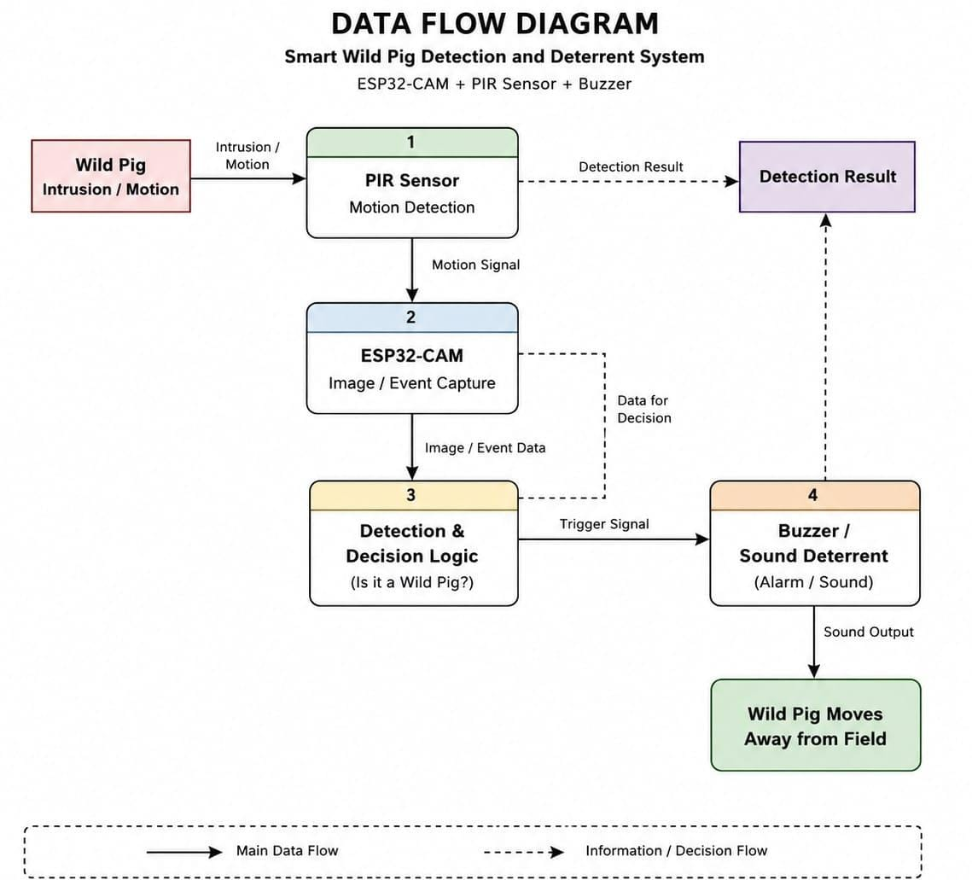
- Data Flow: Motion → Sensor Signal → Image/Event Data → Decision → Trigger Signal → Deterrence.
- Wild pig movement is detected by the PIR sensor.
- The PIR sensor sends a motion signal to the ESP32-CAM.
- The ESP32-CAM captures the image/event data.
- The Detection & Decision Logic determines the required action.
- A trigger signal activates the buzzer.
- The buzzer produces a sound to deter the wild pig
(3) HARDWARE – SOFTWARE PARTIONING:

HARDWARE PARTITION:
Hardware Component | Hardware Function
ESP32-CAM | Main controller and camera interface
PIR Sensor | Detects motion/intrusion
Camera | Captures images of detected events
Ultrasonic Sound Module | Produces deterrent sound
Power Supply/Battery | Supplies power to the system
Voltage Regulation | Provides appropriate supply voltage where required
Wi-Fi Hardware in ESP32 | Provides wireless connectivity

SOFTWARE PARTITION:
Sensor Monitoring | Continuously monitors the PIR sensor
Event Triggering | Activates the camera when motion is detected
Image Capture | Captures the intrusion image/event
Decision Logic | Determines the appropriate system response
Deterrent Control | Controls the ultrasonic module
Wi-Fi Communication | Connects the ESP32-CAM to the network
IoT Alert Generation | Sends intrusion information to the monitoring platform
Notification Handling | Provides an alert to the farmer
Data Logging | Stores event information if implemented

SIMULATION :

Initial Simulation – Motion Detection
Simulation Completed Using PIR Sensor, LED and ESP8266 NodeMCU 1.0
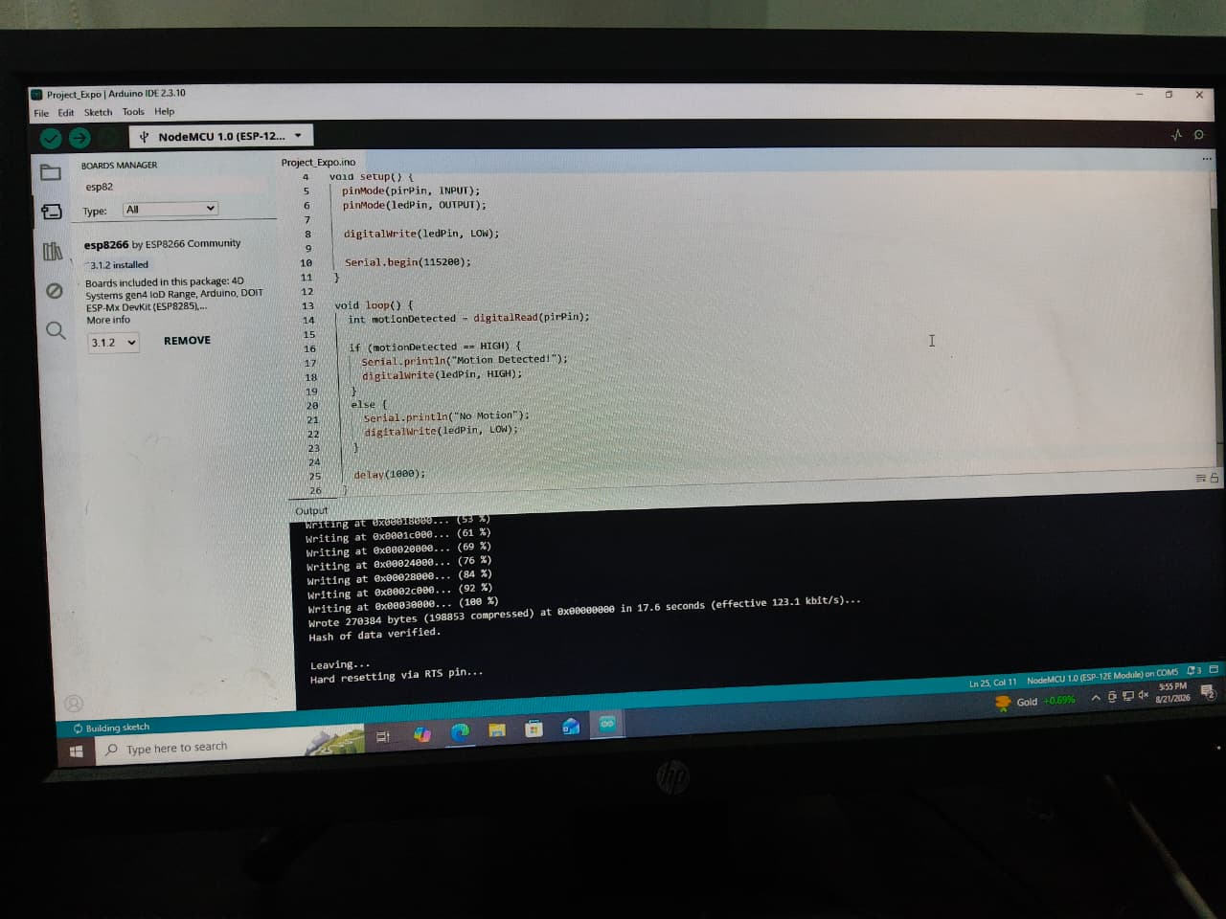

Arduino IDE Programming & Testing
- The ESP8266 NodeMCU 1.0 was selected and programmed using Arduino IDE.
- The program reads the output of the PIR sensor continuously.
- When motion is detected, the Serial Monitor displays “Motion Detected” and the LED turns ON.
- When there is no motion, “No Motion” is displayed and the LED remains OFF.
- The program was successfully compiled and uploaded to the NodeMCU.
- Successful uploading and hardware reset confirmed that the code was executed correctly.

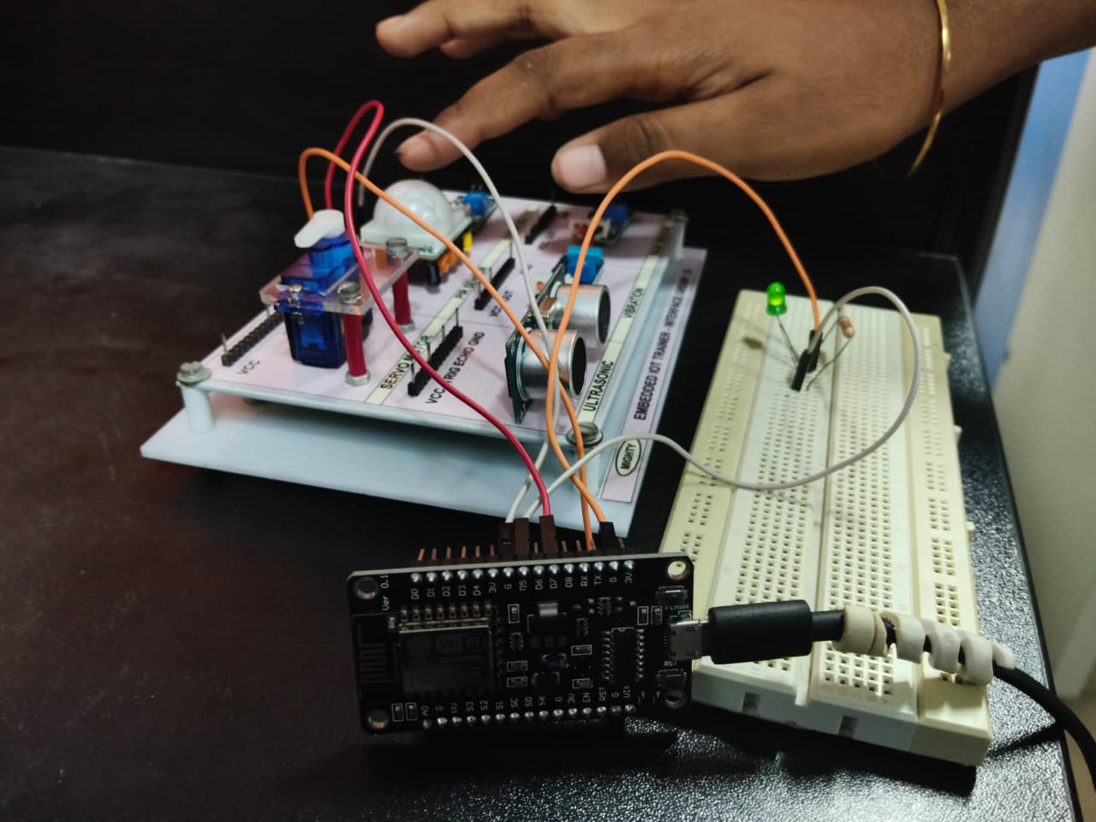
- Successfully developed the first stage of the wild pig detection system.
- An PIR sensor is used to detect movement in the monitored area.
- The ESP8266 NodeMCU 1.0 acts as the main controller and processes the PIR sensor output.
- When motion is detected, the NodeMCU activates the LED as a visual alert.
- When no motion is detected, the LED remains OFF and the system continues monitoring.
- This simulation verifies the basic motion detection and alert mechanism of our proposed system.
- This will serve as the first stage before integrating the ESP32-CAM for image-based pig verification.

II - HARDWARE DESIGN
(1)FINAL BLOCK DIAGRAM:
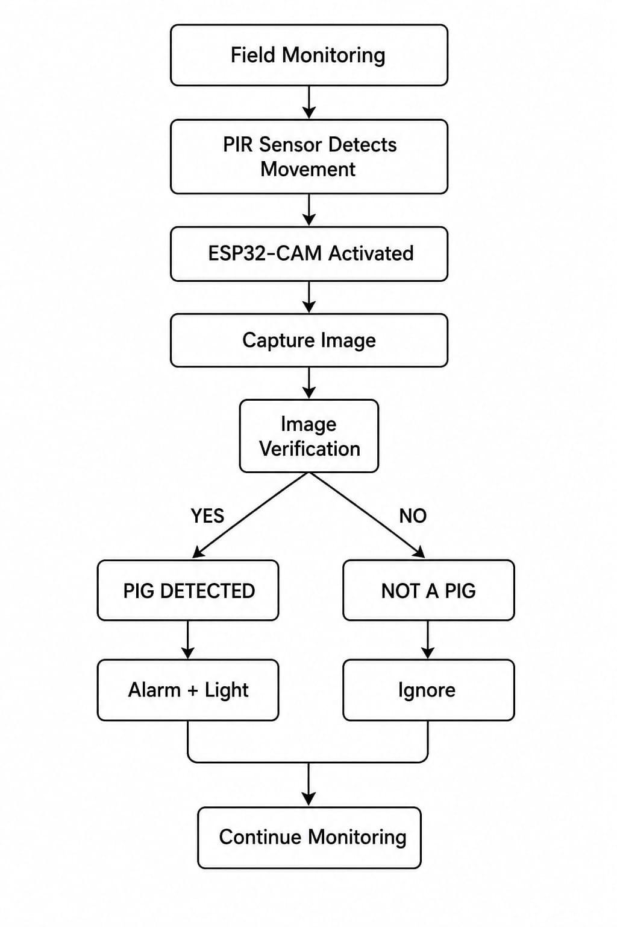

- CIRCUIT SCHEMATICS:
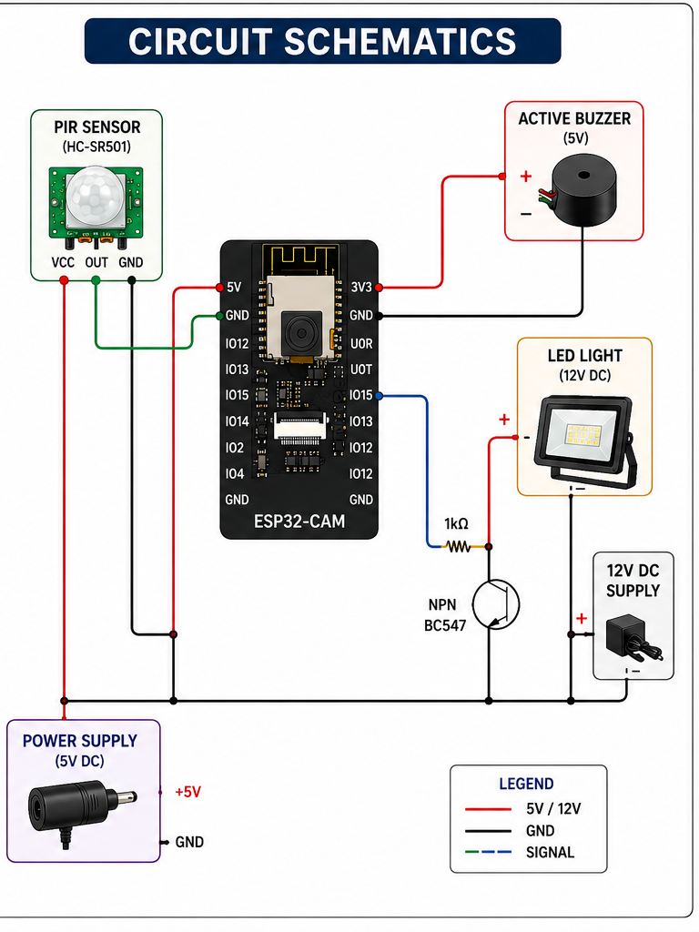

Power Supply and Grounding:

The ESP32-CAM requires a regulated 5V input to the 5V pin for stable operation, especially when using the camera and Wi-Fi simultaneously. The 3.3V pin is derived from the onboard regulator and can power small external sensors, but the OV2640 camera must be powered via its 3.3V pin, never directly from 5V, to prevent damage. All grounds (GND) must be common across the board, camera, and peripherals to avoid signal noise. Adding a 100nF decoupling capacitor at the camera’s power input helps suppress voltage spikes that can cause image artifacts, and a 500mA PTC fuse is recommended if powering via USB to prevent brownouts during initialization.

Camera Interface
The OV2640 camera connects to the ESP32-CAM through a 24-pin FPC connector. Key signal connections include:
- SIOC (I2C clock) → GPIO 22
- SIOD (I2C data) → GPIO 21
- VSYNC → GPIO 25
- HREF → GPIO 23
- PCLK → GPIO 22
- XCLK →GPIO0
These signals handle image synchronization, pixel clock, and camera control. Short wires (under 8 cm) and proper routing prevent interference and data corruption.

Flash LED and Reset
The onboard or external flash LED connects to GPIO 4 with a 220Ω current-limiting resistor to prevent overheating. The reset button is wired to GPIO 0 with a 10kΩ pull-up resistor; grounding this pin triggers a restart, while it must remain HIGH during normal operation.

UART and Programming
The ESP32-CAM lacks a built-in programmer, so UART pins are used for uploading code:
- TX → GPIO 1
- RX → GPIO 3
A 3.3V USB-serial adapter is required; using a 5V adapter without level shifting can damage the board. The FTDI programmer is commonly used for this purpose.

microSD Card Interface
The microSD card slot allows image and video storage. Pins used include SD_DATA0–3 and SD_CLK. Cards should be formatted as FAT32, and using larger clusters (32KB+) improves sequential write performance. Avoid using SD pins for other peripherals simultaneously to prevent conflicts .

Antenna and Wi-Fi :

The ESP32-CAM has a built-in PCB trace antenna. For better Wi-Fi performance, a U.FL connector can be used to attach a 2.4GHz dipole antenna. Enclosures, especially metal, can reduce signal strength or create dead zones, so testing without enclosures is recommended .

GPIO Overview :
The board has limited GPIOs, many of which are dual-purpose:
- Some pins are boot-sensitive (e.g., GPIO 0, 2, 15) and affect flash mode.
- Others serve as camera signals, SD card lines, or general I/O.
- Careful attention to pin functions avoids conflicts during programming and operation.

- COMPONENT SELECTION:
- The components were selected based on their cost, power consumption, ease of interfacing, and suitability for agricultural field conditions.
- The PIR sensor (HC-SR501) was selected because it is low-cost, consumes less power, and can easily detect movement.
- The ESP32-CAM was selected because it is compact, low-cost, and has a built-in camera for capturing images after motion is detected.
- An active buzzer was chosen because it is inexpensive and easy to interface, providing an audible alarm when a pig is detected.
- An LED light or floodlight was selected to provide visual deterrence, especially during nighttime.
- A 5 V DC power supply was selected because it is compatible with the ESP32-CAM and PIR sensor.

Component | Selected Component | Purpose | Reason for Selection
Motion Sensor | PIR Sensor (HC-SR501) | Detects movement in the field | Low cost, low power consumption and easy to use
Camera & Controller | ESP32-CAM | Captures images after motion detection | Compact, low-cost with built-in camera
Alarm | Active Buzzer | Produces a sound when a pig is detected | Low cost and easy to interface
Light | LED Light / Floodlight | Activates to deter wild pigs, especially at night | Suitable for visual deterrence
Power Supply | 5 V DC Supply | Powers ESP32-CAM and PIR sensor | Compatible with the system

- BILL OF MATERIALS(BOM) :
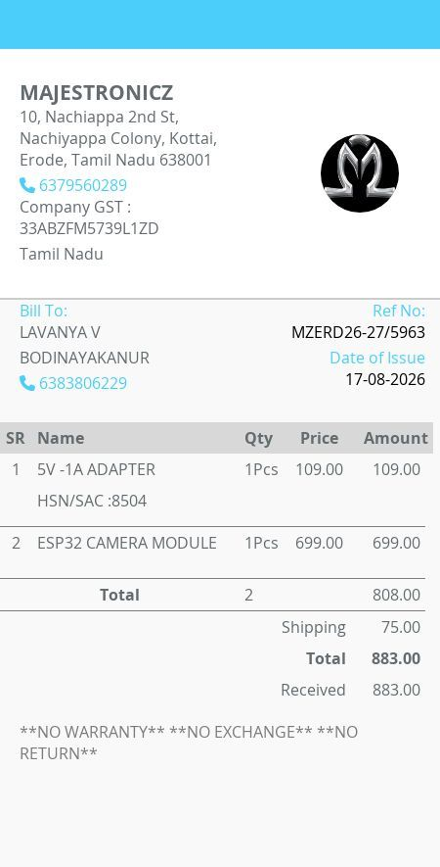

The major components required for the prototype were procured from Majestronicz. The ESP32-CAM module and power adapter were purchased for the project. Other supporting components, including the PIR sensor, LED, buzzer, breadboard, and jumper wires, were available in the college laboratory and were used for prototype development

III - Software design
The software is designed to control the ESP32-based monitoring system, process the PIR sensor signal, capture images using the ESP32-CAM, verify the detected animal, and activate an alert when a wild pig is identified.
(1)-Software Components :
Component ID | Software Component | Function
SC-01 | Sensor Monitoring Module | Continuously monitors the PIR sensor and detects movement in the field.
SC-02 | ESP32 Controller Module | Receives the PIR signal and controls the overall system operation.
SC-03 | Camera Control Module | Controls the ESP32-CAM and captures an image when motion is detected.
SC-04 | Image Verification Module | Analyzes the captured image to determine whether the detected animal is a wild pig.
SC-05 | Decision Module | Makes the decision to activate the alert when a wild pig is confirmed.
SC-06 | Alert Control Module | Activates the alarm and ultrasonic deterrent when a wild pig is detected.
SC-07 | Monitoring Module | Returns the system to normal monitoring after the alert operation.
SC-08 | Communication Module | Provides Wi-Fi/IoT communication for remote monitoring, if implemented.
SC-09 | Data Storage Module | Optionally stores detection records such as date, time, result, and image reference.
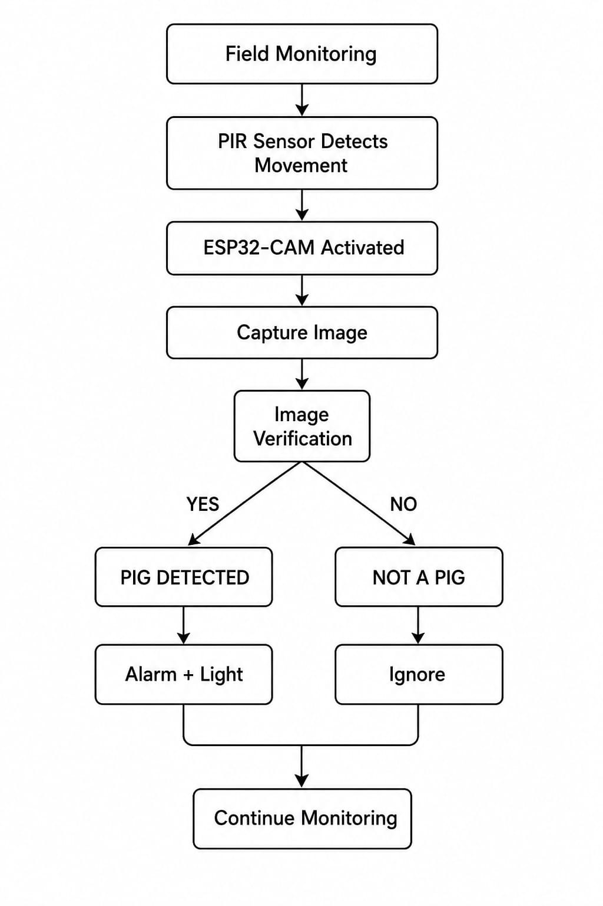
FLOWCHART:

(2)-ALGORITHM:
- Step 1: Start the system.
- Step 2: Initialize ESP32, PIR sensor and ESP32-CAM.
- Step 3: Continuously monitor the PIR sensor.
- Step 4: If no movement is detected, continue monitoring.
- Step 5: If movement is detected, trigger the ESP32-CAM.
- Step 6: Capture an image of the detected animal.
- Step 7: Perform image verification.
- Step 8: If the animal is not a wild pig, ignore the detection and return to monitoring.
- Step 9: If the animal is a wild pig, activate the alarm and ultrasonic deterrent.
- Step 10: Return to monitoring mode.
- Step 11: Repeat continuously.

(3)-COMMUNICATION PROTOCOLS:
Protocol ID | Communication Protocol | Used For | Function
CP-01 | GPIO | PIR Sensor ↔ ESP32 | Transfers the motion detection signal from the PIR sensor to the ESP32.
CP-02 | GPIO | ESP32 ↔ Alarm/Ultrasonic Device | Sends control signals to activate the alarm and ultrasonic deterrent.
CP-03 | Wi-Fi | ESP32 ↔ Network | Provides wireless connectivity for IoT-based monitoring.
CP-04 | HTTP | ESP32 ↔ Server/Application | Can be used to send detection information or receive commands through a network.
CP-05 | UART/Serial | ESP32 ↔ Computer | Used for programming, debugging, and monitoring system messages during development.

(4)-DATABASE STRUCTURE:
Field | Description
Detection ID | Unique detection number
Date | Date of detection
Time | Time of detection
Animal | Detected animal
Confidence | Detection confidence
Image | Captured image reference
Alert_Status | Alert activated or not

