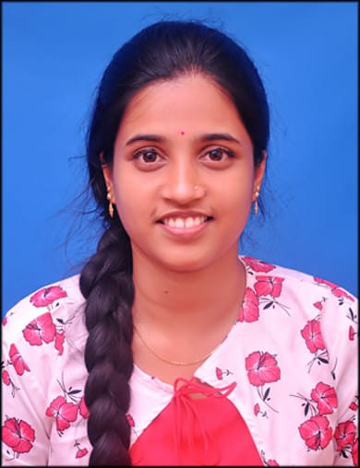 **DHANYASHREE A**

 7624813971

 [dhanyashreea253@gmail.com](mailto:dhanyashreea253@gmail.com)

D/O Sadashiva A

Amchinadka House,Pernaje Post,

Puttur taluk,madnooru village

DK, 574223

**OBJECTIVE**:

To work for organization which provides me the opportunity to improve my skills and knowledge to growth along with company objectives.

**EDUCATION:**

2023 Vivekananda college of Engineering and technology.

MCA

9 -SGPA

85%

2021 ST. Philomena degree college, darbe ,puttur

BSc

93%

2018 Ambika padavi poorva vidyalaya , nellikatte, puttur

PUC

80%

2016 Govt. High school, papemajalu

SSLC

92%

**TECHNICAL SKILL:**

Language: C , C++ , Java ,JS,HTML,CSS

Database: Oracle, MySQL

**LANGUAGES**:

Kannada , English ,Tulu ,Hindi

**INTERESTS**:

* Learning new programming language.
* Photography.
* Craft working

**STRENGTH:**

* Desired to learn new things
* Leadership
* Time management
* Quick learner
* Ability to work in group

**EXTRACURRICULAR ACTIVITIES:**

* Rovers and Rangers:

Participated in district level of “Rover and Ranger Moot 2018” Held

at Mangalore.

* Participated in ten days Quiz Series on Mathematics held at Dharwad.

I hereby declare that above mentioned details are accurate and true to the

best of my knowledge.

Place: Puttur DHANYASHREE A