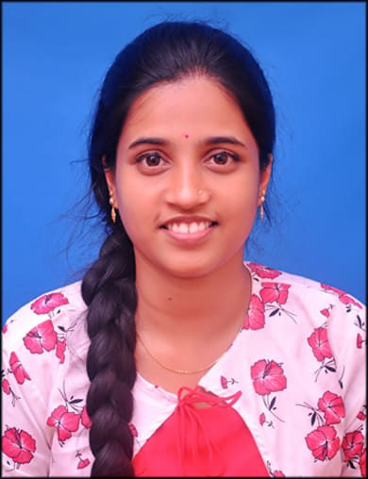

DHANYASHREE A

 7624813971

 [dhanyashreea253@gmail.com](mailto:dhanyashreea253@gmail.com)

## Amchinadka House,Pernaje Post,

Puttur taluk,madnooru village

Dakshina Kannada,574223.

**OBJECTIVE**

To work for organization which provides me the opportunity to improve my skills and knowledge to growth along with company objectives.

**EDUCATION**

2023 Vivekananda college of Engineering and technology.

MCA

70%

2021 ST. Philomena degree college, darbe ,puttur

BSc

93%

2018 Ambika padavi poorva vidyalaya , nellikatte, puttur

PUC

80%

2016 Govt. High school, papemajalu

SSLC

92%

**TECHNICAL SKILL**

Language: C , C++ , Java ,JS,HTML,CSS

Database: Oracle, MySQL

**LANGUAGES**

Kannada , English ,Tulu ,Hindi.

**INTERESTS**

* Learning new programming language.
* Photography.
* Craft working.

**STRENGTH**

* Desired to learn new things.
* Leadership.
* Time management.
* Quick learner.
* Ability to work in group.

**EXTRACURRICULAR ACTIVITIES**

* Rovers and Rangers:

Participated in district level of “Rover and Ranger Moot 2018” Held

at Mangalore.

* Participated in ten days Quiz Series on Mathematics held at Dharwad.

I hereby declare that above mentioned details are accurate and true to the

best of my knowledge.

Place: Puttur DHANYASHREE A