OPERATING SYSTEMS- TASK2
AI-Assisted Synchronization Algorithms with Program-Generated HTML Simulation
Readers-Writers Problem and Dining Philosophers Problem
Student name | Dhanya Kamath
Registration / USN | NNM24IS070
Course | Operating Systems
Assignment type | Programming Assignment
Programming language | Python
GitHub repository | https://github.com/dhanyakamath7/taskos/tree/main/task2

1. Problem Statement and Objective
There might be cases where more than one thread would require access to common data/resource. But accessing them at once by many threads may lead to some errors or wrong results. This is known as a race condition. To overcome this issue, synchronization can be applied which controls the way threads access shared resources.
A synchronization solution is supposed to cover the following points primarily:
• Mutual exclusion: The permitted thread(s) only can access the critical section at once.
• Progress: If there are any resources that can be accessed, the thread should not be waiting unnecessarily.
• Bounded waiting: Every waiting thread will have its turn after a certain period of time.
Two synchronization problems have been considered in this assignment where there are two possible solutions for each of them: semaphores and monitors.
1. Readers-Writers Problem: There are several readers that can access shared data simultaneously, but a writer must access that data exclusively when updating.
2. Dining Philosophers Problem: Four philosophers share four forks between them. Each philosopher requires two forks that lie next to him/her.
2. Readers-Writers Problem Using Semaphores
In the Readers-Writers problem, the shared resource can be something simple like a counter or a document. Readers only access the data, while writers can change it. The code that accesses the shared data is called the critical section.
Semaphores and shared variable
Name | Initial value | Purpose
mutex | 1 | Protects the read_count variable
resource | 1 | Controls access to the shared resource
read_count | 0 | Keeps track of the number of active readers
Reader: acquire mutex, increment read_count, and if this is the first reader, acquire resource; release
How the reader works
When a reader arrives, it first locks mutex and increases read_count. If it is the first reader, it locks resource so that a writer cannot enter while readers are using the data. It then releases mutex and reads the data.
After reading, the reader locks mutex again and decreases read_count. If it is the last reader, it releases resource, allowing a writer to proceed. Finally, it releases mutex.
How the writer works
A writer first acquires resource, which gives it exclusive access to the shared data. It performs the update and releases resource when finished.
Properties and limitation
The main advantage of this approach is that multiple readers can read at the same time, while a writer must wait until the readers finish. One drawback is that readers get priority. If new readers keep arriving, a writer might keep waiting. This situation is called writer starvation.
One way to improve fairness is to add a turnstile semaphore that both readers and writers must pass through. The exact implementation should be checked against the submitted source code.
3. Readers-Writers Problem Using a Monitor
Python does not have a separate built-in monitor statement. Instead, the same idea can be implemented with threading.Lock and threading.Condition. The lock protects the shared variables, and condition variables let a thread wait until it is safe to continue.
Monitor state
The monitor uses these variables:
- active_readers: the number of readers currently reading.
- writer_active: indicates whether a writer is using the resource.
- waiting_writers: the number of writers waiting to enter.
Main operations
- start_read(): A reader waits while a writer is active. In a writer-priority version, it also waits if writers are already waiting. Once the conditions allow it to proceed, the reader count is increased.
- end_read(): The reader count is decreased. If no readers remain, a waiting writer can be notified.
- start_write(): The waiting-writer count is increased. The writer waits until no other writer or reader is active. When it can proceed, it decreases the waiting-writer count and marks the writer as active.
- end_write(): The writer marks itself as inactive and notifies waiting threads.

The condition is checked in a while loop before the thread continues after wait(). This matters because a thread waking up does not automatically mean the resource is available; it must check the condition again.
This version gives priority to writers. It helps prevent writer starvation, although readers may have to wait longer when writers keep arriving. The implementation should be compared with the actual program before submission.
4. Dining Philosophers Problem Using Semaphores
This version has four philosophers sitting around a table with four forks. Each fork is represented by a binary semaphore with an initial value of 1. Philosopher i needs fork i and fork (i + 1) mod 4 to eat, so eating is the critical section.
The deadlock problem
A common but unsafe solution is to make every philosopher pick up the left fork first and then wait for the right one. If all four do this together, each philosopher holds one fork and waits for another fork held by a neighbour. Since nobody can get the second fork, the program gets stuck in a deadlock.
This situation involves the deadlock conditions, especially hold and wait and circular wait.
Preventing deadlock
One way to prevent this situation is to introduce a counting semaphore called room, initialized to 3. A philosopher must acquire room before trying to pick up the forks and release it after putting them down.
Since no more than three philosophers can compete for the four forks at once, the circular-wait situation can be broken, allowing at least one philosopher to obtain both forks. This reasoning assumes the semaphore and fork-acquisition logic are implemented as described.
Starvation
Preventing deadlock does not automatically guarantee fairness. Depending on how the semaphores schedule waiting threads, one philosopher might repeatedly lose the chance to eat. Fair FIFO semaphores or another explicit queueing mechanism can help reduce this risk. The final report should describe the method actually used in the submitted program.
5. Dining Philosophers Problem Using a Monitor
The monitor-based version discussed in this section is the one in dining_philosophers_simulation.py.
Monitor structure
The implementation uses:
- One lock, self.lock, to protect the shared monitor state.
- One condition variable for each philosopher, stored in self.condition[i]. These condition variables share the same lock.
- state[i], which records whether a philosopher is THINKING, HUNGRY, or EATING.
- meals[i], which counts how many meals each philosopher has completed.
Main operations
- pickup_forks(i): The philosopher changes their state to HUNGRY, receives a ticket, and calls test(i). If the philosopher cannot eat yet, they wait on their own condition variable. The state is checked again in a while loop after waking up.
- test(i): The philosopher can start eating only when they are hungry, neither neighbour is eating, and the fairness rule allows them to proceed. If these conditions are met, the state changes to EATING and the philosopher's condition variable is notified.
- putdown_forks(i): After eating, the philosopher changes their state to THINKING and the meal count is updated. The program then checks nearby philosophers who may now be able to eat.
Why this prevents deadlock
In this solution, a philosopher does not pick up one fork and then wait while holding it. The monitor checks whether both forks are available first. If they are, the philosopher can eat; otherwise, the philosopher waits without holding either fork. This removes the hold-and-wait situation and helps prevent deadlock.
How the ticket rule helps with starvation
A basic monitor can prevent deadlock but may still allow a philosopher to wait too long. To improve fairness, each hungry philosopher receives a ticket number. The monitor checks these tickets before allowing a philosopher to eat and prevents a philosopher from passing a hungry neighbour who has an older ticket.
This rule is intended to ensure that a philosopher who has waited longer is not repeatedly skipped. The exact behaviour depends on how the ticket checks are implemented in the code.
Showing fork ownership
Fork k is positioned between philosophers k and k + 1. In the visualization, a fork is shown as being used by a neighbouring philosopher who is eating; otherwise, it is shown on the table. This gives a visual way to follow the philosophers' states during the simulation.
6. Recording Events and Generating the HTML Simulation
The program works in the following order:
Run the program → synchronize the threads → record state changes → create the HTML file → view the replay in a browser.
- The four philosopher threads run using the monitor and wait on condition variables when they cannot continue.
- Whenever a philosopher's state changes to HUNGRY, EATING, or THINKING, the record() method adds an event to a list. The event stores the elapsed time, philosopher number, new state, and meal count. Console messages are also stored with timestamps.
- After all threads finish, build_html() converts the recorded events and console messages into JSON and inserts them into an HTML template. The resulting file is named dining_philosophers_animation.html.
- The HTML page uses JavaScript to replay the recorded events. At each point in the replay, it updates the philosophers, forks, meal counts, and output panel. The page includes Pause, Restart, and Speed controls.
- The program attempts to open the generated file with webbrowser.open(). If the browser does not open automatically, the file can be opened manually.
The animation uses the events recorded while the program is running, so it is meant to show what actually happened in that run instead of playing a fixed example. The same event-recording and HTML-generation approach should be added to the other three programs if the assignment requires it.
7. Execution Traces
7.1 Dining Philosophers Problem Using a Monitor
Execution Trace
Philosopher 1 is thinking
Philosopher 2 is thinking
Philosopher 3 is thinking
Philosopher 4 is thinking
Philosopher 1 is hungry
Philosopher 1 starts eating
Philosopher 2 is hungry
Philosopher 4 is hungry
Philosopher 3 is hungry
Philosopher 1 finishes eating (1/5)
Philosopher 4 starts eating
Philosopher 1 is thinking
Philosopher 4 finishes eating (1/5)
Philosopher 2 starts eating
Philosopher 2 finishes eating (1/5)
Philosopher 3 starts eating
Philosopher 3 finishes eating (1/5)
Final meal counts: [5, 5, 5, 5]
Explanation
At the beginning, all four philosophers are thinking. When Philosopher 1 becomes hungry, the monitor checks whether the required forks are available and allows the philosopher to eat. The other philosophers wait until they can safely get their turns. After one philosopher finishes eating, the monitor checks whether another philosopher can proceed. This helps prevent neighbouring philosophers from eating at the same time. The final meal count shows that each philosopher completed five meals.
7.2 Readers-Writers Problem Using Semaphores
Execution Trace
R1: wants to read
R1: started reading
R2: wants to read
R2: started reading
W1: wants to write
R1: done reading
R2: done reading
W1: started writing
W1: wrote 0 -> 1
W1: done writing
R3: wants to read
R3: started reading
R3: read value = 1
R3: done reading
Explanation
In this execution, Reader 1 and Reader 2 access the shared resource at the same time. When Writer 1 wants to update the data, it has to wait for both readers to finish. Once the resource becomes available, the writer updates its value from 0 to 1 and releases it. Reader 3 then reads the updated value. This shows how semaphores allow readers to work together while ensuring that a writer gets exclusive access.
7.3 Readers-Writers Problem Using a Monitor
Execution Trace
R1: wants to read
R1: started reading
R2: wants to read
R2: started reading
W1: wants to write
W1: waiting
R1: done reading
R2: done reading
W1: started writing
W1: wrote 1 -> 2
W1: done writing
R3: wants to read
R3: started reading
R3: read value = 2
R3: done reading
Explanation
Here, the monitor controls access to the shared resource using a lock and condition variables. Both readers can read together, but the writer must wait until they finish. After the readers leave the critical section, the writer gets access and updates the value from 1 to 2. Reader 3 can then read the new value. If writer priority is used, new readers may need to wait while a writer is waiting. This helps reduce the chance

8. Race Conditions, Mutual Exclusion, Deadlock, and Starvation
Concept | Readers-Writers Problem | Dining Philosophers Problem
Race condition | Without synchronization, a writer could update data while a reader is accessing it, or two writers could interfere with each other's updates. Updating read_count without mutex could also cause a race. | Without a lock, neighbouring philosophers could check the states at the same time and incorrectly decide that both can start eating.
Mutual exclusion | The resource semaphore or the monitor's lock and writer_active state prevent a writer from sharing the resource with readers or another writer. | The monitor lock protects the state checks and updates, preventing neighbouring philosophers from being allowed to eat together.
Deadlock | The described operations use a resource semaphore or monitor lock. Confirm that the actual implementation does not acquire additional locks in a conflicting order. | The semaphore version uses the room semaphore to prevent circular waiting. The monitor version allows a philosopher to start only when both forks are available.
9. Comparing Semaphores and Monitors
Aspect | Semaphores | Monitors with condition variables
Level of abstraction | A lower-level approach using wait and signal operations. | A higher-level approach that groups shared data and the operations that use it.
Mutual exclusion | The programmer must make sure semaphores are acquired and released correctly. | A shared lock protects the monitor's operations and state.
Waiting for a condition | The logic is managed through semaphore operations. | A thread can wait directly until a condition may be satisfied.
Common mistakes | Incorrect ordering or a missing signal can cause threads to get stuck. | Missing notifications or using if instead of rechecking the condition in a while loop can cause errors.
Readability | Often shorter, but the synchronization logic can be harder to follow. | May require more code, but the conditions are often easier to understand.
Fairness | Depends on the semaphore implementation and any extra fairness logic. | Fairness rules, such as ticket ordering, can be added to the monitor.
From this comparison, semaphores provide a fairly direct way to control access, but the programmer has to manage the order of operations carefully. With a monitor, the shared variables and the rules for using them are kept together. In the Dining Philosophers solution, the monitor also makes it easier to apply the ticket rule for fairness.
10. Screenshots of the HTML Simulations
Add screenshots from your own program runs. For each implementation, include the console output and the generated HTML simulation if your lecturer requires both.
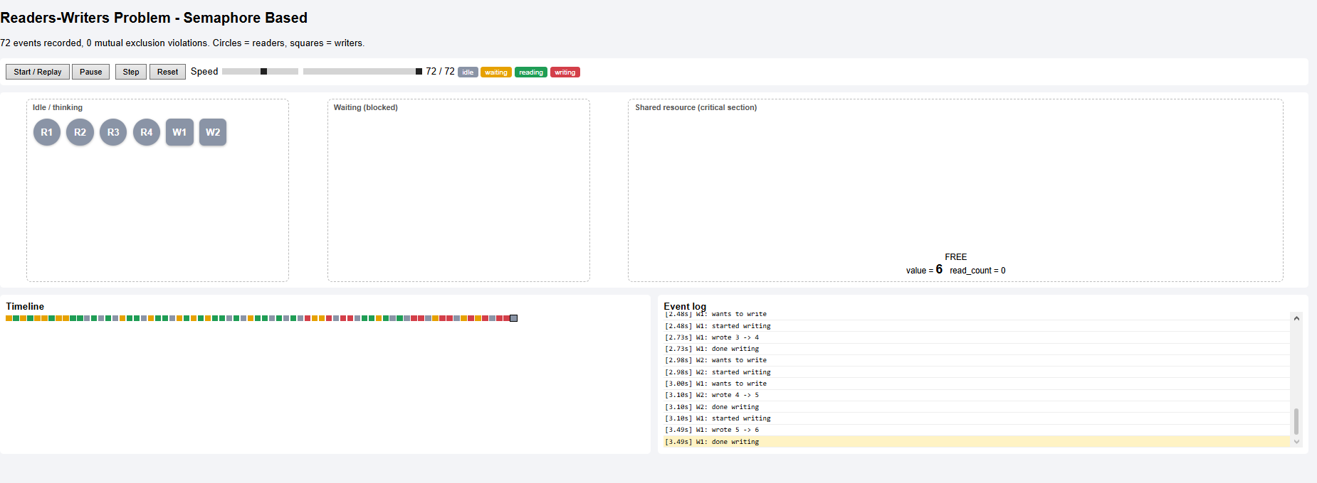

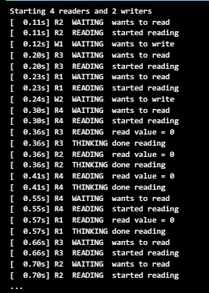

- Figure 1: Readers-Writers using semaphores — console output and HTML simulation.
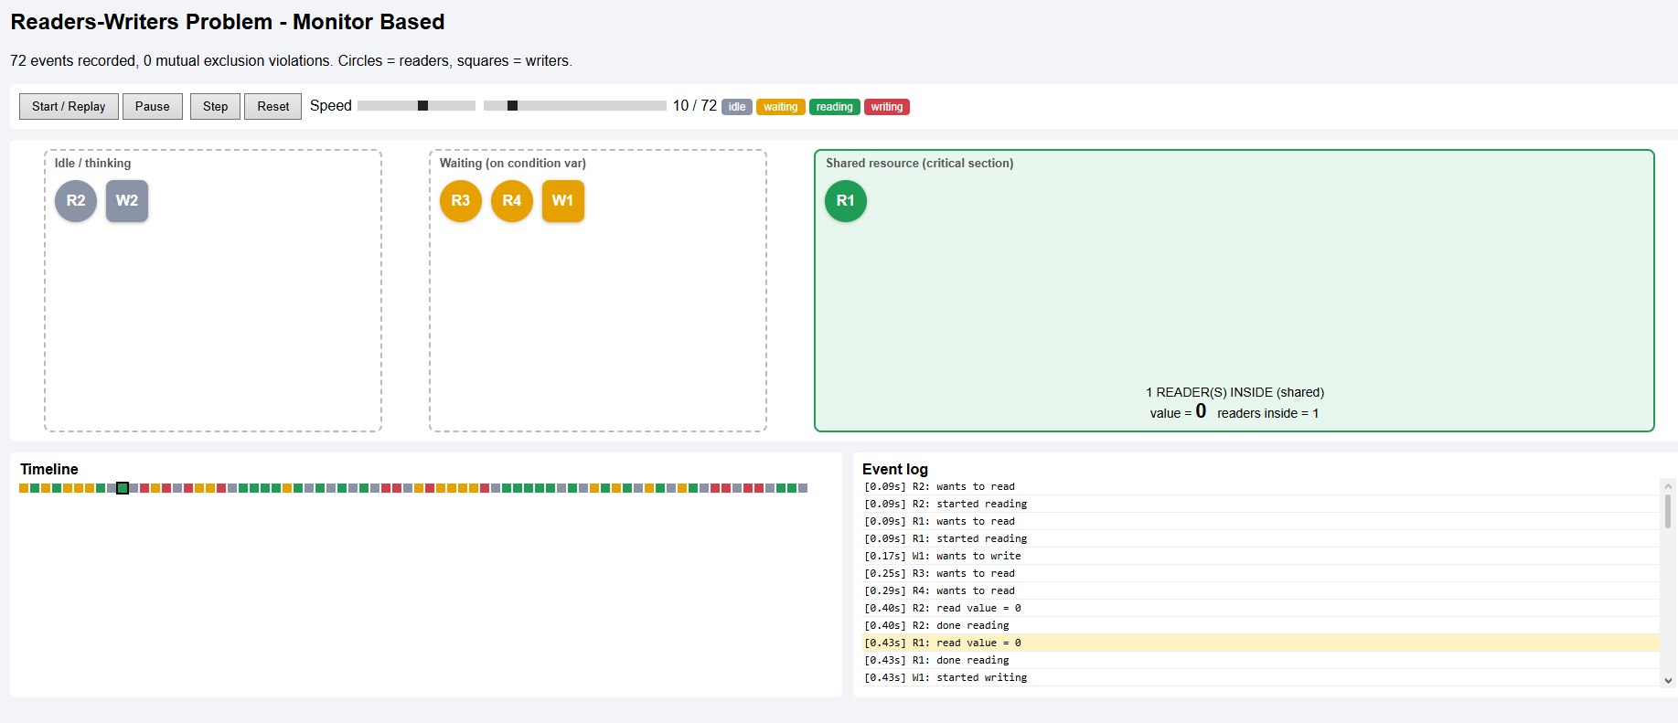
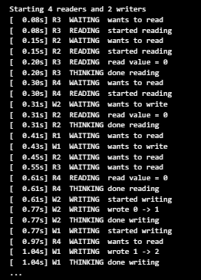
- Figure 2: Readers-Writers using a monitor — console output and HTML simulation.
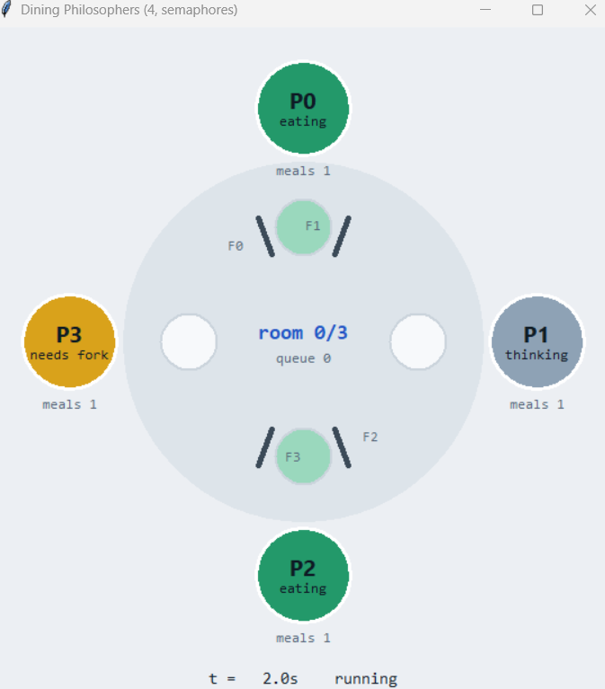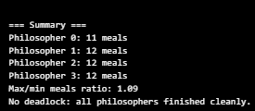
- Figure 3: Dining Philosophers using semaphores — console output and HTML simulation.
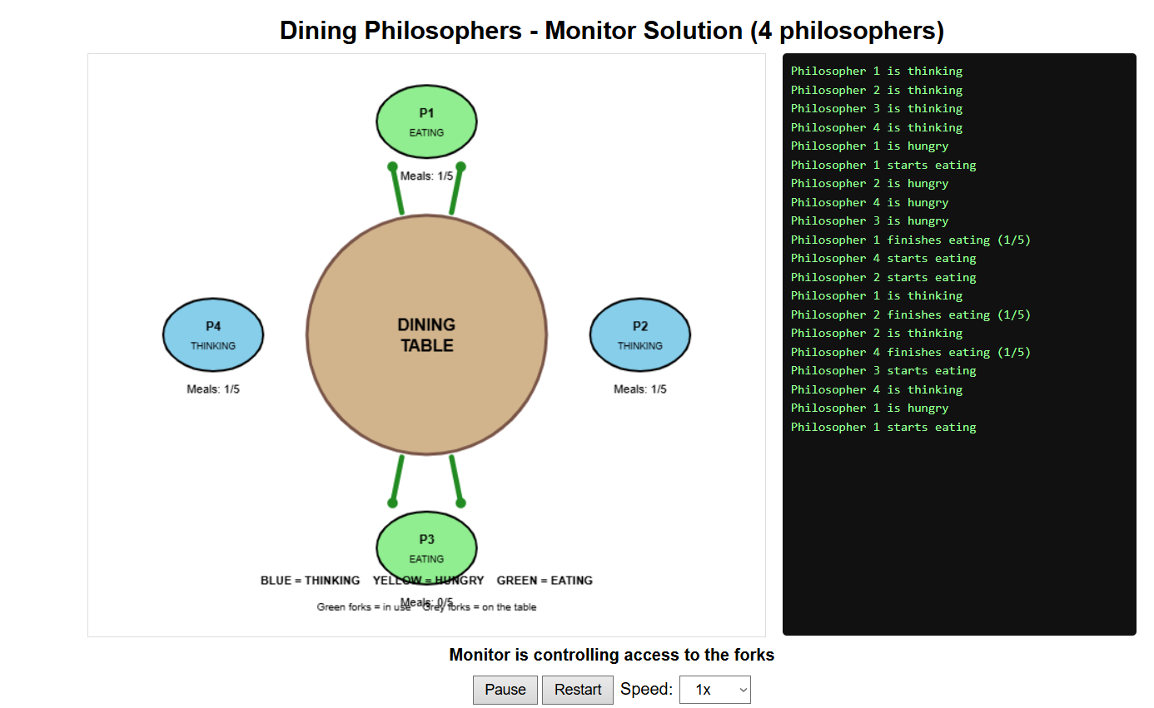
- Figure 4: Dining Philosophers using a monitor — console output and HTML simulation.
11. AI Usage Summary
AI tool used: Claude by Anthropic, accessed through the Claude chat interface.
Prompts and Assistance Used
- Asked for guidance on implementing the Dining Philosophers problem using a monitor and condition variables.
- Asked for help understanding the synchronization logic and checking whether the implementation was correct.
- Sought suggestions for improving the code and resolving issues encountered during testing.
- Asked for troubleshooting help when the Tkinter animation did not display properly.
- Asked how to connect the program's console output with the HTML simulation so that the simulation could open automatically after execution.
- Requested guidance on organizing the implementation details and presenting the project in the assignment report.

My Contribution
I worked on understanding the synchronization concepts and implementing the Dining Philosophers simulation. During development, I tested the program, observed the output, and tried to resolve issues with the animation. When I faced difficulties, I used AI assistance to understand the errors and explore possible solutions. I also reviewed the program's behaviour and prepared the report to explain the synchronization approach, execution flow, and simulation results.

Issues and limitations encountered
- The first version could allow starvation in theory, so a ticket-based fairness mechanism was added.
- The animation did not shut down cleanly if the window was closed early because the threads were not stopped properly.
- The Tkinter animation did not display on the system used, so the program was changed to generate a browser-based HTML replay from recorded events.
- The fork emoji did not respond to colour settings as expected in Tkinter, so the forks were changed to drawn shapes.
- The monitor-based program alone does not complete the full assignment. The other three implementations still need to be implemented, tested, and documented.
Keep only the points that accurately describe what happened during your own work, and update them if the final code behaves differently.
12. References
- Silberschatz, A., Galvin, P. B., and Gagne, G. Operating System Concepts. Chapters covering process synchronization and classical synchronization problems.
- Tanenbaum, A. S., and Bos, H. Modern Operating Systems. Sections on the Dining Philosophers and Readers-Writers problems.
- Python Software Foundation. Python documentation for the threading module, including Lock, Condition, and Semaphore: https://docs.python.org/3/library/threading.html
- Anthropic. Claude AI assistant: https://claude.ai
13. Academic Integrity Declaration
I declare that I have tested and understood the programs included in this assignment. I have acknowledged the AI tools and other resources used while preparing the work. I am prepared to explain the synchronization logic, the HTML simulation, and the changes I made to the code. I have not knowingly submitted another student's work or used third-party material without acknowledgement.
Signature: 
Date: 13/10/2026

