Cognate & False-Friend Detection for Dravidian Languages
Kannada ⇌ Telugu
Aug 2026

Dhanya and Tejaswini
Group 110 | Course Project (CS6120, Natural Language Processing)
Contributions per member. The two of us jointly designed the annotation guidelines, independently double-annotated the pilot (40 pairs) and the main batch (300 pairs) and adjudicated all disagreements together; we both worked on the report. Individually: Dhanya focused on mining candidates from IndoWordNet (Stream A / Stream B), the normalization and ISO-15919 transliteration pipeline, the faithful English glossing, and the stratified sampling scripts. Tejaswini focused on the orthographic / phonetic / semantic feature extractors, the logistic-regression classifier and ablation harness, the evaluation metrics, and the Streamlit app. [Adjust this split to match what you did before submitting.]
Abstract
Kannada and Telugu are closely related Dravidian languages with substantial shared vocabulary, arising both from common Dravidian inheritance and from extensive Sanskrit borrowing. This overlap is a valuable resource for cross-lingual vocabulary learning, but it is unreliable: some form-similar pairs are true cognates (shared origin, shared meaning), others are false friends (similar form, divergent meaning), and others are unrelated. We present the NLP components required by an intercomprehension aid for this language pair. Our work comprises three contributions: (i) a hand-annotated gold-standard dataset of 340 Kannada–Telugu pairs, each labelled cognate, false_friend, or unrelated, drawn from two complementary IndoWordNet candidate streams, with inter-annotator agreement measured on a held-out 300-pair batch (Cohen's kappa = 0.512); (ii) a class-balanced logistic regression over three similarity features: orthographic (edit distance), phonetic (sound-class alignment), and semantic (cosine of LaBSE gloss embeddings); and (iii) a Streamlit application that teaches and evaluates the three categories. On a held-out 30% test set the model attains macro-F1 = 0.750 and accuracy = 0.775. Feature ablations indicate that the semantic feature is decisive for false-friend detection, that the phonetic feature contributes no additional signal over orthographic similarity for this language pair, and that class weighting is essential: without it, accuracy rises to 0.843 while false-friend recall collapses to zero.

1 Introduction
Intercomprehension — the use of shared vocabulary between related languages so that competence in one accelerates acquisition of another — is an established language-teaching strategy for the Romance, Germanic, and Slavic families, but comparable resources for the Dravidian family are scarce. Kannada and Telugu exhibit considerable lexical overlap, both through common Dravidian descent and through a shared layer of Sanskrit loanwords. For a learner, cognate pairs are a direct benefit, but false friends — pairs that are formally similar yet semantically divergent — are a source of systematic error. Distinguishing the two automatically is the core NLP problem underlying any such learning aid, and it is the focus of this work.
The task presents three principal challenges. First, the two languages use distinct scripts, so word forms are not directly comparable and must be romanized to a common scheme before any surface comparison. Second, the cognate/false-friend boundary is inherently fuzzy: shared Sanskrit borrowings whose meanings have diverged in one language are precisely the cases that produced the most annotator disagreement. Third, false friends are rare; a sample drawn only from shared dictionary senses contains almost none, so both data collection and model training must be designed explicitly to address the resulting class imbalance.
Objectives:
- A gold-standard dataset of 340 Kannada–Telugu pairs labelled cognate, false_friend, or unrelated, constructed from two candidate pools and released with both annotators' files, the adjudicated merge, and the annotation guidelines.
- A two-stream candidate-mining strategy designed to surface the rare false-friend class: shared-synset pairs (predominantly cognate/unrelated) together with form-similar pairs drawn from disjoint synsets (the false-friend pool).
- A feature-based classifier combining orthographic, phonetic, and semantic similarity, with an ablation study quantifying each feature's contribution against a baseline.
- A learning application that teaches and evaluates the three categories and produces live model predictions for arbitrary input pairs.
- An empirical finding of methodological interest: for this language pair, the phonetic feature is redundant with orthographic similarity, while the semantic feature is the decisive signal separating cognates from false friends.

2 Prior Work
Intercomprehension: The EuroCom framework [1] pioneered systematic intercomprehension teaching across Romance languages through a set of transfer “sieves.” That work targets reading comprehension across European families; we borrow the premise — shared vocabulary as a learning resource — and apply it to a Dravidian pair and to active vocabulary learning with explicit false-friend warnings.
Cognate detection: Automatic cognate identification goes back a long way in computational historical linguistics. Kondrak's ALINE algorithm [2] aligns phonetic transcriptions to score cognacy; List's LexStat and the LingPy toolkit [3] formalize sound-class alignment (SCA) for cognate detection across word lists. Ciobanu and Dinu [4] approach it through orthographic alignment and look at the cognate-vs-false-friend distinction. These orthographic and phonetic methods are what motivated two of our three features.
Indian-language resources: IndoWordNet [5] is a linked wordnet across many Indian languages; words that share a synset across Kannada and Telugu give us aligned candidate pairs without needing a parallel corpus. Earlier work on using wordnets for cognate detection among Indian languages [6] folds shared loanwords into the “cognate” category, which is the same convention we adopt for our learning-oriented labels.
Multilingual embeddings: Language-agnostic sentence encoders such as LaBSE [7] and MuRIL [8] map many languages, including the major Indian ones, into a shared semantic space, allowing meaning to be compared independently of surface form.

3 Methods
Figure 1 presents the complete pipeline: candidate mining, cleaning and glossing, sampling for annotation, double annotation and adjudication, feature extraction, classifier training, and the learning application. Each stage is described below.

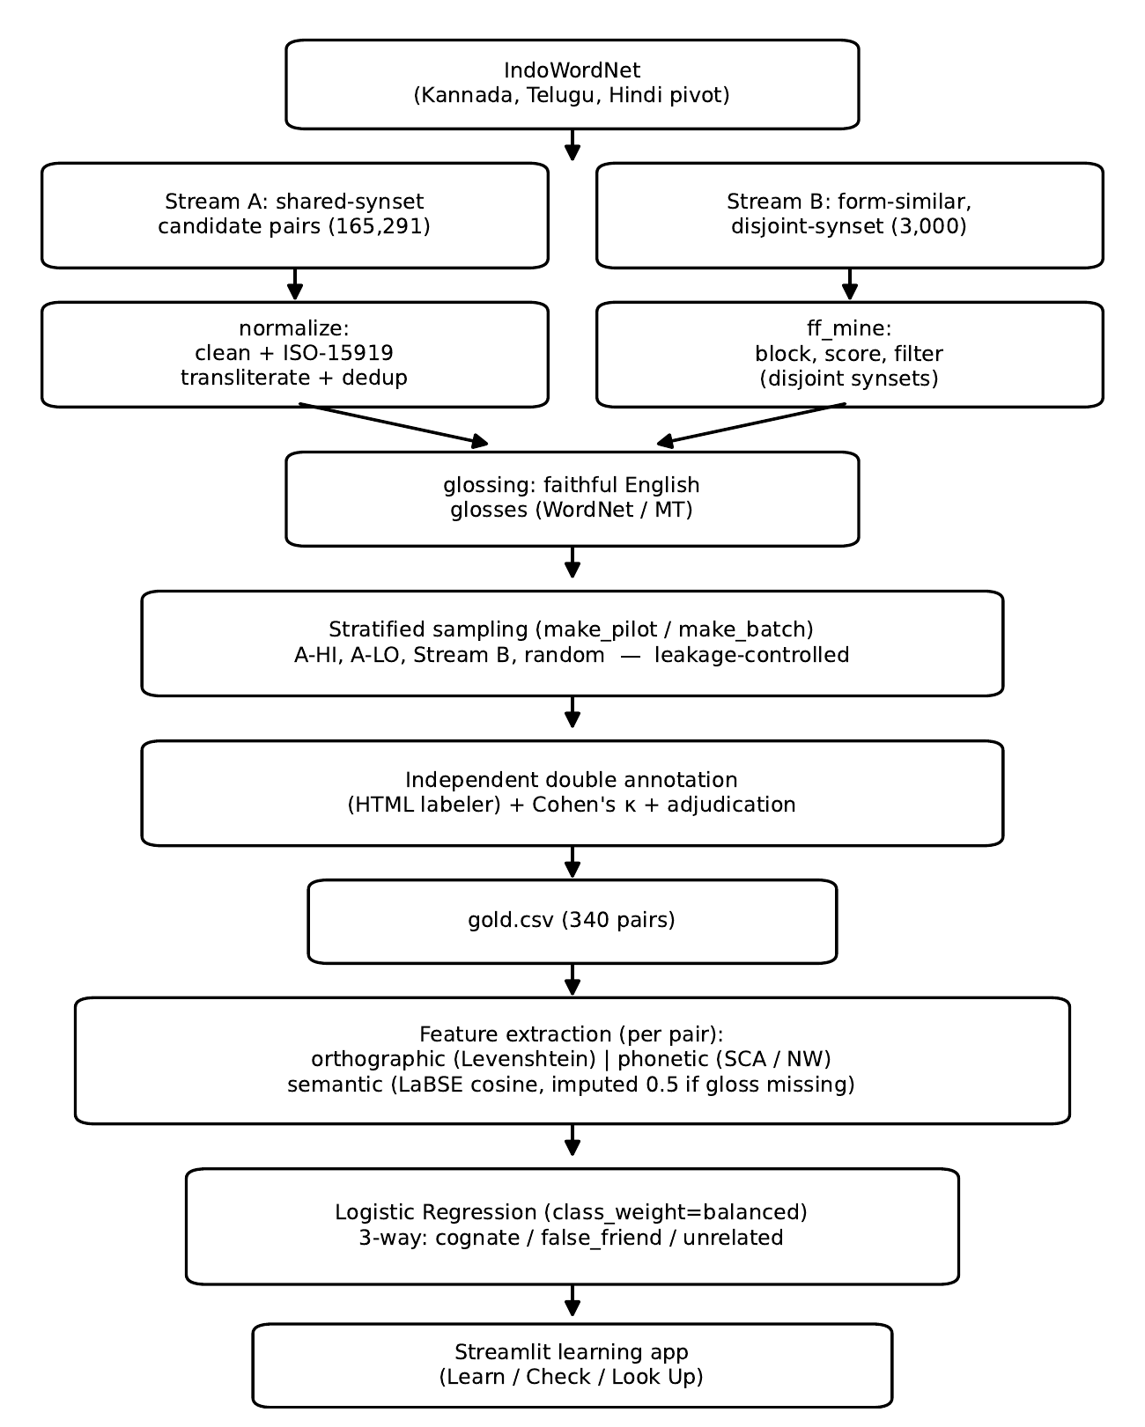
Figure 1. End-to-end pipeline, from IndoWordNet candidate mining through the adjudicated gold set, feature extraction, the class-balanced logistic regression, and the Streamlit learning app.

3.1 Candidate mining: two streams
Since a sample drawn only from shared dictionary senses would contain almost no false friends, candidates are collected from two complementary pools:
- Stream A (shared-synset): Kannada–Telugu pairs that sit in the same IndoWordNet synset (the same concept). This is the pool of likely cognates, plus some shared-meaning pairs we might still judge unrelated. Mining gives 165,291 raw pairs.
- Stream B (form-similar): Pairs that look similar after transliteration but share no synset — similar form, different concept, which is where false friends live. The miner blocks candidates by first romanized character and length, scores each with normalized edit similarity, and keeps a pair only if it's similar enough and the two lemmas' synset sets don't overlap. Capped at 3,000 pairs.
We assert the two streams are disjoint before using them, so no pair can sneak in from both.

3.2 Normalization and transliteration
Each raw pair is first cleaned: edge punctuation is stripped, and a row is discarded if either word is numeric, a single character, longer than 40 characters, internally punctuated, or (by default) multi-word. Both words are then transliterated from their native script to ISO 15919 using Aksharamukha, yielding a common romanization on which all surface comparisons operate. Transliterations are cached for reproducibility, and rows are de-duplicated on the (Kannada, Telugu) pair.

3.3 Faithful English glossing
The semantic feature requires an English gloss for each side of a pair. We enforce a strict faithfulness constraint: a gloss must be a faithful translation of the word's own native gloss, never disambiguated, enriched, or corrected, since any such intervention would leak annotator judgement into the data. The glosser first attempts the English WordNet definition via the shared IndoWordNet synset id (using a Hindi pivot through the Open Multilingual WordNet); failing that, it may fall back to machine-translating the native gloss, but only when explicitly enabled. When no faithful gloss can be obtained, the row is left blank and flagged (needs_gloss=true) rather than populated with an inferred meaning.

3.4 Stratified sampling and annotation
We first drew a 40-pair pilot, followed by a 300-pair batch. Both were sampled by stratification over four groups: Stream A high-similarity, Stream A low-similarity, Stream B, and random Kannada × Telugu negatives. The batch sampler excludes any pair already present in the pilot, so agreement is measured on previously unseen items; 20% of the batch was designated for double annotation. Both annotators labelled independently in a standalone HTML tool, without visibility of each other's decisions, following the written guidelines. The central labelling decision for this language pair is to treat a shared Sanskrit borrowing as a cognate, as it remains a shared, learnable form; etymological origin is recorded in a separate field that does not affect the primary label. This decision accounted for most of the inter-annotator disagreement.

3.5 Features
We compute three features per pair, all scaled to [0,1]:
- Orthographic: normalized Levenshtein similarity, 1 − edit_distance / max(len), on the ISO 15919 forms.
- Phonetic: global sound-class alignment via LingPy SCA, with a hand-built Needleman–Wunsch fallback whose substitution matrix scores phones by articulatory features (place, manner, voicing for consonants; height, backness, length for vowels). Both backends use the same normalization by the longer string's self-alignment score.
- Semantic: cosine of the two LaBSE gloss embeddings, mapped (cos+1)/2 so anti-aligned meanings aren't treated the same as orthogonal ones. When a gloss is missing, we impute the neutral midpoint 0.5 (with a flag), so “unknown” never gets read as “confidently dissimilar.”

3.6 Classifier and baseline
The model is intentionally simple: a multinomial logistic regression over the three features (class_weight="balanced", max_iter=1000, fixed random seed). The baseline is an edit-distance threshold that predicts cognate above a chosen cutoff and unrelated below it. By construction this baseline cannot predict false_friend, which motivates the need for a meaning-aware model. We report per-class precision, recall, and F1, macro-F1, a confusion matrix, and a feature ablation (orth → orth+phon → orth+phon+sem) in which a fresh model is retrained at each step on the same split.

3.7 Learning application
The Streamlit application comprises three screens: Learn & Practice (a teach-then-test progression through the three categories, in either language direction), Check Two Words (a live model prediction with confidence and a tiered gloss lookup), and Look Up a Word (reverse lookup across all known relationships, tagged dataset-verified or model-predicted).

4 Dataset
The final gold set comprises 340 adjudicated pairs (the 40-pair pilot and the 300-pair batch, with uncertain items excluded). All candidates originate from IndoWordNet, and the candidate_source field records the originating stream. Table 1 reports the label distribution, Table 2 the provenance, and Table 3 the stratified 70/30 train/test split (stratified on label, fixed seed).

Table 1. Label distribution in the 340-pair gold set. false_friend is the minority class, which is why we weight the classes and lead with macro-F1.
Label | Count | Share
cognate | 159 | 46.8%
false_friend | 54 | 15.9%
unrelated | 127 | 37.3%
Total | 340 | 100%
Table 2. Provenance of the 340 gold pairs by candidate source (mining stream).
Candidate source | Count | Share
shared_synset (A) | 177 | 52.1%
form_similar (B) | 115 | 33.8%
random | 48 | 14.1%
Total | 340 | 100%
Table 3. Stratified 70/30 train/test split (random_state=42, stratified on the label).
 | cognate | false_friend | unrelated | Total
Train (238) | 111 | 38 | 89 | 238
Test (102) | 48 | 16 | 38 | 102
Total | 159 | 54 | 127 | 340

Inter-annotator agreement: On the 300-pair batch (all unseen pairs), the annotators achieved 68.7% raw agreement and Cohen's kappa = 0.512, conventionally interpreted as “moderate.” Analysis of the disagreements showed a systematic bias: one annotator applied the cognate label more frequently (roughly 58% of labels versus 38%), reflecting a different threshold for shared-origin descent versus mere thematic similarity. The bias was resolved through joint discussion, after which all 94 disagreements were adjudicated to a final label. A full relabel-and-remeasure cycle to confirm the recalibrated agreement was not performed for reasons of time; this is noted as a limitation in the Discussion. Both individual annotation files and the adjudicated merge are released to support reproducibility.
Unpopulated origin field: The schema includes an origin field (inherited / sanskrit / other), intended to support a comparison of model behaviour on inherited cognates versus shared Sanskrit borrowings. It was not populated in the final run — all rows are unspecified — so this analysis remains future work.

5 Results

Table 4. Held-out test-set performance (102 pairs) of the class-balanced logistic regression. macro-F1 is the headline number given the class imbalance.
Class | Precision | Recall | F1
cognate | 0.931 | 0.562 | 0.701
false_friend | 0.400 | 0.875 | 0.549
unrelated | 1.000 | 1.000 | 1.000
Macro-F1 = 0.750 | Accuracy = 0.775
Table 5. Confusion matrix on the test set (rows = true, columns = predicted). All the errors are cognate↔false_friend; unrelated is perfectly separated.
true \ pred | cognate | false_friend | unrelated
cognate | 27 | 21 | 0
false_friend | 2 | 14 | 0
unrelated | 0 | 0 | 38
Table 6. Feature ablation (fresh model per row, same split). Semantic similarity lifts macro-F1 and false-friend F1; the phonetic feature adds no independent signal and slightly hurts false_friend.
Features | Macro-F1 | false_friend F1
orth | 0.704 | 0.526
orth+phon | 0.698 | 0.462
orth+phon+sem | 0.750 | 0.549
Table 7. Effect of class weighting. Turning it off raises accuracy but sends false-friend recall to zero — which is why accuracy is a misleading metric here.
Model | Macro-F1 | Accuracy | ff recall
balanced | 0.750 | 0.775 | 0.875
no weight | 0.619 | 0.843 | 0.000

The principal results are given in Table 4: macro-F1 = 0.750 and accuracy = 0.775. The unrelated class is classified perfectly (Table 5), and all remaining errors are confusions between cognate and false_friend — the fuzzy boundary that also drove annotator disagreement. The model achieves high recall on the rare false-friend class (0.875) at the cost of precision (0.400), i.e. it labels a few cognates as false friends. For a learning aid this is arguably the preferable error direction, favouring over-warning about potential traps over missing them; class weighting induces this behaviour.
Figure 2 explains this behaviour. The unrelated pairs have low orthographic and phonetic similarity (means 0.19 and 0.31, versus 0.80+ for the other two classes) and are therefore easily separated. In contrast, cognate and false_friend are nearly indistinguishable on form (orthographic means 0.80 versus 0.87; phonetic 0.86 versus 0.91), as expected given that Stream B was constructed to be form-similar. The semantic feature is the only one that separates them and does so only partially (means 0.72 versus 0.60).

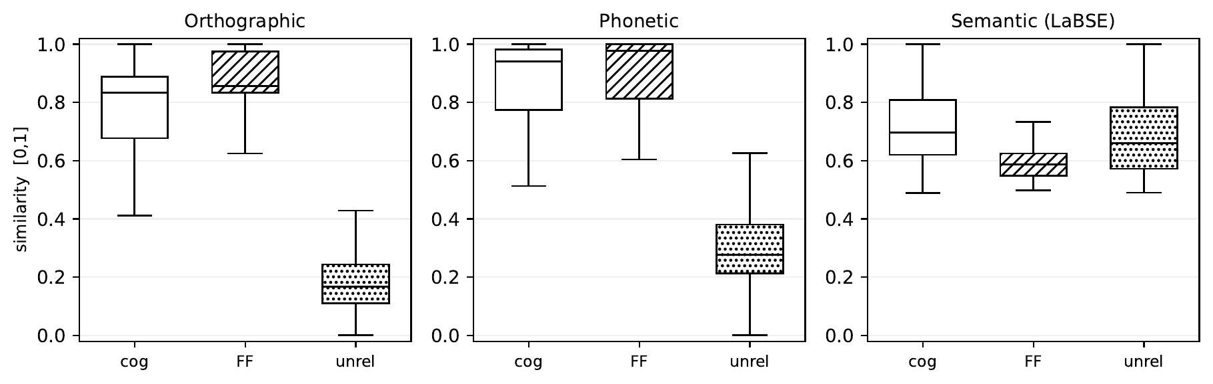
Figure 2. Feature distributions by class. unrelated is separable on form alone; cognate vs. false_friend overlap heavily on orthographic and phonetic similarity and are separated — only partly — by the semantic feature.

The ablation (Table 6) confirms this quantitatively. Adding the phonetic feature to the orthographic feature does not help macro-F1 declines marginally (0.704 → 0.698) and false-friend F1 falls (0.526 → 0.462). This follows from the fact that both features operate on the same romanized strings and therefore carry largely redundant information. The semantic feature provides the decisive gain, raising macro-F1 to 0.750 and false-friend F1 to its best value (0.549). Table 7 isolates the effect of class weighting. Disabling it raises accuracy to 0.843 but reduces false-friend recall to zero and macro-F1 to 0.619; selecting on accuracy alone would therefore have favoured the strictly worse model.

6 Discussion
Principal findings: Three findings emerge. (1) Semantics is the decisive signal. Form features alone cannot distinguish cognates from false friends — both were constructed to be form-similar — and it is the LaBSE gloss embedding that recovers the distinction. (2) The phonetic feature is redundant here. When comparison is performed through a shared romanization, sound-class alignment largely duplicates edit distance, and the ablation shows no benefit. We report this negative result explicitly; a genuinely independent representation, such as IPA with distinctive-feature weighting applied prior to romanization, would be required to test whether phonetics can contribute. (3) Evaluation methodology is consequential. The class-weighting experiment demonstrates that a single accuracy figure can favour a strictly worse model under class imbalance.
Error analysis: The following are representative test pairs (ISO 15919 in parentheses): two classified correctly and one exhibiting the model's characteristic failure mode.
- Caught false friend. sandeśa (Kn “a meaningful communication / message” vs. Te “a type of Bengal sweet”): the forms are identical (orth = 1.00), but the meanings are far apart (sem = 0.54), and the model correctly calls it false_friend. Exactly the kind of pair a form-only system would get wrong.
- Caught false friend. puṭṭa (Kn “small / little” vs. Te “anthill”): same story — identical form, different meaning, labelled correctly.
- Where it slips up. bālahīna vs. balahīna (Kn “tailless” vs. Te “incompetent / weak”): similar form (orth = 0.88) but the glosses are also close (sem = 0.74), so the model guesses cognate when the real answer is false_friend. When a false friend's two glosses happen to sound related, the one feature that could rescue us isn't much help — and that's behind most of the 21 cognate→false mix-ups in Table 5.
Strengths: The dataset construction is reproducible end to end. Pilot/batch leakage control is enforced by assertions rather than convention, the faithful-glossing constraint is implemented in the glosser, and missing semantic values are imputed to a neutral midpoint (0.5) so that “unknown” is not conflated with “dissimilar.” The evaluation is designed for transparency: macro-F1 is the headline metric, the baseline is one that structurally cannot predict the minority class, and the unsuccessful phonetic feature is reported rather than omitted.
Limitations: Several limitations remain. Inter-annotator agreement is only moderate (kappa = 0.512), and the annotator bias was resolved by discussion rather than by a fully re-measured calibration cycle, so the recalibrated agreement is not quantified. The perfect unrelated score partly reflects the sampling of negatives, which are largely dissimilar in form; a harder set of form-similar-but-unrelated pairs would lower this figure and provide a stricter test. The dataset is small (340 pairs) and evaluated on a single split rather than by cross-validation. Finally, the origin field was not populated, precluding the intended inherited-versus-borrowed analysis.
Challenges: The principal challenge was the rarity of false friends, which motivated the dedicated Stream B miner. The labelling of shared Sanskrit vocabulary was the main source of annotator disagreement and was addressed by an explicit project-specific rule. The use of two distinct scripts required romanization to ISO 15919 before any surface comparison was possible.
Future work: Promising directions include a genuinely independent phonetic representation; k-fold cross-validation for more stable estimates; threshold tuning to control the false-friend precision/recall trade-off; a harder negative set for the unrelated class; and populating the origin field to compare model behaviour on inherited cognates versus shared borrowings.

7 References
[1] H. G. Klein and T. D. Stegmann. EuroComRom – The Seven Sieves: How to Read All the Romance Languages Right Away. Shaker, 2000.
[2] G. Kondrak. A New Algorithm for the Alignment of Phonetic Sequences. Proc. NAACL, 2000.
[3] J.-M. List. LexStat: Automatic Detection of Cognates in Multilingual Wordlists. Proc. EACL Workshop (LINGVIS), 2012. (LingPy toolkit.)
[4] A. M. Ciobanu and L. P. Dinu. Automatic Detection of Cognates Using Orthographic Alignment. Proc. ACL, 2014.
[5] P. Bhattacharyya. IndoWordNet. Proc. LREC, 2010.
[6] Utilizing Wordnets for Cognate Detection among Indian Languages. arXiv:2112.15124, 2021.
[7] F. Feng, Y. Yang, D. Cer, N. Arivazhagan, and W. Wang. Language-agnostic BERT Sentence Embedding (LaBSE). Proc. ACL, 2022.
[8] S. Khanuja et al. MuRIL: Multilingual Representations for Indian Languages. arXiv:2103.10730, 2021.

An Appendix: User Manual

A.1 Repository layout
demo.py standalone entry point — run this first
report.pdf / report.docx the report
README.md setup + run instructions
config.yaml pipeline configuration
pyproject.toml package + optional dependencies
conftest.py makes `cognate` importable in tests
annotation_guidelines.md label definitions and edge cases
src/cognate/ core library (installable package)
__init__.py shared CSV schema + gloss helper
normalize.py clean + ISO-15919 transliterate + dedup
transliterate.py Aksharamukha wrapper + on-disk cache
ff_mine.py Stream B false-friend mining
iwn.py IndoWordNet loading helpers
glossing.py faithful English glosses (WordNet / MT)
build.py assemble orth/phon/sem features
model.py train / predict / save / load
evaluate.py metrics, confusion matrix, ablation
baseline.py edit-distance threshold baseline
cli.py featurize / baseline / train / evaluate / ablate
similarity.py compat shim -> features.orthographic
features/orthographic.py normalized Levenshtein
features/phonetic.py LingPy SCA + Needleman–Wunsch fallback
features/semantic.py LaBSE gloss-embedding cosine
scripts/ dataset-construction scripts
make_pilot.py stratified 40-pair pilot
make_batch.py stratified 300-pair batch
build_labeler.py CSV -> standalone HTML labeler
extract_pairs.py Stream A mining (repo root)
build_gold.py merge adjudications -> gold.csv (root)
merge_and_kappa.py Cohen's kappa + worksheet (root)
gloss_lookup.py, ui_theme.py Streamlit app helpers
tests/ unit tests (pytest)
data/ gold.csv, features.csv, models, labeled data
candidates/ cleaned + glossed streams, pilot
artifacts/ standalone HTML labeling tools

A.2 Environment setup
Requires Python 3.10+. From the repository root:
python -m venv .venv (for windows) / python3 -m venv .venv (for ios)
source .venv/bin/activate
pip install -e ".[dev,phonetic,semantic,app]"
Core (enough for demo.py and the model): scikit-learn, joblib, pandas. The phonetic extra adds LingPy (a Needleman–Wunsch fallback runs without it); semantic adds sentence-transformers/LaBSE (only needed to recompute features — data/features.csv already has them); app adds Streamlit; dev adds pytest.

A.3 Running the demo
demo.py is a standalone script that loads the released gold set, features, and trained model, then reproduces the paper's numbers, the ablation, the class-weighting comparison, and a set of example predictions. It needs only pandas/scikit-learn/joblib and runs in seconds:
python demo.py # full demo against data/
python demo.py --data-dir data # explicit data directory

A.4 Running the app and the tests
streamlit run app.py # the learning app
pip install -e ".[dev]" # then run the tests
pytest # conftest.py puts src/ on the path

