1. What is powerBi ?

It is a data visualization platform used for business intelligence process.

Designed to be used by business professionals with varying levels of data knowledge.

It is capable if reporting and visualizing data in a wide range of differenr styles,graphs,maps,charts and more

1. Why should use power Bi?

It has maximum no of features

We can craetw 1200 different functions

Cheapest tool

Data connectivity

1. Components of pwerBi?

* powerBi service
* powerBi Q&A
* data management gateway
* data catalog
* power query
* power pivot
* power map
* power view

**power query**:it is the data transformstion like extraction,transformation and load the data and transform uncleaned data to cleaned data.

**Power pivot**: It is a data modelling technique that create data models,establish relationships and create calculations.it uses data analysis expression language to model simple and complex data

**Power view**: it is technology that is available in excel,share point and powerBi.it connect data to data sources and filter data for each data visualization elements for entire report

**Power Bi Service**: after created the reports and dashboards, you can share them.End users in powerBi service and mobile devices can view and interact with them. You create workspaces where you and your colleagues can collaborate on reports and dashboards

**Power Bi desktop**:it is integrated development tool for power query, power pivot and power view.it lets you build advanced queries,models and reports. With this easy to advance your skills in BI and your experience in data analytics.

**Powermap**: it is used to visualize geospatial data in 3d mode.it works with the BING maps based on the geographical latitutde or longitude or a country,state,city or street address data.

powerBi Q&A: it is an ordianary language motor for your data models question and answers

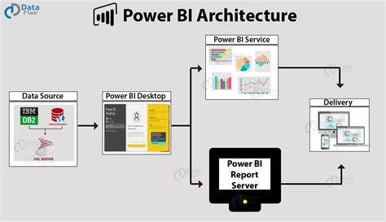

Power Bi Desktop: it is get data from data source like excel, csv, sql,pdf,website etc

Power Bi Service: it is used to share the stored data(report) to delivery team

1. view Data & Export to csv

select the Visual,select More options(…)>Export data.

In the save as dialog box,select a location for the .csv file and edit the file,if u want.

Select save.

1. Include & Exclude ?

**Include:** select any regions, right click on it we have Include option click on it, then we compare the selected regions.

**Exclude:** select any region on right click we have exclude option click on it, then we delete that region.

1. Table visualization in PowerBi?

Able visualization is just a normal grid containing related data in rows and columns. It can have headers ands rows only. Users can create tables in reports and cross highlighting the elements with in the table.they can select individual cells,rows and columns

* How to create the table
* How to format the table
* Conditional formatting :depend on conditions table will changes (In visuals cell elements option)
* Changing of aggregation : by following below process we done the aggregations

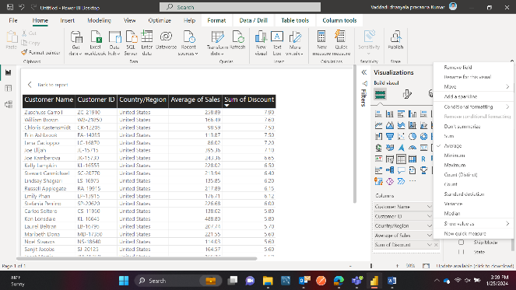

1. Matrix in PowerBi?

It is similar to table but its not allowed duplicate values. Table supports single dimensions only but its supports multiple dimensions

* Create a matrix
* Conditional formatting
* Automatic hierarchy: its displays more information in less space. Its shows how many sales in sub category in category filed

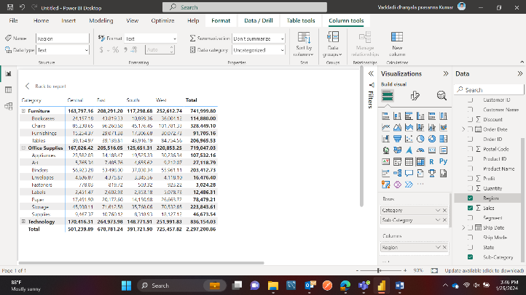

* Subtotal and grand total

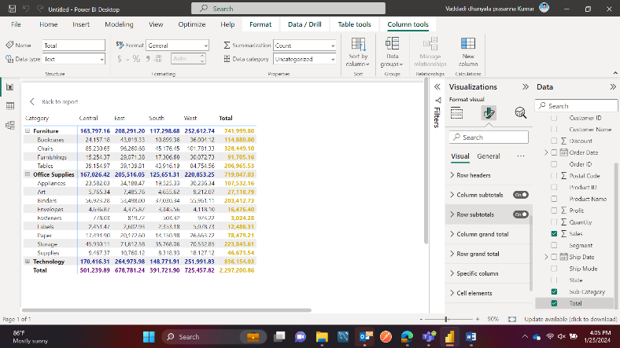

* Number formatting table and matrix

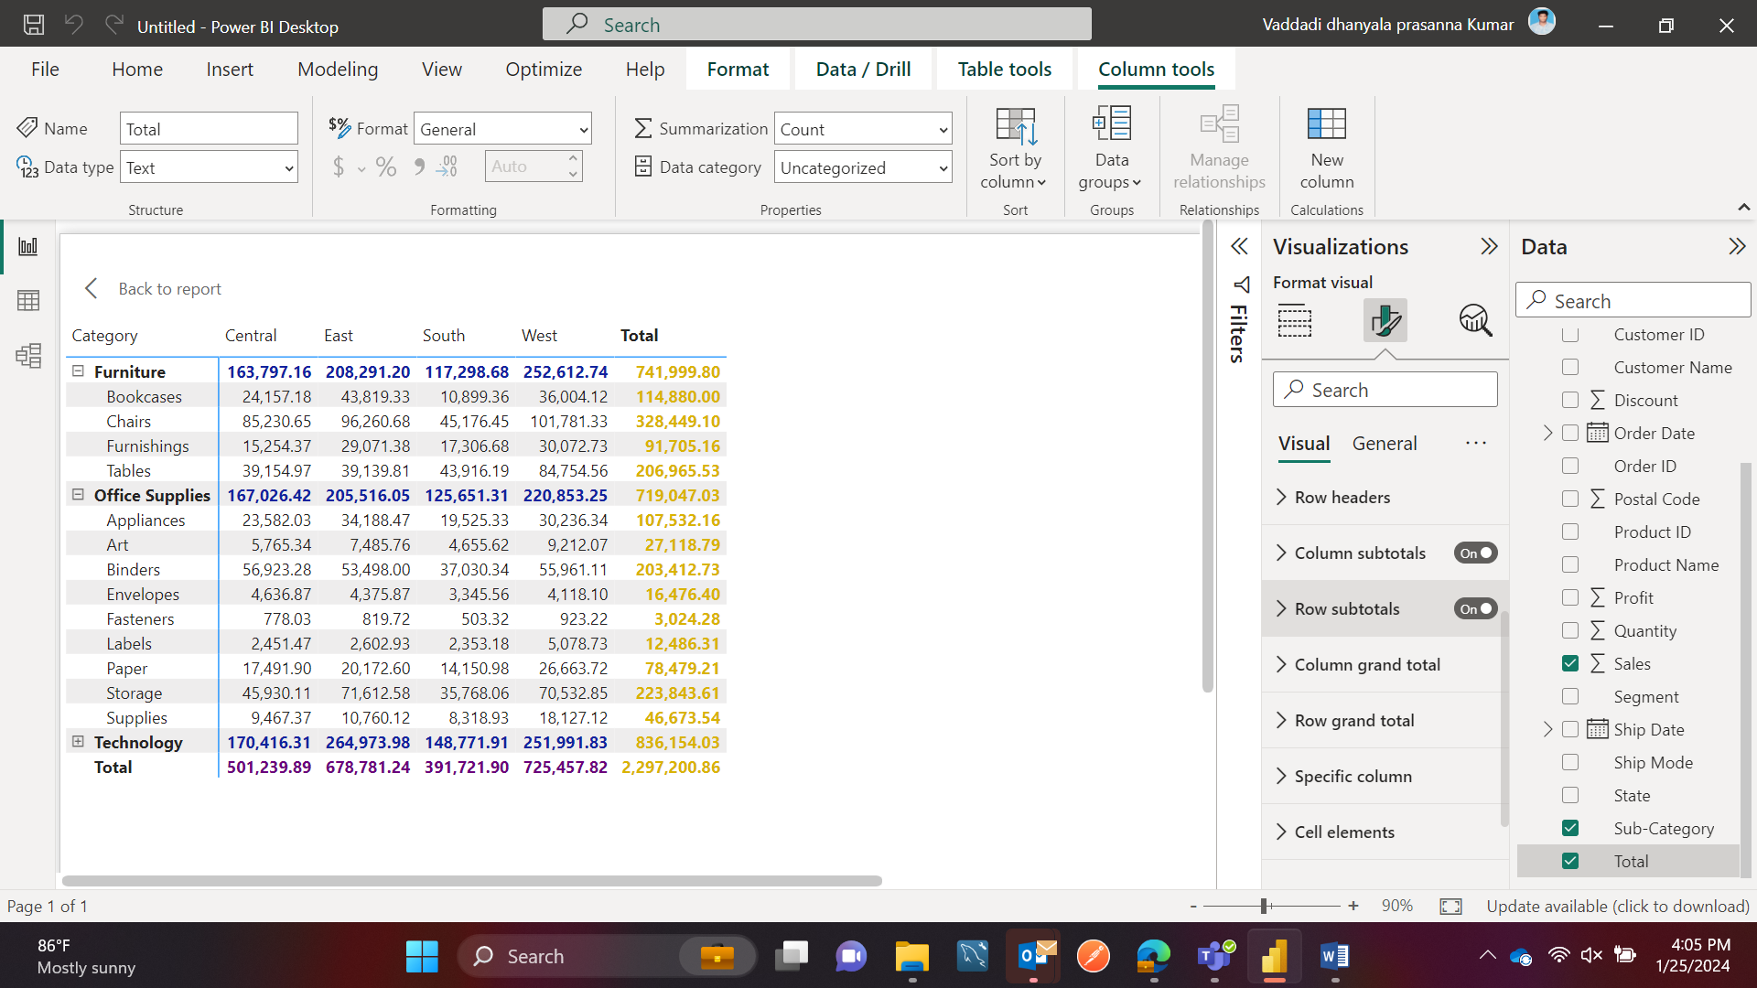

1. Charts in powerBi?

Line chart, drill down in line chart, area chart, Line vs column chart, scatter plot, waterfall chart, treemap,

guage chart: its compare with target value

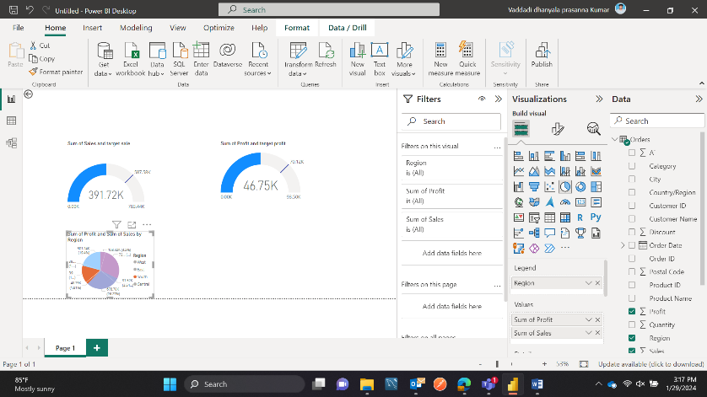

8.Cards and filters in powerBi?

Number card(the columns which has numbers), text card(by filtering we get which has high or low in the form of text ), date(which date has highest ), multi row, filter on visual, filter on page, filter on all pages, drill through

9.slicers in PowerBi?

Slicer for text, format text slicer, date slicer, format date slicer, number slicer

10.DAX functions in powerBi?

**Data analysis expression:** it is a programming language that is used throughout Microsoft power bi for creating calculated columns,measures and custom tables.it is collection of functions,operators and constants that can be used in formulae or expression to calculate and return one or more values

**Types:**

basic date function 1 year=year(filename(date column.(date)),

basic text function( 1 upper=UPPER(filename(columnname)) (functions:uppercase,lowercase,trim,length,concatenate)

LENGTH = LEN(Orders[Customer Name])

basic number function(arthematic operations n mathematical expressions),

basic logical function(if,and,or)

11.calculated columns and measures?

12 Data Modelling?

It is process of creating a relationship between the common columns of multiple tables.If column headings are same acreoss tables,then power Bi auto detects the relation between tables. Using these columns we can merge tables as well.

Types Of relations:

One to one

One to many

Many to one

Many to many

13

* + - * 1. filldown and fill up in powerBi?

Fill the same data down or up

* + - * 1. What is Group by?

Group the same data in particular column name

* + - * 1. What is transpose?

Its convert rows into columns or vice versa

* + - * 1. What is unpivote?
        2. Datatype in power Bi?

It detects data type in a column