Variants of Basic Convolution Function
Standard Convolution vs. Dilated (Atrous) Convolution for Multi-Scale Feature Recognition in Geographic Imaging
A Technical Report
Project Repository: geo-conv-project
Domain: Deep Learning — Convolutional Neural Networks
Date: 5 September 2026

2. Problem Statement
A geographic-imaging system (such as a satellite or aerial-image analysis pipeline) must recognize features that occur at very different spatial scales within a single scene: small isolated point-like objects (e.g., individual buildings), medium-sized elongated structures (e.g., roads and rivers), and large area features (e.g., lakes and forest patches). A single, small convolution kernel operating with the standard (unit) stride between its taps is inherently local: it can only respond to intensity patterns confined to its immediate neighbourhood. This makes it very effective for detecting fine, small-scale detail, but poor at capturing the broad spatial context needed to recognize large, gradually-varying features, unless the network is made very deep or the image is aggressively down-sampled — both of which have costs in computation and lost resolution. The problem addressed in this report is: how can a convolutional feature-extractor be designed so that it can perceive multiple spatial scales in the same image without inflating the number of parameters or discarding resolution?

3. Objective
- To study two variants of the basic 2-D convolution operation: Standard Convolution and Dilated (Atrous) Convolution.
- To implement both variants from first principles (NumPy) and apply them to a synthetic multi-scale geographic image.
- To analyse and compare how the receptive field of each variant affects the resulting feature maps.
- To recommend the convolution variant that is more appropriate for a geographic-imaging system that must recognise features across small, medium and large spatial scales.

4. Concept Used

4.1 Basic Convolution
A 2-D convolution slides a small kernel (filter) of weights across an input image and, at every position, computes a weighted sum of the pixels the kernel currently overlaps. The set of input pixels that influence one output pixel is called the receptive field. For a standard convolution with a k×k kernel and dilation rate 1, the receptive field is exactly k×k, so information more than a couple of pixels away from the output location has no direct effect on it.

4.2 Dilated (Atrous) Convolution
Dilated convolution introduces a dilation rate, r, which spaces out the kernel taps by inserting (r−1) gaps of zero-weight between consecutive samples. A 3×3 kernel with r = 3, for example, still has only 9 trainable weights, but its taps are spread over a 7×7 pixel footprint. The effective receptive field therefore grows from k×k to [k + (k− 1)(r−1)] × [k + (k−1)(r−1)] without adding a single extra parameter and without any pooling or stride-based down-sampling, so the output feature map keeps the same spatial resolution as a standard convolution would produce.

4.3 Why This Matters for Multi-Scale Recognition
Because dilation enlarges the receptive field for free (same parameter budget, same output resolution), it lets a network gather context from a wider neighbourhood — useful for large or elongated features — while a standard convolution remains better matched to compact, small-scale features. Comparing the two variants on the same input, using the same kernel weights, isolates exactly this receptive-field effect.

5. Methodology / Working Steps
- Step 1: Generate a synthetic single-channel geographic feature map containing three distinct spatial scales — small bright dots (buildings), thin linear strips (roads), and large soft Gaussian blobs (lakes).
- Step 2: Define one shared 3×3 Laplacian-type kernel so that any difference in output is attributable only to the convolution variant, not to different learned weights.
- Step 3: Implement a general conv2d(image, kernel, dilation) function from scratch using NumPy stride-tricks, and a dilate_kernel() helper that inserts zero-gaps to build the effective dilated kernel.
- Step 4: Apply the function with dilation = 1 (Standard Convolution) and dilation = 3 (Dilated Convolution) to the same input image.
- Step 5: Visualise and numerically compare the two outputs, focusing on how each responds to the large-scale blob region versus the small-scale dot regions.
- Step 6: Draw conclusions on which variant is more appropriate for the multi-scale geographic mapping task.

6. Implementation

6.1 Tools & Libraries
Tool / Library | Purpose
Python 3 | Core implementation language
NumPy | From-scratch convolution and dilation logic (stride tricks, einsum)
Pandas | Exporting the synthetic image as a CSV dataset
Matplotlib | Visualising input image, feature maps and receptive-field diagrams
Jupyter Notebook | Interactive step-by-step analysis

6.2 Source Code / GitHub Repository
The complete, runnable project (dataset generator, source code, notebook, and result images) is organised as the following GitHub-style repository, submitted alongside this report:
Path | Description
README.md | Project overview and run instructions
requirements.txt | Python dependencies (numpy, pandas, matplotlib)
dataset/generate_dataset.py | Builds the synthetic multi-scale geo-image (+ .npy / .csv)
src/conv_variants.py | Standard vs dilated convolution implementation (from scratch)
notebooks/Conv_Variants_Analysis.ipynb | Interactive analysis notebook
results/*.png | Output feature maps and receptive-field diagrams
screenshots/output.png | Run-output screenshot

Repository URL: <insert your GitHub repository link here after uploading, e.g. https://github.com/<your-username>/geo-conv-project>

7. Results & Output
Figure 1 shows the synthetic multi-scale input image alongside the standard-convolution output and the dilated-convolution output, using the identical 9-weight kernel in both cases.
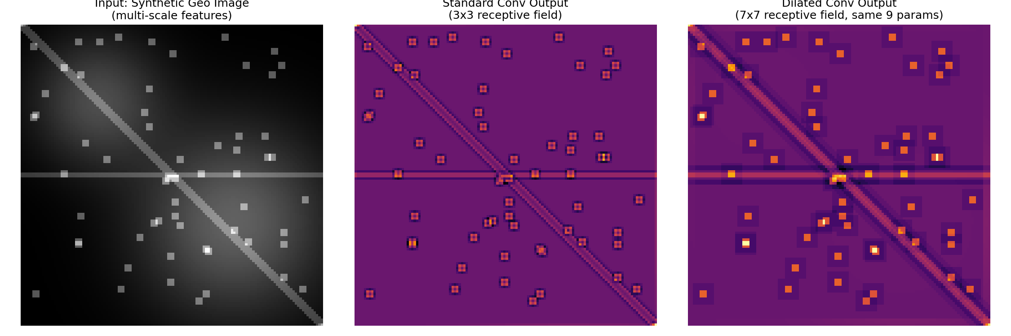
Figure 1: Input image, Standard Convolution output (3×3 receptive field), and Dilated Convolution output (7×7 receptive field).
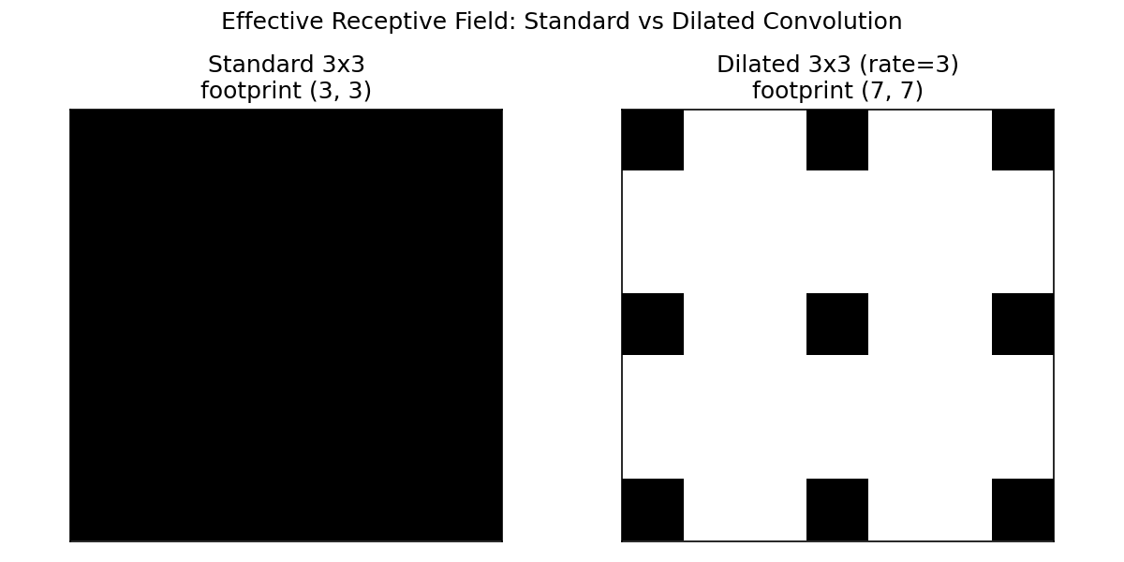
Figure 2: Effective receptive field footprint — Standard 3×3 (fully dense) vs Dilated 3×3 with rate 3 (sparse, spread over a 7×7 area).
Quantitatively, the mean absolute response measured over the large lake-blob region of the image was:
Convolution Variant | Effective Receptive Field | Trainable Parameters | Mean |Response| over Large Blob Region
Standard (dilation = 1) | 3 × 3 | 9 | 0.135
Dilated (dilation = 3) | 7 × 7 | 9 | 0.349

8. Analysis
The standard convolution output (Figure 1, middle panel) shows crisp, tightly localised responses exactly at the small dot-like building features and along the thin road lines, but it produces a very weak, almost negligible response over the large, smoothly-varying lake blob — the 3×3 window is simply too small to detect the gentle intensity gradient that defines the blob's shape.
The dilated convolution output (Figure 1, right panel) shows the opposite trade-off: it produces a much stronger and more spatially spread response over the lake region (mean absolute response 0.349 vs 0.135 for the standard kernel — roughly a 2.6× increase), because its 7×7 effective footprint can sense the broader intensity change across the blob. At the same time, its response to the individual building dots is slightly blurred/spread over a wider area compared to the pin-sharp standard-convolution response, since the dilated taps skip over some of the immediately neighbouring pixels.
This confirms the theoretical expectation from Section 4: enlarging the receptive field via dilation (rather than via a larger dense kernel or extra pooling layers) allows a convolution to capture large-scale context using exactly the same number of parameters, at the cost of slightly coarser localisation of very small features.
For a real geographic-imaging system, small features (buildings) are usually still detectable by dilated convolution, just with marginally less pinpoint precision, whereas a purely standard convolution would need many stacked layers (increasing depth, parameters, and computation) to ever reach a receptive field large enough to ‘see’ an entire lake or forest patch in one pass.

9. Conclusion
Both convolution variants have their strengths: Standard Convolution is best suited to precise, small-scale feature localisation, while Dilated (Atrous) Convolution is markedly better at capturing large-scale spatial context without increasing the parameter count or reducing output resolution. Since the stated mapping task requires recognising features across small, medium and large spatial scales simultaneously in the same geographic image, Dilated (Atrous) Convolution is the more appropriate variant overall — typically deployed as a set of parallel dilated convolutions at multiple dilation rates (an ‘atrous spatial pyramid’) so that both fine detail and broad context are captured together, rather than choosing only one scale.

10. References
1. Yu, F. and Koltun, V. (2016). Multi-Scale Context Aggregation by Dilated Convolutions. International Conference on Learning Representations (ICLR).
2. Chen, L.C., Papandreou, G., Kokkinos, I., Murphy, K. and Yuille, A.L. (2018). DeepLab: Semantic Image Segmentation with Deep Convolutional Nets, Atrous Convolution, and Fully Connected CRFs. IEEE Transactions on Pattern Analysis and Machine Intelligence.
3. Goodfellow, I., Bengio, Y. and Courville, A. (2016). Deep Learning. MIT Press — Chapter 9: Convolutional Networks.
4. NumPy Developers. NumPy Documentation — numpy.lib.stride_tricks.as_strided. https://numpy.org/doc/
5. Matplotlib Developers. Matplotlib Documentation. https://matplotlib.org/

